Delaware

http://www.doe.state.de.us

Districts and schools

Number of districts (CCD) | 1993-94 | 2003-04
 | 19 | 19

Number of public schools (CCD) | 1993-94 | 2003-04
Elementary | 86 | 105
Middle | 41 | 43
High | 32 | 32
Combined | 18 | 19
Other | n/a | 1
Total | 177 | 200

Number of charter schools (CCD) | 2003-04
 | 13

Finances

Total current expenditures  (CCD, in thousands of dollars, adjusted for inflation to 2002-03) | 1993-94 | 2002-03
Instructional | $508,593 | $693,970
Noninstructional | 34,525 | 52,592
Support | 277,358 | 381,184
Total | 820,476 | 1,127,746

Per-pupil expenditures  (CCD, adjusted for inflation to 2001-02) | 1993-94 | 2002-03
 | $7,774 | $9,693

Sources of Funding
(CCD, 2002-03)

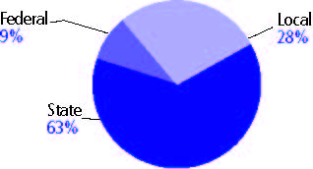

Title I allocation 2003-03 (ED; Includes Title I, Part A) | $30,637,587

Students

Public school enrollment (CCD) | 1993-94 | 2003-04
Pre-K | 565 | 642
K-8 | 76,052 | 82,256
9-12 | 28,930 | 34,770
Total (K-12) | 104,982 | 117,026

Race/ethnicity (CCD) | 1993-94 | 2003-04
American Indian/Alaskan Native | * | *
Asian/Pacific Islander | 2% | 3%
Black, non-Hispanic | 28 | 32
Hispanic | 3 | 8
White, non-Hispanic | 66 | 57

Students with disabilities (OSEP) | 1993-94 | 2003-04
 | 11% | 12%

Students with limited  English proficiency (NCELA) | 1993-94 | 2003-04
 | 1% | 4%

Migrant students (OME) | 1993-94 | 2003-04
 | 1% | 1%

Eighth-grade students enrolled in Algebra I for high school credit (NAEP) | 1996 | 2003
 | 39% | 21%

Students eligible to participate in the Free or Reduced-Price Lunch Program, 2002-03 (CCD) | 39,817

All schools by percent of students eligible to participate in the Free or Reduced-Price Lunch Program, 2002-03 (CCD)
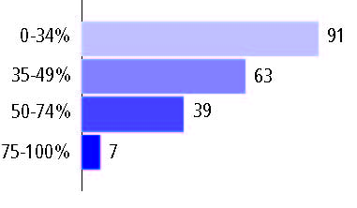

Staff

Number of FTE teachers (CCD) | 1993-94 | 2003-04
Elementary | 2,429 | 3,269
Middle | 1,741 | 1,752
High | 1,838 | 2,159
Combined | 287 | 362
Other | - | 12
Total | 6,295 | 7,554

Number of FTE non-teacher staff (CCD) | 1993-94 | 2003-04
Instructional aides | 846 | 1,361
Instructional coordinators | 61 | 188
Administrators | 491 | 658
Other | 3,862 | 4,631
Total | 5,260 | 6,838

Percentage of teachers with a major in the main subject taught, grades 7-12 (SASS) | 1994 | 2000
English | 90% | 61%
Mathematics | # | 74
Science | 82 | 68
Social Studies | 77 | n/a

Percentage of core courses taught by highly qualified teachers, 2003-04 (As defined and reported by states, collected by ED)

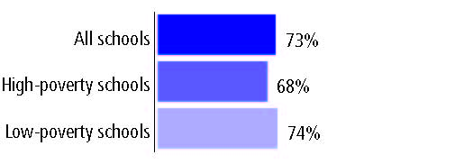

Outcomes

 | 1993-94 | 2000-01
High school dropout rate (NCES) | 5% | 4%
Avg. freshman graduation rate (NCES) | 74 | 71
College-going rate (IPEDS/NCES) | 65 | 60

NAEP state results
Reading, Grade 4 | 1994 | 2005
Proficient level or above | 23% | 35%
Basic level or above | 52 | 74
Math, Grade 8 | 1996 | 2005
Proficient level or above | 19% | 30%
Basic level or above | 55 | 73

Statewide Accountability Information:

State Accountability Website: http://www.doe.state.de.us/docs/pdf/de_edreportcard200304.pdf

State assessment for NCLB accountability: Delaware Student Testing Program

State student achievement levels: Well Below the Standard, Below the Standard, Meets the Standard, Distinguished, Exceeds the Standard

 |  | 2001-02  Annual measurable  objective starting point | Target  2003-04
Grade 3 | Reading | 57% | 57%
 | Mathematics | 33 | 33
Grade 8 | Reading | 57 | 57
 | Mathematics | 33 | 33
Grade 10 | Reading | 57 | 57
 | Mathematics | 33 | 33

2003-04 NCLB accountability results, applied to 2004-05 school year
AYP outcomes and consequences | Title I schools |  | All schools |  | All districts
Made AYP | 81 | 82% | 131 | 76% | 19 | 100%
Identified for improvement:
Year 1 | 6 | 6% | 34 | 20% | 0 | 0
Year 2 | 4 | 4% | 6 | 3% | 0 | 0
Corrective action | 3 | 3% | 3 | 2% | 0 | 0
Restructuring | 0 | 0 | 0 | 0 | 0 | 0
Exited improvement status (made AYP twice after missing twice or more, includes total “made” above) | 0 | 0 | 0 | 0 | 0 | 0

Other indicator, 2003-04 | State target | State outcome
Elementary Indicator: Decrease in the number of students performing below the standard | Progress toward 0 students below the standard | Met
Middle Indicator: Decrease in the number of students performing below the standard | Progress toward 0 students below the standard | Met
High School Indicator: Graduation rate | Progress toward or above 90% | Met

NCLB choice participation | Number of Title I students | Percent of eligible students
Title I school choice | 195 | *
Supplemental educational services | 54 | *

Student Achievement 2003-04

Delaware Student Testing Program, used for NCLB accountability
Grade 3

Reading
Proficient Level or above for:
All students | 82%
Economically disadvantaged students | 73
Migrant students | 90
Students with disabilities | 53
Students with limited English proficiency | 68
Black, non-Hispanic students | 70
Hispanic students | 74
White, non-Hispanic students | 90

Student achievement trend: Reading percent proficient level or above

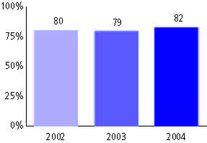

Delaware Student Testing Program, used for NCLB accountability
Grade 3

Mathematics
Proficient Level or above for:
All students | 78%
Economically disadvantaged students | 67
Migrant students | 82
Students with disabilities | 47
Students with limited English proficiency | 70
Black, non-Hispanic students | 61
Hispanic students | 74
White, non-Hispanic students | 87

Student achievement trend: Mathematics percent proficient level or above

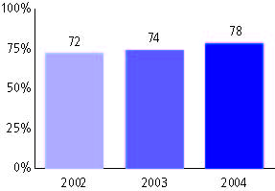

Delaware Student Testing Program, used for NCLB accountability
Grade 4

Reading
Proficient Level or above for:
All students | n/a
Economically disadvantaged students | n/a
Migrant students | n/a
Students with disabilities | n/a
Students with limited English proficiency | n/a
Black, non-Hispanic students | n/a
Hispanic students | n/a
White, non-Hispanic students | n/a

Trend Data Not Available

Delaware Student Testing Program, used for NCLB accountability
Grade 4

Mathematics
Proficient Level or above for:
All students | n/a
Economically disadvantaged students | n/a
Migrant students | n/a
Students with disabilities | n/a
Students with limited English proficiency | n/a
Black, non-Hispanic students | n/a
Hispanic students | n/a
White, non-Hispanic students | n/a

Trend Data Not Available

Delaware Student Testing Program, used for NCLB accountability
Grade 5

Reading
Proficient Level or above for:
All students | 85%
Economically disadvantaged students | 75
Migrant students | 83
Students with disabilities | 56
Students with limited English proficiency | 70
Black, non-Hispanic students | 73
Hispanic students | 84
White, non-Hispanic students | 91

Student achievement trend: Reading percent proficient level or above

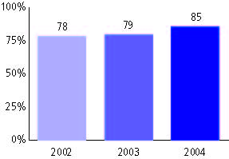

Delaware Student Testing Program, used for NCLB accountability
Grade 5

Mathematics
Proficient Level or above for:
All students | 75%
Economically disadvantaged students | 62
Migrant students | 71
Students with disabilities | 41
Students with limited English proficiency | 61
Black, non-Hispanic students | 58
Hispanic students | 73
White, non-Hispanic students | 85

Student achievement trend: Mathematics percent proficient level or above

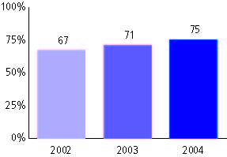

Delaware Student Testing Program, used for NCLB accountability
Grade 6

Reading
Proficient Level or above for:
All students | n/a
Economically disadvantaged students | n/a
Migrant students | n/a
Students with disabilities | n/a
Students with limited English proficiency | n/a
Black, non-Hispanic students | n/a
Hispanic students | n/a
White, non-Hispanic students | n/a

Trend Data Not Available

Delaware Student Testing Program, used for NCLB accountability
Grade 6

Mathematics
Proficient Level or above for:
All students | n/a
Economically disadvantaged students | n/a
Migrant students | n/a
Students with disabilities | n/a
Students with limited English proficiency | n/a
Black, non-Hispanic students | n/a
Hispanic students | n/a
White, non-Hispanic students | n/a

Trend Data Not Available

Delaware Student Testing Program, used for NCLB accountability
Grade 7

Reading
Proficient Level or above for:
All students | n/a
Economically disadvantaged students | n/a
Migrant students | n/a
Students with disabilities | n/a
Students with limited English proficiency | n/a
Black, non-Hispanic students | n/a
Hispanic students | n/a
White, non-Hispanic students | n/a

Trend Data Not Available

Delaware Student Testing Program, used for NCLB accountability
Grade 7

Mathematics
Proficient Level or above for:
All students | n/a
Economically disadvantaged students | n/a
Migrant students | n/a
Students with disabilities | n/a
Students with limited English proficiency | n/a
Black, non-Hispanic students | n/a
Hispanic students | n/a
White, non-Hispanic students | n/a

Trend Data Not Available

Delaware Student Testing Program, used for NCLB accountability
Grade 8

Reading
Proficient Level or above for:
All students | 71%
Economically disadvantaged students | 55
Migrant students | 75
Students with disabilities | 30
Students with limited English proficiency | 19
Black, non-Hispanic students | 54
Hispanic students | 56
White, non-Hispanic students | 82

Student achievement trend: Reading percent proficient level or above

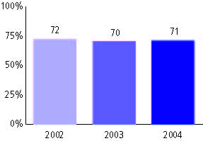

Delaware Student Testing Program, used for NCLB accountability
Grade 8

Mathematics
Proficient Level or above for:
All students | 50%
Economically disadvantaged students | 30
Migrant students | 60
Students with disabilities | 16
Students with limited English proficiency | 23
Black, non-Hispanic students | 28
Hispanic students | 33
White, non-Hispanic students | 64

Student achievement trend: Mathematics percent proficient level or above

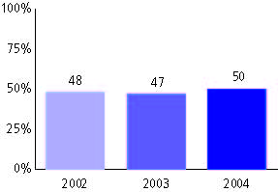

Delaware Student Testing Program, used for NCLB accountability
Grade 10

Reading
Proficient Level or above for:
All students | 71%
Economically disadvantaged students | 50
Migrant students | n/a
Students with disabilities | 16
Students with limited English proficiency | 23
Black, non-Hispanic students | 51
Hispanic students | 55
White, non-Hispanic students | 80

Student achievement trend: Reading percent proficient level or above

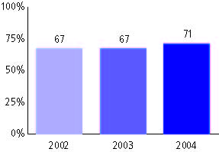

Delaware Student Testing Program, used for NCLB accountability
Grade 10

Mathematics
Proficient Level or above for:
All students | 53%
Economically disadvantaged students | 31
Migrant students | n/a
Students with disabilities | 11
Students with limited English proficiency | 30
Black, non-Hispanic students | 27
Hispanic students | 34
White, non-Hispanic students | 63

Student achievement trend: Mathematics percent proficient level or above

