Routh Roach Elementary School Garland, TX
La historia del George Washington
As a social studies lesson begins, a group of 15 second graders sit on the floor, all eyes and ears focused on their teacher as she reads aloud to them. She is reading a book about George Washington in Spanish. The teacher stops in places to question the students and lots of hands go up. When she finishes reading, students work together at their desks in groups of four to answer the question, “Why was George Washington important?” Engaging in serious conversation, students share what they remember from the text. The teacher moves about the classroom, monitoring the conversations. Some groups are beginning to write facts in Spanish on a cut-out colonial hat shape with lines. It is clear that these students, speaking and writing in their primary language, are engaged in their learning.
Routh Roach Elementary School Garland, Texas
http://www.garlandisd.net/roach 379 students, EC-5

Hispanic 57%
White 25%
African American 18%
Students eligible for free/ reduced price lunch 61%
Students with Limited English Proficiency 45%
Student mobility rate (2004-2005) 24%
Average class size 19
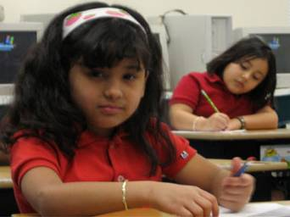
Routh Roach Elementary School is tucked away in a quiet Garland, Texas neighborhood of well-kept brick and stucco homes with private patios and tidy lawns, but draws students from well beyond walking distance. Nearly half of the school’s students are Limited English Proficient (LEP), which presented school staff with a special challenge.
School starts early and parents drive up in drop-off formation, releasing their children by ones, twos, and carloads. The entrance of the sprawling new building is decked with banners proclaiming Routh Roach as a “Texas Exemplary,” a “Distinguished Title I,” and a 2005-06 USDE “Blue Ribbon School.” Students arrive early to eat breakfast and engage in study hall activities as they await the eight o’clock bell. Sunlight dances on polished hallways.
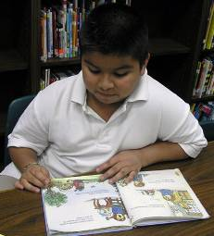
Welcoming the students with a smile and a cheery greeting is the Routh Roach Principal, Ms. Jeanette O’Neal. Principal O’Neal zealously prepares her Spanish-speaking students for success in the bilingual culture of their community. Using a research-driven “additive, late-exit bilingual” approach to educating substantial entering populations of Spanish-speaking students, O’Neal intends to erase the grim prediction that 50 percent of LEP students will drop out of high school.
“Additive Bilingualism”
O’Neal and her team are careful to explain Routh Roach believes in instructing students in their native language and keeping them in this program until they are strong readers in Spanish and are on or above grade level in core subjects. Reasoning that English proficiency is an inevitable by-product of academic success, the staff committed to abandoning any practice that required LEP students to acquire English at the expense of their education.
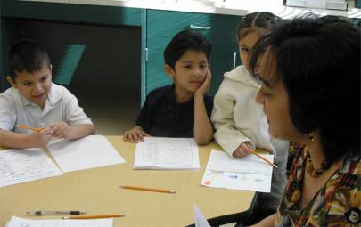
Together with her teachers, O’Neal implemented a plan based on research by Collier and Thomas (2002, 1997), Cummins (2000), Baker (1993), Collier (1989), and others. These studies suggest that when early literacy instruction is accomplished through the child’s native language in an additive bilingualism program, students sustain or increase those gains after transferring to English. Accepting this premise, O’Neal and her teachers set out to create a learning environment where the child’s first language is the language of instruction. In this environment a child’s first language and culture are promoted and developed in the process of gaining early literacy and innumeracy skills in the lower grades. Once those skills are solid in their native Spanish, students begin transitioning into English instruction and learn phonics, reading, and spelling, in English. While students are transitioning into English instruction they continue instruction in Spanish at a higher cognitive level. At Routh Roach, this transition into English typically happens after at least three years of instruction in Spanish. Depending on when a student enters the school, this may occur in third, fourth, or fifth grade. Such additive bilingualism is linked to higher student self-esteem, increased cognitive flexibility, and higher levels of proficiency in their second language (Baker, 2000).
Within this additive bilingualism environment at Routh Roach Elementary School, four characteristics of this high-performing school stand out.
A Two-Hour Language Arts Block
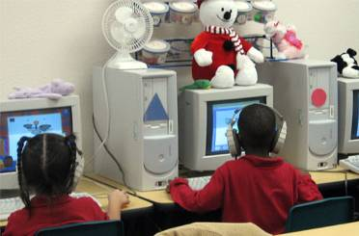
The school and all classrooms are structured to ensure maximum learning for all students. In most classrooms, the day begins with a 120-minute block for English (or Spanish) Language Arts instruction. Every classroom, regardless of grade or language of instruction, uses an identical structure for instruction in core subjects: a series of teacher-led small group instruction, teacher-guided follow-up practice, and independent student work. Independent student work, some of which occurs on the computer, includes reinforcing new skills and practicing recent skills.
In the third grade bilingual classroom, for example, a teacher worked with five to seven students at her horseshoe shaped table, teaching them to recognize nouns and verbs. When these students completed the lesson, they worked independently at their desks, practicing the skill. Other students were doing their daily Success Maker at one of the five computers in the room. And a fourth group is in the library working in the Accelerated Reader Program overseen by the school’s librarian. By successfully completing a series of books and related quizzes, students earn points that can be traded to purchase paperback books and other items. Students rotate through these four stations daily, acquiring the personal management skills to self-motivate through the stations as they learn the skills of the day. All activities are accomplished in Spanish: reading instruction, daily reinforcement, and Accelerated Reader.
Principal O’Neal expects students and teachers to spend their time “on task.” Attention to instructional minutes adds up, according to her philosophy. And teachers agree. “I can’t lose a minute of these children’s time,” one said. Teachers routinely ask themselves: “How is this activity going to benefit my kids in the classroom?” If it doesn’t, they say, they have no business doing it. “Asking ourselves that question,” one teacher said, “took away lots of fluff. And teachers don’t miss it.”
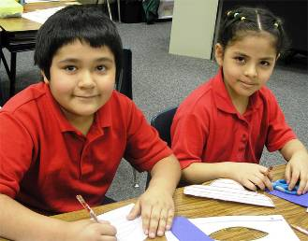
There is no down time in music either. In a recent class, the music teacher engaged the students in movement and music as soon as they entered the room. The students learned the song “Draw a Bucket of Water,” a rope-pulling song that engages students in groups of four holding hands and singing repeating verses as changing numbers of “buckets” are drawn. The song and movement exercise ended when all the children were "under" one another's arms in a woven position. In the process, the students practiced their diction in English and the music teacher incorporated math, asking children to identify the math operation being described, for example, and to identify how many buckets were left at the end of each verse.
Instruction in all content areas starts with a basic question: How can the teacherhelp the child understand what this skill is about and how it can be useful in the child’s life? This can be seen in classrooms as teachers introduce lessons. In one fourth grade classroom, the teacher began a math lesson with a story problem disguised as a complaint about her kitchen. Gathering her students around her one morning, she revealed, “I am sooo tired of my wallpaper in my kitchen. I’ve got to change it. But before I go to Home Depot to get new wallpaper, I have to figure out how much I need to buy. How can I do that?” Soon the students were busy thinking about area and multiplication.
All Students Follow the Same Curriculum
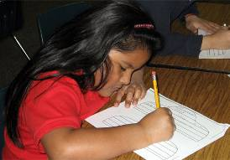
Regardless of native language or language of instruction, all students follow the same curriculum. Spanish- Language Arts instruction in the first grade regular class looks exactly like English-Language Arts instruction in the first grade bilingual class, except that in one class the text and instruction is in Spanish and in the other class it is in English.
A recent reading block in one of the first-grade classrooms began with direct teaching of syllables. Pointing to a number of syllables on the board, the teacher asked, “What words can you think of that contain these syllables?” The lesson was fast-paced but all the children responded. For the syllable “tri” a student gave the word triple and for the syllable “cra” another student offered “cradle.” The children continued to raise their hands, adding more words to the syllables on the board. Sometimes the teacher asked students to talk about the meaning of the word or how many syllables it contained.
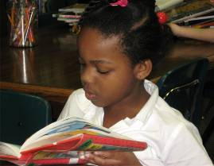
In the bilingual class next door, the teacher followed the same process and timing. Students were grouped by ability into three groups—a maximum of six students each. After about 20 minutes of discussion on syllables, the teacher shifted her focus. She wrote sentences on the board, read them aloud, and asked students to identify the subject and the adjective. All the students appeared excited by the exercise and eager to respond. As the direct teaching and response ended, the teacher quickly transitioned to projecting an overhead of worksheets for practice on syllables, subjects, and adjectives. The students practiced a few with the teacher until she was confident they understood the task. The reading block continued: a new group of students worked with the teacher, while the first group completed the practice assignment at their seats, and another group worked independently at the classroom computers. The teacher checked each for fluency and comprehension as students read with confidence and obvious joy.
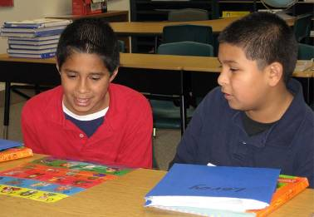
Students in both classrooms are taught to learn—become literate—and build a sound foundation of skills and concepts. They read aloud, ask questions, and think at progressively more abstract levels. Both classes follow an identical curriculum; both teachers use the same pacing guide, the same content, and the same instructional techniques. In doing so, the Routh Roach teachers align their instruction to the Texas grade-level standards and curricula, providing students with appropriate repetition and instructional consistency. Concepts introduced in early grades are revisited each year with different complexity and higher mastery. Because this happens in both English and Spanish-speaking classes, students transitioning from Spanish to English in the later grades rarely miss a beat, since their foundation has been identical to that of their peers.
Strong Student Support
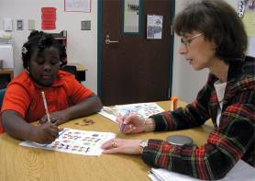
Routh Roach teachers use their district online curriculum extensively to plan, instruct, and assess student progress. That the online curriculum has strong teacher buy-in and is well-used should not be surprising, since the curriculum was developed, in part, by district teachers including some from Routh Roach. All textbooks are aligned to the state standards and available in both English and Spanish. Students in bilingual classrooms and in English classrooms follow the same curriculum and take the same assessments, but in Spanish.
This systemic consistency at Routh Roach—common messages and instructional approaches—was developed, and is refined, through a team approach. A campus improvement team with representatives from each grade level discusses and reaches agreement on the methodology and strategies for all grade levels, so that math regrouping and rounding, for example, are taught the same way in all grades.

Other strong student supports include Success Maker and other district-wide assessments. Individual self-paced Success Maker for Reading and Math student data reports are generated every three weeks. Such formative assessments are monitored closely and both teachers and students pay attention to the results. Teachers are intentional about covering materials likely to appear on the state assessment tests and teach explicit strategies for doing well on the tests. Given that the tests mirror the standards, the Routh Roach teachers view this not as “teaching to the test” but as “teaching to the standards.”
Many Routh Roach students also take advantage of an extended day program taught by classroom teachers. All students, Spanish speakers as well as native English speakers, are welcome to this additional opportunity to master skills, but those in danger of not passing district tests are strongly encouraged to attend. The program offers 60 additional minutes of instruction three days each week. At first, the after-school program was a tough sell, but parents warmed to the idea after the first assessment results showed that students who attended the program improved their scores. Teachers divide the after-school students for efficient instruction and thus may not tutor their own kids—contributing to the faculty’s sense that they “are all in this together” and share responsibilities for all students in the school.
High Expectations
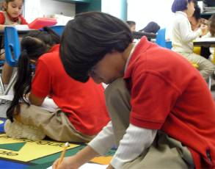
The school thrives on high expectations for students and for faculty. “We believe that our kids can do the work and do it well,” is a frequently-heard belief from administrators, teachers, and classroom specialists. A fourth grade teacher explained that Spanish students, just like their English-speaking peers, can be “masterful at disappearing” when they don’t understand the lesson, but when they are fully engaged in their native language they are very purposeful and directed. “If you expect that the child can do it, he can. And he will feel good about it,” this teacher noted.
In a fourth grade mathematics class where students worked with rays, segments, and angles, not a single student “disappeared.” The lesson (in Spanish) was fast-paced and interactive with a lot of give and take between the teacher and her students. Everything was purposeful. Students worked seriously and used new skills and knowledge as they worked in cooperative table groups to respond to questions or prompts. On the board was a diagram of several intersecting lines with points labeled with question marks. Locating and naming rays, segments, and angles quickly, members earned team points while learning mathematical concepts. A buzz of purposeful activity attested to student learning, and interest.
Teachers are critical to the success of this Routh Roach approach. Not just any teacher meets the school’s requirements. While ESL teachers may not speak the student’s first language, since all ESL instruction is in English, all Routh Roach bilingual teachers must be proficient in the child’s first language. In addition to the ESL lessons bilingual students receive instruction in English during art, music, and physical education. According to Principal O’Neal, teaching these special subjects in English with a little Spanish is a natural way for ELL students to test out and expand their growing English abilities and vocabulary in less academic settings. O’Neal has worked hard to give every class a “special” daily to expose ELL students to functional English.
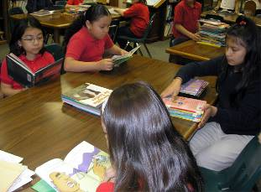
Everyone at Routh Roach works in concert. The library has a large collection of books in Spanish so the bilingual students can acquire literacy in their native language. The librarian states, “My job is more than just checking out books. My job is to get them reading and be successful at it.” The Accelerated Reading program is used to test students on their reading level and put them into the next level when they are ready. The librarian makes sure that kids are on level and that all the resources they need are there for them. Logs are kept on every child and shared with their teachers. The library is “wonderfully used.” Students know their level and go right to the shelves with much excitement.
Even casual conversations in the hallways and in the teachers’ lounge at lunch are about students and how to support students to be successful. In the teachers’ lunchroom one conversation focused on a student with a passionate interest in volcanoes. As they ate, teachers discussed possible resources that might build on this student’s strengths and interests.
All adults in the school work for the success of each and every child, and at Routh Roach, this means instructing students in their native language until they have achieved academic success. Transition to English and further academic success in English will come, they believe, once that solid academic foundation has been achieved.
Routh Roach Elementary School State Criterion-Referenced Tests
% proficient and above: 5th grade Reading
 | 2003 | 2004 | 2005 | 2006
All | 88 | 97 | 98 | 90
Low income | 82 | 94 | 96 | 88
% proficient and above: 5th grade Math
 | 2003 | 2004 | 2005 | 2006
All | 98 | 97 | 100 | 100
Low income | 81 | 94 | 100 | 100

