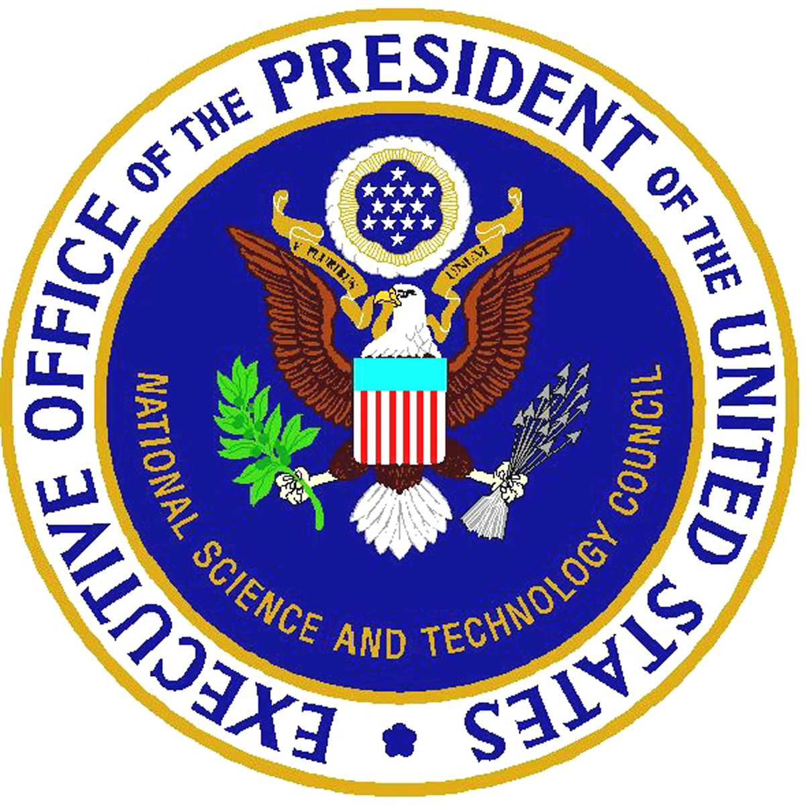The National Science & Technology Council

Regional Forum on Research Business Models

Alignment of Funding Mechanisms

with Scientific Opportunities
Hosted by: Lawrence Berkeley National Laboratory

Monday, October 27, 2003
Lawrence Berkeley National Laboratory
Berkeley, California
Building 50 Auditorium
Agenda

9:00 Coffee available

9:30 Welcome:
- Charles V. Shank, Director, Lawrence Berkeley National Laboratory
- Kathie Olsen, Associate Director for Science, Office of Science and Technology Policy

10:00 Summary of Public Comments:
- Geoff Grant, Staff Director, Subcommittee on Research Business Models, and Deputy Director, Office of Budget, Finance, and Award Mgmt., NSF

10:45 Break

11:00 Panel Discussion: Does How We Support Research Determine What We Get? Perspectives from the Science and Engineering Community
- Nat Pitts, Director, Office of Integrative Activities, NSF (Moderator)
- Arthur Bienenstock, Vice Provost and Dean of Research and Graduate Policy, Stanford University (and former Associate Director for Science, OSTP)
- Dennis Matthews, Director, Center for Bioscience and Engineering, Lawrence Livermore National Laboratory

Noon Lunch (box lunch provided)
- Keynote Speaker: M. R. C. Greenwood, Chancellor, UC-Santa Cruz

1:00 Panel Discussion: New Models for Supporting Science and Engineering Research
- Constance Atwell, Associate Director for Extramural Research, National Institute of Neurological Disorders and Stroke, and Co-Chair, NSTC Subcommittee on Research Business Models (Moderator)
- G. Scott Hubbard, Director, NASA Ames Research Center
- Mary Lidstrom, Associate Dean, School of Engineering, Univ. of Washington
2:00 Public Comment
- 3 minutes/speaker
- People interested in speaking during the public comment period are encouraged also to provide comments in writing (either at the event or via e-mail to: nstc_rbm@ostp.eop.gov).

4:00 Adjourn

