

Telework Center
Survey

March 2006

WHY DO YOU PREFER USING A
TELEWORK CENTER?

SUMMARY:

The Washington Metropolitan Telework Center directors performed two simple surveys of their federal telework clients. The first survey was performed in April 2004 at the Manassas, Herndon, and Fairfax Telework Centers, and consisted of the following question:

“Please take a few minutes to give me your thoughts and feelings about why you’ve chosen to work from a telework center instead of teleworking from home…”

Comments most frequently received from the federal teleworkers in the 2004 survey were:
- Better equipment at a center versus at home
- Higher productivity due to less distractions, quieter environment, ability to focus
- Availability of onsite technical staff, friendly and helpful
- Work better in a structured environment versus at home
- High speed internet access, which is not available at home
- Employer supports telework center as the primary telework location
- Prefer to keep work life and home life separate
- Like interacting with other workers

The second survey was conducted in October 2005. Eight of the fourteen GSA-funded Telework Centers participated in this survey, including the Winchester, Fredericksburg, Stafford, Woodbridge, Frederick, Laurel, Waldorf, and Prince Frederick Telework Centers. The survey consisted of the following question:

“Why do you prefer using a telework center over home-based telework?”

Most respondents listed more than one reason for choosing a telework center over home-based telework. The reasons cited were consistent with the 2004 survey responses.

- Home distractions, spouse, children, housework: 44%
- High end office equipment not available at home: 43%
- Prefer a professional office environment: 29%
- Broadband not available at home: 21%
- Supervisor prefers a telework center: 21%
- Onsite technical support: 16%
- Want to keep home life and work life separate: 11%
- Isolation of home telework: 11%

From the group of survey respondents who DO have the option of working at home because their agency policy permits it and/or they do have broadband at home, 42% clearly stated that they PREFER to work from a telework center.

Following are some of the comments that were received from the federal teleworkers in the course of the two surveys.

“Here are the things off the top-of-my-head. Quieter and more professional-like atmosphere; Printers, connectivity, etc. better; Conference calling, phone services/options better; My wife works exclusively at home and would be difficult to connect online at same time without tying up both phone lines”
Ken Konzen, GSA

“I prefer using the telework center for the following reasons:
-broadband is not yet available at my home
-2 young children at home
-professional, comfortable office environment
-only 1 mile from my home (walking distance)”
Gia Grady, FAA

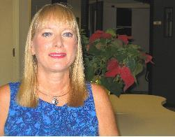
“I enjoy being around people – would feel isolated at home all the time.
- Access to more of the advanced technological equipment.
- A chance to run errands at lunch time, bank, mall, etc
- Closer to doctor’s office for lunch time appointments.
- Having a systems person on site.
- Less distractions at telework site.”
Alice Palumbo, GSA

“Dressing professional and going out to the Waldorf Telecommuting Center does
more for my self esteem and my work productivity than sitting at home in my
flannel pajamas on the couch with my laptop for eight to nine hours. Besides, the center has everything that I need to do my job that my home just does not have, and the odds are overwhelming that I will never have most of those things. For starters, the center has onsite technical support roaming through the center all day available to answer any of my technical questions and to fix any malfunctions with the respect to the computers. This is one of the advantages that I appreciate the most simply because, I have no tolerance for over the phone technical support, and that is what I would get at home. The center has every piece of computer equipment that I could think of, a conference room if I need it, as well as the latest computer programs that I need to get my job done, a nice private cubicle and more! Lastly, I have honestly never met a friendlier staff than the individuals that oversee the Waldorf Telecommuting Center; the staff goes above and beyond the call of duty to ensure that the work environment is professional and conducive to getting my work done effectively and efficiently.”
Iris Bowman, NIH

“I think it's a good question. I do have the option of teleworking from home. For me, the primary reason for using the telework center is that it has fewer potential distractions than I would have at home.”
Larry Stauffer, Treasury

“I prefer working at a telework center as it offers me more options that I
need to complete my job, e.g., computer, printer, xerox, fax, phone, privacy,
'the feel of an office' all of which I do not have at home. But most
importantly, the center provides onsite technical help which is of utmost
importance to completing my job. Many times I utilize these services (via
Paula & Tracy) and it has been very helpful. At home, I would not have that
option. I prefer a work setting as opposed to a home setting and don't need
the disruptions of my children running in and out of the house at various
times during my work day. I fully enjoy using the telework center as it works
100% for me.”
Jody Nyers, USDA

“I like the convenience of not having to clutter my home area with work from my job. I choose not to have office equipment at home and can appreciate the technical support I get at the center, mainly from Tracy Mason. Thanks Tracy. Also I like the professional office environment, the opportunity to still work away from home but not the distance, yet still feel a sense of a true office environment. If I home-teleworked, I don't feel I could really separate "Home" work versus "office " work. Working from the telework center keeps me more focus on the work I need to accomplish for my job.”
Dot Dorsey, Education


“I would easily be distracted at home with chores and phones and laundry. The IT support we receive at the center is worth its weight in gold. I wouldn’t know what to do at home if there were a problem with the computer. I am not the most organized person in the world and feel that I can work better in a structured environment than at home. I also enjoy the interaction with fellow teleworkers. The center is across from the Freedom Center (exercise facility), and it is convenient to go over at lunch and after work hours. I also enjoy the cafeteria.”

April Cadorette, DOD

“My answer to your questions would be: professional office environment”
Jennifer Hatton, Education

“Broadband, equipment, etc. not provided by my agency for home telework, professional office environment”
Traci Least, Census

“There are a few reasons why I prefer the telework center. (1) More distractions at home (thinking and seeing projects that need doing, (2) Highway traffic (3) Broadband/Office equipment also, not available.”
Vincent Keys, FDA

“Conducive work atmosphere.”
Leon Litow, Health and Human Services

“My supervisor is opposed to allowing employees to work from home; and I would not have access to all the necessary office equipment at home.”
Sandra Harris, Education

“Office equipment is not available at my home-point of fact.”
Al Noerling, DOD/Navy

“I do not have the broadband capabilities at home and I do like the more professional environment.”
Gloria Mounts, Education

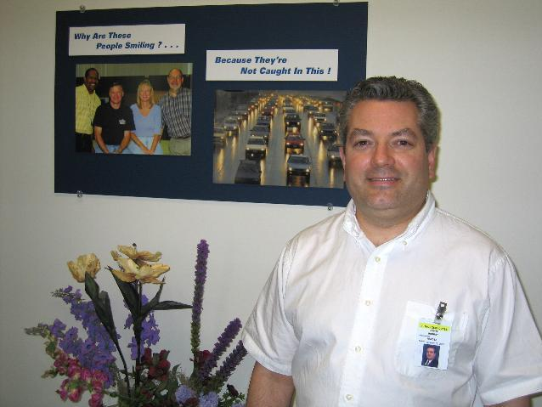
- “My agency supports GSA Telework site as primary telework location.
- Too many distractions at home (i.e., wife and two children at home)
- Working from home would require another telephone line to facilitate telework, as spouse uses primary home phone for business.
- Home office would not have benefit of shared office equipment that is available at telework center (i.e., B/W printer, color printer, fax machine and reproduction machine).”
John Murray, DOD/Navy

“Certainly the availability of office equipment and an office environment is
important as well as fewer interruptions (like the phone ringing at home
every 15 minutes with a telemarketer). Also I only have dial up at home so
if I'm on the computer, it takes forever to access many things (Agency will
not pay for faster service). I do like having immediate technical expertise
right here in the office as well.”
Marilyn Jackson, NIH

“For me, the main ones would be the availability of technical
support and broad band. One thing I think could be added is that
management officials (including myself in some situations or with some
employees) remain skeptical about work at home…”
Sarah Tuck, USDA

“Professional office environment is good for work ethic. No broadband at home”
Brad, GSA

“Work life kept separate from home life”
Judy, DOD/Army

“No Interruptions”
Terri, DOT/FHWA

“No Interruptions”
Sherri, DOT/FHWA

“No Interruptions”
Antoinette, Homeland Security

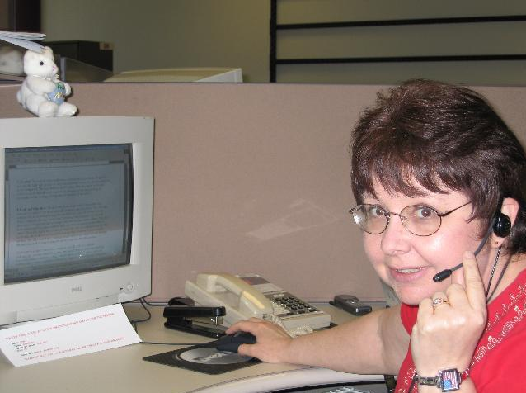
“Although I have not been able to utilize the facilities due to job demands lately, the advantage of having the center over working at home is that there are no personal interruptions. With a retired husband and a teenager in the house there are too many distractions at home. There is also the issue of using my personal telephone line for computer access or having to go to the personal expense of putting in a second line. There are limited office capabilities from home and it is not my intent to fund those resources out of my own pocket. Yes, there is a trade off, but it is not feasible in my case. I have little space at home and do not plan to forfeit a portion of it to create a second office.”
Bonnie Smith, DOD

“Boss will only allow telework from a center”
Kim, DOD/Army

”Center has more office equipment and support”
Bill, DOD/NAVSEA

“No broadband at home”
Sally, DOD/Army

“The reality is that conditions are safer (better ergonomically) and more comfortable for long work sessions, there are fewer distractions (things I might want to get done at home, incoming phone calls to the home phone, family members, etc.), and I tend to be in a more business-like frame of mind while sitting at a fairly sparse desk.”
John, National Geospatial Agency

“Reasons for working at a telework center rather than teleworking from
home:
- Use center's equipment (PC, Printer, Fax) and supplies (paper,
printer cartridge) versus personal equipment and supplies.
- Center offers a better telephone system for business activities with
capability to hold calls, utilize multiple lines and voice mail.
- Telework center office atmosphere preferable to home setting.
- Telework offers more workspace than is available at home.
- Do not have to disrupt or rearrange personal (home) workspace to
accommodate working from home.
- Avoids insurance and workman's comp issues if hurt while performing
duties.
- Offers opportunities for interaction with individuals from other
government agencies/departments and the private sector.”
Gary, DOD

“We're not allowed to work from home, so that's our only option other
than working at the office.”
”I am not authorized to work at home.”

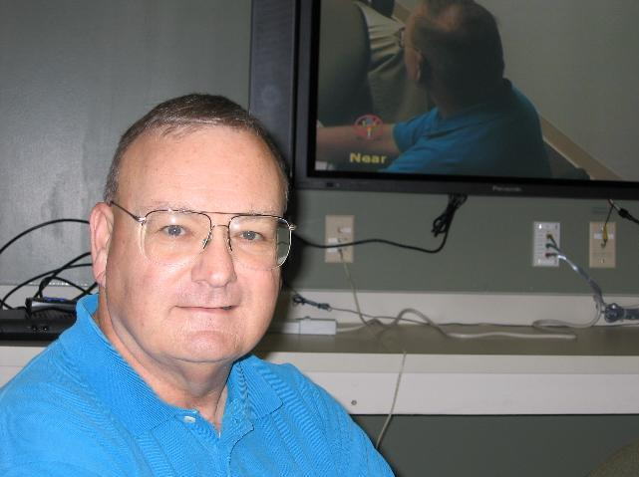
“I only have dial-up access from home, 52 K maximum. At the Telework Center I get 100 mbps at my desktop. Much stronger network connections. Having my own space at the Telework Center is less disruptive and more conducive to getting work accomplished than trying to do it from home. I prefer to keep work in a separate place and away from home if possible. The Telework Center gives me that flexibility.”
Daniel Marsh, Veterans Affairs
”Have you ever tried to get anything done with my kids running around?”
”Access to a fax, copier, another PC, and a nice quiet office setting -
much more so than my other office. Thank-you for everything!”

”I telework in a center because my wife already works at home
and there is not enough room for both of us to work out of the home.”
”The reason why I choose to work at the telecenter rather than at home
are as follows:
- No IT support in case of a problem.
- I do not have a fast broadband connection at this writing.
- I would have to use my own cartridges for my printer, my telephone,
my copy papers.
If I could solve the above problems, I would have no problem working at
home.”
”I choose to work at the telework center for a several different reasons:
- I like to keep my home and work life separate. When I am at home I
try not to think about work. That allows me to reduce the stress caused
by work and keep my home stress free and relaxing.
- I find it difficult to concentrate on work while I am at home
because I would rather be doing something else: hobbies, chores,
exercise, etc.
- I don't have high speed internet connection at home nor a separate
telephone line for my computer. My cell phone doesn't get very good
reception at home so communications would be a problem.”

”Due to my supervisor's policy…”

“The telework center is my only option; my agency does not allow work
from home, except on sporadic and very limited occasions.”
“Fewer distractions, faster IT communication with office, professional
environment, maintain work/personal boundaries.”

“I choose the telecenter because the environment is more conducive to
business/work. Distractions at home are more prevalent. Also, IT and
business equipment is usually more reliable at the telecenter.”

“We have not been given the choice of working at the center or at home.
We are only authorized to work from the center…”

“I like going into an office rather than staying at home.”

“At this time, I do not have the capability to telework from home. My PC
at home is not set up for it nor do I have a fax or copy machine. In
the near future, our PCs will be set up with the capability and I will
probably telecommute from home on days that the weather is bad or there
are family illnesses. However I do not plan to change from working here
to working at home because there are too many distractions at home and I
am much more productive here.”
“My office will not permit work at home unless very extenuating reasons.”
- “It is already paid for through work.
- Security....plus I do not want recipients having my home phone
number.”
“It feels more like being at the workplace and to have an atmosphere like
work outside the home but close to home. Working at home is only good
when the weather is really bad. THANKS!!”

“I choose the telework center because it feels like going to work. Not that I wouldn't work at home, but I can concentrate on work more if I'm not at home.”
Vickie, DOD/NAVY

“I prefer working from the telework center because of equipment advantages. (fax machine, copier, printers, phone system, etc). plus I think (unfortunately) teleworking is better received by my management if I'm at a telework center rather than at home.”
Julalee, DOD/USACE

“In my case, as a Schedule C appointee, while I could work from home, I have extra incentive to avoid any perception of impropriety…”
Brent, EDUCATION

“I choose to work from a telework center because I find it difficult to concentrate on work when I am at home. When I am in the telework center; it’s just like being in the office, and I have no problem focusing on work related tasks. I've also found that I am quite productive; not only am I not worn down from the commute, but I also have less distractions from co-workers, supervisors, etc.”
Michael, DOD/USMC

“It is my command’s policy that telework be accomplished from a telework center except for special circumstances such as medical reasons.”
Dan, DOD/NAVY
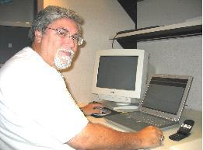
“The telework center is better for me personally because I have access to copier, fax, and a separate telephone. These items I do not have at home. If I had to work from home I could get by but I would not be as productive. I have only one phone line into my home which would have to be used for the computer and would require the shutdown of the computr each time I would have to place a work related call. With my phone being used for the computer I could not receive personal phone message on my answering machine, thus missing messages I need. Also I work better outside the home, as there is less distraction, such as our dog, which if someone is home is very under foot. And my attention span is greater and more focused at the telework center as the quiet environment help this. I also like the personal harbors that allow me to shutout the rest of the office when I need to concentrate on a task, but also allows for the door to be opened when needed. The reservation system that allows you to know where you will be sitting and having your own phone number to give to contact regardless of where you sit is a great convenience.”
Andrew Gray, DOD/USACE

“My boss won't let me work from home…the Telework Center still provides a professional environment. Even though it is a casual atmosphere, everyone is here to do there job. I appreciate the fact there is an alternative location to work from versus commuting to work or home.
- The center provides update-to-date equipment that adapts to everyone's needs.
- The center also provides a conference room for meetings/conference calls/privacy/interviews, etc.
- Your work site can consist of a cubicle, portal, or a private office. Each one provides privacy for any type of work required.
I find this to be a wonderful alternative.”
Mary, VETERANS AFFAIRS

“In response to your question on telework centers verses teleworking from home, I would suspect that management preferred a telework center over telework from home is that the telework center provides the necessary equipment (computers, phone lines, printers, office space, fax machine, maintenance, etc.) that the individual home office would require. Also, it might be the case where some people are more productive outside the home due to distractions at home and possible liability the government might have if someone was injured in the home while conducting government business.”
Robert, DOD/ACA

“I choose the Center because the atmosphere is conducive to business, and all of the equipment I need to conduct business is available there.”
Anne, EDUCATION

- “Fewer distractions (when children are home)
- Equipment and technical support”
Mark, USDA

“For me, it is because I am more productive in an office setting than I would be if I worked at home. My bosses would have allowed me to work at home, but I would be too easily distracted.”
Kevin, STATE

“I work from the telework center for two reasons: first of all, I choose to live in a small condo and do not have the space or equipment for a comfortable, efficient home office. Secondly, I need some social contact since I live alone. And thirdly…getting dressed and leaving home helps me get into a more focused, professional frame of mind…”
Ruth Ann, USDA

“I chose to work at a telework center, rather than teleworking from home because I need more structure in my day. If I were home, I'm sure that I would be interrupted by numerous things and would not be able to concentrate as well as I am able to concentrate at the telework center. I like what the telework center has to offer and being close to home without being at home. I believe that the computer systems at the telework center are much better and are much more consistent than what I have at home. The Woodbridge Telework Center is ideal for me. I believe that I can get more work accomplished there than I ever can in my regular office or more than I would get done at home. The center is quiet, and I appreciate it so much. There have also been times when I can stop into the center in the evening to get some work done without having to go all the way back to my office. I had to leave my regular office one day early to pick up my daughter, but I was able to drop my daughter off at home (she's old enough to stay home by herself - she just can't drive, yet) and go to the center to finish up some things that I wasn't able to at the office because of having to leave early.”
Joan, DOD/ARMY

“I prefer to work from the telework center because it is a more "work-like" environment. I have the telephone available while I'm on-line. I don't have to give out my home phone to everyone. Other people have a different perception of telework when I say I'm working at a center or at home -- telework center = good; home = less professional...”
Mary, DOD/NAVY

- “Too many potential distractions at home.
- Technical issues like hardware or software failures - at a center we expect these to be quickly fixed.
- Hardware and software are available at a telework center and not necessarily at home.”
David, COMMERCE/CENSUS

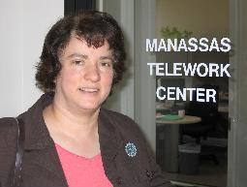
“I prefer to work from a Telework center because I am free from the distractions (both pleasant and not-so-pleasant) of home. I do some of my best work in the quiet environment of the Telework Center.”
Julie Binder, USGS

“…my boss won’t let me work from home.”
Kemper, DOT/FHWA

“The telework center is quieter and away from home distractions, besides, there is an assortment of equipment and supplies at my disposal.”
Curt, DOD/USACE

“I work at the center because we have young children at home and I'd never get anything done if I worked from home.”
Stephen, USDA

“The reason why I choose to work at a center rather than at home is because I work better in a work environment. I would be too easily distracted at home.”
Clayton, USDA

“I choose to work at the (telework center) instead of home because it is a more structured environment and eliminates the possible distractions that can occur at home. It also gives me access to all the office supplies and automation equipment I may need. To me, the (telework center) is the best of both worlds; it cuts out the long commute and still allows me to function in an office environment. I also like the opportunity it presents for interaction with people from other agencies.”
Leslyn, OPM

“I work at a telework center instead of home because I have 4 children who are home schooled (i.e., they are at home during the day) and therefore, I get more done by working from the center instead of from home. Also, working from a telework center has a high speed internet where I have dial-up at home.”
Wynn, DOD/NAVY

“There is a common perception that working at home does not end up as an 8 hour day. To insure that I maintain a good perception, I use the (telework center). In addition, I do not have a (copier) or FAX machine at home.”
Bob, DOD/USACE

“I've preferred to work at a Telework center because I like the office environment and also to minimize interruptions…”
Al, HHS/FDA

“Several reasons:
- Technical
  - telework center has the fast connection for the computer,
  - telework center has a phone line that can be used at the same time as the computer.
- Telework center allows me to keep work and home more separate while also eliminating the commute.
- Telework center allows for some direct connection to other professionals from my home office (several other USACE teleworkers)
Tomiann, DOD/USACE”

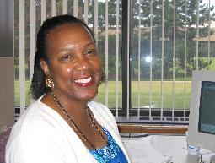
"I elected to work at a telecommute center because my home is not conducive to working without interruption. Also, I enjoy getting up and out of the house when the weather is mild. Going to a telecommute site affords me the opportunity to interact with others. The only time I would prefer to work at home is during the winter months and if I had an area in my home where I could work uninterrupted."
Annie Bell Parker, GSA
“I enjoy working at the Telework center for several reasons:
- Technical Support available - Most important reason for me.
- Equipment available (fax and copier)
- I prefer getting out the house, and being around people, however, really appreciate not having the long commute, and expense with the gas prices. The center provides that, and I am grateful.
- Temptation to waste time does not exist at the center…”
Karen, DOD/ARMY

“I choose to work from the telework center because
- (I’m) too easily distracted at home
- Range of equipment available, fax, printers, etc.
- By allowing my phone to roll to the telework site on days I'm teleworking, I avoid having to give out my home number to many people. Additionally and more importantly, it makes my teleworking seamless to those I work with over the phone and through email.”
John, DOD/USACE

“…Teleworking gives me a very quiet professional office from which to conduct my business. I cannot work from my house - too many distractions.”
Gregory, DOD/USACE

“In my division working at home is frowned upon. Generally, you need to have a medical condition in order for working at home to be granted.”
Bridgette, GSA

“I chose to work at a (telework center) because the… location is convenient (to) my house. I’m able to utilize higher quality copiers and printers and other office equipment along with any technical support. In addition, the possibility to network and interact with other professionals was an incentive…”
Vince, OPM

“One word: Motivation. If I worked at home there are too many distractions such as TV, stereo, and house projects I would want to do. By working at the (telework center) I have a routine where I get up, get ready and get out the door. My supervisor has offered to let me work at home but I find the (telework center) to have everything I need and a pleasant working environment.”
Scott, OPM

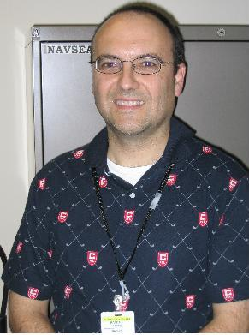
“I utilize the telework center for two main reasons, discipline and resources. First, although I can work at home, when I am in my home office, I am tempted and sometimes succumb to business other than that of my employer. The telework center provides a dedicated physical location to conduct the exclusive work of my employer. On occasions I meet with associates and customers at the telework center. This I am not comfortable to do in my home. Second, the telework center has all required business office resources. I do not have to maintain them at my home. This includes, telephone, fax, copier, paper, computer, conference room, and desk.”
Randall Gibson, DOD/Navy

“Management won't let me work from home.”
Laura, DOD/NAVY

“I find that if I come into the telework center I am more motivated and inclined to get up in the morning at a time to get here to start my normal work hours as if I am going to the office and still get to sleep 2 hours longer. Also I am more inclined to get the work done because of less distraction, no cob webs or laundry screaming at me.”
Terri, USDA

- “I like 'going' to work
- I like keeping my 'home' life and 'work' life separate
- I deal with offices around the world -- I don't want to be answering work questions at 11:00 p.m. when Hawaii calls
- I like the advantage of having all the office equipment I need
- I like the peace and quiet of the center
- I like the transparency of the center -- my phone calls are automatically forwarded, I can customize my voice mail when I'm out, etc.
- I like the administrator and her assistant.”
Maryann, USACE

“I choose to work at the telework center because it still has an office feel. It's convenient because it's located 15 minutes from my house. My agency does not supply all the required equipment (fax, copier) I need when teleworking and the telework center does.”
Loria, DOD/IG

“I do not have internet service or a fax machine at home. I also like the convenience in coming to a (telework center) versus staying at home.”
Theresa, EDUCATION

“(The) center provides everything we need in official setting. Use as needed depend(ing) on flexible schedule and work requirements.
Helps provide time for raising children and community involvement.
Supervisors like the resources at telework sites. Mine totally approves.”
Dave, DOD/USACE

“I prefer to work from the telework center verses my home office because the telework office atmosphere provides greater concentration for accomplishing my work. The center also is exceptional for the great support staff, equipment, and features that allow efficient execution of my required functions. The telework center provides a comprehensive office environment which is not available from my home. I highly recommend the Fredericksburg/Spotsylvania center...”
Steve, DOD/USACE

“There (are) too many distractions at home with stay-at-home spouse and 5 yr
old to interfere with getting work done. The temptation is too great to slack off when at home.”
Thomas, DOT/FAA


“I prefer to work from the Telwork Center because it gives me more structure and discipline to focus on my work. There are no disturbances at the center and that way I can concentrate on my work.”
Mohinder Saini, DOD/USACE

“The infrastructure is already in place, i.e., high speed printers, fax machines, copiers, etc. Additionally, working at a telework center provides an opportunity to interact with other federal workers in an office setting.”
Romme, DOD/TRICARE

“My boss won’t let me work from home. Given the option, though, I would probably still go to the Telework center because:
- I see fellow workers there that I don’t normally see in the office, so I get a better perspective of what is happening in my organization. The buzz word for that is “Situational Awareness” in our office, and staying situationally aware is encouraged.
- The equipment at the telework center is easier to use than our home versions (e.g. fax, copier), although, our home computer is faster.
- I can keep work and home separate better. As it is, I sometimes get calls after hours at home. My husband, who works in for a private company, has been working from home for about 20 years. It works great for him, but he is on-call practically 24 hours. He doesn’t mind, though.”
Janet, DOD/USACE

“Originally, the answer would have been because the boss would not let me work from home. Currently, the answer is because I don’t have the distractions at the telework center that I face at home.”
Dwain, DOD/USACE

“Only one phone line (at home) which ties up telephone communications…”
Belinda, GSA

“I have young kids that wouldn't let me do any work.”
Lawrence, DOD/DLA

“…my internet connection at home is satellite which does not support VPN and that is the only way we are allowed to connect.”
David, DOI/NBC

“I enjoy working at the telecenter because I can concentrate better and there are no distractions. I like having the opportunity to work with other people and have the proper equipment in doing my job. The staff at the telecenter is very professional and they are always there in case I have a problem with my computer. Furthermore, I get more work done at the telecenter than at home.”
Sari Janbozorgi, OPM

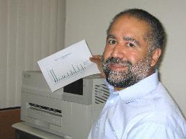
“…I would point out the professional environment, support personnel, and office tools. The individuals which make up the professional environment clearly focus on the required work task while maintaining an air of comradery that is non-intrusive. The support personnel are well informed and will make the extra effort to provide solutions to the difficulties that arise, whether is computer related, security requirements, or assistance with office schedules. The office tools of modern computers, video conference, faxes, and telephones with voice mail provided are more than adequate and may not necessarily be found in the home based unit. In conclusion, I would greatly recommend the Center-based telecommuting over home-based since the personal interruptions (door to door vendors, telemarketers, etc.) to ones time are kept to an absolute minimum and one is able to focus on the work task.”
Pedro Bracero, DOT/FAA

“I have been Teleworking from the Manassas Telework Center for almost 2 years. My decision to use the Center vs. home was based on self-discipline, convenience, and location. I felt there would be too many distractions at home to honestly put in a full days work. I don't feel I have the self-discipline to not answer the home phone or the front door for visiting guests, to not do housework (laundry, vacuuming, dusting, etc) while at home, etc. The Center has all the office equipment need to do my job. I'm provided with a dedicated phone number (with voice mail), a fax machine, workspace, and a professional work environment. The Center is located just 10 minutes from my house, which is a major difference in the hour + commute I would have otherwise.”
Sandy Sisk, DOD

“One of the reasons I like to work at the telecommuting center is the technical support that your center provides. They have always been prompt and knowledgeable.”
Todd Pennington, DOT/FAA


“Working from the telework center:
- provides a working environment that has fewer or no distractions from family or relatives/friends who visit;
- keeps me from the temptation of doing house chores, watching television, running errands, etc., during business hours;
- provides more office space and equipment that I would not have at home;
- motivates me to work and helps me to stay focused; and
- brings more satisfaction to the supervisors, knowing that I’m in a work environment verses at home.”
Celeste Robinson, Justice

“I (personally) do not have access to a home computer to telecommute from my residence. The telecommute site located in Fairfax City provides me the flexibility to telecommute a few times a month, on an as-needed basis, providing fewer interruptions. The Telecommute site also provides access to a fax machine, a copy machine, and has a teleconference capability. It has been very accommodating for me. Thanks for the opportunity to respond to this survey.”
Darlene Curtin, DOT/NHTSA

- “Fewer distractions
- Fax available
- Professional, office-like atmosphere
- A sense of professional purpose regarding work, meaning that it isn’t just “another thing” of interest that you do at home such as a hobby
- High speed internet connection
- Another set of friendly coworkers”
DOD/NAVSEA

“I have a young infant and home-based child care arrangements. I thought it would be less distracting to work from a telecommute center than from home. The key factor in my decision to use the telecommute center was that it is quite close to my house. I doubt that I would be using the telecommute center if it had been more than 15 minutes away.”
Julie Gilmer, SEC

- “A Telework Center maintains a professional workplace environment, which a home cannot do
- This helps establish in the worker a "work mode" instead of a "home mode."
Clayman Myers, DOD/NAVAIR


- “I.T. support – low likelihood that “computer-glitch” will knock me “out of commission” on my telework day
- Availability of a full suite of office technology (including latest computer technology); esp. having the option for teleconferencing if I need to “be there” or “be seen” at a meeting downtown
- Fosters a focused, professional, efficient approach to the work day, free from distractions
- Work-station and professional work environment at the Center are more comfortable, ergonomically correct, and conducive to efficient, highly-productive work as compared to a work-station at home
- Helps keep clear delineation of "work-time" and "home-time," such
that a person is not tempted to keep working all night at the home office (nor be distracted by home duties)
- Easier to sell to management (i.e., to get a flexiplace agreement)”
Nolan Hyatt, EPA

"With the mix of Telework and traditional office work, I have the best of both worlds. Working 2 days per week at the Telework Center provides me with a “no distraction” work environment that allows me to focus in on critical, time sensitive tasks. The remainder of my workweek is at a traditional office and this allows me to maintain key relationships and particpate in team meetings. On the personal side, the Telework Center is a short distance from my home and I very much appreciate and value the extra time I have with my family."
William Irwin, DOD/USACE

“I work at a Telework Center because it has all of the office equipment I need (computer, phone, fax machine) I need to access my job and it gets me away from the distractions of home.”
Michael Torbert, Energy

“The telework center has all the conveniences of being at the office (i.e. fax machine, copy machine and scanner). Working at home also requires more than one phone line.”
Wanda Hanshaw, DOD/NAVSEA

“I have chosen to work from a telework center because I do not yet have a computer at home. I do enjoy the telework center very much: it provides a professional environment with expert technical help, plus all the equipment and software that we need to do our jobs. Also, compared to the government office in which I normally work, the telework center provides an excellent change of pace, a quiet atmosphere to concentrate, and an all around great venue for my productivity. I work at the George Mason University telecommuting center in Fairfax, VA.”
Kathy Friedman, Census

“On some days, I am required to take my son to school, dropping him off at 8:10 AM. At that time of the morning, beltway traffic would require a 90+ minute drive to the office. The telework center is a few blocks from my son’s school, so I can drop him off and be teleworking shortly thereafter. If I still need to be at the office that day, driving time is greatly reduced if I leave the telework center later in the morning. On days when work consists of reading reports and checking e-mail, I can spend the whole day at the telework center and avoid traffic, tolls, and parking fees. “
Wayne Weeks, NOAA

- “I don’t have to pay for my own high-speed connection, printer, and FAX machine; all are included in the telework fees paid by the employer.
- Fewer distractions at the telework center. I don’t know if I would get as much work done at home with the TV and the refrigerator right there.
- I think management is more favorable when you are working from a center rather than from home. I often hear people put the “working” part of working from home in quotes, implying that the person is not really working very hard if at all. I’ve never heard this in reference to the telework center.”
David Boboltz, DOD/NAVY

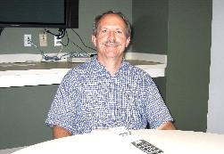
“My office had already established a telecommuting program for its employees at the time I was hired in 1999. The program offered a combination of work from home days and telecenter days - I was not allowed to choose all work from home days or all telecenter days. My only choices were to decide which days of the week I wanted to work from home and which days I would work at the telecenter, as well as which telecenter to use. The program came to an abrupt halt in the summer of 2002 when a senior manager decided to terminate it. After a full year of grievance, informal dispute resolution and binding arbitration, the program was restored by an arbitrator last summer. Let me know if you need more details.”
Claude Denton, Education

“I chose to work from a telework center rather than teleworking from home for the following reasons: (1) the telework center is comparably equipped as my regular office (e.g., desk, filing cabinet, telephone, copier, fax machine, computer, printer, etc.), (2) the telework center has high-speed internet access versus dial-up at home, (3) the telework center is quieter than my home and there are no disruptions, (4) I avoid mixing work with my life at home, and (5) I am more productive working from a telework center than home.”
Andrew Zajac, HHS/FDA

“I first wanted to try at a telework center to synchronize with DC office staff. If this works, then I could request for work from home. I know in my Division it takes time to work out a smooth transition from the DC office to work away from the DC office. I have excellent home based office space, furniture, Computer and Dish high speed connections. I do not need printer nor Fax machines for my work. If needed that work can be done at DC office 7 days in a pay period!!! If I can work more days from “ away from DC office”, I am sure I will have better quality life.”
Talari Jude, USDA/FSA

“The only reason I work at the telework center instead of home is because that was the only way my supervisor would allow any kind of teleworking. And even now, it’s almost impossible for me to get there.”
Sherry Tawfrawe, DODIG/OSD

- “Fewer distractions than at home—especially when other family members are in the house.
- Don’t need to make home or cell phone number available to business associates.
- Office environment is more conducive to productivity.
- I don’t have a laser printer at home.
- Supervisor is more receptive to telecenter than home-based telework.
- If I work at home, I tend to snack all day. At the telecenter I eat only at lunch time.
- I get my cars serviced across the street from the telecenter, so it’s convenient to drop off in the morning and pick up in the afternoon.”
Mike Carpenter, Education

“I am not on the internet at home; I do not have a fax machine at home. My wife belongs to a bridge club and has to have this group in our home every few weeks. She also takes care of a grandchild every so often. So I was concerned about non-work distractions at home. The Telework Center is only eight minutes from my home. It has all the advantages of an office setting, including excellent technical support. For me, it is as convenient as working from home, if not more so.”
Joseph Wyatt, Census

“The main reason I’ve chosen to work from a telework center instead of from home is because we have small children at home. Now the oldest is in first grade and is away at school from 8:00 till 3:00. The younger two are in pre-school and are only away from 8:45 to 12:30. If I were home it would be very difficult to get work done due to the distractions of the kids. Distractions would include the whole process of getting them up in the morning and ready for school. Undoubtedly, if I were there, my wife might call on me to help. In the afternoon, if I were home, the kids would come in and ask me questions/want to be with me. I enjoy the telework center since I can be close to home (10 minutes away instead of over an hour commute to DC) and enjoy a very quiet and productive environment. In addition, if I worked from home, other distractions would be present: home paperwork/clutter, things that need to be done around the house, etc.”
David Sprague, EPA

“I like the structure of an office setting. I am less distracted by my surroundings. If I was working from home, I would receive phone calls from solicitors, and might be more inclined to work around the house, eat. All of which would be distracting. At the telecenter, I have access to a fax machine and copier—both items that I don’t have at home. In addition, my work space at the telecenter is much larger, allowing me to spread papers out and work more effectively. My desk at home is quite small which would make it more difficult to work in the manner that I like.”
Laurie Lindsay, USDA/FSIS

