RURAL UTILITIES SERVICE

SUCCESS STORIES: Town of Ashland, New Hampshire

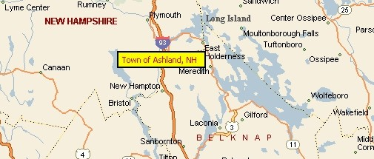

Outline of Need: The Town of Ashland, New Hampshire, needed to extend and upgrade its sewer and water lines to accommodate the conversion of summer homes to year-round dwellings and to bring the on-site waste disposal systems, many of which have failed in recent years due to small lot sizes or unsuitable soil types, up to current public health standards. The failing on-site systems have degraded water quality in the Squam River and Little Squam Lake as evidenced by persistent coliform contamination.

How Rural Development Helped: The Rural Utilities Service co-funded this project with the State of New Hampshire. The project extended sewers and upgraded the water line to 81 customers in the part of town most adversely affected by unsuitable soils conditions. The water main was upgraded to a diameter of 12”, increasing capacity to better serve existing populations.

The Results: Construction of this project began in June 2000 and is expected to be finished in July 2001. The positive environmental benefits that will result from this project include:

- Eliminating failed waste disposal systems.
- Improving the water quality in Squam River and Little Squam Lake.
- Enhancing recreational activities such as boating, fishing, and swimming.
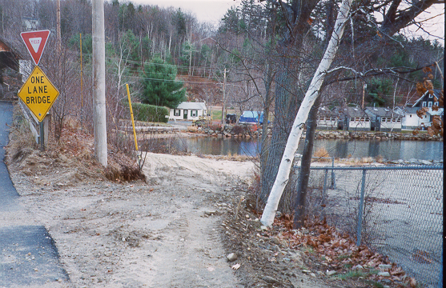
- Provide safe drinking water at adequate pressure.

