Plant Applications for Addressing

Invasive Plant Species

Every day invasive plant species are threatening the conservation of our nation’s vital agricultural and natural resources. Forests and rangelands are being contaminated, cropland production is significantly reduced, streams and water ways are being choked with weeds so they no longer function, and wildlife are losing habitat. This is just the beginning of the destruction invasive plant species exact on our nation’s natural resources if they continue to advance. Because invasive species are too numerous to list in a brief description, they are simply referred to as Invasive Plant Species.
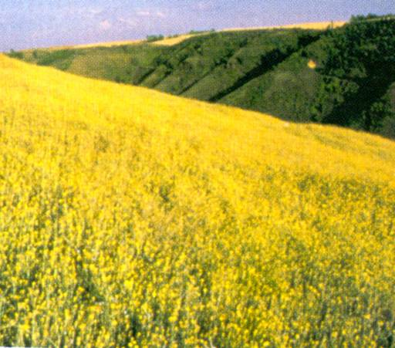
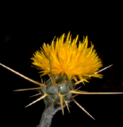
Yellow starthistle (Centaurea solstitialis) is an invasive weed affecting over 9 million acres of U.S. rangelands.

An Effective Counter Assault
Our best defense against invasive plant species is the development of diverse plant communities with competitive desirable species capable of preventing advancement and replacing the invasives when they are controlled. Since 1935, the Plant Materials Program has been providing solutions to address invasive species. These successes are often overshadowed by introductions of new invasive species through our borders in cargo ships, airplanes and automobiles. The traveler is often unaware that they are making these introductions.
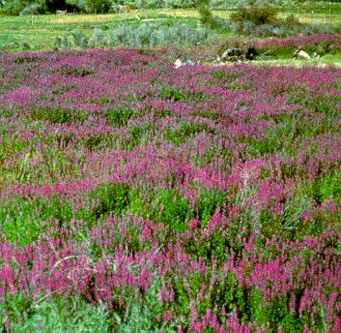
Undeterred against these challenges, the Program continues to find new technologies to address these resource concerns. This new technology is developed at the Program’s 27 Plant Materials Centers (PMC) across America that select, study and release plants and develop planting and management technologies for plant species that ultimately can be used to help restore devastated areas. Additionally, Plant Material Specialists are trained to plan appropriate conservation treatments and work with partners to address these affected areas.
Despite its beauty, purple loosestrife (Lythrum salicaria) is one of the worst invasive plant species.
Yellow Starthistle

Through the Program’s many studies aimed directly at invasive species, they have helped develop methods to control or suppress many of these plants. Additionally, the Program has found appropriate replacements for many invasive plant species once they have been controlled. The Program has developed management strategies to improve established plant communities after invasive plants are controlled.

Highlights of Invasive Species Studies at Plant Materials Centers

Pullman PMC, Pullman, WA
Yellow starthistle is one of the most noxious and tenacious weeds found on over 9.25 million acres of rangeland in the western U.S. Plant Materials Program researchers are examining the effects of native stands of bluebunch wheatgrass on invading yellow starthistle.

Plant Materials Centers in Meeker, CO; Aberdeen, ID; and Los Lunas, NM
Cheatgrass, a winter-annual grass found in all 50 states, severely alters the ecology of our western range and forestlands. PMCs are evaluating native plant species adapted to compete with cheatgrass in infested areas on range, forest and critical areas. Centers also are evaluating the tolerance of desirable native plant species to herbicides used to control cheatgrass and the use of introduced species as a bridge for cheatgrass control and eventual long-term establishment of native plant communities in cheatgrass-infested areas.

Plant Materials Centers in Aberdeen, ID; Corvallis, OR; Elsberry, MO; Big Flats, NY; Beltsville, MD; Pullman, WA; and Los Lunas, NM
Several PMCs throughout the nation are evaluating the ability of native species to compete with invasive plants in riparian and wetland systems. In New York, Oregon, Missouri, New Mexico, and Idaho, the Program is evaluating several native herbaceous and woody wetland species for their ability to compete with some of the worst invasives, including purple loosestrife, Japanese knotweed, invasive thistle species and reed canarygrass. In Missouri and Washington, techniques are being developed that will improve re-establishment of native plants into areas currently infested with reed canarygrass. In Maryland, propagation, production and establishment methods are being developed for native aquatic species to help prevent hydrilla invasion and improve aquatic habitat in the Chesapeake Bay.

Plant Materials Centers in Bridger, MT; Brooksville, FL; and Los Lunas, NM
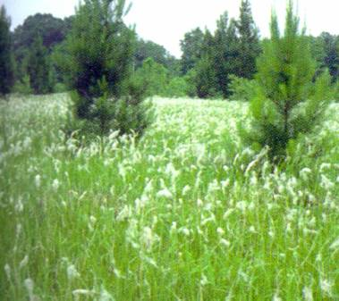
Highly disturbed areas, such as those associated with minelands, saline sites, roadsides and highly acidic sites, are very susceptible to invasion by noxious weeds. Several PMCs are evaluating native plants which are especially adapted to these difficult sites to help prevent infestation by noxious weeds such as knapweed species, Canada thistle and cogongrass.
Cogongrass (Imperata cylindrica) is an invasive plant species in the Southwest

Other Plant Materials Centers across

the country
All 27 PMCs are developing native plants for a variety of conservation uses to combat and replace invasive plant species. For example, the Booneville (AR) PMC is evaluating methods to establish native grasses in existing stands of tall fescue to improve pasture quality. The Elsberry (MO) PMC is developing native shrub alternatives to Amur honeysuckle and autumn olive for wildlife, buffer and shelterbelts plantings. In addition, the Kika de la Garza (TX) PMC is evaluating native grasses to replace buffelgrass on rangeland.

