Plant Releases and Conservation

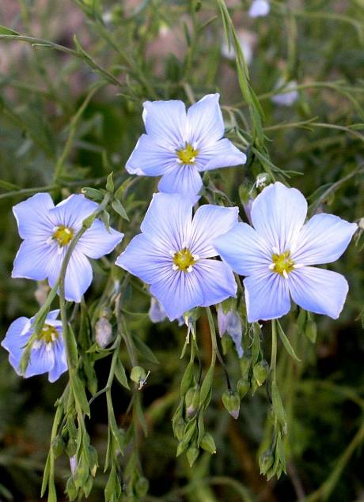
Plants offer a natural solution for addressing many conservation challenges. From wildfire restoration and invasive species control to forage production, wildlife habitat, erosion prevention, nutrient filtering, stream bank protection and sources of biofuels, plants are a sustainable resource that help protect and heal our landscapes.
Maple Grove Germplasm prairie flax (Linum lewisii) was released for erosion control, wildlife habitat and diversity in conservation plantings.
What is a Plant Release? The USDA-NRCS Plant Materials Program, with its 27 plant materials centers (PMCs), cooperates with a variety of public and private conservation partners to collect, evaluate, select and release plants which are intended for commercial production to solve resource conservation problems. This testing helps insure that the plants grow under a variety of climates and soil types and will perform as needed. Very few NRCS plant releases have been genetically manipulated and many are now being selected to maximize genetic diversity. During testing, all NRCS plant collections are evaluated to insure that they are not weedy, invasive or harmful to the environment.
Why does the Plant Materials Program test plants? Evaluating plants to address local conservation needs also meets the needs of national and state conservation programs, including cost share initiatives. PMCs provide proven plants and supply foundation seed and plant technology to support these programs. The Program helps to ensure that farmers and ranchers are successful when planting selected mixes and that each species will perform under its specific soil, water and climate regimes. Untested plants have no guarantee that they will establish and maintain themselves to address the resource concern.
What are common NRCS plant release types? NRCS release types are based primarily on known performance and adaptation, and the heritability of characteristics over several generations. A cultivar could be as much a local ecotype as a source identified release. NRCS release types include:
Cultivar releases are plants that have specific heritable traits which are judged to be superior and perform well in many comparative trials throughout the area of recommended use.
Tested releases have received less extensive comparative testing than cultivars but have been more thoroughly tested than selected releases in order to prove desired traits are heritable.
Selected releases, the most common NRCS release, are plants which show promise of having desirable traits determined from comparative evaluations but have little provenance test data.
Source Identified releases are indigenous ecotypes that are not scientifically evaluated and are only identified as to species and location of collection.
Three Good Reasons to Release Plants:
- Plant releases provide a natural way to solve conservation problems and protect ecosystems.
- Plant releases provide resource managers with proven and dependable plant characteristics such as increased forage and drought tolerance.
- This effort provides plant materials and new technology for a number of national conservation initiatives, including the Environmental Quality Incentives Program (EQIP), Wetlands Reserve Program (WRP), Conservation Reserve Program (CRP) and other cooperative conservation programs.
An Array of Plants
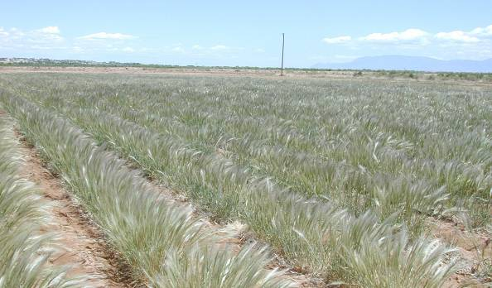
For over 70 years, Plant Materials Centers and plant materials specialists nationwide have collected, evaluated, selected, tested and released more than 600 conservation plants. These plants immediately address the nation’s most critical resource issues. In any given year, enough seed is produced from the Program’s plant releases to plant 3.5 to 5 million acres.
Tusas Germplasm bottlebrush squirreltail (Elymus elymoides) is a release used for wildfire rehabilitation in the Southwest.

Where We Plant
Plant Materials Program releases are planted on an array of sites—from flat grazing land to steep streambanks, and from coastal areas to alpine areas. They repair damage caused by wildfire, floods, noxious weeds invasion, drought, timber harvesting, and mining. They beautify highways and recreation areas, help agricultural producers filter water runoff, and assist ranchers in improving grazing production and wildlife habitat. Most of all, plants—no matter where they are planted—help prevent soil erosion. Saved soil means more productive land, cleaner water and air, and improved habitat for wildlife. Currently, Plant Materials Program releases are being evaluated as potential bioenergy sources.
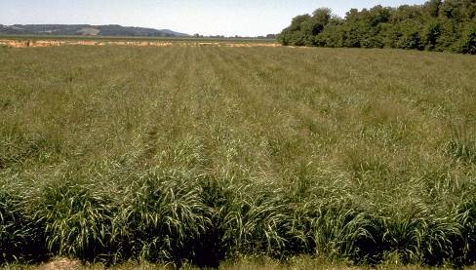
‘Cave-In-Rock’ switchgrass (Panicum virgatum) is used for forage and conservation as well as for a biofuel.

Distribution of Seed and Economic Impacts
After Plant Materials Centers distribute new releases to commercial nurseries and seed growers, large quantities of plants and seed are produced commercially for sale to landowners and land managers. Sales of this seed represent a significant economic value to growers, distributors, and retailers. In any year, seed sales average about $95 million.

Changes and Trends in Plant Materials Program Releases
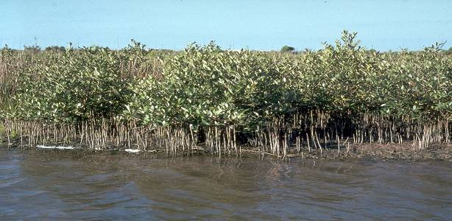
Traditionally, the program has focused attention on long-term cultivar selection of both native and introduced species. The current importance of delivering plants to commercial growers sooner, the desire for broader-based germplasm, and the need for more native materials have brought about significant changes in the program. Plant Materials Centers now focus their efforts almost entirely on native species and use pre-varietal releases (Tested and Selected release types) to get conservation plants to the end user sooner.
Pelican Germplasm black mangrove (Avicennia germinans) is used to stabilize constructed barrier islands along the Gulf Coast.

