STRATEGIC PLAN FOR THE

NATIONAL INSTITUTE OF INVASIVE SPECIES SCIENCE

November 20, 2003

The Problem:

America is under siege by many harmful species of plants, animals and diseases. The current environmental, economic, and health-related costs of invasive species could exceed $138 billion per year, more than all other natural disasters combined. Notorious examples include West Nile virus, Dutch elm disease, chestnut blight, and purple loosestrife in the northeast; kudzu, Brazilian peppertree, water hyacinth, nutria, fire ants, and cactoblastis in the southeast; zebra mussels, leafy spurge, and Asian long-horn beetles in the Midwest; tamarisk (salt cedar), Russian olive, and Africanized bees in the southwest; yellow star thistle, European wild oats, sudden oak death, Asian clams, and white pine blister rust in California; cheatgrass, various knapweeds, and thistles in the Great Basin; whirling disease of salmonids in the northwest; hundreds of invasive species from microbes to mammals in Hawaii; and the brown tree snake in Guam.
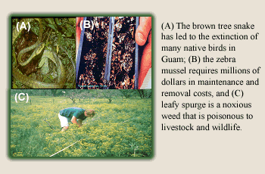

Hundreds of new species from other countries are introduced intentionally or accidentally into the U.S. each year (Kartesz 2001). Based on past experience, 10-15% can be expected to establish free-living populations and about 1% can be expected to cause significant impacts to ecosystems, native species, economic productivity, and/or human health. The increasing threat of new introductions intensifies the need for scientists, managers, and the many stakeholders affected by invasive species to rally together to build better systems to prevent invasions, improve early detection of invaders, track established invaders, and coordinate containment, control, and effective habitat restoration.

Our National Institute of Invasive Species Science will:

- Establish and maintain a “data cooperative” to accelerate the sharing, standardization, completeness, and accessibility of data on the distribution and abundance of non-native plants, animals, and diseases in the United States with a distributed web network on the National Biological Information Infrastructure (NBII).
- Coordinate research and modeling to facilitate prevention, early detection, and rapid response; Promote consistent and comparable inventory and monitoring designs and methods; Advance control and restoration technologies; and Develop predictive models (“ecological forecasting” capabilities) by integrating high-resolution remote sensing and environmental mapping, state-of-the-art spatial and temporal modeling, and high-performance computing technologies.
- Provide technical assistance to states, local government and non-government organizations, land and resource managers, scientists, and the public on all aspects of invasive species science, including control and restoration techniques.
- Develop an extensive outreach program to make all information available to stakeholders, policymakers, and the public as quickly as possible.

The primary goals and operating principles of the National Institute of Invasive Species Science stated above are fully integrated with the USGS Invasive Species Program 5-Year Plan, the objectives of the National Invasive Species Council, and various Executive Orders, laws, mandates, and policies regarding harmful invasive plants, animals, and diseases in the U.S.

THE NATIONAL INSTITUTE OF INVASIVE SPECIES SCIENCE

Mission
Develop cooperative approaches for invasive species science
to meet the urgent needs of land managers and the public.

Vision
Provide a comprehensive strategy for invasive species science, to provide national leadership, and to work with others to disseminate and synthesize current and accurate data and research from many sources to predict and reduce the effects of harmful non-native plants, animals, and diseases in natural areas and throughout the United States with a strategic approach to information management, research and modeling, technical assistance, and outreach.

What is the National Institute of Invasive Species Science?

The National Institute of Invasive Species Science is a quickly growing consortium of strong partnerships between government and non-government organizations administratively based in the U.S. Geological Survey’s Fort Collins Science Center in Colorado, but operated as a virtual “Institute” drawing support from several USGS research centers across the US, scientists from around the country, and with funding and support from several government agencies, non-government organizations, and universities.
The USGS Fort Collins Science Center, Colorado, provides a state-of-the-art home to the National Institute of Invasive Species Science in close proximity to other Federal offices and Colorado State University.

Why Us? The US Geological Survey is uniquely positioned to provide long-term integrated research on invasive species in support of resources management in the Department of the interior and adjacent lands. Newly developed cooperative research programs on invasive species with NASA Goddard Space Flight Center, several DOI agencies, and state and non-government organizations provide the coordinated yet distributed infrastructure to leverage funding, data, research results, and human resources for this challenging endeavor.

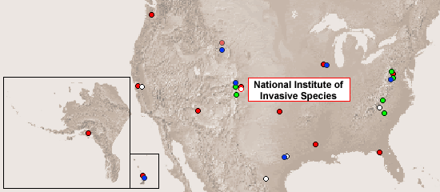

With a network of 32 research centers and Co-op Units in every state, the USGS can insure a long-term commitment to quality science to meet our clients’ highest priority needs. “Invasive Species” is one of the eight future science activities of the U.S. Geological Survey, consistent with the National Invasive Species Management Plan (www.invasivespecies.gov).

Why Now? We are directly responding to urgent needs of land managers in the Department of the Interior, other Federal agencies, the private sector, and elsewhere who have ranked invasive species as their top resource management problem. Invasive non-native plants, animals, and diseases are clearly the greatest environmental challenge of the 21st Century in terms of economic costs, environmental costs, and costs to human health. It is estimated that the economic costs of invasive species in the US exceed the costs from the damage caused by earthquakes, floods, fires, and other natural disasters combined. Invasive species are causing the demise of over 40% of the species listed as Threatened and Endangered. They affect nearly all terrestrial and aquatic ecosystems, and they can poison livestock and wildlife, clog waterways and irrigation canals, alter fire regimes, concentrate heavy metals that end up in the food chain, and affect nutrient cycling.

Core Activities Planned

The National Institute of Invasive Species Science has core activities planned and initiated in information management, research and modeling, technical assistance, and outreach. These core activities will be achieved within a sound research network of cooperators and partners:

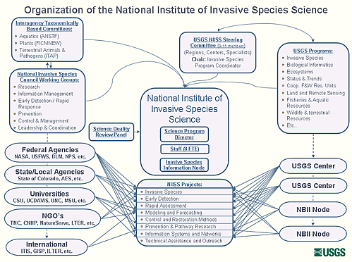
Information Management.

We have established and will greatly expand the concept of a “data cooperative” to accelerate the sharing, standardization, completeness, and accessibility of data on the distribution and abundance of non-native plants, animals, and diseases in the United States. We are using a distributed web network as a part of the National Biological Information Infrastructure (NBII).

The Invasive Species Information Node (ISIN) of the NBII plays a crucial role in support to the scientists associated with the National Institute of Invasive Species Science, the top research priorities of the Institute, and cooperating scientists - all in consultation with the NIISS Steering Committee, the Advisory Group, the National Invasive Species Council, and various interagency, cross-cut budget initiatives. The Director of the Institute (Stohlgren) is the Principle Investigator of the Invasive Species Node, and is ultimately responsible for the integration of research and science support of the node’s activities. Our primary goal is to use information management in support of the primary function of the U.S. Geological Survey - providing integrated science for the management of our natural and mineral resources. The node’s Manager promotes data sharing from all NBII nodes, facilitates the transfer of funds to the Institute’s various cooperating scientists, advances the sharing of information and technologies in support of priority research projects, and assists in reporting activities. When fully operational, the Invasive Species Information Node is designed to assist the National Institute to:
- Evaluate the invasion of multiple biological groups (and several invasive species) simultaneously, relative to habitat and ecosystem maps, land use maps, and “change detection” satellite information and models.
- Zoom in on particular regions, states, parks, refuges, and natural areas by merging data sets from many sources in single, dynamic representations of the highest priority problem species and vulnerable areas.
- Provide immediate access to invasive species information and models on harmful invasive species at local, state, regional, and national scales.
- Quickly assess vulnerability to invasion, current invasions, potential invasions, potential spread of species, natural barriers to invasion, and the economic and ecological effects of invasive species.

The Institute’s information management system was designed primarily by the NIISS research team at Colorado State University with NASA and other USGS scientists and information technology experts and is built to expand in detail as the program grows. This system allows for the integration of disparate datasets that can then be synthesized and used in spatial predictive models.

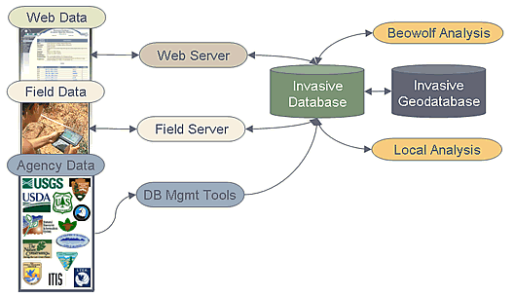

The primary data will come from many government and non-government organizations, citizen groups, and volunteers and can be incorporated into our invasive species database either by large agency dataset uploads, direct field data entry, or individual species occurrence web data entry. All data will be linked in hierarchical tables in relational databases (MSAccess and SQL Server). These linkages will allow for multi-scale analyses. The relational databases will be directly linked to geographic information systems (ARCInfo, ARCView, ARCIMS, ARCGIS) and new spatial analysis tools for interactive queries and multi-scale graphics. A web-based interface will allow customers and stakeholders to access and manipulate a variety of databases, GIS themes, and predictive spatial models at local and regional scales without having extensive hardware, software, or access to experts.

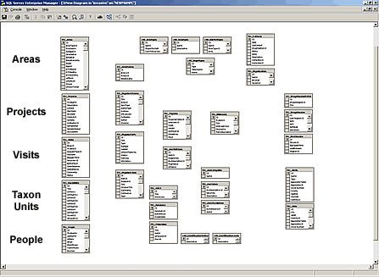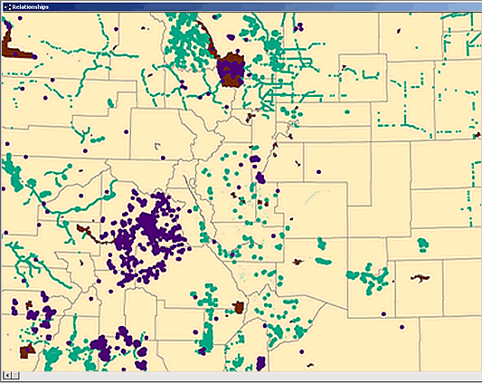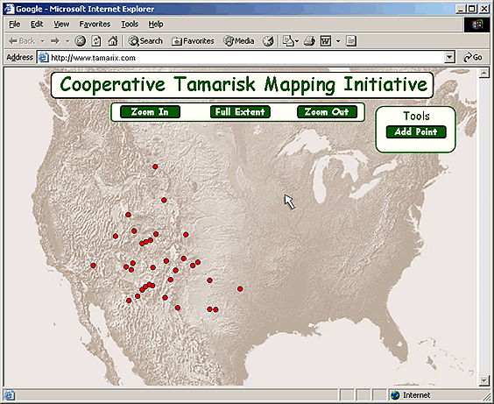
Relational Databases
Spatial Databases
Web Interfaces

The information management system is powered by the “data cooperative.” For example, we began consolidating national-, state-, county- and watershed-scale databases from many disparate sources. Our core datasets include: (1) county-level data on non-native plants from the Biota of North America Program, University of North Carolina (BONAP; Dr. John Kartesz); (2) sub-watershed data on non-indigenous fish in the US from the USGS Florida Caribbean Science Center (Pam Fuller); (3) data on non-indigenous birds from the Breeding Bird Survey group at the USGS Patuxent Wildlife Research Center (Drs. John Sauer and Bruce Peterjohn); and (4) distribution data on wildlife diseases in the US Wildlife Refuge System from the USGS National Wildlife Health Center (Dr. Josh Dein). Many more data sets and partners will be included in the near future.

Current datasets are being augmented with several datasets such as the USDA Forest Service’s Forest Health Monitoring/Forest Inventory and Analysis Program – long-term monitoring plots systematically placed throughout the country, information on other pathogens from the USDA Animal and Plant Health Inspection Service (APHIS), and others. Additional vegetation plot data is available from the USGS Fort Collins Science Center and various state Heritage programs. Map data are available from the EROS Data Center and the Center for Biological Informatics. Additional information management support is added by Dr. Carl Korschgen (Columbia Environmental Research Center, web-tools), Linda Leake (Upper Midwest Environmental Science Center, data management), Dr. John Schnase (NASA Goddard Space Flight Center), Rob Baker (NASA contractor and his team), Dr. Michael Ruggiero (Integrated Taxonomic Information System, taxonomy, synonyms), and Dr. Jim Quinn (International Center for the Environment, University of California, Davis). A long-term partnership with NASA Goddard Space Flight Center, including three competitive grants obtained by Stohlgren and NASA scientists, provides the majority of funding for ISIN activities at Colorado State University (see below). We will combine the basic datasets on invading plants, animals and diseases with high resolution remotely sensed data and derived maps (e.g., land use, vegetation, climate) to develop a better understanding of species invasion patterns relative to the vulnerability of habitats to invasions and underlying biotic and abiotic factors that help predict the establishment and spread of invading species. Data products will include metadata reports of accessible invasive species datasets, “watch lists” of potentially invasive species, control information for priority invasive species, species identification aids, and an “invasive species bulletin board” to aid early detection and rapid response capabilities. Mapped products, in conjunction with predictive modeling activities described below, will include current distribution maps of non-native species, species abundance data where possible, and “risk maps” of vulnerable habitats and resources. Reporting products will include progress reports, DEFINE (GPGA) reports, and outreach activities.

Research and Modeling. We will target research to the following areas:

Prevention. We will focus efforts on a “prevention through awareness” campaign that includes private landowners, DOI resource managers, state weed coordinators and others by documenting the current and potential distributions of invasive species in the United States.
Prevention through awareness begins with an understanding of where non-native species have successfully invaded in the past, and preparing for probable invaders from other countries or ecosystems. For example, patterns of plant invasions in the US (data from the Biota of North America Program) clearly show that coastal counties have been well-invaded by non-native plant species, at least in terms of establishment (species richness per county).

Number of non-native plant species, by county (data from BONAP). Coastal counties are particularly heavily invaded.
Each data set can provide important insights into the invasion process. For example, we evaluated the relationship between native species richness and non-native species richness on a county by county level in each state. We found positive, highly-significant correlations in nearly all the states suggesting that many non-native plant species have successfully established in areas of high native species richness. This research is leading to improved predictions of the spatial patterns of current and potential distributions of non-native species in the U.S. These predictions also lead to improved strategies for prevention and early detection. We also plan to develop “watch lists” for National Wildlife Refuge managers and other land managers to include species from nearby ecosystems that have a high probability of invading and those cryptic species that may already have become established but as yet are undetected or unreported.

Early Detection and Rapid Response. We will continue to develop early detection and rapid assessment methods for invasive plant species, non-indigenous fish and aquatic organisms, birds and mammals, and wildlife diseases. For example, we improved the North America Weed Mapping Association (NAWMA) mapping standards (see www.NAWMA.org, click on mapping standards, to the “Beyond NAWMA Standards”), which was approved by the Federal Interagency Committee for the Management of Noxious and Exotic Weeds (FICMNEW). We continue to publish other sampling efforts for early detection of invasive plants, and expand to include other taxonomic groups.
We are expanding efforts to work with government and non-government partners to improve accessibility of easy identification aids to allow the public to quickly recognize potentially harmful invasive species. Several commercial and freeware products are already available and rapidly improving, so we will emphasize hotlinks to these sites rather than developing these capabilities ourselves.
Major enhancements of the Early Detection and Rapid Response program are planned for FY04 and FY05 including several regional pilot DEFINE (EDRR) programs. These may include Hawaii, California, New England (Invasive Plant Atlas of New England program), Colorado/Wyoming, or the southeastern US. In addition, we will support activities that focus efforts on priority species identified in the cross-cut budget initiative, National Invasive Species Council, and the USGS Five-year Plan for Invasive Species Science. Identified priority species include tamarisk, cactoblastis (cactus moth), nutria, and ballast water organisms. We will be more actively involved with some species than others, but we will link information management for all these efforts.

Inventory and Monitoring Designs and Methods. We plan to greatly expand our research in developing cost-efficient, information-rich, interdisciplinary approaches to inventory and monitoring native and non-native plant diversity with innovative designs that integrate multi-phase and multi-scale field sampling designs to provide more consistent, accurate, and complete data at local, regional, and national scales.
We will especially improve methods for the mapping and modeling of non-native plant species using high-resolution remote sensing; field methods that employ new multi-scale, multi-phase, and nested-intensity designs; high performance computing; and new spatial and spatio-temporal modeling techniques. However, another key focus of our research will be to make the best use of existing data of all types gathered from a variety of sources to assess “data synergies.” This is a cost-efficient means for evaluating data utility, while improving the collection of new information to strategically fill in data gaps and establish quality control/quality assurance measures to complement and vastly improve the credibility, comparability, and utility of the data collected throughout the US. Likewise, we are interested in developing similar approaches for other biological groups.

Control and Restoration Technologies. Control and restoration techniques will be developed for priority species in the most severely impacted areas. We have no research yet specifically developing or testing control methods, but we plan to work more closely with those who specialize in this area.
Restoration research is already underway in many post-fire areas, and we have several projects quantifying and monitoring the effects of wildfire severity, various pre-fire fuel treatments, and post-fire seeding and soil stabilization. We plan to extend studies to evaluate restoration efforts in wetlands, riparian zones, and aquatic ecosystems where invasive species have become dominant. On a national scale, invasive plant control techniques published by The Nature Conservancy, the states, and others will be linked on our Invasive Species Information Node. In addition, we are collecting information on what control techniques have worked best under particular circumstances and in various habitats to share success stories more quickly. It will be equally important to collect and share information on what techniques have not worked.

Predictive Modeling. Predictive modeling research will focus on developing “Ecological Forecasting” capabilities by integrating high-resolution remote sensing and environmental mapping, state-of-the-art spatial and temporal modeling, and high-performance computing. Working with colleagues at Colorado State University (Drs. Mohammed Kalkhan and Robin Reich), NASA Goddard Space Flight Center (Drs. John Schnase, Jim Smith, Jeff Pedalty, Jeff Morisette, Rob Baker and others), and the EROS Data Center (Dan Steinwand and others), significant progress has been made in developing new multivariate techniques and kriging and co-kriging spatial models that are uniquely suited to accurately depict current species distributions and patterns of invasion with known precision and accuracy.
We are improving the speed and potential aerial coverage of the models with parallel processing and high performance computers and supercomputers. For example, the model of exotic plant species richness following the Cerro Grande fire first took over 16 days to run on a conventional workstation. Revised coding and parallel processing has decreased the run time to less than five minutes.

An important component of these predictive models is to quantify the level of uncertainty associated with model outputs to aid in their management utility. When combined with an iterative approach to inventory and monitoring, the spatial models will greatly improve prevention, early detection, rapid response, and control efforts by agencies and the private sector.
We plan to greatly expand these basic technologies through cooperative research with NASA to create ecological forecasting models as part of the “Invasive Species Forecasting System,” which can be widely applied to set priorities for invasive species control efforts at local, regional, and national scales, and in the areas of native biodiversity conservation, vulnerability and risk analysis, and for predictive models for bio-security.

Technical Assistance. We will focus on state partnerships, cooperative training ventures with government and non-government organizations, and teaching and training programs to assist scientists and land managers. We plan to develop training programs for scientists, state invasive species coordinators, and others in predictive spatial modeling, ecological forecasting, data analysis and synthesis, and other aspects of invasive species science.

Outreach. All information will be made available to stakeholders, policymakers, and the public as quickly as possible. Our primary purposes are to raise public awareness, and involve the public and private sectors (e.g., “cross-reach” rather than “outreach”), especially in the “One if by land, two if by sea” initiative. We plan to create web-based tools to allow land managers, private land owners, non-government organizations, policy makers, volunteer groups, and the public to: (1) identify and report invasive species in their area; (2) download “watch lists” for potential invading species; (3) develop local priorities for control and restoration; and (4) actively participate in all phases of invasive species science.

Future Directions:
- Improve cooperation and coordination within the USGS, among agencies, and with states, non-government organizations, and the public. We plan to quickly work with a new USGS Steering Committee, regional offices, and USGS scientists to build broad-based support for the Institute to meet agency needs. We will solicit advice from respected scientists and leaders from universities and non-government organizations, and others outside the USGS to assure that the Institute addresses the highest priority needs of the scientific community, policy makers, and the public.
- Greatly enhance our data management system. We will seek full funding and infrastructure from the NBII to support the Invasive Species Information Node. This includes funding for full-time data managers (2), one programmer, one web-master, an administrative assistant; two servers and mass storage devices; and adequate funding to acquire necessary databases to meet the highest priority science needs of the Institute and its partners and customers.
- Fully develop early detection and rapid response capabilities. We plan to greatly enhance capabilities for early detection and rapid response to newly invading plants, animals, and diseases. On the immediate horizon are cactoblastis, Emerald Ash Borer, Asian Longhorn beetle, brown treesnake, sudden oak death, and many other species. We will provide links to volunteer programs and use the bulletin board concept as an early warning system (e.g., post watch lists and aids for identification, reporting, verification and control). Pilot programs will help – but quickly moving beyond these to a more formalized system is important.
- Integrate the above components in the USGS-NASA Invasive Species Forecasting System. Improving ecological forecasting capabilities will require advances in sampling designs, remote sensing, multivariate approaches, spatial interpolation models, and computational methods. Each of these advances requires the integration of surveys, monitoring, research, analysis, and synthesis.
The “future additions” will require far more resources and coordination than currently available. Interagency partnerships will be required.

- Link to control, restoration, and monitoring programs. We plan to more strongly link our mapping, modeling, and data management programs with control, restoration, and monitoring programs. We plan to work closely with the National Park Service’s invasive plant control teams to better distribute information on what control techniques work best, in which environments, and under which conditions. We will also develop our web site to coordinate control and restoration data from other agencies and sources to more quickly share stories of success and failure.
- Quickly develop training capabilities. We plan to provide training opportunities with a mix of qualified instructors from NASA, the EROS Data Center, the USGS, and spatial modelers from Colorado State University to put the modeling tools into more hands.

