Live oak
Quercus virginiana L.
Plant Symbol = QUVI

Contributed by: USDA NRCS National Plant Data Center & the Biota of North America Program
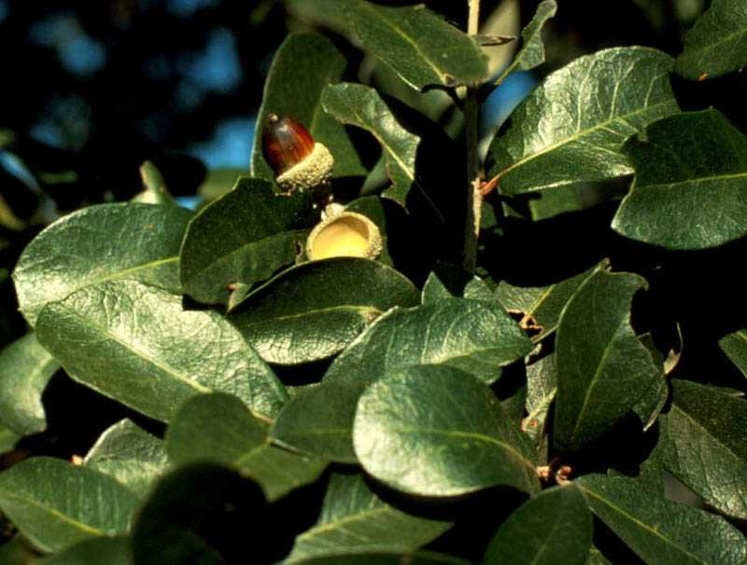
© Walter K. Taylor
Florida Wildflowers In Their Natural Communities

Alternate Name
Virginia live oak

Uses
Erosion Control: This is an excellent species for reforestation to prevent erosion on originally cleared land for agriculture. It also has the potential for revegetating coalmine spoils.

Wildlife: The live oak acorns are important food source for many birds and mammals including northern bobwhite, Florida scrub jay, mallard, sapsuckers, wild turkey, black bear, squirrels, and white-tailed deer. This species provides cover for birds and mammals. The rounded clumps of ball moss that are found in live oak are necessary for nest construction.

Timber: The live oak wood is heavy and strong but of little use commercially.

Recreation and Beautification: Live oak is used for shade and as an ornamental. It is considered “one of the noblest trees in the world and virtually an emblem of the Old South”. Today live oaks are protected for public enjoyment.

Status
Please consult the PLANTS Web site and your State Department of Natural Resources for this plant’s current status, such as, state noxious status and wetland indicator values.

Description
General: This native tree can grow to an average of 50 feet tall and 36-48 inches in diameter, but can have trunks over 70 inches in diameter. The bark is furrowed longitudinally, and the small acorns are long and tapered. The bark and twigs are dark to light grayish color and becomes darker with age. The leaves are thick, shiny, and dark green on top, lighter below. Small flowers are produced when new leaves are grown. The fruit, which is an acorn, has a 1 inch long cup, somewhat narrowed at the base. Root crowns and roots survive fire and sprout vigorously.

Distribution: Live oak is most commonly found on the lower Coastal Plain of southeastern United States.
For current distribution, please consult the Plant Profile page for this species on the PLANTS Web site.

Adaptation
Live oak grows in moist to dry sites. It withstands occasional floods, but not constant saturation. It is resistant to salt spray and high soil salinity. Live oak grows best in well-drained sandy loam soils but also grows in clay and alluvial soils. Live oak is intermediate in shade tolerance.

Establishment
Live oak is monoecious. Germination is hypogeal and occurs shortly after seedfall if the site is moist and warm. Live oak is fast growing if well watered and soil conditions are good. Seedlings grow 4 feet in the first year. Under ideal conditions, a live oak can attain a dbh. of 54 inches in less that 70 years. Live oak sprouts from the collar and roots, and forms dense clones up to 66 feet in diameter.

Management
Once established, live oak withstands competition. It is extremely salt tolerant and this resistance may account for its dominance in many climax coastal forests in the northern part of its range. Dense stands of live oak reduce forage production for livestock. Live oak is extremely hard to kill because it sprouts vigorously from the root collar and roots.

Pests
Some of the pests that causes live oak decline is wilt disease, leaf blister, heartwood decay, gall wasps, and borers, which attacks roots of young live oak. Live oak is extremely susceptible to freezing temperatures and acid rain.

Cultivars, Improved and Selected Materials (and area of origin)
Materials are readily available through nurseries within its range. Contact your local Natural Resources Conservation Service (formerly Soil Conservation Service) office for more information. Look in the phone book under ”United States Government.” The Natural Resources Conservation Service will be listed under the subheading “Department of Agriculture.”

References
Dirr, M.A. 1990. Manual of woody landscape plants: their identification, ornamental characteristics, culture, propagation and uses. 3rd ed. Stipes, Champaign, Illinois.

Duncan, W.H. & M.B. Duncan 1988. Trees of the Southeastern United States. University of Georgia Press, Athens, Georgia.

Elias, T.S. 1989. Field guide to North American trees. Revised ed. Grolier Book Clubs Inc., Danbury, Connecticut.

Flint, H.L. 1983. Landscape plants for eastern North America. John Wiley and Sons, Inc, New York, New York.

Harrar, E.S. & J.G. Harrar. 1962. Guide to southern trees. 2nd ed. Dover Publications, Inc., New York, New York.

Little, E.E. 1996. National Audubon Society field guide to North American trees: Eastern region. Alfred A. Knopf, New York, New York.

USDA Forest Service 1974. Seeds of woody plants in the United States. Agricultural Handbook 450. USDA, Washington, DC.

USDA Forest Service 1990. Silvics of North America. Agricultural Handbook 654. Forest Service, USDA, Washington, DC.

Young, J. A. & C.G. Young. 1992. Seeds of woody plants in North America. Revised and enlarged ed. Dioscorides Press, Portland, Oregon.

Prepared By

Guy Nesom
Formerly Biota of North America Program, Chapel Hill, North Carolina

Species Coordinator

Lincoln M. Moore
USDA, NRCS, National Plant Data Center, Baton Rouge, Louisiana

Edited: 08apr02 ahv; 25feb03 ahv; 060809 jsp

For more information about this and other plants, please contact your local NRCS field office or Conservation District, and visit the PLANTS Web site<http://plants.usda.gov> or the Plant Materials Program Web site <http://Plant-Materials.nrcs.usda.gov>

The U.S. Department of Agriculture (USDA) prohibits discrimination in all its programs and activities on the basis of race, color, national origin, sex, religion, age, disability, political beliefs, sexual orientation, and marital or family status. (Not all prohibited bases apply to all programs.) Persons with disabilities who require alternative means for communication of program information (Braille, large print, audiotape, etc.) should contact USDA's TARGET Center at 202-720-2600 (voice and TDD).
To file a complaint of discrimination write USDA, Director, Office of Civil Rights, Room 326-W, Whitten Building, 14th and Independence Avenue, SW, Washington, DC 20250-9410 or call 202-720-5964 (voice or TDD). USDA is an equal opportunity provider and employer.
Read about Civil Rights at the Natural Resources Convervation Service.

