herbaceous beardtongue
Penstemon rydbergii A. Nels. var. oreocharis (Greene) N. Holmgren
Plant Symbol = PERYO

Contributed by: USDA NRCS Idaho State Office & the National Plant Data Center
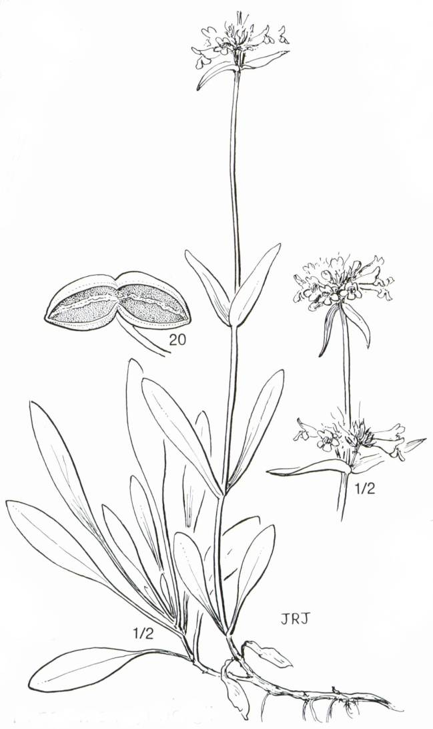
Jeanne R. Janish
Cronquist (1984)
© The New York Botanic Garden

Alternate Names
penstemon, Rydberg’s beardtongue

Uses
Grazing/rangeland: 'Cedar' Palmer’s penstemon (Penstemon palmeri) and 'Bandera' Rocky Mountain penstemon (Penstemon strictus) are the only released penstemons noted to have any forage value. All other varieties are considered fair to poor palatability and considered to be only incidental forage value. All species provide diversity to the seeded plant community.

Erosion control/reclamation: All species are mentioned for their value in mixes for erosion control and beautification values.

Wildlife: Penstemons are considered desirable forages for deer, antelope, and birds either as herbage or seed. They may also provide some cover for selected small bird species. They provide diversity to the plant community.

Status
Please consult the PLANTS Web site and your State Department of Natural Resources for this plant’s current status, such as, state noxious status and wetland indicator values.

Description
General: Figwort Family (Scrophulariaceae). Penstemon or beardtongue species are perennial forbs or sub-shrubs to shrubs with attractive flowers. They are short to long-lived.

Penstemons have opposite, entire, or toothed leaves. They have several stalked flowers or flower clusters that are borne in the axils of the upper leaves or leaflike bracts. The tubular corolla is strongly to distinctly two-lipped at the mouth with a two-lobed upper lip and a three-lobed lower lip. There are 4 anther-bearing (fertile) stamens and a single sterile stamen or staminodia that is often hairy at the tip. The fruit is a many-seeded capsule.

Herbaceous penstemon is a perennial herb to woody subshrub, 2 to 4 dm tall with well-developed basal leaves and stems arising from a woody caudex. Flowers blue to violet or purple with a densely golden-yellow bearded staminode. Cronquist et al. (1984) recognizes three varieties and provides a key.

Distribution
Herbaceous penstemon is distributed throughout the western U.S. Penstemons are common to the western United States. Except for one minor species, the genus Penstemon does not occur naturally outside of North America. For current distribution, please consult the Plant Profile page for this species on the PLANTS Web site.

Establishment
Adaptation: Penstemons do best on well-drained soils. Most ecotypes do well on infertile, disturbed soils. They have excellent cold winter and drought tolerance. They will tolerate weakly saline to weakly acidic sites. They are usually found in open areas, but will tolerate semi-shaded conditions. They are not tolerant of fire, but are fire resistant due to leaves staying green with relatively high moisture content during the fire season.

Herbaceous penstemon is found on moderately moist to dry slopes, meadows, and streambanks from 1300 to 3300 m in elevation.

Planting: These species should be seeded with a drill or broadcast at a depth of 1/4 inch or less into a firm seedbed. Ideal seeding depth is 1/8 inch. Penstemons are not recommended for single species seeding. The full seeding rate (not recommended) for these forbs-shrubs is 1.5 to 3 pounds Pure Live Seed (PLS) per acre or 20 to 26 PLS per square foot (varies somewhat by species). When used as a component of a mix, adjust to percent of mix desired. For mined lands and other harsh critical areas, doubling the seeding rate component of penstemon is not required.

The best seeding results are obtained from seeding in very early spring (because of grass component of mix) on heavy to medium textured soils and in late fall on medium to light textured soils. Late summer (August - mid September) seeding is not recommended. Dormant fall seedings (preferred seeding period for penstemons) will pre-chill seed and reduce seed dormancy which is very strong in some species. Mulching, irrigation and weed control all benefit stand establishment. Seedling vigor is good, but not as good as most grasses. Germination may not occur until the second growing season. Flowering should not be expected until at least the second growing season.

Stands may require weed control measures during establishment. Because penstemons are broadleaf, use of 2,4-D is not recommended. Mow weeds at or prior to their bloom stage. Grasshoppers and other insects may also damage new stands and pesticides may be needed.

Management
Growth of penstemons begins in early spring and flowers appear in May through July depending on species. Weed control and removal of very competitive species may improve chance of establishment. Damage from wildlife and rodents may occur and they may need to be controlled. Disease problems are minimal except under irrigation. Under irrigation, fusarium wilt can be a problem.

Environmental Concerns: Penstemon species establish and spread slowly via seed distribution. They are not considered "weedy" or invasive species, but can spread into adjoining vegetative communities under ideal climatic and environmental conditions. They coexist with other native species and add biodiversity to those plant communities.

Seed Production
Penstemons should be seeded in at least 36-inch rows at the rate of 2.5 pounds PLS per acre to allow mechanical weed control. The use of weed barrier material may be an alternative to allow closer spacing. They should be seeded in late fall or early winter unless seed is stratified under cool moist conditions. "The Clearwater Selection" of alpine penstemon does not require stratification. Transplants by dividing the base of older plants or from greenhouse starts can also be successfully used to establish seed fields.

Seed is generally harvested by hand stripping or by combine. Seed is mature when capsules are dry and seed is hard and dark in color. Flowering is indeterminate with mature capsules and flowers present at harvest period. Multiple harvest periods (by hand) may be necessary to maximize seed collection. Some seed will shatter once capsules open, but the capsule is upright and tends to hold seed very well. Seed can be separated from the capsule by use of a hammer mill or barley de-bearder followed by air screening. Cleaned seed should be allowed to dry and then stored in a cool dry area. An after-ripening period of 3 to 4 months is required. Seed retains viability for several years under these conditions.

Cultivars, Improved and Selected Materials (and area of origin)
Foundation and registered seed is available for each variety through the appropriate state Crop Improvement Association or commercial sources to grow certified seed.

Alpine penstemon (P. venustus) is a selected release from seed originally collected in the Clearwater River drainage, Idaho. 'The Clearwater Selection' of alpine penstemon was selected by Aberdeen Plant Materials Center and was released in 1994. It is a native, perennial cool-season forb to sub-shrub with a strong taproot and woody base. The leaves are oblong and sharply serrate. It is 1 to 2 feet tall and the flowers appear in one or more narrow terminal panicle, 12 to 20 inches long. The flowers are bright lavender to purple or purple-violet. It flowers from early to mid summer. It is best adapted to full sunlight, well to moderately well drained soils, 20 to 35 inch rainfall areas, at 1,000 to 6,000 feet elevation. It is not adapted to poorly drained soils. Its intended uses are for erosion control, diversity and beautification. Certified seed is not readily available at this date and Aberdeen PMC maintains breeder seed.

'Bandera' (P. strictus) Rocky Mountain penstemon was developed from seed originally collected in Torrance County, New Mexico. It was developed by Los Lunas Plant Materials Center and released by New Mexico AES, New Mexico State Highway Department, Colorado State University and the PMC in 1973. It is a native, perennial, cool-season forb with a few large underground stems and many fine roots. The leaves are long and often curl or are reflexed. It is 8 to 23 inches tall and flowers are solitary, on one side of the raceme. The flowers are showy blue to purple and occur primarily between mid May and the end of June. It is best adapted to medium to sandy to rocky textured, weakly acidic to alkaline, well-drained soils, 15 to 20 inch rainfall areas, at 6,000 to 10,000 feet elevation. Its intended uses are for erosion control, diversity and beautification. Certified seed is available and Los Lunas PMC maintains breeder seed.

'Cedar' (P. palmeri) Palmer penstemon was developed from seed originally collected near Cedar City in Iron County, Utah. It was developed by the U.S. Forest Service Intermountain Forest and Range Experiment Station, Provo, Utah and released by Los Lunas PMC, Utah Department of Wildlife, Colorado-Idaho-New Mexico-Utah AES, and Forest Service in 1985. It is an erect, native, perennial (short-lived, 5-7 years), cool-season, semi-evergreen forb with thick fibrous taproots. The leaves may remain green throughout the year. The flowers arise from basal clusters on tall upright stalks and are pink to lavender-pink with red-violet throats. They bloom for several weeks in late spring through early summer. It is best adapted to rocky, gravelly to clayey, weakly acidic to basic, well drained soils, 10 to 16 inch rainfall areas, at 3,500 to 6,000 feet elevation. Its intended uses are winter forage, erosion control, diversity and beautification. Certified seed is available and the Forest Service maintains breeder seed.

Firecracker penstemon (P. eatonii) is a selected release from seed originally collected near Richfield, Utah. 'The Richfield Selection' of firecracker penstemon was selected by Aberdeen Plant Materials Center and was released in 1994. It is an erect, native, perennial, cool-season sub-shrub to shrub with a fibrous root system and decumbent to reclining stems. The leaves are large and slightly pubescent. The flowers are in racemes on 24 to 36 inch tall, upright stems. It has bright red tubular flowers, blooming from early to late summer. It is adapted to full sunlight, well to moderately well drained soils, 10 to 16 inch rainfall areas, at 3,300 to 8,000 feet elevation. It does not do well in poorly drained soils. Its intended uses are for erosion control, diversity, and beautification. Certified seed is not readily available at this date and Aberdeen PMC maintains breeder seed.

A number of other penstemons are seeded primarily for soil stabilization on depleted, disturbed and erosive areas for erosion control and as ornamentals. These include low penstemon (Penstemon humilis), Rydberg penstemon (Penstemon rydbergii), and thickleaf penstemon (Penstemon pachyphyllus). No cultivar releases are known to have have been made. Please check the PLANTS database for the names of native penstemons in your state, then check with your area native plant nurseries for their availability.

Contact your local Natural Resources Conservation Service (formerly Soil Conservation Service) office for more information. Look in the phone book under ”United States Government.” The Natural Resources Conservation Service will be listed under the subheading “Department of Agriculture.”

References
Cronquist, A., A.H. Holmgren, N.H. Holmgren, J.L. Reveal, & P.K. Holmgren 1984. Intermountain flora. Volume Four. Subclass Asteridae (except Asteraceae). The New York Botanical Garden, Bronx, New York.

Crosswhite, F.S. 1967. Revision of Penstemon section Habroanthus (Scrophulariaceae). I: Conspectus, II: series Speciosi, and III: series Virgati. American Midland Naturalist 77:1.41.

Holmgren, N.H. 1971. A new species of Penstemon from Nye Co., Nevada. Aliso 7:351-356.

________, 1978a. An overlooked new species of Penstemon (Scropulariaceae from the Great Basin. Brittonia 30:334-339.

________, 1978b. Three new species of Penstemon (Scrophulariaceae from the Intermountain region. Brittonia 30:416-425.

________, 1979a. Nomenclatural changes in some Intermountain penstemons (Scrophulariaceae). Brittonia 31:104-107.

________, 1979b. New penstemons (Scrophulariaceae) from the Intermountain region. Brittonia 31:217-242.

________, 1979c. Subgeneric and sectional names for Intermountain Penstemon (Scrophulariaceae). Brittonia 31:358-364.

________, 1980. A new Penstemon (Scrophulariaceae) from northwestern Arizona. Brittonia 32:326-329.

Keck, D.D. 1932. Studies in Penstemon. A systematic treatment of the section Saccanthera. Univ. Calif. Publication in Botany 16:367-426.

________, 1937a. Studies in Penstemon IV. The section Ericopsis. Bulletin of the Torrey Botanical Club 64:357-381.

________, 1937b. Studies in Penstemon V. The section Peltanthera. American Midland Naturalist 18:790-829.

________, 1938. Studies in Penstemon VI. The section Autator. Bulletin of the Torrey Botanical Club 65:233-255.

________, 1940. Studies in Penstemon VII. The subsections Gairdneriani, Deusti, and Arenarii of the Graciles, and miscellaneous new species. American Midland Naturalist 23:594-616.

________, 1945. Studies in Penstemon-VIII. A cyto-taxonomic account of the section Spermunculus. American Midland Naturalist 33:128-206.

Pennell, F.W. 1920. Penstemon. IN: Scrophulariaceae of the central Rocky Mountain states. Contributions U.S. Natl. Herbarium 20:325.381.

Prepared By

Daniel G. Ogle
USDA, NRCS, Idaho State Office, Boise, Idaho.

J. Scott Peterson
USDA, NRCS, National Plant Data Center, Baton Rouge, Louisiana

Species Coordinator

Daniel G. Ogle
USDA, NRCS, Idaho State Office, Boise, Idaho.

Edited 05dec00 jsp; 11feb03 ahv; 060803 jsp

For more information about this and other plants, please contact your local NRCS field office or Conservation District, and visit the PLANTS Web site<http://plants.usda.gov> or the Plant Materials Program Web site <http://Plant-Materials.nrcs.usda.gov>

The U.S. Department of Agriculture (USDA) prohibits discrimination in all its programs and activities on the basis of race, color, national origin, sex, religion, age, disability, political beliefs, sexual orientation, and marital or family status. (Not all prohibited bases apply to all programs.) Persons with disabilities who require alternative means for communication of program information (Braille, large print, audiotape, etc.) should contact USDA's TARGET Center at 202-720-2600 (voice and TDD).
To file a complaint of discrimination write USDA, Director, Office of Civil Rights, Room 326-W, Whitten Building, 14th and Independence Avenue, SW, Washington, DC 20250-9410 or call 202-720-5964 (voice or TDD). USDA is an equal opportunity provider and employer.
Read about Civil Rights at the Natural Resources Convervation Service.

