  Plant Guide  

BIG SAGEBRUSH
Artemisia tridentata Nuttall
including:
ssp. tridentata
ssp. wyomingensis Beetle & Young
ssp. vaseyana (Rydb.) Beetle
ssp. spiciformis (Ousterhout) Kartesz & Gandhi
ssp. xericensis Winward ex R. Rosentreter & R. Kelsey
ssp. parishii (Gray) Hall & Clements
Plant symbols = ARTR2, ARTRT, ARTRW8, ARTRV, ARTRS2, ARTRX, ARTRP2

Contributed by: USDA NRCS Idaho State Office

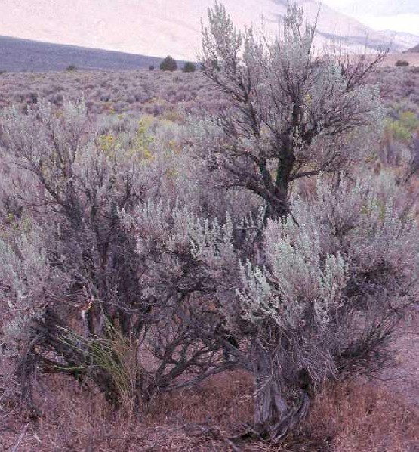
Figure 1. Basin big sagebrush (Artemisia tridentata ssp. tridentata). Photo courtesy of the PLANTS database.

Alternate Names
Artemisia tridentata ssp. tridentata = basin big sagebrush
A. tridentata ssp. wyomingensis = Wyoming big sagebrush
A. tridentata ssp. vaseyana = mountain big sagebrush
A. tridentata ssp. spiciformis = subalpine or spicate big sagebrush
A. tridentata ssp. xericensis = xeric or foothills big sagebrush
A. tridentata ssp. parishii = Parish’s big sagebrush

Uses
Forage/Wildlife: Big sagebrush is perhaps the most important shrub on western rangelands. Evergreen leaves and abundant seed production provide an excellent winter food source to numerous species of large mammals including mule deer, black-tailed deer, white-tailed deer, elk, pronghorn antelope, bighorn sheep and jack rabbits. Nearly 100 bird species depend on sagebrush ecosystems for their habitat needs. Additionally, there are several animal species having an obligate relationship with big sagebrush including sage grouse, sharp tailed grouse, pygmy rabbits, sage thrashers, sage sparrows and Brewer’s sparrow. Sagebrush also provide habitat and food for hosts of invertebrates which in turn support birds, reptiles and small mammals. In addition to the numerous species of animals that depend on sagebrush for food and cover, there are several plant species having close relationships with sagebrush as well.

Sagebrush plants maintain high levels of most nutrients including crude protein (see table 1). This high forage value makes it especially useful for wildlife, and in some areas livestock, winter grazing. Separate studies indicated that sagebrush made up 78% of the annual diet for antelope in Wyoming and 59% of the winter diet of deer and elk near Gardiner, Montana. Sagebrush also makes up close to 100% of the winter diet of sage grouse and over 60% of their total annual diet. Use of sagebrush by livestock is limited and variable.

Animal preference of sagebrush varies with subspecies, populations and even individual plants due to chemical variation found in the foliage. Deer and elk tend to prefer mountain big sagebrush followed by Wyoming big sagebrush and finally basin big sagebrush. Although many range managers believe that deer and other large mammals prefer to browse shrubby members of the Rosaceae such as mountain mahogany (Cercocarpus), bitterbrush (Purshia) and cliffrose (Cowania) over big sagebrush, studies show sagebrush significantly more readily browsed.

Sagebrush’s value as thermal or security cover is also very high for wildlife. This includes nesting cover and escape cover for sage grouse, sharp tailed grouse, pheasants, chukar and other upland birds.
Table 1. Nutritive values as percent dry matter and percent in-vitro dry matter digestibility (IVDMD).
 | Crude Protein | IVDMD
Spring | 12.6 | 58.1
Summer | 13.2 | -
Winter | 11.7 | 57.8
(Adapted from Welch, 2005)

Revegetation/reclamation: Because of its wide range of adaptation and ease of establishment, big sagebrush can be a very important species for use in revegetation efforts. Seedlings are able to compete with grasses and forbs as well as other shrubs allowing it to be used as a component of a wide range of seed mixes. Seedlings are very easy to establish when planted correctly (see “Establishment” section) and can be drill seeded or broadcast with near equal levels of success. Because sagebrush plants spread readily by seed, it can be seeded at relatively low rates and allowed to spread by natural recruitment.

Big sagebrush plants provide many additional benefits to the plant community. The dense canopy protects understory herbaceous plants from grazing. Healthy sagebrush communities provide a multi- tiered ecosystem with high levels of biodiversity. Big sagebrush plants also have a two-part root system with a deep tap root and a shallow, diffuse root system. Numerous studies have shown sagebrush plants create “hydraulic lift” where deep soil moisture is brought to near the soil surface by the tap root system during the day and then released into the upper soil at night. This water is then available to the diffuse root system of big sagebrush as well as to the roots of other understory plants. Sagebrush plants also increase water retention by trapping and holding windblown snow.

Big sagebrush subspecies are often useful indicators of soil characteristics. Generally, a subspecies indicates the soils at a site, thus proper identification of big sagebrush at a subspecific level can provide useful information on soils and ecological site characteristics. In some areas, however, such as those with glacial deposits, a separation based on soil characteristics is considerably more complex.

Status
Consult the PLANTS Web site and your State Department of Natural Resources for this plant’s current status (e.g. threatened or endangered species, state noxious status, and wetland indicator values).

Description
General: Although big sagebrush plants generally have a similar growth form, the species does have considerable morphological variation with several subspecies and ecotypes. Big sagebrush are evergreen shrubs ranging in size from less than 0.6 m (2 ft) tall to as large as 4 m (13 ft) tall. Branches are spreading, arising from numerous main stems in the lower growing subspecies or from one main trunk in the larger forms. Leaves are blue-gray to blue-green in color due to dense gray hairs. They are typically cuneate (wedge-shaped, triangular and gradually tapering to the base) or flabelliform (bell shaped) depending on subspecies, and have three lobes at the apex on the majority of the persistent foliage. Leaves vary in length from 0.5 to 5 cm (0.2 to 2.0 in), and can be 0.2 to 2.0 cm (0.08 to 0.8 in) wide. Leaves are spirally arranged with internodes short in young vegetative stems making the leaves very dense. Panicles overtop plants of mountain and spicate big sagebrush, or can grow throughout the crown in basin and Wyoming big sagebrush. Floral heads contain from three to 18 perfect (both male and female parts present) flowers per head. Achenes are typically glabrous but are hairy in the California endemic Parish’s big sagebrush. Big sagebrush plants are very aromatic with the smell being described as bitter pungent to pleasant, the odor varying by subspecies. Ploidy levels often differ among subspecies and may differ among populations.

Taxonomy
Currently there are six subspecies of Artemisia tridentata recognized by the National Plant Data Center: basin (ssp. tridentata), Wyoming (ssp. wyomingensis Beetle & Young), mountain (ssp. vaseyana [Rydb.] Beetle), subalpine (ssp. spiciformis [Ousterhout] Kartesz & Gandhi), xeric (ssp. xericensis Winward ex R. Rosentreter & R. Kelsey) and Parish’s (ssp. parishii [Gray] Hall & Clements). Each is highly variable with multiple ecotypes, but can generally be separated using a number of morphological, geographical and topographical characters.

All chromosome number information was obtained from McArthur and Sanderson (1999) as updated in McArthur (2005). Appendix 1 contains a general summary of characteristics useful to separate subspecies. See McArthur and Stevens (2004) for a detailed review of the characters for the subspecies occurring in the Intermountain West.

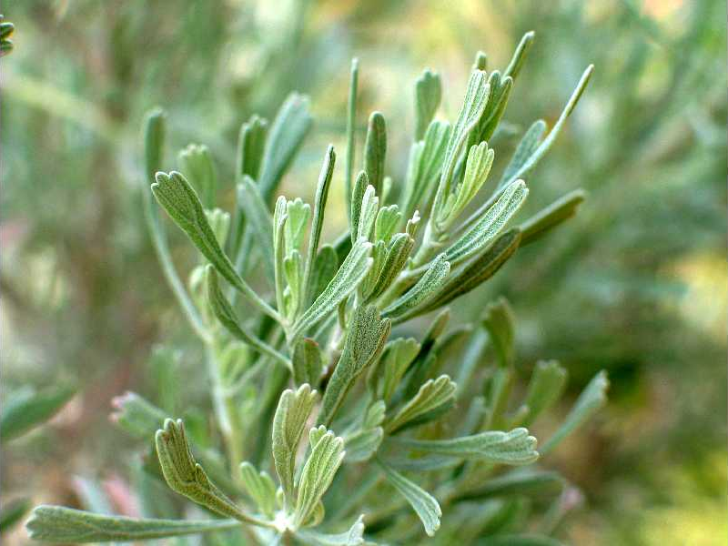
Figure 2. Leafy stem of basin big sagebrush. Photo courtesy of the PLANTS database.

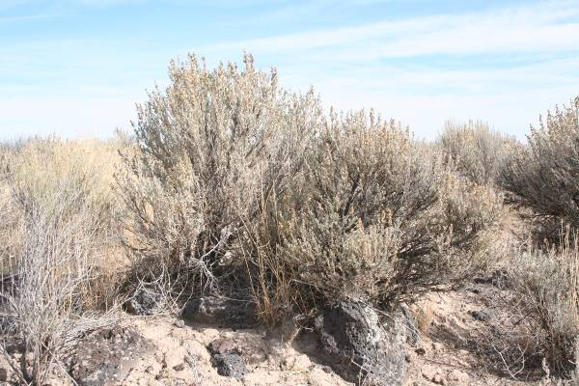
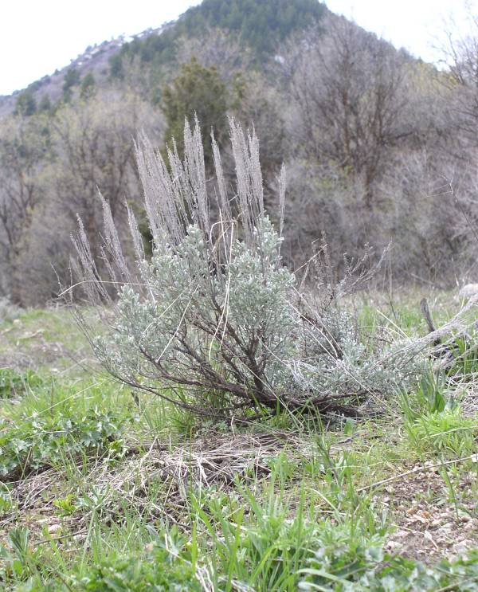
Basin big sagebrush usually occurs at the lowest elevational range of the species, being most abundant in the valley bottoms to mountain foothills. Plants typically have a single main trunk and may grow to a height of 4 m (13 ft) under proper conditions, making basin the largest subspecies. Basin big sagebrush plants are generally uneven-topped with loosely branching flowering stems distributed throughout the crown (see figure 1). Floral heads typically contain 3 to 6 small flowers per head. Leaves of the vegetative stems are narrowly cuneate averaging 2 cm (0.8 in) or more and can be as long as 5 cm (2 in) being many times longer than wide (see figure 2). Ultraviolet visible coumarins in leaf extracts are minimal; leaf UV color is none to light blue in water and a rusty red-brown color in alcohol. 2n = 18 or sometimes 36.

Figure 3. Wyoming big sagebrush. Photo by D. Tilley

Wyoming big sagebrush overlaps in range and elevation with basin big sagebrush. Plants are considerably smaller than those of basin big sagebrush, usually less than 0.9 m (3 ft) tall, and have main stems branching from the ground (see figure 3). Flowering stems are not as widely branching as those of basin, but otherwise closely resemble that subspecies. Leaves are typically shorter, from 1 to 1.5 cm (0.4 to 0.6 in) long, and flabelliform. UV extract color in water is none to light blue and rusty in alcohol. 2n = 36.

The vegetative stems of mountain big sagebrush create a characteristic even topped crown with the panicles rising distinctly and relatively uniformly above the foliage (see figure 3). Plants are normally smaller than those of basin big sagebrush, averaging about 0.9 m (3 ft) tall. Inflorescences are narrow and spicate bearing flower heads containing 4 to 8 flowers per head. Leaves are characteristically wider than those of basin or Wyoming big sagebrush. In extracts, ultraviolet visible coumarins are abundant. Leaf extracts fluoresce blue in water and blue-cream in alcohol. 2n = 18 or sometimes 36.

Figure 4. Even topped mountain big sagebrush. Photo by D. Tilley

Originally considered a xeric form of mountain big sagebrush, xeric big sagebrush shares similarities with both basin and mountain big sagebrush and may be the result of hybridization between the two subspecies. Xeric big sagebrush plants are large and have an uneven topped crown like those of basin big sagebrush, but in leaf UV color and cytological characters it resembles mountain big sagebrush. Ultraviolet visible coumarins are blue in water, blue-cream in alcohol. 2n = 36.

A new variation of big sagebrush being recognized by some is Bonneville big sagebrush. This as yet undescribed taxon may represent hybridization between Wyoming and mountain big sagebrush. It is reported to have the general growth form of Wyoming plants but bears the leaves and fluorescing characteristics of the mountain subspecies. It has been reported from the bench areas of Lake Bonneville and other ancient lakes of the Intermountain West in Utah and Nevada. Reports of Bonneville big sagebrush have also come from western Wyoming and western Colorado. Of particular importance is this sagebrush’s reported high palatability to wild ungulates and sage grouse.

Subalpine, or spicate big sagebrush, is believed to be a stabilized hybrid between mountain big sagebrush and silver sagebrush (Artemisia cana Pursh ssp. viscidula [Osterhout] Beetle). Plants are similar to those of mountain big sagebrush except that leaves and floral heads are larger, the floral heads having 10 to 18 flowers per head. Ultraviolet visible coumarins in leaf extracts fluoresce blue in water and blue-cream in alcohol. 2n = 18 or 36.

Parish’s big sagebrush is an uncommon taxon restricted to dry, sandy soils in the hills of southern California. It is nearest in appearance and relationship to basin big sagebrush, but differs from basin in having drooping flowering branches and the achenes are hairy. 2n = 36.

One additional taxon that should be mentioned is Lahontan sagebrush (Artemisia arbuscula ssp. longicaulis Winward and McArthur). It is thought to be a stable hybrid between low sagebrush (A. arbuscula) and Wyoming big sagebrush. It bears the flowers of low sagebrush but has the vegetative characteristics of its big sagebrush parent. This subspecies forms dominant communities in northwestern Nevada and adjacent portions of California and Oregon in shallow or clayey soils above and around the shoreline of the Pleistocene Lake Lahontan.

The following key should provide some assistance in separating the subspecies of big sagebrush.

1. plants larger, usually >0.9 m (3 ft) tall, with a
single main trunk; crown uneven with floral stems
throughout
2. achenes hairy; floral stems drooping; plants
endemic to sandy soils in southern
California……………………......ssp. parishii
2. achenes glabrous; floral stems erect; plants
widely distributed throughout western U.S,
including southern California
3. plants occurring in valley bottoms and low
foothills, occupying deep fertile soils; leaves
narrowly cuneate, 2-5 cm (0.8-2.0 in) long,
UV leaf color in water=none, in alcohol=red
to brown ……...................…...ssp. tridentata
3. UV in water=blue, in alcohol=blue-cream;
plants restricted to well-drained basaltic soils in western Idaho….........ssp. xericensis
1. plants smaller, averaging 0.9 m (3 ft) or less, with
trunks branching at or near ground level; crowns
various
4. crowns uneven-topped, plants of low
valleys and foothills;
5. UV color in water=none, in alcohol=rust
…………………………..ssp. wyomingensis
5. UV color in water=blue, in alcohol=blue-
cream…………………………..(Bonneville)
4. crowns even-topped, floral stems rising
uniformly above the vegetative stems; plants of
higher elevations
6. flowers 4 to 8; leaf tips lobed
………………………………….ssp. vaseyana
6. flowers 10 to 18; leaf tips often pointed
……….…………...…………..ssp. spiciformis

Additional taxonomic information can be found in the Flora of North America, Volume 19 (FNA Editorial Committee 2006) and the Intermountain Flora, Volume 5 (Cronquist et al. 1994).

Distribution
Fossil records and records from early pioneers indicate that sagebrush was widespread and existed in nearly the same general distribution for the past several thousand years as it does in the present day. Densities of sagebrush communities, however, have been reduced historically due to range management practices. Big sagebrush presently covers a vast ecological range from British Columbia to Baja California eastward to the Dakotas. Mahalovich and McArthur (2004) provide distribution as well as seed and plant transfer guidelines for Artemisia subgenus Tridentatae. For current distribution for each subspecies, please consult the Plant Profile page for this species on the PLANTS Web site.

Habitat
The big sagebrush complex is adapted to a wide range of precipitation zones and soil conditions. Plants are well adapted to the arid plains, valleys, foothills and mountains of the West where annual precipitation ranges from as little as 200 to as much as 750 or more mm (8 to 30 in). It is often found growing in loamy to sandy loam soils, but plants are found on all 12 soil textural classes in five soil orders: Alfisols, Aridisols, Entisols, Inceptisols and Mollisols. Tolerance to alkalinity or acidity varies by subspecies. In general big sagebrush will grow in soils with a pH of 5.9 to 10.0 and with organic matter content of 0.62 to 4.14 percent.

Basin big sagebrush is commonly found at low to mid elevations from 600 to 2,100 m (1,900 to 6,900 ft) in valleys and mountain foothills, occupying sites with deep fertile loamy to sandy soil, 0.9 m (3 ft) or deeper. It is often the dominant shrub species of the plant community, but is also found in association with juniper, piñon pine and rabbitbrush communities. Basin big sagebrush has a deep penetrating root system that allows it to occupy deeper soils in areas receiving little precipitation. Plants are often found growing in valleys, plains, alluvial fans and in seasonal or perennial stream channels. Basin big sagebrush prefers soils which are non-alkaline, non-saline and non-calcareous. The deep root system does not allow plants to grow in soils with a soil depth limiting hardpan or caliche layer. Depending on soil infiltration and water storage capacity, plants will grow in areas receiving less than 200 to more than 400 mm (8 to 16 in) annual precipitation. This subspecies also does not tolerate soils saturated for more than a few weeks in a season.

Wyoming big sagebrush grows at low to intermediate elevations between basin and mountain big sagebrush, but also commonly overlaps in range with the other two subspecies. When found in proximity with basin big sagebrush, Wyoming sagebrush will occupy the shallower, better-drained soils. Like basin big sagebrush, Wyoming is typically found in large stands covering many acres. Plants are also found in juniper, rabbitbrush, bitterbrush and mountain mahogany communities. At lower precipitation areas it is sometimes intermixed with shadscale and other Atriplex species. Wyoming big sagebrush commonly occurs from 800 to 2,200 m (2600 to 7,200 ft) in elevation. Wyoming big sagebrush is the most drought tolerant of the big sagebrush subspecies and is commonly found growing on low valley slopes and foothills receiving between 200 and 300 mm (8 to 12 in) annual precipitation. It occupies loamy soils with high clay content and a depth of 25 to 75 cm (10 to 30 in). Soils may be quite rocky or gravelly, but in these cases plants will be smaller. Wyoming big sagebrush will be found growing in soils underlain by a caliche or silica layer if the available soil is deep enough. Plants are typically found in soils with a low water holding capacity where excess water may run off into channels more suitable to basin big sagebrush.

Mountain big sagebrush grows in mountain and mountain foothill plant communities such as rabbitbrush, piñon pine, juniper, mountain shrub, aspen, Douglas fir, ponderosa pine and spruce-fir habitats from 800 to 3,100 m (2,600 to 10,000 ft). Plants prefer moderately deep to deep, well-drained soils providing summer moisture. Mountain big sagebrush occurs at higher elevations and in higher annual precipitation zones than either Wyoming big sagebrush or basin big sagebrush. Soils are typically 45 to 90 centimeters (18 to 36 in) deep or more, and are most often loamy to gravelly but can contain greater amounts of clay. Plants commonly grow in areas receiving over 350 mm (14 in) annual precipitation, but may be found in lower elevations and precipitation zones under certain conditions such as snow drift accumulation areas and shaded north facing slopes.

Xeric big sagebrush is limited to basaltic and granitic soils of western and west central Idaho and is often associated with bluebunch wheatgrass. Plants grow in the foothills from 800 to 1,500 meters (2,600 to 4,900 ft). Precipitation ranges from 300 to 400 mm (12 to 16 in) annually.

Spicate big sagebrush grows at high elevation ridge lines and snow accumulation areas from 2,000 to 3,300 m (6,500 to 10,800 ft) in annual precipitation zones of over 750 mm (30 in). It is normally found near Douglas fir, spruce-fir, and aspen communities.

spicate

Elevation
mountain

Wyoming

basin

Moisture

Figure 5. Adaptation of Intermountain big sagebrush subspecies based on elevational and moisture gradients (Mahalovich and McArthur, 2004).

Parish’s big sagebrush is adapted to the dry sandy soils of California’s Inner South Coast Ranges, South Coast, Western Transverse Ranges, White and Inyo Mountains and the desert mountains of the Mojave Desert.

Establishment
Seed of big sagebrush are best adapted to germinate in habitats with ecological conditions approximating those of the seed collection site. Seed source and subspecies should always be seriously considered prior to seeding. It may be necessary to use seed from more than one subspecies in a given revegetation project to ensure adequate establishment in all habitats.

Seed should be sown in the late fall or early winter and allowed to naturally stratify. It should be noted that big sagebrush seed has special seed storage requirements (See “Seed and Plant Production” section). If stored in conditions with relative humidity above 30 percent, seeds lose vigor and germinability after two or three years. To ensure a greater chance of establishment success, check the viability of seed lots before planting.

Seed should be planted into a firm, weed-free seedbed at a depth of no more than 1/8 inch. Seed covered too deeply with soil will generally fail to establish. Best results come from surface broadcast seed that has been pressed into the soil to provide for good seed-soil contact. Seed can also be broadcast directly onto snow with good results. Pressing broadcast seed into the soil surface with a land imprinter has provided very good establishment success. Land imprinters create good contact between the seed and soil as well as provide microhabitats that optimize temperature and water requirements. Broadcast seeding has also yielded good results when followed by a cultipacker or drag chain.

Drill seeding can be successful, but strict attention must be paid to seeding depth. Optimal drilling depth is 0 to 1/8 inch.

Sagebrush seed lots range in purity from approximately 8 to 30 percent or greater pure seed. Seed lots with high purity levels (20 percent or greater) can be difficult to seed due to limitations of the seeding equipment. Because sagebrush seed is very small and is metered through seeding equipment with difficulty, seed can be diluted with rice hulls or another inert carrier to improve flow.

Post-fire aerial seeding of big sagebrush has been done with limited success. Studies suggest that best results come from aerial seeding followed by land imprinting, cultipacking or chaining, or after allowing native perennial grasses to establish for a season following fire. It is believed that native grasses would suppress exotic annual grass species while allowing the establishment of sagebrush. Further study of this option is indicated.

Big sagebrush is not recommended for pure seedings. Seed should be a small component of a seed mix. Drill seeding 0.025 lbs PLS per acre (approximately 1 viable seed/ft²) provides approximately 400 plants per acre for optimal wildlife habitat. For broadcast seeding increase to 0.05 to 0.075 lbs PLS (approximately 2-3 viable seeds/ft²). With adequate soil moisture seedlings develop quickly and compete well with other shrubs and most herbaceous plants. However, to enhance establishment, sagebrush should not be sown in the same drill row with more aggressive forbs and grasses.

Sagebrush seedlings require sufficient soil moisture to germinate and survive. Young plants do not do well in open, unprotected locations. Best establishment results occur in sites where soil moisture is at or near field capacity, or in areas where snow accumulates. Existing shrubs, downed trees and litter can create microhabitats which also provide very good germination conditions.

Containerized stock or bareroot seedlings can also be used with high establishment success (50% or greater). This method, however, is quite costly, and is rarely used except in small critical area plantings. Plants can be taken from nursery stock or field harvested wildings. Wildings should be collected and transplanted during dormancy in fall or very early spring when soil moisture conditions are best. For best cost efficiency, “mother plants” should be placed in key locations throughout the revegetation site to allow for natural seed dispersal and recruitment over time.

Management
Historically, sagebrush communities have been poorly managed, mostly in attempts to reduce or eliminate sagebrush stands to increase forage production for livestock. Recently, however, the value of sagebrush to the western rangelands is being recognized, and practices are evolving to better manage healthy and productive sagebrush communities.

Contrary to long standing beliefs, studies show that complete sagebrush removal negatively affects biodiversity and has little long term affect on perennial grass production. Indeed, several studies indicate that forage production may actually decline when sagebrush is completely removed or controlled.

Overgrazing of the understory decreases plant biodiversity, especially the forb component of the plant community and increases the density of weeds. Annual weeds, such as cheatgrass (Bromus tectorum L.) and medusahead (Taeniatherum caput-medusae [L.] Nevski) often out-compete young sagebrush seedlings and create undesirable monocultures. Annual weed infestations also increase the frequency of wildfires which result in eliminating sagebrush stands therefore not allowing stand re-establishment.

Despite the many valuable benefits of sagebrush to rangelands, there may be cases when it is desirable to thin and rejuvenate sagebrush stands. In these instances it is not necessary to remove the entire stand, and control treatments in mosaic patterns are recommended. Several methods exist for partial removal of the shrubby over story.

Herbicide use is an effective means of thinning sagebrush stands. Contact your local agricultural extension specialist or county weed specialist to determine what works best in your area and how to use it safely.

Probably the simplest and most cost effective means of stand reduction is through prescribed burning. If there is sufficient fuel, a burn can completely eliminate a sagebrush community. For this reason niche burning is recommended when possible. In situations where cheatgrass is a dominant part of the understory, burning should take place when ripe cheatgrass seeds are still on the plants and will be consumed in the fire.

Methods of mechanical removal for sagebrush include anchor chaining, pipe harrowing, land imprinting offset disking and brush beating with brush hogs or mowers. Of these, chaining and land imprinting are the least expensive and do an excellent job of reducing sagebrush stands while still leaving enough plants for diversity and browsing. Brush beating does a good job, but it is expensive. Disking and harrowing also do a good job of shrub removal, but are more expensive and more destructive to under-story plant populations.

Pests and Potential Problems
Perhaps the greatest danger to sagebrush stands comes from fire. Big sagebrush plants have no fire resistance and many acres are destroyed annually because of increased fire frequency resulting from infestations of exotic annual weeds such as cheatgrass and medusahead.

Another minor cause of sagebrush mortality is winter injury. This occurs when temperatures drop quickly below freezing before plants have entered dormancy, or when a warm spell promotes winter growth followed by a return to typical winter temperatures. Extended periods of winter and summer drought (normally more than 2 years) can also cause dehydration and death.

Big sagebrush is occasionally susceptible to limited outbreaks of the sagebrush defoliator moth, or webworm, (Aroga websteri). Although the moths can cause extensive damage, they too are subject to insect predators, and it is rare that entire stands will be lost.

Additionally, there are a number of other microbial and fungal pathogens known to attack big sagebrush. Although these may inflict serious damage locally, they have not been viewed as a great threat to sagebrush populations.

Seed and Plant Production
The vast majority of big sagebrush seed used in revegetation is wildland collected material. Seed collection occurs in late fall to early winter (early October through the end of December) depending on the subspecies. Collections are commonly made by hand stripping, beating or clipping seed heads into containers or by using a reel type harvester. Seed can be cleaned with a hammermill, debearder, air-screen or gravity table with varying results. Most sagebrush seed lots used for rangeland seeding are only cleaned to a purity of 15 to 20 percent due to the small nature of the seeds (achenes). This practice requires less time for cleaning and also allows for easier seed flow and metering in seeding equipment. Pure seed yields approximately 1.7 to 2.5 million seeds per pound. The NRCS Plant Materials Center in Bridger, MT reported four hours collecting time and 5.5 hours cleaning yielded 200g (0.45 lb) cleaned material, or 21g (0.04 lb) per hour.

Sagebrush seed that has been dried to a minimum of 9 percent moisture content will remain viable for many years when stored under cool, dry conditions. Welch et al (1996) reported seed viabilities above 90% for seed stored at 10 ºC (50 ºF) and relative humidity (RH) of 20 percent after nine years of storage. Seed stored at higher RH levels are susceptible to germination or damage by insects or microorganisms.

Because sagebrush seed can readily be collected from wild stands, sagebrush is rarely grown in commercial production fields. However, in very droughty periods, very little sagebrush seed can be collected from wild stands. Increasing seed demands and decreasing sagebrush stands lost to weeds and fire are growing concerns. Recent studies suggest protecting wildland seed-producing stands for optimum harvesting. The greatest factor in seed production for sagebrush is protection against grazing animals. Surrounding plants with a wire fence has shown an increase in seed stalk number of as much as 3 to 5 times the amount of unprotected plants. Studies also show significantly higher seed yields from plants grown on reclaimed mine lands when compared with those on adjacent non-mined areas. The reason for this correlation is unclear, but it may be a result of increased available soil moisture due to lower competing plant frequencies on the mined lands.

Seed production varies greatly between years and between stands due to differences in climate, stand density and maturity, soil and genetics. It has been estimated that an average stand of big sagebrush could potentially produce 100 to 300 lbs PLS per acre annually. Seed production declines as plants and stands mature creating larger amounts of woody biomass. Greater seed yields can be achieved by thinning decadent stands to encourage new flower stalk production

For nursery plantings, pre-stratified seed can be planted in greenhouse conditions, or seed can be allowed to naturally stratify after being planted in containers outdoors. Keep soil medium slightly moist during germination. Greenhouse sprayers or misters are commonly used during daylight hours at a rate of 10 seconds every 15 minutes. Uniform germination occurs after two weeks of temperatures over 20º C (70º F). Seedlings are ready for field transplanting approximately 5 months after germination.

Cultivars, Improved, and Selected Materials (and area of origin)
‘Hobble Creek’ mountain big sagebrush was released by the Utah Agricultural Experiment Station, Utah State University and the USDA Forest Service Rocky Mountain Research Station in 1987. Seed was originally collected in 1968 by A. Perry Plummer at the Hobble Creek drainage east of Springville, UT. ‘Hobble Creek’ was chosen for its high vegetative production and for its high palatability to mule deer and wintering domestic sheep. It is adapted to sites with deep, well-drained soils receiving more than 350 mm (14 in) of annual precipitation and having a growing season of 90 days or longer. Soils should be no finer than a clay loam, containing 40% or less clay and have a pH between 6.6 and 8.6. Breeder seed is maintained at a breeder block at the USDA Forest Service Rocky Mountain Research Station, Shrub Sciences Laboratory, Provo, UT.

‘Gordon Creek’ Wyoming big sagebrush was originally collected near Helper, Carbon County, UT. It was released in 1992 by the USDA Forest Service Rocky Mountain Research Station to fill the need for a low precipitation ecotype of big sagebrush to improve winter diets of mule deer and sage grouse and for rangeland restoration. Gordon Creek was chosen for its high growth rate, nutrient levels and mule deer preference. It is widely adapted to dry regions of the west receiving 250 or more mm (10 in) mean annual precipitation. It prefers deep to shallow, well-drained soils with up to 55% clay content with a pH of 6.6 to 8.8.

Contact your local Natural Resources Conservation Service (formerly Soil Conservation Service) office for more information. Look in the phone book under ”United States Government.” The Natural Resources Conservation Service will be listed under the subheading “Department of Agriculture.”

References
Booth, D.T. 2005. Wyoming big sagebrush seed orchards on reclaimed mined land. Native Plants Journal. 6(3): 247-253.

Booth, D.T., Y. Bai and E.E. Roos. 2004. Cultural methods for enhancing Wyoming big sagebrush seed production. USDA Forest Service Proceedings RMRS-P-31: 95-99.

Butler, J, C. Frieswyk. 2002. Propagation protocol for production of Artemisia tridentata seeds; Rocky Mountain National Park. In: Native Plant Network. URL: http://www.nativeplantnetwork.org (accessed 25 March 2005). Moscow (ID): University of Idaho, College of Natural Resources, Forest Research Nursery.

Cronquist, A. et al. 1994. Intermountain flora: Vascular plants of the Intermountain West, U.S.A., Volume Five: Asterales. The New York Botanical Garden, Bronx, New York. Pages: 146-160.

Flora of North America Editorial Committee. 2006. Flora of North America North of Mexico. Volume 19: Magnoliophyta: Asteridae, part 6: Asteraceae, part 1. Oxford University Press, New York, New York. Pages: 503-518.

Francis, John K. ed. 2004. Wildland shrubs of the United States and its Territories: thamnic descriptions: volume 1. Gen. Tech. Rep. IITF-GTR-26. San Juan, PR: USDA, Forest Service, International Institute of Tropical Forestry, and Fort Collins, CO: USDA, Forest Service, Rocky Mountain Research Station. 830 p.

Hickman, J.C., ed. 1993. The Jepson manual: higher plants of California. Berkeley: University of California Press. 1400 p.

Jensen, K. H. Horton, R. Reed, R. Whitesides and USDA-ARS-FRRL. 2001. Intermountain planting guide. Utah State University. AG 510.

Luna, T., J. Evans and D. Wick. 2004. Propagation protocol for production of container Artemisia tridentata; Glacier National Park. In: Native Plant Network. URL: http://www.nativeplantnetwork.org (accessed 25 March 2005). Moscow (ID): University of Idaho, College of Natural Resources, Forest Research Nursery.

Lysne, C.R. and M. Pellant. 2004. Establishment of aerially seeded big sagebrush following southern Idaho wildfires. USDI, BLM. Technical Bulletin no. 2004-01.

Mahalovich, M.F. and E.D. McArthur. 2004. Sagebrush (Artemisia spp.) Seed and Plant Transfer Guidelines. Native Plants. Fall 2004: 141-148.

McArthur, E.D. 2005. Sagebrush, common and uncommon, palatable and unpalatable. Rangelands. 27(4): 47-51.

McArthur, E.D. and S.C. Sanderson. 1999. Cytogeography and chromosome evolution of subgenus Tridentatae of Artemisia. American Journal of Botany 86: 1754-1775.

McArthur, E.D. and R. Stevens. 2004. Composite shrubs. In: S.B. Monsen, R. Stevens, and N.L. Shaw [compilers]. Restoring western ranges and wildlands. Fort Collins, CO: USDA Forest Service, Rocky Mountain Research Station. General Technical Report RMRS-GTR-136-vol-2. p. 493-537.

Ogle, D.G., L. St. John, M. Stannard and L. Holzworth. 2003. Technical Note 24: Grass, grass-like, forb, legume, and woody species for the intermountain west. USDA-NRCS, Boise, ID. ID-TN 24. 41p.

Peterson, J.G.1995. Sagebrush: ecological implications of sagebrush manipulation. Wildlife Management Division, Montana Fish, Wildlife and Parks. 50p.

Rosentreter, R. and R.G. Kelsey. 1991. Xeric big sagebrush, a new subspecies in the Artemisia tridentata complex. Journal of Range Management 44(4): 330-335.

Schultz, B. and K. McAdoo. 2002. Common sagebrush in Nevada. University of Nevada, Reno. Special Publication SP-02-02. 9p.

Stevens, R. K.R. Jorgensen, S.A. Young and S.B. Monsen. 1996. Forb and shrub seed production guide for Utah. Utah State University Extension. 51p.

USDA, NRCS. 2004. The PLANTS Database, Version 3.5 (http://plants.usda.gov). National Plant Data Center (accessed 28 March, 2005), Baton Rouge, LA 70874-4490 USA.

Van Dersal, W.R. 1938. Native Woody Plants of the United States: Their Erosion-Control and Wildlife Values. USDA Miscellaneous Publication No. 303.

Wambolt, C.L. 1996. Mule deer and elk foraging preference for 4 sagebrush taxa. Journal of Range Management 49(6): 499-503.

Welch, B.L. 2005. Big sagebrush: a sea fragmented into lakes, ponds, and puddles. General Technical Report RMRS-GTR-144. USDA, Forest Service, Rocky Mountain Research Station. Fort Collins, CO. 210 p.

Welch, B.L., S.F. Briggs and J.H. Johansen. 1996. Big sagebrush seed storage. Res. Note INT-RN-430. Ogden, UT: US Department of Agriculture, Forest Service, Rocky Mountain Research Station. 3p.

Welch, B.L. and C. Criddle. 2003. Countering Misinformation Concerning Big Sagebrush. Research Paper RMRS-RP-40. Ogden, UT: US Department of Agriculture, Forest Service, Rocky Mountain Research Station. 28 p.

Welch, B.L., E. D. McArthur, D.L. Nelson, J.C. Pederson and J.N. Davis. 1986. 'Hobble Creek'- a superior selection of low elevation mountain big sagebrush. Research Paper INT-370. USDA, Forest Service, Intermountain Research Station, Ogden, UT.

Welch, B.L., Nelson, E.E., Young, S.A., Sands, A.R., Wagstaff, F.J., and D.L. Nelson. 1992. 'Gordon Creek'- a superior, tested germplasm of Wyoming big sagebrush. Research Paper INT-461. USDA Forest Service, Intermountain Research Station, Ogden, UT.

Welch, B.L. and F.J. Wagstaff. ‘Hobble Creek’ big sagebrush vs. antelope bitterbrush as a winter forage. Journal of Range Management. 45(2): 140-142.

Welsh, S. L., N. D. Atwood, S. Goodrich and L. C. Higgins. 1993. A Utah Flora. Brigham Young University Press, Provo, Utah.

Winward, A.H. 2004. Sagebrush of Colorado: taxonomy, distribution, ecology and management. Colorado Division of Wildlife. Denver, CO. 46 p.

Winward, A.H. and E.D. McArthur. 1995. Lahontan sagebrush (Artemisia arbuscula ssp. longicaulis): a new taxon. Great Basin Naturalist 55(2): 151-157.

Prepared By:
Derek J. Tilley, Range Conservationist (Plants) USDA NRCS Plant Materials Center, Aberdeen, ID

Dan Ogle, Plant Materials Specialist

USDA NRCS Idaho State Office, Boise, ID

Loren St. John, Manager

USDA NRCS Plant Materials Center, Aberdeen, ID

Brock Benson, Area Range Conservationist
USDA NRCS, Ogden, UT

Acknowledgements:
The authors would like to thank the following people for reviewing this manuscript and providing their thoughtful input:

Stephen C. Bunting, Professor of Rangeland Ecology, University of Idaho. Moscow, ID.

Jim Cornwell, State Range Conservationist,
USDA NRCS, Idaho State Office, Boise, ID

Dave Franzen, Intermountain Rangeland Consultants, LLC. Wilder, ID

Jacy Gibbs, Intermountain Rangeland Consultants, LLC. Wilder, ID

E. Durant McArthur, Project Leader, Shrub Sciences Laboratory, Rocky Mountain Research Station. USDA Forest Service. Provo, Utah

Carl L. Wambolt, Professor of Range Science, Montana State University. Bozeman, MT.

Bruce L. Welch, Plant Physiologist, Ret. Rocky Mountain Research Station. USDA Forest Service. Provo, UT.

Species Coordinator:

Dan Ogle, Plant Materials Specialist

USDA NRCS Idaho State Office, Boise, Idaho

Edited: dgo010406; lsj052005; edm060105; scb060105; df061805; jg061805; blw070105; clw071505; djt122105; 061214 jsp

For more information about this and other plants, please contact your local NRCS field office or Conservation District, and visit the PLANTS Web site<http://plants.usda.gov> or the Plant Materials Program Web site <http://Plant-Materials.nrcs.usda.gov>

The U.S. Department of Agriculture (USDA) prohibits discrimination in all its programs and activities on the basis of race, color, national origin, gender, religion, age, disability, political beliefs, sexual orientation, and marital or family status. (Not all prohibited bases apply to all programs.) Persons with disabilities who require alternative means for communication of program information (Braille, large print, audiotape, etc.) should contact USDA’s TARGET Center at 202-720-2600 (voice and TDD).

To file a complaint of discrimination, write USDA, Director, Office of Civil Rights, Room 326W, Whitten Building, 14th and Independence Avenue, SW, Washington, DC 20250-9410 or call (202) 720-5964 (voice or TDD). USDA is an equal opportunity provider and employer.

Appendix 1. Summary of characteristics of big sagebrush subspecies.
 | Basin | Wyoming | Mountain | Xeric | Subalpine | Parish’s
Height | 3 to 6’ (13) | 2 to 3’ | 2 to 3’ | 3 to 6’ | 2 to 5’ | See basin
Stem | Single main trunk | Branching at or slightly above ground | Branching at or slightly above ground | Branching at or slightly above ground | Branching at or slightly above ground | See basin
Evergreen Leaves on vegetative stems | Narrowly cuneate, up to 5 cm long, many times longer than wide  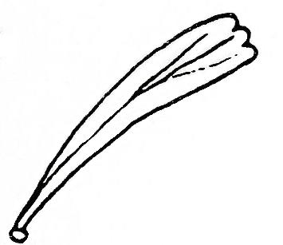 |   Flabelliform, 1-1.5 cm long, ca. 3X longer than wide | Cuneate, 1-2.5 cm long; usually wider than basin or Wyoming   |  | Cuneate, 1-2.5 cm long; lobes often pointed | See basin
Crown shape | Uneven-topped, floral stems growing throughout crown | Uneven-topped, floral stems growing throughout crown | Even-topped, floral stems rising above crown | Uneven-topped, floral stems growing throughout crown | Even-topped, floral stems rising above crown | Uneven-topped, floral stems growing throughout and drooping
Flrs/head | 3 to 6 | 3 to 8 | 4 to 8 |  | 10 to 18 | 3-6; achenes hairy
UV color: water/alcohol | None to light blue/ rust | None to light blue/rust | Intense blue/ blue-cream | Blue/ blue-cream | Blue/blue-cream
Elevational range | 600-2100m | 800-2200m | 800-3000m | 800-1500m | 2000-3000+m | 300-?m
Soil | Sandy to loamy; deep & fertile (36”+) | Loamy to silt loam; often very gravelly; dry & shallow (10 to 30”), caliche possible | Loamy to clay loam; often gravelly (18 to 36”) | Basalt or granite derived (12 to 22”) |  | Sandy, well drained
Soil chemistry | Non-alkaline, non-saline and non-calcareous | Can be mildly alkaline | Non-alkaline, non-saline and non-calcareous
Precipitation range | 8 to 16”+ | 8 to 12” | 14”+ | 12 to 16” | 30”+
Topography | Valleys, low foothills, seasonal stream channels | Mid-elevation valleys, foothills | Foothills and mountains, plateaus and ridges | Basalt flows and granite outcrops | High mountain ridges and plateaus | Deep soils in Southern California

