Orange zexmenia
Wedelia texana
(A. Gray) B.L. Turner
Plant Symbol = WETE

Contributed by: E. “Kika” de la Garza Plant Materials Center, Kingsville, Texas

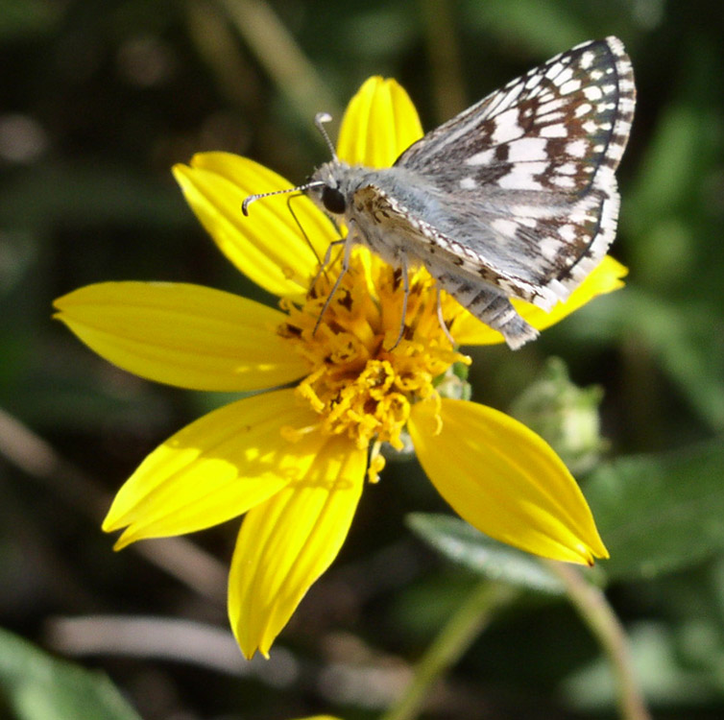
Shelly D. Maher, USDA NRCS Kika de la Garza PMC

Alternate Names
Hairy wedelia. Previous scientific names include Wedelia acapulcensis Kunth var. hispida auct. non (Kunth) Strother, Wedelia hispida auct. non Kunth, and Zexmenia hispida auct. non (Kunth) A. Gray ex Small.

Uses
Wildlife: Orange zexmenia is a good plant for inclusion in native seed mixes for range use. It is browsed by white-tailed deer, cattle, sheep, and goats. Wildlife species such bobwhite quail and white tail deer have been observed browsing seed and vegetative material in observation plots. Orange zexmenia may also provide unknown benefits by maintaining and contributing habitat that harbors beneficial insects and butterflies.

It also can be used in many types of conservation plantings, such as stream-side buffers and filter strips.
Beautification: Orange zexmenia is an attractive plant for landscaping use because of its all around hardiness, drought tolerance, small shrub growth form, and brightly colored yellow-orange flowers. It is recommended for landscaping on roadside, native gardens, and other low rainfall locations. It is a larval host for bordered patch butterfly larvae and a nectar source for various species of adult butterflies.

Status
Please consult the PLANTS Web site and your State Department of Natural Resources for this plant’s current status (e.g. threatened or endangered species, state noxious status, and wetland indicator values).

Description and Adaptation
Orange zexmenia is a native Texas sub-shrub 5-10 dm tall. The stems are usually solitary and woody at the base. The many branches and leaves are covered with rough stiff hairs. The leaves are simple, ovate-lanceolate, sessile or nearly so, and mostly opposite. Leaves are generally scabrous or strigose on both sides and turn black after drying.

The flower stems are terminal and solitary or occasionally in a cyme of three. The flower heads are about 3 cm across. The ray flowers are broad, conspicuous, 7-15 in number, with the corollas being yellow or orange. Both the disk and ray flowers produce achenes. The plants bloom and produce seed from March to December.

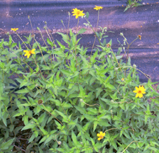
Shelly D. Maher, USDA NRCS Kika de la Garza PMC

Orange zexmenia is frequent on various soils in openings and partially shaded brushy sites in the Edwards Plateau and Rio Grande Plains ecoregions of Texas. It is less frequent in the Trans Pecos and southeast and north central Texas. It can also be found in northeastern Mexico, southeast to Veracruz and Hidalgo. For current distribution maps, please consult the Plant Profile page for this species on the PLANTS Web site.

Establishment
Orange zexmenia can best be established from seed. Seeds can be sown directly, or can be grown in a greenhouse to establish transplants for later planting. Germination tests conducted at the Kika de la Garza Plant Material Center (1999) found germination rates ranging from a low of 1% to a high of 73%.

For direct seeding, broadcast seed in the late winter or early spring into a clean, weed free seedbed. Seeds should be covered from ¼ to ½” depth to ensure good soil to seed contact. Transplants should be planted in early to mid-spring, to ensure good root establishment before the summer heat arrives.

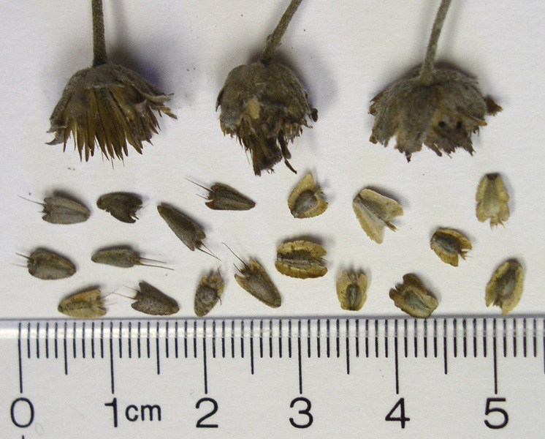
Shelly D. Maher, USDA NRCS Kika de la Garza PMC

For greenhouse seeding, it is important not to over water, because the small seedlings are prone to damping off. New plants can be transplanted into their permanent locations after three months.

Management
Orange zexmenia requires little management other than occasional weeding. It can survive in both droughty and moist conditions. For seed production purposes, occasional irrigation during extremely droughty periods may help seed fertility.

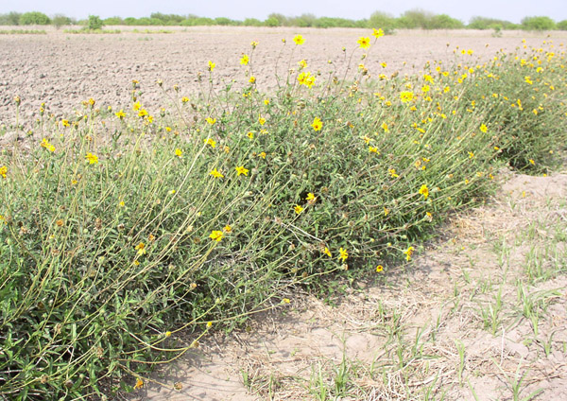
Shelly D. Maher, USDA NRCS Kika de la Garza PMC

Orange zexmenia can be harvested with a combine. When harvesting orange zexmenia, run the combine’s cylinder speed at 900 RPM, the concave is at 6 mm, the sieve is open ¼”, and the fan is off. Orange zexmenia can also be harvested using a weed eater with a stripper attachment. To clean the seed, it should first be run through a brush machine and can then be cleaned further using a clipper style seed cleaner. It is recommended that after cleaning, the seed should be stored at 45ºF and less than 50% humidity. Dryland (non-irrigated) field production can yield 60 pounds of seed per acre per year.

Pests and Potential Problems
White flies have been observed to completely defoliate orange zexmenia plants. However, the defoliated plants survived. Bordered patch butterfly larvae have also defoliated the plants. Aphids and leaf-footed bugs have been documented on orange zexmenia. All of the above pests are fairly easy to control with Organophosphate (Ex.-Malathion) and carbamate (Ex.-Sevin) insecticides.

Cultivars, Improved, and Selected Materials
Goliad Germplasm is a selected class release developed from seed originating from seven South Texas counties. It was released cooperatively with the South Texas Natives project in 2008. It was selected for superior adaptation to South Texas over other commercially available forbs, high active germination, and drought and disease resistance. It is intended to provide food and cover for wildlife. Certified seed is available and the E. “Kika” de la Garza PMC maintains breeder seed.

Prepared By and Species Coordinator:
John Lloyd-Reilley & Shelly D. Maher, USDA NRCS E. “Kika” de la Garza Plant Materials Center, Kingsville, Texas

Edited: August 2008; 081030 jsp

For more information about this and other plants, please contact your local NRCS field office or Conservation District, and visit the PLANTS Web site<http://plants.usda.gov> or the Plant Materials Program Web site <http://Plant-Materials.nrcs.usda.gov>

The U.S. Department of Agriculture (USDA) prohibits discrimination in all its programs and activities on the basis of race, color, national origin, sex, religion, age, disability, political beliefs, sexual orientation, and marital or family status. (Not all prohibited bases apply to all programs.) Persons with disabilities who require alternative means for communication of program information (Braille, large print, audiotape, etc.) should contact USDA's TARGET Center at 202-720-2600 (voice and TDD).
To file a complaint of discrimination write USDA, Director, Office of Civil Rights, Room 326-W, Whitten Building, 14th and Independence Avenue, SW, Washington, DC 20250-9410 or call 202-720-5964 (voice or TDD). USDA is an equal opportunity provider and employer. Read about Civil Rights at the Natural Resources Conservation Service.

