Invasive Species
“Public lands—especially federal lands—have become the last refuge for endangered species—the last place where they can find the habitat they need to survive. If invasives take over, these imperiled animals and plants will have nowhere else to go. Forest Service Chief Dale Bosworth
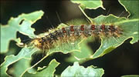
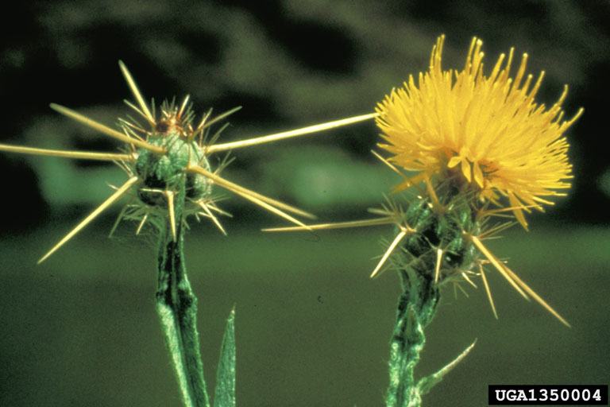
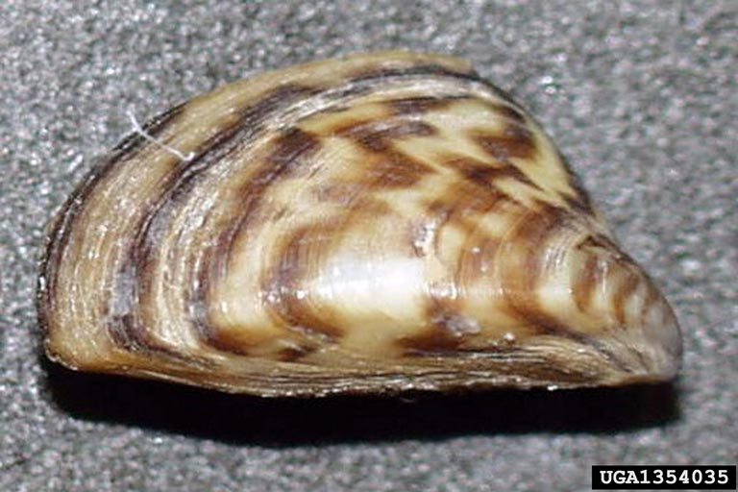

Thousands of non-native invasive plants, invertebrates, vertebrates, and disease-causing pathogens are infesting millions of acres of lands and waters across the nation. These invaders cause massive disruptions in ecosystem function, reducing biodiversity, and degrade ecosystem health in our nation’s forests, prairies, mountains, wetlands, rivers, and oceans. Invasive species affect the health of not only the nation’s forests and rangelands, but also the health and survival of wildlife, livestock, fish, and humans. The financial impact from invasive species infestations in the United States has been estimated at $138 billion per year in total economic damages and associated control costs.
A strategic Forest Service response to invasive specifies is embodied in the National Strategy and Implementation Plan for Invasive Species Management launched in October 2004. The strategy is an aggressive program that harnesses the capabilities of the Forest Service. The Forest Service provides cutting edge leadership in natural resource management and research and development. For more information on the Forest Service National Invasive Species program, please visit http://www.fs.fed.us/invasivespecies/index.shtml
Quick Facts
For the Forest Service, the focus is on non-native terrestrial and aquatic species. Invasive species (“invasives”) come in all shapes and many guises: nonnative insects (e.g., Asian longhorned beetle, hemlock woolly adelgid, emerald ash borer), aquatic invasives (e.g. New Zealand mudsnail, zebra mussel, and rusty crayfish) land-based and aquatic invasive plants (e.g., yellow starthistle, Japanese knotweed, Eurasian watermilfoil, and tamarisk), diseases and pathogens (e.g., sudden oak death, whirling disease, white pine blister rust, tree blights) – the list is almost endless.

Invasives have the capacity to dominate, overwhelm, or wipe out native species. Case in point: Chestnut blight all but killed the American chestnut while Dutch elm disease decimated Dutch elm trees from our landscape.

Invasive Plants
- California, Florida, and Hawaii are hosts to 2,000 nonnative plants or half of the 4,000 exotic species that exist nationwide of which 400 are considered invasive.
- Invasive plants are found on 133 million acres (as big as California and New York combined), in federal, state, and private ownerships.
- Invasives are choking 3.6 million acres of the national forests, an area the size of Connecticut.
- Each year, invasives advance by 1.7 million acres per year across the land in all directions, an area that is two-thirds bigger than the state of Delaware.
- Cheatgrass, leafy spurge, knapweeds and starthistles, saltcedar (tamarisk), nonnative thistles, purple loosestrife, and kudzu are major concerns in areas (especially in the West) where they proliferate and dominate native species.

Invasive Insects and Diseases
- Nationwide, 70 million acres of public and private lands are at serious risk from 26 different insects and diseases, most of which are nonnative invasives.
- Major nonnative invasive threats include: gypsy moth, hemlock woolly adelgid, emerald ash borer, dogwood anthracnose, Asian longhorned beetle, white pine blister rust, sudden oak death, Port Orford cedar root and beech bark diseases.

Costs of Threat
- Estimates are that the United States spends $138 billion per year in total economic damages and associated control costs.
- Invasive species are a factor in the decline of 49 percent of all imperiled (listed as threatened or endangered) species.

Prevention, Early Detection and Rapid Response, Control and Management
The Invasive Species Issues Team (ISIT) has developed a four-prong strategic implementation plan for the Forest Service aimed at early detection, prevention, control and management, rehabilitation and restoration. The strategy includes a whole range of programs involving various treatment regimes such as: (1) mechanical removal, (2) cultural methods, (3) biological control, and (4) chemical treatments.

