POLAR Spacecraft Status As of: Tues, 12 Sept 06, 16:00 EST
(changes from last week in bold border)
Subsystem/  Component | NOAA-12D  AM 16:59=AN  STIP data only | NOAA-14J  AM: 21:10=AN  STIP data only | NOAA-15K  AM: 17:49=AN  GAC data only | NOAA-16L  PM: 15:04=AN  GAC&LAC data | NOAA-17M  AM: 22:23=AN  GAC&LAC data | NOAA-18N  PM 13:49=AN  GAC & LAC data
LAUNCHED | 05/14/91 | 12/30/94 | 05/13/98 | 09/21/00 | 6/24/02 | 5/20/05
CNTL OBP | OBP2  Recursive SCT | OBP2  OBP1 inoperative | OBP2 | OBP2 | OBP2 | OBP2
BUS | B-BUS  XSU-1 | B-BUS  XSU2 (XSU1 inop) | B-BUS  XSU-1 | B-BUS  XSU-1: TOAR444 | B-BUS  XSU-1 | B-BUS  XSU-1
BUS VETO | NO | NO | NO | NO | NO | NO
ADACS | Nominal Mode  Autonomous swap to YGC 30 Aug, | Nominal Mode  Rgmode=Monitor  Gyro chans=XYZ | Nominal Mode  Rgmode=Monitor  Gyro-3 Off 6/26/00 Gyro chans=AAB | RGYRO Mode  Estimate Y-ROLL  Rgmode=PASSIVE  Gyros-1 & 3 Inop/Off  Gyro chans XA-ZB | Nominal Mode  Rgmode=Monitor  Gyro-3 Off 6/10/04  Gyro chans=AAB | Nominal Mode  Gyro-A MIMU-2  Z-wheel -Pitch  TOAR 447
RXO | PRI  BU random enables  daily bias+6.5 mS | PRI  BU random enables daily bias–7.0 mS | PRI  daily bias -8 mS  -500 mS 12/31/05 | PRI  Daily Bias –5.5 mS  -1500 mS 31Dec05 | PRI  Daily Bias –3 mS  -1500 mS 31Dec05 | PRI  No daily bias  -1500 mS 31Dec05
CLOCK DIV | 2 | 2 | 2 | 2 | 2 | 2
MIRP | External Synch  Rephase Enabled | External Synch  Rephase each orbit | External Synch Rephase 0730 daily | External Sync  Rephase each orbit | External Sync  Rephase Enabled | External Synch  Rephase Enabled
TIP SIDE | 1 | 2  Since 19 Jul 06 | 2  (since 4/3/03)  3 channels inop | 2  (drifting?)  since 4/18/05 | 1  Analog telem drifting  Swap planned 9/20/06 | 1  Analog telem drifting
Recorders  (DTR, SSR) | DTRs 3A, 4, 5B  Safestate 5B | DTRs 1, 2B, 5 Safestate- 1B | DTRs 1, 2, 3, 4 Safestate 1B EOT | DTRs 1, 2, 3, 4A  Safestate 3A  4B STIP only | DTR 1,3,4 / SSR 2  Safestate=SSR 2B | SSRs 1,2,3,4,5  Safestate=5B  Current spikes  TOAR 450
VTX  (APT data) | #1 ON  137.50 MHZ | OFF (nominal)  Since 8/2/05 | #1 ON  137.50 MHZ | OFF / INOP  since 11/15/00 | #2 ON  137.62 MHZ | #2 ON  137.9125 MHZ  Investigating output power instability
BTX | #1  136.77 MHZ | #2  137.77 MHZ | #1  137.35 MHZ | #2  137.77 MHZ | #2  137.77 MHZ | #1  137.35 MHZ
STX  1 = rcp 1698.0 mhz  2 = lcp 1702.5 mhz  3= rcp 1707.0 mhz  4= rcp 2247.5 mhz | 1 – HRPT;  2,3 - Playback | 3 – HRPT  2, 1 – Playback | 2-Omni HRPT  2 Omni=rcp  Power Drop  TOAR 446  4-Playback  1,2,3-Degraded | 2 – HRPT  1– Playback  4 – Playback  & MCM usage  3 low power unused | 3 – HRPT  TOAR424 low power  2 & 4 Playback  1-Standby  STX-1 Power drop TOAR 443. | 1 - HRPT  3 - Playback  2-Playback  4-Test & Standby
POWER  (Array offset and CANT angle, charge & V/T rates, eclipse states and sun angle)  SUN-MOON ECLIPSE 22 SEPT BETWEEN 08:00 AND 16:00Z | ArrayOff +60  since 8/31/06  Full Sun  Sun Angle 17 trend down to 9 in Oct  Batts 1&2=LRC  Batt 1&2 V/T=4  Shunt degraded  SA CANT=37 degs  PSSS trigger =18.5 | Array Off -50  Since 22Nov05  Batts 1&3V/T=6/9  Batt2 VT=7/9  Eclipse all year  Sun angle at 57 steady trend  Batts 1-3= LRC  Degraded shunts  SA CANT=22 degs  PSS Macro loaded | Array Off -45  Since 1/25/01  Full Sun  Sun Angle 17  downtrend to 5 in mid-Oct  Batts 1-3= LRC  V/T=7/9  SA CANT=37 degs | Array Off -40  Since 7/16/02  Eclipse all year  Sun Angle 40  Down trend to 33 in late Oct  Batts 1-3= LRC  V/T=4/8  SA CANT=22 degs | Array Off. –40  Since 1/29/04  Eclipse all year  Sun Angle at 67  Steady trend  Batts 1-3= LRC  V/T= 4/8  SA CANT=37 degs | Array Off. -40  Since 6/6/05  Eclipse all year  Sun Angle 65 downtrend to 60 on 1 Nov 06  Batts 1-3=LRC  Batts 1-3 V/T=4/8  SA CANT=22  BVR Phase Control auton swap 3/29/06
AVHRR | Nominal | Nominal  Since 18 Feb 06  Occasional scan motor current surge  Channels 2&4  IR channels re-enabled 14-Aug-06 | Nominal  Channel 3B only  Recent minor scan motor instabilities | Nominal  since mid Oct 05  TCE24 OFF 4/14/04  Channel 3B only | Nominal  3A-B switch enabled  Frequent scan motor current mini surges | Nominal  Channel 3B only  Scan motor current drop 29 Aug 06
AMSU-A1 |  |  | Operational  Ch14 inoperative  Ch11 inoperative | Operational  Primary PLLO chans 9-14 bias shift.  Backup PLLO inop.  Channel 9-14 noise | OFF/INOP  Since 10/30/03  Survival heat on. | Nominal  Full Scan mode
AMSU-A2 |  |  | Nominal | Nominal  Space Position-2 | Nominal | Nominal  Full scan mode
AMSU-B |  |  | Operational  Bias in All Chans.  Motor surges most recent 11/14/04  Degraded Chan-3 since 4/30/05 | Operational  Space Position-3  IPD reports channel 8 degradation | Nominal | Replaced by MHS
HIRS | ON/Inop  Turned On 4/30/05  for power balance  Filter Wheel OFF | NOMINAL  Operational  Occasional loss of Fwheel synch  Electronics turned back on 14-Aug-06 after turnoff for  10 Aug POM test | NOMINAL  FW Abrupt return to nominal 7/12/05  After years of minor and major current surges  FW mode=Hi Powr | NOMINAL  Imagery occasionally exhibits high levels of radiometric noise  Recent momentary FW synch dropouts  Occasional major FM surges, most recent  12/9/04 | NOMINAL  1 Pixel cross track misalignment. | IWT Test Mode  Lens stabilization test #1 implemented 9/11/06. Mirror placed at IWT  LW channel 1-12 noise TOAR 448 Loose LWIR lens.  Inconsistent, LW often erratic.
MHS/MIU |  |  |  |  |  | Nominal  Space View=0  Occasional Flywheel motor current surges most recent 17Jul 06  Rare Turbo anomalies over SAA  Most recent 12/16/05
MSU | OFF/Inop  Turned off for power balance  6/23/05 | Operational  Scan motor and antenna problems
SSU |  | OFF/Nominal  Turned off 5 May for power balance
DCS  RFI investigation | Nominal | Nominal | Nominal | Nominal  Pseudo message turned on 1/5/06 | Nominal | Nominal  DRU’s 1-7 On  DRU8 inop/off
SARR |  | Nominal  All time high component temps | Operational  A-Side, AGC Mode  Intermittent failures for 243MHz A&B | Operational  Mode =AA  A-side, AGC Mode  (B-side in FG mode)  243 MHz = INOP. | Nominal  A-side  All AGC Mode | Nominal  A-Side  All AGC Mode  Since 15 Aug 05
SARP |  | OFF  Power Failure | Nominal  RCVR B/W = 2 | Nominal  RCVR B/W = 2 | Nominal | Nominal  A-side 23 May05
SEM | ON/Nominal  Autonomous reset  8 Jun, back to nominal 10 June  Turned on 8/30/04  Elec-CH-HVPS=4  Prot-CH-HVPS=0  TED level=3 | Operational  Elec-CH-HVPS=0  Prot-CH-HVPS=0  1 of 4 Tscopes inop | Nominal  E-CDEM-HVPS=2  P-CDEM-HVPS=0 | Nominal  E-CDEM-HVPS=6  P-CDEM-HVPS=5  27 Jun 15:30z | Nominal  E-CDEM-HVPS=2  P-CDEM-HVPS=4  27 June 16:00z | Nominal  Elec-CH-HVPS=1  27 June 17:00z  Prot-CH-HVPS=0
SBUV |  | Degraded  Grate motor sticks  Flex memory 3 (giant step) ops suspended 12/2/03  Reduced operations  Transient anomaly  1 Sept 05 |  | Operational  Degraded Ozone data  Backup Diffuser inop  Primary Diffuser deployment problem TOAR 426  AMSU EMI causing erratic Behavior in PMT cathod, range 3 | Nominal  Anode Mode  Plan sweep mode  Standard Ops  TOAR 463 sun glint  IBSL test planned for 12 Sept | Nominal  Anode mode  since 6 July 13:30z  Electronics turnoff taken out of STESM safestate table  TOAR 462 sun glint  IBSL Testing implemented 9/12/06
SADPOS |  |  | N/A | ON  Enabled MFactor50%  Timer = 12 mins | ON  ENABLED  Timer = 12mins | ON  Enabled  Timer =12 mins
THERMAL  Heaters, louvers  TCE’s | Nominal  TCE’s back to nominal configuration following 7/25/04 UVtrip. | Nominal | TCE26 & 15H  Telem invalid  TOAR 432  TCE24L&25L (HIRS & AVHRR) failed 5/13/98  RCE thermostat failed 5/13/98  Spacecraft thermal in downtrend | Nominal  TCE24 OFF 4/14/05  (AVHRR H&L)  HIRS Filter heater turned OFF 1/18/05 | TCE3H Batt 2A heater failed ON, turned off 8/26/03  AMSU-A1 survival heaters on 10/29/03 | All TCE’s active  HIRS filter heater turned ON 9/11/06  TCE3H displaying invalid readings  TOAR 458  submitted
 | N12 | N14 | N15 | N16 | N17 | N18

COMMENTS/CHANGES:

NOAA-12: No changes since last weeks report. Spacecraft is operating in nominal attitude mode with nominal power balance and
no residual effects from the autonomous swap to YGC mode and the solar array offset move two weeks ago.

NOAA-14: The N14 AVHRR has begun to exhibit some scan motor current instabilities in recent days with two, significant though short-lived surges occurring in the past week (illustration 1). These surges were not accompanied by any changes in other AVHRR telemetry (temperatures, synch deltas, etc) and there has been no reports of degraded imagery received by EMOSS engineers. Otherwise, there was no change to N14 during the past week with all other subsystems performing in a nominal and stable manner and the power system remaining well within balance (illustration 2).

NOAA-15: There were no changes to N15 during the past week as all payloads, power and attitude control subsystems performed
nominally while in the middle of a strong thermal downtrend that is expected to last until mid October (illustrations 3 through 5).

NOAA-16: There were no significant changes to N16 during the past week as all payloads, power and attitude control subsystems
performed nominally with a steady thermal trend (illustrations 6). The attitude control system did experience some minor instabilities on 8 and 9 Sept when a full moon introduced light into ESA quads 2&4 which could not be knocked out because of the Rgyro attitude control mode situation. However, these instabilities only last two days and the situation has since resolved itself (illustrations 7 & 8).

NOAA-17: The N17 AMSU’s (A2 and B) were generally nominal and stable last week while the AVHRR experienced almost
continual scan motor current “mini surges” (all within the “normal” range for such events, see illustration 9). Otherwise the remainder of the spacecraft was relatively nominal, stable and unchanged during the past week (illustration 10).

EMOSS engineers continue planning the N17 TIP swap because of its analog drift problem. The current planning date for this change has been selected as 20 Sept. Will Chadwick and Jon Woodward are EMOSS POC’s for this reconfiguration.

EMOSS engineers implemented N17 SBUV IBSL tests on 12 Sept starting at 15:09z which were partially executed out of stored commands and partially out of realtime commanding. Details of this test were specified in the 29 Aug Weekly Report. Sally House is EMOSS POC.

NOAA-18: N18 HIRS lens stabilization testing began on 11 Sept when the mirror was placed in IWT position at 16:00z and the
filter heater was turned on one orbit later (illustrations 11 and 12). This configuration is expected to remain in place at least through 13 Sept after which additional testing may be implemented pending analysis by NASA and factory engineers. While in this configuration, HIRS imagery products are not available to EMOSS engineers nor is the channel noise data that typically appears in this report. Sally House is EMOSS POC for this testing which was also outlined in the 29 Aug Weekly Report. Preliminary reports from Changyong Cao indicate that the noise dropped significantly during the IWT Dwell (see illustration 13).

The N18 AVHRR is performing nominally following a noticeable drop in its scan motor current last week. No imagery
degradation or peripheral AVHRR affects have been noted since that occurrence (illustration 14). Otherwise, all other
payloads and subsystems were nominal for N18 during the last week (illustrations 15 and 16). One additional item of
note was the N18 VTX transmitter power. Engineer John Vollmer, replacing Will Chadwick as POES DHS-Comm
engineers noticed a significant difference in the stability of the N18 VTX-2 transmitter output power (illustration 17) relative to that of N18 VTX-1 or the VTX transmitters on N15 and 17 (N16 VTX is inoperative and N14 has been off for years.) This stability has actually improved somewhat since the VTX—2 was turned back on in late July 06 after having been off for 7 months prior. Subsequent coordination of this finding with NASA engineers has led to the conclusion that this is not presently a cause for concern but is worthy of closer scrutiny.

NOTES: Illustrations 2, 5, 7-10, 16 and 17 have been omitted for web hosting.

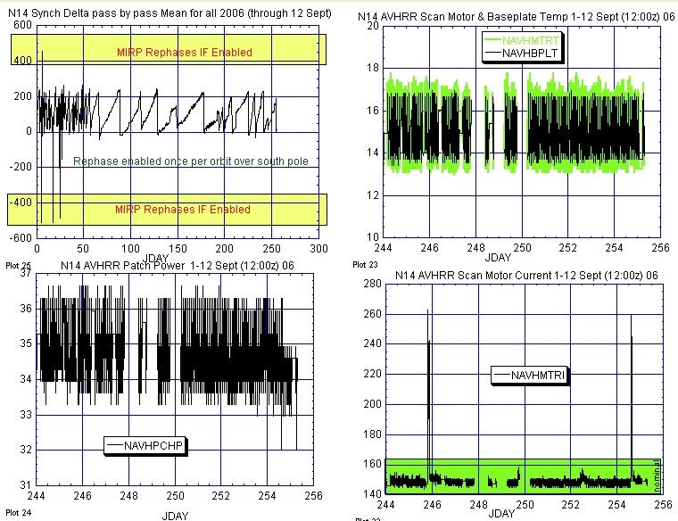

Illustration 1: NOAA-14 AVHRR Health Analysis

(The scan motor [lower right plot] is showing some signs of instability in recent days but no other item is coinciding with this instability. )

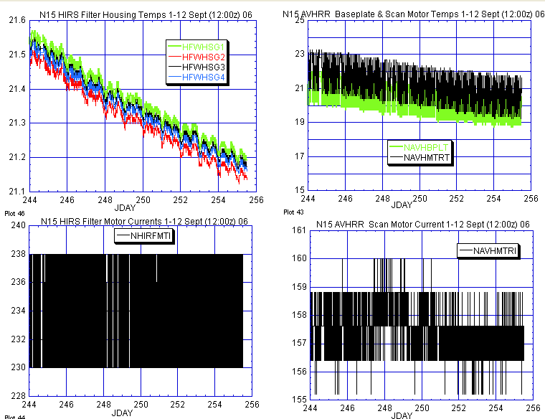
HIRS AVHRR

Illustration 3: NOAA-15 HIRS and AVHRR Health Analysis

(Nominal last week, as thermal trend continues downward.)

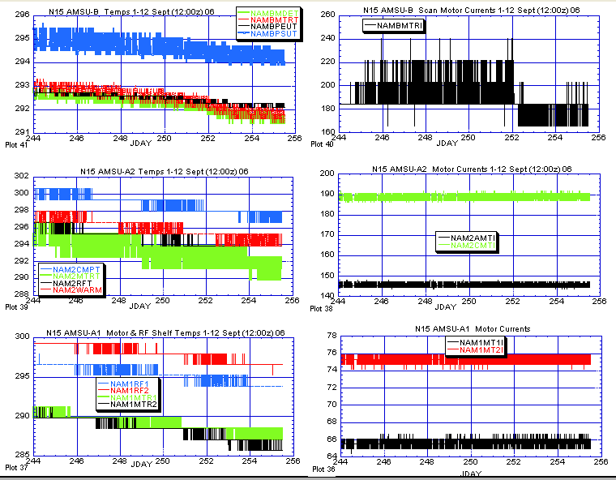

Illustration 4: N15 AMSU Analysis

(Nominal and stable last week while continuing its thermal downtrend. The minor instabilities on the AMSU-B scan motor current value [upper right plot] appear to have stabilized.)

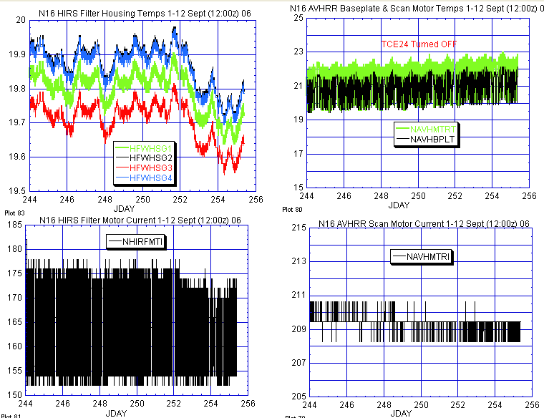

Illustration 6: N16 HIRS and AVHRR Health Analysis

(Nominal and stable last week with the HIRS filter motor current [lower right plot] actually showing some minor improvements. All three AMSU’s, not depicted in this report, were also nominal and stable last week.)

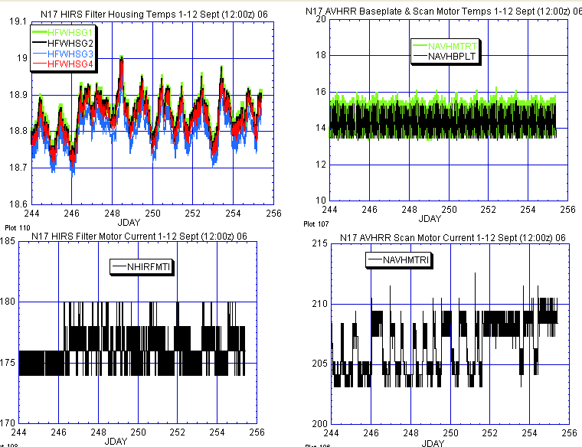
HIRS AVHRR

ILLUSTRATION 9: N17 HIRS & AVHRR Health Analysis

(AVHRR scan motor mini surges are increasing in frequency. No impacts have been detected as yet. AMSU’s-2 and B, not depicted this week were both nominal and stable last week.)

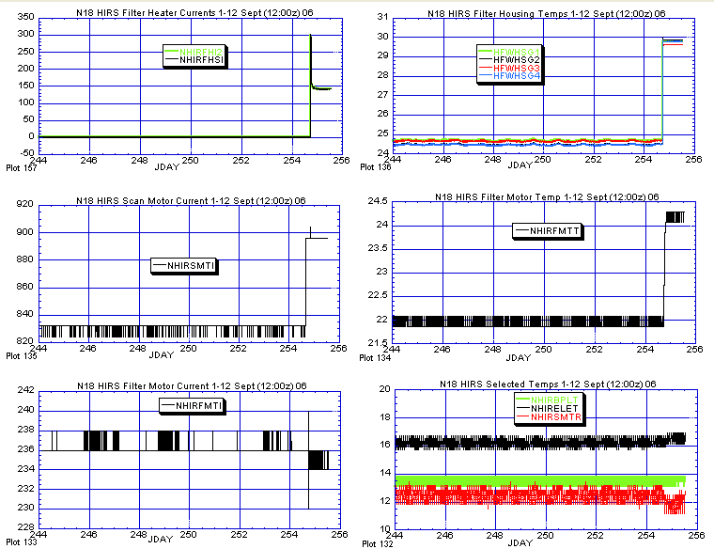

ILLUSTRATION 11: N18 HIRS Analysis

(Lens stabilization test #1 implemented late on Jday 254 [11 Sept]. Positioned mirror at IWT at 16:00z then one orbit later turned on filter heater. The effects are obvious. Imagery no longer being telemetered.)

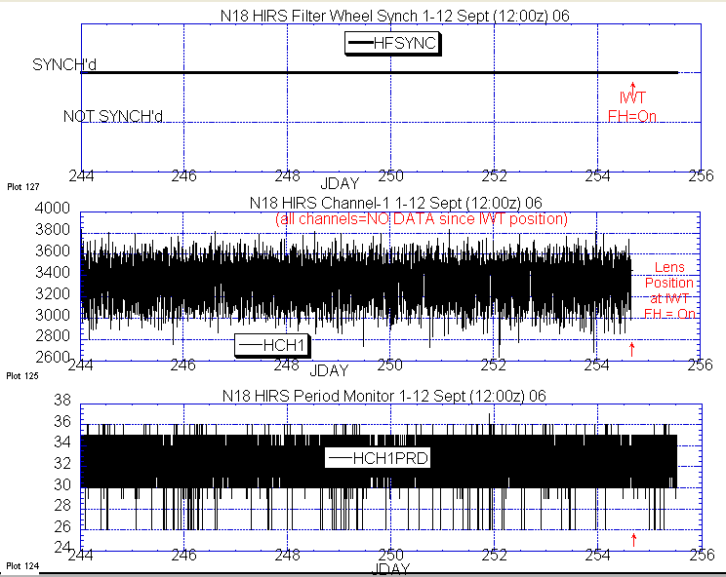

ILLUSTRATION 12: N18 HIRS DIG-A Data Analysis

(Period monitor and filter wheel synch remained nominal and stable after lens test was implemented. All channels now no longer being telemetered [see middle plot] into a form that can be reviewed directly by EMOSS engineers.)

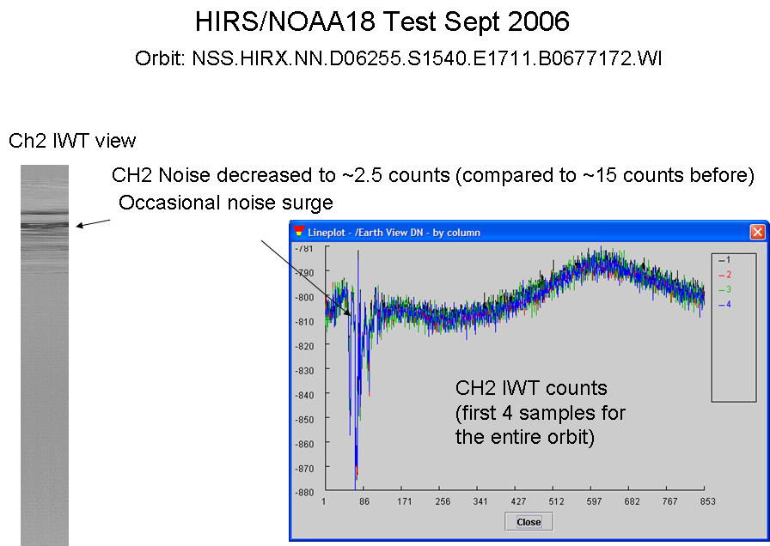

ILLUSTRATION 13: N18 HIRS Test Data Analysis

(Changyong Cao slide depicting improvement in HIRS channel-2 noise situation with the implementation of IWT test.)

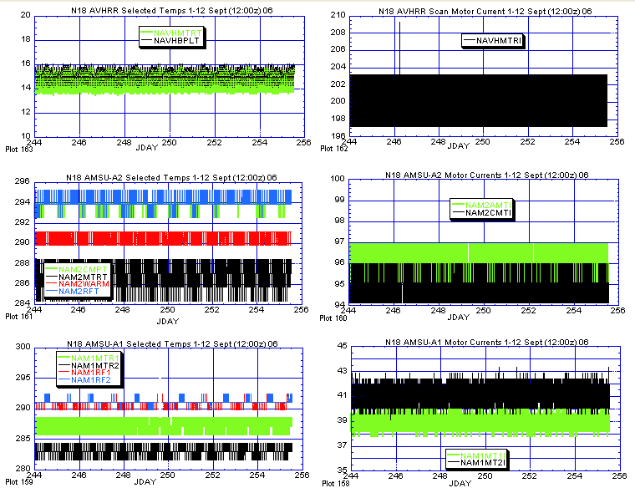

ILLUSTRATION 14: N18 AVHRR and AMSU Health Analysis

(Nominal and stable last week.)

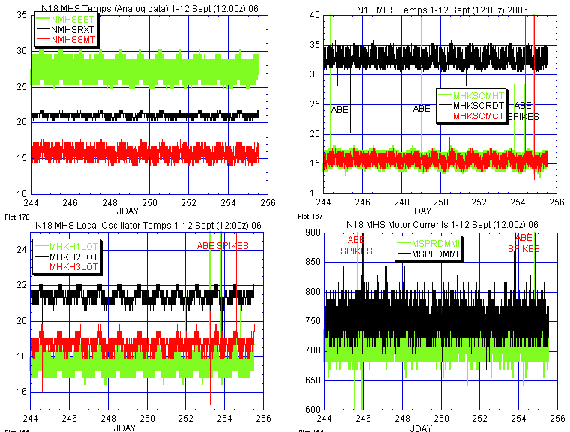

ILLUSTRATION 15: N18 MHS Analysis

(Ignoring all the ABE system induced spikes, MHS was nominal and stable last week.)

