POLAR Spacecraft Status As of: Tues, 11 Jul 06, 17:00 EST
(changes from last week in bold border)
Subsystem/  Component | NOAA-12D  AM 16:59=AN  STIP data only | NOAA-14J  AM: 21:10=AN  STIP data only | NOAA-15K  AM: 17:49=AN  GAC data only | NOAA-16L  PM: 15:04=AN  GAC&LAC data | NOAA-17M  AM: 22:23=AN  GAC&LAC data | NOAA-18N  PM 13:49=AN  GAC & LAC data
LAUNCHED | 05/14/91 | 12/30/94 | 05/13/98 | 09/21/00 | 6/24/02 | 5/20/05
CNTL OBP | OBP2  Recursive SCT | OBP2  OBP1 inoperative | OBP2 | OBP2 | OBP2 | OBP2
BUS | B-BUS  XSU-1 | B-BUS  XSU2 (XSU1 inop) | B-BUS  XSU-1 | B-BUS  XSU-1: TOAR444 | B-BUS  XSU-1 | B-BUS  XSU-1
BUS VETO | NO | NO | NO | NO | NO | NO
ADACS | Nominal Mode  RGmode=Monitor  Gyro chans=XYZ  Z-Wheel sticking during transition through 0 RPM | Nominal Mode  Rgmode=Disabled  Gyro chans=XYZ  Very low N2 gas  Pitch Over Maneuver planned for 19 Jul. | Nominal Mode  Rgmode=Monitor  Gyro-3 Off 6/26/00 Gyro chans=AAB  . | RGYRO Mode  Estimate Y-ROLL  Rgmode=PASSIVE  Gyros-1 & 3 Inop/Off  Gyro chans XA-ZB | Nominal Mode  Rgmode=Monitor  Gyro-3 Off 6/10/04  Gyro chans=AAB | Nominal Mode  Gyro-A MIMU-2  Z-wheel -Pitch  TOAR 447
RXO | PRI  BU random enables  daily bias+6.5 mS | PRI  BU random enables daily bias–7.0 mS | PRI  daily bias -8 mS  -500 mS 12/31/05 | PRI  Daily Bias –5.5 mS  -1500 mS 31Dec05 | PRI  Daily Bias –3 mS  -1500 mS 31Dec05 | PRI  No daily bias  -1500 mS 31Dec05
CLOCK DIV | 2 | 2 | 2 | 2 | 2 | 2
MIRP | External Synch  Rephase Enabled | External Synch  Rephase each orbit | External Synch Rephase 0730 daily | External Sync  Rephase each orbit | External Sync  Rephase Enabled | External Synch  Rephase Enabled
TIP SIDE | 1 | 1 | 2 (since 4/3/03)  #2 has 3 chans inop | 2 (drifting?)  since 4/18/05 | 1  Analog telem drifting | 1  Analog telem drift?
Recorders  (DTR, SSR) | DTRs 3A, 4, 5B  Safestate 5B | DTRs 1, 2B, 5 Safestate- 1B | DTRs 1, 2, 3, 4 Safestate 1B EOT | DTRs 1, 2, 3, 4A  Safestate 3A  4B STIP only | DTR 1,3,4 / SSR 2  Safestate=SSR 2B | SSRs 1,2,3,4,5  Safestate=5B  Current spikes  TOAR 450
VTX  (APT data) | #1 ON  137.50 MHZ  Conflict with N15 | OFF (nominal)  Since 8/2/05 | OFF  18Jun-21Jul  Conflict with 12 | OFF / INOP  since 11/15/00 | #2 ON  137.62 MHZ | #1 ON  137.10 MHZ
BTX | #1  136.77 MHZ | #2  137.77 MHZ | #1  137.35 MHZ | #2  137.77 MHZ | #2  137.77 MHZ | #1  137.35 MHZ
STX  1 = rcp 1698.0 mhz  2 = lcp 1702.5 mhz  3= rcp 1707.0 mhz  4= rcp 2247.5 mhz | 1 – HRPT;  2,3 - Playback | 3 – HRPT  2, 1 – Playback | 2-Omni HRPT  2 Omni=rcp  Power Drop  TOAR 446  4-Playback  1,2,3-Degraded | 2 – HRPT  1– Playback  4 – Playback  & MCM usage  3 low power unused | 3 – HRPT  TOAR424 low power  2 & 4 Playback  1-Standby  STX-1 Power drop TOAR 443. | 1 - HRPT  3 - Playback  2-Playback  4-Test & Standby
POWER  (Array offset and CANT angle, charge & V/T rates, eclipse states and sun angle) | ArrayOff -60  since 6/28/06  Eclipse season peaked 21 Jun  Ends 12 Aug  Sun Angle 34 trend down to 9 in Oct  Batts 1&2=LRC  Batt 1&2 V/T=4  Shunt degraded  SA CANT=37 degs  PSSS trigger lowered to 18.5 on 11 Jul | Array Off -50  Batts 1&3V/T=6/9  Batt2 VT=7/9  Since 11/22/05  Reduced load 5 May with SSU turnoff  Eclipse all year  Sun angle at 60 steady trend  Batts 1-3= LRC  Degraded shunts  SA CANT=22 degs  PSSS change plan | Array Off -45  Since 1/25/01  Eclipse season waning, peaked 18 Jun,  Ends 1 Aug  Sun Angle 31  downtrend to 5 in mid-Oct  Batts 1-3= LRC  V/T=7/9  SA CANT=37 degs | Array Off -40  Since 7/16/02  Eclipse all year  Sun Angle 52  Steady trend  Batts 1-3= LRC  V/T=4/8  SA CANT=22 degs | Array Off. –40  Since 1/29/04  Eclipse all year  Sun Angle at 70  Steady trend  Batts 1-3= LRC  V/T= 4/8  SA CANT=37 degs | Array Off. -40  Since 6/6/05  Eclipse all year  Sun Angle 72 end uptrend  Batts 1-3=LRC  Batts 1-3 V/T=4/8  SA CANT=22  BVR Phase Control autonomous swap 3/29=TOAR 457
AVHRR | Nominal | Nominal  Since 18 Feb 06  Occasional scan motor current surge  Channels 2&4 APT | Nominal  Channel 3B only  Recent minor scan motor instabilities | Nominal  since mid Oct 05  TCE24 OFF 4/14/04  Channel 3B only | Nominal  3A-B switch enabled  Scan motor stability degradation? | Nominal  Channel 3B only  Frequent scan motor current mini surge
AMSU-A1 |  |  | Operational  Ch14 inoperative  Ch11 inoperative | Operational  Primary PLLO chans 9-14 bias shift.  Backup PLLO inop.  Channel 9-14 noise | OFF/INOP  Since 10/30/03  Survival heat on. | Nominal  Full Scan mode
AMSU-A2 |  |  | Nominal | Nominal  Space Position-2 | Nominal | Nominal  Full scan mode
AMSU-B |  |  | Operational  Bias in All Chans.  Motor surges most recent 11/14/04  Degraded Chan-3 since 4/30/05 | Operational  Space Position-3  IPD reports channel 8 degradation | Nominal | Replaced by MHS
HIRS | ON/Inop  Turned On 4/30/05  for power balance  Filter Wheel OFF | NOMINAL  Operational  Occasional loss of Fwheel synch | NOMINAL  FW Abrupt return to nominal 7/12/05  After years of minor and major current surges  FW mode=Hi Powr | Operational  Imagery high levels radiometric noise  TOAR 441 CLOSED  Recent momentary FW synch dropouts  Occasional major FM surges, most recent  12/9/04 | NOMINAL  1 Pixel cross track misalignment. | Operational  LW Chans degraded 25 June  LW channel 1-12 noise TOAR 448 Loose LWIR lens.  Inconsistent, LW often erratic.
MHS/MIU |  |  |  |  |  | Nominal  Flywheel current increase 23 Jun big surge 25 Jun  again on 8 Jul  Space View=0  Rare Turbo anomalies  over SAA
MSU | OFF/Inop  Turned off for power balance  6/23/05 | Operational  Scan motor and antenna problems  EOL test planned
SSU |  | OFF/Nominal  Turned off 5 May for power balance
DCS  RFI investigation | Nominal | Nominal | Nominal | Nominal  Pseudo message turned on 1/5/06 | Nominal | Nominal  DRU’s 1-7 On  DRU8 inop/off
SARR |  | Nominal  All time high component temps | Operational  A-Side, AGC Mode  Intermittent failures for 243MHz A&B | Operational  Mode =AA  A-side, AGC Mode  (B-side in FG mode)  243 MHz = INOP. | Nominal  A-side  All AGC Mode | Nominal  A-Side  All AGC Mode  Since 15 Aug 05
SARP |  | OFF  Power Failure | Nominal  RCVR B/W = 2 | Nominal  RCVR B/W = 2 | Nominal | Nominal  A-side 23 May05
SEM | ON/Nominal  Autonomous reset  8 Jun, back to nominal 10 June  Turned on 8/30/04  Elec-CH-HVPS=4  Prot-CH-HVPS=0  TED level=3 | Operational  Elec-CH-HVPS=0  Prot-CH-HVPS=0  1 of 4 Tscopes inop | Nominal  E-CDEM-HVPS=2  P-CDEM-HVPS=0 | Nominal  E-CDEM-HVPS=6  P-CDEM-HVPS=5  27 Jun 15:30z | Nominal  E-CDEM-HVPS=2  P-CDEM-HVPS=4  27 June 16:00z | Nominal  Elec-CH-HVPS=1  27 June 17:00z  Prot-CH-HVPS=0
SBUV |  | Degraded  Grate motor sticks  Flex memory 3 (giant step) ops suspended 12/2/03  Reduced operations  Transient anomaly  1 Sept 05 |  | Operational  Degraded Ozone data  Backup Diffuser inop  Primary Diffuser deployment problem TOAR 426  AMSU EMI causing erratic Behavior in PMT cathod, range 3 | Nominal  Anode Mode  Plan sweep mode  Standard Ops | Nominal  Anode mode  since 6 July 13:30z  Electronics turnoff taken out of STESM safestate table
SADPOS |  |  | N/A | ON  Enabled MFactor50%  Timer = 12 mins | ON  ENABLED  Timer = 12mins | ON  Enabled  Timer =12 mins
THERMAL  Heaters, louvers  TCE’s | Nominal  TCE’s back to nominal configuration following 7/25/04 UVtrip. | Nominal | TCE26 & 15H  Telem invalid  TOAR 432  TCE24L&25L (HIRS & AVHRR) failed 5/13/98  RCE thermostat failed 5/13/98  Spacecraft thermal in downtrend | Nominal  TCE24 OFF 4/14/05  (AVHRR H&L)  HIRS Filter heater turned OFF 1/18/05 | TCE3H Batt 2A heater failed ON, turned off 8/26/03  AMSU-A1 survival heaters on 10/29/03 | All TCE’s active  TCE3H displaying invalid readings  TOAR 458  submitted
 | N12 | N14 | N15 | N16 | N17 | N18
COMMENTS/CHANGES:

NOAA-12: N12 power balance remained stable and nominal during the past week as the N12 eclipse season began to wane
(illustration 1). The solar array offset configuration of -60 degrees will have to be re-considered by mid-August at the latest because of the risk of autonomous switching to YGC attitude control mode that may result once the sun angle on the spacecraft falls below 20 degs (predicted for 3 Sept).

To improve the margin of safety engineers implemented a change to the power survival safestate trigger on 11 Jul at 18:15z. The new battery voltage for triggering PSSS is 18.5, down from 18.73 previously.

The N12 X-(Yaw) Wheel continues sticking as it passes through 0 RPM and the ADACS engineers continue investigating this behavior. Currently, the wheel is not causing out of spec yaw errors and so immediate action is not considered imperative.

NOAA-14: The N14 AVHRR was relatively nominal and stable last week and power balance remained stable as well (illustration
2). Concerns about the record high value of the low pressure nitrogen gas situation are being discussed. At the present time it is still not known what the cause is of the slow increase in the low pressure value which started its uptrend on early July of 2005. Among the possibilities under discussion is the that the values are not “true”. This possibility was raised because the low pressure value on N15 became invalid two years ago when 4 contiguous telemetry channels on the same mux chip ceased reporting valid telemetry (N2 low pressure being one of the channels on that chip.) Engineers continue to investigate. The channels indicating the telemetry readings for the low pressure appear to be reporting nominally. Another possibility under consideration was that TIP drift was responsible because the low pressure trend since 11 Jul 05 does resemble that “classic”, one count at a time, stair step pattern (while displaying minimal correlation with the N2 tanks thermal environment). However, no other analog values are showing that same pattern so it is unlikely that TIP drift is the cause. Despite these two possibilities being discounted the belief that the telemetry is invalid remains. One reason for this sustained belief is that the low pressure relief valve has in fact actually “cracked” once before (during OV) at a value of 565 (PSI), 28 PSI lower than the present value. (Which begs the question, why has it not cracked again unless the value is invalid?) The major concern with this issue is that the Pitch Over Maneuver test remains scheduled for 19 Jul and if the low pressure relief valve cracked while this operation was in progress it could significantly complicate recovery operations and negatively impact the tests success potential. Presently, there are no plans to perform a “manual venting” of this component to preemptively lower the pressure prior to the maneuver.

NOAA-15: The N15 payload suite was relatively nominal during the past week (illustration 5) while the N15 eclipse season
continued to slowly wane, while the power subsystem remained nominal (illustration 6). On the other hand, the N15
Z-wheel transition turnaround (from a positive speed bias to one that is trending back toward negative again) continued
last week with the wheel continuing to stick as it passed through 0 RPM (in either direction) with a corresponding negative impact on pitch precision. Given its present rate of transition, EMOSS engineers are predicting the wheel speed crossover point (where it will no longer cross 0 RPM) will be on or about 23 July. (See illustrations 7 and 8). Conversely, after operating with less than optimum stability over much the past week, within the last two days, the N15 gyro-1 spin motor current returned back to nominal (illustration 9) which is a welcome sign given the degraded state of the N15 gyro suite.

The N15 VTX-1 (APT data transmitter) remains powered off through 21 July because of an RF conflict with N12.

NOAA-16: The N16 payload suite was relatively nominal and stable during the past week (illustration 10) as was the ADACS
subsystem (illustration 11 and 12) although in the past 2 days the pitch axis has become slightly less stable as a result of a new full moon cycle stating up. Basically, there was no change to N16 during the past week.

NOAA-17: The N17 AMSU’s (A2 and B) were nominal during the past week while the HIRS filter motor and AVHRR scan motor continues to exhibit less than optimum stability (illustration 13). The AVHRR scan motor current reached a new “record high” value during its most recent “mini surge” although, since the new high was only one count higher than previous “ceilings”, it is possible that TIP drift is the cause (TIP drift is well established on N17). The N17 ADACS was generally nominal and stable throughout the week as well (illustrations 14 and 15).

NOAA-18: On Friday, 7 July, engineers notified the MHS community that: “The N18 MHS flywheel motor current continues to perform with less stability than has been its historical norm. In the past 2 weeks there has been several current surges in this component including one yesterday with a distinct, strong uptrend in mean value also being recorded since late June. Conversely, today, 7 Jul, the motor current abruptly dropped to what had previously been its nominal range. This type of performance is relatively erratic and generally Atypical of that seen during most of this mission (notwithstanding the 2 turbo anomalies) and is being brought to your attention for precautionary purposes”. A day later on Saturday, 8 July at 18:25Z (see illustration 16-18.) the N18 MHS flywheel motor experienced a significant motor current surge that resulted in a second record high value in as many weeks (1110 mAmps) before returning back to lower, albeit less than historically stable values. (The scanner motor
N18 (cont)

remained stable and nominal.) This surge was also accompanied by the critical error composite flag (QSPCRFLT) triggering although the event did not trigger fault mode nor did there appear to be any obvious thermal changes to any of the MHS components. After consulting with EUMETSAT systems engineers it was determined that there was no health and safety risk to the instrument, but that it was possible that the instrument would put itself into fault mode if the current rose too high (to date it has not gone too high).

In response to this situation, engineers made the following changes: “For the FDM motor current the PACS yellow high limit was reset to 1300mA, and the PACS red high limit was set to 1500mA. These values were chosen to be higher than anything witnessed so far, but to still be short of the 1600mA current needed to trip the instrument into fault mode. We modified the limits on the critical fault flags so that they would read yellow if there was one critical fault, and red if there were two.
While this situation may not be a cause for concern regarding the overall health of the MHS instrument, engineers believe that the significant reduction in historic performance stability of the flywheel motor does not bode especially well for operations stability in the coming weeks and months and that additional “events” are likely to occur. In the meantime, engineers are maintaining close scrutiny over this payload at this time. Otherwise there was little change to the remainder of the N18 payload suite with the AMSU’s and the AVHRR performing nominally (illustration 19) and the HIRS experiencing continued degradation in a variety of channels while its hardware remained nominal (Illustration 20).

As part of its MHS flywheel anomaly analysis, engineers did a spectrum analysis of the filtered GYRO rates for pitch and roll before, during, and after the MHS flywheel motor current incident to see if any flex modes of s/c were excited, any new frequencies showed, or present frequencies changed in power. No obvious observations were deducted from this analysis. From this one would conclude that the flywheel motor current changed but the correction for the MHS scan antenna momentum was maintained. This analysis is only good to 0.5. Otherwise the N18 attitude control subsystem was nominal and stable during the past week (illustrations 20-21).

Illustrations 1-4,6,7,9, 11,12,14,15,21,22: Omitted for web release

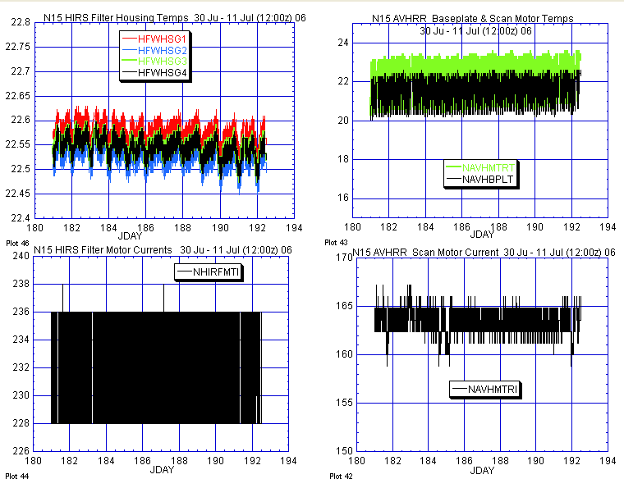
HIRS AVHRR

Illustration 5: N15 Payloads Analysis.

(Relatively nominal and stable last week. AMSU motor currents and temperature [not depicted here] were also stable and nominal last week.)

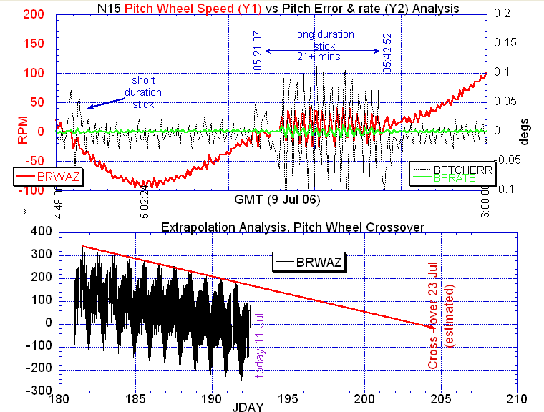

ILLUSTRATION 8: N15 Wheel transition reversal analysis

(If present Rwheel trend continues [bottom plot] the Z-wheel should stop going through zero RPM, and thus stop sticking and perturbating pitch values, on or about Jday 204-23 Jul. Wheel sticking has been significant in recent days and continues to affect pitch precision [upper plot].)

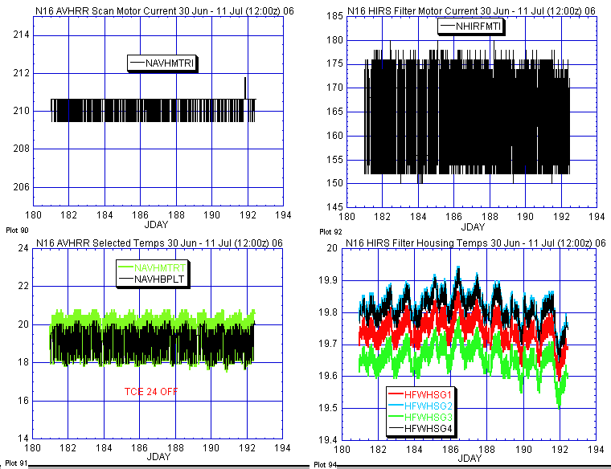

ILLUSTRATION 10: N16 Primary Payload Motor Current Analysis

(Generally nominal and stable last week.)

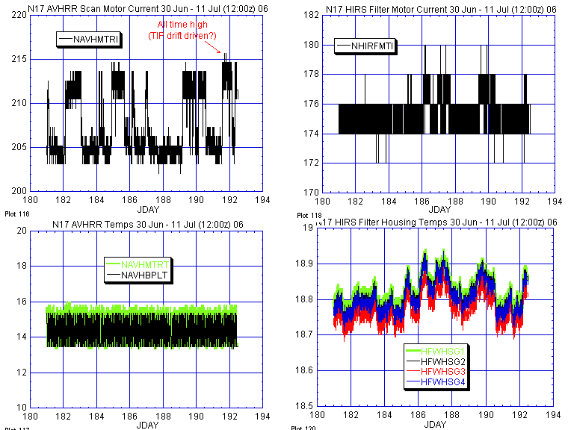
AVHRR HIRS

ILLUSTRATION 13: N17 primary Payload Health Analysis
(AVHRR scan motor current continues its less than stable performance, experiencing several mini surges and reaching a new high last week [although since the increase was only one count more than the previous “ceilings” this value might have been caused by TIP drift]. The HIRS filter motor was also slightly less stable than historical norms. Otherwise payloads were relatively nominal, including the two remaining operational AMSU’s [not depicted here].)

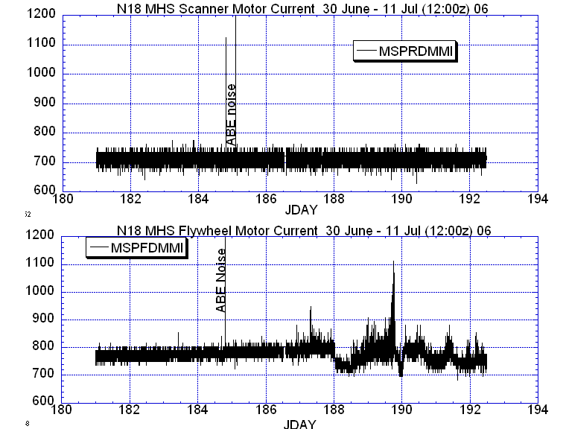

ILLUSTRATION 16: N18 MHS Health Analysis

(Less than historically stable flywheel values [bottom plots] throughout most of the past week, not mirrored by the scanner. MHS temperatures [not depicted here] also did not change in any obvious relation to the flywheel surges in the past several days nor did gyro spin motors [also not depicted here].)

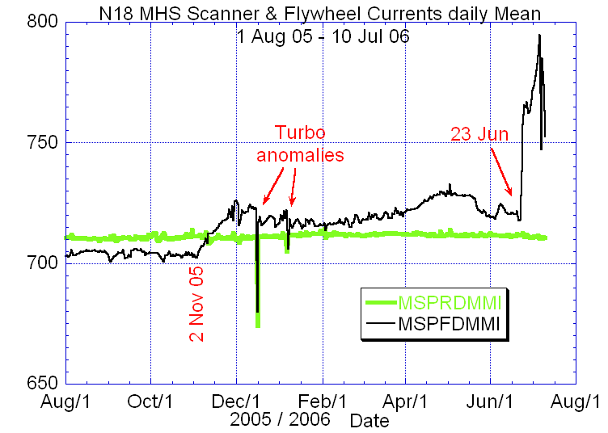

ILLUSTRATION 17: N18 MHS Flywheel Motor Current Analysis

(The flywheel looking significantly less stable relative to both its own past performance and the scanner motor as well. Not considered a cause for concern by EUMETSAT engineers but EMOSS engineers are predicting additional realtime alarms in the coming weeks and months. )

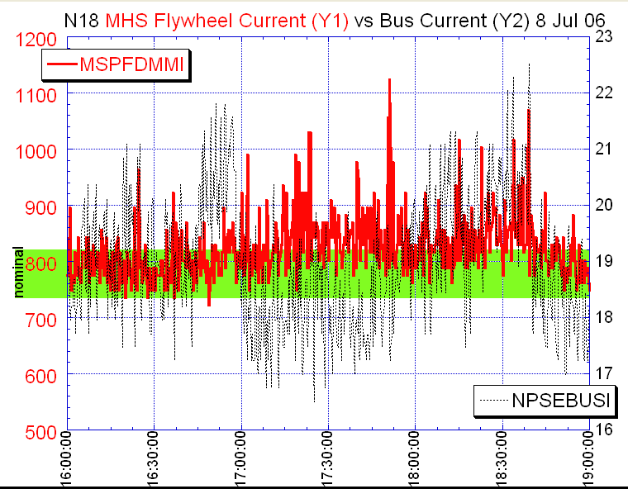

ILLUSTRATION 18: N18 MHS Flywheel Motor Current Alarm Analysis

(A close in look at the flywheel current as compared with spacecraft bus current during the same time period. A possible loose correlation is apparent. )

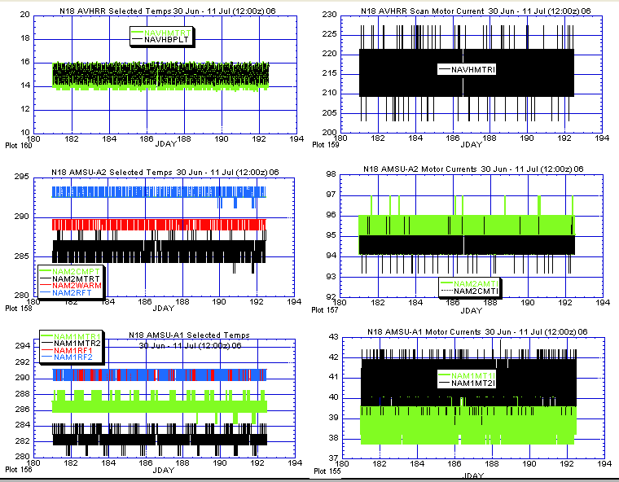

ILLUSTRATION 19: N18 AVHRR & AMSU

(All three payloads appeared nominal and stable last week.)

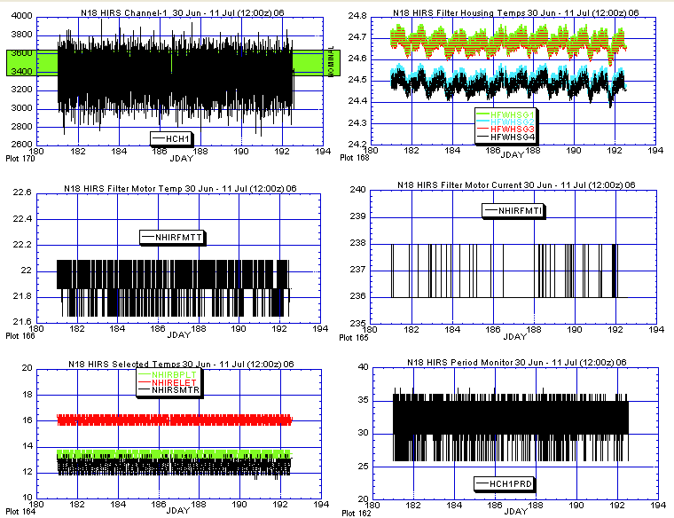

ILLUSTRATION 20: N18 HIRS Analysis

(Various channels were noisy last week [upper left plot] while hardware components appeared nominal and stable.)

POLAR SPACECRAFT TIP CLOCK ERROR

WEEK ENDING July 7, 2006
DAY/DATE | NOAA-12 | NOAA-14 | NOAA-15 | NOAA-16 | NOAA-17 | NOAA-18
FRI. 06/30 | +286 msec | -109 msec | -039 msec | +045 msec | -058 msec | -017 msec
SAT. 07/01 | +286 msec | -107 msec | -041 msec | +046 msec | -058 msec | -014 msec
SUN. 07/02 | +280 msec | -108 msec | -041 msec | +047 msec | -058 msec | -011 msec
MON. 07/03 | +282 msec | -107 msec | -041 msec | +048 msec | -057 msec | -009 msec
TUE. 07/04 | +280 msec | -107 msec | -043 msec | +049 msec | -054 msec | -011 msec
WED. 07/05 | +275 msec | -106 msec | -043 msec | +050 msec | -053 msec | -004 msec
THU. 07/06 | +278 msec | -105 msec | -043 msec | +052 msec | -051 msec | -005 msec

NOAA-14: As of 12/23/03 the TIP clock is corrected daily by –7.0 msec to compensate for drift.
NOAA-15: As of 04/22/03 the TIP clock is corrected daily by –8.0 msec to compensate for drift.
NOAA-16: As of 12/23/03 the TIP clock is corrected daily by -5.5 msec to compensate for drift.
NOAA-17: As of 12/23/03 the TIP clock is corrected daily by –3.0 msec to compensate for drift.
NOAA-12: As of 12/10/03 the TIP clock is corrected daily by +6.5 msec to compensate for drift.
* A clock jump of -500 milliseconds on 02/14/06 due to fractional second daily ETCUP. A clock
jump of +500 milliseconds on 05/01/06 due to fractional second daily ETCUP. Alternating +/-
500 millisecond clock jumps will ccur at 76-day intervals as long as fractional second daily
ETCUP is utilized to manage clock drift. The next -500 millisecond jump is expected on 07/16/06.
** TIP Clock corrections were made to compensate for the positive leap second introduced on 12/31/05.

