POLAR Spacecraft Status As of: Tues, 16 May 06, 16:00 EST
(changes from last week in bold border)
Subsystem/  Component | NOAA-12D  AM 16:59=AN  STIP data only | NOAA-14J  AM: 21:10=AN  STIP data only | NOAA-15K  AM: 17:49=AN  GAC data only | NOAA-16L  PM: 15:04=AN  GAC&LAC data | NOAA-17M  AM: 22:23=AN  GAC&LAC data | NOAA-18N  PM 13:49=AN  GAC & LAC data
LAUNCHED | 05/14/91 | 12/30/94 | 05/13/98 | 09/21/00 | 6/24/02 | 5/20/05
CNTL OBP | OBP2  Recursive SCT | OBP2  OBP1 inoperative | OBP2 | OBP2 | OBP2 | OBP2
BUS | B-BUS  XSU-1 | B-BUS  XSU2 (XSU1 inop) | B-BUS  XSU-1 | B-BUS  XSU-1: TOAR444 | B-BUS  XSU-1 | B-BUS  XSU-1
BUS VETO | NO | NO | NO | NO | NO | NO
ADACS | Nominal Mode  RGmode=Monitor  Gyro chans=XYZ | Nominal Mode  Rgmode=Disabled  Gyro chans=XYZ | Nominal Mode  Rgmode=Monitor  Gyro-3 Off 6/26/00 Gyro chans=AAB | RGYRO Mode  Estimate Y-ROLL  Rgmode=PASSIVE  Gyros-1 & 3 Inop/Off  Gyro chans XA-ZB | Nominal Mode  Rgmode=Monitor  Gyro-3 Off 6/10/04  Gyro chans=AAB | Nominal Mode  Gyro-A MIMU-2  Z-wheel -Pitch
RXO | PRI  BU random enables  daily bias+6.5 mS | PRI  BU random enables daily bias–7.0 mS | PRI  daily bias -8 mS  -500 mS 12/31/05 | PRI  Daily Bias –5.5 mS  -1500 mS 31Dec05 | PRI  Daily Bias –3 mS  -1500 mS 31Dec05 | PRI  No daily bias  -1500 mS 31Dec05
CLOCK DIV | 2 | 2 | 2 | 2 | 2 | 2
MIRP | External Synch  Rephase Enabled | External Synch  Rephase each orbit | External Synch Rephase 0730 daily | External Sync  Rephase each orbit | External Sync  Rephase Enabled | External Synch  Rephase Enabled
TIP SIDE | 1 | 1 | 2 (since 4/3/03)  #2 has 3 chans inop | 2  since 4/18/05 | 1  Analog telem drifting | 1  Analog telem drift?
Recorders  (DTR, SSR) | DTRs 3A, 4, 5B  Safestate 5B | DTRs 1, 2B, 5 Safestate- 1B | DTRs 1, 2, 3, 4 Safestate 1B EOT | DTRs 1, 2, 3, 4A  Safestate 3A  4B STIP only | DTR 1,3,4 / SSR 2  Safestate=SSR 2B | SSRs 1,2,3,4,5  Safestate=5B  Current spikes  TOAR 450
VTX  (APT data) | #1 ON  137.50 MHZ | OFF (nominal)  Since 8/2/05 | #1 ON  137.50 MHZ | OFF / INOP  since 11/15/00 | #2 ON  137.62 MHZ | #1 ON  137.10 MHZ
BTX | #1  136.77 MHZ | #2  137.77 MHZ | #1  137.35 MHZ | #2  137.77 MHZ | #2  137.77 MHZ | #1  137.35 MHZ
STX  1 = rcp 1698.0 mhz  2 = lcp 1702.5 mhz  3= rcp 1707.0 mhz  4= rcp 2247.5 mhz | 1 – HRPT;  2,3 - Playback | 3 – HRPT  2, 1 – Playback | 2-Omni HRPT  2 omni=rcp  Power Drop  TOAR 446  4-Playback  1,2,3-Degraded | 2 – HRPT  1– Playback  4 – Playback  & MCM usage  3 low power unused | 3 – HRPT  TOAR424 low power  2 & 4 Playback  1-Standby  STX-1 Power drop TOAR 443. | 1 - HRPT  3 - Playback  2-Playback  4-Test & Standby
POWER  (Array offset and CANT angle, charge & V/T rates, eclipse states and sun angle) | ArrayOff +60  since 6/23/05  Eclipse season started 29 Apr  SADBIAS activated 29Apr  Sun Angle 26 uptrend to 35 in mid-June  Batts 1&2=LRC  Batt 1&2 V/T=4  Shunt degraded  SA CANT=37 degs | Array Off -50  Batts 1&3V/T=6/9  Batt2 VT=7/9  Since 11/22/05  Reduced load 5 May with SSU turnoff  Eclipse all year  Sun angle 55 up trend to 60 in June  Batts 1-3= LRC  Degraded shunts  SA CANT=22 degs  PSSS change plan | Array Off -45  Since 1/25/01  Eclipse season started 15 May  Peaks mid-Jun  Ends 1 Aug  Sun Angle 21  New uptrend to 32 in mid-June  Batts 1-3= LRC  V/T=7/9  SA CANT=37 degs | Array Off -40  Since 7/16/02  Eclipse all year  Sun Angle 47  Up Trend to 52 in mid-June  Batts 1-3= LRC  V/T=4/8  SA CANT=22 degs | Array Off. –40  Since 1/29/04  Eclipse all year  Sun Angle at 69  uptrend to 71 at end of May  Batts 1-3= LRC  V/T= 4/8  SA CANT=37 degs | Array Off. -40  Since 6/6/05  Eclipse all year  Sun Angle 67 up trend to 72 mid-Jul  Batts 1-3=LRC  Batts 1-3 V/T=4/8  SA CANT=22  BVR Phase Control autonomous swap 3/29=TOAR 457
AVHRR | Nominal | Nominal  Since 18 Feb 06  Occasional scan motor current surge  Channels 2&4 APT | Nominal  Channel 3B only  Recent minor scan motor instabilities | Nominal  since mid Oct 05  TCE24 OFF 4/14/04  Channel 3B only | Nominal  3A-B switch enabled  Scan motor stability degradation? | Nominal  Channel 3B only
AMSU-A1 |  |  | Operational  Ch14 inoperative  Ch11 inoperative | Operational  Primary PLLO chans 9-14 bias shift.  Backup PLLO inop.  Channel 9-14 noise | OFF/INOP  Since 10/30/03  Survival heat on. | Nominal  Full Scan mode
AMSU-A2 |  |  | Nominal | Nominal  Space Position-2 | Nominal | Nominal  Full scan mode
AMSU-B |  |  | Operational  Bias in All Chans.  Motor surges most recent 11/14/04  Degraded Chan-3 since 4/30/05 | Operational  Space Position-3  IPD reports channel 8 degradation | Nominal | Replaced by MHS
HIRS | ON/Inop  Turned On 4/30/05  for power balance  Filter Wheel OFF | NOMINAL  Operational  Occasional loss of Fwheel synch | NOMINAL  FW Abrupt return to nominal 7/12/05  After years of minor and major current surges  FW mode=Hi Powr | Operational  Imagery high levels radiometric noise  TOAR 441 CLOSED  Recent momentary FW synch dropouts  Occasional major FM surges, most recent  12/9/04 | NOMINAL  1 Pixel cross track misalignment. | Operational  LW channel 1-12 noise TOAR 448 Loose LWIR lens.  Inconsistent, LW often erratic.
MHS/MIU |  |  |  |  |  | Nominal  Space View=0  Two Turbo anomalies  Caused by proton hits over SAA
MSU | OFF/Inop  Turned off for power balance  6/23/05 | Operational  Scan motor and antenna problems  EOL test planned
SSU |  | OFF/Nominal  Turned off  5 May for  power balance
DCS  RFI investigation | Nominal | Nominal | Nominal | Nominal  Pseudo message turned on 1/5/06 | Nominal | Nominal  DRU’s 1-7 On  DRU8 inop/off
SARR |  | Nominal  All time high component temps | Operational  A-Side, AGC Mode  Intermittent failures for 243MHz A&B | Operational  Mode =AA  A-side, AGC Mode  (B-side in FG mode)  243 MHz = INOP. | Nominal  A-side  All AGC Mode | Nominal  A-Side  All AGC Mode  Since 15 Aug 05
SARP |  | OFF  Power Failure | Nominal  RCVR B/W = 2 | Nominal  RCVR B/W = 2 | Nominal | Nominal  A-side 23 May05
SEM | ON/Nominal  Turned on 8/30/04  Elec-CH-HVPS=4  Prot-CH-HVPS=0  TED level=3 | Operational  Elec-CH-HVPS=0  Prot-CH-HVPS=0  1 of 4 Tscopes inop | Nominal  E-CDEM-HVPS=2  P-CDEM-HVPS=0 | Nominal  E-CDEM-HVPS=5  P-CDEM-HVPS=4 | Nominal  E-CDEM-HVPS=2  P-CDEM-HVPS=3 | Nominal  Elec-CH-HVPS=0  Prot-CH-HVPS=0
SBUV |  | Degraded  Grate motor sticks  Flex memory 3 (giant step) ops suspended 12/2/03  Reduced operations  Transient anomaly  1 Sept 05 |  | Operational  Degraded Ozone data  Backup Diffuser inop  Primary Diffuser deployment problem TOAR 426  AMSU EMI causing erratic Behavior in PMT cathod, range 3 | Nominal  Anode Mode  Plan sweep mode  Standard Ops Procedure changes  forthcoming | Nominal  Anode mode  since 6 July 13:30z  Electronics turnoff taken out of STESM safestate table
SADPOS |  |  | N/A | ON  Enabled MFactor50%  Timer = 12 mins | ON  ENABLED  Timer = 12mins | ON  Enabled  Timer =12 mins
THERMAL  Heaters, louvers  TCE’s | Nominal  TCE’s back to nominal configuration following 7/25/04 UVtrip. | Nominal | TCE26 & 15H  Telem invalid  TOAR 432  TCE24L&25L (HIRS & AVHRR) failed 5/13/98  RCE thermostat failed 5/13/98  Spacecraft thermal uptrend ended | Nominal  TCE24 OFF 4/14/05  (AVHRR H&L)  HIRS Filter heater turned OFF 1/18/05 | TCE3H Batt 2A heater failed ON, turned off 8/26/03  AMSU-A1 survival heaters on 10/29/03 | All TCE’s active  TCE3H displaying invalid readings  TOAR 458  submitted
 | N12 | N14 | N15 | N16 | N17 | N18

COMMENTS/CHANGES:

NOAA-12: Eclipse season is progressing nominally and there has been no repetition of the autonomous SADBIAS implementation
that occurred on 29 Apr. On 10 May at 20:10z the SADBIAS value was commanded back to 80 deg offset (where it should be, vs. 54 deg where it actually was) after which SADBIAS was re-enabled for the first time since the 29 Apr event.

NOAA-14: N14, batteries continue to trend lower (illustration 1) during the dark part of their orbit, again falling slightly below 20
volts, despite Engineers turned off the nominal and operational SSU payload on 5 May, in order to conserve power and prevent a potential power survival safestate situation.

The N14 SARR continued to operate at or near all time high temperatures during the past week (illustration 2). There is presently no health related concerns that have been identified

NOAA-15: The N15 AMSU’s A1 and A2 were generally nominal during the last week while continuing their thermal uptrends.
On the other hand AMSU-B continued to exhibit slightly less stable scan motor current performance (and trends) during the past week although it remains within historically acceptable norms (illustration 3). The N15 AVHRR also showed slightly less than optimum scan motor stability during the past week although it too remains within historically acceptable norms (illustration 4). There have been no reports received of degraded products from either of these situations.

N15 began its eclipse season on 15 May as the first battery discharge currents were registered. At the present time no reconfigurations are planned and the eclipse is proceeding as predicted (illustrations 5 and 6).

The N15 Attitude Control Subsystem was also generally nominal and stable last week (illustrations 7 and 8).

NOAA-16: The N16 payload suite was also generally nominal and stable during the past week (illustration 9) with the
AVHRR sustaining its historical low scan motor current and all other performing in a nominal and stable manner. Thermally N16 remains stable with no discernable trend. The N16 ADACS subsystem was also nominal during the past week (illustrations 10 and 11) relative to its severely degraded status although there were some minor perturbations on 13 and 14 May due to a full moon and sun-moon warning events.

NOAA-17: The N17 AVHRR scan motor continues to exhibit less stability than engineers prefer but also continues to produce nominal products. The scan motor current “mini surges” continue to increase in frequency but the value remains within an acceptable norm. Changes to the synch delta value generally mirrors the scan motor current changes Engineers continues to monitor this payload closely. In addition, the N17 HIRS showed slightly less stability on the past several days as the filter motor current increased slight and the period monitor value range followed suit. Otherwise the N17 payload suite was nominal during the past week (illustration 12).

NOAA-18: Most of the N18 payload suite was nominal and stable during the past week (illustration 15) except for the HIRS which
started to degrade on 8 May and has remained that way since that time. Furthermore, for the first time, the filter housing temperatures appeared to show slightly less stability by suddenly rising slightly in conjunctions with a slight rise in filter motor current (illustration 16). HIRS imagery remains degraded in numerous channels at the present time (illustration 17). The payload remains Yellow in status with no new tests or reconfigurations under consideration at this time

The N18 ADACS was nominal during the past week (illustrations 18 and 19) and the TCE3H heater continued its abnormal telemetry reporting which resulted in TOAR 458 being submitted two weeks previous. Ultimately, there were no changes to N18 during the past week.

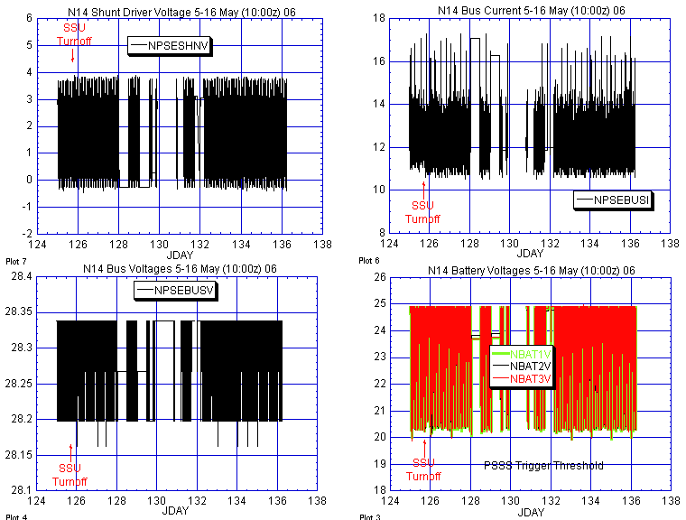

Illustration 1: NOAA-14 Power Analysis

Battery voltages continue dipping below 20 Volts in darkness despite turning off SSU. Otherwise power subsystem was relatively nominal during the past week. )

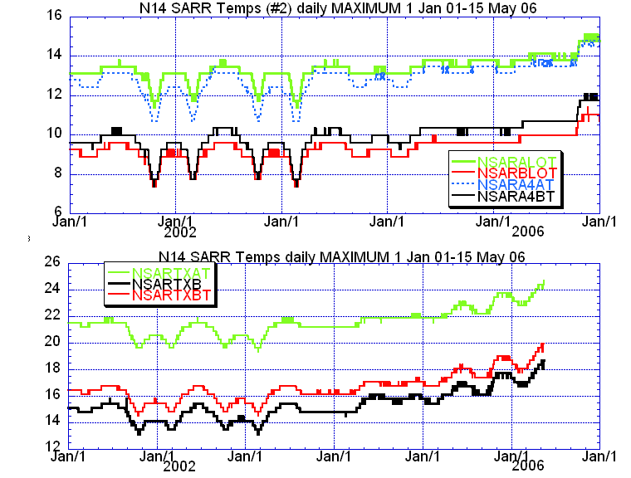

Illustration 2: N14 SARR Temps

(Running at or near all time highs on numerous components. Not considered a serious concern at these levels.)

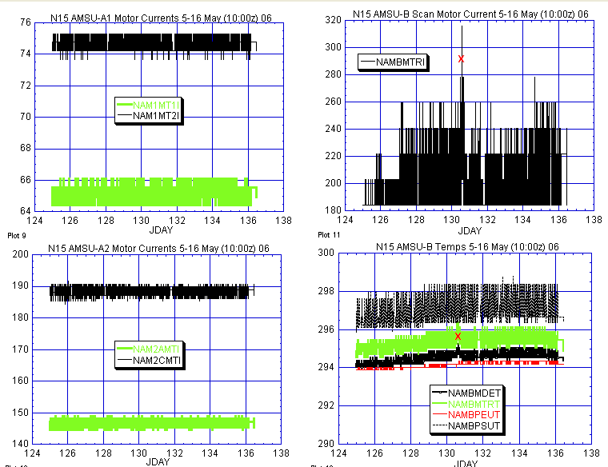

Illustration 3: N15 AMSU Health Analysis
(AMSU-A1 and A2 were both nominal and stable last week although their thermal uptrend’s continued. AMSU-B continued to run at slightly higher than usual scan motor currents. Note the jump in AMSU-B motor current coinciding with that of its component temps on JDAY 130 [10 May, red x.])

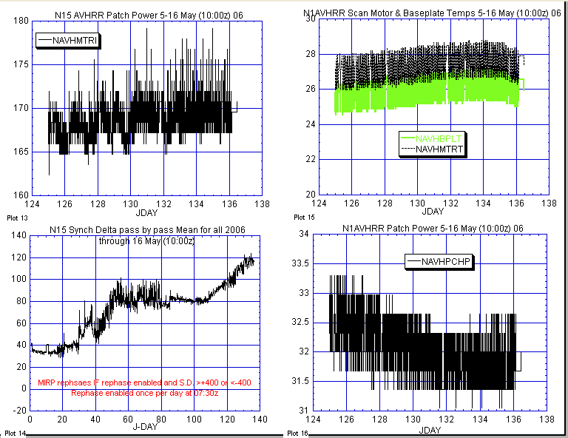

Illustration 4: N15 AVHRR Health Analysis.

(Scan motor continues to trend in an inauspicious direction, as does synch delta although both remain within historically acceptable ranges.)

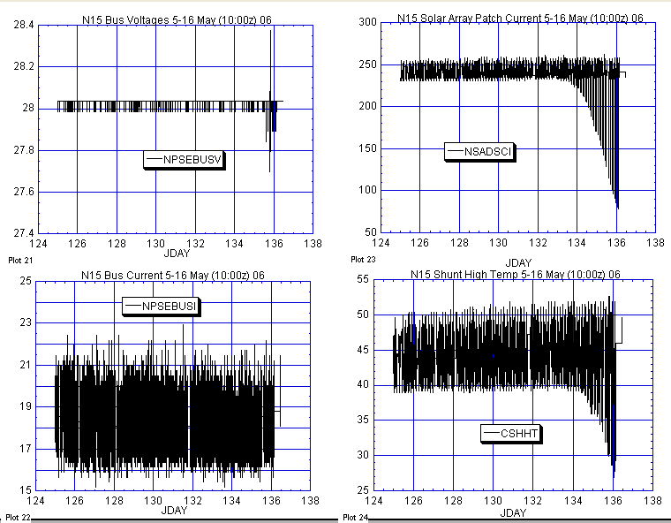

Illustration 5: N15 Power Analysis

(Eclipse season is underway.)

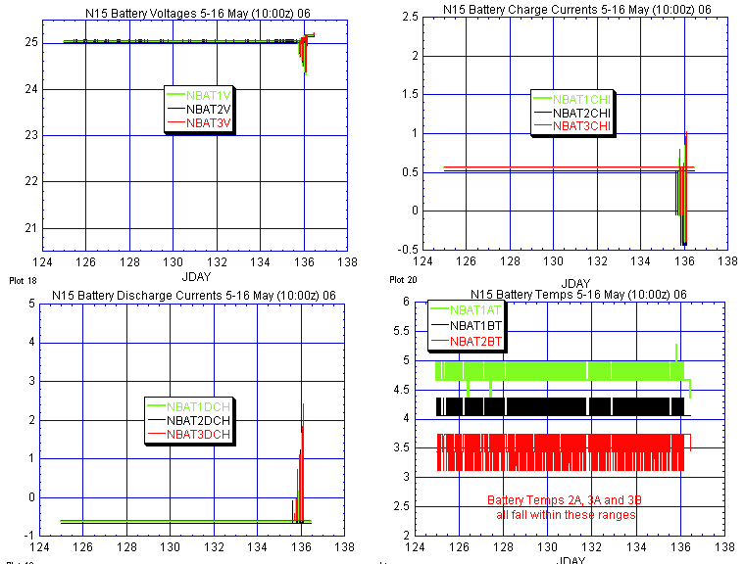

Illustration 6: N15 Battery Analysis

(Starting to show the effects of the new eclipse season.)

Illustration 7,8: omitted for web release

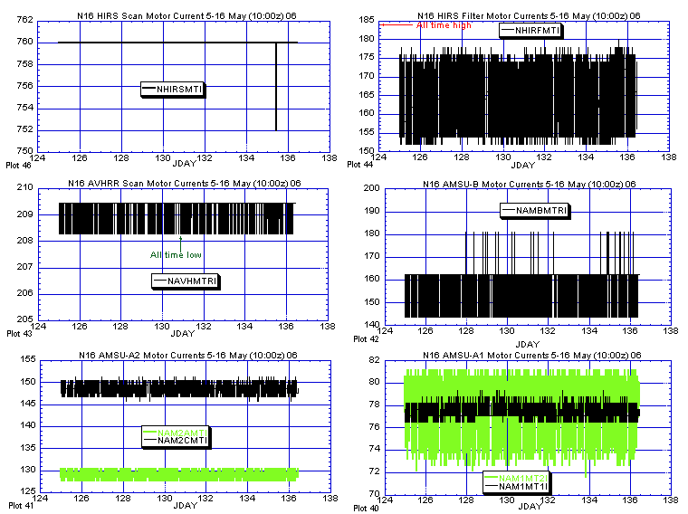

Illustration 9: N16 Primary Payloads Health Analysis

(Nominal and stable last week.)

ILLUSTRATION 10, 11: omitted for web release.

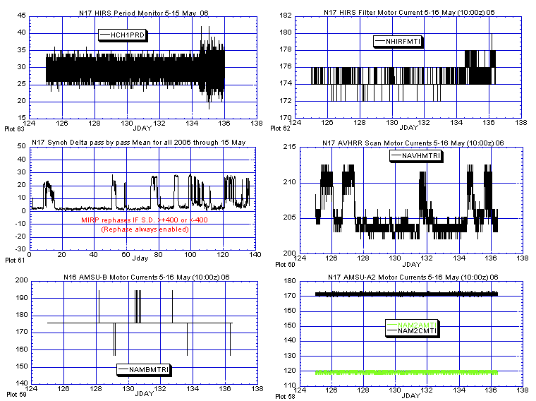

ILLUSTRATION 12: N17 Primary Payload Health Analysis

(AVHRR instabilities continue, although it has not gotten any worse [middle plots]. HIRS instability seems to have recently started anew [top plots] with no reports of degraded imagery. AMSU’s look nominal.)

ILLUSTRATION 13, 14: omitted for web release.

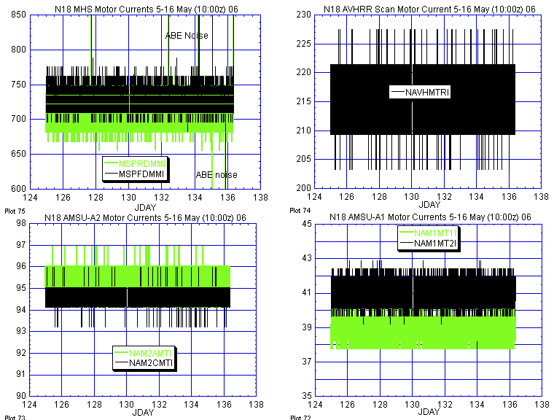

ILLUSTRATION 15: N18 Primary Payload Motor Current Analysis

(Nominal and stable last week.)

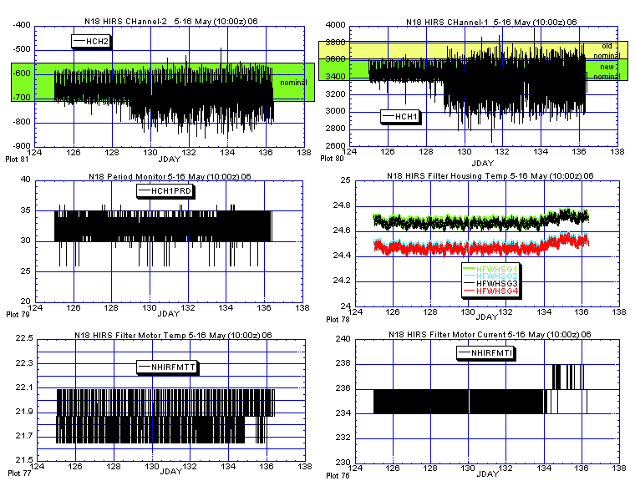

ILLUSTRATION 16: N18 HIRS Health Analysis

(Hardware was nominal and stable last week with the possible exception o the filter housing temps which appeared to have trended up [middle right plots] in conjunction with the slight rise in filter motor current [bottom right plot]. Long wave channels [both top plots] were degraded all week.

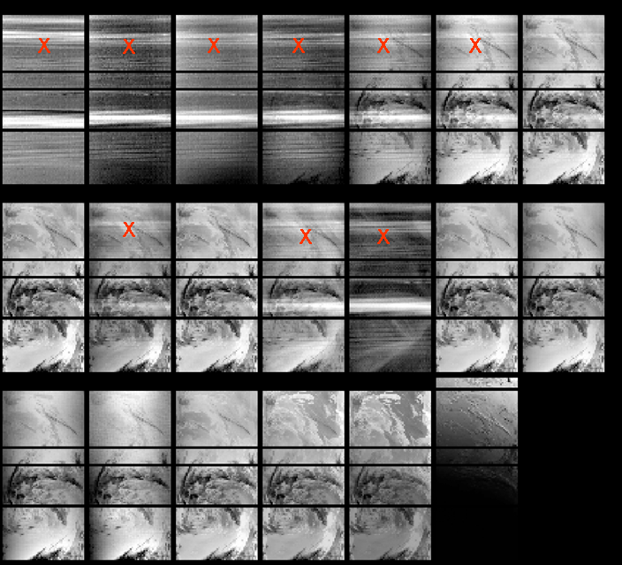

ILLUSTRATION 17: N18 HIRS Imagery Analysis

(Imagery again degraded red X shows channels with obvious streak degradation.)

ILLUSTRATION 18, 19: omitted for web release.

POLAR SPACECRAFT TIP CLOCK ERROR

WEEK ENDING May 12, 2006
DAY/DATE | NOAA-12 | NOAA-14 | NOAA-15 | NOAA-16 | NOAA-17 | NOAA-18
FRI. 05/05 | +375 msec | -135 msec | +016 msec | -010 msec | -130 msec | -118 msec
SAT. 05/06 | +370 msec | -134 msec | +017 msec | -009 msec | -130 msec | -116 msec
SUN. 05/07 | +372 msec | -134 msec | +015 msec | -011 msec | -127 msec | -115 msec
MON. 05/08 | +369 msec | -130 msec | +011 msec | -008 msec | -126 msec | -113 msec
TUE. 05/09 | +368 msec | -129 msec | +010 msec | -008 msec | -126 msec | -113 msec
WED. 05/10 | +368 msec | -132 msec | +011 msec | -008 msec | -125 msec | -111 msec
THU. 05/11 | +367 msec | -128 msec | +012 msec | -007 msec | -123 msec | -109 msec

NOAA-14: As of 12/23/03 the TIP clock is corrected daily by –7.0 msec to compensate for drift.
NOAA-15: As of 04/22/03 the TIP clock is corrected daily by –8.0 msec to compensate for drift.
NOAA-16: As of 12/23/03 the TIP clock is corrected daily by -5.5 msec to compensate for drift.
NOAA-17: As of 12/23/03 the TIP clock is corrected daily by –3.0 msec to compensate for drift.
NOAA-12: As of 12/10/03 the TIP clock is corrected daily by +6.5 msec to compensate for drift.
* A clock jump of -500 milliseconds on 02/14/06 due to fractional second daily ETCUP. A clock
jump of +500 milliseconds on 05/01/06 due to fractional second daily ETCUP. Alternating +/-
500 millisecond clock jumps will ccur at 76-day intervals as long as fractional second daily
ETCUP is utilized to manage clock drift. The next -500 millisecond jump is expected on 07/16/06.
** TIP Clock corrections were made to compensate for the positive leap second introduced on 12/31/05.

