POLAR Spacecraft Status As of: Thus 19 Feb 2009, 12:00 EST
(Changes from last week in bold border)
Subsystem/  Component | NOAA-15K  AM: 17:49=AN  GAC data only | NOAA-16L  PM: 15:04=AN  GAC data | NOAA-17M  AM: 22:23=AN  GAC&LAC data | NOAA-18N  PM 13:49=AN  GAC & LAC data
LAUNCHED | 05/13/98 | 09/21/00 | 6/24/02 | 5/20/05
CNTL OBP | OBP2 | OBP2 | OBP2 | OBP2
BUS | B-BUS  XSU-1 | B-BUS  XSU-2: TOAR472 | B-BUS  XSU-2:TOAR 471 | B-BUS  XSU-1
BUS VETO | NO | NO | NO | NO
ADACS | Nominal Mode  Rgmode=Monitor  Gyro-3 Off 6/26/00 Gyro chans=AAB  N2 Low PSI invalid | RGYRO Mode  Forced Nominal Mode  Estimate Y-ROLL  Rgmode=PASSIVE  Gyros-1 & 3 Inop/Off  Gyro chans XA-ZB  Pitch wheel bias 2400  *Z gas unload = 145  Gyro2 safe macro | Nominal Mode  Rgmode=Monitor  Gyro-3 Off 6/10/04  Gyro chans=AAB GAS Enabled Dec 05  *Z Gas unload =45 | Nominal Mode  Gyro-A MIMU-2  Z-wheel -Pitch  Z-momentum transition complete  Pitch Torquer again active  Gas auto unloading enabled &*Z Gas unload =45 12/9/08
RXO | PRI  daily bias -8 mS  -500 mS 12/31/05 | PRI  Daily Bias –5.5 mS  -1500 mS 31Dec05 | PRI  Daily Bias –3 mS  -1500 mS 31Dec05 | PRI  No daily bias  -1500 mS 31Dec05
CLOCK DIV | 2 | 2 | 2 | 2
MIRP | External Synch Rephase 0730 daily | External Sync  Rephase each orbit | External Sync  Rephase Enabled | External Synch  Rephase Enabled
TIP SIDE | 2  since 4/3/03  3 channels inop  analog telem drifting | 2  since 4/18/05  analog telem drifting | 2  Swapped 9/20/06  analog telem drifting | 1  Analog telem drifting
Recorders  (DTR, SSR) | DTRs 1, 2, 3, 4 Safestate 1B EOT | DTRs 1, 2, 3, 4A  Safestate 3A  4B STIP only | DTR 1,3,4 / SSR 2  Safestate=SSR 2B  4A Pressure leak | SSRs 1,2,3,4,5  Safestate=5B  Current spikes
VTX  (APT data) | #1 ON  As of 19 June 07 | OFF / INOP  since 11/15/00 | #2 ON  137.62 MHZ | #1 ON  137.1 MHZ  As of 16 Aug 07
BTX | #1  137.35 MHZ | #2  137.77 MHZ | #2  137.77 MHZ | #1  137.35 MHZ
STX  1 = rcp 1698.0 mhz  2 = lcp 1702.5 mhz  3= rcp 1707.0 mhz  4= rcp 2247.5 mhz | 2-Omni HRPT  2 Omni=rcp  Power TOAR 446  4-Playback  1,2,3-Degraded | 2 – HRPT  1– Playback  4 Standby  3 low power INOP -10 Aug 2007 | 1 – HRPT  TOAR424 low power  2 & 4 Playback  STX-1 Power drop 2.29W 3/2/08  STX-4 nominal  STX-3 Failed 2/14/08 | 3 - HRPT  1 - Playback  2 - Playback  4-Test & Standby
POWER  (Array offset and CANT angle, eclipse states and sun angle) | Array Off -45  Since 1/25/01  Full Sun  Sun Angle 13  Uptrend to 18 early Jan 07  SA CANT=37 degs | Array Off -20  Since 9/13/07  Eclipse all year  Sun Angle 34  Steady trend  SA CANT=22 degs  Full sun S/C in Sept 07  BVR Phase Control auton swap 7/19/07 | Array Off. –55  Since 12/18/08  Eclipse all year  Sun Angle at 66  Steady trend  SA CANT=37 degs  BVR Phase Control auton swap 9/17/07  Swap back 9/18/07  SADPOS Enabled 2/12/08  PSE swap to back-up 11/3/08 | Array Off. -40  Since 6/6/05  Eclipse all year  Sun Angle 63 uptrend to 65 on  1 Jan 07  SA CANT=22  BVR Phase Control auton swap 3/29/06 & 1/4/07
AVHRR | Nominal  Channel 3B only  Occasional minor scan motor instabilities | Nominal  Recent SM current increases  TCE24 OFF 4/14/04  Channel 3B only | Nominal  3A-B switch enabled  Previous scan motor current mini surges | Nominal  Channel 3B only  Scan motor current drop 29 Aug 06
AMSU-A1 | Operational  Ch14 inoperative  Ch11 inoperative | Operational  Primary PLLO chans 9-14 bias shift.  Backup PLLO inop.  Channel 9-14 noise  Channel 4 severely degraded 4 Mar 08 | OFF/INOP  Since 10/30/03  Survival heat on. | Nominal  Full Scan mode
`AMSU-A2 | Nominal | Nominal | Nominal | Nominal  DIG-A Temps erratic 2/7/08  Cold Cal Pos 2 2/21/08  DIG-A Temps return to nominal 8/5/08
AMSU-B | Operational  Bias in All Chans.  Degraded Chan-3 | Operational  Space Position-3  Chan-8 degradation | Nominal | Replaced by MHS
HIRS | NOMINAL  FW Abrupt return to nominal 7/12/05  After years of minor and major current surges  FW mode=Hi Powr | NOMINAL  New all time high filter motor current reached 9/17/06.  Imagery occasionally exhibits high levels of radiometric noise | NOMINAL  1 Pixel cross-track misalignment. | Operational  Downgraded to red for products unusable  Filter Heat OFF.  LW channel 1-12 noise TOAR 448 Loose LWIR lens.  LW imagery erratic.  CH 1 Period Monitor event 13 May 08
MHS/MIU |  |  |  | Nominal  Fly Wheel Motor Current occasionally spiking since 27 Dec 06  Entered Motor Spin State on 9 May 08  H4 gain increased to 2-9 May 08  H3 gain increased to 3-9 May 08  H3/H4 QSB Instability latest 23 Dec 08 Automatic DC Offset Adjustment enabled 5 Sep 08  H3 DCO changed to 0x91-4 Dec 08, H4 DCO changed to 0x91-23 Dec 08
DCS  RFI investigation | Nominal | Nominal  Pseudo message turned on 1/5/06 | Nominal | Nominal  DRU’s 1-7 On  DRU8 inop/off
SARR | Operational  B-Side Receivers & Converters Activated, 13 Dec 07  AGC Mode  Intermittent failures for 243MHz A&B  1.21.5 & 243 MHz Off1 Feb 09 | Operational  Mode =AA  A-side, AGC Mode  (B-side in FG mode)  121.5 & 243 MHz = INOP & OFF as of 29 Jul 08  PDS ATT set to 0dB, 406 MHz RCVR ATT set to 2dB on 5 Sept. 08 | Nominal  A-side  All AGC Mode  1.21.5 & 243 MHz Off1 Feb 09 | Nominal  A-Side  All AGC Mode  Since 15 Aug 05  1.21.5 & 243 MHz Off 1 Feb 09
SARP | Nominal  RCVR B/W = 2 | Nominal  RCVR B/W = 2 | Nominal | Nominal  A-side 23 May05
SEM | Nominal  E-CDEM-HVPS=2  P-CDEM-HVPS=0 | Nominal  E-CDEM-HVPS=7  P-CDEM-HVPS=7  11 Jan 0714:47z | Nominal  E-CDEM-HVPS=2  P-CDEM-HVPS=4  27 June 06 16:00z | Nominal  Elec-CH-HVPS=1  27 June 06 17:00z  Prot-CH-HVPS=1  11 Jan 07 14:15z
SBUV |  | Operational  Degraded Ozone data  Backup Diffuser inop  Primary Diffuser deployment problem TOAR 426  AMSU EMI causing erratic Behavior in PMT cathod, range 3 | Nominal  Anode Mode  Plan sweep mode  Standard Ops  TOAR 463 sun glint  IBSL test performed 12 Sept 06  Grating motor investigation | Operational  Anode mode  since 6 July 05 13:30z  Electronics turnoff taken out of STESM safestate table  TOAR 462 sun glint  Chop Motor stalled 22 May 08 & 9 Nov 08.  Thermal increase 1 to 1.5 C, 31 Dec 08, under investigation
SADPOS |  | ON  Enabled MFactor50%  Timer = 12 mins | ON  ENABLED  Timer = 12mins | ON  Enabled  Timer =12 mins
THERMAL  Heaters, louvers  TCE’s | TCE26 & 15H  Telem valid  TOAR 432 closed  TCE24L&25L (HIRS & AVHRR) failed 5/13/98  RCE thermostat failed 5/13/98  Spacecraft in thermal uptrend | Nominal  TCE24 OFF 4/14/05  (AVHRR H&L)  HIRS Filter heater turned OFF 1/18/05 | TCE3H Batt 2A heater failed ON, turned off 8/26/03  AMSU-A1 survival heaters on 10/29/03 | All TCE’s active  HIRS filter heater turned OFF 9/28/06

COMMENTS/CHANGES:

MISC:

NOAA-15: There were relatively no changes to the NOAA-15 bus or payload health situation during the past week.

The #2 gyro is still relatively quiet. Daily monitoring continues.
NDCS5V limit updated for TIP Drift.

NOAA-16: There was relatively no change in the performance of the NOAA-16 bus & payload subsystems during the past week.

NAIPSD1 limit updated for TIP Drift.

NOAA-17: There was relatively no change in the performance of the NOAA-17 bus & payload subsystems during the past week.

NXSU2PL1 limit updated for TIP Drift.

NOAA-18: There was relatively no change in the performance of the NOAA-18 bus & payload subsystems during the past week.

MetOp-A: There was relatively no change in the performance of the NOAA Instruments on MetOp-A spacecraft during the past week.

Trend Observations (NOAA Instruments)
- Based on the CVF Digital A daily, weekly and long term trend reports, all AMSU, AVHRR and HIRS parameters are nominal and stable. All performance parameters are well within specification (e.g. NEdT, NEdN, NEdA and SNR), with the exception of AMSU-A1 Channel 7 NEdT which has exceeded the 0.25 K specifications and is currently at 0.43 K and steeply increasing (see Figures 2 & 3). The AMSU HK and science trends are summarized each week in an Excel file available on the MetOp Data server under the following directory: /2009_CVF_data/CVF_Reports/AMSA_trend/AMSA_DATA_FILE
- The AVHRR Scan Motor Current continues it’s decreasing trend, as previously addressed as part of the Dec. 1-2 Annual Performance Review at the SOCC. See Figure 4 for the daily averages, currently at 182 mAmps and still decreasing.
- The HIRS Filter Wheel re-synch period during this reporting period averaged between 97-98 seconds between resynchs.

Anomalies
AR10693, “AMSU-A1 Channel 7 NEdT”: EUMETSAT has raised an anomaly report to document the increased noise in Channel 7. Since mid December 2008, the increasing trend has become steeper and is currently at 0.43 K and climbing. An ARB telecon was held on January 15. The NOAA SOCC raised a SOAR on Jan. 23 (SOAR-METOP-A-0014), which should now allow NASA and Northrop Grumman to support with root cause investigations.

Operations Performed
- The SEM IFCs were run on their regular Tuesday schedule, with the TED IFC starting on Feb. 17 at 09:07:37 UTC and the MEPED IFC starting at 09:08:57 UTC.
- HRPT operations continued in toggling mode, operating on the HRPT B-side and only operating in northern hemisphere low risk zones during descending passes (i.e. over northern Europe and the northern Atlantic).

Operations Planned
The next SEM IFCs are planned for Tue., Feb.24.
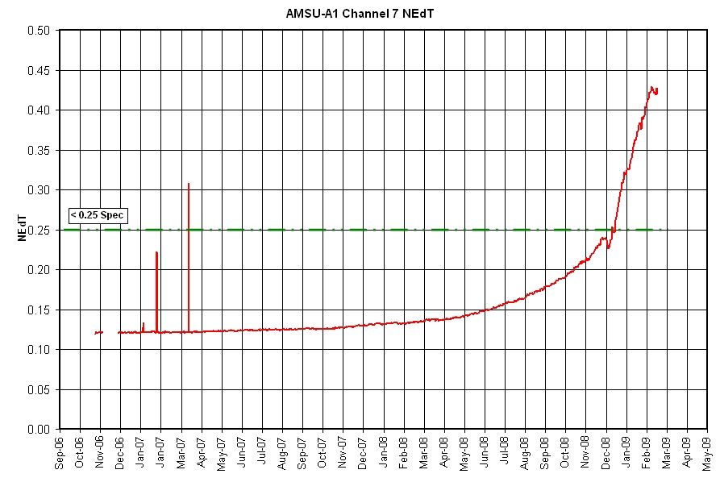
Figure 2: MetOp-A AMSU-A1 Channel 7 NEdT

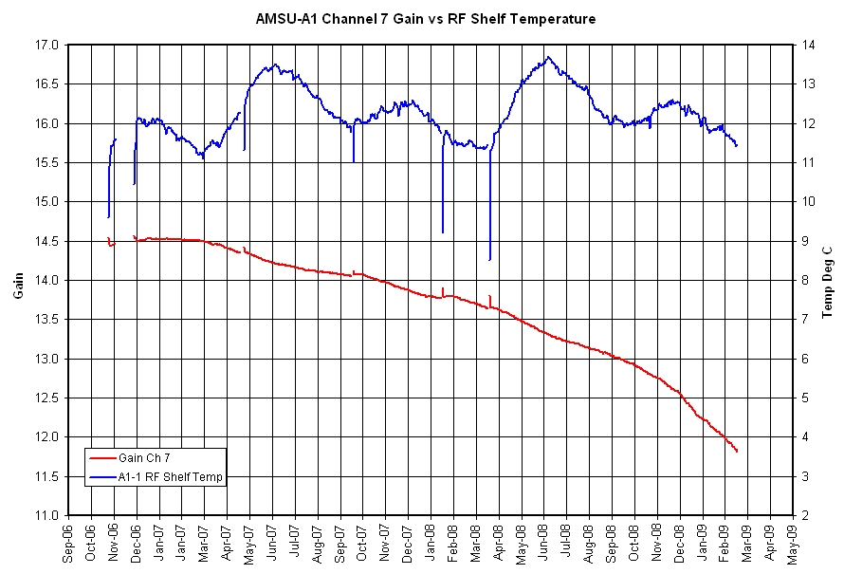
Figure 3: MetOp-A AMSU-A1 Channel 7 Gain
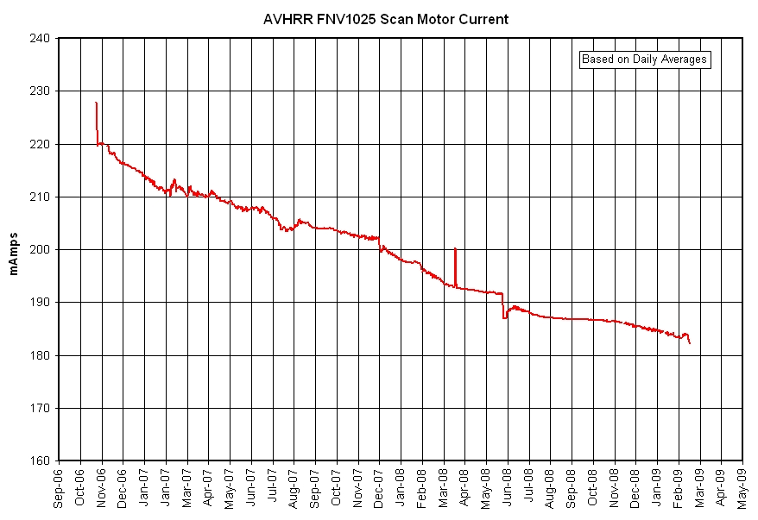
Figure 4: MetOp-A AVHRR Average Scan Motor Current

