POLAR Spacecraft Status As of: Tues, 14 Feb, 16:00 EST
(changes from last week in bold border)
Subsystem/  Component | NOAA-12D  AM 16:59=AN  STIP data only | NOAA-14J  AM: 21:10=AN  STIP data only | NOAA-15K  AM: 17:49=AN  GAC data only | NOAA-16L  PM: 15:04=AN  GAC&LAC data | NOAA-17M  AM: 22:23=AN  GAC&LAC data | NOAA-18N  PM 13:49=AN  GAC & LAC data
LAUNCHED | 05/14/91 | 12/30/94 | 05/13/98 | 09/21/00 | 6/24/02 | 5/20/05
CNTL OBP | OBP2  Recursive SCT | OBP2  OBP1 inoperative | OBP2 | OBP2 | OBP2 | OBP2
BUS | B-BUS  XSU-1 | B-BUS  XSU2 (XSU1 inop) | B-BUS  XSU-1 | B-BUS  XSU-1  XSU-1 TOAR 444 | B-BUS  XSU-1 | B-BUS  XSU-1
BUS VETO | NO | NO | NO | NO | NO | NO
ADACS  X=Yaw  Y=Roll  Z=Pitch | Nominal Mode  RGmode=Monitor  Gyro chans=XYZ | Nominal Mode  Rgmode=Disabled  Gyro chans=XYZ | Nominal Mode  Rgmode=Monitor  Gyro-3 Off 6/26/00 Gyro chans=AAB | RGYRO Mode  Estimate ROLL  Rgmode=PASSIVE  Gyro-1 Off 10/24/05  Gyro-3 Off 6/10/04  Gyro chans XA-ZB  TOAR 454 | Nominal Mode  Rgmode=Monitor  Gyro-3 Off 6/10/04  Gyro chans=AAB  Gyro-2 TOAR 451 | Nominal Mode  Gyro-A MIMU-2  Z-wheel -Pitch  TOAR 447  NEW Z-Momentum shift transition started 1 Feb 06
RXO | PRI  BU random enables  daily bias+6.5 mS | PRI  BU random enables daily bias–7.0 mS | PRI  daily bias -8 mS  -500 mS 12/31/05 | PRI  Daily Bias –5.5 mS  -1500 mS 31Dec05 | PRI  Daily Bias –3 mS  -1500 mS 31Dec05 | PRI  No daily bias  -1500 mS 31Dec05
CLOCK DIV | 2 | 2 | 2 | 2 | 2 | 2
MIRP | External Synch  Rephase Enabled | External Synch  Rephase each orbit | External Synch Rephase 0730 daily | External Sync  Rephase each orbit | External Sync  Rephase Enabled | External Synch  Rephase Enabled
TIP SIDE | 1 | 1 | 2 (since 4/3/03)  #2 has 3 chans inop | 2  since 4/18/05 | 1  Analog telem drifting | 1  Analog telem drift?
Recorders  (DTR, SSR) | DTRs 3A, 4, 5B  Safestate 5B | DTRs 1, 2B, 5 Safestate- 1B | DTRs 1, 2, 3, 4 Safestate 1B EOT | DTRs 1, 2, 3, 4A  Safestate 3A  4B STIP only | DTR 1,3,4 / SSR 2  Safestate=SSR 2B | SSRs 1,2,3,4,5  Safestate=5B  Current spikes  TOAR 450
VTX  (APT data) | #1 ON  137.50 MHZ | OFF (nominal)  Since 8/2/05 | #1 ON  137.50mhz | INOP/Off  OFF since 11/15/00 | #2 ON  137.62 MHZ  Turnoff planned 3/1 | #1 ON  137.10 MHZ  Swapped 1/4/06
BTX | #1  136.77 MHZ | #2  137.77 MHZ | #1  137.35 MHZ | #2  137.77 MHZ | #2  137.77 MHZ | #1  137.35 MHZ
STX  1 = rcp 1698.0 mhz  2 = lcp 1702.5 mhz  3= rcp 1707.0 mhz  4= rcp 2247.5 mhz | 1 – HRPT;  2,3 - Playback | 3 – HRPT  2, 1 – Playback | 2-Omni HRPT  2 omni=rcp  Power Drop  TOAR 446  4-Playback  1,2,3-Degraded | 2 – HRPT  1– Playback  4 – Playback  & MCM usage  3 low power unused | 3 – HRPT  TOAR424 low power  2 & 4 Playback  1-Standby  STX-1 Power drop TOAR 443. | 1 - HRPT  3 - Playback  2-Playback  4-Test & Standby
POWER  (Array offset and CANT angle, charge & V/T rates, eclipse states and sun angle) | ArrayOff +60  since 6/23/05  Full Sun  Sun Angle 20 steady trend  Batts 1&2=LRC  Batt 1&2 V/T=4  Shunt degraded  SA CANT=37 degs | Array Off -50  Batts 1&3V/T=6/9  Batt2 VT=7/9  Since 11/22/05  Eclipse all year  Sun angle 43  Steady trend  Batts 1-3= LRC  Degraded shunts  SA CANT=22 degs | Array Off -45  Since 1/25/01  Full Sun  Sun Angle 10  Downtrend to 7  1 Mar  Batts 1-3= LRC  V/T=7/9  SA CANT=37 degs | Array Off -40  Since 7/16/02  Eclipse all year  Sun Angle 57  Steady Trend  Batts 1-3= LRC  V/T=4/8  SA CANT=22 degs | Array Off. –40  Since 1/29/04  Eclipse all year  Sun Angle at 61  Steady trend  Batts 1-3= LRC  V/T= 4/8  SA CANT=37 degs | Array Off. -40  Since 6/6/05  Eclipse all year  Sun Angle 65 up trend to 72 mid-Jul  TOAR 453 on  Batt C/D ratio  Batts 1-3=LRC  Batts 1-3 V/T=4/8  SA CANT=22
AVHRR | Nominal | Variable  Status upgraded to Yellow 20 Dec  Occasional scan motor current surge  and bar codes  Channels 2&4 APT | Nominal  Rare major scan motor surges. Last  Incident 11/18/04  Channel 3B only  Recent scan motor current rise | Variable  Nominal scan motor currents & imagery since mid Oct 05  TCE24 OFF 4/14/04  Channel 3B only. | Nominal  3A-B switch enabled | Nominal  3A-B switch Disabled 8/05/05  Channel 3B only
AMSU-A1 |  |  | Operational  Ch14 inoperative  Ch11 inoperative | Operational  Primary PLLO chans 9-14 bias shift.  Backup PLLO inop.  Channel 9-14 noise | OFF/INOP  Since 10/30/03  Survival heat on. | Nominal  Full Scan mode
AMSU-A2 |  |  | Nominal | Nominal  Space Position-2 | Nominal | Nominal  Full scan mode
AMSU-B |  |  | Operational  Bias in All Chans.  Motor surges most recent 11/14/04  degraded data on Chan-3 since 4/30 | Operational  Space Position-3  IPD reports channel 8 degradation | Nominal | Replaced by MHS
HIRS | OFF/Inop  Turned off 6/23/05  For power balance  Filter Wheel turned OFF 10/17/02. | NOMINAL  Operational  Occasional loss of Fwheel synch | NOMINAL  FW Abrupt return to nominal 7/12/05  After years of minor and major current surges  FW mode=Hi Powr | Operational  Imagery high levels radiometric noise  TOAR 441 CLOSED  Recent FW synch dropouts  Occasional major FM surges, most recent  12/9/04 | NOMINAL  1 Pixel cross track misalignment. | Operational  LW channel 1-12 noise TOAR 448 Problem isolated to loose LWIR lens.  Increased longwave noise since 5 Feb  Status UPGRADED to Green 4 Jan 05
MHS/MIU |  |  |  |  |  | Nominal  Space View=0  Turbo anomalies  16 Dec & 6 Jan TOAR 456  Investigating dropouts on 20 Jan
MSU | OFF/Inop  Turned off for power balance  6/23/05 | Operational  Scan motor and antenna problems  EOL test planned
SSU |  | Nominal
DCS  RFI under investigation | Nominal | Nominal | Nominal | Nominal  Pseudo message turned on 1/5/06 | Nominal | Nominal  DRU’s 1-7 On  DRU8 off  TOAR 449 Closed 6 no fix possible
SARR |  | Nominal | Operational  A-Side, AGC Mode  Intermittent failures for 243MHz A&B | Operational  Mode =AA  A-side, AGC Mode  (B-side in FG mode)  243 MHz = INOP. | Nominal  A-side  All AGC Mode | Nominal  A-Side  All AGC Mode  Since 15 Aug 05
SARP |  | OFF  Power Failure | Nominal  RCVR B/W = 2 | Nominal  RCVR B/W = 2 | Nominal | Nominal  A-side 23 May05
SEM | ON/Nominal  Turned on 8/30/04  Elec-CH-HVPS=4  Prot-CH-HVPS=0  TED level=3 as of 27 Sept | Operational  Elec-CH-HVPS=0  Prot-CH-HVPS=0  1 of 4 Tscopes inop  Autonomous TED shutdown 24 Sept | Nominal  E-CDEM-HVPS=2  P-CDEM-HVPS=0 | Nominal  E-CDEM-HVPS=5  P-CDEM-HVPS=4 | Nominal  E-CDEM-HVPS=2  P-CDEM-HVPS=3 | Nominal  Elec-CH-HVPS=0  Prot-CH-HVPS=0
SBUV |  | Degraded  Grate motor sticks  Flex memory 3 (giant step) ops suspended 12/2/03  Reduced operations  Transient anomaly  1 Sept 05 |  | Operational  Degraded Ozone data  Backup Diffuser inop  Primary Diffuser deployment problem TOAR 426  AMSU EMI causing erratic Behavior in PMT cathod, range 3 | Nominal  Anode Mode  Plan sweep mode  Standard Ops Procedure changes  forthcoming | Nominal  Anode mode  since 6 July 13:30z  Electronics turnoff taken out of STESM safestate table
SADPOS |  |  | N/A | ON  Enabled MFactor50%  Timer = 12 mins | ON  ENABLED  Timer = 12mins | ON  Enabled  Timer =12 mins
THERMAL  Heaters, louvers  TCE’s | Nominal  TCE’s back to nominal configuration following 7/25/04 UVtrip. | Nominal | TCE26 & 15H  Telem invalid  TOAR 432  TCE24L&25L (HIRS & AVHRR) failed 5/13/98  RCE thermostat failed 5/13/98  Thermal downtrend | Nominal  TCE24 OFF 4/14 (AVHRR H&L)  HIRS Filter heater turned OFF 1/18/05 | TCE3H Batt 2A heater failed ON, turned off 8/26/03 TOAR 428  CLOSED 9/14/04 no corrective action possible.  AMSU-A1 survival heaters on 10/29/03 | All TCE’s active
 | N12 | N14 | N15 | N16 | N17 | N18

COMMENTS/CHANGES:

NOAA-12: There were no changes to N12 during the past reporting period. N12 and N15 are coming into RF conflict starting 19
Feb with N15 VTX-1 (APT data) will be off beginning 1 Mar through 2 April.

NOAA-14: The AVHRR scan motor current spikes have ceased in recent days resulting in nominal HRPT imagery. The N14
Power subsystem was also relatively nominal during the past week (illustration 1).

NOAA-15: There were no changes of note during the past week. The N15 payload suite was generally nominal with the AMSU’s
thermal trend currently down, slowly, as the sun angle on the spacecraft falls to 7 degrees (illustration 2). The AVHRR scan motor exhibited some improvements last week after some instabilities were evident the week prior (illustration 3) while the N15 HIRS filter motor current remained rock solid.
N12 and N15 are coming into RF conflict starting 19 Feb with N15 VTX-1 (APT data) will be off beginning 1 Mar through 2 April.

NOAA-16: The N16 AMSU’s were all nominal and stable during the past week (illustration 5) and the AVHRR returned to more
nominal values after experiencing a significant but not anomalous scan motor current surge the week prior (illustration 6). On the other hand, despite this instability on scan motor current (and synch delta) N16 AVHRR imagery remained completely nominal throughout with no wave patterns, MIRP rephase frame losses or bar codes evident at any time (illustration 7). The HIRS also remained relatively stable at slightly below historical high filter motor current values last week (illustration 8) and there was no additional instances where filter wheel synch was momentarily lost (since 4 Feb).

There was no change to the DCS configuration on N16 during the past week with pseudo messaging remaining on for N16 but off for all other POES spacecraft.

NOAA-17: The two operational N17 AMSU’s were stable and nominal during the past week (illustration 12) as were the AVHRR
and HIRS (illustration 13).

NOAA-18: The N18 HIRS long wave channels remained somewhat unstable and less than nominal during much of the past week
with impacts on products still occurring even though all HIRS engineering values appear nominal and stable (illustration 16 & 17) nor were any spacecraft reconfigurations implemented that could produce LWIR lens vibrations. Other than these HIRS problems, the remainder of the N18 payload suite was nominal and stable during the past week (illustration 18-20).

Engineers continue to investigate the “dual problem” of MHS dropouts on 20 Jan and the minor frame counter “problem” that has since been determined to be caused an as yet isolated ground system processing problem. No additional information has yet been determined.

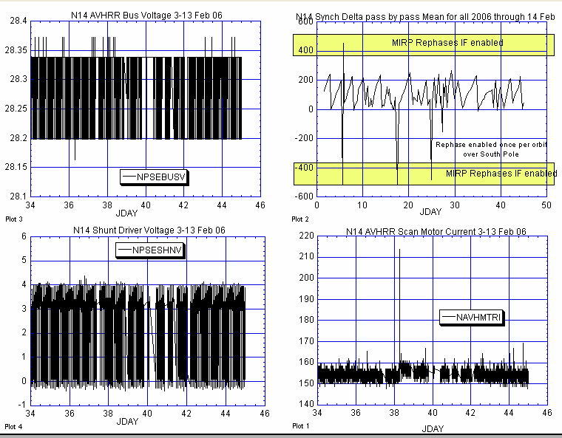

POWER SUBSYSTEM AVHRR

Illustration 1: NOAA-14 Power & AVHRR Health Analysis

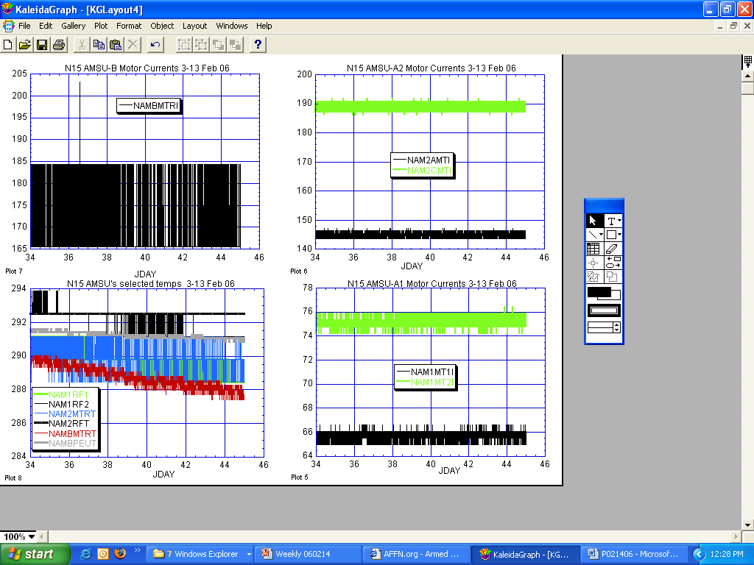

Illustration 2: N15 AMSU’s Health Analysis
(Nominal with thermal profile trending downward as sun angle cycle approaches its bottom of 7 degrees in the next several days.)

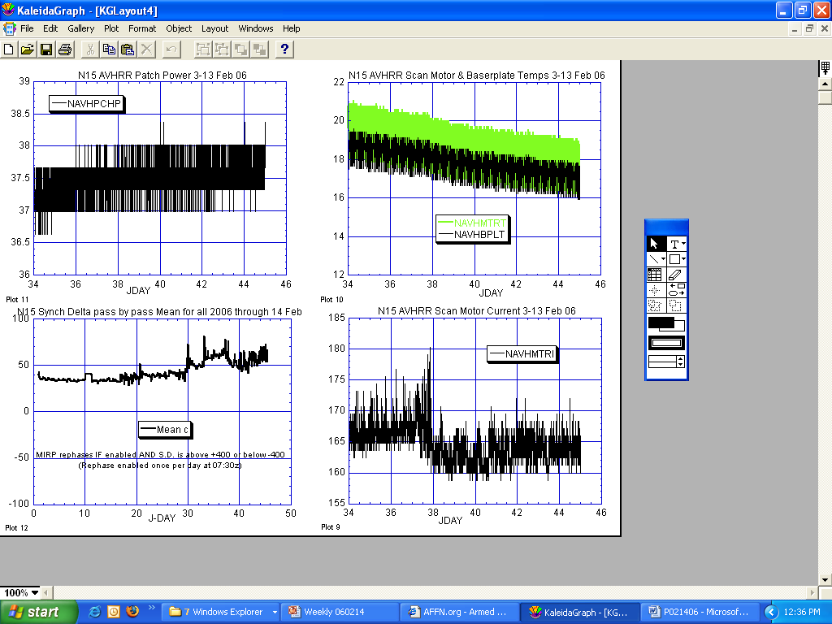

Illustration 3: N15 AVHRR Health Analysis

(A return to more auspicious values for the scan motor last week. Not yet all the way back but more than halfway.)

Illustration 4 omitted for web publication

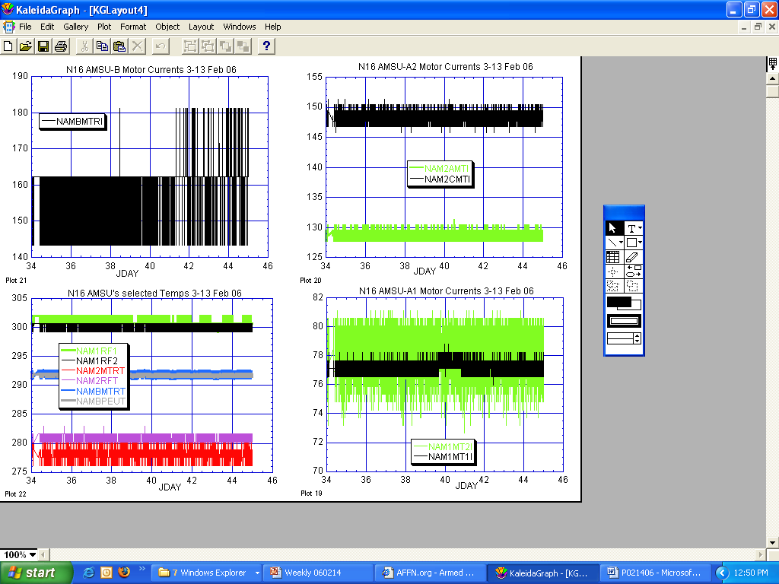

Illustration 5: N16 AMSU’s Health Analysis
(Nominal and stable last week.)

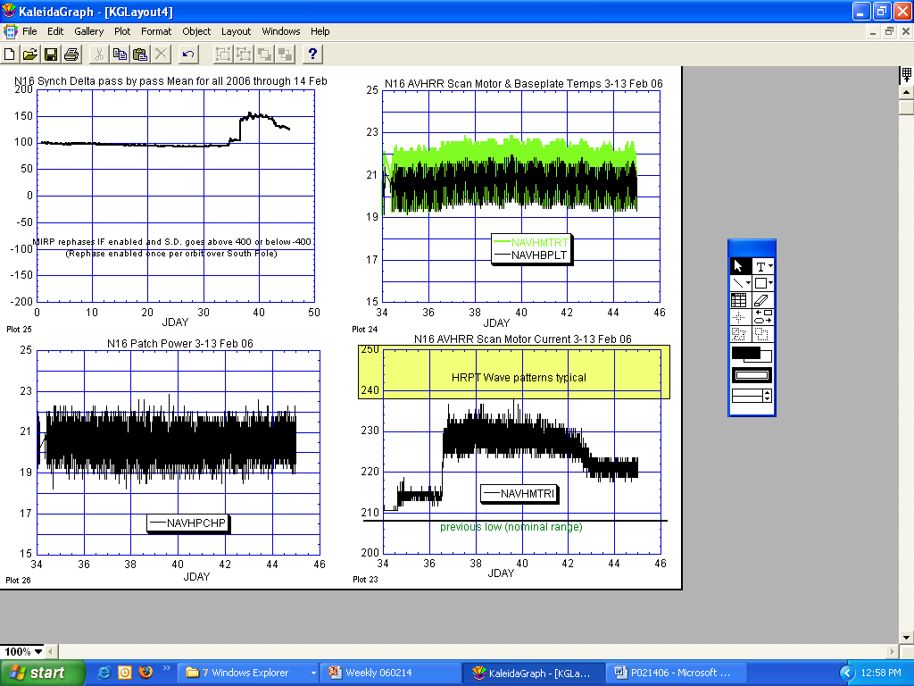

Illustration 6: N16 AVHRR Health Analysis
(After a significant rise, stability was reached than a return to more nominal values. No imagery impacts were apparent.)

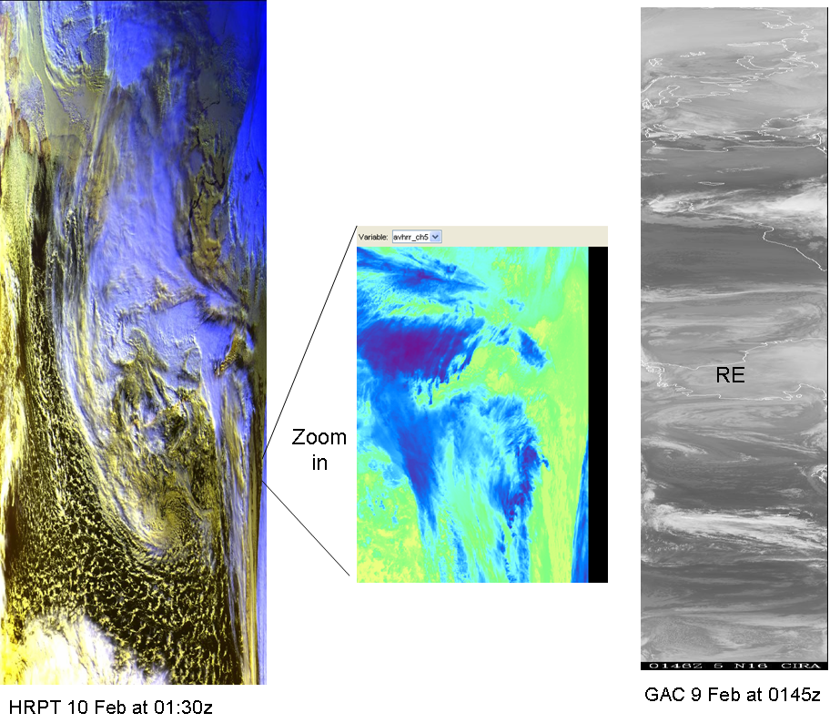

Illustration 7: N16 AVHRR Imagery Analysis
(During the “worst” of last weeks scan motor current surge, no waves, no bars, and no frame losses.)

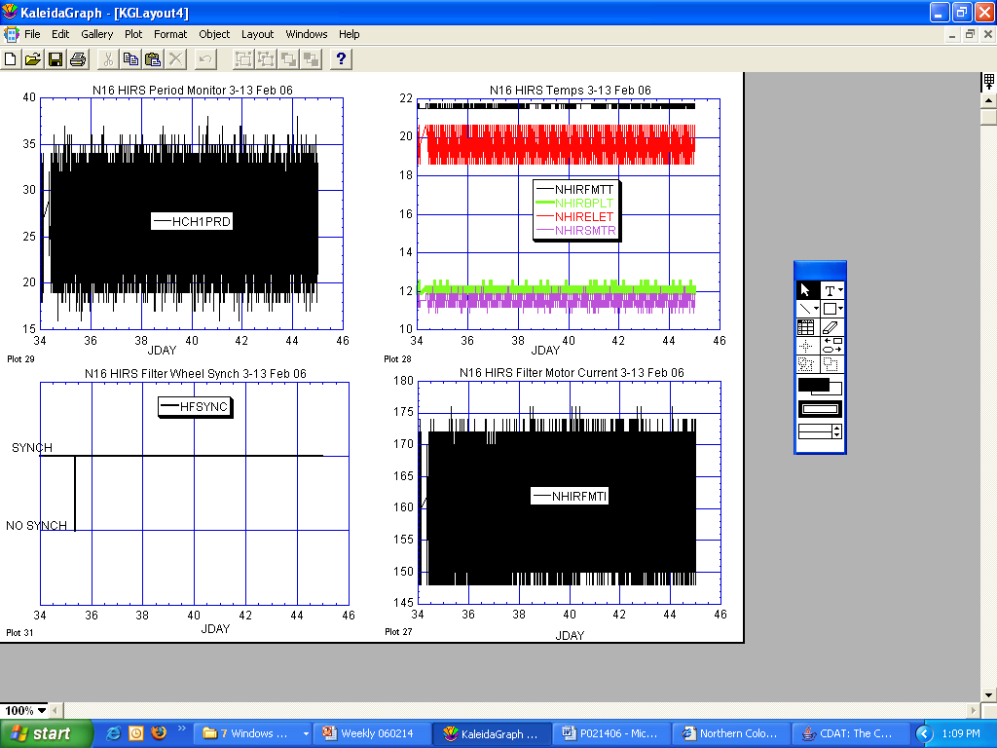

Illustration 8: N16 HIRS Health Analysis
(generally nominal and stable last week.)

Illustrations 9-11 omitted for web publication

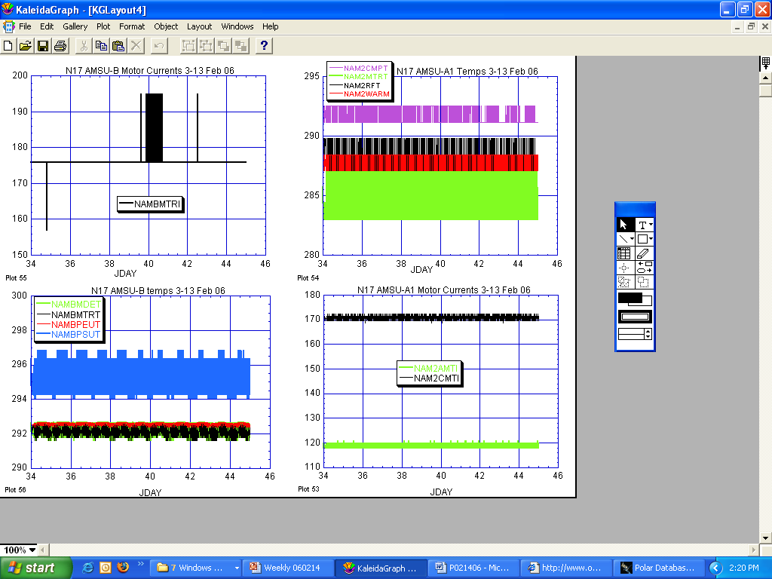

ILLUSTRATION 12: N17 AMSU’s Health Analysis
(Everything appears nominal and stable during the past week.)

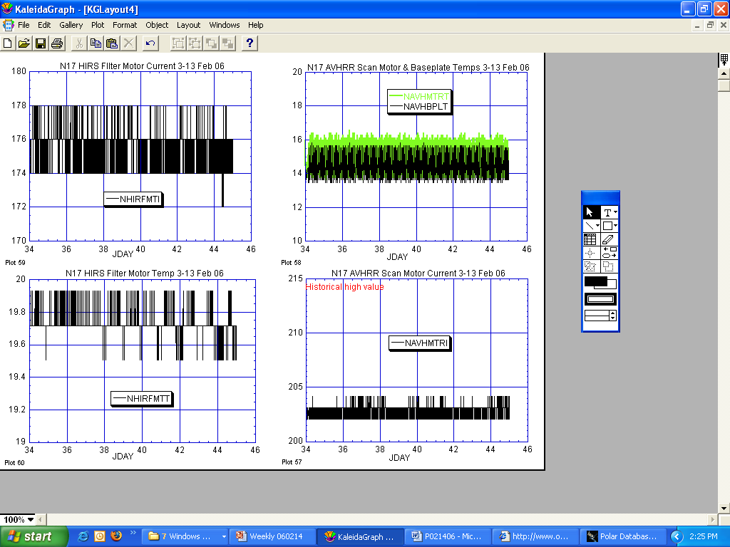
HIRS AVHRR

ILLUSTRATION 13: N17 AVHRR & HIRS Health Analysis

(Nominal and stable last week.)

Illustration 17 omitted for web publication

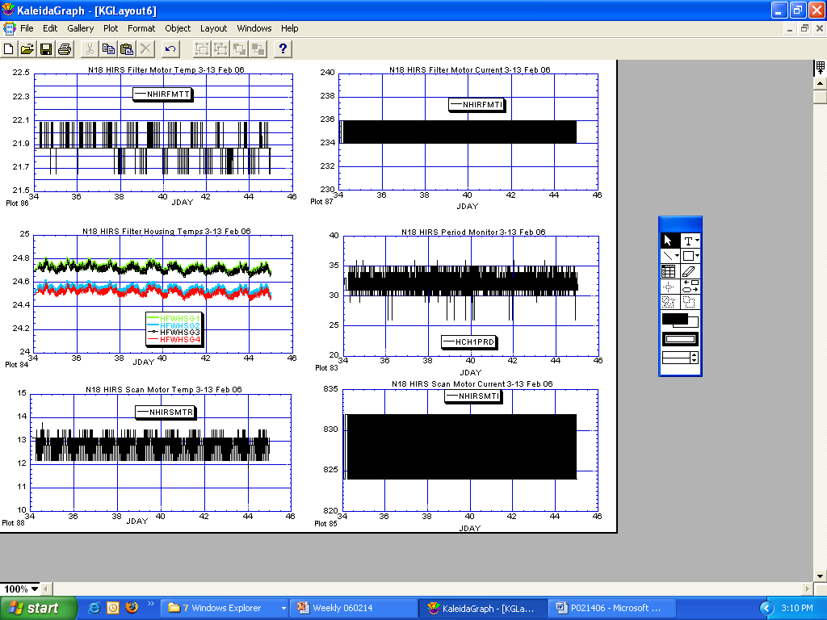

ILLUSTRATION 16: N18 HIRS Health History Analysis
(Engineering aspect of the HIRS remained nominal and stable throughout the channel-1 noise situation nor were any spacecraft reconfigurations implemented that might have induced vibration into the loose lens cover.)

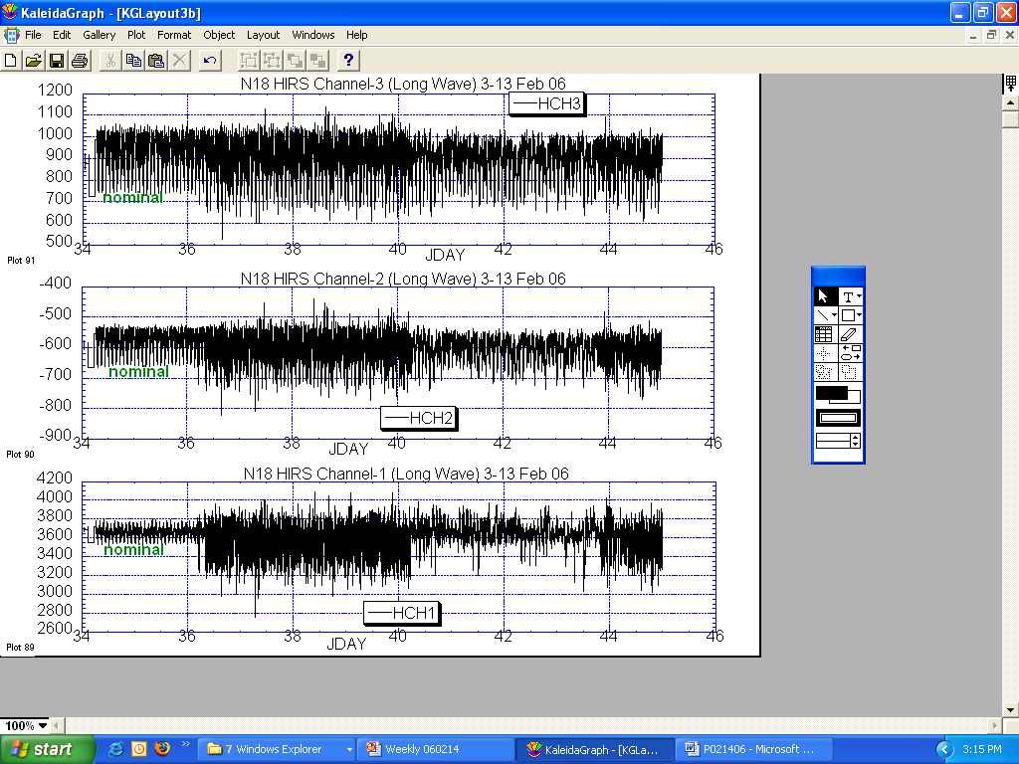

ILLUSTRATION 17: N18 HIRS Imagery Comparison

(Significantly less stable than desired. Especially channel-1)

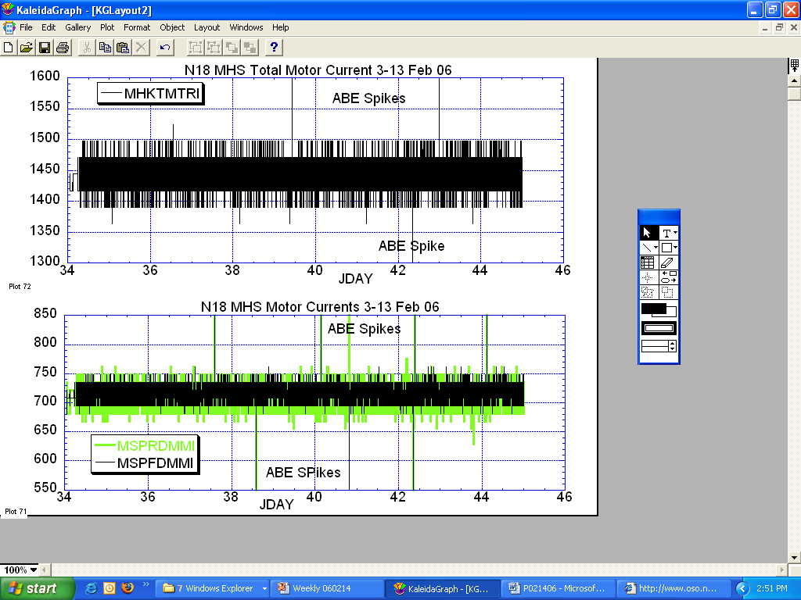

ILLUSTRATION 18: N18 MHS Health Analysis
(Nominal and stable last week, spikes all caused by ground processing problems.)

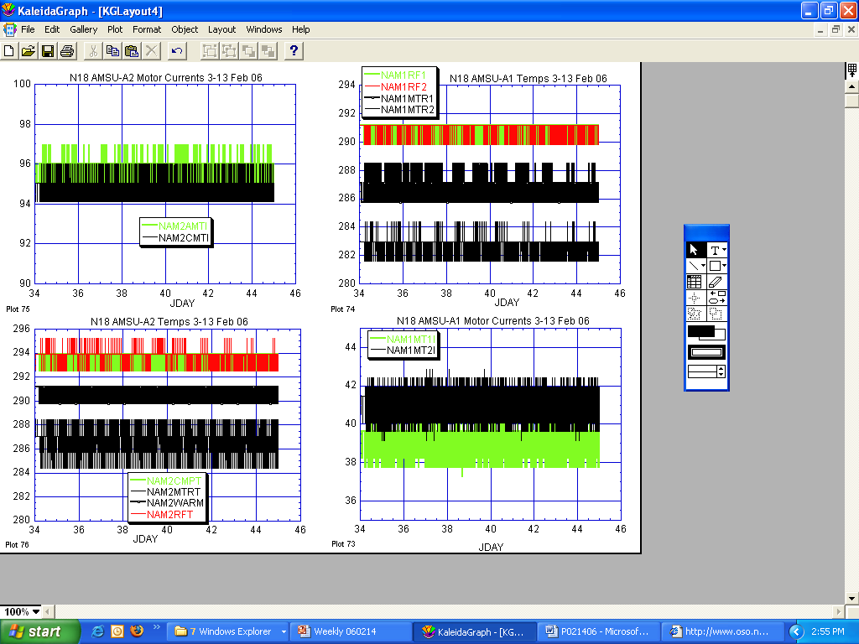

ILLUSTRATION 19: N18 AMSU’s Health Analysis

(Stable and nominal across the board.)

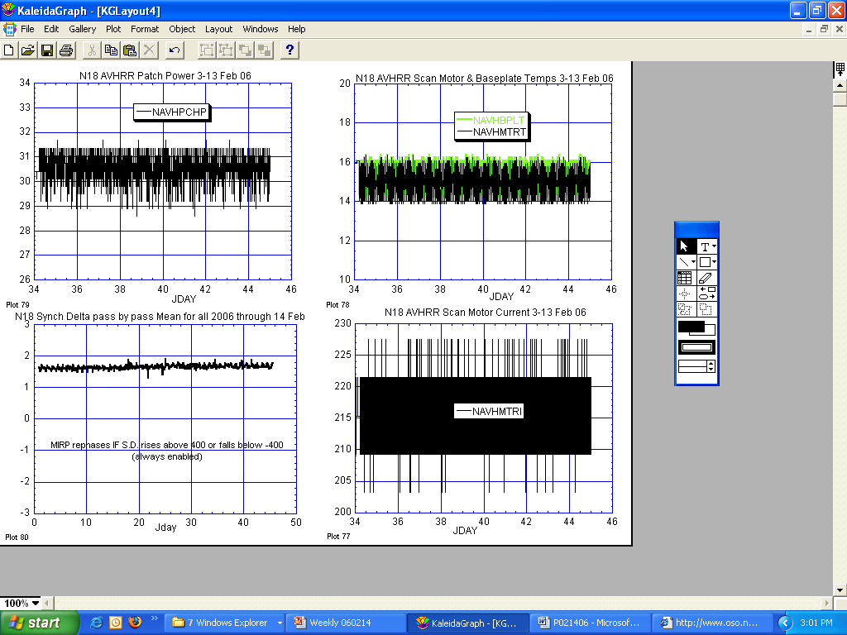

ILLUSTRATION 20: N18 AVHRR Analysis
(Stable and nominal)

Illustration 21 and 22 omitted for web publication

POLAR SPACECRAFT TIP CLOCK ERROR

WEEK ENDING February 10, 2006
DAY/DATE | NOAA-12 | NOAA-14 | NOAA-15 | NOAA-16 | NOAA-17 | NOAA-18
FRI. 02/03 | +502 msec | -179 msec | +097 msec | -088 msec | -242 msec | -279 msec
SAT. 02/04 | +503 msec | -179 msec | +096 msec | -088 msec | -240 msec | -275 msec
SUN. 02/05 | +502 msec | -181 msec | +094 msec | -087 msec | -238 msec | -273 msec
MON. 02/06 | +502 msec | -178 msec | +093 msec | -085 msec | -237 msec | -272 msec
TUE. 02/07 | +500 msec | -180 msec | +090 msec | -086 msec | -236 msec | -270 msec
WED. 02/08 | +498 msec | -177 msec | +092 msec | -084 msec | -235 msec | -269 msec
THU. 02/09 | +497 msec | -171 msec | +092 msec | -085 msec | -234 msec | -270 msec

NOAA-14: As of 12/23/03 the TIP clock is corrected daily by –7.0 msec to compensate for drift.
NOAA-15: As of 04/22/03 the TIP clock is corrected daily by –8.0 msec to compensate for drift.
NOAA-16: As of 12/23/03 the TIP clock is corrected daily by -5.5 msec to compensate for drift.
NOAA-17: As of 12/23/03 the TIP clock is corrected daily by –3.0 msec to compensate for drift.
NOAA-12: As of 12/10/03 the TIP clock is corrected daily by +6.5 msec to compensate for drift.
* A clock jump of -500 milliseconds on 09/15/05 due to fractional second daily ETCUP. A clock
jump of +500 milliseconds on 11/30/05 due to fractional second daily ETCUP. Alternating +/-
500 millisecond clock jumps will ccur at 76-day intervals as long as fractional second daily
ETCUP is utilized to manage clock drift. The next -500 millisecond jump is expected on 02/14/06.
** TIP Clock corrections were made to compensate for the positive leap second introduced on 12/31/05.

