POLAR Spacecraft Status As of: Thurs 10 Jan 08, 12:00 EST
(Changes from last week in bold border)
Subsystem/  Component | NOAA-15K  AM: 17:49=AN  GAC data only | NOAA-16L  PM: 15:04=AN  GAC data | NOAA-17M  AM: 22:23=AN  GAC&LAC data | NOAA-18N  PM 13:49=AN  GAC & LAC data
LAUNCHED | 05/13/98 | 09/21/00 | 6/24/02 | 5/20/05
CNTL OBP | OBP2 | OBP2 | OBP2 | OBP2
BUS | B-BUS  XSU-1 | B-BUS  XSU-2: TOAR472 | B-BUS  XSU-1 | B-BUS  XSU-1
BUS VETO | NO | NO | NO | NO
ADACS | Nominal Mode  Rgmode=Monitor  Gyro-3 Off 6/26/00 Gyro chans=AAB  N2 Low PSI invalid | RGYRO Mode  Estimate Y-ROLL  Rgmode=PASSIVE  Gyros-1 & 3 Inop/Off  Gyro chans XA-ZB  Pitch wheel bias 2400  *Z gas unload = 145  Gyro2 safe macro | Nominal Mode  Rgmode=Monitor  Gyro-3 Off 6/10/04  Gyro chans=AAB GAS Enabled Dec 05  *Z Gas unload =45 | Nominal Mode  Gyro-A MIMU-2  Z-wheel -Pitch  TOAR 447  Z-momentum transition complete  Pitch Torquer again active
RXO | PRI  daily bias -8 mS  -500 mS 12/31/05 | PRI  Daily Bias –5.5 mS  -1500 mS 31Dec05 | PRI  Daily Bias –3 mS  -1500 mS 31Dec05 | PRI  No daily bias  -1500 mS 31Dec05
CLOCK DIV | 2 | 2 | 2 | 2
MIRP | External Synch Rephase 0730 daily | External Sync  Rephase each orbit | External Sync  Rephase Enabled | External Synch  Rephase Enabled
TIP SIDE | 2  (since 4/3/03)  3 channels inop | 2  since 4/18/05  (analog drifting?) | 2  Swapped 9/20/06 | 1  Analog telem drifting
Recorders  (DTR, SSR) | DTRs 1, 2, 3, 4 Safestate 1B EOT | DTRs 1, 2, 3, 4A  Safestate 3A  4B STIP only | DTR 1,3,4 / SSR 2  Safestate=SSR 2B  4A Pressure leak | SSRs 1,2,3,4,5  Safestate=5B  Current spikes
VTX  (APT data) | #1 ON  As of 19 June 07 | OFF / INOP  since 11/15/00 | #2 ON  137.62 MHZ | #1 ON  137.1 MHZ  As of 16 Aug 07
BTX | #1  137.35 MHZ | #2  137.77 MHZ | #2  137.77 MHZ | #1  137.35 MHZ
STX  1 = rcp 1698.0 mhz  2 = lcp 1702.5 mhz  3= rcp 1707.0 mhz  4= rcp 2247.5 mhz | 2-Omni HRPT  2 Omni=rcp  Power TOAR 446  4-Playback  1,2,3-Degraded | 2 – HRPT  1– Playback  4 Restored -11 Oct 2007  3 low power INOP -10 Aug 2007 | 3 – HRPT  TOAR424 low power  2 & 1 Playback  STX-1 Power drop  STX-4 no modulation | 1 - HRPT  3 - Playback  2-Playback  4-Test & Standby
POWER  (Array offset and CANT angle, eclipse states and sun angle) | Array Off -45  Since 1/25/01  Full Sun  Sun Angle 13  Uptrend to 18 early Jan 07  SA CANT=37 degs | Array Off -20  Since 9/13/07  Eclipse all year  Sun Angle 34  Steady trend  SA CANT=22 degs  Full sun S/C in Sept 07  BVR Phase Control auton swap 7/19/07 | Array Off. –40  Since 1/29/04  Eclipse all year  Sun Angle at 66  Steady trend  SA CANT=37 degs  BVR Phase Control auton swap 9/17/07  Swap back 9/18/07 | Array Off. -40  Since 6/6/05  Eclipse all year  Sun Angle 63 uptrend to 65 on  1 Jan 07  SA CANT=22  BVR Phase Control auton swap 3/29/06 & 1/4/07
AVHRR | Nominal  Channel 3B only  Occasional minor scan motor instabilities | Nominal  Recent SM current increases  TCE24 OFF 4/14/04  Channel 3B only | Nominal  3A-B switch enabled  Previous scan motor current mini surges | Nominal  Channel 3B only  Scan motor current drop 29 Aug 06
AMSU-A1 | Operational  Ch14 inoperative  Ch11 inoperative | Operational  Primary PLLO chans 9-14 bias shift.  Backup PLLO inop.  Channel 9-14 noise | OFF/INOP  Since 10/30/03  Survival heat on. | Nominal  Full Scan mode
`AMSU-A2 | Nominal | Nominal | Nominal | Nominal
AMSU-B | Operational  Bias in All Chans.  Degraded Chan-3 | Operational  Space Position-3  Chan-8 degradation | Nominal | Replaced by MHS
HIRS | NOMINAL  FW Abrupt return to nominal 7/12/05  After years of minor and major current surges  FW mode=Hi Powr | NOMINAL  New all time high filter motor current reached 9/17/06.  Imagery occasionally exhibits high levels of radiometric noise | NOMINAL  1 Pixel cross-track misalignment. | Operational  Filter Heat OFF.  LW channel 1-12 noise TOAR 448 Loose LWIR lens.  LW imagery erratic.
MHS/MIU |  |  |  | Nominal  Fly Wheel Motor Current Spiking but not alarming since 27 Dec 06  Entered Motor Spin State on 27 March 07  H4 gain increased 2 Oct 07  H3 gain increased 31Oct 07
DCS  RFI investigation | Nominal | Nominal  Pseudo message turned on 1/5/06 | Nominal | Nominal  DRU’s 1-7 On  DRU8 inop/off
SARR | Operational  B-Side, 13 Dec 07  AGC Mode  Intermittent failures for 243MHz A&B | Operational  Mode =AA  A-side, AGC Mode  (B-side in FG mode)  243 MHz = INOP. | Nominal  A-side  All AGC Mode | Nominal  A-Side  All AGC Mode  Since 15 Aug 05
SARP | Nominal  RCVR B/W = 2 | Nominal  RCVR B/W = 2 | Nominal | Nominal  A-side 23 May05
SEM | Nominal  E-CDEM-HVPS=2  P-CDEM-HVPS=0 | Nominal  E-CDEM-HVPS=6  P-CDEM-HVPS=5  27 Jun 0615:30z | Nominal  E-CDEM-HVPS=2  P-CDEM-HVPS=4  27 June 06 16:00z | Nominal  Elec-CH-HVPS=1  27 June 06 17:00z  Prot-CH-HVPS=0
SBUV |  | Operational  Degraded Ozone data  Backup Diffuser inop  Primary Diffuser deployment problem TOAR 426  AMSU EMI causing erratic Behavior in PMT cathod, range 3 | Nominal  Anode Mode  Plan sweep mode  Standard Ops  TOAR 463 sun glint  IBSL test performed 12 Sept 06  Grating motor investigation | Nominal  Anode mode  since 6 July 05 13:30z  Electronics turnoff taken out of STESM safestate table  TOAR 462 sun glint
SADPOS |  | ON  Enabled MFactor50%  Timer = 12 mins | ON  ENABLED  Timer = 12mins | ON  Enabled  Timer =12 mins
THERMAL  Heaters, louvers  TCE’s | TCE26 & 15H  Telem valid  TOAR 432 closed  TCE24L&25L (HIRS & AVHRR) failed 5/13/98  RCE thermostat failed 5/13/98  Spacecraft in thermal uptrend | Nominal  TCE24 OFF 4/14/05  (AVHRR H&L)  HIRS Filter heater turned OFF 1/18/05 | TCE3H Batt 2A heater failed ON, turned off 8/26/03  AMSU-A1 survival heaters on 10/29/03 | All TCE’s active  HIRS filter heater turned OFF 9/28/06

COMMENTS/CHANGES:
MISC: In preparation for the NOAA-17 XSU swap next week, Beacon transmission testing was completed for all spacecrafts from each site successfully.

Initial analysis and planning for the upcoming Eclipse on 7 February 2008 has begun.

NOAA-15: There were relatively no changes to the NOAA-15 payload health situation during the past week.

NOAA-15 Yaw gyro a bit quieter in the New Year, but still basically unchanged. Daily monitoring continues.

NOAA-16: There was relatively no change in the performance of the NOAA-16 payload or bus subsystems during the past week.

On 11 January 2008, the NOAA-16 TED Electron and Proton Analyzers bias voltages will be adjusted. The Electron Analyzer will be adjusted from 6 to 7, and Proton Analyzer from 5 to 7. This request came from SEC based on the in-flight calibrations for the TED instruments show that the channel multiplier gains are inadequate.

NOAA-17: There was relatively no change in the performance of the NOAA-17 payload or bus subsystems during the past week.

On 15 January 2008, during rev 28899 beginning at 21:18z, the cross strapping unit (XSU) on NOAA-17 will be switched to the redundant side. There will be outage of HRPT during the contact while the transmitters are turned off. TIP will be configured to beacon, BTX#2, 137.77MHz. A shift in the instrument analog values as the XSU switches causes clocks to re-synchronize and may be observed as it was for the NOAA-16 XSU swap. HRPT should be commanded on before loss of signal over the CDA. There will be a gap in the data of approximately one major frame.

NOAA-18: There were relatively no changes to the NOAA-18 health situation during the past week.

TIP drift caused NTIP1_2 and NDCS12V to exceed their YH limits. They were adjusted by John Vollmer.

On 11 January 2008, the NOAA-18 TED Proton Analyzers bias voltages will be adjusted. The Proton Analyzer will be changed from 0 to 1. This request came from SEC; the multiplier gain in the 0-degree, high-energy proton analyzer is not adequate.

MetOp-A: There were relatively no changes to the MetOp-A health situation during the past week.

The AMSU-A1 A1-2 reflector cold cal counts (Dig A telemetry) were documented as out of spec via AR7221 during the SIOV activities in January 2007. The CVF daily reports continue to document an increasing frequency of limit violations for the cold cal and warm load reflector position counts. Typically a spot check of various reflector positions for trending (i.e. Pos 1, 15, 30, CC and WL) is performed. The A1-2 Reflector Cold Cal position counts since October 2007 are shown in Figure 2, demonstrating a trend downwards in counts for both the first look and second look counts (a longer term plot is currently in work). This is still an acceptable condition, but we should continue to monitor this trend.
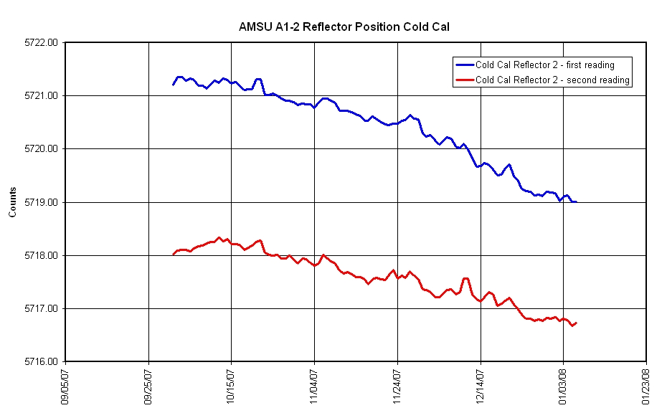
Figure 2 MetOp-A AVHRR (2007/274-2008/010)

