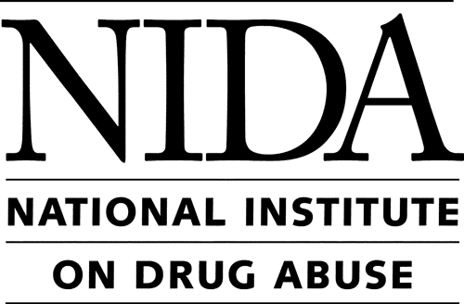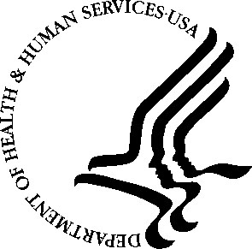

Computational Modeling and Systems Biology of Drug Abuse
January 15, 2008, 8:45 a.m. – 5:00 p.m.

Neuroscience Center – 6001 Executive Boulevard, Rockville, Maryland
Conference Room A1/A2

Agenda

Morning Session: Macro- and Mid-Scale Models in Addiction Behavior, Epidemiology, and Economics

8:45 – 9:00 a.m. Registration

9:00 – 9:15 a.m. Welcome
Nora D. Volkow, M.D.
Director, National Institute on Drug Abuse (NIDA)

9:15 – 9:45 a.m. Opening Remarks and Comprehensive Modeling of Addictive Processes
Georgiy Bobashev, Ph.D.
RTI International, Research Triangle Park

9:45 – 10:15 a.m. Illicit Drug Markets as Complex Adaptive Systems
Lee Hoffer, Ph.D.
Washington University, St. Louis

10:15 – 10:30 a.m. Break

10:30 – 11:00 a.m. Benefits and Costs of Methadone Treatment: Results From a Lifetime Simulation Model
Laura Dunlap, Ph.D.
RTI International, Rockville

11:00 – 11:30 a.m. Social Processes of Addiction: Computational and Mathematical Models
Paul Gruenewald, Ph.D.
Pacific Institute for Research and Evaluation

11:30 – 11:45 a.m. Break

11:45 – 12:15 p.m. Control Theory of Addiction Processes
David Newlin, Ph.D.
RTI International, Baltimore

12:15 – 1:15 p.m. Lunch (on your own)

Afternoon Session: Micro-Scale Models in Addiction Behavior

1:15 – 1:45 p.m. Addiction as Vulnerabilities in the Decision-Making Machine
David Redish, Ph.D.
University of Minnesota

1:45 – 2:15 p.m. Neurodynamics of Nicotine Addiction: From Receptors to Behavior
Boris Gutkin, Ph.D.
École Normale Supérieure, Paris

2:15 – 2:30 p.m. Break

2:30 – 3:00 p.m. Drug Self-Administration Thresholds
Vladimir L. Tsibulsky, Ph.D.
University of Cincinnati College of Medicine

3:00 – 3:30 p.m. A Quantitative Approach to Antagonist Effects on Drug
Self-Administration
Andrew B. Norman, Ph.D.
University of Cincinnati College of Medicine

3:30 – 3:45 p.m. Break

3:45 – 4:15 p.m. Does Addiction Require Protein Synthesis?
Michael Kuhar, Ph.D., M.D.
Yerkes National Primate Research Center, Emory University

4:15 – 5:00 p.m. Discussion
Tandy Herren, Ph.D.
DNAPrint Pharmaceuticals

Colleen Hanlon, Ph.D.
Wake Forest University

James Anthony, Ph.D., M.Sc.
Michigan State University

5:00 p.m. Adjournment

