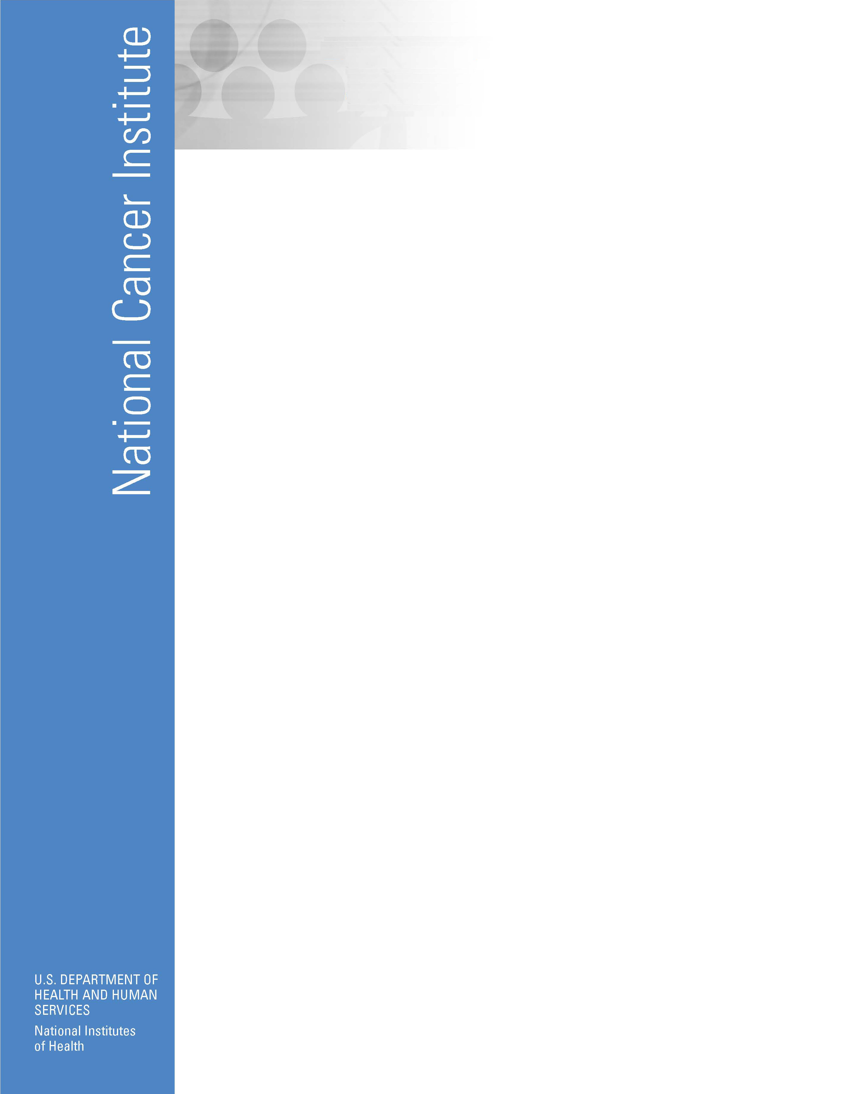
Office of Cancer Survivorship
http://survivorship.cancer.gov

OVERVIEW  The Office of Cancer Survivorship (OCS) was established in 1996 by the National Cancer Institute (NCI) in recognition of the large number of individuals now surviving cancer for long periods of time. The OCS is dedicated to enhancing the length and quality of life of the estimated 10.5 million cancer survivors in the United States and addressing their unique and poorly understood needs.  The OCS considers an individual a cancer survivor from the time of diagnosis through the balance of his or her life. Family members, friends, and caregivers are also impacted by the survivorship experience and are therefore included in this definition.  The mission of the OCS is to enhance the quality and length of survival of all persons diagnosed with cancer and to minimize or stabilize adverse effects experienced during cancer survivorship. The OCS carries out its mission through:  - Directing and supporting research that will: identify, examine, prevent, and control adverse cancer diagnosis and treatment-related outcomes (such as late effects of treatment, second cancers, and poor quality of life); provide a knowledge base regarding optimal follow-up care and surveillance of cancer survivors; and optimize health after cancer treatment.  - Educating professionals who deal with cancer survivors about issues and practices critical to the optimal well-being of their patients.  - Communicating to cancer survivors and their families information gleaned from our funded research that can affect their survivorship. |  | PRIORITY AREAS FOR CANCER SURVIVORSHIP RESEARCH  The goal of cancer survivorship research supported by the OCS is to address the health and life of a person with a history of cancer beyond the acute diagnosis and treatment phase.  As well as supporting exploratory levels of research, the OCS seeks to expand its research portfolio to include (a) theory-based descriptive and analytical studies that document the physiologic, psychosocial, and economic effects of cancer and its treatment on survivors’ quality of life, functioning, and health, and (b) intervention studies that seek to develop and test novel strategies to prevent or reduce adverse outcomes and/or promote optimal health or well-being after cancer treatment  Topical areas of particular interest to the OCS are:  (1) Understudied cancer sites: such as colorectal, lung, ovarian, head and neck, and adult hematologic malignancies.  (2) Health Disparities: Quantitative and/or qualitative research addressing cancer survivorship among minority, rural, elderly, and medically underserved populations. Examples include development or modification of scales that reflect sociocultural relevance, exploring where and how underserved populations obtain follow-up care, and examining adherence to healthy lifestyles.  (3) Family and Caregiver Issues: Studies that examine or address the impact on health and well-being of cancer treatment, and the sequelae of cancer survivorship, on a family unit, family member, or caregiver.


(4) Economic Outcomes, Patterns of Care, and Service Delivery: Studies that assess the impact of survivorship on work and economic status; insurability; the relative costs of care and cancer control practices by service delivery setting; access to care; the impact of patterns of care on health status, morbidity and mortality among cancer survivors; and decision-making among providers or survivors.  (5) Healthy Lifestyle and Behaviors: Research that addresses the prevalence of behaviors that affect cancer risk (e.g. smoking, alcohol use, sun exposure), promote well-being (e.g. exercise, vegetable consumption) or reflect accepted surveillance practices (e.g. mammogram use, PSA testing, colonoscopy) and interventions to improve health practices.  (6) Cancer Communication: Initiatives that utilize collaborations among survivors, the medical community, and the health care system to develop educational and training programs for cancer survivors and their families and friends. Communication projects address such topics as what information survivors need and when in the course of their cancer care, and how survivorship information should be delivered to physicians and families.  (7) Instrument/Theory Development: Exploratory research may be necessary for developing or refining instruments and for developing or expanding theoretical models. Most QOL and outcomes instruments currently used in oncology are geared toward patients undergoing, or who have recently completed, cancer treatments. The OCS seeks to stimulate the development of instruments designed for use with long-term cancer survivors that encompass their specific needs and outcomes, and permit the cross-comparison of health-related outcomes with other healthy or chronically ill populations.  Investigators are strongly encouraged to read and use the language contained in the following two documents to support the significance of their proposed research: The Nation’s Investment in Cancer Research, which can be found at: http://plan.cancer.gov, and the Progress Review Group (PRG) reports, which can be found at: http://prg.cancer.gov/index.html.  FUNDING MECHANISMS  The OCS supports a broad range of investigator-initiated applications addressing the aforementioned topic areas. Please feel free to contact one of the OCS Program Directors regarding scientific and programmatic questions or clarifications pertaining to the following grant mechanisms: |  | - Small Grants Program for Behavioral Research in Cancer Control (RO3), PAR-06-073  (Opportunities exist for pre-doctoral & postdoctoral researchers.)  - Exploratory Grants for Behavioral Research in Cancer Control (R21), PA-04-034  - Social and Cultural Dimensions of Health  (Trans-NIH, R01), PA-05-029  - Understanding and Promoting Health Literacy  (Trans-NIH, R01, R03), PAR-04-116, PAR-04-117  - Research on the Economics of Diet, Activity, and Energy Balance (R01, R21), PA-05-009, PA-06-292  - Training Opportunities (pre-doctoral, post-doctoral, and mid-career)  - Cancer Prevention, Control and Population Sciences Career Development Award (K07), PAR-06-381  - Mentored Patient-Oriented Research Career Development Award (K23), PA-05-143  OFFICE OF CANCER SURVIVORSHIP CONTACTS  Office of Cancer Survivorship  Division of Cancer Control and Population Sciences  National Cancer Institute, NIH  6116 Executive Boulevard, Suite 404  Bethesda, MD 20892  301-402-2964  - Julia Rowland, Ph.D., Director  (rowlandj@mail.nih.gov)  - Noreen Aziz, M.D., Ph.D., M.P.H., Program Director (azizn@mail.nih.gov)  - Diana D. Jeffery, Ph.D., Program Director  (jefferyd@mail.nih.gov)  - Meryl Sufian, Ph.D., Program Director  (sufianm@mail.nih.gov)  - Carmina Valle, M.P.H., Program Analyst  (vallec@mail.nih.gov)  Revised 8/06

