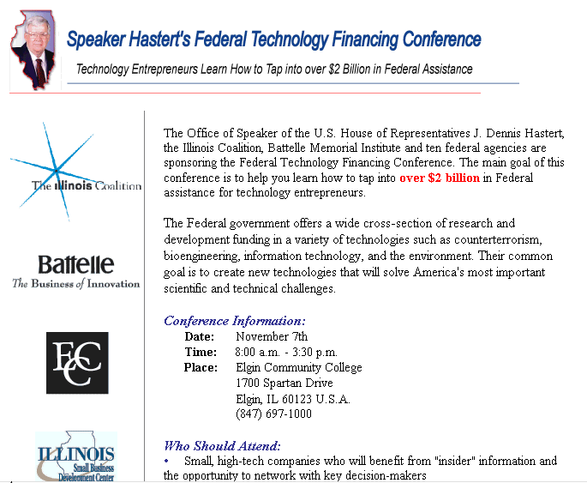
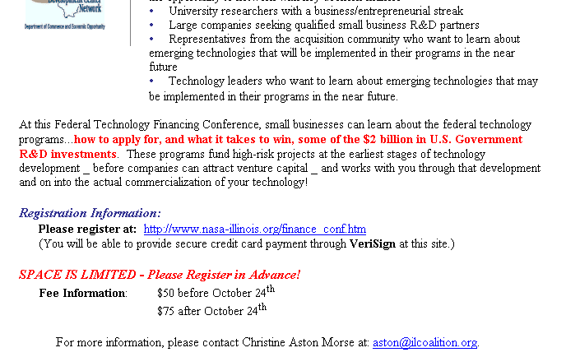
From: Dr. Victor Pinks II [vicp@tbc.net]
Sent: Thursday, October 16, 2003 2:29 AM
To: Holland, Michael J.
Subject: Fixing the unsolicited research hole (follow up to previous e-mail from Vic Pinks)
Hi Mike,

I promise you that I won't go on forever on this stuff. It has come up from my direct experience and I figured that it would have special value in the sense that I am independent and not biased by any dependency on federal funding. In other words, you will get a straight answer from me (the best that I can give). I believe that this is the kind of information that is more helpful than someone with a big agenda.

Anyway, I thought it only fair to propose a remedy to the unsolicited research concern that I expressed in my e-mail yesterday. In yesterday's e-mail I included two charts that, when compared, attempted to illustrate what I feel to be a problem that could have both economic and security implications for the U.S.. I am not an expert on science policy, however, that does not weaken my observations from an individual researcher's perspective - I appreciate your extra effort to understand this concern.

The specific concern I have is that, I believe, there is more unsolicited research than the current SBIR system can handle. The current system does not have a sufficiently diverse or contemporary mechanism to address most unsolicited research. And, isn't unsolicited research actually a little more innovative by definition? If you look at the two charts I sent yesterday, you can see that I divided funding at TRL level number = 3 (proof-of-concept) into government and commercial areas. Frankly, I think it is a good split. If any commercial venture is successful, the government will still get their tax dollars. I believe that the original ideas to seed fundamental research were good but technology has antiquated the system. For a current example, look at the Federal Technology Financing Conference being sponsored by my congressional representative, Speaker Dennis Hastert:

Notice the wording in this advertisement: "what it takes to win" . That doesn't sound like anyone promoting innovation. It sounds like a criterion. If federal scientists don't think of it first, your research will be considered unsolicited and will most likely not get funded. There is no pre-built pigeon hole for it. One could say that there is a 'sense of entitlement' to the money in federally funded science labs. A sort of federal protectorate or welfare system (a charge often projected on the individual researcher by this protectorate - unfairly since the budget of the unsolicited research of the individual is extremely smaller than federal science agencies). In a world of affordable computational power it isn't prudent for a country such as the US which professes a determination to successfully compute grand challenge problems to believe that only a federal computer installation can be innovative. It's nonsense, static, and counter productive to the economy and national security. Especially if a new software technology sparks a computational power race.

And so, I believe the situation is more dynamic due to the rapid advances in technology that make powerful equipment more affordable. That is a given. I think there is a growing percentage of lost research that could not be categorized for an SBIR solicitation that is available on the world market that should have been US funded (most notably, in the area of computational science). Some of this research, if not developed in the US for national security and economic reasons, could be developed and locked away as either a commercial trade secret, or financed with foreign money, thus placing the US at a security disadvantage due to cutting edge research that got away. My research is a case in point.

So here is my proposal for fixing this apparent economic and security hole:

Fixing the unsolicited research hole - create "The Office of Research Assessment at OSTP"

Require by law that all SBIR granting agencies forward all unsolicited research inquiries to the Office of Research Assessment at OSTP for qualification, categorization, and distribution to an appropriate federal SBIR research granting agency. Here are some of the benefits of this new office:

- SBIR granting agencies will try harder to keep unsolicited research and fit it into their paradigm.
- SBIR granting agencies will be accountable for their choices of solicited research.
- SBIR granting agencies may change internal protocols to address and use unsolicited research if it means losing possible SBIR monies.
- "The Office of Research Assessment at OSTP" will prevent SBIR granting agencies from protectionism (i.e., burying unsolicited research by labeling it as unqualified)
- "The Office of Research Assessment at OSTP" will help OSTP stay contemporary with the dynamic landscape of innovative research in an ever increasing technological society - including technological threats from foreign governments.
- "The Office of Research Assessment at OSTP" will increase the perceived value of the innovator.
- The SBIR granting agencies will be motivated to change their practices to include more contemporary research so as not to lose pace with the world. This can be an effective policy decision tool.

These are just preliminary thoughts. I appreciate the opportunity to send these ideas to you.

Thanks,

Vic Pinks

*****************************************************************************************
Victor Pinks II, PhD vpinks@ildsimulation.com
Robert S. Wilson, Ph.D. rwilson@ildsimulation.com
The Institute of Liquid Dynamics Simulation
2610 Laurel Lane
Sycamore, Illinois 60178

Cell Phone: 815-739-6785
Evening Phone: 815-895-6413

Web site: www.ildsimulation.com
MUNCC Supercomputer project web site: http://muncc.marmionacademy.org
*****************************************************************************************

