CPS version 4.01
User Release Notes

1. Introduction
The purpose of this document is to alert our users of fixes and enhancements that will be implemented in the CPS system. For the most part, most of our users will not notice any change while working in the CPS. These fixes and enhancements have been made to improve the quality of the data, operation of the system and provide consistency in the terminology used.

2. New/Improved Features and Functionality

2.1 Work Requirement Descriptions
The Work Requirement textbox on the Contract Data tab is a required field. In the current version of CPS, if the user typed in spaces the system would accept them. This bug has been fixed with the implementation of this version. If a user enters spaces he/she will receive an error message. The user will only be allowed to enter text.

2.2 Last and First Names
Last and First Names are required fields for a person’s profile. The system allowed the user to enter spaces for these fields in the following areas:
- Add a User
- Update/Change a User Profile
- Your Profile
- CR registration
This bug has been fixed in all areas mentioned above. If a user enters spaces, he/she will receive an error message. The user will only be allowed to enter text.

2.3 Reactivate the Delete User Function
Previously, System Administrators (SA), Organization Administrators (OA) and Contracting Officers (CO) had the capability of deleting a user role and/or profile. This function was temporarily disabled for modification. With the implementation of this release, the function has been enabled. The function has been renamed, Deactivate a User Profile. Now when the SA, OA, CO selects this function, the user and/or role will no longer be deleted, the user and/or role will be deactivated instead.

2.4 Access Finalized Evaluation
When a Contracting Officer reclaimed an evaluation from the Contractor Representative and finalized the evaluation the Contractor Representative would still get a system generated email notifying the Contractor Representative that an evaluation was available for their review. When the Contractor Representative logged into the CPS to review the evaluation, the evaluation was not listed on their Evaluation Status page. With the implementation of this version release no email will be sent to the Contractor Representative.

2.5 Remove Default Rating for Cost Control
The CPS was set up to default the rating for Cost Control to N/A on the Standard evaluation. Per our user’s requests, this default has been removed. Now a user must make a rating selection. If the user does not, an error will be displayed when the user clicks on the Assign/Submit tab. Note that a user has the ability to still select N/A for Contracts classified as Fixed Price.

2.6 Alternate Contractor Representative Information
With the release of this version, the Alternate Contractor Representative information will no longer appear on the Admin Info page if the Contracting Officer reclaims an evaluation from the Contractor Representative.

2.7 Design Services Completion Date for A&E Evaluation
With this release, the Design Services Completion Date on an A&E Evaluation is no longer a required field. However, either the Design Services Completion Date or the Construction Phase Service Date must have a value entered. If both fields have values then the Construction Phase Service Date must be greater than the Design Services Completion Date which must be greater than the Award Date.

2.9 Evaluator on the A&E Evaluation Form
Prior to this release finalized A&E evaluations always named the Contracting Officer of record as the evaluator of the phase(s). With this fix, if the Project Officer/COTR prepared the Ratings and Comments, the Project Officer/COTR will appear as the evaluator. If the Contracting Officer prepared the Ratings and Comments, the Contracting Officer will appear as the evaluator.

2.10 State Code Issue Resulting in Abnormal System Termination
Prior to this release, if the user, using the Lookup Contractor Info link on the Contract Data tab, typed in a DUNS where no State code exists and the Country code was either the United States or Canada, the application would abnormally terminate. The implementation of this release fixes this problem.

2.11 Archiving Construction Evaluations
With this version release, the algorithm to determine if an evaluation is to be archived has been changed from using an internal data item, Last Update Timestamp, to using Evaluation Completion Date. Since Construction evaluations should be archived six years and one day after the “report completion date”, the Evaluation Completion Date better reflects this value.

2.12 Improved Handling of Unexpected Database Error
There are some instances when an unexpected database error occurs. Prior to this version release, the application was not set up to capture and display these errors properly. With the release of this version, users will find a friendlier message indicating that an unexpected database error has occurred and to email the CPS Support group. See below for an example of the Error screen:

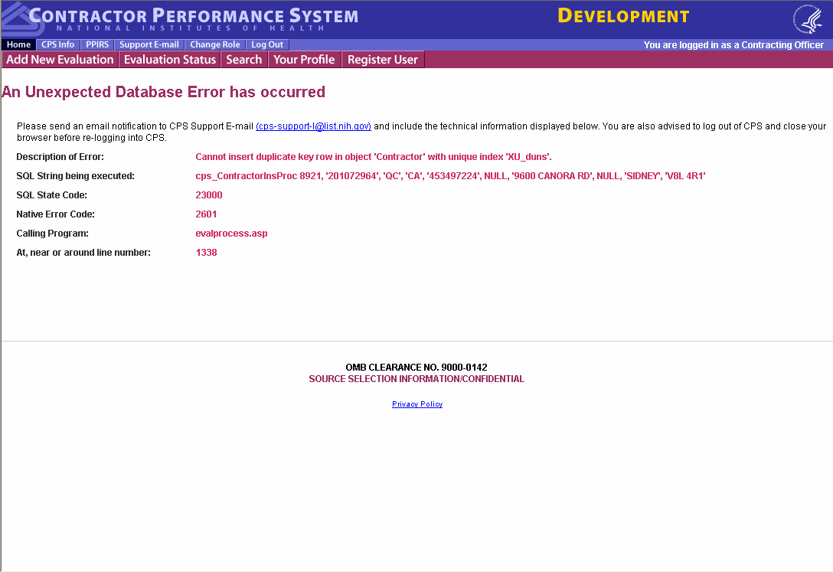

2.13 Contracting Officer, Project Officer/COTR and Contractor Representative Title Suppression
CPS does not collect or display the title for its registered users on evaluations. What appears on the PPIRS screen for Title is the user’s role. It was decided that since this may not always be true, the data should be suppressed in the weekly feed to PPIRS. This data has been suppressed since the June 7 PPIRS feed.

2.14 Typographical Error in Title of Standard Evaluation When Logo is Centered
A typographical error in the HTML code prevented Agency logos that were designated to be centered from being displayed properly. This error has been fixed with this release.

