DSMB Report Template
-Closed Session-

For Multi-Site Studies

Title Page

(Title of the study, PI)

Table of Contents

Title Page i
Table of Contents ii
Closed Session Report Summary 1
Recruitment and Participant Status: Figure and Tables 2
Figure 1: Overall Study Status by Treatment Group 3
Table 5: Demographic and Key Baseline Characteristics by Blinded Treatment Group 4
Table 6: Treatment Duration for All Participants 5
Safety Assessments: Tables and Listings 6
Table 10: Incidence of Adverse Events by Body System, Preferred Term and Treatment Group 7
Table 11: Severity of Adverse Events by Preferred Term and Treatment Group 8
Listing 1: Serious Adverse Events by Treatment Group 9
Listing 2: Deaths by Treatment Group 10
Listing 3: Adverse Events by Treatment Group 11
Table 12a: Laboratory Test Results Summary Treatment Group A 12
Table 12b: Laboratory Test Results Summary Treatment Group B 13
Listing 4: Clinically Significant Abnormal Lab Values 14

* Please note that the tables are numbered based on the corresponding Open session tables for consistency. Only tables that are applicable to Closed session need to be included here. The final format of the reports, tables, and listings are to be determined by the Data and Safety Monitoring Board.

Closed Session Report Summary

Study Administration

Recruitment and Participant Status:

Figure and Tables

Figure 1: Overall Study Status by Treatment Group

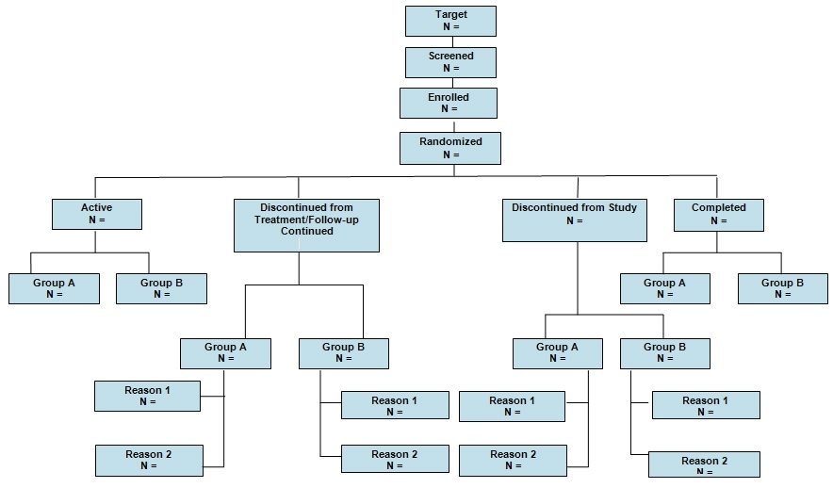

Table 5: Demographic and Key Baseline Characteristics by Blinded Treatment Group

Data as of:_________

Date of report:_________

Characteristics |  | Group A  n (%) | Group B  n (%) | Total  N
Total Enrolled:
Gender | Male
Gender | Female
Ethnicity | Hispanic or Latino
Ethnicity | Not Hispanic or Latino
Ethnicity | Unknown or not reported
Race | American Indian/Alaska Native
Race | Asian
Race | Black or African American
Race | Native Hawaiian or Other Pacific Islander
Race | White
Race | More than one race
Race | Unknown or not reported
Clinical Features/  Stratification | BMI ≥ 30*
Age | Mean
Age | Median
Age | Standard Deviation
Age | Minimum
Age | Maximum

* This is an example, needs to be protocol specific.

Table 6: Treatment Duration for All Participants
Data as of:_________

Date of report:_________

Time in Study* | Group A: n | Group A: % | Group B: n | Group B: % | Total
Visit 1
Visit 2
Visit 3
Visit 4
Completed Study

* Needs to be protocol specific and can be shown by visits, days, weeks, months, or treatment periods.
Final format and content is determined by DSMB.

Safety Assessments:

Tables and Listings

Table 10: Incidence of Adverse Events by Body System, Preferred Term and Treatment Group
Data as of:_________

Date of report:_________
Body System and Preferred Term | Group A  N=n* | Group A  N=%** | Group A  N=Events*** | Group B  N=n* | Group B  N=%** | Group B  N=Events***
Overall
Cardiovascular
Myocardial Infarction
Increased Blood Pressure
etc.
Genitourinary
Yeast Infection
Vaginal Bleeding
etc.
Gastrointestinal
etc….
* Number of participants experiencing an adverse events (participant is to be counted only once for each adverse event) in a Treatment Group
** % of total number of participants in the study
*** Number of events for Body System and Preferred Term
This table can present overall incidence of adverse events as shown above; or adverse events related to the intervention as judged by the investigator; or treatment emergent events.

Table 11: Severity of Adverse Events by Preferred Term and Treatment Group

Data as of:_________

Date of report:_________

Preferred Term* | Group A  N=Mild n** (%)*** | Group A  N=Moderate n (%) | Group A  N=Severe n (%) | Group B  N=Mild n** (%)*** | Group B  N=Moderate n (%) | Group B  N=Severe n (%)
Headache
Pain
etc.

* For preferred term, sort by most common event in descending order of incidence
** Number of participants experiencing a certain severity of an adverse event where each participant is counted once at the highest level of severity for the event.
*** % of participants experiencing a certain severity of an adverse event within Treatment Group

This table can present severity of all adverse events sorted by preferred term in descending order of incidence as shown above; or adverse events related to the intervention as judged by the investigator; or treatment emergent events.

Listing 1: Serious Adverse Events by Treatment Group

Data as of:_________

Date of report:_________

Site | Treatment Group | Participant ID | Onset Date | Stop Date | Expected  (Y/N) | Relationship to Intervention*  (Y/N) | Outcome** | Description of SAE

* Definite, Possible, Not Related
** Outcome:
Recovered, without treatment
Recovered, with treatment
Still Present, no treatment
Still Present, being treated
Residual effect(s) present – no treatment
Residual effect(s) present- being treated
Subject died
Site | Treatment Group | Participant ID | Date of Death | Cause of Death | Relationship to Intervention*

Listing 2: Deaths by Treatment Group

Data as of:_________

Date of report:_________

* Definite, Possible, Not Related

Listing 3: Adverse Events by Treatment Group*
Data as of:_________

Date of report:_________

Site | Treatment Group | Participant ID | Days on Intervention | Preferred Term | Relationship to Intervention** | Severity | Serious (Y/N) | Outcomes***

* This listing could be sorted by Preferred Term or by Treatment Group.
** Definite, Possible, Not Related
*** Outcome:
Recovered, without treatment
Recovered, with treatment
Still Present, no treatment
Still Present, being treated
Residual effect(s) present – no treatment
Residual effect(s) present- being treated
Subject died

Table 12a: Laboratory Test Results Summary Treatment Group A*
Data as of:_________

Date of report:_________
Laboratory Test | Sample Study Visits | N | Mean | SD | Min | Median | Max | N | Mean | SD | Min | Median | Max
Test 1 | Screening
 | 6 Months
 | 12 Months
 | 24 Months
 | 36 Months
Test 2 | Screening
 | 6 Months
 | 12 Months
 | 24 Months
 | 36 Months
Etc… | Screening
 | 6 Months
 | 12 Months
 | 24 Months
 | 36 Months
---------------Change from Baseline--------------
* Table may include lab test results that are clinically significant, as defined by the protocol, or ALL lab test results.
Final format is determined by the DSMB.

Table 12b: Laboratory Test Results Summary Treatment Group B*
Data as of:_________

Date of report:_________
---------------Change from Baseline--------------
Laboratory Test | Sample Study Visits | N | Mean | SD | Min | Median | Max | N | Mean | SD | Min | Median | Max
Test 1 | Screening
 | 6 Months
 | 12 Months
 | 24 Months
 | 36 Months
Test 2 | Screening
 | 6 Months
 | 12 Months
 | 24 Months
 | 36 Months
Etc… | Screening
 | 6 Months
 | 12 Months
 | 24 Months
 | 36 Months
* Table may include lab test results that are clinically significant, as defined by the protocol, or ALL lab test results. Final format is determined by the DSMB.

Listing 4: Clinically Significant Abnormal Lab Values

Data as of:_________

Date of report:_________

Site | Treatment Group | Participant ID | Visit | Age | Gender | Lab Panel | Lab Test | Result

