Recommended Needle Sizes, Sites, and Volumes for Injection

Species | Subcutaneous | Intramuscular | Intraperitoneal | Intravenous | Intragastric
Rat | Scruff, back,  5-10 ml,  21 G or smaller | Quadriceps/posterior thigh, 0.3 ml,  23 G or smaller | 5-10 ml,  23 G or smaller | Lateral tail vein, 0.5 ml, 25 G or smaller | 5 ml
Mouse | Scruff, 2-3 ml,  21 G or smaller | Quadriceps/posterior thigh, 0.05 ml,  25 G or smaller | 2-3 ml,  23 G or smaller | Lateral tail vein, 0.5 ml, 25 G or smaller | 0.5 ml

Adapted from Laboratory Animals Anesthesia (P.A. Flecknell, Academic Press, 1987) and Experimental and Surgical Technique in the Rat – Second Edition (H.B. Waynforth and P.A. Flecknell, Academic Press, 1992)

GENERAL ADMINISTRATION NOTES

- Recommendations are based on the adult body weight of a rat [200 g] and the adult body weight of a mouse [20 g]
- These volumes should be reduced if the injected material is likely to irritate tissues OR if using an
oil-based vehicle for gavaging
- Changing needles also serves to keep the injection needle from becoming dulled if passed through a stoppered vial
- For IV injections, it is recommended to use the lateral tail vein, while the mouse is enclosed within a commercial or custom made restrainer. Dilation of the vein is accomplished by warming of the tail by immersion in warm water or use of a heat lamp. Five minutes of supplemental heat may be necessary for optimal dilation. Monitor carefully to prevent the animal from being burned or overheated by the heat source. The vein is best entered in the proximal 1/3 of the tail, and a successful injection is obvious to the user [based on lack of resistance as the plunger is depressed]. If repeat injections are performed, it is recommended that user start further down the tail and to work upwards. In most cases a maximum injection volume of 0.5 ml can be safely given to an adult mouse [based on experience and veterinary observations]. Most users try to limit the injection to 0.25 ml [a standard veterinary recommendation]. For cell injections, over-concentration may lead to embolism in lung capillaries and death of the recipient. The tendency to clump is cell line dependent. Mastering of the injection technique takes practice and training sessions may be scheduled by contacting the facility manager or the LAM veterinary staff.
- For hydrodynamic gene therapy, the volumes range from 1.6 to 2.5 ml, which is given over 3-5 seconds or 6-8 seconds depending on the volume. The standard needle size used for Balb/c mice is 25 gauge and for mice with smaller tail veins [i.e., C57BL/6] a 27 gauge needle is used. Please note that it can take up to 15 seconds to administer the agent if a 27 gauge needle is used. Based on veterinary observations, the appearance of the mice post-injection is strain dependent. The Balb/c mice are not as affected by the injections as the B6 mice. The usual clinical manifestation post-injection ranges from mild immobility with the lower volume to extended periods of immobility with the higher volume. Most often, the animals are alert but have a reduced activity level [stunned appearance]. Severe dyspnea has been reported by others and if seen the animals must be humanely euthanized.
- For routine hydrodynamic-based transfection, anesthesia is not recommended prior to the injection due to observed gasping and delayed recovery as compared with unanesthetized animals

GUIDELINES FOR NEEDLE USE

Reuse of needles on multiple animals can lead to dulling of the needle, increasing the discomfort associated with injections, and can lead to disease transmission and/or contamination of vials of material to be injected. Therefore the ACUC requires justification be provided if the reuse of needles exceeds the following criteria:
- A needle may not be used on more than five animals, and must be replaced before this point if there is evidence that it is becoming dull (e.g., needle is difficult to insert through skin).
- A needle should only be reused on animals from the same cage to avoid transmission of infectious diseases from one cage to the next.
- A needle, once used on an animal, may not be reintroduced into the vial of material being injected unless the vial is to be discarded immediately after dosing (avoids the possibility of significant bacterial contamination at subsequent use).

From: http://www.caninediabetes.org/pdorg/bd_needle.htm
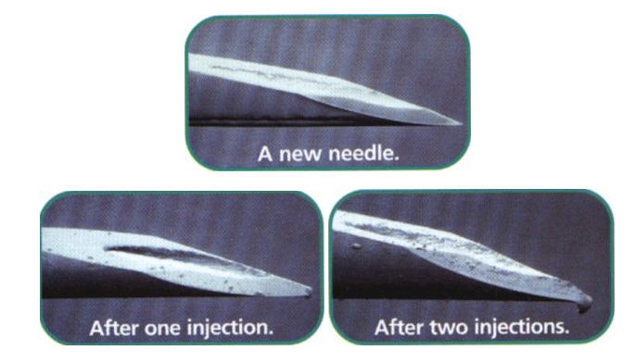

From: http://www.bddiabetes.com/us/main.aspx?cat=1&id=266

The harm you can cause yourself by reusing a needle is much greater than any convenience or cost savings. The tips of needles may become damaged after just one injection. Even though you can’t see this damage with the naked eye, it’s still there – and it may become worse each time you reuse. There are a lot of good reasons not to reuse syringe or pen needles:

The tip of a reused needle can be weakened to the point where it breaks off and gets stuck under your skin.
A reused needle doesn’t inject as easily or as cleanly as a new one and can cause pain, bleeding, and bruising.
Studies have shown that there’s a link between needle reuse and the appearance of lumps of fatty tissue that can form at an injection site (lipodystrophy).
BD’s thin, fine, high quality needles are designed to be used one time only. These are photographs showing the type of damage that can occur with needle reuse.*

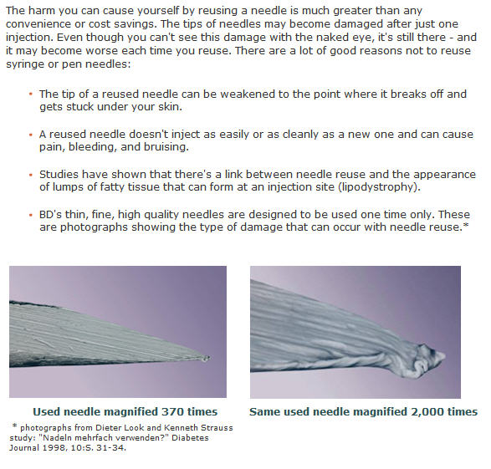
*photographs from Dieter Look and Kenneth Strauss study: “Nadeln mehrfach verwenden?” Diabetes Journal 1998, 10:S. 31-34.

