Department of Health and Human Services
National Institutes of Health
NIH Enterprise Information Portal

MY.NIH.GOV Portal

User Guide for Project Leaders and Members

June 2006

Contents

Structure of This Document 1
Contact Information 1
Project Roles 2
Project Administration and Setup 5
Changing How My Project Is Set Up 5
I Need to Add Project Members 6
To Add a Group of Users 7
To Add an Individual User 8
Deleting a Project Participant 8
I Need to Assign Project Privileges 9
Editing a Project Member’s Privileges 9
Searching a Project 9
Archiving a Project 9
To Restore An Archived Project 10
Deleting A Project 10
Project Recycle Bin 11
Emptying Items 11
Undeleting Items 11
Project Access and Overview 13
How Do I Access a Project? 13
Adding a Project to the My Projects Portlet on My Pages 14
To Remove a Project From the My Projects Selector Portlet on My Pages 14
Subscribing to a Project 14
Notifying Someone About a Project 15
Creating a New Announcement 16
Project Calendar 19
I Need to Create An Event 20
I Need to Edit an Event 21
I Need to Change Who Can Access a Calendar Event 21
I Need to Attach a Document to a Calendar Event 22
Removing an Attached Document From a Calendar Event 23
I Need to Attach a Discussion to a Calendar Event 23
Removing an Attached Discussion From a Calendar Event 23
I Need to Attach a Task List to a Calendar Event 24
Removing an Attached Task List From a Calendar Event 24
I Need to Delete An Event 24
Project Task Lists and Tasks 27
I Need to Create a Task List 27
I Need to Edit a Task List 28
I Need to Attach a Document to a Task List 28
Removing an Attached Document From a Task List 28
I Need to Attach a Discussion to a Task List 28
Removing an Attached Discussion From a Task List 28
I Need to Copy/Move a Task List 29
I Want to Subscribe to a Task List 29
Unsubscribing From a Task List 29
I Need to Notify Others About a Task List 30
I Want to Export a Task List 30
I Want to Add a Task List to My QuickLinks 30
Accessing Task List QuickLinks 31
Removing a Task List’s QuickLink 31
I Want to Print a Task List 31
I Need to Delete a Task List 32
I Need to Create a Task (or Multiple Tasks) 32
I Need to Access a Task 33
I Need to Edit a Task 34
I Want to Assign a Task 34
I Want to Claim a Task 34
I Want to Change a Task’s Status 34
I Need to Create New Subtasks 35
I Want to See a Task’s History 35
I Want to Sort the Tasks in a Task List 35
I Want to Change to a Timeline (or Table) View of Tasks 35
I Want to Print a Task 36
I Want to Add a Task to My QuickLinks 36
Accessing Task QuickLinks 37
Removing a Task’s QuickLink 37
I Need to Delete a Task 37
Project Folders and Documents 39
I Need to Create a Folder 40
I Want to Change a Folder’s (or Subfolder’s) Name 40
I Need to Change Who Can Access a Folder or Subfolder 40
I Want to Subscribe to a Folder 41
Unsubscribing From a Folder 41
I Need to Notify Someone About a Folder 41
I Need to Copy/Move a Folder 42
I Need to Create a Subfolder 42
I Need to Delete a Folder 43
I Need to Upload a File 43
I Need to Zip Download Multiple Files and/or Folders 43
I Need to Assign Moderators to a Folder 44
I Need to Create an Office Document 44
I Need to Access a Document 45
I Want to Change a Document’s Name 45
I Need to Change Who Can Access a Document 45
I Want to Subscribe to a Document 46
Unsubscribing From a Document 46
I Want To Notify Someone About a Document 46
I Need to Attach a Discussion to a Document 47
Removing an Attached Discussion From a Document 47
I Need to Attach a Task List to a Document 47
Removing an Attached Task List From a Document 47
I Need to Download a Document 48
I Want to View a Document’s Version History 48
Deleting a Version of a Document 48
Reverting to a Previous Version of a Document 48
I Want to Edit a Document Using WebEdit 49
I Need to Checkout a Document 49
Checking in a Document 50
Undoing a Document’s Checkout 50
I Need to Copy/Move a Document 50
I Need to Publish a Document 51
I Want to Create a Shortcut to a Document 51
I Want to Upload a New Document by Sending E-Mail to a Collaboration Project 52
I Want to Add a Document to My QuickLinks 52
Accessing Document QuickLinks 52
Removing a QuickLink 53
I Need to Delete a Document 53
I Want to Map a Web Folder to My Network Places 53
Project Discussions 56
I Need to Create a New Discussion Thread 57
I Need to Edit a Discussion Thread’s Details 57
I Need to Assign/Change a Discussion Thread’s Moderator 58
I Need to Subscribe to a Discussion Thread 58
Unsubscribing from a Discussion Thread 58
I Want to Notify Someone About a Discussion Thread 58
I Need to Attach a Document to a Discussion Thread 59
Removing an Attached Document From a Discussion Thread 59
I Need to Attach a Task List to a Discussion Thread 59
Removing an Attached Task List From a Discussion Thread 60
I Want to Add a Discussion Thread to My QuickLinks 60
Accessing Discussion Thread QuickLinks 60
Removing a QuickLink 61
I Need to Export a Discussion Thread 61
I Need to Delete a Discussion Thread 61
I Need to Create a New Discussion Message 61
I Want to Access a Discussion Message 62
I Need to Reply to a Discussion Message 62
I Need to Edit a Discussion Message’s Details 63
I Need to Approve/Reject a Discussion Message 63
I Want to Subscribe to a Discussion Message 63
Unsubscribing from a Discussion Message 63
I Want to Add a Discussion Message to My QuickLinks 64
Accessing Discussion Message QuickLinks 64
Removing a QuickLink 64
I Need to Delete a Discussion Message 65
I Want to Create a New Discussion Message by Sending E-Mail to a Collaboration Project 65
What’s a Personal Project? 66
Creating Personal Project Notes 66
To Edit a Personal Project Note 67
To Delete a Personal Project Note 67
Permission Matrix 69

Figures
Figure 1 – Overview Page 5
Figure 2 – Edit Project Page 6
Figure 3 – Adding Project Members/Modifying Permissions 7
Figure 4 – Project Participant Deletion Confirmation Window 8
Figure 5 – Archival Confirmation Window 10
Figure 6 – Deletion Confirmation Window 10
Figure 7 – Overview Page 12
Figure 8 – Overview Page 13
Figure 9 – Subscription Confirmation Window 15
Figure 10 – Send Notification Window 15
Figure 11 – Project Notification URL Textbox 16
Figure 12 – New Announcement Window 16
Figure 13 – Calendar Page 18
Figure 14 – Calendar Display 19
Figure 15 – New Event Window 20
Figure 16 – Event Details Window 21
Figure 17 – Edit Event Window 22
Figure 18 – Project Deletion Confirmation Window 24
Figure 19 – Tasks Page (Task Lists View) 25
Figure 20 – Tasks Page (Tasks View) 26
Figure 21 – New Task List Window 27
Figure 22 – Task List Notification URL Textbox 30
Figure 23 – Print Task List 32
Figure 24 – New Task Window 33
Figure 25 – Task Details 33
Figure 26 – Print Task List 36
Figure 27 – Documents Page 38
Figure 28 – Documents Page 39
Figure 29 – New Folder Properties Window 40
Figure 30 – Folder Notification URL Textbox 42
Figure 31 – Document Details Area 45
Figure 32 – Document Notification URL Textbox 46
Figure 33 – Discussions Page 55
Figure 34 – Discussion → Message → Item Hierarchy 56
Figure 35 – Discussions Page 56
Figure 36 – New Discussion Window 57
Figure 37 – Discussion Thread Notification URL Textbox 59
Figure 38 – My Projects Portlet 66
Figure 39 – Project Explorer 66
Figure 40 – New Note Window 67

Structure of This Document
The intended audience for this document is Project Leaders and/or Members of the My.NIH.Gov portal located at https://my.nih.gov. Project Leaders are those individuals who create and maintain Projects within an NBII Community. Project Members are those individuals who use a Project (e.g., calendaring, document sharing, online discussions) to facilitate teamwork.

Instructions in this Guide are annotated by a Reminder: if they are only available to a specific role. Project participants’ permissions and access are further described in the “Project Roles” section.

NOTE: If you are a Community Manager, please see the My.NIH.Gov Portal, User Guide for Community Managers for specifics about Community management including Community setup, access, and content.

Contact Information
- For questions about this Guide, contact the NIH Help Desk: 301-594-6248 or helpdesk@nih.gov

Project Roles
On each Project, there are three roles available: Project Leader, Project Member, and Project Guest.
- Project Leader: This role has full control of all project-related activities and can assign access privileges to Projects and Project features including read, write, and edit permissions.
- Project Member: By default, this role has Write access to most Project features so as to participate in the Project.
- Project Guests: Project Guests are users who require read-only access to the Project, cannot upload or modify documents, and cannot update task lists. They can, however, reply to messages in threaded discussions (but cannot create new threads). Use the Project Guest setting only for users who have a tertiary interest or stake in your Project.

The following table lists those activities that, by default, are available to a Project Leader or a Project Member. However, Project Members’ access can be changed by the Project Leader. Instructions in this Guide are annotated by a Reminder: if they are only available to a specific role.

Table Legend
*Available only if the item was created (or in the case of documents, uploaded) by a Project Member.
**Approve and reject are only available if the person is classified as a Moderator.

Project Role Associations
Activity | Project Leader | Project Member
Projects
Modify project properties/access | x
Search a project | x | x
Assign project members/roles | x
View projects | x | x
Add/remove a project to/from the My Project portlet | x | x
Subscribe/unsubscribe to a project | x | x
Notify someone about a project | x | x
Create an announcement | x
Edit an announcement | x
Delete an announcement | x
Delete a project | x
Project Recycle Bin | x
Calendar
Configure calendar security/access | x | x*
Create/add an event | x | x*
Change access to a calendar event | x | x*
Edit an event | x | x*
Delete an event | x | x*
Attach/remove documents, discussions, & task lists to/from an event | x | x*
Task Lists/Tasks
Configure task lists/tasks security/access | x
Create a task list | x
Edit a task list | x
Attach/Remove a document or discussion to/from a task list | x | x
Copy/Move a task list | x
Subscribe/unsubscribe to/from a task list | x | x
Notifying others of a task list | x | x
Export a task list | x | x
Add/remove task list/task to/from My QuickLinks | x | x
Print a task list/task | x | x
Delete a task list | x
Create a task (or multiple tasks) | x | x
Access a task | x | x
Edit a task | x | x*
Assign owners to a task | x | x*
Claim tasks | x | x
Update a task’s status | x | x*
Create a subtask | x | x*
View task history | x | x
Sort tasks or change task view | x | x
Delete a task | x | x*
Folders/Documents
Configure folder/document security/access | x | x*
Create a folder | x | x
Rename a folder | x | x*
Subscribe/unsubscribe to/from a folder | x | x
Notify someone about a folder | x | x
Copy/move a folder | x | x*
Create a subfolder | x | x
Delete a folder | x | x*
Upload a file | x | x
Folder Moderators | x
Create a New Web Folder in My Network Places | x
Create a new Office document | x | x
Access a document | x | x
Change a document’s name | x | x*
Configure document security/access | x | x*
Subscribe/unsubscribe to/from a document | x | x
Notify someone about a document | x | x
Attach/Remove task lists and discussions to/from a document | x | x
Download a document | x | x
View a document’s version history | x | x
Edit a document using Web Edit | x | x*
Check In/check out a document | x | x
Undo check out of a document | x | x
Copy/move a document | x | x*
Publish a document to Knowledge Directory | x | x*
Create shortcuts to a document | x | x*
Add/Remove a document to/from My QuickLinks | x | x
Delete a document | x | x*
Delete a document’s versions | x | x*
Revert documents to the previous version | x | x*
Discussions
Configure discussion thread security/access | x
Create a new discussion thread | x
Edit a discussion thread’s details | x
Change a discussion thread’s moderator | x
Subscribe/unsubscribe to a discussion thread/message | x | x
Notify someone about a discussion thread | x | x
Attach/remove a document or task list to/from a discussion thread | x | x
Add/remove a document to/from My QuickLinks | x | x
Export a discussion thread | x
Delete a discussion thread | x
Create a new discussion message | x | x
Access a discussion message | x | x
Create new discussion message by e-mail to a Collaboration project | x
Reply to a discussion message | x | x
Edit a discussion message’s details | x | x*
Approve/reject a discussion message | x** | x**
Subscribe/unsubscribe to/from a discussion message | x | x
Add/remove a discussion message to/from My QuickLinks | x | x
Delete discussion messages | x | x*
Subscribe others to a discussions | x | x

Project Administration and Setup
Projects allow additional workspaces within a Community for tasks that involve subsets of a Community’s Membership. You can create multiple Projects, each with its own set of documents, discussions, and tasks. A Project Leader can delegate “ownership” of a Project to another Project Member, decentralizing responsibility and encouraging wider participation in the day-to-day management of the overall system. Moreover, non-Community Members who are registered portal users can be given access to a particular Project when collaboration is required—facilitating cross-Node and cross-Project collaboration, while maintaining the integrity of individual Community workspaces.

Please click on “Project Request” link on the Portal Info Center Community for creation of a new Project.

After Portal Administrator creates your project and you are designated Project Leader, you will be able to edit the parameters of the project.

How Do I Know if I am a Project Leader?
- Go to your Community and navigate to the Community Projects portlet or access your Project directly from your own Projects portlet.
- Click the hyperlink of the Project whose information you want to see.
The Overview page appears.
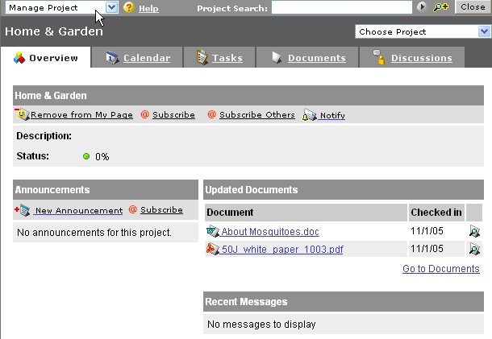
Figure 1 – Overview Page
If the Manage Project link appears in the upper left corner, you have been designated as a Project Leader for that project.

Changing How My Project Is Set Up
Reminder: You can modify project settings only if you’re a Project Leader.

You may want/need to change project settings—for example, the project’s name or status, project membership or access rights, or what functional areas (i.e., calendar, tasks, documents, discussions) are available.

- Go to your Community’s home page and navigate to the Community Projects portlet or access your Project directly from your own Projects portlet.
- Click the hyperlinked name of the Project whose information you want to change.
- On the Overview page, select .
The Edit Project page appears.
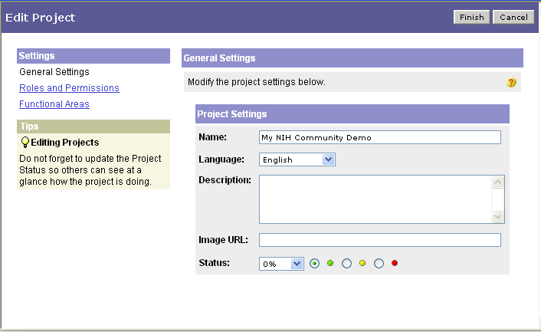
Figure 2 – Edit Project Page
- Do any of the following:
- Enter/change Project setup information, e.g., name, description, status.
- To change a Project participant’s permissions, click .
- Click for the role whose access you want to change.
- Specify permissions by selecting/deselecting radio buttons ().
- To save your changes, click . (To exit without saving your changes, click .)
- To change a Project participant’s role, click. (For specifics, see “I Need to Add Project Members.”)
- To change the Project’s functional areas (i.e., calendar, tasks, documents, discussions), click .
- Check () the box(es) next to those functional areas you want available in this Project.
- To save your changes and return to the Overview page, click . (To exit without saving your changes, click .)
- To save Project changes, click . (To exit without saving your changes, click .)

I Need to Add Project Members
Reminder: You can only add project members if you’re a Project Leader.

Project roles (i.e., Leaders, Members, Guests) can be assigned by specific user or by group. You can also assign project participants from another Community. For more, see the “Project Roles” section.

Below is a sample of the Roles and Permissions area, where you can add/remove Project participants as well as change general Project settings and/or modify functional areas (e.g., documents, discussions) available to the Project.
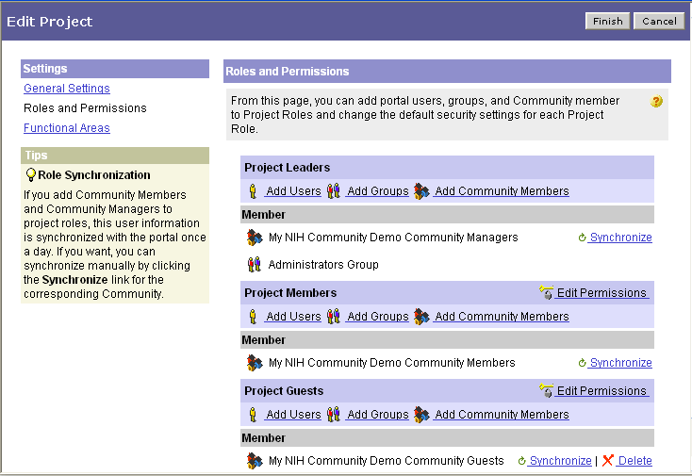
Figure 3 – Adding Project Members/Modifying Permissions

To Add a Group of Users
Reminder: You can only add project members if you’re a Project Leader.

- To access the Roles and Permissions area (where Project participants are assigned), if you are creating a new Project, from the New Project page, click ,
-or-
from your Community’s Home Page, in the Community Projects portlet, click your Project’s hyperlinked name; on the Overview page, click ; then click .
- In the Roles and Permissions area, go to the area for which you want to add users (i.e., Project Leaders, Project Members, Project Guests) and click .
A pop-up selection of Group folders will appear.

- To expand a Group’s listing, click its hyperlinked folder name.
- Check the box(es) () next to the Group(s) you want to add to the Project.
- Click . (To exit without adding the selected Group[s], click .)
The Group(s) will appear in the selected role’s area when the page reloads.
- (Optional) To change a participant’s Project access privileges, go to “I Need to Assign Project Privileges.”)

NOTE: The portal uses groups that currently exist in the Active Directory. It is highly possible that a group you would like to use already exists and you can just assign it rights. If your group only exists in the Global Address List (viewable via Outlook) then it is a Distribution List, not a Security Group. Send an email to the NIH Help Desk and instruct them to convert the Distribution List to a “mail-enabled security group”. If no group already exists, send an email to the Help Desk and instruct them to create a “mail-enabled security group” for use in the portal. Once this group is converted or created, the portal will need up to 24 hours to see it. You will be able to add or delete members via Outlook and continue to email to your group while it is being used to secure your community or project.

To Add an Individual User
Reminder: You can only add project members if you’re a Project Leader.

- To access the Roles and Permissions area (where Project participants are assigned), if you are creating a new Project, from the New Project page, click ,
-or-
from your Community’s Home Page, in the Community Projects portlet, click your Project’s hyperlinked name; on the Overview page, click ; then click .
- In the Roles and Permissions area, go to the area for which you want to add users (i.e., Project Leaders, Project Members, Project Guests).
- Click ,
NOTE: To search for a user you should be entering the actual portal username (e.g. doej) not the proper name (e.g. John Doe). Entering “doe*” will return a list of users, but you will still need to determine if it is the correct name. To be certain, you can find the user in the Global Address List via Outlook. The field “Alias” is typically that used by the portal to identify the user.

- Check the box(es) () next to the individual(s) you want to add to the Project.
- Click . (To exit without adding the selected individual(s), click .)

The individual(s) will appear in the selected role’s area when the page reloads.

- (Optional) To change a participant’s Project access privileges, go to “I Need to Assign Project Privileges.”)

Deleting a Project Participant
Reminder: You can only delete project participants if you’re a Project Leader.

- To access the Roles and Permissions area from your Community’s Home Page, in the Community Projects portlet, click your Project’s hyperlinked name.
- Click .
- Click .
- In the Roles and Permissions area, click in the row of the participant to be removed.
You are prompted to confirm deletion.
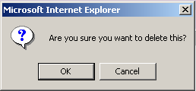
Figure 4 – Project Participant Deletion Confirmation Window

- To delete the participant, click . (To exit without deleting the participant, click .)

I Need to Assign Project Privileges
Reminder: You can only assign project privileges if you’re a Project Leader.

Once you’ve added Project participants (if you haven’t, see “I Need to Add Project Members”), you need to determine whether they have the correct privileges within the Project. For a listing of default privileges, see “Project Roles.”

REMEMBER: Guests cannot upload or modify documents and cannot update task lists. They can, however, reply to messages in threaded discussions (but cannot create new threads).

Editing a Project Member’s Privileges
Reminder: You can only edit a project member’s privileges if you’re a Project Leader.

IMPORTANT‼ The Access Level “Read” is the standard setting for Project Members. Changing the Access Level setting to “Write” or “Full Control” may result in accidental overwrites or deletes of critical Project resources.

- To access the Roles and Permissions area from your Community’s Home Page, in the Community Projects portlet, click your Project’s hyperlinked name.
- On the Overview page, click .
- Click .
- Click for the role whose access you want to change.
- Specify permissions by selecting/deselecting radio buttons ().
- To save your changes, click . (To exit without saving your changes, click .)

Searching a Project
- To search the selected Project, go to .
- Enter search criteria and click .
Results appear.
- (Optional) To refine the search criteria, click the drop arrow(s) and make selection(s).
- Click .

Archiving a Project
Reminder: You can archive a project only if you’re a Project Leader.

When a Project is complete, you may want to keep records of it. You can do this using the archive feature. To completely remove a Project, use the Delete feature. For more, see “Deleting A Project.” Or, you can remove the Project from the My Project Selector portlet on your My Pages. For more, see “To Remove a Project From the My Projects Selector Portlet on My Pages.”

- Go to your Community’s home page and navigate to the Community Projects portlet.
- Click .
- Navigate through the folder structure to the Project you want to archive.
- Check () the Project to be archived.
- Click .
The following window appears where you are asked to confirm archival.
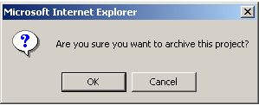
Figure 5 – Archival Confirmation Window

- To archive the Project, click . (To exit without archiving the Project, click .)
A message appears indicating that the Project has been archived.

To Restore An Archived Project
Reminder: You can restore an archived project only if you’re a Project Leader.

- Go to your Community’s home page and navigate to the Community Projects portlet or access your Project directly from your own Projects portlet.
- Click .
- Navigate through the folder structure to the Project you want to restore from archive.
- Check () the Project to be restored.
- Click .

You are returned to Explorer—no confirmation message appears.

Deleting A Project
Reminder: You can delete a project only if you’re a Project Leader.

IMPORTANT‼ When you delete a Project, it is permanently deleted and cannot be restored. You may want to archive the Project instead. For more information, see “Archiving a Project” or “To Remove a Project From the My Projects Selector Portlet on My Pages.”

- Go to your Community’s home page and navigate to the Community Projects portlet or access your Project directly from your own Projects portlet.
- Click .
- Navigate through the folder structure to the Project you want to delete.
- Check () the Project to be deleted.
- Click .
The following window appears where you are asked to confirm deletion.
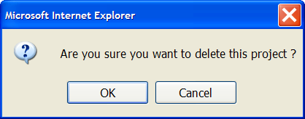
Figure 6 – Deletion Confirmation Window
- To confirm the deletion, click . (To exit without deleting the Project, click .)
A message appears indicating that the Project has been deleted.

Project Recycle Bin
Reminder: Once you have removed items from the recycle bin, you cannot undelete the items
The project's recycle bin displays all of the contents that grouped by functional area (Tasks, Documents, and Discussions) that have been deleted from that specific project.

Emptying Items
1. Click on on the upper left corner.
- In the drop-down list, select
- Right-click on the Tasks, Documents or Discussions node in the navigation tree.
- Choose

NOTE: To empty all items from the recycle bin, choose the root node of the navigation tree and click the Empty Recycle Bin button.

Undeleting Items
1. Click on on the upper left corner.
2. In the drop-down list, select
3. Click on the Tasks, Documents or Discussions node in the navigation pane, depending on the type of
item that you want to undelete.
4. In the table pane, choose one or more items, then right click to select .
Overview Page
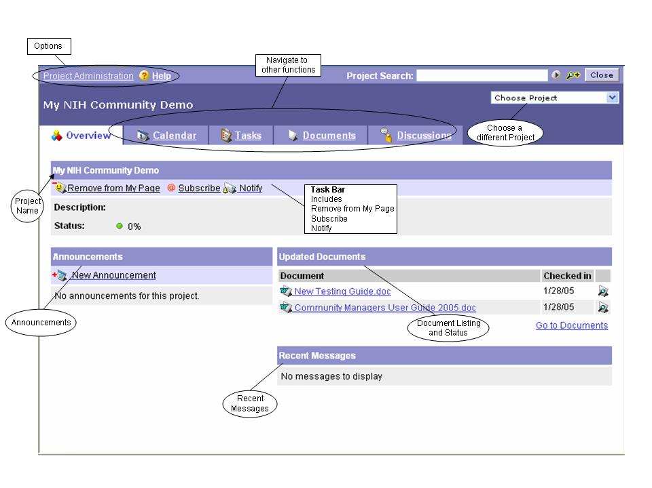
Figure 7 – Overview Page

Project Access and Overview
Once your Project has been created and participants have been assigned, your project can be accessed from the Community Project Portlet on your Community’s home page.

How Do I Access a Project?
The Overview page is where you will perform all Project-specific functions and see all Project-specific information. It’s your Project’s home page.
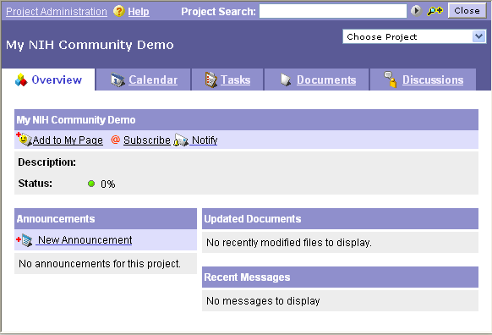
Figure 8 – Overview Page

To access the Overview page, do the following:

- Go to your Community’s home page and navigate to the Community Projects portlet or access your Project directly from your own Projects portlet.
- Click the hyperlink of the Project whose information you want to see.
- Perform any of the following actions:
- Add a project to your My Pages (See “Adding a Project to the My Projects Portlet on My Pages.”)
- Subscribe to the Project (See “Subscribing to a Project.”)
- Send notifications about the Project (See “Notifying Someone About a Project.”)
- Create Project announcements (See “Creating a New Announcement.”)
- Access Project administration functions (See “Changing How My Project Is Set Up.”)
- Search the Project (See “Searching a Project.”)
- Navigate to a different Project
- Click .
- Click the name of the desired Project.
-or-
Click Project Explorer. (Navigate through the folder structure to the desired project and click its hyperlinked name.)
- Access other Project functions (e.g., the Project Calendar). (For more information, see “Project Calendar,” “Project Task Lists and Tasks,” “Project Folders and Documents,” or “Project Discussions.”)

Adding a Project to the My Projects Portlet on My Pages
When you add a link to the My Projects portlet on your My Pages, you can use that link as a shortcut to access Project-related information. The Project will still appear in your Community’s Project Selector portlet. (NOTE: The My Projects portlet must be added separately to your My Pages before your project will appear.)

- Go to your Community’s home page and navigate to the Community Projects portlet or access your Project directly from your own Projects portlet.
- Click the hyperlinked name of the Project that you want to appear in the My Projects portlet of your My Pages.
- On the Overview page, click .
The currently selected Project is added to the My Projects Selector portlet on your customized My Pages.
- Click .

To Remove a Project From the My Projects Selector Portlet on My Pages
(NOTE: Removing a Project from the My Projects portlet does not delete the Project. For information on deleting a Project, see “Deleting A Project,” or for information on archiving a Project, see “Archiving a Project.”)

- Go to your Community’s home page and navigate to the Community Projects portlet or access your Project directly from your own Projects portlet.
- Click the hyperlink of the Project you want to remove from the Project Selector Portlet.
IMPORTANT‼ When you click the link in the next step, the current Project will be removed from your My Projects Selector portlet. If that is not what you want to do, do not complete step 3.
- Click .
The currently selected Project is removed from your My Projects portlet on your customized My Pages.
- Click .

Subscribing to a Project
To be notified about changes to a Project, use the feature. You will be e-mailed whenever activity occurs in the Project. You can specify whether to be notified for each event or to receive a summary of events.

- Go to your Community’s home page and navigate to the Community Projects portlet or access your Project directly from your own Projects portlet.
- Click the hyperlinked name of the Project to which you want to subscribe.
- On the Overview page, click .

A confirmation window appears.
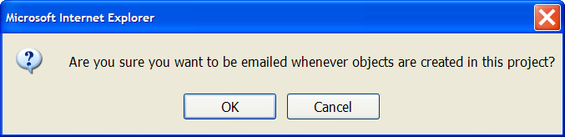
Figure 9 – Subscription Confirmation Window

- To subscribe, click .
-or-
to exit without subscribing, click .

Notifying Someone About a Project
You can send an e-mail notification about the selected Project to a user or group of users.

- Go to your Community’s home page and navigate to the Community Projects portlet or access your Project directly from your own Projects portlet.
- Click the hyperlinked name of the Project for which you want to send an e-mail notification.
- On the Overview page, click .

The Send Notification window appears.
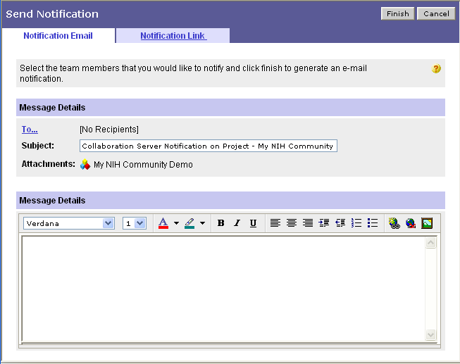
Figure 10 – Send Notification Window

- Enter/select information in the message fields.
- (Optional) To change how the e-mail notification is sent, click . To create the
e-mail using your own e-mail software, click . An e-mail will be created using your default
e-mail software. Address and send the e-mail.
-or-
to paste the link into another software package, copy the URL that appears in the text box, e.g.,:
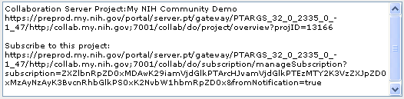
Figure 11 – Project Notification URL Textbox
- To send the e-mail notification, click .
-or-
to exit without sending the e-mail, click .

Creating a New Announcement
Reminder: You can only create an announcement if you’re a Project Leader.

- Go to your Community’s home page and navigate to the Community Projects portlet or access your Project directly from your own Projects portlet.
- Click the hyperlinked name of the Project for which you want to create an announcement.
- Click .
The New Announcement window appears.
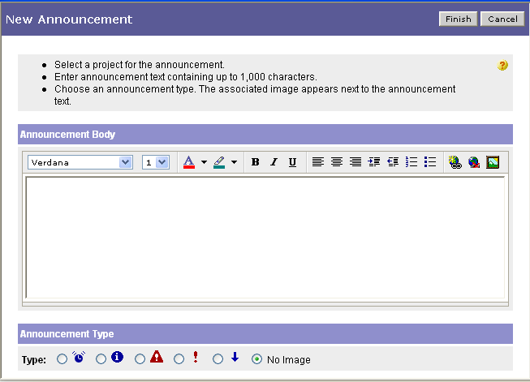
Figure 12 – New Announcement Window

- Enter the text of the announcement (up to 1,000 characters).
- (Optional) Use text formatting buttons for text emphasis.
- Select the announcement type.
- To save the announcement and post it to your Project, click . (To exit without saving the announcement, click .)

You are returned to the Overview page. The new announcement appears at the top of the Project Announcements portlet along with the username of the person who created it and the date and time it was posted.
Calendar Page
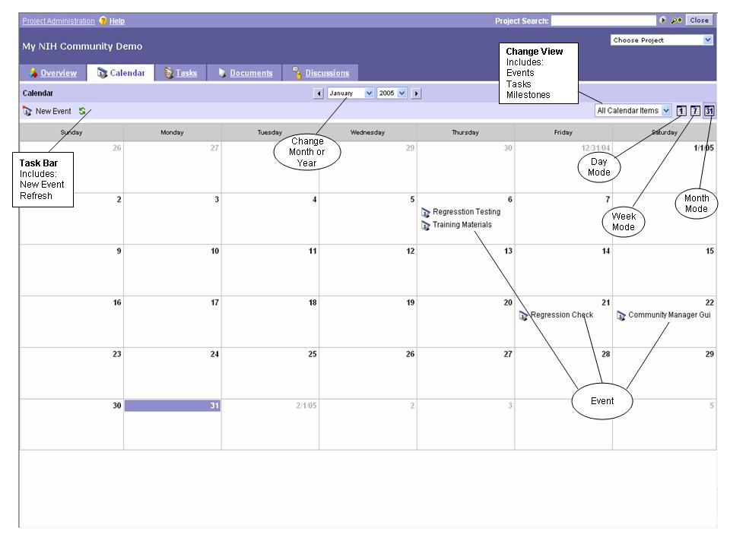
Figure 13 – Calendar Page

Project Calendar
To access a Project’s calendar, do the following:

- Go to your Community’s home page and navigate to the Community Projects portlet or access your Project directly from your own Projects portlet.
- Click the hyperlink of the Project whose calendar information you want to view.
- On the Overview page, click .

The calendar for the current month appears.
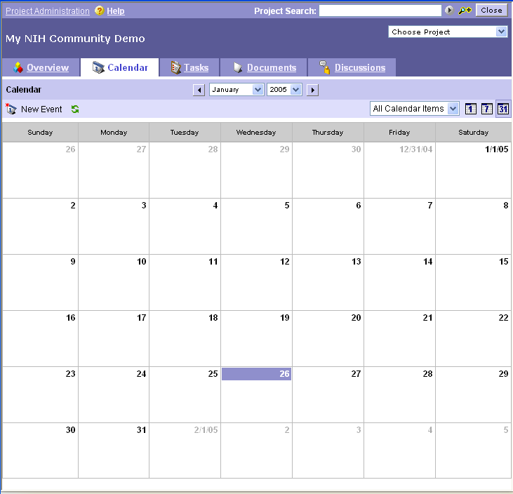
Figure 14 – Calendar Display
- Do any of the following and/or go to step 5:
- To view an event, hover your mouse pointer over it.
- To view event details and access other event options, click the event’s hyperlinked name.
- To access a specific calendar day, click the date. (NOTE: To return to a monthly view, click .)
- To change the month, click the scroll buttons ( ) on either side of the date to scroll backward and forward. To change the month and/or year, click the appropriate drop arrow(s) () and select the desired month/year.
- To change the view to daily, click . To change the view to weekly, click . To change the view to monthly, click .
- To change the view from all calendar items to either events, tasks, or milestones, click , then click your choice.
- To refresh the calendar display, click .
- To create a calendar entry, go to “I Need to Create An Event.”

I Need to Create An Event
- Go to your Community’s home page and navigate to the Community Projects portlet or access your Project directly from your own Projects portlet.
- Click the hyperlink of the Project for which you want to create a calendar event.
- On the Overview page, click .
- On the Project calendar, click .
The New Event window appears.
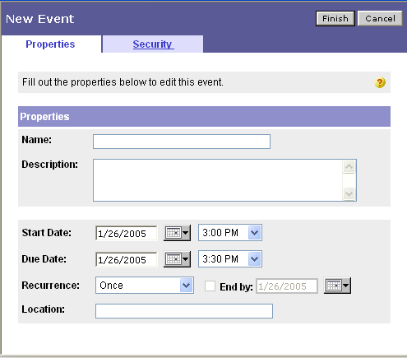
Figure 15 – New Event Window

- Enter/select event details.
- (Optional) To change who can see the calendar event, click .
  - Uncheck .
  - Use the drop lists to specify access options for Project Members and Guests.
- To save the event to the calendar, click . (To exit without creating an event, click .)

I Need to Edit an Event
Reminder: You can modify an event only if you created it or if you’re a Project Leader.

- Go to your Community’s home page and navigate to the Community Projects portlet or access your Project directly from your own Projects portlet.
- Click the hyperlink of the Project whose calendar information you want to access.
- On the Overview page, click .
- On the Project calendar, click the event whose details you want to change.
The Event Details window appears.
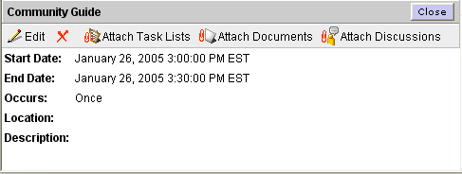
Figure 16 – Event Details Window
- To edit the event, click .
- Enter/select event details.
- (Optional) To change who can see the calendar event, go to “I Need to Change Who Can Access a Calendar Event.”
- To save your changes, click . (To exit without saving your changes, click .)

I Need to Change Who Can Access a Calendar Event
Reminder: You can modify who can access an event only if you created it or if you’re a Project Leader.

- Go to your Community’s home page and navigate to the Community Projects portlet or access your Project directly from your own Projects portlet.
- Click the hyperlink of the Project whose calendar event access you want to change.
- On the Overview page, click .
- On the Project calendar, right-click the event whose access you want to change, then
click .

The Edit Event window appears.
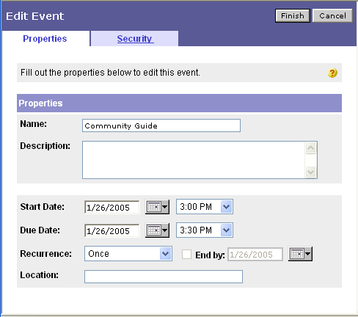
Figure 17 – Edit Event Window

- Click .
- Uncheck and use the drop lists to specify access options for Project Members and Guests.
- To save your changes, click . (To exit without saving your changes, click .)

I Need to Attach a Document to a Calendar Event
Reminder: You can attach a document to a calendar event only if you created the event or if you’re a Project Leader.

- Go to your Community’s home page and navigate to the Community Projects portlet or access your Project directly from your own Projects portlet.
- Click the hyperlink of the Project whose calendar information you want to access.
- On the Overview page, click .
- On the Project calendar, click the event to which you want to attach a document.
- Click .
- Navigate to the item(s) to attach, check [] the name(s), then click . (To exit without attaching a document, click .)
- (Optional) To access a document, click its hyperlinked name.
- To return to the Project calendar, click .

Removing an Attached Document From a Calendar Event
Reminder: You can detach a document from a calendar event only if you created the event or if you’re a Project Leader.

- Go to your Community’s home page and navigate to the Community Projects portlet or access your Project directly from your own Projects portlet.
- Click the hyperlink of the Project whose calendar event information you want to access.
- On the Overview page, click .
- Click the hyperlinked name of the calendar event whose document attachment you want to remove.
- Click at the end of the hyperlinked document name that you want to remove.
- To remove the attachment, click . (To exit without removing the attachment, click .)

I Need to Attach a Discussion to a Calendar Event
Reminder: You can attach a discussion to a calendar event only if you created the event or if you’re a Project Leader.

- Go to your Community’s home page and navigate to the Community Projects portlet or access your Project directly from your own Projects portlet.
- Click the hyperlink of the Project whose calendar information you want to access.
- On the Overview page, click .
- On the Project calendar, click the event to which you want to attach a discussion.
- Click .
- Navigate to the item(s) to attach, check [] the name(s), then click . (To exit without attaching a discussion, click .)
- (Optional) To access a discussion, click its hyperlinked name.
- To return to the Project calendar, click .

Removing an Attached Discussion From a Calendar Event
Reminder: You can detach a discussion from a calendar event only if you created the event or if you’re a Project Leader.

- Go to your Community’s home page and navigate to the Community Projects portlet or access your Project directly from your own Projects portlet.
- Click the hyperlink of the Project whose calendar event information you want to access.
- On the Overview page, click .
- Click the hyperlinked name of the calendar event whose discussion attachment you want to remove.
- Click at the end of the hyperlinked discussion name that you want to remove.
- To remove the attachment, click . (To exit without removing the attachment, click .)

I Need to Attach a Task List to a Calendar Event
Reminder: You can attach a task list to a calendar event only if you created the event or if you’re a Project Leader.

- Go to your Community’s home page and navigate to the Community Projects portlet or access your Project directly from your own Projects portlet.
- Click the hyperlink of the Project whose calendar information you want to access.
- On the Overview page, click .
- On the Project calendar, click the event to which you want to attach a task list.
- Click .
- Navigate to the item(s) to attach, check [] the name(s), then click . (To exit without attaching a task list, click .)
- (Optional) To access a task list, click its hyperlinked name.
- To return to the Project calendar, click .

Removing an Attached Task List From a Calendar Event
Reminder: You can detach a task list from a calendar event only if you created the event or if you’re a Project Leader.

- Go to your Community’s home page and navigate to the Community Projects portlet or access your Project directly from your own Projects portlet.
- Click the hyperlink of the Project whose calendar event information you want to access.
- On the Overview page, click .
- Click the hyperlinked name of the calendar event whose task list attachment you want to remove.
- Click at the end of the hyperlinked task list name that you want to remove.
- To remove the attachment, click . (To exit without removing the attachment, click .)

I Need to Delete An Event
Reminder: You can delete an event only if you created it or if you’re a Project Leader.

- Go to your Community’s home page and navigate to the Community Projects portlet or access your Project directly from your own Projects portlet.
- Click the hyperlink of the Project whose calendar information you want to delete.
- On the Overview page, click .
- On the Project calendar, right-click the event you want to delete.
- Click .
The following window appears where you are asked to confirm deletion.
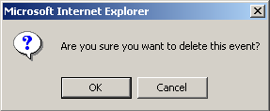
Figure 18 – Project Deletion Confirmation Window

- To delete the event, click . (To exit without deleting the event, click .)
Task Lists
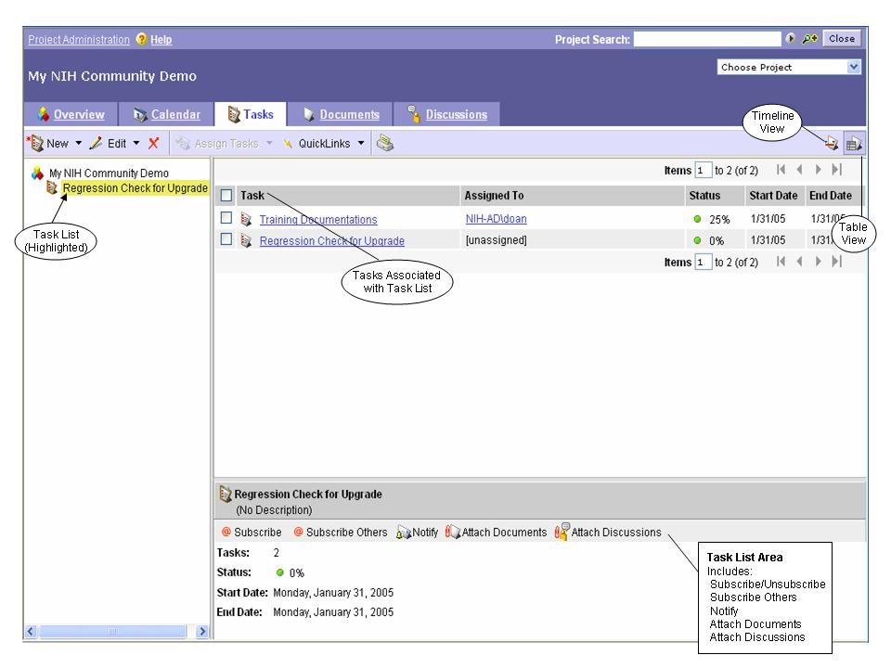
Figure 19 – Tasks Page (Task Lists View)

Tasks
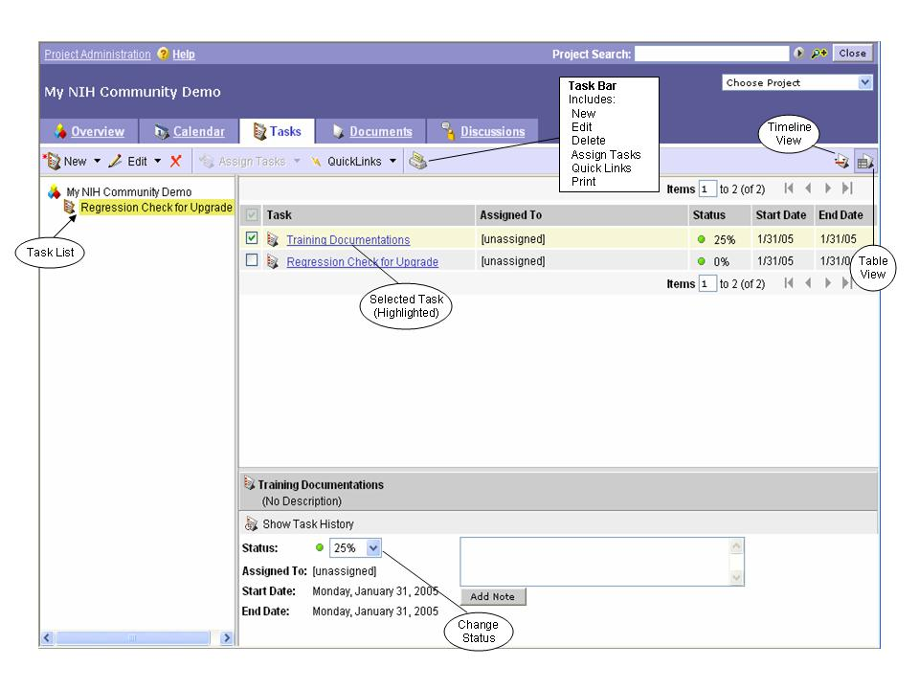
Figure 20 – Tasks Page (Tasks View)

Project Task Lists and Tasks
A task list is a grouping of related tasks. On the Tasks page, you can perform a variety of functions for both task lists and tasks. Before you can create a task or use options on the Tasks page, you must first create a task list.

I Need to Create a Task List
Reminder: You can create a task list only if you’re a Project Leader.

The following procedure explains how to create a task list. For information on creating an individual task, see “I Need to Create a Task (or Multiple Tasks).”

- Go to your Community’s home page and navigate to the Community Projects portlet or access your Project directly from your own Projects portlet.
- Click the hyperlink of the Project whose task list information you want to see.
- On the Overview page, click .
- On the Tasks page, click .
The New Task List window appears.
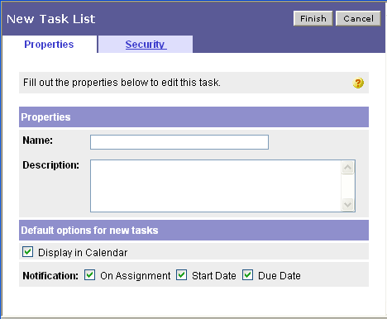
Figure 21 – New Task List Window

- Enter/select task list details.
- (Optional) To change who can see the task list, click .
- Uncheck .
- Use the drop lists to specify access options for Project Members and Guests.
- To save the task list, click . (To exit without saving, click .)

For information on creating an individual task, see “I Need to Create a Task (or Multiple Tasks).”

I Need to Edit a Task List
Reminder: You can edit a task list only if you’re a Project Leader.

The following procedure explains how to edit a task list. For information about editing an individual task, see “I Need to Edit a Task.”

- Go to your Community’s home page and navigate to the Community Projects portlet or access your Project directly from your own Projects portlet.
- Click the hyperlink of the Project whose task list information you want to access.
- On the Overview page, click .
- Right-click the hyperlinked name of the task list you want to edit, then click .
- Enter/select changes.
- To save your changes, click . (To exit without saving your changes, click .)

I Need to Attach a Document to a Task List
- Go to your Community’s home page and navigate to the Community Projects portlet.
- Click the hyperlink of the Project whose task list information you want to access.
- On the Overview page, click .
- On the Tasks page, click the task list to which you want to attach a document.
- Click .
- Navigate to the document(s) you want to attach and check [] the desired name(s).
- Click . (NOTE: To access a document, click its hyperlinked name.)

Removing an Attached Document From a Task List
- Go to your Community’s home page and navigate to the Community Projects portlet or access your Project directly from your own Projects portlet.
- Click the hyperlink of the Project whose task list information you want to access.
- On the Overview page, click .
- Click the hyperlinked name of the task list whose document attachment you want to remove.
- In the task list details area, click at the end of the hyperlinked document name that you want to remove.
- To remove the attachment, click . (To exit without removing the attachment, click .)

I Need to Attach a Discussion to a Task List
- Go to your Community’s home page and navigate to the Community Projects portlet.
- Click the hyperlink of the Project whose task list you want to access.
- On the Overview page, click .
- On the Tasks page, click the task list to which you want to attach a discussion.
- Click .
- Navigate to the discussion(s) to be attached and check [] the desired name(s).
- Click . (NOTE: To access a discussion, click its hyperlinked name.)

Removing an Attached Discussion From a Task List
- Go to your Community’s home page and navigate to the Community Projects portlet or access your Project directly from your own Projects portlet.
- Click the hyperlink of the Project whose task list information you want to access.
- On the Overview page, click .
- Click the hyperlinked name of the task list whose discussion attachment you want to remove.
- In the task list details area, click at the end of the hyperlinked discussion name that you want to remove.
- To remove the attachment, click . (To exit without removing the attachment, click .)

I Need to Copy/Move a Task List
Reminder: You can copy/move a task list only if you’re a Project Leader.

- Go to your Community’s home page and navigate to the Community Projects portlet or access your Project directly from your own Projects portlet.
- Click the hyperlink of the Project whose task list information you want to copy/move.
- On the Overview page, click .
- Click the hyperlinked name of the task list you want to copy/move.
- Click the drop arrow () beside , then click either or .
- Click .
- Navigate to the desired project, click its radio button (), then click .
- Specify task list copy/move options by selecting/checking desired options.
- To create the copy (or move the task list) and place it in the specified project, click . (To exit without copying/moving the task list, click .)
- To exit the Summary window, click .

I Want to Subscribe to a Task List
- Go to your Community’s home page and navigate to the Community Projects portlet or access your Project directly from your own Projects portlet.
- Click the hyperlink of the Project whose task list you want to access.
- On the Overview page, click .
- On the Tasks page, click the task list name for which you want to add/change subscription information.
- In the task list details area, click either or .
- If you chose to Subscribe Others, click , then navigate to the individual(s) and check [] the desired name(s). Check () whether to provide Immediate or Summary information, then click . (To exit without subscribing others, click .)

Unsubscribing From a Task List
- Go to your Community’s home page and navigate to the Community Projects portlet or access your Project directly from your own Projects portlet.
- Click the hyperlink of the Project whose task list you want to access.
- On the Overview page, click .
- On the Tasks page, click the task list name for which you want to change subscription information.
- In the task list details area, click either or .
- If you chose Subscribe Others, uncheck [] both the Immediate and Summary checkboxes, then click . (To exit without unsubscribing others, click .)

I Need to Notify Others About a Task List
- Go to your Community’s home page and navigate to the Community Projects portlet or access your Project directly from your own Projects portlet.
- Click the hyperlink of the Project whose task list you want to access.
- On the Overview page, click .
- On the Tasks page, click the task list for which you want to send a notification.
- In the task list details area, click .
- Enter/select information in the message fields.
- (Optional) To change how the e-mail notification is sent, click . To create the e-mail using your own e-mail software, click . An e-mail will be created using your default e-mail software. Address and send the e-mail.
-or-
to paste the link into another software package, copy the URL that appears in the text box, e.g.,:
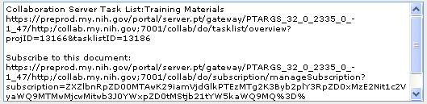
Figure 22 – Task List Notification URL Textbox
- To send the e-mail notification, click .
-or-
to exit without sending the e-mail, click .

I Want to Export a Task List
To export a task list, it must contain tasks. The task list will be exported to a comma separated values (CSV) file.

- Go to your Community’s home page and navigate to the Community Projects portlet or access your Project directly from your own Projects portlet.
- Click the hyperlink of the Project whose task list information you want to export.
- On the Overview page, click .
- Click the hyperlinked name of the task list you want to export.
- Click the click drop arrow () beside , then click .
- Click 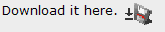.
- Click .
- Specify the location to which to save the file, then click .
- To exit the Download Complete window, click .
- To exit the Summary window, click .

I Want to Add a Task List to My QuickLinks
QuickLinks are a way to specially mark task lists (or tasks) for easy access later. Listed next is the procedure for creating a QuickLink for a task list. For information on using a QuickLink, see “Accessing Task QuickLinks.” For information on creating a QuickLink to a task, see “I Want to Add a Task to My QuickLinks.”

- Go to your Community’s home page and navigate to the Community Projects portlet or access your Project directly from your own Projects portlet.
- Click the hyperlink of the Project whose task list information you want to access.
- On the Overview page, click .
- Click the hyperlinked name of the task list for which you want to create a QuickLink.
- Click .
- In the QuickLinks modification window, to confirm modification, click .

Accessing Task List QuickLinks
By using the QuickLinks feature in the My Tasks portlet on your My Pages, you can filter out all other task lists/tasks and see only those previously marked as QuickLinks.

NOTE: Before you can access task list QuickLinks, you must first have created them. For more information, see “I Want to Add a Task List to My QuickLinks.”

- Go to your My Pages.
- Go to the My Tasks portlet.
- Click , then click .

A listing of only those task lists/tasks marked as QuickLinks appears. NOTE: To return to the entire listing, click , then click .

Removing a Task List’s QuickLink
- Go to your Community’s home page and navigate to the Community Projects portlet or access your Project directly from your own Projects portlet.
- Click the hyperlink of the Project whose task list information you want to access.
- On the Overview page, click .
- Click the hyperlinked name of the task list whose QuickLink you want to remove.
- Click the drop arrow [] beside , then click .
- In the QuickLinks modification window, to confirm modification, click .

I Want to Print a Task List
- Go to your Community’s home page and navigate to the Community Projects portlet or access your Project directly from your own Projects portlet.
- Click the hyperlink of the Project whose task list information you want to print.
- On the Overview page, click .
- Click the hyperlinked name of the task list you want to print.
- Click .
The Print Task List window appears.
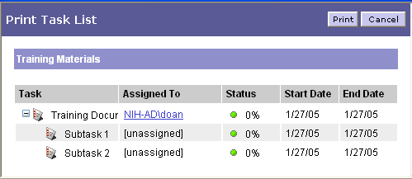
Figure 23 – Print Task List

- (Optional) To move to a different page, click a scroll button () (first page, previous page, next page, last page), or enter an item number in the Items box () and press ENTER.
- (Optional) To view information about a task assignee, click the assignee’s hyperlinked username.
- To print, click . (To exit without printing, click .)

I Need to Delete a Task List
Reminder: You can delete a task list only if you’re a Project Leader.

The following procedure explains how to delete a task list. For information on deleting an individual task, see “I Need to Delete a Task.”

- Go to your Community’s home page and navigate to the Community Projects portlet or access your Project directly from your own Projects portlet.
- Click the hyperlink of the Project whose task list you want to delete.
- On the Overview page, click .
- Click the hyperlinked name of the task list you want to delete.
- Click .
- To delete the task list, click . (To exit without deleting the task list, click .)

I Need to Create a Task (or Multiple Tasks)
The following procedure explains how to create an individual task. You must first have created a task list with which to associate the task. For information on creating a task list, see “I Need to Create a Task List.”

- Go to your Community’s home page and navigate to the Community Projects portlet or access your Project directly from your own Projects portlet.
- Click the hyperlink of the Project containing the task list for which you want to create a task.
- On the Overview page, click .
- On the Tasks page, click the hyperlinked name of the task list for which you want to create a task.
- Click . (NOTE: To create multiple tasks, click the drop arrow [] beside , click , then click .)
The New Task window appears. (NOTE: If you chose to create multiple tasks, the Create New Tasks window appears.)

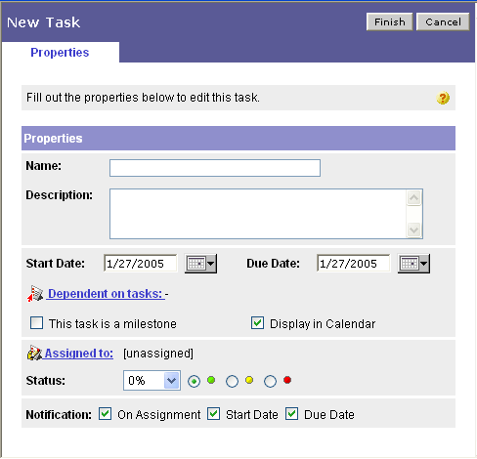
Figure 24 – New Task Window

- Enter/select task details.
- (Optional) If the new task is dependent upon anther task, click .
  - Check the box () beside the task you want to link.
  - Click .
- To save, click . (To exit without creating the task(s), click .)

If you assigned the task(s), by default, the individual is notified of the assignment based on the username/e-mail address specified. If you checked , the task(s) also appear(s) on the Project’s calendar (see “Project Calendar.”)

I Need to Access a Task
- Go to your Community’s home page and navigate to the Community Projects portlet or access your Project directly from your own Projects portlet.
- Click the hyperlink of the Project whose task information you want to see.
- On the Overview page, click .
- Click the task list name with which the task is associated.
- Click the hyperlinked task name.
A listing of task details appears at the bottom of the pane.
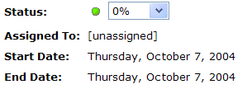
Figure 25 – Task Details

- To move to a different page, click a scroll button () (first page, previous page, next page, last page),
-or-
enter an item number in the Items box () and press ENTER.
(NOTE: The remainder of this section describes the other available task options.)

I Need to Edit a Task
Reminder: You can edit a task only if you created it or if you’re a Project Leader.

The following procedure explains how to edit an individual task. For information about editing a task list, see “I Need to Edit a Task List.”

- Go to your Community’s home page and navigate to the Community Projects portlet or access your Project directly from your own Projects portlet.
- Click the hyperlink of the Project whose task information you want to change.
- On the Overview page, click .
- Click the task list name with which the task is associated.
- Right-click the hyperlinked task name, then click .
- Enter/select changes.
- To save your changes, click . (To exit without saving your changes, click .)

I Want to Assign a Task
Reminder: You can assign a task only if you created it or if you’re a Project Leader.

- Go to your Community’s home page and navigate to the Community Projects portlet or access your Project directly from your own Projects portlet.
- Click the hyperlink of the Project whose task information you want to access.
- On the Overview page, click .
- Click the task list name with which the task is associated.
- Check () the box next to the task you want to assign, then click .
- Navigate to the user you want to assign and check () the box next to the name.
- To save the assignment, click . (To exit without assigning the task, click .)

I Want to Claim a Task
- Go to your Community’s home page and navigate to the Community Projects portlet.
- Click the hyperlink of the Project whose task information you want to access.
- On the Overview page, click .
- Click the task list name with which the task is associated.
- Right-click the hyperlinked task name, then click .
You will receive an e-mail notification of the task assignment.

I Want to Change a Task’s Status
Reminder: You can change a task’s status only if you created the task or if you’re a Project Leader.

IMPORTANT‼ If you want to change the status of a task that has subtasks, you must instead change the subtask(s)’s status which subsequently updates the status of the task.

- Go to your Community’s home page and navigate to the Community Projects portlet or access your Project directly from your own Projects portlet.
- Click the hyperlink of the Project whose task information you want to access.
- On the Overview page, click .
- On the Tasks page, click the task list name with which the task is associated.
- In the task details area, click 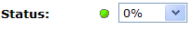.
- Click the desired task status.

I Need to Create New Subtasks
Reminder: You can create a subtask only if you created the original task or if you’re a Project Leader.

(NOTE: A subtask cannot be added to a dependent task.)

- Go to your Community’s home page and navigate to the Community Projects portlet or access your Project directly from your own Projects portlet.
- Click the hyperlink of the Project whose information you want to access.
- On the Overview page, click .
- Click the task list name with which the task is associated.
- Right-click the hyperlinked task name, then click .
-or-
Click , then click .
- Click or .
- Enter/select subtask details.
- To create the subtask(s), click . (To exit without creating the subtask[s], click .)

I Want to See a Task’s History
- Go to your Community’s home page and navigate to the Community Projects portlet or access your Project directly from your own Projects portlet.
- Click the hyperlink of the Project whose task information you want to see.
- On the Overview page, click .
- Click the task list name with which the task is associated.
- Click the hyperlinked task name.
- Click . (NOTE: To hide the task’s history, click .)

I Want to Sort the Tasks in a Task List
- Go to your Community’s home page and navigate to the Community Projects portlet or access your Project directly from your own Projects portlet.
- Click the hyperlink of the Project whose task information you want to sort.
- On the Overview page, click .
- On the Tasks page, click the task list name with which the tasks are associated.
- To sort the tasks, click a column heading.

I Want to Change to a Timeline (or Table) View of Tasks
- Go to your Community’s home page and navigate to the Community Projects portlet.
- Click the hyperlink of the Project whose task information you want to see.
- On the Overview page, click .
- On the Tasks page, click the task list name with which the tasks are associated.
- To change to a timeline view, click.
-or-
To change to a table view, click

I Want to Print a Task
- Go to your Community’s home page and navigate to the Community Projects portlet or access your Project directly from your own Projects portlet.
- Click the hyperlink of the Project whose task information you want to print.
- On the Overview page, click .
- On the Tasks page, click the task list name with which the task is associated.
- Check () the box next to the task you want to print, then click .
The Print Task List window appears.
Figure 26 – Print Task List
- (Optional) To move to a different page, click a scroll button () (first page, previous page, next page, last page), or enter an item number in the Items box () and press ENTER.
- (Optional) To view information about a task assignee, click the assignee’s hyperlinked username.
- To print, click . (To exit without printing, click .)

I Want to Add a Task to My QuickLinks
QuickLinks are a way to specially mark tasks (or task lists) for easy access later. Listed next is the procedure for creating a QuickLink for a task. For information on using a QuickLink, see “Accessing Task QuickLinks.” For information on creating a QuickLink to a task list, see “I Want to Add a Task List to My QuickLinks.”

- Go to your Community’s home page and navigate to the Community Projects portlet or access your Project directly from your own Projects portlet.
- Click the hyperlink of the Project whose task information you want to access.
- On the Overview page, click .
- On the Tasks page, click the task list name with which the task is associated.
- Check () the box next to the task for which you want to create a QuickLink, then click .
- In the QuickLinks modification window, to confirm modification, click .

Accessing Task QuickLinks
By using the QuickLinks feature in the My Tasks portlet on your My Pages, you can filter out all other tasks and see only those previously marked as QuickLinks.

NOTE: Before you can access task QuickLinks, you must first have created them. For more information, see “I Want to Add a Task to My QuickLinks.”

- Go to your My Pages.
- Go to the My Tasks portlet.
- Click , then click .

A listing of only those tasks marked as QuickLinks appears. NOTE: To return to the entire listing, click , then click .

Removing a Task’s QuickLink
- Go to your Community’s home page and navigate to the Community Projects portlet or access your Project directly from your own Projects portlet.
- Click the hyperlink of the Project whose task information you want to access.
- On the Overview page, click .
- On the Tasks page, click the task list name with which the task is associated.
- Check () the box next to the task whose QuickLink you want to remove.
- Click the drop arrow [] beside , then click .
- In the QuickLinks modification window, to confirm modification, click .

I Need to Delete a Task
Reminder: You can delete a task only if you created it or if you’re a Project Leader.

The following procedure explains how to delete an individual task. For information on deleting a task list, see “I Need to Delete a Task List.”

- Go to your Community’s home page and navigate to the Community Projects portlet or access your Project directly from your own Projects portlet.
- Click the hyperlink of the Project whose task information you want to delete.
- On the Overview page, click .
- On the Tasks page, click the task list name with which the task is associated.
- Check () the box next to the hyperlinked name of the task to be deleted, then click .
- In the confirmation window, to delete the task, click . (To exit without deleting the task, click .)

Documents Page
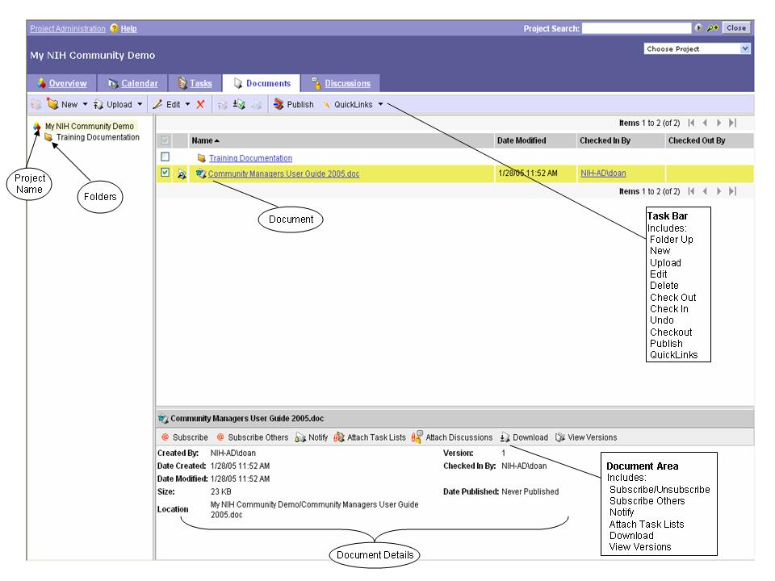
Figure 27 – Documents Page

Project Folders and Documents
You can share documents among Project Members allowing them to post various file formats. Folder access is controlled at the group level, meaning that access is based on user roles for Project Leaders, Project Members, and Project Guests, not on an individual user level. For more information, see “Project Roles.”

Documents can be placed at the Project level and no folder structure used; however, for document management purposes, it is recommended that documents be placed into a folder structure created by you, (see “I Need to Create a Folder ”).

Some document functions (e.g., creating a folder) are accessed through the Documents page via a Project while others are accessed while viewing a specific document’s details (e.g., attaching a discussion to a document).

To access the Documents page, do the following:
- Go to your Community’s home page and navigate to the Community Projects portlet or access your Project directly from your own Projects portlet..
- Click the hyperlink of the Project whose documents you want to access.
- On the Overview page, click .

The Documents page appears.
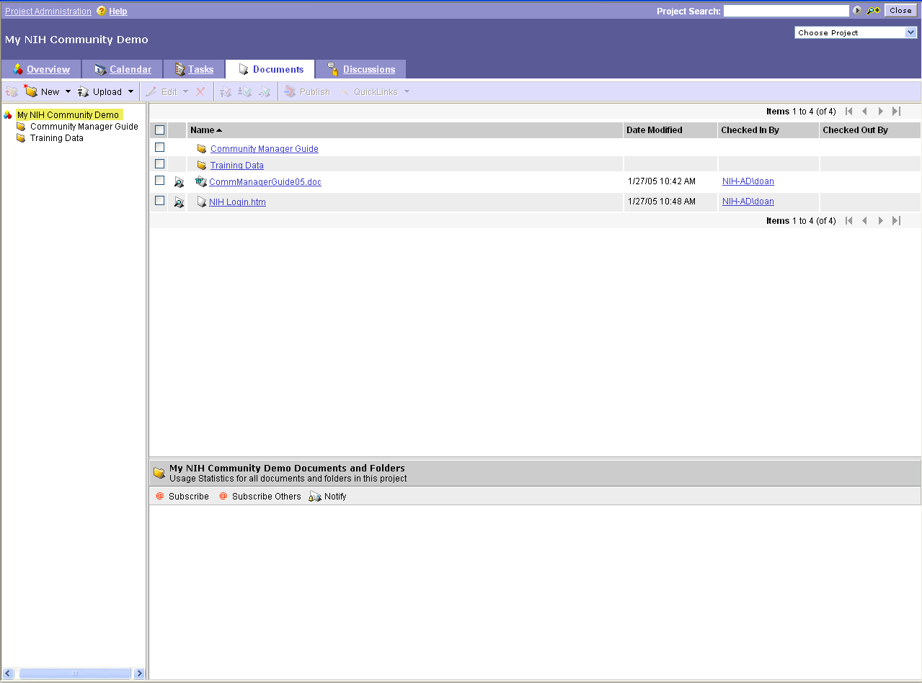
Figure 28 – Documents Page

- For information about creating a folder, go to “I Need to Create a Folder .”

I Need to Create a Folder
- Go to your Community’s home page and navigate to the Community Projects portlet or access your Project directly from your own Projects portlet.
- Click the hyperlink of the Project whose documents you want to access.
- On the Overview page, click .
- On the Documents page, click the dropdown, then click ,
-or-
right-click the project for which you want to create a new folder, click .
The New Folder Properties window appears.
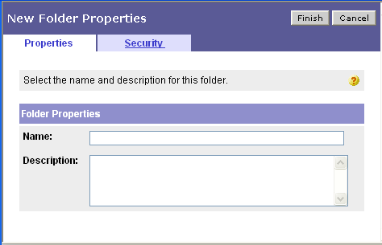
Figure 29 – New Folder Properties Window

- Enter folder details.
- (Optional) To change who can see the folder, click .
- Uncheck
- Use the drop lists to specify access options for Project Members and Guests.
- Click . (To exit without creating a folder, click .)

I Want to Change a Folder’s (or Subfolder’s) Name
Reminder: You can change folder’s name only if you created it or if you’re a Project Leader.

- Go to your Community’s home page and navigate to the Community Projects portlet or access your Project directly from your own Projects portlet.
- Click the hyperlink of the Project whose documents you want to access.
- On the Overview page, click .
- On the Documents page, right-click the folder/subfolder whose name you want to change.
- Click .
- Change folder information as desired.
- To save your changes, click . (To exit without saving, click .)

I Need to Change Who Can Access a Folder or Subfolder
Reminder: You can change folder access only if you created it or if you’re a Project Leader.

- Go to your Community’s home page and navigate to the Community Projects portlet or access your Project directly from your own Projects portlet.
- Click the hyperlink of the Project whose documents you want to access.
- On the Overview page, click .
- On the Documents page, right-click the folder (or subfolder) whose access you want to change.
- Click .
- Click .
- Uncheck .
- Use the drop lists to specify access options for Project Members and Guests.
- To save your changes, click . (To exit without saving, click .)

I Want to Subscribe to a Folder
- Go to your Community’s home page and navigate to the Community Projects portlet or access your Project directly from your own Projects portlet.
- Click the hyperlink of the Project whose documents you want to access.
- On the Overview page, click .
- On the Documents page, click the folder name for which you want to add/change subscription information.
- In the folder details area, click either or .
- If you chose to Subscribe Others, click , then navigate to the individual(s) and check [] the desired name(s). Check () whether to provide Immediate or Summary information, then click . (To exit without subscribing others, click .)

Unsubscribing From a Folder
- Go to your Community’s home page and navigate to the Community Projects portlet or access your Project directly from your own Projects portlet.
- Click the hyperlink of the Project whose documents you want to access.
- On the Overview page, click .
- On the Documents page, click the folder name for which you want to change subscription information.
- In the folder details area, click either or .
- If you chose Subscribe Others, uncheck [] both the Immediate and Summary checkboxes, then click . (To exit without unsubscribing others, click .)

I Need to Notify Someone About a Folder
- Go to your Community’s home page and navigate to the Community Projects portlet or access your Project directly from your own Projects portlet.
- Click the hyperlink of the Project whose documents you want to access.
- On the Overview page, click .
- On the Documents page, click the folder name for which you want to send a notification.
- In the folder details area, click .
- Enter/select information in the message fields.
- (Optional) To change how the e-mail notification is sent, click . To create the e-mail using your own e-mail software, click . An e-mail will be created using your default e-mail software. Address and send the e-mail.
-or-
to paste the link into another software package, copy the URL that appears in the text box, e.g.,:
Figure 30 – Folder Notification URL Textbox
- To send the e-mail notification, click .
-or-
to exit without sending the e-mail, click .

I Need to Copy/Move a Folder
Reminder: You can copy/move a folder only if you created it or if you’re a Project Leader.

- Go to your Community’s home page and navigate to the Community Projects portlet or access your Project directly from your own Projects portlet.
- Click the hyperlink of the Project whose documents you want to access.
- On the Overview page, click .
- Click the drop arrow () beside .
- Click either or .
- Click .
- Navigate to the desired project/folder, then click .
- Specify security options by clicking a radio button ().
- To create the copy (or move the folder) and place it in the specified project/folder, click . (To exit without copying/moving the folder, click .)
- To exit the Summary window, click .

I Need to Create a Subfolder
- Go to your Community’s home page and navigate to the Community Projects portlet or access your Project directly from your own Projects portlet.
- Click the hyperlink of the Project whose documents you want to access.
- On the Overview page, click .
- On the Documents page, right-click the folder for which you want to create a subfolder.
- Click .
- Enter subfolder details.
- (Optional) To change who can see the subfolder, click .
- Uncheck .
- Use the drop lists to specify access options for Project Members and Guests.
- Click . (To exit without creating a subfolder, click .)

I Need to Delete a Folder
Reminder: You can delete a folder only if you created it or if you’re a Project Leader.

IMPORTANT‼ When you delete a folder, you also delete all its documents. Once you delete a folder, you cannot recover it.

- Go to your Community’s home page and navigate to the Community Projects portlet or access your Project directly from your own Projects portlet.
- Click the hyperlink of the Project whose documents you want to access.
- On the Overview page, click .
- On the Documents page, click the folder to be deleted.
- Click .
You are prompted to confirm deletion.
- To delete the folder, click . (To cancel the deletion, click .)

I Need to Upload a File
You can upload files at both the Project and folder level. (NOTE: To switch between single or multiple files, in the Upload window, click or .)

- Go to your Community’s home page and navigate to the Community Projects portlet or access your Project directly from your own Projects portlet.
- Click the hyperlink of the Project whose documents you want to access.
- On the Overview page, click .
- On the Documents page, click .
- Click or .
- Click .
- Navigate to the desired file, then click .
- To upload the file(s), click . (To exit without uploading the file, click .)

I Need to Zip Download Multiple Files and/or Folders
1. Go to your Community’s home page and navigate to the Community Projects portlet or access your
Project directly from your own Projects portlet
2. Click the hyperlink of the Project whose documents you want to access.
3. On the Overview page, click .
4. On the Documents page, select the files or folders that you want to download as a Zip.
5. Click
6. Select
NOTE: You can also use Zip download to more quickly download a single, large file.

I Need to Assign Moderators to a Folder
Reminder: You can assign moderators to folder if you’re a Project Leader.
NOTE: Documents in a moderated folder do not become publicly available until a moderator approves it.

1. Go to your Community’s home page and navigate to the Community Projects portlet access your
Project directly from your own Projects portlet.
2. Click the hyperlink of the Project whose documents you want to access.
3. On the Overview page, click .
4. Right-click a folder that you want to assign the moderators to.
5. Click Edit Properties.
6. Click
7. In the Choose Users dialog box, select the project personnel whom you want to make moderators of
this folder and click Finish or type in the username ex: DoeJ in the Search text box, select the user a
and click Finish.
8. In the Edit Folder Properties dialog box, click Finish.

I Need to Create an Office Document
You can create a new Microsoft Office document directly from the Documents explorer. (Reminder: The appropriate Microsoft Office software must already be installed on your computer before you can perform this operation.)

- Go to your Community’s home page and navigate to the Community Projects portlet or access your project directly from your own Projects portlet.
- Click the hyperlink of the Project whose documents you want to access.
- On the Overview page, click .
- On the Documents page, in the folder listing, either click a Project or folder name.
- Click the dropdown.
- Click .
- Enter/select document details.
(NOTE: If this is the first time you have used this option, you will be prompted to install Web Edit. In the Security Warning window, to install the required software, click . Once the installation is complete, re-select the dropdown on the Documents page, followed by .) If your browser is configured to prevent popups, you may have to accept the security warning in the upper bar of the browser window.
- (Optional) To change who can see the document, click .
a. Uncheck .
b. Use the drop lists to specify access options for Project Members and Guests.
- Click . (To exit without creating an Office document, click .)
The new Office document opens in MS Word, Excel or PowerPoint. It also appears as checked out on the list of documents on the Documents page.

I Need to Access a Document
- Go to your Community’s home page and navigate to the Community Projects portlet or access your project directly from your own Projects portlet.
- Click the hyperlink of the Project whose documents you want to access.
- On the Overview page, click .
- On the Documents page, to access a document, click its hyperlinked document name,
-or
to access other document options, click. The document details area appears.
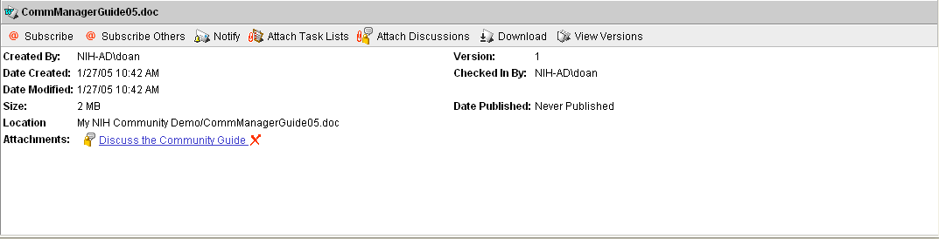
Figure 31 – Document Details Area

(NOTE: The remainder of this section describes the other available document options.)

I Want to Change a Document’s Name
Reminder: You can change a document’s name only if you uploaded or created it or if you’re a Project Leader.

- Go to your Community’s home page and navigate to the Community Projects portlet or access your project directly from your own Projects portlet.
- Click the hyperlink of the Project whose documents you want to access.
- On the Overview page, click .
- On the Documents page, right-click the document’s hyperlinked name, then click .
- Change document information as desired.
- To save your changes, click . (To exit without saving, click .)

I Need to Change Who Can Access a Document
Reminder: You can change document’s name only if you uploaded or created it or if you’re a Project Leader.

- Go to your Community’s home page and navigate to the Community Projects portlet.
- Click the hyperlink of the Project whose documents you want to access.
- On the Overview page, click .
- On the Documents page, right-click the document’s hyperlinked name, then click .
- Click .
- Uncheck .
- Use the drop lists to specify access options for Project Members and Guests.
- To save your changes, click . (To exit without saving, click .)

I Want to Subscribe to a Document
- Go to your Community’s home page and navigate to the Community Projects portlet.
- Click the hyperlink of the Project whose documents you want to access.
- On the Overview page, click .
- On the Documents page, click next to the document name for which you want to add/change subscription information.
- In the document details area, click either or .
- If you chose to Subscribe Others, click , then navigate to the individual(s) and check [] the desired name(s). Check () whether to provide Immediate or Summary information, then click . (To exit without subscribing others, click .)

Unsubscribing From a Document
- Go to your Community’s home page and navigate to the Community Projects portlet.
- Click the hyperlink of the Project whose documents you want to access.
- On the Overview page, click .
- On the Documents page, click the folder name for which you want to change subscription information.
- On the Documents page, click next to the document name whose subscription information you want to change.
- In the document details area, click either or .
- If you chose Subscribe Others, uncheck [] both the Immediate and Summary checkboxes, then click . (To exit without unsubscribing others, click .)

I Want To Notify Someone About a Document
- Go to your Community’s home page and navigate to the Community Projects portlet.
- Click the hyperlink of the Project whose documents you want to access.
- On the Overview page, click .
- On the Documents page, click next to the document name for which you want to send a notification.
- In the document details area, click .
- Enter/select information in the message fields.
- (Optional) To change how the e-mail notification is sent, click . To create the e-mail using your own e-mail software, click . An e-mail will be created using your default e-mail software. Address and send the e-mail.
-or-
to paste the link into another software package, copy the URL that appears in the text box, e.g.,:
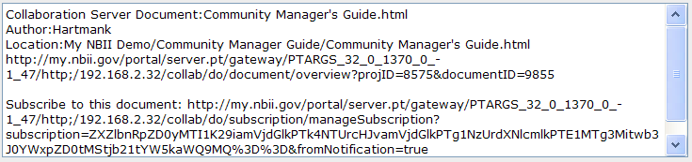
Figure 32 – Document Notification URL Textbox
- To send the e-mail notification, click .
-or-
to exit without sending the e-mail, click .

I Need to Attach a Discussion to a Document
- Go to your Community’s home page and navigate to the Community Projects portlet.
- Click the hyperlink of the Project whose documents you want to access.
- On the Overview page, click .
- On the Documents page, click next to the document name for which you want to attach a discussion.
- Click .
- Navigate to the discussion(s) to be attached and check [] the desired name(s).
- Click . (To exit without attaching a discussion, click .)

(NOTE: To access a discussion, click its hyperlinked name.)

Removing an Attached Discussion From a Document
- Go to your Community’s home page and navigate to the Community Projects portlet.
- Click the hyperlink of the Project whose documents you want to access.
- On the Overview page, click .
- On the Documents page, click next to the document name whose discussion attachment you want to remove.
- In the document details area, click at the end of the hyperlinked discussion name that you want to remove.
- To remove the attachment, click . (To exit without removing the attachment, click .)

I Need to Attach a Task List to a Document
- Go to your Community’s home page and navigate to the Community Projects portlet.
- Click the hyperlink of the Project whose documents you want to access.
- On the Overview page, click .
- On the Documents page, click next to the document name for which you want to attach a task list.
- Click .
- Navigate to the task list(s) to be attached and check [] the desired name(s).
- Click . (To exit without attaching a task list, click .)

(NOTE: To access a task list, click its hyperlinked name.)

Removing an Attached Task List From a Document
- Go to your Community’s home page and navigate to the Community Projects portlet.
- Click the hyperlink of the Project whose documents you want to access.
- On the Overview page, click .
- On the Documents page, click next to the document name whose task list attachment you want to remove.
- In the document details area, click at the end of the hyperlinked task list name that you want to remove.
- To remove the attachment, click . (To exit without removing the attachment, click .)

I Need to Download a Document
- Go to your Community’s home page and navigate to the Community Projects portlet.
- Click the hyperlink of the Project whose documents you want to access.
- On the Overview page, click .
- On the Documents page, click next to the name of the document you want to download.
- Click .
- Click .
- Specify the location to which to save the file, then click .
- To exit the Download Complete window, click .

I Want to View a Document’s Version History
- Go to your Community’s home page and navigate to the Community Projects portlet.
- Click the hyperlink of the Project whose documents you want to access.
- On the Overview page, click .
- On the Documents page, click next to the name of the document whose version history you want to view.
- Click .
- To download a version, click its version number.
- Specify the location to which to save the file, then click .
- To exit the Download Complete window, click .
- To exit the Document Versions window, click .

Deleting a Version of a Document
Reminder: You can delete a version of a document only if you created or uploaded it or if you’re a Project Leader.

IMPORTANT‼ When you delete a version of a document, that version is permanently deleted and cannot be restored.

- Click the hyperlink of the Project whose documents you want to access.
- On the Overview page, click .
- On the Documents page, click next to the name of the document that has a version you want to delete.
- Click .
- Click in the row of the document version you want to delete.
- In the deletion confirmation window, to delete the version, click . (To exit without deleting the version of the document, click .)

Reverting to a Previous Version of a Document
Reminder: You can revert to a previous version of a document only if you created or uploaded it or if you’re a Project Leader.

When you revert to a previous version, that version becomes the “new” latest (or most current) version and is the one participant’s will see if they choose to click the document’s hyperlinked name on the Documents page.

- Click the hyperlink of the Project whose documents you want to access.
- On the Overview page, click .
- On the Documents page, click next to the name of the document whose versions you want to access.
- Click .
- Click in the row of the document version you want to make the current version.

I Want to Edit a Document Using WebEdit
Reminder: You can WebEdit a document only if you created or uploaded it or if you’re a Project Leader.

Using WebEdit allows you to edit a file directly without going through the check-in/check-out process. This procedure applies to Microsoft Office files only; other files (such as a bitmap [.bmp] file) must go through the check-in/check-out process. For more about checking out files, see “I Need to Checkout a Document.”

When you use WebEdit, the document is locked for editing by other users until you save and close it (in effect automatically checking it back in), at which time the lock is removed and the latest copy is available to others for editing. NOTE: While the document is being edited, it can still be viewed and downloaded by others.

- Go to your Community’s home page and navigate to the Community Projects portlet or access your project directly from your own Projects portlet.
- Click the hyperlink of the Project whose documents you want to access.
- On the Overview page, click .
- On the Documents page, click next to the name of the document for which you want to use WebEdit.
- Click .
(NOTE: If this is the first time you have used this option, you will be prompted to install Web Edit. In the Security Warning window, to install the required software, click . Once the installation is complete, re-select the button. If your browser is configured to prevent popups, you may have to accept the security warning in the upper bar of the browser window.

The file is opened in the default software package and is checked out to you. Once the file is saved and closed, it will be updated and automatically checked in. Note that, at this time, once the document is checked back in via WebEdit, the comments in the View Version screen indicate merely that it was edited in this fashion. You are unable to annotate versions using this method. If it is important to maintain comments when versioning, you should use the traditional method of uploading and downloading.

I Need to Checkout a Document
Reminder: You can check out a document only if you created or uploaded it or if you’re a Project Leader.

When you check out a document, others can download and view it, but cannot check it out for editing.
- Go to your Community’s home page and navigate to the Community Projects portlet or access your Project directly from your own Projects portlet.
- Click the hyperlink of the Project whose documents you want to access.
- On the Overview page, click .
- On the Documents page, click next to the name of the document you want to check out.
- Click .
- Specify whether to download the document or use a previously downloaded version.
- Click . (To exit without checking out the document, click .)
- Click .
- Specify the location to which to save the file, then click .
- To exit the Download Complete window, click .

Checking in a Document
Reminder: You can check in a document only if you’ve got it checked out. If you’re a Project Leader, you can undo the checkout. For more information, see “Undoing a Document’s Checkout.”

After a document is checked out, to upload your changes and “unlock” the document, you must check it in. If you would rather simply “unlock” the document, go to “Undoing a Document’s Checkout.”

- Go to your Community’s home page and navigate to the Community Projects portlet or access your Project directly from your own Projects portlet.
- Click the hyperlink of the Project whose documents you want to access.
- On the Overview page, click .
- On the Documents page, click next to the name of the document you want to check in.
- Click .
- Click .
- Navigate to the document’s location, then click .
- (Optional) To retain the checkout lock on the file check .
- Click . (To exit without checking in the document, click .)

Undoing a Document’s Checkout
Reminder: You can undo a document’s checkout only if you’re the one whose got the document checked out or if you’re a Project Leader.

- Go to your Community’s home page and navigate to the Community Projects portlet or access your Project directly from your own Projects portlet.
- Click the hyperlink of the Project whose documents you want to access.
- On the Overview page, click .
- On the Documents page, click next to the name of the document you want to “unlock.”
- Click .

I Need to Copy/Move a Document
Reminder: You can copy/move a document only if you created or uploaded it or if you’re a Project Leader.

- Go to your Community’s home page and navigate to the Community Projects portlet or access your Project directly from your own Projects portlet.
- Click the hyperlink of the Project whose documents you want to access.
- On the Overview page, click .
- On the Documents page, click next to the name of the document you want to copy/move.
- Click the drop arrow () beside .
- Click either or .
- Click in the row of the new document location (Project or Folder).
- Navigate to the desired location, click its radio button (), then click .
- Specify security options by clicking a radio button ().
- To create the copy (or move the document) and place it in the specified project/folder, click . (To exit without copying/moving the document, click .)
- To exit the Summary window, click .

I Need to Publish a Document
Reminder: You can publish a document only if you created or uploaded it or if you’re a Project Leader.

When you “publish” a document, you create a link to it in the portal Knowledge Directory via the Community Documents portlet. Those users with access to the folder in which the document is published will be able to access it.

- Go to your Community’s home page and navigate to the Community Projects portlet or access your Project directly from your own Projects portlet.
- Click the hyperlink of the Project whose documents you want to access.
- On the Overview page, click .
- On the Documents page, click next to the name of the document you want to publish.
- Click .
- Click .
- Navigate to and check () the target folder to which to publish the document.
- Click .
- (Optional) To change the document’s name or summary information, check and make changes as desired.
- To publish the document, click . (To exit without publishing the document, click .)

I Want to Create a Shortcut to a Document
Reminder: You can create a shortcut to a document only if you created or uploaded it or if you’re a Project Leader.

A shortcut allows you to create a quick way to access a single copy of a file in a Project and refer to the file via the shortcut rather than uploading multiple copies. When the file to which the shortcut is referring is deleted, the shortcut is automatically removed.

- Go to your Community’s home page and navigate to the Community Projects portlet or access your Project directly from your own Projects portlet.
- Click the hyperlink of the Project whose documents you want to access.
- On the Overview page, click .
- On the Documents page, click the drop arrow () beside .
- Click .
- To select the Project where you want to place the shortcut, click .
- Navigate to the desired Project, then click .
- Repeat for the desired folder.
- To create the shortcut, click . (To exit without creating the shortcut, click .)

I Want to Upload a New Document by Sending E-Mail to a Collaboration Project
Reminder: You can save this e-mail address in your e-mail client's address book to upload a file to the folder anytime, each folder has a unique address..

  - Go to your Community’s home page and navigate to the Community Projects portlet or access your Project directly from your own Projects portlet.
  - Click the hyperlink of the Project whose documents you want to access.
  - On the Overview page, click .
  - On the Documents page, Select the folder that you want to send an e-mail to.
  - Click the folder's e-mail address.
A new e-mail message appears in your personal computer's e-mail program, addressed to the folder.
  - Now you can send new documents to your Collaboration project from the email address. Simply attach a document to that email and it will be uploaded to the project momentarily.

I Want to Add a Document to My QuickLinks
QuickLinks are a way to specially mark documents for easy access later. Listed next is the procedure for creating a QuickLink for a document. For information on using a QuickLink, see “Accessing Document QuickLinks.”

- Go to your Community’s home page and navigate to the Community Projects portlet or access your Project directly from your own Projects portlet.
- Click the hyperlink of the Project whose documents you want to access.
- On the Overview page, click .
- On the Documents page, click next to the name of the document for which you want to create a QuickLink.
- Click .
- In the QuickLinks modification window, to confirm modification, click .

Accessing Document QuickLinks
By using the QuickLinks feature in the My Document portlet on your My Pages, you can filter out all other documents and see only those previously marked as QuickLinks.

NOTE: Before you can access document QuickLinks, you must first have created them. For more information, see “I Want to Add a Document to My QuickLinks.”

- Go to your My Pages.
- Go to the My Documents portlet.
- Click , then click .

A listing of only those documents marked as QuickLinks appears. NOTE: To return to the entire listing, click , then click .

Removing a QuickLink
- Go to your Community’s home page and navigate to the Community Projects portlet or access your Project directly from your own Projects portlet.
- Click the hyperlink of the Project whose documents you want to access.
- On the Overview page, click .
- On the Documents page, click next to the name of the document whose QuickLink you want to remove.
- Click the drop arrow [] beside .
- Click .
- In the QuickLinks modification window, to confirm modification, click .

I Need to Delete a Document
Reminder: You can delete a document only if you created or uploaded it or if you’re a Project Leader.

- Go to your Community’s home page and navigate to the Community Projects portlet or access your Project directly from your own Projects portlet.
- Click the hyperlink of the Project whose documents you want to access.
- On the Overview page, click .
- On the Documents page, click next to the name of the document you want to delete.
- Click .
- To delete the file, in the confirmation window, click . (To exit without deleting the file, click .)

I Want to Map a Web Folder to My Network Places
The Web Folder Settings page lets you select the projects whose documents you want to access on your personal computer with Microsoft Windows Explorer. For each project that you select, Collaboration Server places a project subfolder into your personal computer's web folder. The default setting is to mirror the projects that you already have in your Projects portlet.
Note: To view the projects for which you have a role, click View User Profile on the page.
Note: this feature is for Windows users only.

1. Click on the link at the top of the page
2. Click
3. Click
4. Select
5. Click to exit the Collaboration Settings page
6. Go to any Collaboration Project
7. Click the hyperlink of the Project whose documents you want to access.
8. On the Overview page, click
9. Click
10. Select
11. Copy the URL from the Web Folder Location text box.
- Open My Network Places on your desktop
- Double-click Add Network Place. The Add Network Place Wizard appears.
- If prompted, select the then, click Next.
- In the Network Address text box, paste the URL then click Next.
- Type in your User name (for example, NIH\doej) and Password and click OK
- If desired, type in a preferred name for this network folder; then click Finish.
- A new Web Folder is created and your Collaboration Project is mapped in Windows Explorer

NOTE: You will now be able to work with all the documents that are in your projects, based on the access which has been assigned to you by the project leader. When you open a document for editing, it is checked out, when you save and close it, it is checked back in and you are given the opportunity to make check in comments.

All Microsoft Office Documents (PowerPoint, Word, Excel) will behave in this way. Other documents, e.g., text, will need to be removed from the folder for editing.

Discussions Page
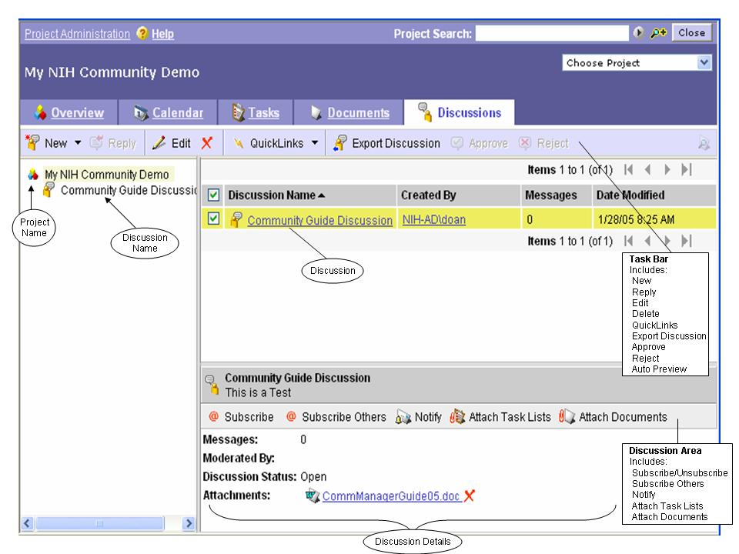

Figure 33 – Discussions Page

Project Discussions
Threaded discussions (a discussion and its sequentially listed messages and replies) can be stand-alone conversations related to your Project or discussions tied to specific calendar events, task lists, or documents. Each discussion thread contains messages. The hierarchy of discussions is:

Figure 34 – Discussion → Message → Item Hierarchy

To access the Discussions page:
- Go to your Community’s home page and navigate to the Community Projects portlet or access your Project directly from your own Projects portlet.
- Click the hyperlink of the Project whose discussions you want to access.
- On the Overview page, click .
The Discussions page appears.
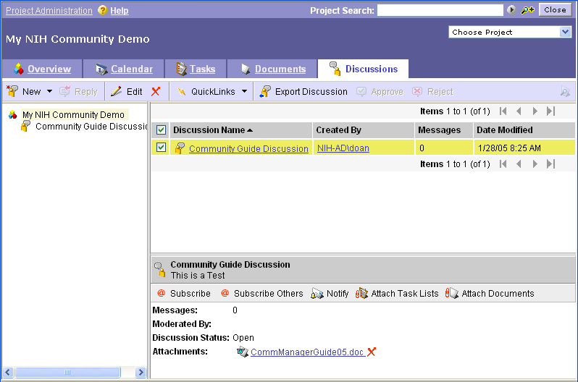
Figure 35 – Discussions Page

I Need to Create a New Discussion Thread
Reminder: You can create a new discussion thread only if you’re a Project Leader.

Before you can create a discussion message or use options on the Discussions page, you must first create a discussion thread.

- Go to your Community’s home page and navigate to the Community Projects portlet or access your Project directly from your own Projects portlet.
- Click the hyperlinked name of the Project whose discussions you want to access.
- On the Overview page, click .
- On the Discussions page, click .
The New Discussion window appears.
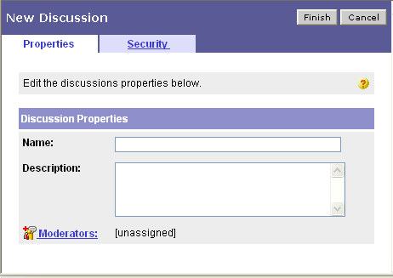
Figure 36 – New Discussion Window

- Enter discussion details.
- (Optional) To assign a moderator(s), click , navigate to the desired user(s), then check () the name(s).
- (Optional) To change who can see the discussion, click .
  - Uncheck .
  - Use the drop lists to specify access options for Project Members and Guests.
- To save the discussion, click . (To exit without creating a discussion, click .)

For information on creating a discussion message for the newly created discussion thread, see “I Need to Create a New Discussion Message.”

I Need to Edit a Discussion Thread’s Details
Reminder: You can edit a discussion thread only if you’re a Project Leader.

The following procedure explains how to edit a discussion thread’s details. For information on editing a specific discussion message, see “I Need to Edit a Discussion Message’s Details.”

- Go to your Community’s home page and navigate to the Community Projects portlet or access your Project directly from your own Projects portlet.
- Click the hyperlink of the Project whose discussions you want to access.
- On the Overview page, click .
- Right-click the discussion thread name, then click .
- Enter/select discussion details.
- To save your changes, click . (To exit without saving your changes, click .)

I Need to Assign/Change a Discussion Thread’s Moderator
Reminder: You can assign/change a discussion thread’s moderator only if you’re a Project Leader.

A moderator approves or rejects a message created in a discussion thread prior to it being posted to the discussion thread (i.e., messages will not be posted to the discussion thread unless they are approved by the moderator). You can specify more than one moderator.

- Go to your Community’s home page and navigate to the Community Projects portlet or access your Project directly from your own Projects portlet.
- Click the hyperlink of the Project whose discussions you want to access.
- On the Overview page, click .
- Right-click the discussion thread name, then click .
- Click .
- Navigate to the desired user(s) and check () the name(s).
- To save your changes, click . (To exit without saving your changes, click .)

I Need to Subscribe to a Discussion Thread
- Go to your Community’s home page and navigate to the Community Projects portlet or access your Project directly from your own Projects portlet.
- Click the hyperlink of the Project whose discussions you want to access.
- On the Overview page, click .
- On the Discussions page, click the discussion thread to which you want to subscribe.
- In the discussion details area, click either or .
- If you chose to Subscribe Others, click , then navigate to the individual(s) and check [] the desired name(s). Check () whether to provide Immediate or Summary information, then click . (To exit without subscribing others, click .)

Unsubscribing from a Discussion Thread
- Go to your Community’s home page and navigate to the Community Projects portlet or access your Project directly from your own Projects portlet.
- Click the hyperlink of the Project whose discussions you want to access.
- On the Overview page, click .
- On the Discussions page, click the discussion thread for which you want to change subscription information.
- In the discussion details area, click either or .
- If you chose Subscribe Others, uncheck [] both the Immediate and Summary checkboxes, then click . (To exit without unsubscribing others, click .)

I Want to Notify Someone About a Discussion Thread
- Go to your Community’s home page and navigate to the Community Projects portlet or access your Project directly from your own Projects portlet.
- Click the hyperlink of the Project whose discussions you want to access.
- On the Overview page, click .
- On the Discussions page, click the discussion thread name for which you want to send a notification.
- In the discussion details area, click .
- Enter/select information in the message fields.
- (Optional) To change how the e-mail notification is sent, click . To create the e-mail using your own e-mail software, click . An e-mail will be created using your default e-mail software. Address and send the e-mail.
-or-
to paste the link into another software package, copy the URL that appears in the text box, e.g.,:
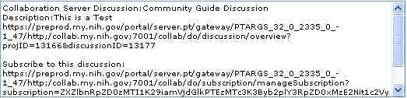
Figure 37 – Discussion Thread Notification URL Textbox
- To send the e-mail notification, click .
-or-
to exit without sending the e-mail, click .

I Need to Attach a Document to a Discussion Thread
- Go to your Community’s home page and navigate to the Community Projects portlet or access your Project directly from your own Projects portlet.
- Click the hyperlink of the Project whose discussions you want to access.
- On the Overview page, click .
- On the Discussions page, click the discussion thread name to which you want to attach a document.
- In the discussions detail area, click .
- Navigate to the document(s) to be attached and check [] the desired name(s).
- Click . (To exit without attaching a document, click .)
(NOTE: To access a document, click its hyperlinked name.)

Removing an Attached Document From a Discussion Thread
- Go to your Community’s home page and navigate to the Community Projects portlet or access your Project directly from your own Projects portlet.
- Click the hyperlink of the Project whose discussions you want to access.
- On the Overview page, click .
- On the Discussions page, click next to the discussion thread name whose document attachment you want to remove.
- In the discussion thread details area, click at the end of the hyperlinked document name that you want to remove.
- To remove the attachment, click . (To exit without removing the attachment, click .)

I Need to Attach a Task List to a Discussion Thread
- Go to your Community’s home page and navigate to the Community Projects portlet.
- Click the hyperlink of the Project whose discussions you want to access.
- On the Overview page, click .
- On the Discussions page, click the discussion thread name to which you want to attach a task list.
- In the discussions detail area, click .
- Navigate to the task list(s) to be attached and check [] the desired name(s).
- Click . (To exit without attaching a task list, click .)
(NOTE: To access a task list, click its hyperlinked name.)

Removing an Attached Task List From a Discussion Thread
- Go to your Community’s home page and navigate to the Community Projects portlet or access your Project directly from your own Projects portlet.
- Click the hyperlink of the Project whose discussions you want to access.
- On the Overview page, click .
- On the Discussions page, click next to the discussion thread name whose task list attachment you want to remove.
- In the discussion thread details area, click at the end of the hyperlinked task list name that you want to remove.
- To remove the attachment, click . (To exit without removing the attachment, click .)

I Want to Add a Discussion Thread to My QuickLinks
QuickLinks are a way to specially mark discussion threads (or discussion messages) for easy access later. Listed next is the procedure for creating a QuickLink for a discussion thread. For information on using a QuickLink, see “Accessing Discussion Thread QuickLinks.” For information on creating a QuickLink to a discussion message, see “I Want to Add a Discussion Message to My QuickLinks.”

- Go to your Community’s home page and navigate to the Community Projects portlet or access your Project directly from your own Projects portlet.
- Click the hyperlink of the Project whose discussions you want to access.
- On the Overview page, click .
- On the Discussions page, click the discussion thread name for which you want to create a QuickLink.
- Click .
- In the QuickLinks modification window, to confirm modification, click .

Accessing Discussion Thread QuickLinks
By using the QuickLinks feature in the My Discussions portlet on your My Pages, you can filter out all other discussions threads/discussion messages and see only those previously marked as QuickLinks.

NOTE: Before you can access discussion thread QuickLinks, you must first have created them. For more information, see “I Want to Add a Discussion Thread to My QuickLinks.”

- Go to your My Pages.
- Go to the My Discussions portlet.
- Click , then click .

A listing of only those discussions threads/discussion messages marked as QuickLinks appears. NOTE: To return to the entire listing, click , then click .

Removing a QuickLink
- Go to your Community’s home page and navigate to the Community Projects portlet or access your Project directly from your own Projects portlet.
- Click the hyperlink of the Project whose discussions you want to access.
- On the Overview page, click .
- On the Discussions page, click the discussion thread name whose QuickLink you want to remove.
- Click the drop arrow [] beside .
- Click .
- In the QuickLinks modification window, to confirm modification, click .

I Need to Export a Discussion Thread
Reminder: You can export a discussion thread only if you’re a Project Leader.

- Go to your Community’s home page and navigate to the Community Projects portlet or access your Project directly from your own Projects portlet.
- Click the hyperlink of the Project whose discussions you want to access.
- On the Overview page, click .
- On the Discussions page, click the discussion thread name for which you to export discussion information.
- Click .
- To specify the location for the exported discussion, click .
- Navigate to the desired folder, click its radio button (), then click .
- Enter the filename and/or summary, then click . (To exit without exporting the discussion, click .)

I Need to Delete a Discussion Thread
Reminder: You can delete a discussion thread only if you’re a Project Leader.

(NOTE: The following procedure explains how to delete a discussion thread and its associated discussion messages. For information on deleting a specific discussion message, see “I Need to Delete a Discussion Message.”)

- Go to your Community’s home page and navigate to the Community Projects portlet or access your Project directly from your own Projects portlet.
- Click the hyperlink of the Project whose discussions you want to access.
- On the Overview page, click .
- On the Discussions page, click the discussion thread name you want to delete.
- Click .
- In the confirmation window, to delete the discussion thread, click . (To exit without deleting the discussion thread, click .)

I Need to Create a New Discussion Message
(NOTE: Before you can create a discussion message, you must first have created a discussion thread. For more information, see “I Need to Create a New Discussion Thread.”)

- Go to your Community’s home page and navigate to the Community Projects portlet or access your Project directly from your own Projects portlet.
- Click the hyperlink of the Project whose discussions you want to access.
- On the Overview page, click .
- On the Discussions page, right-click the discussion thread for which you want to create a discussion message, then click .
-or-
Click the discussion thread for which you want to create a discussion message and click ; then click .
- Enter message details.
- To save the discussion message, click . (To exit without creating a discussion message, click .)

I Want to Access a Discussion Message
- Go to your Community’s home page and navigate to the Community Projects portlet or access your Project directly from your own Projects portlet.
- Click the hyperlink of the Project whose discussions you want to access.
- On the Overview page, click .
- On the Discussions page, to access a discussion message, click its hyperlinked discussion message name.
The discussion details area appears.
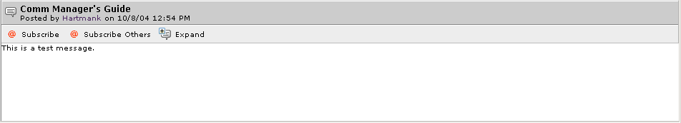
- Click .

A window appears displaying message contents including replies to the selected message.

I Need to Reply to a Discussion Message
- Go to your Community’s home page and navigate to the Community Projects portlet or access your Project directly from your own Projects portlet.
- Click the hyperlink of the Project whose discussions you want to access.
- On the Overview page, click .
- On the Discussions page, click the discussion thread containing the discussion message to which you want to reply.
- Click the hyperlinked name of the discussion message to which you want to reply, then click ,
-or-
right click the hyperlinked message to which you want to reply, then click .
- (Optional) Enter a new subject.
- Enter the message reply. (NOTE: If you want to include the body of the previous message, click .)
- To save your reply, click . (To exit without saving your reply, click .)
The reply appears at the end of the message’s discussion list.

I Need to Edit a Discussion Message’s Details
Reminder: You can edit a discussion message’s details only if you created it or if you’re a Project Leader.

The following procedure explains how to edit a specific discussion message’s details. For information on editing an entire discussion thread, see “I Need to Edit a Discussion Thread’s Details.”

- Go to your Community’s home page and navigate to the Community Projects portlet or access your Project directly from your own Projects portlet.
- Click the hyperlink of the Project whose discussions you want to access.
- On the Overview page, click .
- Click the discussion thread name that contains the discussion message whose details you want to edit.
- Right-click the discussion message’s name, then click .
- Enter/select discussion message details.
- To save your changes, click . (To exit without saving your changes, click .)

I Need to Approve/Reject a Discussion Message
To approve or reject a discussion message, you must be a discussion moderator. For more about moderators, see “I Need to Assign/Change a Discussion Thread’s Moderator.”

- Go to your Community’s home page and navigate to the Community Projects portlet or access your Project directly from your own Projects portlet.
- Click the hyperlink of the Project whose discussions you want to access.
- On the Overview page, click .
- Click the discussion thread name that contains the discussion message you want to approve/reject.
- Check () the box next to the hyperlinked name of the message you want to approve/reject.
(NOTE: You can approve or reject only one message at a time.)
- To approve the discussion message, click ; or to reject the discussion message, click .

I Want to Subscribe to a Discussion Message
- Go to your Community’s home page and navigate to the Community Projects portlet or access your Project directly from your own Projects portlet.
- Click the hyperlink of the Project whose discussions you want to access.
- On the Overview page, click .
- On the Discussions page, click the discussion thread containing the discussion message to which you want to subscribe.
- Click the hyperlinked name of the discussion message to which you want to subscribe.
- In the discussion details area, click either or .
- If you chose to Subscribe Others, click , then navigate to the individual(s) and check [] the desired name(s). Check () whether to provide Immediate or Summary information, then click . (To exit without subscribing others, click .)

Unsubscribing from a Discussion Message
- Go to your Community’s home page and navigate to the Community Projects portlet or access your Project directly from your own Projects portlet.
- Click the hyperlink of the Project whose discussions you want to access.
- On the Overview page, click .
- On the Discussions page, click the discussion thread containing the discussion message whose subscription option you want to change.
- Click the hyperlinked name of the discussion message for which you want to change subscription information.
- In the discussion details area, click either or .
- If you chose Subscribe Others, uncheck [] both the Immediate and Summary checkboxes, then click . (To exit without unsubscribing others, click .)

I Want to Add a Discussion Message to My QuickLinks
QuickLinks are a way to specially mark discussion messages (or discussion threads) for easy access later. Listed next is the procedure for creating a QuickLink for a discussion message. For information on using a QuickLink, see “Accessing Discussion Message QuickLinks.” For information on creating a QuickLink to a discussion thread, see “I Want to Add a Discussion Thread to My QuickLinks.”

- Go to your Community’s home page and navigate to the Community Projects portlet or access your Project directly from your own Projects portlet.
- Click the hyperlink of the Project whose discussions you want to access.
- On the Overview page, click .
- On the Discussions page, click the discussion thread containing the discussion message for which you want to create a QuickLink.
- Click the hyperlinked name of the discussion message for which you want to create a QuickLink.
- Click .
- In the QuickLinks modification window, to confirm modification, click .

Accessing Discussion Message QuickLinks
By using the QuickLinks feature in the My Discussions portlet on your My Pages, you can filter out all other discussions messages/discussion threads and see only those previously marked as QuickLinks.

NOTE: Before you can access discussion message QuickLinks, you must first have created them. For more information, see “I Want to Add a Discussion Message to My QuickLinks.”

- Go to your My Pages.
- Go to the My Discussions portlet.
- Click , then click .

A listing of only those discussions messages/discussion threads marked as QuickLinks appears.
NOTE: To return to the entire listing, click , then click .

Removing a QuickLink
- Go to your Community’s home page and navigate to the Community Projects portlet or access your Project directly from your own Projects portlet.
- Click the hyperlink of the Project whose discussions you want to access.
- On the Overview page, click .
- On the Discussions page, click the discussion thread containing the discussion message whose QuickLink you want to remove.
- Click the hyperlinked name of the discussion message whose QuickLink you want to remove.
- Click the drop arrow [] beside .
- Click .
- In the QuickLinks modification window, to confirm modification, click .

I Need to Delete a Discussion Message
Reminder: You can delete a discussion message only if you created it or if you’re a Project Leader.

(NOTE: The following procedure explains how to delete a specific discussion message. For information on deleting an entire discussion thread, see “I Need to Delete a Discussion Thread.”)

- Go to your Community’s home page and navigate to the Community Projects portlet or access your Project directly from your own Projects portlet.
- Click the hyperlink of the Project whose discussions you want to access.
- On the Overview page, click .
- On the Discussions page, click the discussion thread containing the discussion message you want to delete.
- Check () the box next to the hyperlinked name of the discussion message you want to delete, then click .
- In the confirmation window, to delete the discussion message, click . (To exit without deleting the discussion message, click .)

I Want to Create a New Discussion Message by Sending E-Mail to a Collaboration Project
Reminder. You can save this e-mail address in your e-mail client's address book to contribute to the discussions anytime without having to click on this link

1. Go to your Community’s home page and navigate to the Community Projects portlet or access your Project directly from your own Projects portlet.
- Click the hyperlink of the Project whose discussions you want to access.
- On the Overview page, click .
- On the Discussions page, select the discussion that you want to send an e-mail to.
- Click the discussion e-mail address
- A new e-mail message will appear in your personal computer's e-mail program, addressed to the discussion.
- Now you can send new discussions to your Collaboration project from the email address. The text and documents will be added as a message in the discussion.

What’s a Personal Project?
A personal Project is one that’s created using the My Projects portlet on your My Pages. It allows you to use Project features to track items for your personal use.

- To access your personal Project, go to your My Pages and navigate to the My Projects portlet or access your Project directly from your own Projects portlet.
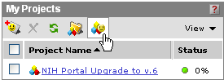
Figure 38 – My Projects Portlet
- Click Personal Project 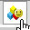.
The Overview page appears.
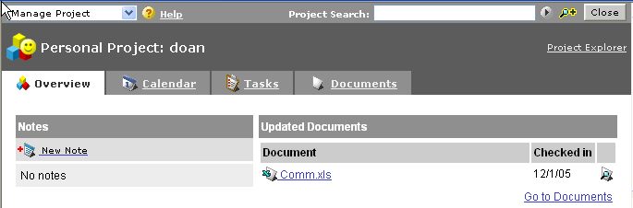
Figure 39 – Project Explorer

You can access the same types of information that you normally access from a Community-based Project, i.e., calendar, tasks, and documents, except this information is only accessible by you.

- To see a listing of all the projects to which you have access, click the hyperlink.
-or-
For further instructions, go to the following sections:
- Notes – “Creating Personal Project Notes”
- Calendar information – “Project Calendar”
- Task list and/or task information – “Project Task Lists and Tasks”
- Folder and document information – “Project Folders and Documents”
-or-
To exit the Overview page, click .

Creating Personal Project Notes
Personal Project notes are very similar to Project announcements and appear on the Overview page.

- Go to your My Page and navigate to the My Projects portlet or access your Project directly from your own Projects portlet.
- Click Personal Project .
- To create a note, click .
The New Note window appears.
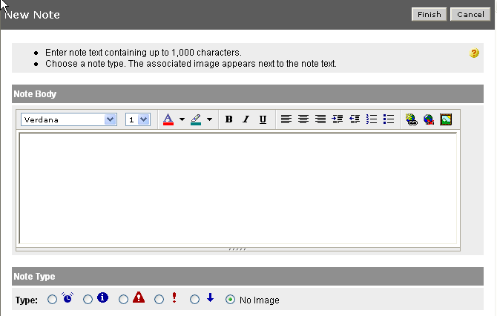
Figure 40 – New Note Window

- Enter the text of the note (up to 1,000 characters).
- (Optional) Use text formatting buttons for text emphasis.
- Select the note type.
- To save the note and post it to your Project, click . (To exit without saving the note, click .)

You are returned to the Overview page. The new note appears along with the date and time it was posted.

To Edit a Personal Project Note
- Go to your My Page and navigate to the My Projects portlet or access your Project directly from your own Projects portlet.
- Click Personal Project .
- On the Overview page, click next to the note whose content you want to edit.
- In the Edit Note window, edit note information and/or use text formatting buttons for text emphasis.
- (Optional) Select the note type.
- To save your changes, click . (To exit without saving your changes, click .)

You are returned to the Overview page. The updated note appears along with the date and time it was posted.

To Delete a Personal Project Note
- Go to your My Page and navigate to the My Projects portlet or access your Project directly from your own Projects portlet.
- Click Personal Project .
- On the Overview page, click next to the note you want to delete.
- In confirmation window, to delete the note, click . (To exit without deleting the note, click .)

Permission Matrix
Each access level above No Access inherits the rights from all lower access levels.
 | Read | Write | Edit | Full Control
Projects | - View project | - View project | - Save project  - Modify project properties | - Create announcements  - Delete announcements  - Edit announcements  - Publish project to the portal
Calendar | - View Calendar  - Notify other users about an event. | - Create events  - Attach files and discussions | - Modify event properties | - Delete events  - Configure calendar security
Tasks | - View Tasks  - Notify other users about a task or task list. | - Create tasks  - Claim tasks  - Attach files and discussions  - Update task status | - Modify task list and task properties  - Create task lists  - Assign owners  - Copy task lists  - Import and export task lists | - Delete task lists and tasks  - Move task lists  - Configure task list security
Folders | - View folders  - Notify other users about changes made to the contents of the folder. | - Add files to folders  - Upload documents  - Create new Microsoft Office documents | - Modify folder properties  - Rename folders  - Copy folders  - Create folders | - Delete folder  - Move folders  - Configure folder security
Documents | - View files  - Notify other users about the file. | - Check files in and out  - Undo check-out  - Attach task lists and discussions | - Modify file properties  - Create shortcuts  - Publish to Knowledge Directory  - Revert files to previous versions  - Copy files | - Delete files  - Move files  - Configure file security  - Delete previous versions of the file.
Discussions | - View Discussions  - Notify other users about the file. | - Post messages  - Reply to messages  - Attach task lists and files | - Modify discussion properties  - Create new discussions  - Export discussions  - Copy discussions | - Delete discussions and messages  - Move discussions  - Configure discussion security  - Edit messages  - Approve or reject messages

