

Best Practices:
FileVault Encryption
for
Macintosh Laptops

Version 2
March 2007

Table of Contents

Technological Aspects of FileVault 3
Important Features of FileVault 4
Recommendations 5
Enabling FileVault: Setting the Master Password 6
Enabling FileVault: Verifying Master Password 9
Enabling FileVault: FileVaulting an Account 10
Important Caveats 13
Troubleshooting FileVault 13

Information Technology Management Council
Infrastructure & Operations Subcommittee
Ed and Al Whitley, co-chairs

Prepared by the Infrastructure & Operations Subcommittee Working Group:

David Hester (NIDCD)
Bill Knight (NIAID)
Thalene Mallus (NIMH)
Andy Rosado (NCI)
Scot Ryder (NIDCD)
Scott Spencer (NIAAA)
Rich Trouton (NHGRI)
Jeff Wilkerson (CIT)

Best Practices: Macintosh Laptop Encryption

In response to a June 23, 2006 memo from Office of Management and Budget (OMB), Health and Human Services (HHS) has mandated that all agency data on mobile computers be encrypted by March 31, 2007. This mandate was contained in a memo sent to all operational divisions dated January 25, 2007. In order to facilitate compliance with this directive, HHS has identified the use of FileVault as an encryption mechanism for Macintosh laptops if there is an overwhelming need due to the laptops having sensitive information on them. FileVault has not yet been certified as being FIPS 140-2 compliant.

Although each National Institutes of Health (NIH) Institutes and Centers (IC) has the responsibility for determining how FileVault will be configured and implemented, this guide was developed by a cross-IC team of Macintosh specialists and is meant as a best practice guide for configuring and implementing FileVault.

The guidelines cover two types of implementation - one for Macintosh computers that participate in the NIH Active Directory (AD) and one for those that do not. In either case, implementation is identical. Major differences only exist when troubleshooting, and these differences will be indicated when appropriate.

Technological Aspects of File Vault

- FileVault is an OS-level service that is built into Macintosh OS X 10.3 and later.
- FileVault therefore supports all Macintosh hardware that can run OS X 10.3 and later.
- FileVault uses AES-128 bit encryption technology to encrypt the entire contents of a user’s home folder on the local desktop.
- FileVault is transparent to the user: user logs into his/her home folder as normal.
- FileVault comes with a backdoor solution, should the user forget his/her password.
- FileVault is not a whole-disk encryption solution.
- FileVault is not directory-services (i.e. AD) aware: its encryption key is based upon a manually entered password that is cached in the local NetInfo directory.
- FileVault cannot provide two-factor authentication out-of-the-box.
Important Features of FileVault

- If FileVault is enabled without a Master Password, there is no backdoor to recover the encrypted data. If a user forgets their user password, and no Master Password exists, the data is permanently lost.
- Some applications (notably Adobe Acrobat and Microsoft Office) may require reinstallation after the user’s home folder is FileVaulted, as the preference files can become corrupted. This does not happen frequently.
- FileVault requires free space on the hard drive equivalent to the size of the user’s home folder. It builds an encrypted sparseimage and copies the entire contents of the user’s home folder into it before erasing the original home folder.
- FileVault only encrypts the user’s home folder and all data contained therein. Any data existing elsewhere in the file structure remains unencrypted. Any data on external USB or FireWire hard drives connected to the computer while logged in under the user’s account remains unencrypted.
- FileVault works behind the scenes to decrypt when logging in. There may be a slight delay opening documents at the user’s desktop, but in most cases it is not noticeable.
- FileVault works upon the sparseimage technology developed by Apple. This technology allows the envelope containing the data to grow automatically as data size increases. However, the envelope does not transparently compress when data is deleted. In this case, the user will be asked whether to allow the operating system to compress the data upon logout. The user may choose not to do so, though this is not recommended. Compressing the data will require the user to have to wait a few moments before logout is completed.
- If running a third-party backup system on the laptop, the entire FileVaulted home folder will be backed up, as the data is enveloped into the sparseimage, which will update its modification data with each login/logout.
- FileVault works seamlessly with mobile home folder synchronization (Portable Home Directories - PHDs), and only the modification dates of individual files and folders are accessed when synchronizing, not the entire home folder.
- Very few incidents of corruption of the sparseimage have been reported. Disk Utility and third-party programs can target only the image and repair it.
Recommendations

- Create a local admin account (for use by local IT support only) in addition to the user’s account.
- Enable Master Password on computer before building FileVaulted home directory.
- For purposes of initial rollout, maintain user environment and profile; i.e., if user is a local user, do not convert user to an AD profile before FileVaulting the account. Likewise, if the user is already an AD user, FileVault accordingly.
- Except for cases where mobile home folder synchronization has been deployed, users should be required to take responsibility for backing up their data. It is best that they do not back up to a local or external hard drive, as data on this hard drive will not automatically be encrypted through FileVault. It is recommended that they work with their system administrators to manually back up their data onto servers.
- If the laptop has been bound to an Open Directory Master (OS X Server), it is recommended that Security Preferences (under System Preferences) be made unavailable to the normal user. This prevents the user from turning off FileVault.
- Password problems will ultimately need to be handled by the IC’s local desktop support team. However, as with all IT-related issues, the user can contact the NIH Help Desk to report the problem. The Help Desk in turn will contact the appropriate IC local desktop support team. Suggestions concerning troubleshooting under circumstances where password synchronization has been de-linked can be found at the end of this document (Troubleshooting FileVault).
- For those users running POP mail clients, it is recommended that they configure their client to leave messages on the server. This will allow the user to access email through OWA in cases of sparseimage corruption.
- To enable certain troubleshooting steps (see Troubleshooting Filevault section, below), it is recommended that Remote Login (SSH) be enabled in System Preferences > Sharing.
Enabling FileVault: Setting the Master Password

The first thing to do is to set the FileVault Master Password.

- Open the System Preferences and click on the Security icon.

- In the Security pane, it is recommended that you enable the options in the picture below. Then, click on the “Set Master Password…” button.

As the “Require password…” may not be universally deployed, the NIH recommends a screen saver lock in 30 minutes or less (set in System Preferences > Desktop & Screen Saver panel).
- Enter a Master Password. This password is one that the IT team in a given IC will use when a customer forgets their Macintosh login password and needs it reset. It is recommended that the Hint field be left blank. This password should conform to the NIH password complexity rules. This is not the password that a user of the computer will use – they will continue to use their normal machine account credentials to login.

You will now be returned to the main Security settings window (see above).

Now, you may now proceed to the next step.

Enabling FileVault: Verifying Master Password
It will be valuable to verify the Master Password on equipment where a Master Password has been set, but was done so by the user, previous users or support, i.e. where a Master Password is set but not known.

- Open Terminal while logged in as a local administrative user.
- Enter the following command at the prompt:
security unlock-keychain /Library/Keychains/FileVaultMaster.keychain

- You'll be prompted for the FileVault Master Password. Enter it and hit return.
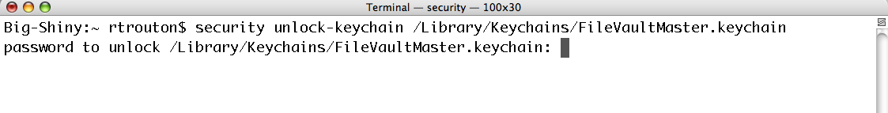
- If it succeeds, you'll get the next system prompt.
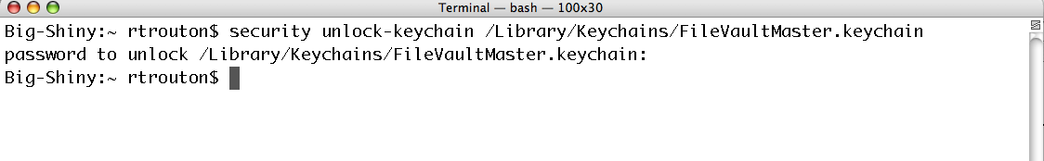

If you enter the FileVault Master Password and it is not the one set on the Mac, you will receive an error message.

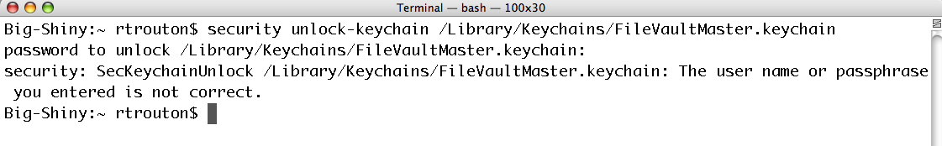

This error message indicates that the Master Password you entered is not the current Master Password that is in use on this Mac. Proceed to Troubleshooting FileVault.

- At this point, assuming there was no error message, enter the following command to lock the keychain:
security lock-keychain /Library/Keychains/FileVaultMaster.keychain

If it succeeds, you'll get the next system prompt.

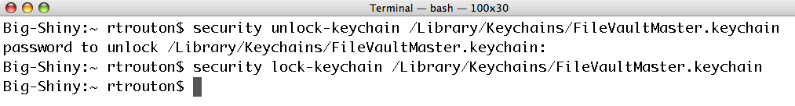

You may now proceed to “Enabling FileVault: FileVaulting an Account”.

Enabling FileVault: FileVaulting an Account

- Ask the user of the account to be vaulted to login to the computer with their normal login credentials.
- Open the System Preferences and click on the Security icon.
- Click on the “Turn On FileVault…” button.
- Enter the normal login credentials for this user and click on the OK button.

- Once the credentials have been verified, FileVault will inform you that you are now ready to turn on FileVault protection for this account. Click on the “Turn On FileVault” button.

The “Use secure erase” option is not required. It will ensure that the user’s old home folder information is not recoverable. Enabling this function can substantially add to the amount of time FileVault requires to finish its process.

- As the dialog above indicates, the user will be automatically logged out and the vault protection encryption will begin.

This could take some time and is influenced by factors such as how much data is in the home folder of that account, speed of the processor, etc.

Once the process has been completed, the customer will be returned to the login window. They can login with their normal credentials and begin work.

The only visible indications that this account has been vaulted are:

- System Preferences’ Security window shows the status of “FileVault protection is On for this account”

- User folder has been replaced by a grey house icon.

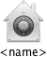

- Finder window sidebar shows a grey house icon.

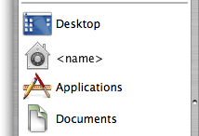

The FileVault Master password is stored in:

- /Library/Keychains/

There are 2 files:

- FileVaultMaster.cer
- FileVaultMaster.keychain

The FileVault password for each user is not stored in the Master Password file but is instead in embedded in that user’s FileVault encrypted sparseimage file.

It is recommended that you copy the Master Password files to a secure location and denote which set/pair of keys belong to that computer. These files will enable the vault to be accessed again should the local copies of these files get corrupted or the Master Password is forgotten. Also, this Master Password can be copied to all computers for which FileVault will be enabled and thus standardize and expedite implementation of FileVault.
Important Caveats

- An AD user should never change their network password by any other means than by accessing the “Change Password” tool in System Preferences > Accounts. If they do so, their FileVault password (as well as their local keychain password) will be unsynchronized when they next log onto the network. This will bring about the following symptoms:
  - User will login as usual, using new password
  - Login screen will accept password, due to network authentication
  - Login screen will disappear, leaving blue screen
  - Blue screen will never resolve to Desktop

- Unlike local accounts that have been FileVaulted, AD accounts have their encrypted sparseimage contained inside a folder. Both the folder and the sparseimage are assigned permissions to the user, only.
- Replacing the Master Password files on a computer that already has a Master Password set will break the Master Password’s capability to unlock the FileVaulted user account.

Troubleshooting FileVault

Forgotten User Password (Local Users)

- In the case of a local user having forgotten her/his password, log into the local admin account, open the Accounts pane in System Preferences and authenticate to unlock the Login Options. Once unlocked, check “Show password hints” and then log out.
- Once you are back at the login screen, enter the user’s login and a wrong password (can be anything.) After three attempts the login window will request the Master password. Once at the desktop, use System Preferences > Accounts to change the user’s password.

Resetting Master Password (Local and AD User)

- If the Master Password is not set to the password you expect, delete the following files from /Library/Keychains (for location, see image, below):

FileVaultMaster.cer
FileVaultMaster.keychain

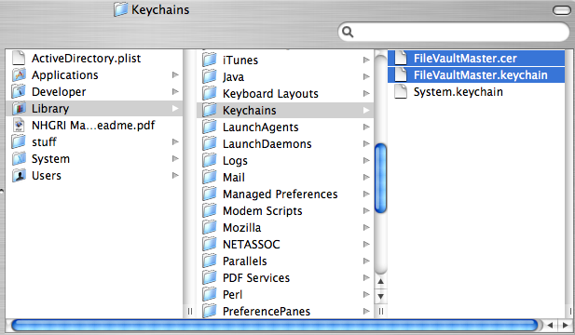

- Authenticate using a local admin account, when prompted.
- Restart the computer.
- If you have any accounts FileVaulted with the old Master Password, decrypt them at this time
- Return to System Preferences > Security and set the Master Password.
- Re-encrypt the user account again.

Blue Screen (AD User)

- If the computer is stuck at the blue screen, an administrator should SSH onto the client and kill the loginwindow process. This will return user to the login screen.
- If this is not available, the user should power down the laptop manually by pressing and holding the power key for 5-10 seconds.
- Log onto computer using another local admin account. Alternative: boot up using Target Disk mode (press and hold “T” when turning on computer until you see a FireWire symbol), then connect to another Mac computer.
- Open /Users.
- Click on user home folder and Get Info (Cmd-I) and expose Ownership & Permissions.
- Click on lock icon next to Owner, authenticate, and change ownership to the local admin account.
- Double-click user the folder and Get Info (Cmd-I) on sparseimage (this is the encrypted FileVaulted user home folder).
- Expose Ownership & Permissions, click on lock icon next to Owner.
- Authenticate and change ownership to the local admin account.
- Double-click on the sparseimage icon.
- Enter the FileVault password.
- You may now access all folders and documents in the user’s home folder.

Change Password on Sparseimage (Local and AD Users)

- If you wish to change the password on the FileVaulted sparseimage, once you have reset permissions on the enveloping folder and on the sparseimage itself, open Disk Utility.
- Drag the sparseimage into the sidebar of Disk Utility.
- Highlight the icon in the sidebar and select from the Images menu and choose “Change Password”.
- Input the old/outdated password when prompted.
- Input the new password, verify and click on the OK button.
- You will be notified when the password has been successfully changed. Click the OK button.
- The user may now login using the new password.

User Changed AD Password While Off Network (AD Users)

- Before the user returns to the network (i.e., the user should not connect the laptop to the network), the AD user should log out and log back into the user home folder. Once arriving at the Desktop, the user should access the “Change Password” tool in System Preferences > Accounts and replace the old password with the new network password.
- After logging out again, the user should then connect to the network and log in, using the new network password.
Recovering a FileVault Image’s Contents to an External Drive when only Master Password is known (Local and AD Users)
You will need only as much free space on the external harddrive as the data contained within the FileVaulted user folder.
- Log onto computer using a local admin account.
- Enter the following commands at the prompt to unlock the FileVault keychain:
security unlock-keychain /Library/Keychains/FileVaultMaster.keychain

- You will be prompted for the FileVault Master Password. Enter it and hit return.
- Next, enter the following command to mount the user’s encrypted sparseimage in /Volumes:
sudo hdiutil attach /Users/username/username.sparseimage -owners on –recover /Library/Keychains/FileVaultMaster.keychain

- Enter your admin password when prompted. You should then see output similar to this:
/dev/disk1 Apple_partition_scheme
/dev/disk1s1 Apple_partition_map
/dev/disk1s2 Apple_HFS /Volumes/username

Note: The disk image will not mount on the desktop.
- To recover the data on the mounted drive to an external drive, run the following command to copy the data to another drive (for this example, we’re using an external drive named Backup):
sudo ditto /Volumes/username /Volumes/Backup/username

This will create a new directory on Backup named username, with the same permissions as the existing user account. From there, you can change permissions on the new directory to access the data inside.
- To unmount the sparse diskimage, run the following command:
sudo hdiutil detach /Volumes/username

You should see output similar to the following:
"disk3" unmounted.
"disk3" ejected.

At this point, assuming that all the data in the FileVault image has been recovered and verified, you can proceed to delete the malfunctioning account and its associated FileVault sparseimage and set the account up fresh with your backed-up data.

Recovering back to /Users (Local and AD Users)
If there is sufficient space on the hard drive, you can recover a FileVault account back to an unencrypted home folder in /Users. This assumes that there is enough space for both the complete home folder and the FileVault sparseimage.
- Log in with a local admin account and open the Terminal.
- Move the FileVault encrypted home to a new home folder by using the following command, and authenticate with the admin password when prompted:
sudo mv /Users/username /Users/.username

- Enter the following command at the prompt to unlock the FileVault keychain in /Library/Keychains:
security unlock-keychain /Library/Keychains/FileVaultMaster.keychain

- You’ll be prompted for the FileVault Master Password. Enter it and hit return.
- Next, enter the following command to mount the user’s encrypted sparseimage in /Volumes:
sudo hdiutil attach /Users/username/username.sparseimage -owners on -recover /Library/Keychains/FileVaultMaster.keychain

- Enter your local admin password when prompted. You should then see output similar to this:
/dev/disk1 Apple_partition_scheme
/dev/disk1s1 Apple_partition_map
/dev/disk1s2 Apple_HFS /Volumes/username

The disk image will not mount on the desktop.
- To recover the data on the mounted drive to an external drive, run the following command to copy the data from the mounted disk to the user's home directory in /Users (this will create a new directory at /Users/username):
sudo ditto /Volumes/username /Users/username

- Next, unmount the disk image by running the following command:
sudo hdiutil detach /Volumes/username

You should see output similar to the following:
"disk3" unmounted
"disk3" ejected

- Next, modify the account info in Directory Services so that the home no longer points to the .sparseimage by running the following command:
sudo dscl . delete /Users/username HomeDirectory

- The user should now be able to log in and access their (now) unencrypted home directory.
At this point, there are two copies of the home folder on the Mac, both the FileVault sparseimage that is still stored in /Users/.username, and the now-unecrypted home folder in /Users/username. Assuming that the user is able to log in and is access all of their data in their unencrypted home folder, the FileVault sparse diskimage should now be removed by running the following command:
sudo rm -r /Users/.username

Increasing FileVault sparseimage Size (Local and AD Users)
Under certain circumstances (not frequently met with), the amount of data accumulated in the user’s FileVaulted home folder may exceed the original limit set when the sparseimage was first created. In such rare circumstances, you can reset that limit and increase the sparseimage size:
- Log in with a local admin account and open the Terminal.
- Type the following command, substituting for “40g” any number greater than the current sparseimage size, or “max” to make it as big as possible:
hdiutil resize 40g /Users/username/username.sparseimage

For additional implementation or troubleshooting questions not indicated in this document, please contact the NIH Help Desk at http://ithelpdesk.nih.gov.

