Instructions for Entering DCIS Data for

World Travel Service (WTS)

Delivery Orders

Step 1: To access DCIS outside of PRISM go to https://dcis.hhs.gov, then click the hyperlink “DCIS Login”.

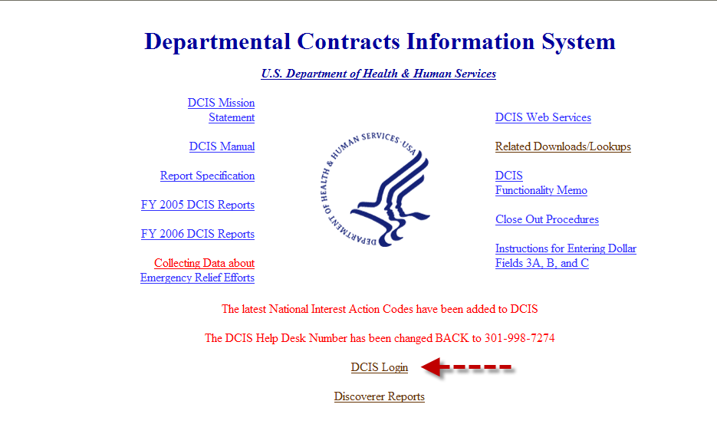

Step 2: Review and agree to the terms, provisions, and guidelines of the DCIS Rules of Behavior document.

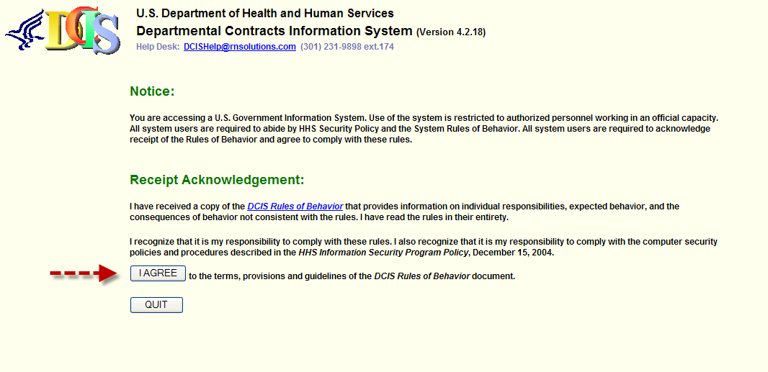

Step 3: Enter your DCIS username and password, click Login.

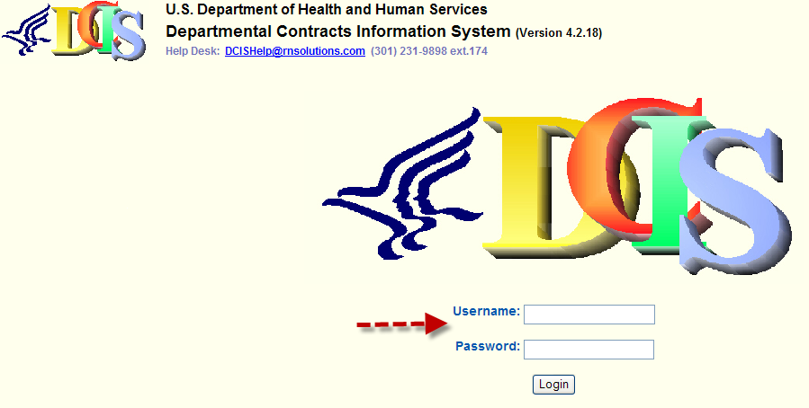

Step 4: From the ICAR Menu Bar, click New.

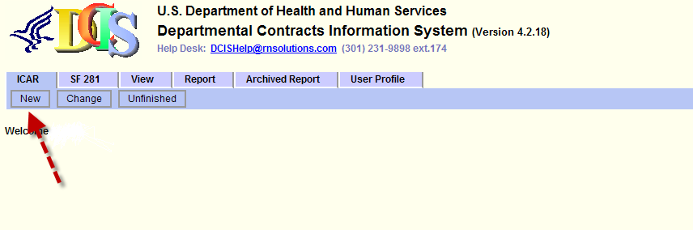
Step 5: From the IDV/Award Type drop-down, select AWARD – DO Delivery Order.

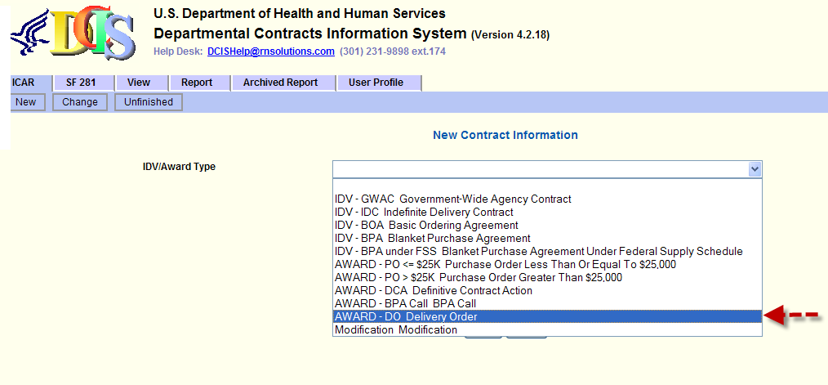
Step 6: Enter HHSN26820064276G in the Contract Number field, click Search.

Note: Contract number HHSN26820064276G must be entered for all WTS orders as the “Contract Number.”

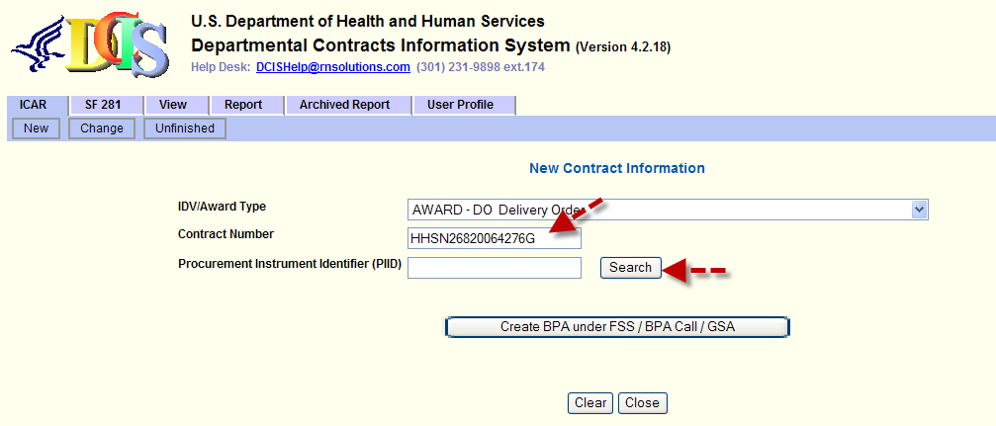

Step 7: Retrieve the Parent Award information by clicking the Contract Number in the first row, click Search.

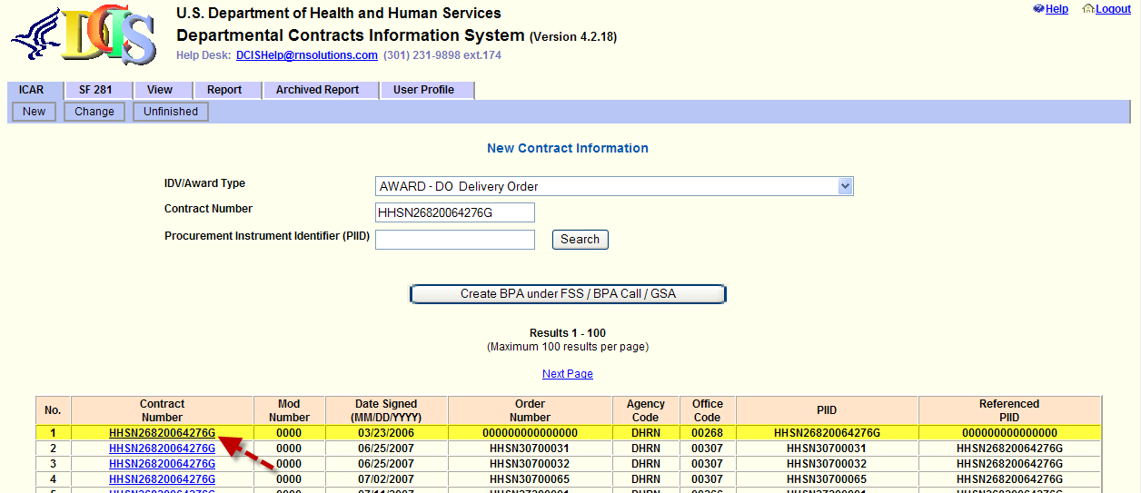

Step 8: Follow steps a – c to enter the Office Code, Order Number and Modification Number, if applicable.

a. The system shall default to your Office (code), if not select your Office (code) from the drop-down,

b. The Order Number will be a combination of the last 5 digits of your PRISM Delivery Order Number and an assigned 5 digit number associated with the PRISM contract number for which the order was generated against (found below in Table 1, Column B)

- Enter the last 5 digits of your PRISM Delivery Order Number in the Order Number field followed by,
- Enter the 5 digit number from column B – table 1 that is associated with the PRISM Contract Number, and

c. Click Create or enter the Modification Number, if applicable, and click Create.

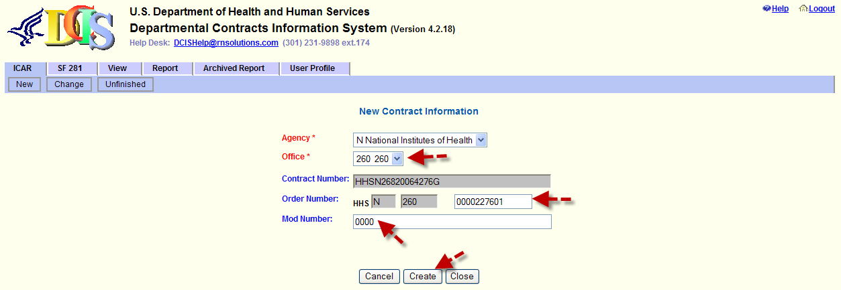

Table 1: PRISM Contract Number and associated 5-digits for DCIS Order Number
Column A | Column B
Contract Number | Last 5-digits for DCIS
HHSN268999900201I | 27601
HHSN268999900202I | 27602
HHSN268999900203I | 27603
HHSN268999900204I | 27604
HHSN268999900205I | 27605
HHSN268999900206I | 27606
HHSN268999900207I | 27607
HHSN268999900208I | 27608
HHSN268999900209I | 27609
HHSN268999900210I | 27610
HHSN268999900211I | 27611
HHSN268999900212I | 27612
HHSN268999900213I | 27613
HHSN268999900214I | 27614
HHSN268999900215I | 27615
HHSN268999900216I | 27616
HHSN268999900217I | 27617
HHSN268999900218I | 27618
HHSN268999900219I | 27619
HHSN268999900220I | 27620
HHSN268999900221I | 27621
HHSN268999900222I | 27622
HHSN268999900223I | 27623

