

National Institutes of Health
Center for Information Technology
CIT Telecommunications
Standard Operating Procedures

SOP Number: CIT-MAC-110

SOP Name: NIH LAN/Telecommunications Closet Access

Owners: National Institutes of Health (NIH) CIT Telecommunications

SOP Scope: The purpose of this Standard Operating Procedure is to document the
Procedure and processes that comply with: 1) directives associated with
Inspector General Audit guidelines, 2) DHHS ISSO security requirements
and 3) NIH Policy on Key, Lock and Card Key Services. The procedure
will demonstrate the process for authorized NIH personnel to gain access
to locked NIH LAN and Telecommunications closets.

Related SOPs:

Daily MAC (CIT-MAC-101)  Floor Plan Survey (CIT-MAC-104)  Line Card Administration (CIT-OAM-701)  Building One MAC (CIT-PRM-203)  Building Projects (CIT-PRM-201)  Building Projects PMO (CIT-PRM-202) | Red Emergency Back-up Phones (CIT-EMS-302)  Security Phones (CIT-EMS-303)  Blue Light Phones (CIT-EMS-301)  ECC Systems (CIT-EMS-305)  Elevator Phones (CIT-EMS-304)

Standard Operating Procedures:

- A master listing of contacts for obtaining NIH LAN/Telecommunications closet keys will
be maintained and updated by CIT Telecommunications. By the 1st of each month a CIT Telecommunications representative will forward the following information to the NIH Help Desk:

  - Updated LAN/Telco Master Closet Key Listing
  - CIT Telecommunications/LAN Closet Criteria
  - Closet Examples

2. The LAN/Telco Master Closet Key is a listing of all LAN or Telecommunications closets
located in all NIH buildings (on or off campus). It includes pertinent key holder information, i.e. location group, contact name, telephone number, address of building, if the key is a Card Key or a Metal Key etc. See Exhibit 1 - LAN/Telco Master Closet Key Listing

3. The CIT Telecommunications/LAN Closet Criteria is a document referencing industry guidelines for closet construction specifications and maintenance. See Exhibit 2 - CIT Telecommunications/LAN Closet Criteria. The closet examples are photographs of closets that are well maintained and examples of closets that are not maintained properly. See Exhibit 3- Closet Examples

4. All requests for changes in contact names or closet key holders for the LAN/Telco Master Closet Key Listing will be forwarded to the CIT Telecommunications Branch Chief to authorize and confirm any changes to the listing.

5. The 5ESS Switch Vendor will send a list of required keys for the daily workload to the Cable Management Branch each day to assist in the coordination of associated closet access requests with each Institute/Center POC that submitted the DELPRO/TSR

6. All inquiries for access to a NIH LAN/Telecommunications Closet will be forwarded to the NIH Help Desk at 301-594-6248. Access to a closet may require a METAL key or a CARD key and would include authorized NIH personnel and authorized primary vendors.

7. There is a listing of Contacts for NIH LAN/Telco Closet Key Access in Exhibit 4. This
list is used for internal purposes and for CIT Management problem resolution only. All inquires and request for closet access should go through the NIH Help Desk.

8. All person’s requesting access to an NIH closet must have completed the IT and Physical
Security Awareness Training.

NIH Help Desk Procedures

1. When the NIH Help Desk is contacted, the Agent will assist by contacting the appropriate NIH key holder by referencing LAN/Telco Master Closet Key Listing and conferencing the requester with the correct NIH key holder contact, when possible.

2. The NIH Help Desk must create a new Remedy Service Ticket for each NIH Campus
building LAN or Telco closet access request.

3. The NIH Help Desk must determine if the closet open or close request is associated with
TELEPHONE or DATA support services. Telephone service is associated with
Telecommunications closets and Data service is associated with LAN closets.

4. The NIH Help Desk updates the service ticket with the appropriate information using
the query criteria listed below:

a. IC name and telephone number that is requesting Telco or LAN closet access
b. Closet type: Telco or LAN?
c. Building and closet room number(s)
d. Reason for the closet access request
e. Date and time for the closet access
f. Duration of the closet access
g. Suite or Lab outer entry required before closet access.
h. Has the person requesting access completed the IT and Physical Security Awareness
Training?
i. Other pertinent information as provided by the IC POC

See Exhibit 5 – Closet Access Request Remedy Screen

5. For Telco closet access, the NIH Help Desk assigns the Remedy Service Ticket to “DNST-
Cabling Infrastructure -SLA and MAC Team” (Assignee = dnstcismac) Mark Campbell
(Primary) or Randy Massagee (Secondary) and provides a live hand-off of the Remedy ticket
by calling the Cable Infrastructure contacts.

6. Should the Cabling Infrastructure designate be unable to contact anyone to gain access to the
Telco closets, they will contact the NIH Locksmith at 301-496-3507. When contacting the NIH Locksmith, provide them with a contact name and room number. The Cabling Infrastructure designate will keep the requestor updated throughout notification to the NIH Locksmith and after resolution.

7. For LAN closet access, the NIH Help Desk assigns the Remedy Service Ticket to DNST -Network and Engineering - Network Operations Section/Network Operations
Center/DNST-NOC (Internal Use) and provides a “live hand-off” of the Remedy Service
Ticket by calling the Network Operations Center. The Remedy Ticket will be assigned to the
NOC personnel that receives the call.

8. Should the Network Operations Center designate be unable to contact anyone to gain access to the closets, they will then contact the NIH Locksmith at 301-496-3507. When contacting the NIH Locksmith, provide them with a contact name and room number. The Network Operations Center (NOC) designate will keep the requestor updated throughout notification to the NIH Locksmith and after resolution.

9. When the requestor has gained access via the DNST NOC personnel or the DNST Cabling Infrastructure MAC Team, the Remedy Service Ticket will be closed.

10. Should the NIH Help Desk Agent encounter any problems with processing the request, they
will get assistance from an NIH Help Desk Supervisor.

Change or Repair of NIH LAN/Telco Closet Door Locks

1. Requests to change or repair the closet door will also be forwarded by the NIH Help Desk to the Telecom or LAN designate for disposition. The NIH Help Desk Agent will assign the Remedy Ticket for disposition as follows:

a. For change or repair of Telco closet door locks the NIH Help Desk assigns the Remedy Service Ticket to “DNST- Cabling Infrastructure -SLA and MAC Team” (Assignee = dnstcismac) Mark Campbell (Primary) or Randy Massagee (Secondary) and provides a live hand-off of the Remedy ticket by calling the Cable Infrastructure contacts.

b. For change or repair of LAN closet door locks, the NIH Help Desk assigns the Remedy Service Ticket to DNST -Network and Engineering - Network Operations Section/Network Operations Center/DNST-NOC (Internal Use) and provides a “live hand-off” of the Remedy Service Ticket by calling the Network Operations Center. The Remedy Ticket will be assigned to the NOC personnel that answers the call.

2. For CARD Key locks the DNST Cable or NOC representative will contact the Access Control Help Desk at 301-451-4766 for assistance.

3. For METAL locks the DNST Cable or NOC representative will contact Clarence Bruce at 301-496-3507 for assistance.

Delivery Schedule:

Requests for access to NIH LAN/Telecommunications closets are negotiated on an individual as needed basis through the Help Desk.

Exhibits

Exhibit 1 - LAN/Telco Master Closet Key Listing - EXAMPLE
Exhibit 2 - CIT Telecommunications/LAN Closet Construction Criteria
Exhibit 3 - Closet Examples
Exhibit 4 - Contact Listing for NIH LAN/Telco Closet Key Access
Exhibit 5 - Closet Access Request Remedy Screen
Exhibit 6 - NIH LAN/Teleco Closet Access Workflow

Exhibit - 1
LAN/Telco Master Closet Key Listing

LG | ADDRESS | ZIP |  | KEY TYPE | CIT has key | NOTES/CAVEATS
20004 | 6006 Executive Blvd Rockville MD | 20852 |  | Guard | No
 | 6006 Exec Blvd LAN Closet Rm 301 |  | 1 |  | No
20005 | Federal Building 7550 Wisconsin Ave Bethesda MD | 20814 |  | NA | No
20006 | Gateway Building 7201 Wisconsin Ave Bethesda MD | 20814 |  | Engineer 301-440-5351 | No
 | 7201 Wisc Ave Telecom Closet Floor 2 Room 228 |  | 1 |  | No | Engineer 301-440-5351
25039 | 9800 Medical Center Drive Rockville MD | 20850 | 1 | Temporary Locks on 1,2,3 floor closets | No | See Joe Collins A.R.E. 301-573-9698
 |  |  |  | supplied by A. R. E. Property Mgmt
20038 | Key West Medical Ctr 9610 Medical Center Drive Rockville MD | 20850 | 1 |  | No
20013 | ANIMAL FARM 101 Club Hollow Road Poolesville MD | 20837 | 1 | None Needed | n/a
20023 | 6101 EXECUTIVE 6101 Executive Blvd Rockville MD | 20852 |  | UG = Maint / Closet =Medeco | No | See NCI Closet exception below

Exhibit 2 - CIT Telecommunications/LAN Closet Construction Criteria

Telecommunications/LAN Closet/Room Construction Criteria

General Description

These specifications are minimums based on the experiences of the Center for Information Technology (CIT), Division of Network Systems and Telecommunications (DNST). This Telecommunications/LAN Closet is the transition point between the Information Technology Backbone and the horizontal pathways. It serves as the Horizontal Distribution Center for the Telecommunications/LAN cabling and is where the cable tray and feeder conduits terminate. It houses the LAN patch panels, Telecommunication cross connect fields, Telecommunication and LAN electronic equipment. Telecommunications and Fiber Optic riser cabling are also housed and terminated at this location. This space shall not be used for any occupant-related servers and systems. Utilities and equipment not related to the support of the Telecommunications/LAN closet such as piping, ductwork, and distribution of power shall not be located in or pass through the closet.

Closet Size

The closet shall be 150 net sq. ft. minimum per 10,000 sq. ft. of occupied space. The closet dimensions shall be 10’. X 15’. There shall be no obstructions in the room, including the ceiling area.

Quantity

There shall be a minimum of one centrally located closet(s) per floor. The closet(s) must be located so the most distant Work Area Outlet does not exceed a 250’ radius. Additional closets shall be provided as required to maintain the 250’ radius requirement.

Codes and Standards

The Telecommunications/LAN closet(s) shall meet the Telecommunication Codes and Standards developed by the following groups:

- EIA-Electronics Industries Alliance
- TIA-Telecommunications Industries Association
- BOCA-Building Officials and Code Administrators
- ANSI-American Standards Institute
- IEEE-Institute of Electronic Engineers
- NFPA-National Fire Protection Association
- NEC-National Electric Code
- NESC-National Electric Safety Code
- OSHA-Occupational Safety and Health Administration
- BiCSi-Building Industry Consulting Service International
- NIH/DPG-NIH Design Policy Guidelines
- FIPS 175 –Federal Information Processing Standard

Construction Notes

Wall Requirements

- Walls shall extend from the finished floor to the structural ceiling, with a minimum 1-hour fire rated wall.
- All walls and plywood shall be covered with two coats of fire-retardant white paint and per local code. White paint shall be Federal Spec. Color 27780, with fire rating symbol exposed on each sheet.
- All walls of the closet shall be lined with rigidly installed, wall-to-wall ¾” A-C fire-retardant plywood, 8’ tall. Bottom of plywood shall be 6” above finished floor.

Door Requirements

- A Single door, 36” wide and 80” tall is required. The door is to swing out from the closet.
- Standard locks of the Mortise 1000 series shall be installed. Card access shall be provided.
- A latch-plate guard shall be installed to prevent prybar entry on double doors or single doors that swing out from closet.

Ceiling Requirements

- Lay-in ceiling are not permitted in the Telecommunications/LAN Closet.
- The ceiling must be painted white with Federal Spec. Color 27780.

Floor Requirements

- The floor shall be off white, anti static, Vinyl Covering Tile.
- The floor shall have a minimum load rating of 150lbs. per sq. ft.
- All floor penetrations sleeves shall extend 4” above and below the finished surface

Environmental Requirements

HVAC systems shall operate 24 hrs per day, 365 days per year. If the buildings system cannot ensure continuous operation, there shall be provided a stand-alone HVAC unit. This unit shall not be placed inside the Telecommunications/LAN closet. If an emergency power source is available, connect the HVAC system that serves the Telecommunications/LAN closet.

Maintain positive pressure relative to adjacent spaces with a minimum of one air change per hour. This temperature shall be adjustable from inside the Telecommunications/LAN closet. Heat dissipation shall be 15,000 BTU’s per hour, this will accommodate for three racks.

Environmental Factor Requirement

- Temperature 18 °C to 24 °C (64 °F to 75 °F)
- Relative humidity 30% to 55%
- Heat dissipation shall be 15,000 BTU’s per hour.
- NOTES: Filtration systems may be required to minimize particle levels in the air.
- Keep changes in temperature and humidity to a minimum.
- HVAC sensors and controls must be located in the ER. Ideally, the sensors are placed 1.5 m (5 ft) above finished floor (AFF).

Fire Protection Requirements

- Provide fire protection for the Telecommunications/LAN Closet(s) as required by applicable codes.
- If sprinkler heads are required they shall be of the “on-off” type and wire caged.
- An audio/visual building fire alarm shall be installed in the Telecommunications/LAN closet.
- A wall mounted 5 lb. CO2 fire extinguisher shall be mounted as close to the entrance as possible.
- Fire stopping methods, materials and considerations for reestablishing the integrity of fire rated architectural structures and assemblies (e.g. walls, floors and ceilings) required by building codes shall be observed when cables, pathways, such as conduits and cable tray, penetrate these barriers.
- A copy of the UL document will be provided prior to installation.

Lighting Requirements

- Fixture: 2 tube, 4’, strip light fixture with metal cage protection, 32watt fluorescent T-8 lamps with electronic ballast. Locate light fixtures a minimum of 8’-6” AFF.
- The closet shall have uniform lighting that provides a minimum of 540-lux (54 foot -candles) when measured 3’ above the finished floor.
- Coordinate fixture layout with the equipment rack location and the overhead cable trays to ensure the fixtures are not obstructed.
- At least one fixture in the Telecommunications/LAN Closet shall be on the emergency lighting circuit.

Utilities/Equipment Requirements

- Utilities/Equipment not related to the support of the Telecommunication/LAN Closet such as piping, ductwork, auxiliary cooling unit and distribution of power shall not be located in or pass through the Closet.
- Telecommunications/LAN Closet shall not be shared with building or custodial services.

Base Electrical Requirements

- Provide an insulated Grounding Busbar in each Telecommunications/LAN Closet.
- Provide one 1” conduit from the electrical closet on each floor to each Telecommunications/LAN Closet on that floor. Connect a #1 copper ground wire to the building ground busbar in the electrical closet and the telecommunications grounding busbar in each TEL/LAN Closet.
- Provide grounding to all racks inside the TEL/LAN Closet to the insulated Grounding Busbar in that Closet
- Provide a 120volt 20amp 3-wire utility NEMA 5-20 outlet on each wall in each Closet. This will be placed at 18”AFF.
- On the Telephone Equipment wall-field there shall be one 120volt 20amp 3-wire emergency circuit Quad NEMA 5-20 outlet placed at 7’6” AFF.
- On the Telephone Equipment wall-field there shall be one 120volt 20amp 3-wire circuit Quad NEMA 5-20 outlet at 18” AFF.
- A circuit ID will be labeled on each outlet.
- Provide one (1) Square D NQ0D Panel with 42 pole, 3 phase, 4 wire, 225 amp with a 100amp main circuit per closet. The panel shall only feed the Telecommunications/LAN Closet in which the panel resides and one closet above and below in a stacked room configuration.

Network Equipment Electrical Requirements

- A circuit ID will be labeled on each outlet located on the rack(s).
- There shall be a minimum of at least two outlets per rack.
- The bottom of the lowest outlet shall be placed at 24” AFF, the bottom of the upper outlet shall be placed 6” above the top of the bottom outlet.
- Power fed from the bottom of the rack up shall not have on-site 90 degree bends, only factory condulets will be accepted. Rack space may be lost by utilizing on-site bends
- Power feeding the rack shall originate from the TEL/LAN closet Panel

Due to the on-going changes in Network Technology, the Architect must contact the CIT Network Infrastructure Section to verify the type of outlets required. These outlets are determined by Manufacturer, Equipment size, UPS size and the area to be served. The Network Infrastructure Section has the final say as to Power provided to the racks. To contact the Network Infrastructure Section please call: 301-496-4357. Please provide the following information:

- Notify the person answering the call that this request is for the Network Infrastructure Section
- Your Name
- A project Identifier, Building number or Project name
- Your Cable Infrastructure section contact.
- Contact information for yourself, Telephone number and email please.

This process will generate a Request for Reply

Additional Requirements

There shall be a cable-tray a minimum of 18” wide and 4” deep with rung spacing every 9”. The tray shall be installed around the main hallway perimeter of the building and penetrating into and extending the length of the TEL/LAN Closet. All joints in the tray shall use factory made joint couplings. A #6 copper-bonding jumper must be installed between each section of the tray and terminated with #2 crimp type connector.

There shall be minimum trade size #6 copper riser installed from the Entrance Facility Grounding Electrode to the TMGB (Telecommunications Main Grounding Busbar) and to each TGB (Telecommunications Grounding Busbar) on every floor. The Center for Information Technology (CIT), Division of Network Systems and Telecommunications (DNST) Project Officer must review the final grounding design.

There shall be a 12”x 1” ladder rack installed around the closet perimeter and to equipment racks to distribute cable in the closet. There shall be a 12”x 1” ladder rack installed vertically slab to slab behind the metallic sleeves for vertical riser cable support. This is to be installed by Cabling Contractor.

Utilities/Equipment not related to the support of the Telecommunication/LAN Closet such as piping, ductwork, and distribution of power shall not be located in or pass through the Closet.

Four, 4” conduits shall connect the Telecommunications/LAN Closet with the first floor LAN closet(s). Each 4” conduit bank shall have one conduit installed with three 1¼” inner ducts with pull lines.

Exhibit 3 – Closet Examples

BAD EXAMPLE - 1

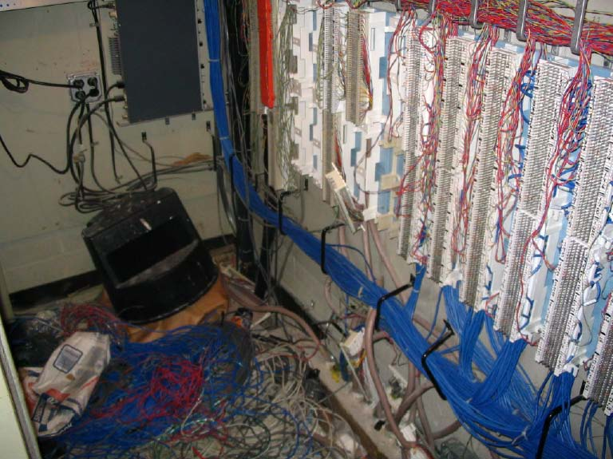

Exhibit 3 – Closet Examples (con’t) BAD EXAMPLE - 2

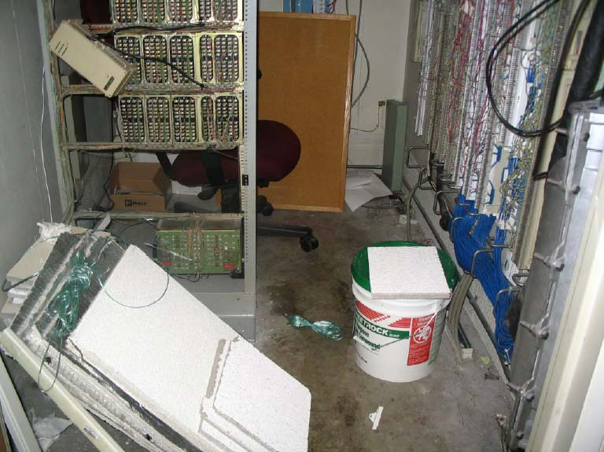

Exhibit 3 – Closet Examples (con’t) BAD EXAMPLE - 3

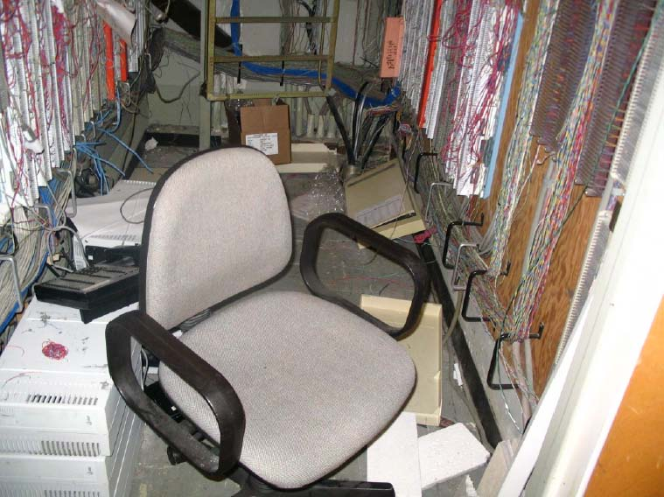

Exhibit 3 – Closet Examples (con’t) BAD EXAMPLE - 4

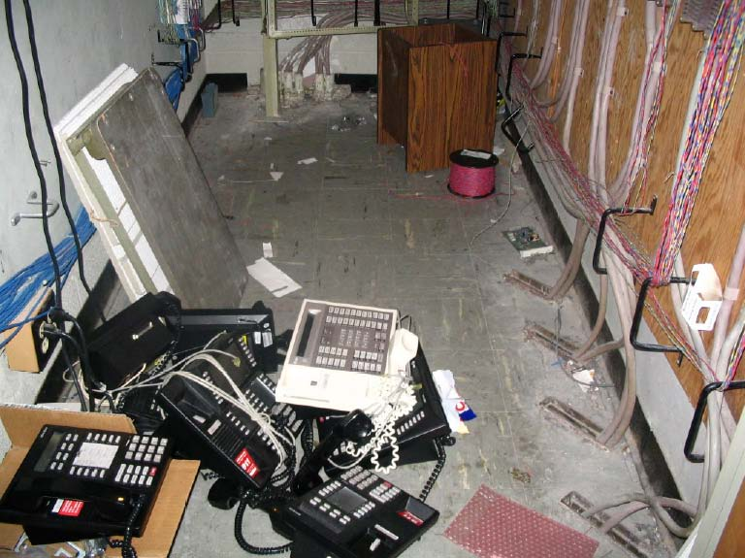

Exhibit 3 – Closet Examples (con’t) GOOD EXAMPLE - 1

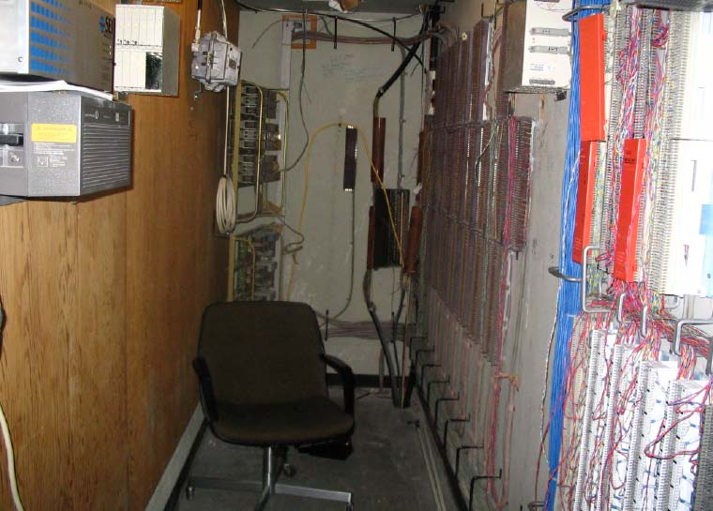

Exhibit 3 – Closet Examples (con’t) GOOD EXAMPLE - 2

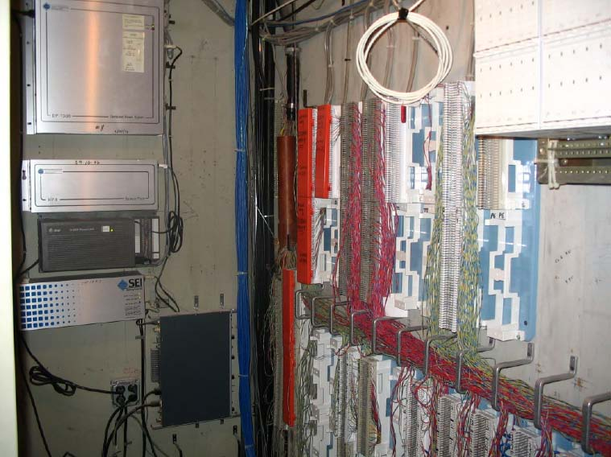

Exhibit 3 – Closet Examples (con’t) GOOD EXAMPLE - 3

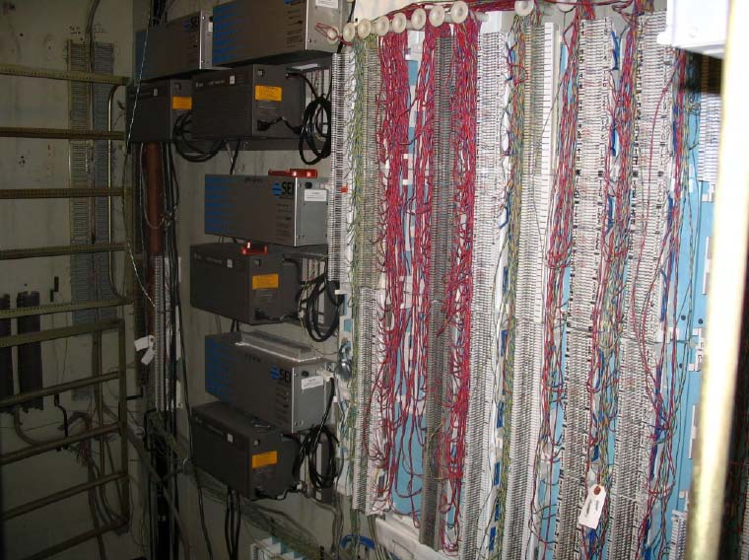
Exhibit 4:

Contact Listing for NIH LAN/Telco Closet Key Access

Contact Name & Position | Telephone Number | Area of Responsibility
Richard Payne,  CIT Telecommunications | 301-451-1410 | Maintain and updates  LAN/Telco Master Closet Key Listing
Greg Duling  CIT Telecommunications | 301-594-9470 | Team Leader Emergency Telecommunications Services Section
Yvonne A. Brooks,  CIT Telecommunications Branch Chief | 301-594-9409 | Authorizes LAN/Telco Master Closet Key Listing updates
Anthony Trang  CIT Cable Management Branch | 301-594-7411 | Maintains keys for all NIH Telco closets and handles escalations relative to closet access
Mark Campbell  DNST Cabling Infrastructure SLA and MAC Team | 301-594-9456 | PRIMARY- Assigned and processes Remedy Service Ticket for NIH Telco Closet access
Randy Massagee  DNST Cabling Infrastructure SLA and MAC Team | 301-594-1480 | SECONDARY -Assigned and processes Remedy Service tickets for NIH Telco Closet access
Brian Simpson  Network Operations Center Section Chief (NOC) | 301-451-5164 | Maintains keys for all NIH LAN closets handles escalations relative to closet access
Patricia Baldwin  Network Operations Center Supervisor (NOC) | 301-594-7435 | Area is assigned and processes Remedy Ticket for NIH LAN Closet access
NIH Help Desk | 301-594-6248 | Receives all calls for request for access to NIH closets and opens Remedy ticket
Network Operations Center (NOC) | 301-451-3141 | Receives calls and handles Remedy Service Tickets for NIH LAN Closet access requests
Access Control Help Desk | 301-451-4766 | Handles repair and changing of CARD Key access locks
Clarence Bruce  Office of Director. Office of Research | 301-496-3507 | Handles repair and changing of NIH metal locks

Exhibit 5 - Closet Access Request Form Remedy Screen

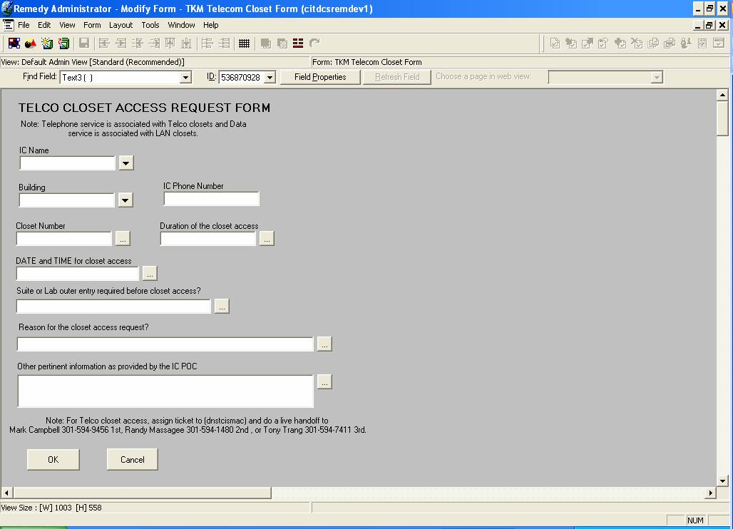
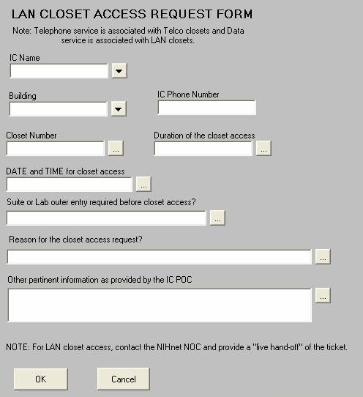

Exhibit 6 - NIH LAN/Teleco Closet Access Workflow

