Checking Submission Status in Commons - PI

For the purposes of documenting these steps the eRA Commons Demo site will be used. The steps are the same in production.

- Login to eRA Commons with your Principal Investigator (PI) account Username and Password.
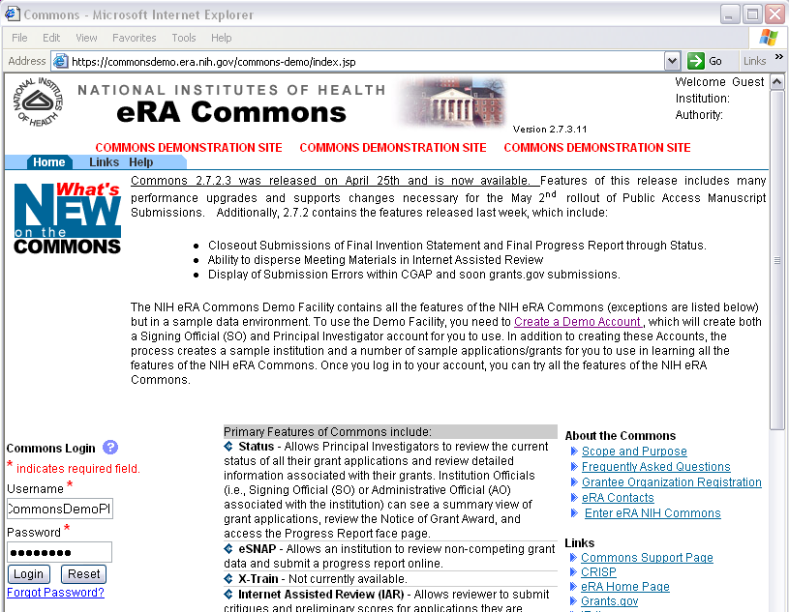
- Click the Status tab to view the PI status (1). Find application that shows “eSubmission Error” in Application Status (2). Follow the link on the Application ID to see specific error/warning messages (3).
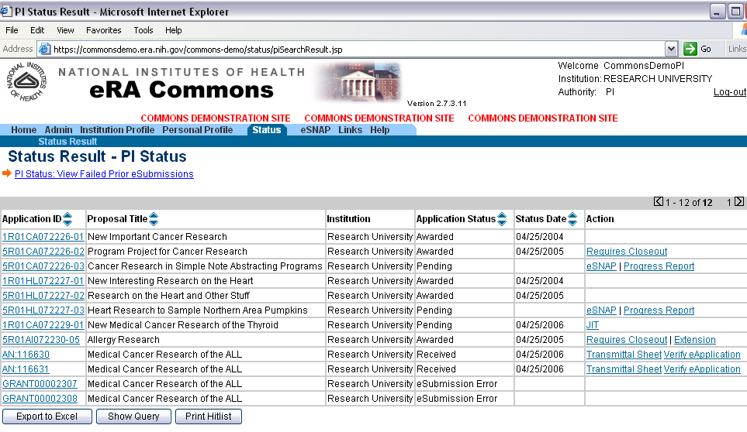
1
2
3
- View the list of eSubmission Errors/Warnings. Warnings can be fixed at the applicant’s discretion but do not require action for the application to move on. Errors must be addressed before the application can move on.
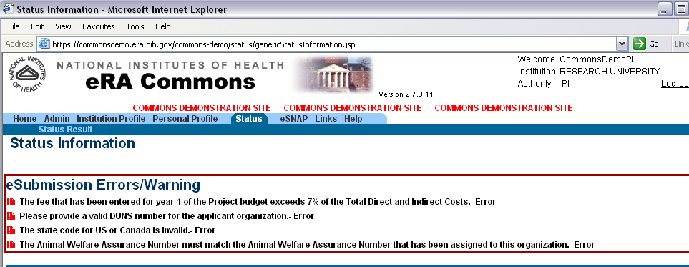

- Applicants should refer to the application guide and announcement instructions for guidance on the expected values for specific fields.
The Avoiding Common Errors section of the Electronic Submission of Grant Applications website is another valuable source of information.
If (after using the available resources) you are unable to identify and address the errors in your application, please contact the eRA Helpdesk via Web Support at http://ithelpdesk.nih.gov/eRA/.
- After making all corrections to the application forms, the entire changed/corrected application must be resubmitted through Grants.gov. Once an error-free application is received, the eRA system will assemble the application and make the grant image available to the PI and Signing Official for a final check.

