Minority Views of Hon. Jerry Lewis, Hon. C.W. Bill Young, Hon. Harold Rogers, Hon. Frank R. Wolf, Hon. Jack Kingston, Hon. Rodney P. Frelinghuysen, Hon. Todd Tiahrt, Hon. Zach Wamp, Hon. Tom Latham, Hon. Robert B. Aderholt, Hon. Jo Ann Emerson, Hon. Kay Granger, Hon. Michael K. Simpson, Hon. John Abney Culberson, Hon. Mark Steven Kirk, Hon. Ander Crenshaw, Hon. Dennis R. Rehberg, Hon. John R. Carter, Hon. Rodney Alexander, Hon. Ken Calvert, Hon. Jo Bonner, Hon. Steven C. LaTourette, and Hon. Tom Cole

America's economic crisis continues, and there is an immediate need for Congress to produce a strong and definitive plan to help weather this financial storm.

As Republican Members of the House Appropriations Committee, we want to express our willingness and desire to work with President Obama to help our economy out of its current economic decline. In fact, Ranking Member Lewis appealed to the President in his opening statement at the Committee mark up of this legislation, saying: “Mr. President, each of us wants to see you be successful. As we celebrate this historic moment in our nation’s history, we welcome the opportunity to work with you and your administration. The challenges we face as Americans — not Democrats or Republicans, but Americans — are great. We have much work to do. It is our sincere hope that we will work together — across party lines — to restore confidence in our economy and create a climate conducive to job growth. We can no longer afford to point fingers and cast blame. If there was ever a time for our country to come together, it is now.”

There is no greater challenge facing working families today than our nation’s struggling economy. Each of us can speak passionately — and with great empathy — of people we know in our own districts who have lost their jobs, are unable to pay their mortgage, don’t have health insurance, and are struggling to make ends meet. They are asking for our help.

As we demonstrate our compassion, let us also be mindful of our responsibility to assist those in need without creating an untenable situation for future generations. That is the balance we must strive to achieve.

The centerpiece of any stimulus bill ought to be near-term job creation. Government has a role — but our constituents are not asking for an unlimited expansion of government. They are asking Congress to focus on specific sectors of our economy and to provide solutions that will offer tangible, near-term results.

Most of us would agree that the recent $700 billion Troubled Asset Relief Program (TARP) bill is an illustration of how good intentions don’t always deliver desired results. Many Members would like to have that vote back.

When Congress spends too much, too quickly, it doesn’t think through the details and oversight becomes more difficult. The TARP bill is only the most recent example. The lesson learned was this: We cannot manage what we do not measure. We simply cannot afford to make the same mistake again.

Public dismay over the lack of transparency in TARP implies a public desire for more openness and thoughtful consideration of stimulus spending. The majority’s proposed $14 million reporting website is not oversight. Posting $550 billion worth of federal spending on a website does not ensure that these funds will be well-spent.

Each and every agency should be required to submit a spending plan to Congress —on the front-end and not after-the-fact — to ensure that every dollar is spent as intended. Our constituents deserve no less.

These taxpayers — who will repay this debt over time — also deserve specific answers before we spend another nickel of their money. They deserve to know how many jobs will be created in six months, 12 months, 18 months, and beyond. These are thoughtful, reasonable questions deserving a thoughtful, reasonable response.

Many have described this legislation as a transportation and infrastructure investment package. However, the fact remains that only $30 billion — or three percent — of the funding is directed toward “shovel ready” road and highway spending. The backlog for these projects is $64.3 billion.

Similarly, $4.5 billion is allocated for the Corps of Engineers for improved flood protection and navigation when a $61 billion backlog exists for Corps projects that are fully authorized. These are the types of targeted infrastructure investments that will create sustainable jobs and should be given even greater priority within this package.

Many Republicans support wellness programs, analog TV conversion coupons, and the NEA — but these and many other items in this bill don’t create jobs and ought to be funded through our regular appropriations process. They do not belong in a stimulus bill.

Nor should a stimulus package be used to establish 32 new government programs at a cost of over $136 billion — which this bill does. Thirty-seven percent of the total funding in the portion of the bill under the Appropriations Committee’s jurisdiction — more than one out of every three dollars — is dedicated to creating new government programs. Are we fostering job creation and economic stimulus or are we simply growing the size of government?

Our opposition to this package is not based on partisan politics but on economic reality. There is tremendous pressure on Congress to maintain funding for existing programs even before we create new ones. Again, let’s take off our partisan hats and look at the sobering facts.

Congress recently provided $700 billion for TARP. It’s now considering an $825 billion stimulus bill. There is talk of the Senate adding another $70 billion to address the AMT fix. Congress will soon be considering nine of the remaining FY09 spending bills at a cost of $410 billion. And, before long, we’ll be considering another emergency supplemental spending bill.

Let’s be perfectly honest — all of this spending is placing a tremendous burden of debt on present and future generations. Our projected deficit for 2009 is already approaching $1.2 trillion — the largest in history — even before we consider this proposal.

So, what can be done to make this a better and, perhaps, even a bipartisan bill?

- Narrow the focus of the appropriations to those items that provide measurable economic stimulus or produce jobs. Spending should be targeted to key infrastructure investments that will create jobs over the next two years. We do not question the urgency of this package; we question its priorities and its price tag.

- Address public concern over adequate transparency and accountability by requiring agencies to submit a spending plan to Congress—as we did with the 9/11 relief bill—on the front-end and not after-the-fact. This will ensure that every dollar is spent as intended.

- Ensure that this bill captures the full costs associated with waiving cost-share requirements and the hiring of additional federal employees. Proper safeguards are needed to prevent the unintentional growth of government over time.

- Limit the use of the stimulus bill as a vehicle for increasing base funding of popular domestic programs. Large increases in these programs create unrealistic expectations for future spending.

Just the size of the total bill, some $825 billion, should and does raise serious concerns. Without a clear assurance of how, why and if this proposal will create jobs and promote economic recovery, Congress cannot simply write an $825 billion blank check at taxpayer expense and hope for the best. We should demand that there be some clear, unequivocal assurance of the desired outcomes, in the form of a revitalized economy.

Unfortunately, the evidence from past attempts at stimulating the economy through government spending does not lead to this needed measure of certainty.

Previous attempts to use this redistribution strategy did not work. Over the 1990s, Japan engaged in massive, multiple stimulus efforts and saw its economy remain stagnant and its per capita income go from the world's second-highest to the tenth-highest, behind Austria, Australia, Belgium, Canada, Denmark, Finland, Ireland, Holland, Switzerland, Sweden and the United States. We ignore this lesson at great risk to our society.

With respect to this legislation, the majority leadership claims that this bill will create or save about 3 million jobs, but the cost for this is a shocking $275,000 for each new job created (assuming they actually materialize). Even worse, this calculation is only a partial measure of cost. In reality, the cost of each government-sponsored job should reflect how the private sector would have spent the $275,000 if the government had never gotten its hands on it in the first place. More than likely the private sector could have created many more than one job for $275,000 - especially considering the average U.S. household income is around $45,000.

Finally, we must not forget that this massive government spending doesn't come out of thin air and that we run the perilous risk of leaving a terrible fiscal legacy for future generations. Based on Congressional Budget Office (CBO) recent figures, by 2019 we will have to spend $750 billion per year just on the interest we will owe on current debt - and this does not include the addition of $825 billion in new "stimulus" spending. To borrow these funds and pay the interest on the ensuing debt, the government will have to raise its implicit interest rates by more than four percentage points over the next decade. This is the legacy created by this bill – a significant increase in interest rates that we, our children, and our grandchildren must all endure in the future.

Overview of Appropriations Within the Bill

What follows is a brief description of the flaws in the Committee passed bill, a summary of the various programs funded in the legislation, and a description of the Committee Republicans’ attempts to improve various portions of the bill through the mark up process.

Immediate Economic Assistance is Needed - Not Massive, Extraneous Spending Under the Guise of Stimulus

American workers, businesses and families need real help, not a windfall of deficit spending under the guise of stimulus with no guarantees of economic relief. To help prevent further economic decline, the government has a responsibility to provide common sense investments that will help stabilize the aspects of our economy which put us in the greatest peril, and provide temporary relief to American families who are bearing the brunt of this crisis. Despite claims the stimulus legislation contains “targeted” and “prioritized” investments, in reality this bill will blanket government programs in spending with little thought toward real economic results, job creation, or respect for the taxpayer.

We must not pour hundreds of billions of dollars into government programs, saddling future generations with the debt, without having a clear understanding of what we are willing to sacrifice for the hope - but no guarantee - of economic recovery today, or even tomorrow.

This legislation should contain the highest degree of fiscal restraint and discretion - especially considering that this spending will bypass customary oversight, public scrutiny, and debate by circumventing the normal authorization and Appropriations process. We must ask ourselves, is each and every program in this bill really stimulative? Do they create jobs (and how many and for how long)? Are they worth the cost? Are they one-time costs, or are they programs that will have to be funded year after year? And, are they things that must be done immediately, or could they be done more effectively and efficiently under the normal funding process?

If we fail to protect the interest of the taxpayer and make decisions without these common sense questions, the result will be continued economic decline, vast government waste, long term budget shortfalls and shortages, and a perilous national financial future.

Undoing Decades of Proven Policy

The Pelosi-Obey stimulus bill contains massive shifts in federal policy. These changes have not been approved by the relevant authorizing committees, and do not take into account the fact that established policies in place for decades are usually still there for two reasons – because they work, or because they are extraordinarily difficult to change.

Government agencies will have serious difficulties implementing these new, broad policy changes – especially without the normal instruction and guidance that comes from a proper authorization and regulatory process. This difficulty will make it nearly impossible for agencies to adopt these changes in a prompt fashion – thereby negating any time savings gained by tacking these provisions onto an emergency Appropriations bill instead of allowing them to be approved by the normal legislative process.

The government’s role in public housing is one of these massive policy shifts. Thirty years ago, the government decided to get out of the business of building public housing. The large failure of the program had led to over-crowding, poor sanitation, high crime rates, and a general lower quality of life for residents. Instead, the government turned to the voucher program, which gives low-income residents better housing options - allowing them to live closer to their jobs and better schools, and providing an escape from deteriorating conditions and concentrations of poverty. To date over two million families receive assistance through the voucher program. As public housing stock has decreased, vouchers have replaced that stock.

The stimulus bill ignores the lessons of history and attempts to preserve and perhaps reverse this trend. This bill spends $5 billion to modernize and upgrade the existing public housing stock - propping up unsuccessful and problem-ridden housing authorities and prolonging bad policy. In contrast, this same amount of money could provide voucher assistance for over 100,000 families for five years.

Another policy shift occurs in changing the role of the Department of Energy (DOE). The Pelosi-Obey stimulus bill shifts the role of DOE from a research and development agency into a grant and loan making body. Roughly $30 billion is included in this bill to accomplish this goal. For example, this bill begins entirely new grant programs to states and localities, turning the DOE into nothing more than a pass-through for taxpayer dollars and throwing accountability go out the window. The losers? The American taxpayers and their hope for energy independence.

The changing role of the federal government in education and healthcare is yet another massive policy shift included in this stimulus bill. While some investments in health care and education are regularly included in the federal budget, the Pelosi-Obey stimulus bill goes far beyond the firmly established and authorized role of government in these areas – including creating 9 new programs for a total of $106 billion. For example, this bill contains $20 billion to insert the federal government into school construction which, until this bill, was exclusively the responsibility of state and local governments. And, this bill includes $24.7 billion to lay the groundwork for a highly controversial shift to universal healthcare (which has yet to be approved by Congress).

Circumventing PAYGO

This stimulus legislation contains $224 billion that under the regular legislative process would be subject to the Pay-As-You-Go (PAYGO) rule. This rule was put in place by the Democrat majority at the beginning of the last Congress, and requires any new spending to be offset by increased taxes or budget cuts in other areas.

The Pelosi-Obey stimulus legislation, being an appropriations bill, circumvents this rule and includes this massive spending which would normally be subject to PAYGO. By tacking on these provisions, the Democrat majority will attempt to avoid potentially embarrassing public in-fighting down the road, and fast-track party and administration priorities without proper public scrutiny and oversight.

Piling Money on Money – Can We Even Spend This Much?

In one bill, the Pelosi-Obey stimulus contains almost as much funding as the entire federal government spends in one year. It is without a doubt the most expensive single piece of legislation Congress has considered. This bill even dwarfs the $700 billion Troubled Asset Relief Plan (TARP) bail out that passed Congress last fall.

Because of this bill’s unprecedented size, federal agencies will have a difficult time spending this money. Federal bureaucracies are notoriously slow, unresponsive, and unwieldy, which makes this bill’s exponential growth in existing programs extraordinarily difficult to implement in a short period of time. These agencies have neither the staff nor the organizational capacity to handle this influx of funds. To make matters more complicated, this bill contains 32 new programs (totaling $137 billion), but does not include the kind of legislative language and guidance which normally comes from a proper authorization process.

In addition, many of the projects funded in this bill could take years – not months - to complete. For example, this bill includes $7.7 billion for the General Services Administration (GSA) building fund. The GSA’s target average completion dates for construction projects is 8.5 years. (Further, of the GSA’s project funding that can get out the door in 120 days, 36% will go to projects in Washington, D.C.)

Also, many provisions in this bill fund programs that are already sitting on large, unspent pots of money. The amount of unspent funds already sitting in federal coffers raises serious questions about the economic benefit of piling on even more money. If federal agencies can’t spend the money they already have, does the economy really benefit by giving them more? If we require the agencies to spend this stimulus money in a short period of time, won’t they just pass over their existing funds, resulting in no real additional “stimulus” spending? And, if these agencies have been sitting on funds in accounts that have “stimulus” potential, why hasn’t this money already been spent?

The Congressional Budget Office (CBO) – a non-partisan entity that provides unbiased budget analysis for Congress - produced a report of the Pelosi-Obey stimulus bill that indicates that the legislation will not provide the kind of immediate results that will boost our economy in the short term. The following table highlights when the funding contained in the Appropriations stimulus legislation will actually be spent. According to the CBO, only 7% of the discretionary spending in the stimulus bill will be spent in the first year, while the bulk of the funding won’t be spent for years – including 18% which won’t be spent until five, ten, or even more years after this bill is enacted.

STIMULUS PACKAGE SPENDOUT ($ in thousands)
FISCAL YEAR | Budget Authority by Year | Outlays by Year | Cumulative Outlays | Total % Spent
FY09 | 273,986.0 | 26,156.0 | 26,156.0 | 7%
FY10 | 66,529.0 | 110,167.0 | 136,323.0 | 38%
FY11 | 4,147.0 | 103,048.0 | 239,371.0 | 67%
FY12 | 3,575.0 | 52,948 | 292,319.0 | 82%
FY13-19 | 9,852.0 | 63,213.0 | 355,532.0 | 99%
After FY19 | - | 2,557.0 | 358,089.0 | 100%
Total | 358,089.0 | 358,089.0

Following is a CBO summary of the legislation, received by the Appropriations Committee on January 19th at 3:00 pm. This report shows the CBO estimate of the American Recovery and Reinvestment Act of 2009 as posted on the Appropriations Committee majority website on January 15, 2009. This estimate assumes a mid-February, 2009 enactment date.

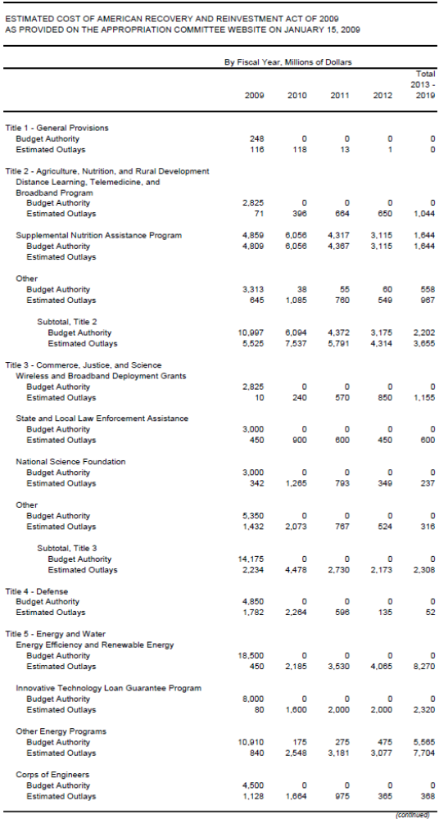
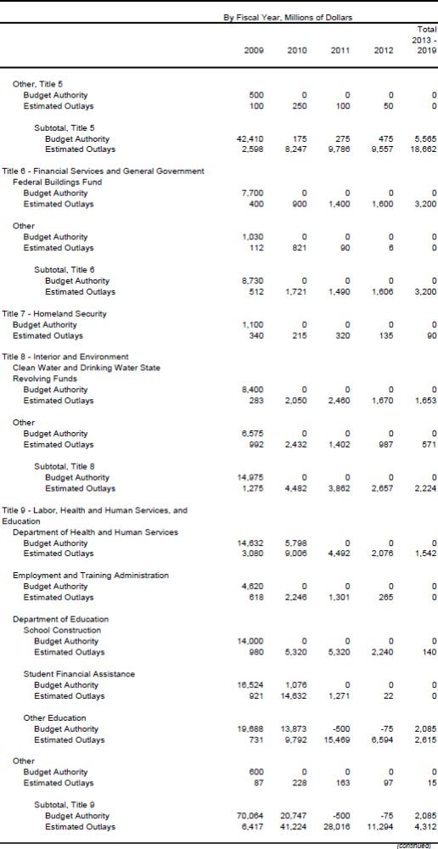
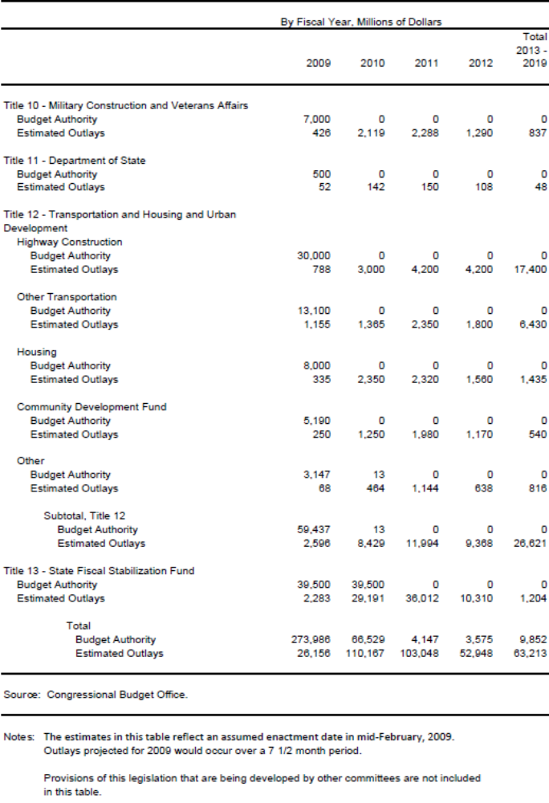

Effectiveness of Government Spending to Help Our Economy

Over the last year, Congress has pumped massive amounts of government spending into the economy with limited results. To make matters worse, much of this spending has not gone to the uses that Congress intended, and was spent without proper oversight, transparency or accountability to the taxpayer.

For example, Congress approved $700 billion in TARP funding last fall to help financial companies deal with the fiscal burden created by the housing crisis. However, those funds were redirected, without the consent of Congress and behind closed doors, to other purposes -including an auto industry bail out.

This questionable record of spending raises serious red flags. Before approving an additional $825 billion, we must ask: If government spending hasn’t worked to stabilize the economy throughout this year or in the past, why should we think it will work now? Do we have any guarantees that the agencies will spend the money the way Congress intended and the American people expect? Or is a “bait and switch” spending approach going to be the precedent for future stimulus funding?

“Accountability” Measures

The draft stimulus legislation contains several “accountability” measures to provide spending oversight. These measures include the creation of a new “Recovery Act Accountability and Transparency Board,” public notification, certifications, and descriptions of funding decisions, a new $14 million website, and additional resources for the Government Accountability Office (GAO) and various agency Inspectors General (IG).

While we applaud the attempt at oversight, these measures are all designed to take effect after the funds are spent. Limited attempts were made to address critical budgetary concerns – including efficiency of the programs, past effectiveness, and long-term costs – that should addressed before funds are spent as a part of a responsible budget process.

However, we are disappointed that the majority – on a party line vote –rejected the Lewis amendment to establish a bi-partisan Appropriations Subcommittee to oversee the Executive Branch on Oversight and Taxpayer Protection. The Constitution vests with the Congress the power of the purse, with the Appropriations Committee being charged to fulfill that constitutional mandate. Oversight of spending is fundamental to the Committee’s responsibilities.

The stimulus bill considered by the Committee contains unprecedented new spending and proper oversight is needed to bolster public confidence and demonstrate that Congress can be a responsible steward of the public trust — and the public’s money.

To prevent the mistakes of the past becoming the mistakes of the future, the Lewis amendment would have established a special bi-partisan Subcommittee whose sole function would be to conduct vigorous oversight of appropriated funds for stimulus and economic recovery. This would have ensured the funds were used in a manner to ensure maximum effectiveness, that they achieve their goals, and that the taxpayer’s investment is protected.

Modeled after similar select oversight panels created by Speaker Pelosi, this new Subcommittee would have been made up of ten Members of the Appropriations Committee, equally split between the majority and minority parties, and charged with one mission -- conducting comprehensive oversight across Subcommittee lines on the entirety of the package of spending. The new Subcommittee would not have the authority to produce legislation, but instead would regularly report and make recommendations to the relevant Subcommittees and the Committee based on its findings. The Subcommittee would be tasked with reviewing how economic stimulus funds are used. It would provide the oversight and accountability that the public is demanding from us.

We would point out that the majority party felt it necessary to put provisions in the bill to ensure that the Executive Branch have one centralized board in place to ensure accountability on their end. We have no disagreement with that idea. In fact, the new Subcommittee would be tasked with reviewing the activities and recommendations of the new Executive Branch oversight and accountability panel. Therefore we cannot understand why the majority would reject creating a similar mechanism for this Committee since, let’s face it, the buck starts—and stops—with this Committee.

We are disappointed in the majority’s actions as we believe that the Committee is in danger of being unable to fulfill its most fundamental responsibility to remain faithful to the taxpayer in protecting their investments.

Stimulus Summary

The following is a summary of the Pelosi-Obey economic recovery bill. While every item included in the bill should be considered on its own merit, most of the spending would not provide the kind of job creation or other benefits needed to sustain our economy through these tough times; rather, it would fund programs that will have no immediate or short term relief to struggling American families. Unfortunately for the American taxpayer, the vast majority of this spending is not designed for economic recovery, and would further bloat federal programs, expand the role of government in Americans’ lives, and is intended to provide the Democratic majority some political cover by funding campaign promises.

Total Stimulus Spending included in the Pelosi-Obey Stimulus Legislation: $551.7 billion

- Discretionary spending currently in the bill: $358.1 billion*
- Estimated mandatory spending expected to later be included in the bill: $193.6 billion
- Portion to be added by the Ways and Means Committee: $275 billion

* The proposed Pelosi-Obey stimulus language approved by the House Appropriations Committee contained $358 billion in spending – not $550 billion as Chairman Obey announced in his press release of 1/15/09.

Spending by Subcommittee:

- Agriculture: $26.863. Includes $19.991 billion in mandatory spending (Food Stamps) that is not offset.
- Commerce Justice: $14.191 billion.
- Defense: $4.865 billion.
- Energy and Water: $48.915 billion
- Financial Services: $8.760 billion
- Homeland Security: $1.104 billion
- Interior: $15.010 billion
- Labor/HHS: $171.363 billion.
- Military Construction/Veterans: $7.001 billion
- State/Foreign Operations: $0.500 billion
- Transportation/HUD: $59.485 billion

Additional Labor/HHS related spending (FMAP, UI, COBRA, etc) in the bill: $193.603
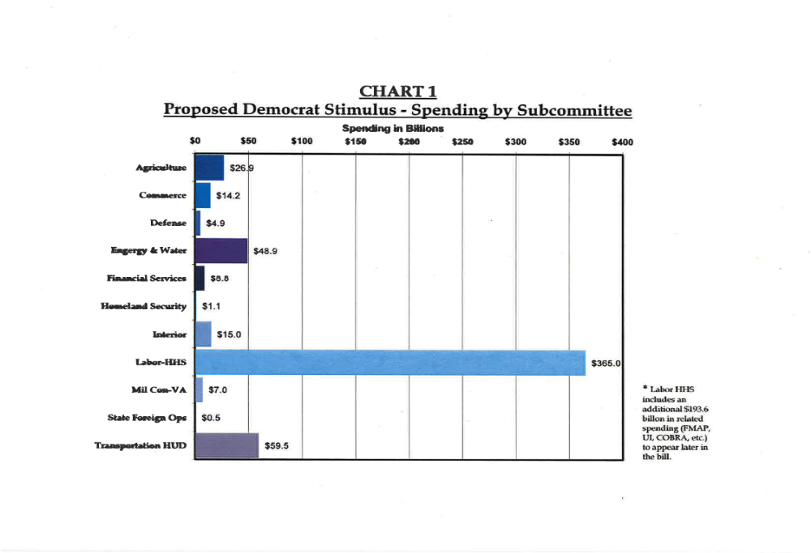

Spending by Category

($ in millions)
Category | Stimulus Amt | FY08 Amt
New Programs | $ 136,756 | $ 0
Program Expansions | 91,958 | 109,277
One-time Increase to Existing Programs | 100,241 | 128,281
Subtotal | $ 328,955 | $ 237,679
Entitlement Program Increases | 29,134 | N/A
Total, Spending (currently in bill) | $ 358,089 | $ 237,679

New Programs in the bill:
- There are 32 new programs totaling $137 billion (38% of all spending in the current bill).
- Seventeen of these new programs have never been authorized by the Congress. Instead the authorizations are being carried in this bill. These programs account for $123 billion or 34% of all spending in the current bill.
- The vast majority of these new programs fall under the Labor/HHS Subcommittee. This bill creates 10 new Labor-HHS programs, totaling $107 billion.

Program Expansions in the bill:
- The stimulus proposal expands 60 existing programs (normally funded in regular Appropriations bills) at a cost of $76 billion in FY09 – a 68% increase over last year. (In FY08 these programs received a total of $111 billion).
- There will be tremendous pressure to fund many - if not most - of these programs at this new, higher level in future years, especially given that much of this money will have to be spent getting these programs up and running and properly staffed.
- The Labor/HHS bill accounts for 30 of the 60 program expansions and $40 billion (53%) of the FY09 growth. This represents a 44% increase over the total amount provided for these programs over last year. The bill also includes an additional $17 billion to fund next year’s costs for more than half these programs.
- This widespread and rapid program expansion indicates a clear intention for these types of increases to be permanent. For example, the bill spends $15.6 billion to increase each Pell grant by $500. After 2 years, this extra funding vanishes, meaning Congress will have to replenish the funds or Pell grant recipients will face a sudden and sharp decline in financial support.

One-time Infusions to Existing Programs:
- The bill includes an additional $100 billion in anticipated “one-time” infusions to existing programs, primarily for construction and other non-recurring items. These programs were funded at $128 billion in FY08.
- This category includes funding for transportation programs (highways, bridges, rail and transit systems) as well as Corps of Engineers and Bureau of Reclamation projects. These programs receive a total of $48 billion, or roughly 13 percent of the total spending in the bill.
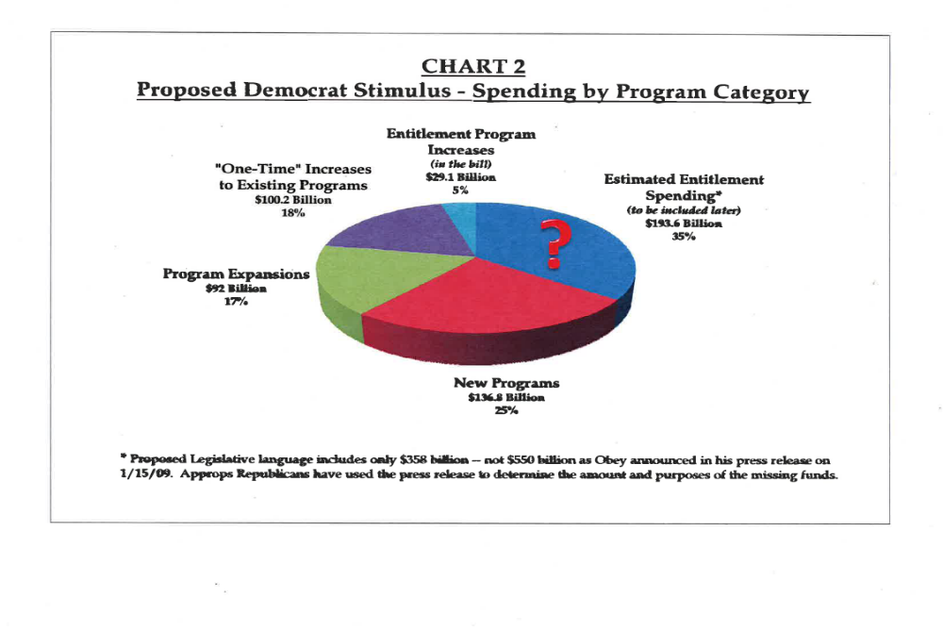
Minority Views on the Labor, Health, and Human Services (Labor/HHS) Spending in the Pelosi-Obey Stimulus Bill

There are many programs funded within the Labor/HHS portion of this bill that may or may not be good things to do, but that is not the fundamental question facing the Congress or the nation. The reality is that this bill should focus on the best way for the federal government to do its part to stimulate the economy – to foster an atmosphere in which private sector employers expand their businesses and hire more workers, and consumers have the confidence to return to shopping malls, to take a trip to their local automobile dealership to buy a new car, or to contact a real estate agent in the hope of finding their dream home.

In the case of programs within the jurisdiction of the Labor, Health and Human Services Subcommittee, which constitutes roughly $170 billion of the $358 billion (nearly half) in the bill reported by the House Appropriations Committee, just the opposite is true. The majority party is using this bill, and the economic crisis, to begin to implement its social agenda. The facts seem to bear that out – particularly as there is no less than $5 billion in this bill to prepare the federal agencies for what will likely be a highly controversial move to universal health care. The funding contained in this bill for programs within the jurisdiction of the Labor/HHS Subcommittee dwarfs the funding for all other programs, combined.

House Republicans have several major concerns with items contained in the Labor/HHS bill:

Many of the programs funded in the bill are simply “freebies.” The Labor/HHS Subcommittee portion of the bill includes spending to please liberal special interest groups and advance the Democrats’ social agenda. They do not pass the laugh test if the purpose of the bill is to stimulate the economy in the short-term. Our issue is not whether these are good programs, but whether these activities will result in legitimate, economic stimulus. The following is a list of Labor/HHS programs that will achieve little in creating jobs, growing the economy in the short-term, and getting this nation back on sound fiscal footing:

Program | Amount
Community health center operations | $500,000,000
Training doctors, nurses and other primary care providers | 600,000,000
Biomedical research at the National Institutes of Health | 1,500,000,000
Comparative effectiveness research | 1,100,000,000
Low Income Home Energy Assistance Program (LIHEAP) | 1,000,000,000
Head Start and Early Head Start | 2,100,000,000
Community Services Block Grant | 1,000,000,000
Child Care Development Block Grant | 2,000,000,000
Nutrition programs for senior citizens | 200,000,000
Prevention and wellness fund | 3,000,000,000
Grants for state and local education | 13,000,000,000
K-12 education technology | 1,000,000,000
Teacher Incentive Fund | 200,000,000
Statewide education data systems | 250,000,000
Special education | 13,600,000,000
Grants to pay AmeriCorps volunteers | 200,000,000

This bill provides $60 billion in advance appropriations that cannot be spent until at least 2010. If the goal of economic stimulus is to infuse capital into the economy quickly, should we really hold $60 billion in funding in reserve until FY10? Providing $60 billion in advance appropriations is nothing less than a hollow attempt to buy down our obligations in the FY10 appropriations cycle or substantially increase program funding in future years for pet programs. In any case, this funding will do absolutely nothing to put Americans back to work now. The following is a list of the funding in the bill that will do nothing to create jobs now because it is not available to be spent until October 2010:

Program | Amount of Delayed Funding
Community health center operations | 250,000,000
Training doctors, nurses and other primary care providers | 300,000,000
Biomedical research at the National Institutes of Health | 750,000,000
Low Income Home Energy Assistance Program | 1,000,000,000
Head Start and Early Head Start | 1,050,000,000
Community Services Block Grant | 500,000,000
Child Care Development Block Grant | 1,000,000,000
Compassion Capital Fund | 50,000,000
Nutrition programs for senior citizens | 100,000,000
Prevention and wellness fund | 797,900,000
Grants for state and local education | 6,500,000,000
K-12 education technology | 500,000,000
Education for homeless children and youth | 33,000,000
Special education | 7,300,000,000
Vocational rehabilitation state grants | 250,000,000
Centers for Independent Living | 100,000,000
College Work-Study | 245,000,000
Mandatory Pell grants | 831,000,000
State Fiscal Stabilization Fund | 39,500,000,000

Much of this funding will need to be continued in the future. The majority has indicated that funds contained in this package can be scaled back as our economy recovers. While that may be true in some areas, there are no “sunset” provisions included in this legislation, and it is unlikely that Congress will voluntarily undo increased spending levels once they are enacted. For example, it is very hard to imagine that the Labor/HHS Subcommittee will scale back $13 billion in funding for special education, trim $1 billion in LIHEAP funding, and reduce the size of the maximum Pell grant award down the road. This means that, come FY11, the Labor/HHS Subcommittee will need a discretionary allocation well in excess of $200 billion to sustain the massive and borrowed cash infusion that is being made to these programs under the guise of economic stimulus. In short, this bill is intended to put more pressure on Congress to massively expand social programs contained in the Labor/HHS Appropriations bill well into the future without regard to our Nation’s fiscal health or the burden it will place on American families in the form of higher taxes, greater national debt and associated economic realities such as inflation and annual interest payments on the debt. It represents a massive policy shift in the federal role in education and health care delivery and it does nothing to create sustainable jobs in the near term. Further, it ignores any funding needs that may arise in the future, including areas like defense, homeland security, and housing.

Republican Amendments to the Pelosi-Obey Stimulus Bill
The following amendments were offered by Committee Republicans in an attempt to improve the bill by providing additional oversight and ensuring that these investments are thoughtful, targeted, and timely.

Labor, HHS Subcommittee Ranking Member Todd Tiahrt offered an amendment to strike all new programs created in the bill - funding that does not have the ability to be spent in the short term. The majority included seventeen separate authorizations to create new programs, many of which are highly dubious in terms of their ability to create jobs in the short term. Among these non-stimulative authorizations and appropriations are $3 billion for a prevention and wellness fund that essentially duplicates public health efforts currently underway at the Centers for Disease Control and Prevention; $1.1 billion for a highly controversial research program on the comparative effectiveness of medical treatments, the results of which could be used to deny more expensive, yet more appropriate, therapies to patients in need; and nearly $3 billion for wireless and broadband grants, which would supplant private sector investments in these very areas. In total, the amendment would have cut $122.3 billion in new spending from the bill. The amendment was rejected by a vote of 21-39.

Energy and Water Subcommittee Ranking Member Rodney Frelinghuysen and Transportation, Housing and Urban Development Ranking Member Tom Latham offered an amendment to strike about $61 billion in non-stimulus funds that would not be available until FY10 and instead use those funds today for vital investments in our Nation’s infrastructure. The amendment would have added more than $24 billion to the Army Corps of Engineers to address the $61 billion backlog in already authorized projects addressing safety, maintenance, and improvements to our Nation’s system of locks, levies, dams and ports. The amendment would have also added $2 billion to the transit account to address capital needs and $34 billion to the highway account, bringing the total highway funding up to $64 billion, the same level advocated by the American Association of State Highway and Transportation Officials based on a poll of state Departments of Transportation on the number of projects across the country that are “shovel-ready”. The Frelinghuysen/Latham amendment would have created or saved an estimated 1.7 million jobs, rather than prepay for programs that lack a demonstrated ability to create local jobs across the country and should instead be considered in the regular FY10 bill. The amendment was rejected by a vote of 22-37.

Interior Subcommittee Ranking Member Mike Simpson offered an amendment to strike section 1105(b) of the bill. As originally drafted, the bill language would have allowed agencies—after two years—to divert funds for purposes other than job creation without approval of the House or Senate Committee’s on Appropriations. Mr. Simpson’s amendment would restore the Committee’s longstanding practice of providing proper oversight of taxpayers’ money. The amendment was adopted by the Committee with a slight modification to only allow projects under the jurisdiction of the Military Construction/Veterans Affairs Subcommittee this authority, as these projects traditionally take more than two years to obligate.

Transportation, Housing and Urban Development Subcommittee Ranking Member Tom Latham offered an amendment to require federal agencies to certify that they will use funds provided in the bill to add to, and not replace, existing project funds already in federal pipelines to ensure that the additional funds will have an immediate effect on the economy. This bill adds almost $195 billion to programs that are already funded as part of the annual budget process, many of which already have billions in unspent funds still in the pipeline from previous budget cycles. Stimulus funding must not simply sit at the end of the pipeline while existing funds for these programs are spent first. The amendment was rejected by a vote of 22-36.
Homeland Security Ranking Member Harold Rogers offered an amendment to withhold fifty percent of the funds made available in the bill until a detailed expenditure plan is submitted to the Committees on Appropriations. The amendment would have required that the plan include a detailed explanation of how funding would stimulate the economy (as per the bill’s stated objectives in Section 1101), and a certification that the bill’s oversight requirements were met (as specified in Sections 1221, 1225, and 1229 of the bill and including the establishment of a reporting website, a transparency board, and an advisory panel for the transparency board). The amendment was rejected by a vote of 22-36.
Interior Subcommittee Ranking Member Mike Simpson offered an amendment to apply the PAYGO rule to the direct spending items in this bill, requiring that all such spending in the bill be deficit-neutral. The intent is no different than the commitment made by Speaker Pelosi at the beginning of the 110th Congress to return to PAYGO rules. The amendment would have prohibited any provision in the bill that provides new or increased entitlement spending from taking effect until a bill is passed with corresponding offsets. The amendment was rejected by a vote of 22-35.

Financial Services Subcommittee Ranking Member Jo Ann Emerson offered an amendment to prohibit appropriations from being used to administer, implement or enforce an increase in tax rates enacted during calendar year 2009 and calendar year 2010. The purpose of this bill is to stimulate the economy. If we want businesses to create jobs and make capital investments, and if we want consumers to increase spending, Congress needs to make it clear that Americans’ tax rates will not be increased at least for the next two years, the intended time period of this bill. The majority was not willing to make this commitment. The amendment was rejected by voice vote.

Commerce, Justice, Science Subcommittee Ranking Member Frank Wolf offered an amendment to create a SAFE (Securing America’s Future Economy) Commission. The amendment would have established a bipartisan commission to develop legislation to address long-term national debt, budget and economic issues. This bipartisan plan garnered the support of 110 co-sponsors in the 110th Congress. Whatever short-term stimulus plan is finally enacted, Congress must simultaneously incorporate long-term budget controls. As former Comptroller General David Walker stated, "We should not just engage in timely and targeted stimulus. We need to put a process in place that will enable elected officials to make a range of tough decisions that have been delayed for far too long." By rejecting the Wolf Amendment, the Committee wasted an opportunity to set up a bipartisan mechanism to deal with the underlying problem of government spending that is on autopilot, and to show the American people that we can make difficult choices. The amendment was rejected by a vote of 23-34.

Agriculture Subcommittee Ranking Member Jack Kingston and Committee member Ken Calvert offered amendments to prohibit funds in the bill from being provided to entities that do not participate in the E-verify program, and to extend the authorization of the program, in an effort to ensure that all new jobs created will go to American citizens and those lawfully in our country. The Calvert amendment contained the full text of H.R. 6633, as passed by the House 407-2 last year. Both amendments were accepted by the Chair.
Conclusion

The issue of our struggling economy is not about Republicans and Democrats, Committee process, or long term social goals: it’s about how best to help our economy right now – without doing more harm than good.

To be clear, we do not believe that all the programs contained in the Pelosi-Obey stimulus proposal are bad programs - some of them have had long-time Republican support, and some of the new programs are worthy of consideration. However, the vast majority of the spending in the bill will not help the economy recover in the short-term. This is a stimulus bill – we must make tough spending decisions so that our nation receives the most economic benefit for every tax dollar we spend.

However, because Republicans were left out of crafting of this bill, and because our suggestions and modifications were largely denied by the majority, this stimulus legislation does not reflect this goal.

Therefore, we’ll conclude our views as we began them, with a message to our President, given by Ranking Member Lewis at the Committee mark up of this bill:

“Mr. President, the challenges we face transcend partisan politics. We have an historic opportunity to work together to craft a stimulus package that Republicans and Democrats can support. We appeal to you to include us in this process.”

