Adult Education
and Family Literacy Act

Program Year 2003–2004

Report to Congress
on State Performance

U.S. Department of Education
Office of Vocational and Adult Education
2006
Table of Contents
Executive Summary iii
Introduction 1
Accountability System—The National Reporting System 9
Setting Performance Benchmarks 10
Measuring Educational Gain 11
Collecting Follow-up Measures 13
Federal Investments to Improve Program Data and Accountability 14
Federal Assistance in PY 2003–04 15
NRS Implementation by States 16
Summary of National Performance Results 17
National Profile of Selected Program and Student Information 24
State Profiles of Selected Program and Student Information 27

Executive Summary
The state-administered grant program authorized under the Adult Education and Family Literacy Act (AEFLA), enacted as Title II of the Workforce Investment Act (WIA) of 1998, is the major source of federal support for adult basic and literacy education programs. The purpose of the program is to provide educational opportunities to adults sixteen and older, not currently enrolled in school, who lack a high school diploma or the basic skills to function effectively in society or who are unable to speak, read, or write the English language.
When AEFLA was reauthorized in 1998, Congress made accountability for results a central focus of the new law, setting out new performance accountability requirements for states and local programs that measure program effectiveness on the basis of student academic achievement and employment related outcomes. To define and implement the accountability requirements of AEFLA, the U.S. Department of Education’s Office of Vocational and Adult Education (OVAE) established the National Reporting System (NRS).
To monitor data collection procedures and to promote data quality improvement, OVAE developed data quality standards to clarify the policies, processes, and materials the states and local programs should have in place to collect valid and reliable data. To assist states in meeting the standards, OVAE has provided resources, training, and technical assistance activities to improve data quality. OVAE has provided individual technical assistance to states on NRS implementation, published documents further refining NRS requirements, including guidelines for conducting follow-up surveys. Since 2001, OVAE has made available online training resources to states and local providers.
In program year (PY) 2003–2004, the program enrolled 2,677,119 learners, of which just under 40 percent (39.7) were enrolled in Adult Basic Education, 16.5 percent were enrolled in Adult Secondary Education, and 43.8 percent were enrolled in English Literacy programs.
Below is a summary table providing a comparison of actual performance on each of the core measures for adult education for the past years under the NRS. The data show modest increases
(1–3 percentage points over three years) in all areas except the two employment measures.
Actual Performance on Core Measures
National Totals
2000–01, 2001–02, 2002–03, and 2003–04

Actual Performance: 2000–01, 2001–02, 2002–03 and 2003–04
Performance Measures | Performance  2000–2001  (National Averages) | Performance  2001–2002  (National Averages) | Performance  2002–2003  (National Averages) | Performance  2003–2004  (National Averages) | 4-Yr Total  2000–01 to 2003–04  # Adults Achieving Outcome
Educational Gain  ABE/ASE* | 36% | 37% | 38% | 38% | 2,009,753
Educational Gain  English Literacy** | 32% | 34% | 36% | 36% | 1,590,181
High School Completion | 33% | 42% | 44% | 45% | 707,556
Entered Postsecondary Education/Training | 25% | 29% | 30% | 30% | 194,052
Entered Employment | 31% | 39% | 37% | 36% | 546,417
Job Retention | 62% | 63% | 69% | 63% | 752,249
* Percentage of adults enrolled who completed one or more educational levels
** Percentage of adults enrolled who completed one or more educational levels
Introduction
Adult education programs meet a critical need in our nation to improve the literacy skills of adults and enhance their ability to be more productive members of society and the workforce. The Adult Education and Family Literacy Act (AEFLA), enacted as Title II of the Workforce Investment Act (WIA) of 1998, is the principal source of federal support for adult basic skills programs. The purpose of the program, as defined in AEFLA, is to:
- Assist adults to become literate and obtain the knowledge and skills necessary for employment and self-sufficiency;
- Assist adults who are parents to obtain the educational skills necessary to become full partners in the educational development of their children; and
- Assist adults in the completion of a secondary school education.
The purpose of the state-administered grant program is to provide educational opportunities for adults sixteen and older, not currently enrolled in school, who lack a high school diploma, the basic skills, or the ability to function effectively in the workplace or in their daily lives. These state grants are allocated by formula based upon the number of adults sixteen and over who are not enrolled or required to be enrolled in secondary school and who do not have a secondary school credential. These data are drawn from the U.S. Census on Population and Housing as required by WIA, Title II.
The federal allocation for AEFLA grants to states for Program Year (PY) 2003–2004 (or Fiscal Year 2003) was $561,042,109. Nationally, this amount represented approximately 25 percent of the total amount expended at the state and local levels to support adult education and literacy in PY 2003–2004. States distribute 82.5 percent of the federal funds competitively, using 12 quality criteria identified in the law, to local adult education providers. The provider network includes a variety of local agencies – local educational agencies, community colleges, community-based organizations, and volunteer literacy organizations. Many adult education programs also work with welfare agencies at the state and local level to provide instruction to adults needing basic skills who are receiving Temporary Assistance for Needy Families (TANF) benefits. In addition, adult education supports adults in job training programs through partnerships with One Stop Career Centers and other job training programs in the community.
Courses of instruction offered by local providers include:
- Adult Basic Education (ABE), instruction in basic skills designed for adults functioning at the lower literacy levels to just below the secondary level;
- Adult Secondary Education (ASE), instruction for adults whose literacy skills are at approximately the high school level and who are seeking to pass the General Educational Development (GED) tests or obtain an adult high school credential; and
- English Literacy (EL), instruction for adults who lack proficiency in English and who seek to improve their literacy and competence in English.
In PY 2003–2004, the program enrolled 2,677,119 learners, of which just under 40 percent (39.7) were enrolled in Adult Basic Education, 16.5 percent were enrolled in Adult Secondary Education, and 43.8 percent were enrolled in English Literacy programs, as shown in Table 1, below.
Table 1
Enrollment by Program Area, PY 2003–2004

Program Area | Enrollment | Percent of Total Enrollment
Adult Basic Education | 1,061,814 | 39.7%
Adult Secondary Education | 442,726 | 16.5%
English Literacy | 1,172,579 | 43.8%
Total | 2,677,119

Table 2 shows the percent of learners in the three program areas by age, and Table 3 shows the ethnic composition of learners by age.
Table 2
Enrollment by Program Area by Age, PY 2003–2004*

Program Area | 16–18 |  | 19–24 |  | 25–44 |  | 45–59 |  | 60 & Older |  | Total
Adult Basic Education | 176,422 | 17% | 314,908 | 30% | 417,261 | 39% | 120,897 | 11% | 32,326 | 3% | 1,061,814 | 100%
Adult Secondary Education | 158,252 | 36% | 132,110 | 30% | 119,873 | 27% | 26,311 | 6% | 6,180 | 1% | 442,726 | 100%
English Literacy | 37,917 | 3% | 230,522 | 20% | 663,511 | 57% | 181,356 | 15% | 59,273 | 5% | 1,172,579 | 100%
Total | 372,591 | 14% | 677,540 | 25% | 1,200,645 | 45% | 328,564 | 12% | 97,779 | 4% | 2,677,119 | 100%

Table 3
Enrollment by Ethnicity by Age, PY 2003–2004*

Age Group | American Indian or Alaskan Native |  | Asian |  | Black, or African American |  | Hispanic or Latino |  | Native Hawaiian or Other Pacific Islander |  | White |  | Total
16–18 | 5,786 | 2% | 6,825 | 2% | 84,942 | 23% | 111,986 | 30% | 4,678 | 1% | 158,374 | 43% | 372,591 | 100%
19–24 | 11,541 | 2% | 23,709 | 3% | 158,194 | 23% | 279,746 | 41% | 6,473 | 1% | 197,877 | 29% | 677,540 | 100%
25–44 | 14,582 | 1% | 96,134 | 8% | 218,664 | 18% | 603,722 | 50% | 6,923 | 1% | 260,620 | 22% | 1,200,645 | 100%
45–59 | 3,364 | 1% | 42,927 | 13% | 60,524 | 18% | 131,945 | 40% | 2,094 | 1% | 87,710 | 27% | 328,564 | 100%
60 & Older | 698 | 1% | 20,139 | 21% | 13,165 | 13% | 30,169 | 31% | 660 | 1% | 32,948 | 34% | 97,779 | 100%
Total | 35,971 | 1% | 189,734 | 7% | 535,489 | 100% | 1,157,568 | 100% | 20,828 | 1% | 737,529 | 28% | 2,677,119 | 100%
* Percentages may not add to 100% due to rounding.
As shown in Table 2, in PY 2003–2004, most participants (70 percent) were between the ages of 19 and 44, but the age distribution varied across instructional area. For example, participants in Adult Secondary Education tended to be younger: 66 percent were between the ages of 16 and 24. Participants in English Literacy, on the other hand, tended to be older: 57 percent were between the ages 25 and 44, and an additional 20 percent were 45 years of age or older.
The participation of 16 to 18 year olds in adult education is of particular interest to policy-makers because earning a high school diploma through the regular elementary and secondary education system is the preferred outcome for these youth. In PY 2003–2004, as in the previous three program years, 14 percent of program participants were between the ages of 16 and 18. As shown in Table 3, a plurality of these youth were white (43 percent). Another 30 percent were Hispanic, while 23 percent were African-American. In contrast, Hispanics comprised a plurality in most of the other age cohorts: 41 percent of 19 to 24 year olds, 50 percent of 25 to 44 year olds, and 40 percent of 45 to 59 year olds.
The extent to which 16 to 18 year olds participate in adult education varies widely across states. Table 4 shows the number of 16 to 18 year olds who enrolled in adult education in each state in each of the last three program years, and the percentage of total participants this number represents.
Table 4
Enrollment of Youth Ages 16–18 in Adult Education, by State

State or Outlying Area | Program Year 2001–2002 |  | Program Year 2002–2003 |  | Program Year 2003–2004
State or Outlying Area | # 16–18 Year Olds Enrolled | % of Total Participants | # 16–18 Year Olds Enrolled | % of Total Participants | # 16–18 Year Olds Enrolled | % of Total Participants
Alabama | 5,629 | 29% | 6,545 | 30% | 6,643 | 31%
Alaska | 810 | 15% | 735 | 16% | 606 | 17%
Arizona | 4,337 | 13% | 3,033 | 9% | 2,374 | 9%
Arkansas | 6,669 | 17% | 6,644 | 17% | 5,408 | 15%
California | 49,554 | 9% | 49,960 | 9% | 50,771 | 9%
Colorado | 2,410 | 16% | 2,373 | 16% | 2,138 | 14%
Connecticut | 5,759 | 18% | 6,165 | 19% | 6,411 | 19%
Delaware | 1,096 | 20% | 898 | 15% | 988 | 16%
District of Columbia | 322 | 9% | 195 | 6% | 209 | 7%
Florida | 104,850 | 26% | 95,291 | 25% | 100,220 | 27%
Georgia | 18,855 | 17% | 19,421 | 17% | 18,476 | 16%
Hawaii | 2,400 | 22% | 2,679 | 25% | 1,658 | 18%
Idaho | 1,561 | 16% | 1,618 | 18% | 1,268 | 17%
Illinois | 7,060 | 6% | 7,164 | 5% | 8,920 | 7%
Indiana | 13,916 | 31% | 12,662 | 31% | 12,308 | 30%
Iowa | 3,277 | 17% | 2,984 | 18% | 2,101 | 17%
Kansas | 2,568 | 24% | 2,357 | 23% | 2,104 | 21%
Kentucky | 5,702 | 17% | 5,656 | 16% | 3,507 | 11%
Louisiana | 9,621 | 30% | 9,372 | 29% | 8,156 | 25%
Maine | 3,068 | 28% | 2,525 | 24% | 2,196 | 25%
Maryland | 3,973 | 13% | 3,764 | 13% | 3,745 | 12%
Massachusetts | 1,709 | 7% | 1,337 | 6% | 1,425 | 7%
Michigan | 3,838 | 5% | 3,644 | 5% | 2,387 | 5%
Minnesota | 2,808 | 7% | 2,476 | 6% | 2,426 | 5%
Mississippi | 7,267 | 21% | 6,776 | 19% | 5,150 | 19%
Missouri | 6,561 | 16% | 7,065 | 17% | 4,156 | 11%
Montana | 992 | 22% | 977 | 22% | 850 | 22%
Nebraska | 1,974 | 21% | 1,986 | 19% | 1,773 | 17%
Nevada | 461 | 6% | 449 | 6% | 437 | 5%
New Hampshire | 990 | 15% | 909 | 14% | 821 | 14%
New Jersey | 2,814 | 7% | 2,831 | 7% | 2,814 | 7%
New Mexico | 3,652 | 17% | 3,820 | 18% | 3,691 | 16%
New York | 11,850 | 7% | 5,915 | 4% | 7,429 | 4%
North Carolina | 21,768 | 19% | 19,741 | 18% | 19,418 | 18%
North Dakota | 503 | 23% | 487 | 23% | 457 | 21%
Ohio | 6,984 | 11% | 5,764 | 10% | 4,787 | 8%
Oklahoma | 3,833 | 18% | 3,710 | 17% | 2,873 | 14%
Oregon | 4,074 | 15% | 3,334 | 13% | 2,800 | 13%
Pennsylvania | 6,021 | 12% | 2,757 | 5% | 6,508 | 12%
Puerto Rico | 9,979 | 18% | 13,414 | 27% | 15,634 | 34%
Rhode Island | 631 | 12% | 531 | 12% | 577 | 11%
South Carolina | 12,710 | 14% | 7,789 | 11% | 7,284 | 11%
South Dakota | 611 | 22% | 614 | 18% | 582 | 16%
Tennessee | 6,381 | 14% | 6,620 | 14% | 8,829 | 18%
Texas | 14,073 | 12% | 14,436 | 11% | 13,845 | 11%
Utah | 3,710 | 12% | 3,258 | 10% | 3,143 | 10%
Vermont | 206 | 18% | 427 | 22% | 716 | 31%
Virginia | 2,907 | 9% | 2,642 | 8% | 2,351 | 8%
Washington | 3,683 | 6% | 3,385 | 6% | 1,990 | 5%
West Virginia | 1,651 | 16% | 1,923 | 18% | 1,754 | 17%
Wisconsin | 4,723 | 15% | 3,970 | 13% | 3,864 | 13%
Wyoming | 692 | 31% | 737 | 28% | 695 | 29%
United States | 403,493 | 15% | 375,765 | 14% | 371,673 | 14%
Source: U.S. Department of Education, Office of Vocational and Adult Education, Division of Adult Education and Literacy, March 2006

Accountability System—The National Reporting System
Since Program Year 2000, the National Reporting System (NRS) has been the accountability system for the adult education program. Each state has established a performance accountability system that meets NRS requirements, and NRS data are the basis for assessing the effectiveness of states in achieving continuous improvement of adult education and literacy activities to optimize the return on investment of federal funds [P.L. 105-220 Section 212(a)]. The NRS includes three core indicators, identified in AEFLA, that are used to assess state performance:
- Demonstrated improvements in the literacy skill levels in reading, writing and speaking English, numeracy, problem-solving, English language acquisition, and other literacy skills;
- Placement in, retention in, or completion of postsecondary education, training, unsubsidized employment, or career advancement; and
- Receipt of a secondary school diploma or a recognized equivalent [P.L. 105-220, Section 212(b)(2)].
These indicators are embodied in the five basic core measures of the NRS:
- Educational Gain—The percentage of adult learners in basic and English literacy programs who acquire the basic or English language skills needed (validated through standardized assessment) to complete the educational functioning level in which they were initially enrolled.
To measure educational gain, the NRS established a hierarchy of six educational functioning levels, from beginning literacy through high school-level completion, and six levels for English literacy, from beginning literacy level to high advanced. The levels are defined through reading, writing, numeracy and functional and workplace skills (and, for English literacy, speaking and listening skills) at each level. Included for each level is a corresponding set of benchmarks on commonly used standardized assessments, such as the Test of Adult Basic Education (TABE) and the Comprehensive Adult Student Assessment System (CASAS), as examples of how students functioning at each level would perform on these tests.
- High School Completion—The percentage of adult learners with a high school completion goal who earned a high school diploma or recognized equivalent.
- Entered Postsecondary Education—The percentage of adult learners who establish a goal to continue their education at the postsecondary level and who entered postsecondary education or training after program exit.
- Entered Employment—The percentage of unemployed adult learners (in the workforce) with an employment goal who obtained a job within one quarter after program exit.
- Retained Employment—The percentage of adult learners with a job retention goal who (a) entered employment within one quarter after exiting and (b) were still employed in the third quarter after program exit.
States also may identify additional performance indicators for adult education and literacy activities and incorporate these indicators, as well as corresponding annual levels of performance, in their state plans.
Setting Performance Benchmarks
The Adult Education and Family Literacy Act requires that states work with OVAE to determine the levels of performance for the core measures that become baseline performance levels for subsequent decisions related to federal incentives. States that exceed the agreed upon performance levels may be eligible for incentive awards. To qualify for an incentive award, a state must exceed performance levels for Title I and Title II of the Workforce Investment Act as well as for the Carl D. Perkins Vocational and Technical Education Act.
The determination of whether a state has exceeded its adjusted levels of performance is based on the state’s cumulative achievement across all measures. This is done by calculating the percent of the state adjusted level achieved for each measure, and then averaging the percent achieved across all measures. When the cumulative average exceeds 100 percent, the state is deemed to have exceeded the overall adjusted performance levels.
WIA section 503 indicates that incentive awards are to be issued in an amount not less than $750,000 and not more than $3,000,000, to the extent that funds are available; otherwise, prorated amounts are to be awarded. In PY 2003–2004, forty-three states exceeded their adult education performance levels. Nineteen of those states also exceeded WIA Title I and Perkins performance levels and qualified to receive a share of the $16.6 million available for incentive awards for PY 2003–2004. The nineteen states were: Alabama, Colorado, Delaware, Georgia, Iowa, Indiana, Louisiana, Maryland, Michigan, Minnesota, Missouri, North Dakota, Nebraska, Nevada, Oregon, Pennsylvania, South Carolina, South Dakota, and Tennessee. In PY 2003–2004, AEFLA funds for the incentive grants were $10,152,002, Perkins funds were $6,453,041, and WIA (Title I) were $0.
Table 5 identifies the core outcome measures and the number of states that met, exceeded, or did not meet their performance targets on the outcome measures for PY 2003–2004. Forty-three states met or exceeded the average performance targets negotiated for the basic literacy sub-measures for educational gain, while nine states did not meet their negotiated targets. Thirty-nine states met or exceeded the average performance targets negotiated for the English literacy (English language acquisition) sub-measures for educational gain, while thirteen states did not meet their targets. Forty states met or exceeded their targets for the high school completion measure, and forty-three states met or exceeded their performance targets for transitioning into postsecondary education or training. Forty states met or exceeded their performance targets for the employment measure, and forty-one states met or exceeded their job retention targets.
Table 5
States Meeting/Not Meeting Performance Targets for Core Performance Measures

Core Performance Measures
Core Measures | Educational Gain |  | High School Completion | Transition  Post-Secondary  Education | Entered  Employment | Retained  Employment
Sub-Measures | Basic Literacy Skills | English Literacy Skills
Number of States Meeting/Exceeding Targets | 43* | 39* | 40 | 43 | 40 | 41
Number of States Not Meeting/Exceeding | 9 | 13 | 12 | 9 | 12 | 11
Number of States Reporting | 52 | 52 | 52 | 52 | 52 | 52
* The average performance of all sub-measures equaled or exceeded the average performance targets for all sub-measures.

Measuring Educational Gain
Under the NRS, each state must establish standardized assessment procedures local programs must use, first at intake, to identify an adult learner’s educational functioning level and then, after a period of instruction, to measure educational gain (level advancement). States are free to use the assessments that best address the needs of their students and delivery system, but they must use standardized assessments. Consequently, each state assesses students somewhat differently, using different assessments and posttests of students at different times. The most frequently used assessments are the Test of Adult Basic Education (TABE), Comprehensive Adult Student Assessment System (CASAS), and the Basic English Skills Test (BEST or BEST Plus), the last used exclusively with English Literacy learners.
The following tables identify the number and percentage of adults enrolled in each of the educational levels in the ABE, ASE, and EL programs. The enrollment figures represent initial student placement based on standardized tests administered at program entry. Within ABE/ASE, the majority of students (47 percent) fall within the intermediate level, while for English literacy the majority (50 percent) are within the beginning level. Secondary (ASE) or advanced (EL) levels comprise 29 and 16 percent, respectively.
Table 6
Adult Basic and Secondary Education by Educational Level
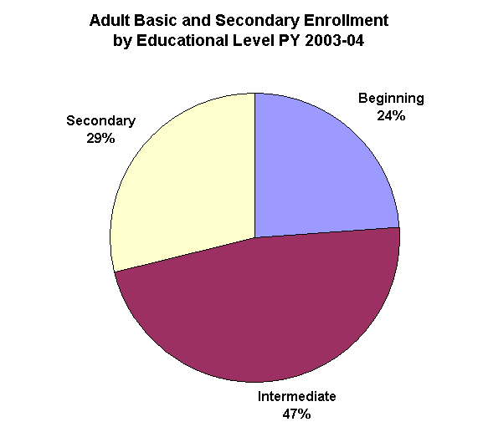
ABE/ASE Level* | Number  Enrolled | Percent  Enrolled
Beginning Literacy | 153,744 | 10%
Beginning | 205,010 | 14%
Low Intermediate | 303,741 | 20%
High Intermediate | 399,319 | 27%
Low Adult Secondary | 271,548 | 18%
High Adult Secondary | 171,178 | 11%
Total | 1,504,540
* Grade Level Equivalent—2 years

Table 7
English Literacy Enrollment by Educational Level
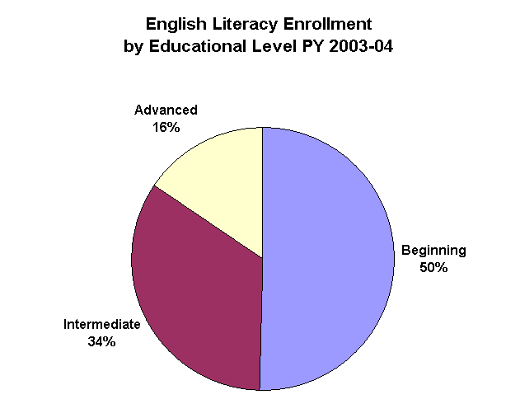
EL Level | Number  Enrolled | Percent  Enrolled
Beginning Literacy | 247,916 | 21%
Beginning | 342,928 | 29%
Low Intermediate | 241,707 | 21%
High Intermediate | 157,439 | 13%
Low Advanced | 137,642 | 12%
High Advanced | 44,947 | 4%
Total | 1,172,579
Collecting Follow-up Measures
The four follow-up outcome measures need be collected only for students who identified the outcomes as a goal for attending and who left the program within this reporting period, July 1, 2003, through June 30, 2004. States may collect these measures through the use of administrative records or through a follow-up survey. The use of administrative records is clearly preferred because of its greater accuracy and lower cost and is possible in most states for the high school completion measure. In PY 2003–2004, 38 states used administrative records to determine student outcomes for high school completion and 4 additional states supplemented administrative records with surveys. For the employment measures, consulting state unemployment insurance (UI) wage records is the most efficient, accurate, and cost-effective approach to determine the post-program employment outcomes. However, not all states have the capability to use the UI system; there are data privacy issues or technical problems in some states. Twenty eight states used this method solely (compared to 22 states in PY 2001), and an additional 6 states used this method in combination with surveys. For entrance to postsecondary education, there are few comprehensive databases available to states for measuring postsecondary enrollment. Consequently, most states must use individual student surveys to collect some or all of the follow-up measures. Table 8 identifies how states currently collect data for the four follow-up measures.
Table 8
Number of States Using Data Collection Methods for Follow-up Measures

Measure | Data Collection Method
Measure | Administrative Records/ Data Matching | Survey | Both | 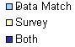
Obtained High School Diploma or Passed GED | 38 | 10 | 4 | 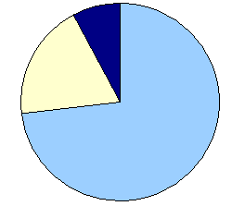
Entered Postsecondary Education | 19 | 26 | 7 | 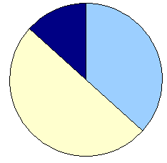
Entered Employment | 28 | 18 | 6 | 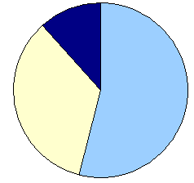
Retained Employment | 28 | 18 | 6

Federal Investments to Improve Program Data and Accountability
Through the NRS project, OVAE has provided states with training and technical assistance to improve the quality and use of NRS data. This assistance has also included the development of guidebooks that helped states implement the NRS requirements and provided additional instruction on conducting follow-up surveys and other data quality issues. Over the last four years, OVAE has also made training resources available online. To monitor improvements in data quality, OVAE has continued to use state NRS data quality standards, which identify the policies, processes, and materials that states and local programs should have in place to collect valid and reliable data. The standards define quality data policies and procedures and also provide guidance to states on how to improve their systems.
Federal Assistance in PY 2003–04
In PY 2003–2004, OVAE continued to promote improvement in the quality and use of state NRS data through resources and state training. For example, in the spring of 2004, the NRS held regional trainings entitled Data Monitoring for Program Improvement. Topics covered during these three-day meetings included “Shared Accountability with Appropriate Rewards and Sanctions” and the development of state action plans. These sessions built on the foundation established by the NRS national institute held the previous summer (July, 2003) entitled Using NRS Data for Program Management and Improvement, based on a second guidebook with the same title.
“The excellent training materials were very useful and easy to tailor for our statewide training… The NRS Guidelines and staff trainings on using data for program improvement have contributed to progress at the program level across our state.
--Massachusetts Project Manager
In addition to in-person workshops and hands-on experiences, the NRS added, updated, and expanded the Web-based training courses. The NRS has two Web sites to provide continuous and ongoing training resources for the field.
- NRSWeb (www.nrsweb.org)—provides an overview of the NRS; training materials; guidelines for data quality, use, collection, and reporting; and other publications and links.
- NRSOnline (www.nrsonline.org)—offers interactive trainings, a learner self-assessment, and information about the implementation of NRS to adult education teachers, administrators, and others interested in adult education.
The NRS project has also helped states meet the requirement to have individual student record systems in a relational database to report and use NRS data for program improvement. Through the NRS, 13 states received training and resources on developing and improving their management information systems to meet these requirements. For example, a small group of states sent data personnel to attend a training session in Washington, DC, held in the fall of 2003. An NRS team member who is an MIS expert worked with each state to develop plans to build a student-level data system. The NRS staff has also provided individual technical assistance to dozens of states on meeting NRS requirements, improving data quality, and using data. States have also received assistance on monitoring local programs and setting local performance standards.
NRS Implementation by States
States continue to focus on ways to improve and use data for overall program management. For example, states have reported:
- Setting performance standards that include a system of sanctions and rewards and shifting toward performance-based funding.
- Strengthening processes for monitoring and evaluation to include more desk monitoring with data and indicators of program quality.
- Continually training staff on the use of data for decision making related to program improvement, including professional development and changes in the delivery of services, assessments, and instruction throughout the state. For example, states are initiating systemic reforms by adopting standards-based education, and many are “mining their data” to guide reform efforts.
As data systems have become more stable, many states can rely on real-time data to set performance standards, monitor local performance, and implement performance-based funding. Stable data are being used more meaningfully by administrators, teachers, and support staff to make decisions that help them design more effective programs to meet students’ needs. Training conducted during the second phase of NRS has prepared local staff in many states to access and use their data on a regular basis. Staff can now use data as part of their research to identify effective practices for classroom instruction, professional development and goal-setting and to determine which support mechanisms will help learners persist long enough to reach their education, training, and employment goals. As staff get more directly involved in using data, they begin to trust the data and participate more effectively in the program improvement process.
“By using NRS data we are continually improving program performance. Some ways we have used NRS data to improve program performance include: allocating resources, making fact-based decisions, raising standards and expectations, setting goals and measuring progress, evaluating program performance, informing the public, and planning staff development events, just to name a few.
-- Alabama
State Administrator for GED
State Administrator for GED
- State Director of Adult Education
Summary of National Performance Results
Program Year 2003–2004 marked the fourth year of the implementation of the NRS accountability requirements. Below is a summary chart providing a comparison of actual performance on each of the core measures for adult education for the four years under the NRS. Most measures showed improvement over the four years. For the two educational gain measures and transition to postsecondary, there was a steady, modest increase, while high school completion showed the greatest overall improvement. Employment entrance and retention also showed trends of improvement with spikes in 2001–02 and 2002–03, respectively.
Exhibit A
Exhibit B
Educational Gain—Basic Literacy Skills
Percent of enrolled adults who acquired the level of basic skills needed to complete at least one educational level (minimum Grade Level Equivalent—2 years).

- Over three program years, 1,542,907 adults advanced one or more educational levels
Exhibit B shows that 38 percent of students enrolled in ABE and low ASE in PY 2003–2004 advanced at least one educational level, consistent with the previous program year. This is a modest 2 percentage point increase over the baseline year of 2000–01.
Exhibit C
Educational Gain—English Language Acquisition
Percent of enrolled adults who acquired the level of English language skills needed to complete at least one educational level.

- Over three program years, 1,239,910 adults advanced one or more education levels
Exhibit C shows the percentage and number of learners enrolled in the six EL levels that advanced one or more educational levels in PY 2003–2004, compared to PY 2001–2002 and PY 2002–2003. The number of learners advancing at least one level increased from about 403,000 in PY 2001–2002 to a high of nearly 420,000 (418,732) students in PY 2003–2004.
Exhibit D
High School Completion
Percent of enrolled adults with a high school completion goal who earned a high school diploma or GED.

- Over three program years, 509,836 adults earned a high school diploma or GED
Exhibit D shows the percent and number of enrolled adults who had a goal of high school completion and obtained a diploma or passed the GED tests. The percent of students achieving this goal continued to increase to 45 percent in PY 2003–2004, a 36 percent increase over the baseline (33 percent in 2000–01). However, the number of students having and attaining this goal has declined by almost 20 percent since the baseline PY 2000–01. This difference is, in part, a result of the publication of a revised version of the GED test in PY 2001 to replace the one that had been in use for over twenty years. A large number of adults enrolled in PY 2000–2001 to prepare to complete the GED prior to the publication of the new test.

Exhibit E
Entered Postsecondary Education or Training
Percent of enrolled adults with a goal to transition to postsecondary education or training who enrolled in postsecondary education or training after exiting the program.
- Over three program years, 140,192 adults enrolled in postsecondary education or training
Exhibit E shows that, among adults who entered with a goal of transition to postsecondary education or training, 30 percent, or approaching 50,000 students (45,264), entered a postsecondary institution after exiting the program in PY 2003–2004. This is an increase from the 25 percent and 29 percent of adults in 2000–01 and 2001–02, respectively, who entered postsecondary education.
Exhibit F
Entered Employment
Percent of enrolled adults with an employment goal who were employed one quarter after exit.

- Over three program years, 408,768 adults were employed one quarter after program exit
Exhibit F shows that the number and percent of enrolled adults who had a goal of obtaining employment and were employed one quarter after exiting the program decreased to about 116,000 students and 36 percent. Much of this decrease may be attributable to the fact that the number of students who had employment as a goal decreased by more than 30,000 over that same year.

Exhibit G
Job Retention
Percent of enrolled adults who retained a job three quarters after program exit.

- Over three program years, 519,526 adults retained employment three quarters after leaving the program
Exhibit G shows that in PY 2003–2004, 63 percent of participants, or over 150,000 participants, retained a job three quarters after program exit, which was consistent with the 63 percent of students who retained employment in PY 2001–2002.
The following pages present national student and program data from the NRS. Following these pages are data tables for each of the 50 states, the District of Columbia, and Puerto Rico. The state tables begin with a one-page demographic display of each state’s program, including the amount of federal adult education funds allocated to the state for FY 2003. The second page of each state analysis contains a summary of the state’s performance on each performance measure required by AEFLA. The state’s PY 2003–2004 performance is compared to its PY 2001–2002 and PY 2002–2003 performance on each measure.

National Profile of Selected Program
and Student Information

PROGRAM FACTS 2003–2004
United States
Participant Status
 | 2002–03 | 2003–04
Employed | 1,022,394 | 1,008,684
Unemployed | 1,044,223 | 1,054,507
Correctional Setting | 265,575 | 249,620
On Public Assistance | 284,272 | 284,426
Other Institutionalized | 38,303 | 39,445
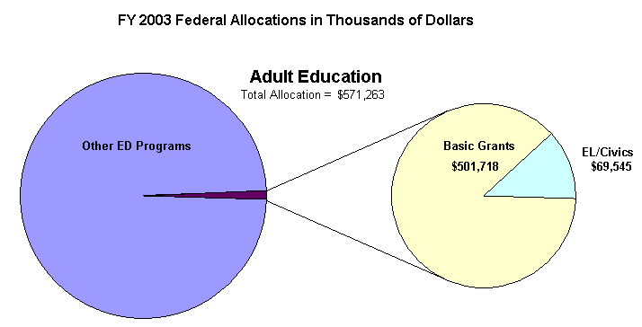
Enrollment by Race/Ethnicity and by Gender
 | 2003–04 |  |  |  | % Change from 2002–03
 | ABE | ASE | EL | Total | % Change from 2002–03
Race/Ethnicity
American Indian/Alaskan Native | 22,355 | 6,504 | 7,112 | 35,971 | –6%
Asian | 19,989 | 8,961 | 160,784 | 189,734 | –8%
Black/African American | 378,853 | 96,636 | 60,000 | 535,489 | –7%
Hispanic/Latino | 210,470 | 114,144 | 832,954 | 1,157,568 | 3%
Native Hawaiian/Pacific Islander | 8,863 | 6,877 | 5,088 | 20,828 | –13%
White | 421,284 | 209,604 | 106,641 | 737,529 | –9%
TOTAL | 1,061,814 | 442,726 | 1,172,579 | 2,677,119 | –4%
Gender
Male | 514,796 | 223,772 | 485,383 | 1,223,951 | –3%
Female | 547,018 | 218,954 | 687,196 | 1,453,168 | –1%
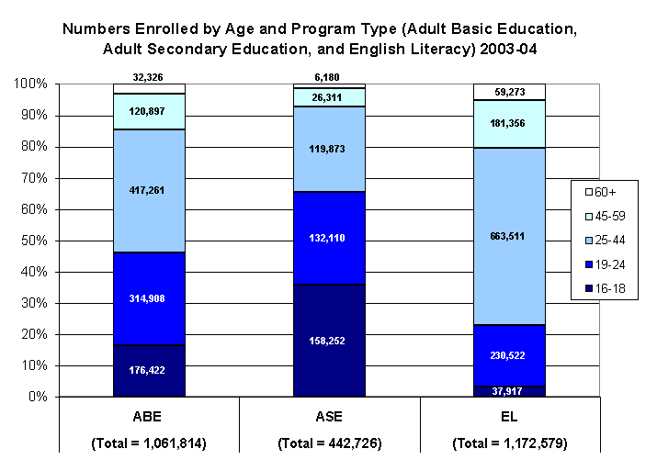
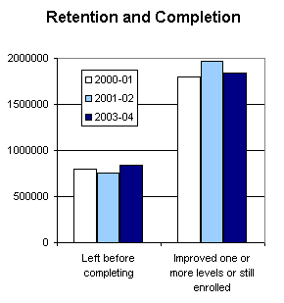

PROGRAM FACTS 2003–2004

United States | Actual Performance
United States | 2001–02 | 2002–03 | 2003–04 |  | TOTAL
United States | Percent | Percent | Percent | # Adults completing at least one level or one outcome | 3-Year Total #
Performance Measure I: Demonstrated Improvement in Literacy Skills
Sub Measures:  - Adult Basic and Secondary Education  The percentage of adults enrolled in basic literacy programs who acquired the basic skills needed to complete one or more levels of instruction in which they were initially enrolled. | 37 | 38 | 38 | 499,341 | 1,542,907
- English Literacy  The percentage of adults enrolled in English literacy programs who acquired the level of English language skills needed to complete one or more levels of instruction in which they were initially enrolled. | 34 | 36 | 36 | 418,732 | 1,239,910
Performance Measure II: High School Completion
The percentage of adult learners with a high school completion goal who earned a high school diploma or GED after exiting the program. | 42 | 44 | 45 | 162,954 | 509,836
Performance Measure III: Entered Postsecondary Education or Training
The percentage of adult learners with a goal to continue their education who enter postsecondary education or training after exiting the program. | 29 | 30 | 30 | 45,264 | 140,192
Performance Measure IV: Entered Employment
The percentage of unemployed adult learners (in the workforce) with an employment goal who were employed at the end of the first quarter after exiting the program. | 42 | 37 | 36 | 115,766 | 408,768
Performance Measure V: Retained Employment
The percentage of adult learners with (a) a job retention goal at the time of enrollment and (b) those adults with an employment goal who obtained work by the end of the first quarter after leaving the program who were employed at the end of the third quarter after exiting the program. | 63 | 69 | 63 | 156,163 | 519,526

State Profiles of Selected Program
and Student Information

PROGRAM FACTS 2003–2004
Alabama
Participant Status
 | 2002–03 | 2003–04
Employed | 7,411 | 7,119
Unemployed | 11,631 | 11,368
Correctional Setting | 2,193 | 1,802
On Public Assistance | 3,293 | 3,385
Other Institutionalized | 501 | 374
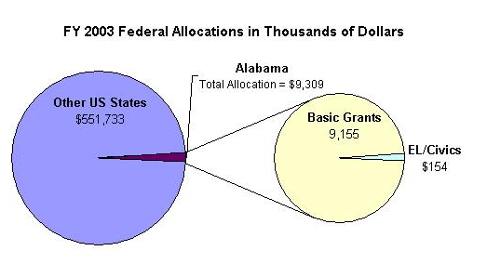
Enrollment by Race/Ethnicity and by Gender
 | 2003–04 |  |  |  | % Change from 2003–04
 | ABE | ASE | EL | Total | % Change from 2003–04
Race/Ethnicity
American Indian/Alaskan Native | 143 | 26 | 13 | 182 | -7%
Asian | 89 | 9 | 259 | 357 | 6%
Black/African American | 8,226 | 501 | 25 | 8,752 | -20%
Hispanic/Latino | 372 | 39 | 1,172 | 1,583 | -5%
Native Hawaiian/Pacific Islander | 26 | 3 | 14 | 43 | -39%
White | 8,567 | 1,978 | 93 | 10,638 | -9%
TOTAL | 17,243 | 2,556 | 1,576 | 21,555 | -13%
Gender
Male | 8,090 | 1,244 | 709 | 10,043 | -3%
Female | 9,333 | 1,312 | 867 | 11,512 | -2%

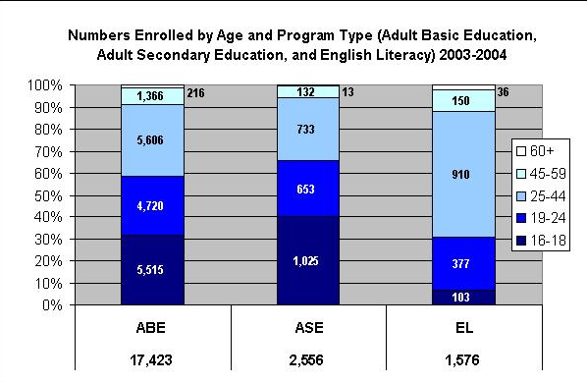

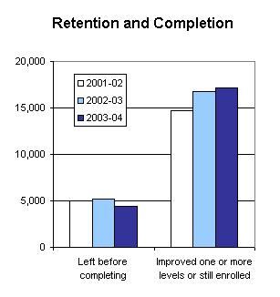

PROGRAM FACTS 2003–2004

Alabama | Actual Performance
Alabama | 2001–02 | 2002–03 | 2003–04 |  | TOTAL
Alabama | Percent | Percent | Percent | # Adults completing at least one level or one outcome | 3-Year Total #
Performance Measure I: Demonstrated Improvement in Literacy Skills
Sub Measures:  - Adult Basic and Secondary Education  The percentage of adults enrolled in basic literacy programs who acquired the basic skills needed to complete one or more levels of instruction in which they were initially enrolled. | 25 | 41 | 40 | 7,633 | 21,619
- English Literacy  The percentage of adults enrolled in English literacy programs who acquired the level of English language skills needed to complete one or more levels of instruction in which they were initially enrolled. | 34 | 39 | 40 | 625 | 1,701
Performance Measure II: High School Completion
The percentage of adult learners with a high school completion goal who earned a high school diploma or GED after exiting the program. | 33 | 53 | 51 | 2,166 | 6,882
Performance Measure III: Entered Postsecondary Education or Training
The percentage of adult learners with a goal to continue their education who enter postsecondary education or training after exiting the program. | 29 | 56 | 46 | 506 | 1,166
Performance Measure IV: Entered Employment*
The percentage of unemployed adult learners (in the workforce) with an employment goal who were employed at the end of the first quarter after exiting the program. | 46 | 60 | 26 | 113 | 511
Performance Measure V: Retained Employment*
The percentage of adult learners with (a) a job retention goal at the time of enrollment and (b) those adults with an employment goal who obtained work by the end of the first quarter after leaving the program who were employed at the end of the third quarter after exiting the program. | 73 | 77 | 24 | 22 | 189
* Response rate was too low on follow-up survey to validate outcomes.

PROGRAM FACTS 2003–2004
Alaska
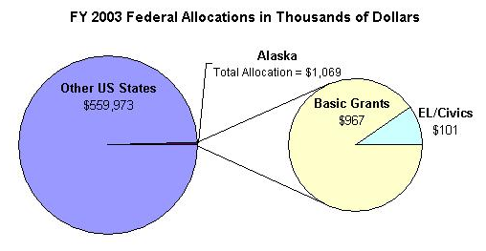
Participant Status
 | 2002–03 | 2003–04
Employed | 1,419 | 1,059
Unemployed | 2,297 | 2,150
Correctional Setting | 666 | 306
On Public Assistance | 694 | 301
Other Institutionalized | 1 | 43

Enrollment by Race/Ethnicity and by Gender
 | 2003–04 |  |  |  | % Change from 2002–03
 | ABE | ASE | EL | Total | % Change from 2002–03
Race/Ethnicity
American Indian/Alaskan Native | 922 | 245 | 3 | 1,170 | -22%
Asian | 113 | 22 | 165 | 300 | -55%
Black/African American | 128 | 31 | 1 | 160 | -33%
Hispanic/Latino | 166 | 31 | 213 | 410 | -39%
Native Hawaiian/Pacific Islander | 50 | 11 | 7 | 68 | -15%
White | 827 | 540 | 113 | 1,480 | -30%
TOTAL | 2,206 | 880 | 502 | 3,588 | -32%
Gender
Male | 1,001 | 508 | 148 | 1,657 | -23%
Female | 1,205 | 372 | 354 | 1,931 | -25%

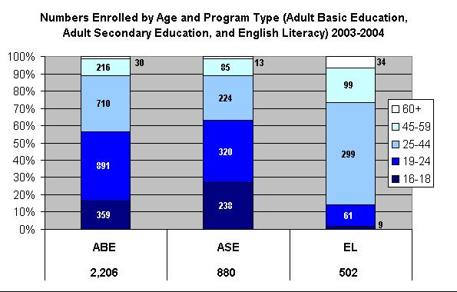

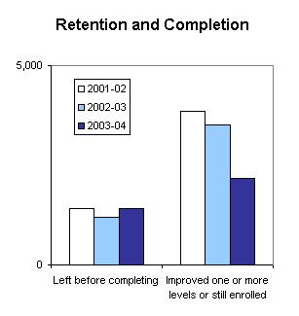

PROGRAM FACTS 2003–2004

Alaska | Actual Performance
Alaska | 2001–02 | 2002–03 | 2003–04 |  | TOTAL
Alaska | Percent | Percent | Percent | # Adults completing at least one level or one outcome | 3-Year Total #
Performance Measure I: Demonstrated Improvement in Literacy Skills
Sub Measures:  - Adult Basic and Secondary Education  The percentage of adults enrolled in basic literacy programs who acquired the basic skills needed to complete one or more levels of instruction in which they were initially enrolled. | 44 | 41 | 49 | 1,285 | 3,915
- English Literacy  The percentage of adults enrolled in English literacy programs who acquired the level of English language skills needed to complete one or more levels of instruction in which they were initially enrolled. | 19 | 32 | 31 | 156 | 782
Performance Measure II: High School Completion
The percentage of adult learners with a high school completion goal who earned a high school diploma or GED after exiting the program. | 54 | 54 | 79 | 1,138 | 3,316
Performance Measure III: Entered Postsecondary Education or Training
The percentage of adult learners with a goal to continue their education who enter postsecondary education or training after exiting the program. | 37 | 32 | 74 | 158 | 562
Performance Measure IV: Entered Employment
The percentage of unemployed adult learners (in the workforce) with an employment goal who were employed at the end of the first quarter after exiting the program. | 44 | 55 | 62 | 324 | 1,348
Performance Measure V: Retained Employment
The percentage of adult learners with (a) a job retention goal at the time of enrollment and (b) those adults with an employment goal who obtained work by the end of the first quarter after leaving the program who were employed at the end of the third quarter after exiting the program. | 53 | 55 | 73 | 58 | 244

PROGRAM FACTS 2003–2004
Arizona
Participant Status
 | 2002–03 | 2003–04
Employed | 14,750 | 12,679
Unemployed | 12,317 | 10,535
Correctional Setting | 1,544 | 1,172
On Public Assistance | 1,743 | 1,593,
Other Institutionalized | 165 | 67
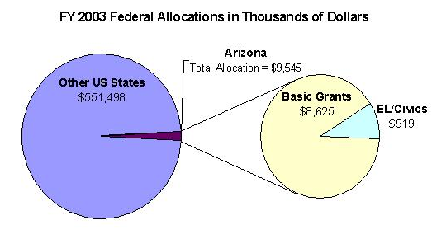
Enrollment by Race/Ethnicity and by Gender
 | 2003–04 |  |  |  | % Change from 2002–03
 | ABE | ASE | EL | Total | % Change from 2002–03
Race/Ethnicity
American Indian/Alaskan Native | 1,112 | 100 | 5 | 1,217 | -28%
Asian | 217 | 20 | 966 | 1,203 | -13%
Black/African American | 683 | 46 | 295 | 1,024 | -14%
Hispanic/Latino | 5,297 | 423 | 14,421 | 20,141 | -16%
Native Hawaiian/Pacific Islander | 46 | 10 | 10 | 66 | 3%
White | 2,985 | 620 | 443 | 4,048 | -15%
TOTAL | 10,340 | 1,219 | 16,140 | 27,699 | -16%
Gender
Male | 4,340 | 564 | 5,917 | 10,821 | -15%
Female | 6,000 | 655 | 10,223 | 16,878 | -15%

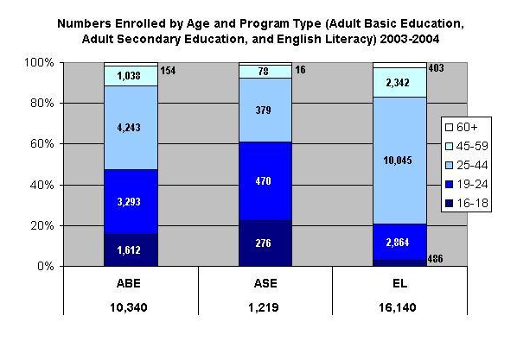

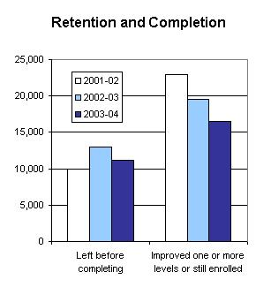

PROGRAM FACTS 2003–2004

Arizona | Actual Performance
Arizona | 2001–02 | 2002–03 | 2003–04 |  | TOTAL
Arizona | Percent | Percent | Percent | # Adults completing at least one level or one outcome | 3-Year Total #

Performance Measure I: Demonstrated Improvement in Literacy Skills
Sub Measures:  - Adult Basic and Secondary Education  The percentage of adults enrolled in basic literacy programs who acquired the basic skills needed to complete one or more levels of instruction in which they were initially enrolled. | 39 | 24 | 43 | 4,758 | 13,147
- English Literacy  The percentage of adults enrolled in English literacy programs who acquired the level of English language skills needed to complete one or more levels of instruction in which they were initially enrolled. | 47 | 42 | 53 | 8,494 | 24,882
Performance Measure II: High School Completion
The percentage of adult learners with a high school completion goal who earned a high school diploma or GED after exiting the program. | 57 | 75 | 80 | 1,875 | 6,357
Performance Measure III: Entered Postsecondary Education or Training
The percentage of adult learners with a goal to continue their education who enter postsecondary education or training after exiting the program. | 78 | 78 | 84 | 643 | 2,227
Performance Measure IV: Entered Employment
The percentage of unemployed adult learners (in the workforce) with an employment goal who were employed at the end of the first quarter after exiting the program. | 60 | 72 | 77 | 1,349 | 4,092
Performance Measure V: Retained Employment
The percentage of adult learners with (a) a job retention goal at the time of enrollment and (b) those adults with an employment goal who obtained work by the end of the first quarter after leaving the program who were employed at the end of the third quarter after exiting the program. | 74 | 86 | 84 | 2,162 | 2,162

PROGRAM FACTS 2003–2004
Arkansas
Participant Status
 | 2002–03 | 2003–04
Employed | 13,018 | 11,615
Unemployed | 17,016 | 17,373
Correctional Setting | 4,282 | 3,911
On Public Assistance | 5,515 | 5,191
Other Institutionalized | 1,692 | 1,369
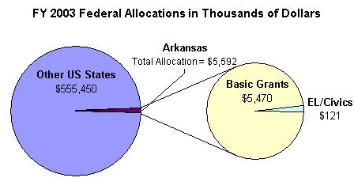
Enrollment by Race/Ethnicity and by Gender
 | 2003–04 |  |  |  | % Change from 2002–03
 | ABE | ASE | EL | Total | % Change from 2002–03
Race/Ethnicity
American Indian/Alaskan Native | 332 | 126 | 1 | 459 | -14%
Asian | 231 | 69 | 582 | 882 | -6%
Black/African American | 8,173 | 1,325 | 16 | 9,514 | -24%
Hispanic/Latino | 978 | 225 | 4,363 | 5,566 | 6%
Native Hawaiian/Pacific Islander | 54 | 16 | 39 | 109 | -24%
White | 12,657 | 6,177 | 148 | 18,982 | -13%
TOTAL | 22,425 | 7,938 | 5,149 | 35,512 | -14%
Gender
Male | 10,656 | 3,847 | 2,446 | 16,949 | -7%
Female | 11,769 | 4,091 | 2,703 | 18,563 | -7%

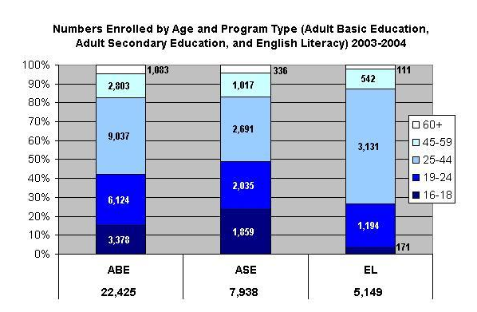

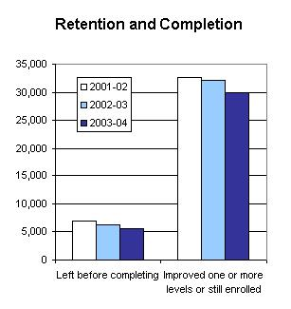

PROGRAM FACTS 2003–2004

Arkansas | Actual Performance
Arkansas | 2001–02 | 2002–03 | 2003–04 |  | TOTAL
Arkansas | Percent | Percent | Percent | # Adults completing at least one level or one outcome | 3-Year Total #
Performance Measure I: Demonstrated Improvement in Literacy Skills
Sub Measures:  - Adult Basic and Secondary Education  The percentage of adults enrolled in basic literacy programs who acquired the basic skills needed to complete one or more levels of instruction in which they were initially enrolled. | 44 | 43 | 55 | 14,761 | 39,935
- English Literacy  The percentage of adults enrolled in English literacy programs who acquired the level of English language skills needed to complete one or more levels of instruction in which they were initially enrolled. | 39 | 35 | 54 | 2,759 | 6,389
Performance Measure II: High School Completion
The percentage of adult learners with a high school completion goal who earned a high school diploma or GED after exiting the program. | 77 | 65 | 74 | 4,575 | 15,094
Performance Measure III: Entered Postsecondary Education or Training
The percentage of adult learners with a goal to continue their education who enter postsecondary education or training after exiting the program. | 61 | 65 | 77 | 1,113 | 3,664
Performance Measure IV: Entered Employment
The percentage of unemployed adult learners (in the workforce) with an employment goal who were employed at the end of the first quarter after exiting the program. | 69 | 62 | 76 | 1,848 | 7,172
Performance Measure V: Retained Employment
The percentage of adult learners with (a) a job retention goal at the time of enrollment and (b) those adults with an employment goal who obtained work by the end of the first quarter after leaving the program who were employed at the end of the third quarter after exiting the program. | 61 | 72 | 80 | 1,125 | 5,060

PROGRAM FACTS 2003–2004
California
Participant Status
 | 2002–03 | 2003–04
Employed | 201,760 | 214,278
Unemployed | 157,109 | 177,964
Correctional Setting | 34,345 | 40,902
On Public Assistance | 28,548 | 28,543
Other Institutionalized | Not Collected | 0

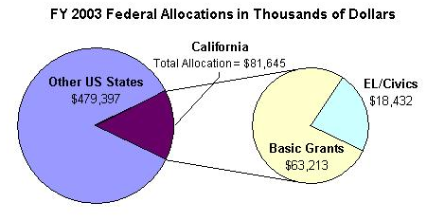
Enrollment by Race/Ethnicity and by Gender
 | 2003–04 |  |  |  | % Change from 2002–03
 | ABE | ASE | EL | Total | % Change from 2002–03
Race/Ethnicity
American Indian/Alaskan Native | 2,576 | 1,485 | 6,220 | 10,281 | 18%
Asian | 3,904 | 3,419 | 72,210 | 79,533 | -2%
Black/African American | 18,264 | 8,111 | 2,808 | 29,183 | 1%
Hispanic/Latino | 42,132 | 33,433 | 327,912 | 403,477 | 6%
Native Hawaiian/Pacific Islander | 2,459 | 2,227 | 1,913 | 6,599 | -11%
White | 19,985 | 17,802 | 24,714 | 62,501 | 5%
TOTAL | 89,320 | 66,477 | 735,777 | 591,574 | 4%
Gender
Male | 52,672 | 34,782 | 184,419 | 271,873 | 6%
Female | 36,648 | 31,695 | 251,358 | 319,701 | 4%

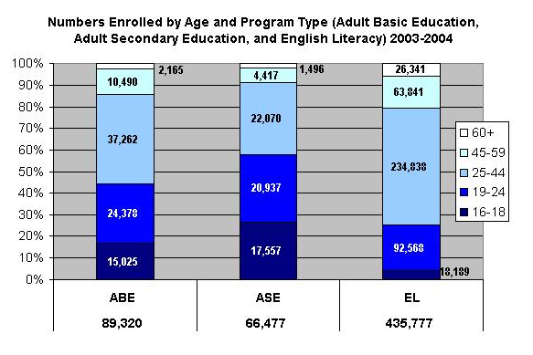

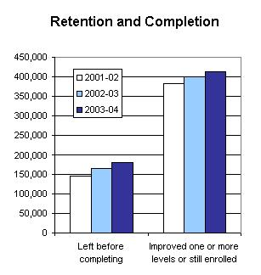

PROGRAM FACTS 2003–2004

California | Actual Performance
California | 2001–02 | 2002–03 | 2003–04 |  | TOTAL
California | Percent | Percent | Percent | # Adults completing at least one level or one outcome | 3-Year Total #
Performance Measure I: Demonstrated Improvement in Literacy Skills
Sub Measures:  - Adult Basic and Secondary Education  The percentage of adults enrolled in basic literacy programs who acquired the basic skills needed to complete one or more levels of instruction in which they were initially enrolled. | 29 | 29 | 28 | 38,605 | 110,742
- English Literacy  The percentage of adults enrolled in English literacy programs who acquired the level of English language skills needed to complete one or more levels of instruction in which they were initially enrolled. | 33 | 34 | 35 | 151,749 | 422,699
Performance Measure II: High School Completion
The percentage of adult learners with a high school completion goal who earned a high school diploma or GED after exiting the program. | 32 | 28 | 29 | 12,470 | 34,195
Performance Measure III: Entered Postsecondary Education or Training*
The percentage of adult learners with a goal to continue their education who enter postsecondary education or training after exiting the program. | 60 | 48 | 55 | 1,022 | 2,857
Performance Measure IV: Entered Employment*
The percentage of unemployed adult learners (in the workforce) with an employment goal who were employed at the end of the first quarter after exiting the program. | 55 | 54 | 55 | 1,288 | 3,106
Performance Measure V: Retained Employment*
The percentage of adult learners with (a) a job retention goal at the time of enrollment and (b) those adults with an employment goal who obtained work by the end of the first quarter after leaving the program who were employed at the end of the third quarter after exiting the program. | 86 | 82 | 82 | 865 | 2,273
* Response rate was too low on follow-up survey to validate outcomes.

PROGRAM FACTS 2003–2004
Colorado
Participant Status
 | 2002–03 | 2003–04
Employed | 7,827 | 7,656
Unemployed | 5,059 | 5,407
Correctional Setting | 703 | 659
On Public Assistance | 1,427 | 1,379
Other Institutionalized | 5 | 577
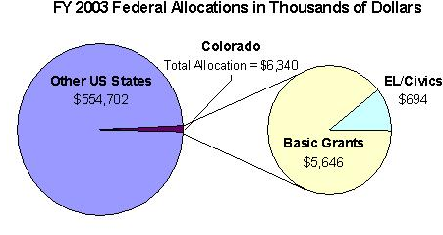
Enrollment by Race/Ethnicity and by Gender
 | 2003–04 |  |  |  | % Change from 2002–03
 | ABE | ASE | EL | Total | % Change from 2002–03
Race/Ethnicity
American Indian/Alaskan Native | 229 | 79 | 10 | 318 | -7%
Asian | 118 | 18 | 685 | 821 | -17%
Black/African American | 334 | 65 | 201 | 600 | -17%
Hispanic/Latino | 2,103 | 427 | 7,823 | 10,353 | 2%
Native Hawaiian/Pacific Islander | 20 | 10 | 8 | 38 | 9%
White | 1,602 | 797 | 568 | 2,967 | -8%
TOTAL | 4,406 | 1,396 | 9,295 | 15,097 | -3%
Gender
Male | 1,708 | 676 | 3,777 | 6,161 | -3%
Female | 2,698 | 720 | 5,518 | 8,936 | 2%

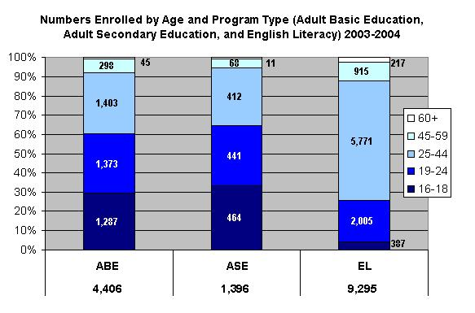

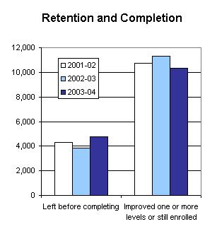

PROGRAM FACTS 2003–2004

Colorado | Actual Performance
Colorado | 2001–02 | 2002–03 | 2003–04 |  | TOTAL
Colorado | Percent | Percent | Percent | # Adults completing at least one level or one outcome | 3-Year Total #
Performance Measure I: Demonstrated Improvement in Literacy Skills
Sub Measures:  - Adult Basic and Secondary Education  The percentage of adults enrolled in basic literacy programs who acquired the basic skills needed to complete one or more levels of instruction in which they were initially enrolled. | 50 | 50 | 43 | 2,249 | 7,879
- English Literacy  The percentage of adults enrolled in English literacy programs who acquired the level of English language skills needed to complete one or more levels of instruction in which they were initially enrolled. | 40 | 47 | 43 | 3,951 | 11,709
Performance Measure II: High School Completion
The percentage of adult learners with a high school completion goal who earned a high school diploma or GED after exiting the program. | 59 | 51 | 45 | 1,053 | 3,659
Performance Measure III: Entered Postsecondary Education or Training
The percentage of adult learners with a goal to continue their education who enter postsecondary education or training after exiting the program. | 73 | 49 | 65 | 301 | 930
Performance Measure IV: Entered Employment
The percentage of unemployed adult learners (in the workforce) with an employment goal who were employed at the end of the first quarter after exiting the program. | 93 | 77 | 30 | 125 | 1,011
Performance Measure V: Retained Employment
The percentage of adult learners with (a) a job retention goal at the time of enrollment and (b) those adults with an employment goal who obtained work by the end of the first quarter after leaving the program who were employed at the end of the third quarter after exiting the program. | 94 | 91 | 46 | 165 | 2,527

PROGRAM FACTS 2003–2004
Connecticut
Participant Status
 | 2002–03 | 2003–04
Employed | 14,155 | 14,297
Unemployed | 11,402 | 11,385
Correctional Setting | 2,690 | 2,580
On Public Assistance | 772 | 685
Other Institutionalized | 140 | 108
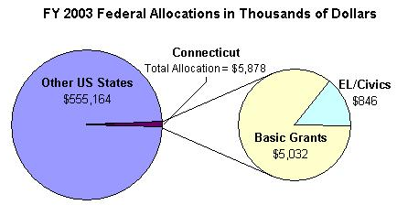
Enrollment by Race/Ethnicity and by Gender
 | 2003–04 |  |  |  | % Change from 2002–03
 | ABE | ASE | EL | Total | % Change from 2002–03
Race/Ethnicity
American Indian/Alaskan Native | 35 | 91 | 7 | 133 | -19%
Asian | 123 | 196 | 1,767 | 2,086 | -8%
Black/African American | 2,443 | 3,351 | 1,091 | 6,885 | 1%
Hispanic/Latino | 1,766 | 4,025 | 8,488 | 14,279 | -1%
Native Hawaiian/Pacific Islander | 9 | 26 | 18 | 53 | -30%
White | 1,200 | 4,938 | 3,304 | 9,442 | 2%
TOTAL | 5,576 | 12,627 | 14,675 | 32,878 | 0%
Gender
Male | 3,180 | 6,161 | 6,011 | 15,352 | 0%
Female | 2,396 | 6,466 | 8,664 | 17,526 | -1%

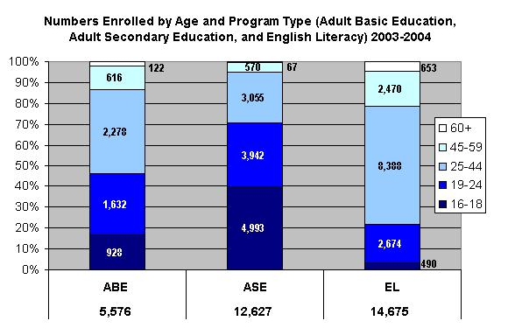

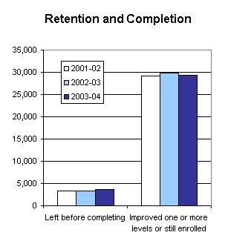

PROGRAM FACTS 2003–2004

Connecticut | Actual Performance
Connecticut | 2001–02 | 2002–03 | 2003–04 |  | TOTAL
Connecticut | Percent | Percent | Percent | # Adults completing at least one level or one outcome | 3-Year Total #
Performance Measure I: Demonstrated Improvement in Literacy Skills
Sub Measures:  - Adult Basic and Secondary Education  The percentage of adults enrolled in basic literacy programs who acquired the basic skills needed to complete one or more levels of instruction in which they were initially enrolled. | 39 | 49 | 46 | 7,167 | 21,272
- English Literacy  The percentage of adults enrolled in English literacy programs who acquired the level of English language skills needed to complete one or more levels of instruction in which they were initially enrolled. | 34 | 39 | 38 | 5,507 | 16,576
Performance Measure II: High School Completion
The percentage of adult learners with a high school completion goal who earned a high school diploma or GED after exiting the program. | 83 | 67 | 96 | 1,544 | 2,610
Performance Measure III: Entered Postsecondary Education or Training*
The percentage of adult learners with a goal to continue their education who enter postsecondary education or training after exiting the program. | 52 | 27 | 20 | 41 | 73
Performance Measure IV: Entered Employment
The percentage of unemployed adult learners (in the workforce) with an employment goal who were employed at the end of the first quarter after exiting the program. | 44 | 44 | 66 | 264 | 614
Performance Measure V: Retained Employment
The percentage of adult learners with (a) a job retention goal at the time of enrollment and (b) those adults with an employment goal who obtained work by the end of the first quarter after leaving the program who were employed at the end of the third quarter after exiting the program. | 63 | 71 | 67 | 453 | 1,607
* Response rate was too low on follow-up survey to validate outcomes.

PROGRAM FACTS 2003–2004
Delaware
Participant Status
 | 2002–03 | 2003–04
Employed | 2,293 | 2,359
Unemployed | 2,017 | 2,305
Correctional Setting | 1,224 | 1,162
On Public Assistance | 482 | 510
Other Institutionalized | 23 | 26
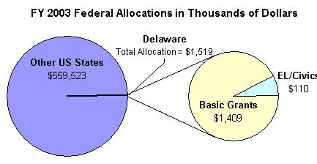
Enrollment by Race/Ethnicity and by Gender
 | 2003–04 |  |  |  | % Change from 2002–03
 | ABE | ASE | EL | Total | % Change from 2002–03
Race/Ethnicity
American Indian/Alaskan Native | 26 | 8 | 1 | 35 | -13%
Asian | 36 | 7 | 255 | 298 | -6%
Black/African American | 1,956 | 326 | 118 | 2,400 | 23%
Hispanic/Latino | 285 | 46 | 1,197 | 1,528 | 4%
Native Hawaiian/Pacific Islander | 10 | 1 | 1 | 12 | 71%
White | 1,236 | 484 | 126 | 1,846 | 12%
TOTAL | 3,549 | 872 | 1,698 | 6,119 | 13%
Gender
Male | 1,806 | 475 | 768 | 3,049 | 0%
Female | 1,743 | 397 | 930 | 3,070 | 5%

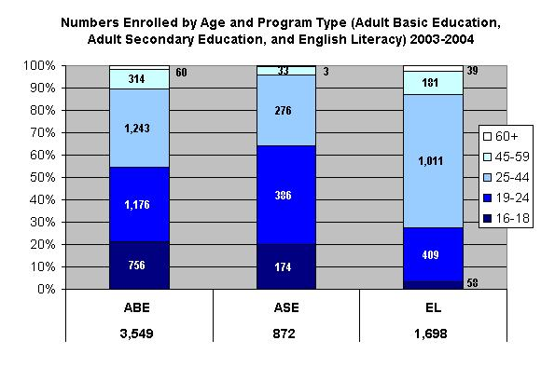

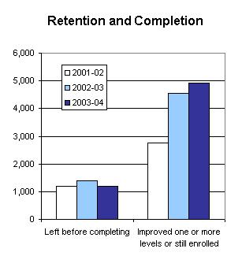

PROGRAM FACTS 2003–2004

Delaware | Actual Performance
Delaware | 2001–02 | 2002–03 | 2003–04 |  | TOTAL
Delaware | Percent | Percent | Percent | # Adults completing at least one level or one outcome | 3-Year Total #
Performance Measure I: Demonstrated Improvement in Literacy Skills
Sub Measures:  - Adult Basic and Secondary Education  The percentage of adults enrolled in basic literacy programs who acquired the basic skills needed to complete one or more levels of instruction in which they were initially enrolled. | 35 | 35 | 32 | 1,374 | 4,109
- English Literacy  The percentage of adults enrolled in English literacy programs who acquired the level of English language skills needed to complete one or more levels of instruction in which they were initially enrolled. | 23 | 23 | 21 | 360 | 1,126
Performance Measure II: High School Completion
The percentage of adult learners with a high school completion goal who earned a high school diploma or GED after exiting the program. | 30 | 33 | 41 | 213 | 798
Performance Measure III: Entered Postsecondary Education or Training
The percentage of adult learners with a goal to continue their education who enter postsecondary education or training after exiting the program. | 60 | 73 | 71 | 65 | 342
Performance Measure IV: Entered Employment
The percentage of unemployed adult learners (in the workforce) with an employment goal who were employed at the end of the first quarter after exiting the program. | 70 | 39 | 54 | 185 | 853
Performance Measure V: Retained Employment
The percentage of adult learners with (a) a job retention goal at the time of enrollment and (b) those adults with an employment goal who obtained work by the end of the first quarter after leaving the program who were employed at the end of the third quarter after exiting the program. | 78 | 60 | 42 | 67 | 1,059

PROGRAM FACTS 2003–2004
District of Columbia
Participant Status
 | 2002–03 | 2003–04
Employed | 2,238 | 2,033
Unemployed | 732 | 850
Correctional Setting | 143 | 246
On Public Assistance | 434 | 300
Other Institutionalized | 0 | 0
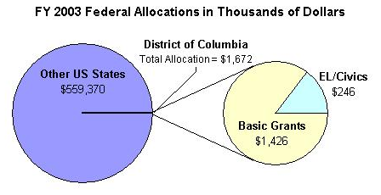
Enrollment by Race/Ethnicity and by Gender
 | 2003–04 |  |  |  | % Change from 2002–03
 | ABE | ASE | EL | Total | % Change from 2002–03
Race/Ethnicity
American Indian/Alaskan Native | 6 | 1 | 0 | 7 | -50%
Asian | 17 | 6 | 105 | 128 | 36%
Black/African American | 1,061 | 450 | 238 | 1,749 | 29%
Hispanic/Latino | 54 | 41 | 1,107 | 1,202 | -23%
Native Hawaiian/Pacific Islander | 2 | 0 | 0 | 2 | -94%
White | 25 | 5 | 52 | 82 | 78%
TOTAL | 1,165 | 503 | 1,502 | 3,170 | 2%
Gender
Male | 532 | 320 | 662 | 1,514 | -1%
Female | 633 | 183 | 840 | 1,656 | -2%

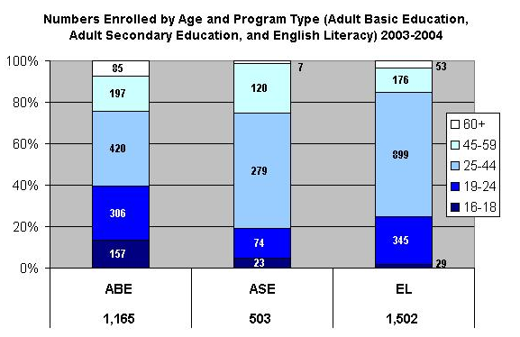

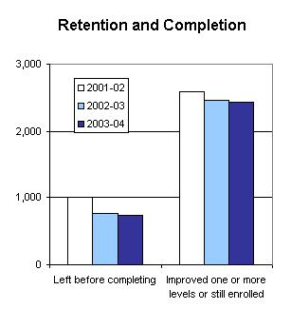

PROGRAM FACTS 2003–2004

District of Columbia | Actual Performance
District of Columbia | 2001–02 | 2002–03 | 2003–04 |  | TOTAL
District of Columbia | Percent | Percent | Percent | # Adults completing at least one level or one outcome | 3-Year Total #
Performance Measure I: Demonstrated Improvement in Literacy Skills
Sub Measures:  - Adult Basic and Secondary Education  The percentage of adults enrolled in basic literacy programs who acquired the basic skills needed to complete one or more levels of instruction in which they were initially enrolled. | 37 | 41 | 35 | 482 | 1,564
- English Literacy  The percentage of adults enrolled in English literacy programs who acquired the level of English language skills needed to complete one or more levels of instruction in which they were initially enrolled. | 67 | 56 | 74 | 1,114 | 3,341
Performance Measure II: High School Completion*
The percentage of adult learners with a high school completion goal who earned a high school diploma or GED after exiting the program. | 19 | 63 | 53 | 54 | 164
Performance Measure III: Entered Postsecondary Education or Training
The percentage of adult learners with a goal to continue their education who enter postsecondary education or training after exiting the program. | 21 | 100 | 24 | 20 | 129
Performance Measure IV: Entered Employment
The percentage of unemployed adult learners (in the workforce) with an employment goal who were employed at the end of the first quarter after exiting the program. | 43 | 75 | 82 | 190 | 609
Performance Measure V: Retained Employment
The percentage of adult learners with (a) a job retention goal at the time of enrollment and (b) those adults with an employment goal who obtained work by the end of the first quarter after leaving the program who were employed at the end of the third quarter after exiting the program. | 76 | 92 | 93 | 54 | 1,843
* Response rate was too low on follow-up survey to validate outcomes.

PROGRAM FACTS 2003–2004
Florida
Participant Status
 | 2002–03 | 2003–04
Employed | 140,798 | 126,109
Unemployed | 244,248 | 247,107
Correctional Setting | 29,219 | 24,146
On Public Assistance | 33,910 | 41,008
Other Institutionalized | 13,643 | 20,404
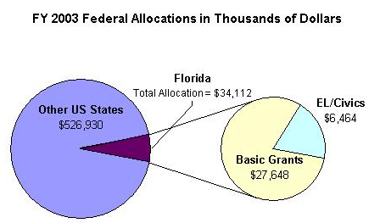
Enrollment by Race/Ethnicity and by Gender
 | 2003–04 |  |  |  | % Change from 2002–03
 | ABE | ASE | EL | Total | % Change from 2002–03
Race/Ethnicity
American Indian/Alaskan Native | 673 | 341 | 57 | 1,071 | -3%
Asian | 2,665 | 1,602 | 4,492 | 8,759 | 9%
Black/African American | 52,430 | 29,246 | 19,286 | 100,962 | -6%
Hispanic/Latino | 42,638 | 28,510 | 93,111 | 164,259 | 5%
Native Hawaiian/Pacific Islander | 1,596 | 1,110 | 567 | 3,273 | -27%
White | 45,139 | 39,144 | 8,378 | 92,661 | -8%
TOTAL | 145,141 | 99,953 | 125,891 | 370,985 | -2%
Gender
Male | 70,946 | 51,349 | 51,370 | 173,665 | -6%
Female | 74,195 | 48,604 | 74,521 | 197,320 | -3%

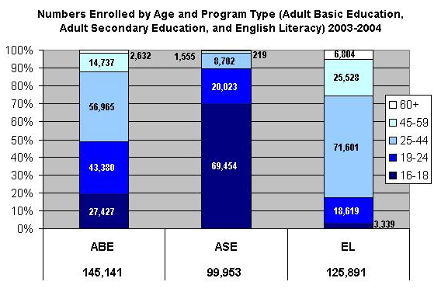

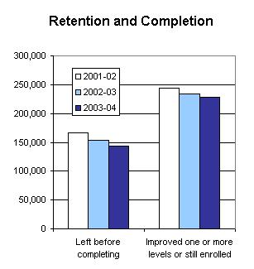

PROGRAM FACTS 2003–2004

Florida | Actual Performance
Florida | 2001–02 | 2002–03 | 2003–04 |  | TOTAL
Florida | Percent | Percent | Percent | # Adults completing at least one level or one outcome | 3-Year Total #
Performance Measure I: Demonstrated Improvement in Literacy Skills
Sub Measures:  - Adult Basic and Secondary Education  The percentage of adults enrolled in basic literacy programs who acquired the basic skills needed to complete one or more levels of instruction in which they were initially enrolled. | 36 | 40 | 41 | 88,755 | 259,043
- English Literacy  The percentage of adults enrolled in English literacy programs who acquired the level of English language skills needed to complete one or more levels of instruction in which they were initially enrolled. | 33 | 35 | 35 | 43,952 | 141,251
Performance Measure II: High School Completion
The percentage of adult learners with a high school completion goal who earned a high school diploma or GED after exiting the program. | 67 | 71 | 78 | 22,052 | 65,650
Performance Measure III: Entered Postsecondary Education or Training
The percentage of adult learners with a goal to continue their education who enter postsecondary education or training after exiting the program. | 29 | 23 | 31 | 6,933 | 17,937
Performance Measure IV: Entered Employment
The percentage of unemployed adult learners (in the workforce) with an employment goal who were employed at the end of the first quarter after exiting the program. | 35 | 33 | 31 | 47,484 | 151,704
Performance Measure V: Retained Employment
The percentage of adult learners with (a) a job retention goal at the time of enrollment and (b) those adults with an employment goal who obtained work by the end of the first quarter after leaving the program who were employed at the end of the third quarter after exiting the program. | 75 | 76 | 74 | 102,279 | 316,794

PROGRAM FACTS 2003–2004
Georgia
Participant Status
 | 2002–03 | 2003–04
Employed | 40,358 | 47,118
Unemployed | 45,999 | 47,494
Correctional Setting | 9,102 | 7,999
On Public Assistance | 8,080 | 7,367
Other Institutionalized | 344 | 398
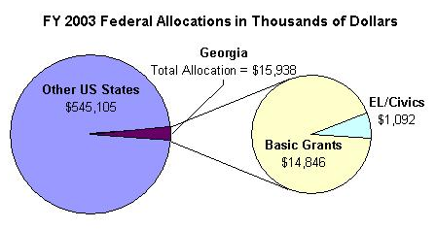
Enrollment by Race/Ethnicity and by Gender
 | 2003–04 |  |  |  | % Change from 2002–03
 | ABE | ASE | EL | Total | % Change from 2002–03
Race/Ethnicity
American Indian/Alaskan Native | 239 | 30 | 38 | 307 | -35%
Asian | 590 | 129 | 5,451 | 6,170 | -11%
Black/African American | 36,785 | 5,217 | 4,383 | 46,385 | -8%
Hispanic/Latino | 2,944 | 396 | 28,672 | 32,012 | 25%
Native Hawaiian/Pacific Islander | 73 | 12 | 11 | 96 | -79%
White | 24,097 | 6,348 | 3,043 | 33,488 | -10%
TOTAL | 64,728 | 12,132 | 41,598 | 229,458 | -2%
Gender
Male | 28,242 | 5,703 | 19,772 | 53,717 | 2%
Female | 36,486 | 6,429 | 21,826 | 64,741 | 6%

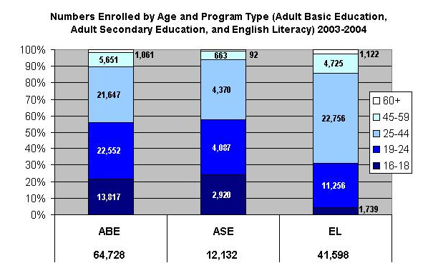

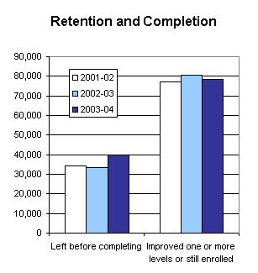

PROGRAM FACTS 2003–2004

Georgia | Actual Performance
Georgia | 2001–02 | 2002–03 | 2003–04 |  | TOTAL
Georgia | Percent | Percent | Percent | # Adults completing at least one level or one outcome | 3-Year Total #
Performance Measure I: Demonstrated Improvement in Literacy Skills
Sub Measures:  - Adult Basic and Secondary Education  The percentage of adults enrolled in basic literacy programs who acquired the basic skills needed to complete one or more levels of instruction in which they were initially enrolled. | 28 | 31 | 29 | 20,553 | 62,430
- English Literacy  The percentage of adults enrolled in English literacy programs who acquired the level of English language skills needed to complete one or more levels of instruction in which they were initially enrolled. | 27 | 30 | 27 | 11,129 | 31,795
Performance Measure II: High School Completion
The percentage of adult learners with a high school completion goal who earned a high school diploma or GED after exiting the program. | 71 | 97 | 47 | 7,035 | 19,325
Performance Measure III: Entered Postsecondary Education or Training
The percentage of adult learners with a goal to continue their education who enter postsecondary education or training after exiting the program. | 52 | 68 | 51 | 1,715 | 5,311
Performance Measure IV: Entered Employment
The percentage of unemployed adult learners (in the workforce) with an employment goal who were employed at the end of the first quarter after exiting the program. | 61 | 79 | 41 | 1,801 | 6,711
Performance Measure V: Retained Employment
The percentage of adult learners with (a) a job retention goal at the time of enrollment and (b) those adults with an employment goal who obtained work by the end of the first quarter after leaving the program who were employed at the end of the third quarter after exiting the program. | 61 | 95 | 35 | 1,101 | 4,318

PROGRAM FACTS 2003–2004
Hawaii
Participant Status
 | 2002–03 | 2003–04
Employed | 3,471 | 2,718
Unemployed | 4,668 | 3,054
Correctional Setting | 182 | 183
On Public Assistance | 784 | 689
Other Institutionalized | 102 | 206
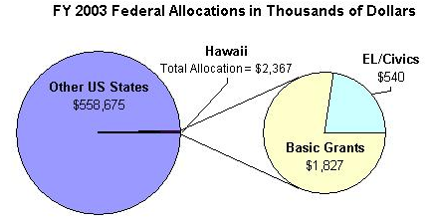
Enrollment by Race/Ethnicity and by Gender
 | 2003–04 |  |  |  | % Change from 2002–03
 | ABE | ASE | EL | Total | % Change from 2002–03
Race/Ethnicity
American Indian/Alaskan Native | 11 | 42 | 4 | 57 | -39%
Asian | 269 | 511 | 3,058 | 3,838 | -6%
Black/African American | 35 | 213 | 12 | 260 | 23%
Hispanic/Latino | 107 | 341 | 263 | 711 | -10%
Native Hawaiian/Pacific Islander | 660 | 2,064 | 471 | 3,195 | -17%
White | 214 | 703 | 111 | 1,028 | -29
TOTAL | 1,296 | 3,874 | 3,919 | 9,089 | -14%
Gender
Male | 566 | 1,921 | 948 | 3,435 | -12%
Female | 730 | 1,953 | 2,971 | 5,654 | -17%

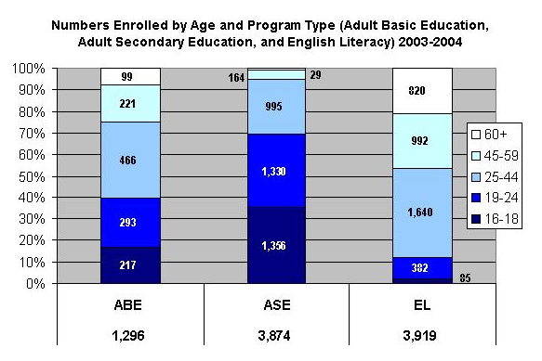

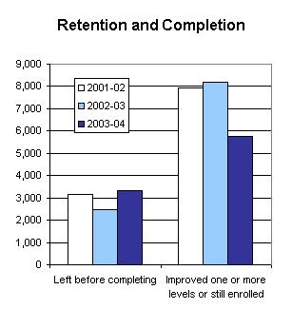

PROGRAM FACTS 2003–2004

Hawaii | Actual Performance
Hawaii | 2001–02 | 2002–03 | 2003–04 |  | TOTAL
Hawaii | Percent | Percent | Percent | # Adults completing at least one level or one outcome | 3-Year Total #
Performance Measure I: Demonstrated Improvement in Literacy Skills
Sub Measures:  - Adult Basic and Secondary Education  The percentage of adults enrolled in basic literacy programs who acquired the basic skills needed to complete one or more levels of instruction in which they were initially enrolled. | 36 | 35 | 30 | 1,058 | 4,680
- English Literacy  The percentage of adults enrolled in English literacy programs who acquired the level of English language skills needed to complete one or more levels of instruction in which they were initially enrolled. | 50 | 41 | 34 | 1,319 | 4,762
Performance Measure II: High School Completion
The percentage of adult learners with a high school completion goal who earned a high school diploma or GED after exiting the program. | 99 | 99 | 56 | 1,454 | 4,431
Performance Measure III: Entered Postsecondary Education or Training*
The percentage of adult learners with a goal to continue their education who enter postsecondary education or training after exiting the program. | 43 | 100 | 23 | 21 | 249
Performance Measure IV: Entered Employment*
The percentage of unemployed adult learners (in the workforce) with an employment goal who were employed at the end of the first quarter after exiting the program. | 88 | 100 | 21 | 27 | 242
Performance Measure V: Retained Employment
The percentage of adult learners with (a) a job retention goal at the time of enrollment and (b) those adults with an employment goal who obtained work by the end of the first quarter after leaving the program who were employed at the end of the third quarter after exiting the program. | 55 | 100 | 63 | 123 | 184
* Response rate was too low on follow-up survey to validate outcomes.

PROGRAM FACTS 2003–2004
Idaho
Participant Status
 | 2002–03 | 2003–04
Employed | 3,691 | 3,124
Unemployed | 3,158 | 3,096
Correctional Setting | 1,082 | 645
On Public Assistance | 1,075 | 1,442
Other Institutionalized | 31 | 7
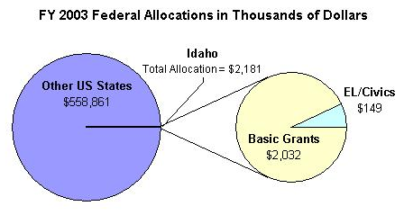
Enrollment by Race/Ethnicity and by Gender
 | 2003–04 |  |  |  | % Change from 2002–03
 | ABE | ASE | EL | Total | % Change from 2002–03
Race/Ethnicity
American Indian/Alaskan Native | 165 | 28 | 0 | 193 | -19%
Asian | 45 | 7 | 276 | 328 | -18%
Black/African American | 61 | 10 | 32 | 103 | 2%
Hispanic/Latino | 754 | 85 | 1,885 | 2,724 | -23%
Native Hawaiian/Pacific Islander | 23 | 4 | 3 | 30 | -14%
White | 2,747 | 932 | 204 | 3,883 | -23%
TOTAL | 3,795 | 1,066 | 2,400 | 7,261 | -22%
Gender
Male | 1,593 | 407 | 1,144 | 3,144 | -24%
Female | 2,202 | 659 | 1,256 | 4,117 | -12%

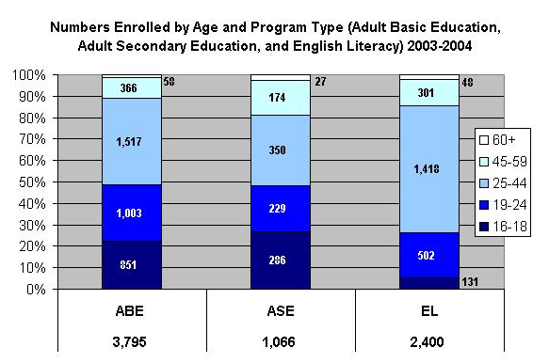

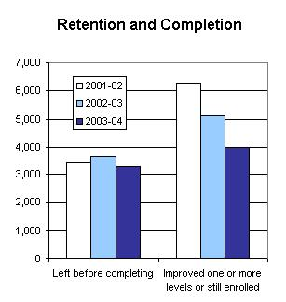

PROGRAM FACTS 2003–2004

Idaho | Actual Performance
Idaho | 2001–02 | 2002–03 | 2003–04 |  | TOTAL
Idaho | Percent | Percent | Percent | # Adults completing at least one level or one outcome | 3-Year Total #
Performance Measure I: Demonstrated Improvement in Literacy Skills
Sub Measures:  - Adult Basic and Secondary Education  The percentage of adults enrolled in basic literacy programs who acquired the basic skills needed to complete one or more levels of instruction in which they were initially enrolled. | 44 | 36 | 32 | 1,383 | 5,561
- English Literacy  The percentage of adults enrolled in English literacy programs who acquired the level of English language skills needed to complete one or more levels of instruction in which they were initially enrolled. | 28 | 25 | 25 | 595 | 2,293
Performance Measure II: High School Completion
The percentage of adult learners with a high school completion goal who earned a high school diploma or GED after exiting the program. | 39 | 32 | 39 | 719 | 3,132
Performance Measure III: Entered Postsecondary Education or Training
The percentage of adult learners with a goal to continue their education who enter postsecondary education or training after exiting the program. | 24 | 22 | 37 | 351 | 985
Performance Measure IV: Entered Employment
The percentage of unemployed adult learners (in the workforce) with an employment goal who were employed at the end of the first quarter after exiting the program. | 37 | 20 | 50 | 521 | 1,229
Performance Measure V: Retained Employment
The percentage of adult learners with (a) a job retention goal at the time of enrollment and (b) those adults with an employment goal who obtained work by the end of the first quarter after leaving the program who were employed at the end of the third quarter after exiting the program. | 48 | 44 | 62 | 250 | 1,708

PROGRAM FACTS 2003–2004
illinois
Participant Status
 | 2002–03 | 2003–04
Employed | 62,343 | 60,068
Unemployed | 51,584 | 49,010
Correctional Setting | 6,504 | 3,713
On Public Assistance | 18,196 | 19,907
Other Institutionalized | 373 | 247
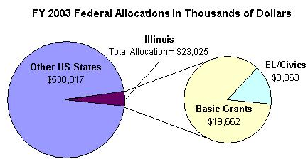
Enrollment by Race/Ethnicity and by Gender
 | 2003–04 |  |  |  | % Change from 2002–03
 | ABE | ASE | EL | Total | % Change from 2002–03
Race/Ethnicity
American Indian/Alaskan Native | 110 | 81 | 18 | 209 | 7%
Asian | 1,287 | 172 | 7,030 | 8,489 | -4%
Black/African American | 16,339 | 5,001 | 1,137 | 22,477 | -8%
Hispanic/Latino | 12,619 | 2,588 | 46,616 | 61,823 | 5%
Native Hawaiian/Pacific Islander | 7 | 9 | 12 | 28 | 22%
White | 10,230 | 7,701 | 13,440 | 31,378 | -1%
TOTAL | 40,592 | 15,559 | 68,253 | 124,404 | 0%
Gender
Male | 18,263 | 7,065 | 29,217 | 54,545 | -7%
Female | 22,329 | 8,494 | 39,036 | 69,859 | -2%

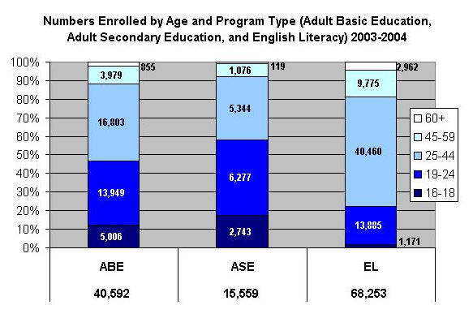

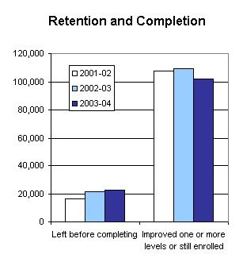

PROGRAM FACTS 2003–2004

Illinois | Actual Performance
Illinois | 2001–02 | 2002–03 | 2003–04 |  | TOTAL
Illinois | Percent | Percent | Percent | # Adults completing at least one level or one outcome | 3-Year Total #
Performance Measure I: Demonstrated Improvement in Literacy Skills
Sub Measures:  - Adult Basic and Secondary Education  The percentage of adults enrolled in basic literacy programs who acquired the basic skills needed to complete one or more levels of instruction in which they were initially enrolled. | 29 | 29 | 28 | 13,324 | 42,247
- English Literacy  The percentage of adults enrolled in English literacy programs who acquired the level of English language skills needed to complete one or more levels of instruction in which they were initially enrolled. | 33 | 36 | 31 | 21,410 | 68,039
Performance Measure II: High School Completion
The percentage of adult learners with a high school completion goal who earned a high school diploma or GED after exiting the program. | 28 | 26 | 27 | 5,052 | 12,979
Performance Measure III: Entered Postsecondary Education or Training
The percentage of adult learners with a goal to continue their education who enter postsecondary education or training after exiting the program. | 18 | 17 | 18 | 5,050 | 13,921
Performance Measure IV: Entered Employment
The percentage of unemployed adult learners (in the workforce) with an employment goal who were employed at the end of the first quarter after exiting the program. | 51 | 50 | 47 | 18,360 | 56,454
Performance Measure V: Retained Employment
The percentage of adult learners with (a) a job retention goal at the time of enrollment and (b) those adults with an employment goal who obtained work by the end of the first quarter after leaving the program who were employed at the end of the third quarter after exiting the program. | 80 | 87 | 83 | 15,167 | 47,072

PROGRAM FACTS 2003–2004
indiana
Participant Status
 | 2002–03 | 2003–04
Employed | 15,687 | 14,896
Unemployed | 15,732 | 16,229
Correctional Setting | 5,534 | 5,197
On Public Assistance | 4,906 | 5,648
Other Institutionalized | 700 | 644
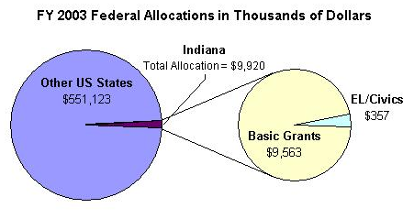
Enrollment by Race/Ethnicity and by Gender
 | 2003–04 |  |  |  | % Change from 2002–03
 | ABE | ASE | EL | Total | % Change from 2002–03
Race/Ethnicity
American Indian/Alaskan Native | 176 | 78 | 5 | 259 | -21%
Asian | 185 | 134 | 1,268 | 1,587 | 0%
Black/African American | 5,920 | 2,607 | 366 | 8,893 | -9%
Hispanic/Latino | 1,485 | 626 | 6,063 | 8,174 | -4%
Native Hawaiian/Pacific Islander | 31 | 14 | 7 | 52 | 0%
White | 13,881 | 7,696 | 606 | 22,183 | -6%
TOTAL | 21,678 | 11,155 | 8,315 | 41,148 | -6%
Gender
Male | 10,953 | 5,873 | 3,891 | 20,717 | -3%
Female | 10,725 | 5,282 | 4,424 | 20,431 | 2%

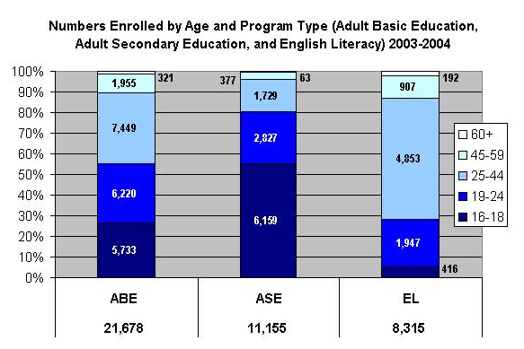

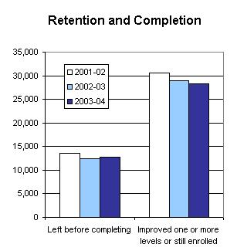

PROGRAM FACTS 2003–2004

Indiana | Actual Performance
Indiana | 2001–02 | 2002–03 | 2003–04 |  | TOTAL
Indiana | Percent | Percent | Percent | # Adults completing at least one level or one outcome | 3-Year Total #
Performance Measure I: Demonstrated Improvement in Literacy Skills
Sub Measures:  - Adult Basic and Secondary Education  The percentage of adults enrolled in basic literacy programs who acquired the basic skills needed to complete one or more levels of instruction in which they were initially enrolled. | 37 | 39 | 43 | 11,295 | 31,625
- English Literacy  The percentage of adults enrolled in English literacy programs who acquired the level of English language skills needed to complete one or more levels of instruction in which they were initially enrolled. | 35 | 40 | 39 | 3,270 | 9,847
Performance Measure II: High School Completion
The percentage of adult learners with a high school completion goal who earned a high school diploma or GED after exiting the program. | 74 | 84 | 91 | 5,974 | 17,802
Performance Measure III: Entered Postsecondary Education or Training
The percentage of adult learners with a goal to continue their education who enter postsecondary education or training after exiting the program. | 77 | 83 | 90 | 1,660 | 4,981
Performance Measure IV: Entered Employment
The percentage of unemployed adult learners (in the workforce) with an employment goal who were employed at the end of the first quarter after exiting the program. | 82 | 96 | 90 | 4,459 | 14,772
Performance Measure V: Retained Employment
The percentage of adult learners with (a) a job retention goal at the time of enrollment and (b) those adults with an employment goal who obtained work by the end of the first quarter after leaving the program who were employed at the end of the third quarter after exiting the program. | 87 | 62 | 91 | 1,911 | 8,607

PROGRAM FACTS 2003–2004
iowa
Participant Status
 | 2002–03 | 2003–04
Employed | 6,467 | 4,579
Unemployed | 6,992 | 5,322
Correctional Setting | 1,396 | 1,263
On Public Assistance | 1,460 | 1,380
Other Institutionalized | 2,242 | 212
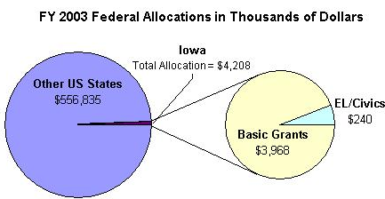
Enrollment by Race/Ethnicity and by Gender
 | 2003–04 |  |  |  | % Change from 2002–03
 | ABE | ASE | EL | Total | % Change from 2002–03
Race/Ethnicity
American Indian/Alaskan Native | 134 | 48 | 17 | 199 | -31%
Asian | 102 | 23 | 742 | 867 | -16%
Black/African American | 1,020 | 118 | 196 | 1,134 | -23%
Hispanic/Latino | 530 | 142 | 2,420 | 3,092 | -15%
Native Hawaiian/Pacific Islander | 24 | 6 | 15 | 45 | -24%
White | 4,243 | 2,008 | 454 | 6,705 | -30%
TOTAL | 6,053 | 2,345 | 3,844 | 12,242 | -25%
Gender
Male | 2,791 | 1,246 | 1,736 | 5,773 | -28%
Female | 3,262 | 1,099 | 2,108 | 6,469 | -22%

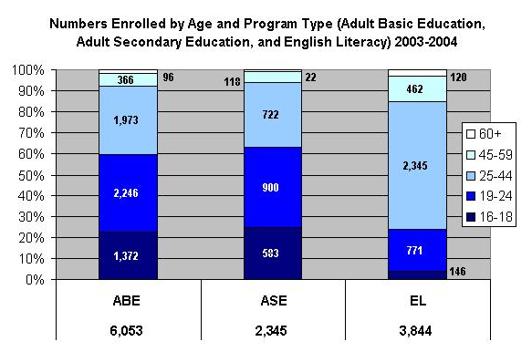

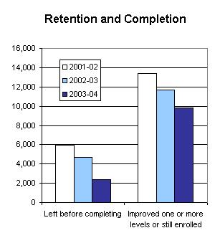

PROGRAM FACTS 2003–2004

Iowa | Actual Performance
Iowa | 2001–02 | 2002–03 | 2003–04 |  | TOTAL
Iowa | Percent | Percent | Percent | # Adults completing at least one level or one outcome | 3-Year Total #
Performance Measure I: Demonstrated Improvement in Literacy Skills
Sub Measures:  - Adult Basic and Secondary Education  The percentage of adults enrolled in basic literacy programs who acquired the basic skills needed to complete one or more levels of instruction in which they were initially enrolled. | 39 | 43 | 58 | 4,559 | 14,604
- English Literacy  The percentage of adults enrolled in English literacy programs who acquired the level of English language skills needed to complete one or more levels of instruction in which they were initially enrolled. | 14 | 26 | 32 | 1,242 | 3,132
Performance Measure II: High School Completion
The percentage of adult learners with a high school completion goal who earned a high school diploma or GED after exiting the program. | 69 | 63 | 74 | 1,898 | 7,164
Performance Measure III: Entered Postsecondary Education or Training
The percentage of adult learners with a goal to continue their education who enter postsecondary education or training after exiting the program. | 27 | 53 | 46 | 373 | 1,528
Performance Measure IV: Entered Employment
The percentage of unemployed adult learners (in the workforce) with an employment goal who were employed at the end of the first quarter after exiting the program. | 73 | 66 | 76 | 677 | 2,334
Performance Measure V: Retained Employment
The percentage of adult learners with (a) a job retention goal at the time of enrollment and (b) those adults with an employment goal who obtained work by the end of the first quarter after leaving the program who were employed at the end of the third quarter after exiting the program. | 81 | 84 | 88 | 757 | 1,907

PROGRAM FACTS 2003–2004
kansas
Participant Status
 | 2002–03 | 2003–04
Employed | 4,869 | 4,620
Unemployed | 4,105 | 3,697
Correctional Setting | 777 | 763
On Public Assistance | 1,272 | 1,247
Other Institutionalized | 132 | 90
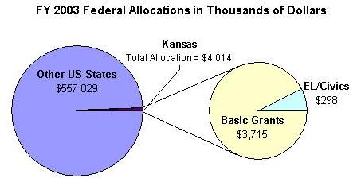
Enrollment by Race/Ethnicity and by Gender
 | 2003–04 |  |  |  | % Change from 2002–03
 | ABE | ASE | EL | Total | % Change from 2002–03
Race/Ethnicity
American Indian/Alaskan Native | 201 | 27 | 4 | 232 | -8%
Asian | 140 | 30 | 603 | 773 | -15%
Black/African American | 870 | 71 | 78 | 1,019 | -21%
Hispanic/Latino | 780 | 141 | 3,051 | 3,972 | -7%
Native Hawaiian/Pacific Islander | 13 | 1 | 1 | 15 | -21%
White | 2,902 | 739 | 136 | 3,777 | -14%
TOTAL | 4,906 | 1,009 | 3,873 | 9,788 | -12%
Gender
Male | 2,156 | 543 | 1,571 | 4,270 | -7%
Female | 2,750 | 466 | 2,302 | 5,518 | -5%

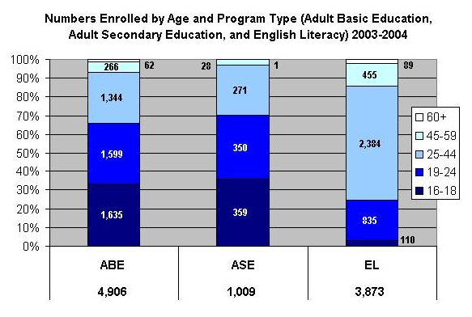

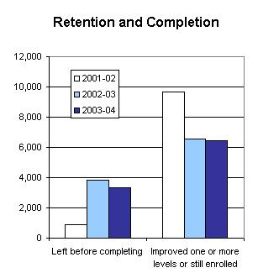

PROGRAM FACTS 2003–2004

Kansas | Actual Performance
Kansas | 2001–02 | 2002–03 | 2003–04 |  | TOTAL
Kansas | Percent | Percent | Percent | # Adults completing at least one level or one outcome | 3-Year Total #
Performance Measure I: Demonstrated Improvement in Literacy Skills
Sub Measures:  - Adult Basic and Secondary Education  The percentage of adults enrolled in basic literacy programs who acquired the basic skills needed to complete one or more levels of instruction in which they were initially enrolled. | 76 | 58 | 60 | 3,310 | 11,644
- English Literacy  The percentage of adults enrolled in English literacy programs who acquired the level of English language skills needed to complete one or more levels of instruction in which they were initially enrolled. | 68 | 55 | 59 | 2,283 | 7,363
Performance Measure II: High School Completion
The percentage of adult learners with a high school completion goal who earned a high school diploma or GED after exiting the program. | 71 | 61 | 64 | 1,995 | 5,470
Performance Measure III: Entered Postsecondary Education or Training
The percentage of adult learners with a goal to continue their education who enter postsecondary education or training after exiting the program. | 69 | 62 | 58 | 506 | 857
Performance Measure IV: Entered Employment
The percentage of unemployed adult learners (in the workforce) with an employment goal who were employed at the end of the first quarter after exiting the program. | 59 | 52 | 62 | 792 | 1,564
Performance Measure V: Retained Employment
The percentage of adult learners with (a) a job retention goal at the time of enrollment and (b) those adults with an employment goal who obtained work by the end of the first quarter after leaving the program who were employed at the end of the third quarter after exiting the program. | 74 | 54 | 69 | 682 | 1,293

PROGRAM FACTS 2003–2004
Kentucky
Participant Status
 | 2002–03 | 2003–04
Employed | 10,132 | 9,506
Unemployed | 16,546 | 15,853
Correctional Setting | 7,825 | 5,214
On Public Assistance | 5,124 | 2,507
Other Institutionalized | 75 | 0
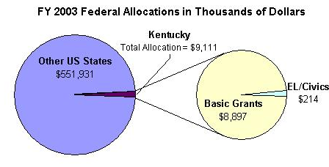
Enrollment by Race/Ethnicity and by Gender
 | 2003–04 |  |  |  | % Change from 2002–03
 | ABE | ASE | EL | Total | % Change from 2002–03
Race/Ethnicity
American Indian/Alaskan Native | 206 | 45 | 4 | 255 | -24%
Asian | 144 | 25 | 722 | 891 | -7%
Black/African American | 4,570 | 466 | 134 | 5,170 | -7%
Hispanic/Latino | 498 | 119 | 1,886 | 2,503 | -5%
Native Hawaiian/Pacific Islander | 32 | 8 | 14 | 54 | 46%
White | 17,580 | 5,429 | 353 | 23,362 | -16%
TOTAL | 23,030 | 6,092 | 3,113 | 32,235 | -14%
Gender
Male | 11,305 | 2,890 | 1,284 | 15,479 | -9%
Female | 11,725 | 3,202 | 1,829 | 16,756 | -6%

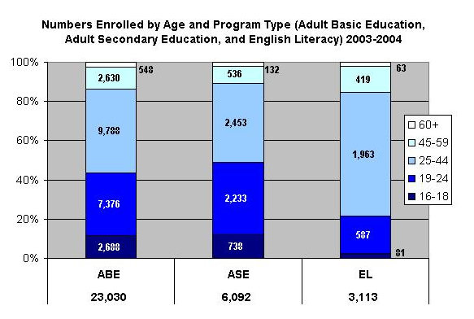

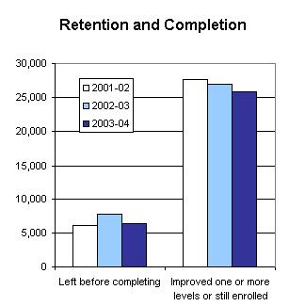

PROGRAM FACTS 2003–2004

Kentucky | Actual Performance
Kentucky | 2001–02 | 2002–03 | 2003–04 |  | TOTAL
Kentucky | Percent | Percent | Percent | # Adults completing at least one level or one outcome | 3-Year Total #
Performance Measure I: Demonstrated Improvement in Literacy Skills
Sub Measures:  - Adult Basic and Secondary Education  The percentage of adults enrolled in basic literacy programs who acquired the basic skills needed to complete one or more levels of instruction in which they were initially enrolled. | 57 | 67 | 53 | 14,160 | 45,837
- English Literacy  The percentage of adults enrolled in English literacy programs who acquired the level of English language skills needed to complete one or more levels of instruction in which they were initially enrolled. | 50 | 52 | 52 | 1,631 | 5,116
Performance Measure II: High School Completion
The percentage of adult learners with a high school completion goal who earned a high school diploma or GED after exiting the program. | 67 | 63 | 80 | 5,246 | 23,732
Performance Measure III: Entered Postsecondary Education or Training
The percentage of adult learners with a goal to continue their education who enter postsecondary education or training after exiting the program. | 74 | 77 | 68 | 1,140 | 6,263
Performance Measure IV: Entered Employment
The percentage of unemployed adult learners (in the workforce) with an employment goal who were employed at the end of the first quarter after exiting the program. | 67 | 72 | 81 | 1,220 | 7,065
Performance Measure V: Retained Employment
The percentage of adult learners with (a) a job retention goal at the time of enrollment and (b) those adults with an employment goal who obtained work by the end of the first quarter after leaving the program who were employed at the end of the third quarter after exiting the program. | 90 | 94 | 100 | 1,831 | 14,971

PROGRAM FACTS 2003–2004
louisiana
Participant Status
 | 2002–03 | 2003–04
Employed | 10,460 | 9,663
Unemployed | 14,717 | 15,234
Correctional Setting | 4,909 | 5,069
On Public Assistance | 3,822 | 4,650
Other Institutionalized | 694 | 445
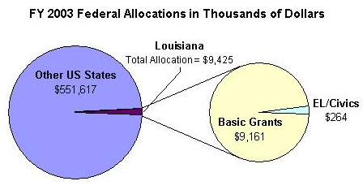
Enrollment by Race/Ethnicity and by Gender
 | 2003–04 |  |  |  | % Change from 2002–03
 | ABE | ASE | EL | Total | % Change from 2002–03
Race/Ethnicity
American Indian/Alaskan Native | 232 | 62 | 1 | 295 | -5%
Asian | 205 | 54 | 399 | 658 | -11%
Black/African American | 14,056 | 1,778 | 112 | 15,946 | -6%
Hispanic/Latino | 534 | 129 | 1,257 | 1,920 | -8%
Native Hawaiian/Pacific Islander | 21 | 5 | 7 | 33 | 22%
White | 9,808 | 3,708 | 134 | 13,650 | -10%
TOTAL | 24,856 | 5,736 | 1,910 | 32,502 | -8%
Gender
Male | 12,159 | 2,983 | 777 | 15,919 | 3%
Female | 12,697 | 2,753 | 1,133 | 16,583 | 1%

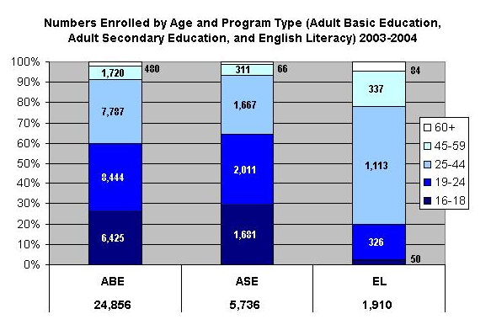

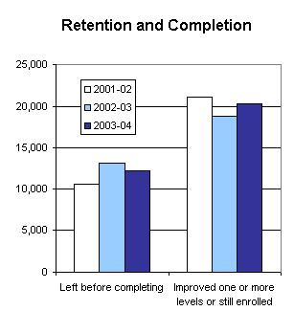

PROGRAM FACTS 2003–2004

Louisiana | Actual Performance
Louisiana | 2001–02 | 2002–03 | 2003–04 |  | TOTAL
Louisiana | Percent | Percent | Percent | # Adults completing at least one level or one outcome | 3-Year Total #
Performance Measure I: Demonstrated Improvement in Literacy Skills
Sub Measures:  - Adult Basic and Secondary Education  The percentage of adults enrolled in basic literacy programs who acquired the basic skills needed to complete one or more levels of instruction in which they were initially enrolled. | 45 | 45 | 43 | 12,260 | 36,018
- English Literacy  The percentage of adults enrolled in English literacy programs who acquired the level of English language skills needed to complete one or more levels of instruction in which they were initially enrolled. | 34 | 28 | 32 | 603 | 1,789
Performance Measure II: High School Completion
The percentage of adult learners with a high school completion goal who earned a high school diploma or GED after exiting the program. | 78 | 54 | 52 | 3,348 | 11,161
Performance Measure III: Entered Postsecondary Education or Training
The percentage of adult learners with a goal to continue their education who enter postsecondary education or training after exiting the program. | 70 | 23 | 47 | 422 | 860
Performance Measure IV: Entered Employment
The percentage of unemployed adult learners (in the workforce) with an employment goal who were employed at the end of the first quarter after exiting the program. | 38 | 52 | 56 | 1,113 | 2,658
Performance Measure V: Retained Employment
The percentage of adult learners with (a) a job retention goal at the time of enrollment and (b) those adults with an employment goal who obtained work by the end of the first quarter after leaving the program who were employed at the end of the third quarter after exiting the program. | 44 | 57 | 96 | 297 | 549

PROGRAM FACTS 2003–2004
maine
Participant Status
 | 2002–03 | 2003–04
Employed | 2,436 | 2,689
Unemployed | 2,466 | 3,482
Correctional Setting | 1,408 | 611
On Public Assistance | 1,544 | 1,770
Other Institutionalized | 13 | 15
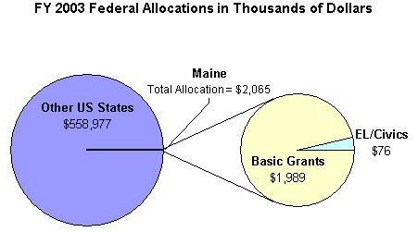
Enrollment by Race/Ethnicity and by Gender
 | 2003–04 |  |  |  | % Change from 2002–03
 | ABE | ASE | EL | Total | % Change from 2002–03
Race/Ethnicity
American Indian/Alaskan Native | 77 | 43 | 0 | 120 | -2%
Asian | 58 | 18 | 275 | 351 | -25%
Black/African American | 151 | 65 | 589 | 805 | -7%
Hispanic/Latino | 83 | 57 | 210 | 350 | -20%
Native Hawaiian/Pacific Islander | 4 | 3 | 3 | 10 | 100%
White | 3,385 | 3,401 | 392 | 7,178 | -21%
TOTAL | 3,758 | 3,587 | 1,469 | 8,814 | -20%
Gender
Male | 1,693 | 1,747 | 528 | 3,968 | -22%
Female | 2,065 | 1,840 | 941 | 4,846 | -10%

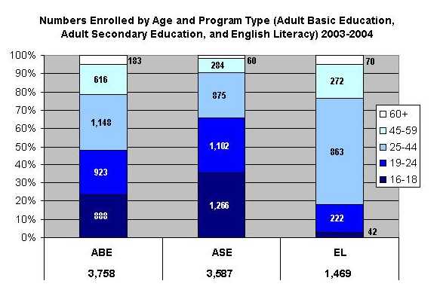

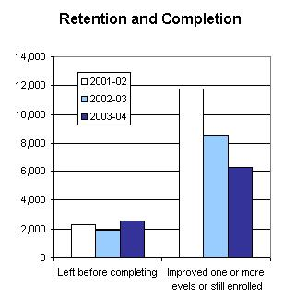

PROGRAM FACTS 2003–2004

Maine | Actual Performance
Maine | 2001–02 | 2002–03 | 2003–04 |  | TOTAL
Maine | Percent | Percent | Percent | # Adults completing at least one level or one outcome | 3-Year Total #
Performance Measure I: Demonstrated Improvement in Literacy Skills
Sub Measures:  - Adult Basic and Secondary Education  The percentage of adults enrolled in basic literacy programs who acquired the basic skills needed to complete one or more levels of instruction in which they were initially enrolled. | 43 | 44 | 45 | 2,628 | 9,270
- English Literacy  The percentage of adults enrolled in English literacy programs who acquired the level of English language skills needed to complete one or more levels of instruction in which they were initially enrolled. | 28 | 39 | 36 | 523 | 1,551
Performance Measure II: High School Completion
The percentage of adult learners with a high school completion goal who earned a high school diploma or GED after exiting the program. | 72 | 79 | 80 | 1,994 | 6,385
Performance Measure III: Entered Postsecondary Education or Training
The percentage of adult learners with a goal to continue their education who enter postsecondary education or training after exiting the program. | 63 | 67 | 45 | 485 | 1,601
Performance Measure IV: Entered Employment
The percentage of unemployed adult learners (in the workforce) with an employment goal who were employed at the end of the first quarter after exiting the program. | 66 | 42 | 45 | 485 | 1,709
Performance Measure V: Retained Employment
The percentage of adult learners with (a) a job retention goal at the time of enrollment and (b) those adults with an employment goal who obtained work by the end of the first quarter after leaving the program who were employed at the end of the third quarter after exiting the program. | 92 | 61 | 52 | 78 | 794

PROGRAM FACTS 2003–2004
maryland
Participant Status
 | 2002–03 | 2003–04
Employed | 13,611 | 13,844
Unemployed | 8,442 | 8,518
Correctional Setting | 5,405 | 6,033
On Public Assistance | 1,874 | 1,682
Other Institutionalized | 768 | 189
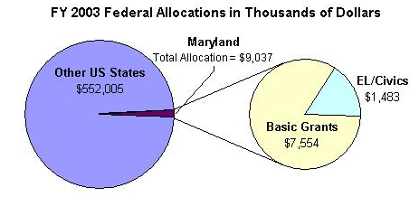
Enrollment by Race/Ethnicity and by Gender
 | 2003–04 |  |  |  | % Change from 2002–03
 | ABE | ASE | EL | Total | % Change from 2002–03
Race/Ethnicity
American Indian/Alaskan Native | 194 | 70 | 21 | 285 | -8%
Asian | 241 | 100 | 2,364 | 2,705 | -7%
Black/African American | 8,068 | 2,769 | 1,138 | 11,975 | -3%
Hispanic/Latino | 724 | 233 | 7,488 | 8,445 | 7%
Native Hawaiian/Pacific Islander | 31 | 13 | 25 | 69 | 1%
White | 3,454 | 2,387 | 984 | 6,825 | -7%
TOTAL | 12,712 | 5,572 | 12,020 | 30,304 | -2%
Gender
Male | 7,264 | 3,218 | 4,812 | 15,294 | 2%
Female | 5,448 | 2,354 | 7,208 | 15,010 | -1%

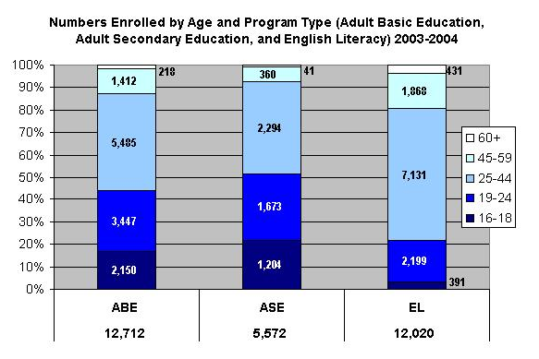

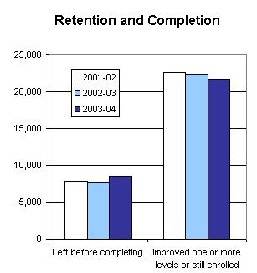

PROGRAM FACTS 2003–2004

Maryland | Actual Performance
Maryland | 2001–02 | 2002–03 | 2003–04 |  | TOTAL
Maryland | Percent | Percent | Percent | # Adults completing at least one level or one outcome | 3-Year Total #
Performance Measure I: Demonstrated Improvement in Literacy Skills
Sub Measures:  - Adult Basic and Secondary Education  The percentage of adults enrolled in basic literacy programs who acquired the basic skills needed to complete one or more levels of instruction in which they were initially enrolled. | 46 | 46 | 44 | 7,563 | 24,079
- English Literacy  The percentage of adults enrolled in English literacy programs who acquired the level of English language skills needed to complete one or more levels of instruction in which they were initially enrolled. | 33 | 38 | 40 | 4,817 | 12,880
Performance Measure II: High School Completion
The percentage of adult learners with a high school completion goal who earned a high school diploma or GED after exiting the program. | 22 | 64 | 76 | 2,769 | 7,989
Performance Measure III: Entered Postsecondary Education or Training
The percentage of adult learners with a goal to continue their education who enter postsecondary education or training after exiting the program. | 18 | 27 | 9 | 84 | 273
Performance Measure IV: Entered Employment
The percentage of unemployed adult learners (in the workforce) with an employment goal who were employed at the end of the first quarter after exiting the program. | 39 | 59 | 54 | 921 | 2,240
Performance Measure V: Retained Employment
The percentage of adult learners with (a) a job retention goal at the time of enrollment and (b) those adults with an employment goal who obtained work by the end of the first quarter after leaving the program who were employed at the end of the third quarter after exiting the program. | 66 | 68 | 49 | 1,085 | 1,719

PROGRAM FACTS 2003–2004
massachusetts
Participant Status
 | 2002–03 | 2003–04
Employed | 10,825 | 11,156
Unemployed | 4,617 | 4,660
Correctional Setting | 1,171 | 1,373
On Public Assistance | 3,135 | 4,728
Other Institutionalized | 0 | 0
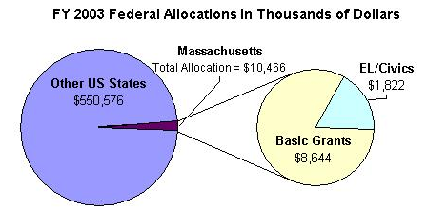
Enrollment by Race/Ethnicity and by Gender
 | 2003–04 |  |  |  | % Change from 2002–03
 | ABE | ASE | EL | Total | % Change from 2002–03
Race/Ethnicity
American Indian/Alaskan Native | 47 | 18 | 22 | 87 | -1%
Asian | 372 | 61 | 2,062 | 2,495 | -9%
Black/African American | 2,119 | 367 | 1,932 | 4,418 | 4%
Hispanic/Latino | 2,015 | 407 | 4,839 | 7,261 | 4%
Native Hawaiian/Pacific Islander | 9 | 3 | 17 | 29 | 26%
White | 2,909 | 1,363 | 3,016 | 7,288 | -6%
TOTAL | 7,471 | 2,219 | 11,888 | 21,578 | -1%
Gender
Male | 3,444 | 1,099 | 3,804 | 8,347 | 0%
Female | 4,027 | 1,120 | 8,084 | 13,231 | 2%

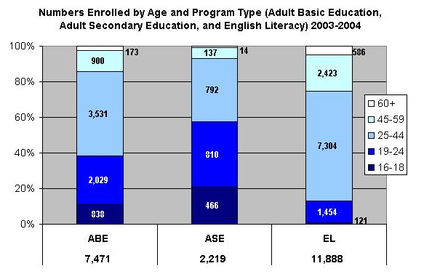

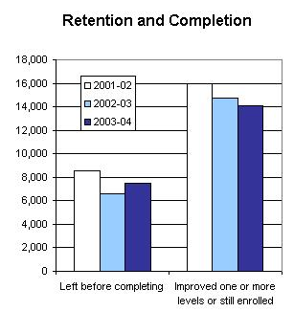

PROGRAM FACTS 2003–2004

Massachusetts | Actual Performance
Massachusetts | 2001–02 | 2002–03 | 2003–04 |  | TOTAL
Massachusetts | Percent | Percent | Percent | # Adults completing at least one level or one outcome | 3-Year Total #
Performance Measure I: Demonstrated Improvement in Literacy Skills
Sub Measures:  - Adult Basic and Secondary Education  The percentage of adults enrolled in basic literacy programs who acquired the basic skills needed to complete one or more levels of instruction in which they were initially enrolled. | 23 | 24 | 25 | 2,164 | 6,293
- English Literacy  The percentage of adults enrolled in English literacy programs who acquired the level of English language skills needed to complete one or more levels of instruction in which they were initially enrolled. | 36 | 33 | 34 | 4,073 | 13,164
Performance Measure II: High School Completion
The percentage of adult learners with a high school completion goal who earned a high school diploma or GED after exiting the program. | 65 | 31 | 53 | 1,183 | 3,038
Performance Measure III: Entered Postsecondary Education or Training
The percentage of adult learners with a goal to continue their education who enter postsecondary education or training after exiting the program. | 63 | 45 | 37 | 276 | 907
Performance Measure IV: Entered Employment
The percentage of unemployed adult learners (in the workforce) with an employment goal who were employed at the end of the first quarter after exiting the program. | 76 | 48 | 57 | 864 | 2,061
Performance Measure V: Retained Employment
The percentage of adult learners with (a) a job retention goal at the time of enrollment and (b) those adults with an employment goal who obtained work by the end of the first quarter after leaving the program who were employed at the end of the third quarter after exiting the program. | 36 | 56 | 42 | 269 | 553

PROGRAM FACTS 2003–2004
michigan
Participant Status
 | 2002–03 | 2003–04
Employed | 22,830 | 14,307
Unemployed | 28,635 | 17,181
Correctional Setting | 12,023 | 11,912
On Public Assistance | 6,027 | 3,794
Other Institutionalized | 1,438 | 2,075
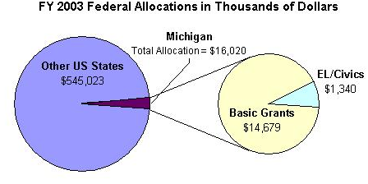
Enrollment by Race/Ethnicity and by Gender
 | 2003–04 |  |  |  | % Change from 2002–03
 | ABE | ASE | EL | Total | % Change from 2002–03
Race/Ethnicity
American Indian/Alaskan Native | 287 | 201 | 25 | 513 | -34%
Asian | 245 | 159 | 2,642 | 3,046 | -75%
Black/African American | 13,269 | 2,962 | 400 | 16,631 | -10%
Hispanic/Latino | 861 | 595 | 4,947 | 6,403 | -40%
Native Hawaiian/Pacific Islander | 61 | 63 | 28 | 152 | -40%
White | 9,558 | 6,711 | 5,259 | 21,528 | -31%
TOTAL | 24,281 | 10,691 | 13,301 | 48,273 | -34%
Gender
Male | 16,497 | 5,116 | 5,192 | 26,805 | -28%
Female | 7,784 | 5,575 | 8,109 | 21,468 | -37%

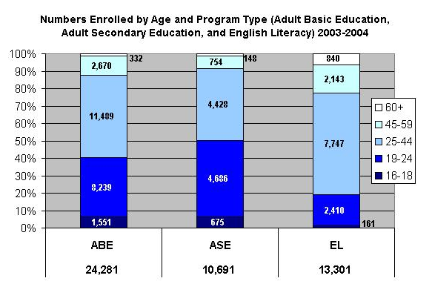

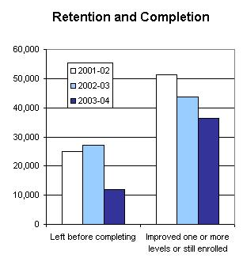

PROGRAM FACTS 2003–2004

Michigan | Actual Performance
Michigan | 2001–02 | 2002–03 | 2003–04 |  | TOTAL
Michigan | Percent | Percent | Percent | # Adults completing at least one level or one outcome | 3-Year Total #
Performance Measure I: Demonstrated Improvement in Literacy Skills
Sub Measures:  - Adult Basic and Secondary Education  The percentage of adults enrolled in basic literacy programs who acquired the basic skills needed to complete one or more levels of instruction in which they were initially enrolled. | 29 | 17 | 24 | 7,173 | 28,631
- English Literacy  The percentage of adults enrolled in English literacy programs who acquired the level of English language skills needed to complete one or more levels of instruction in which they were initially enrolled. | 34 | 37 | 45 | 6,047 | 21,764
Performance Measure II: High School Completion
The percentage of adult learners with a high school completion goal who earned a high school diploma or GED after exiting the program. | 37 | 32 | 36 | 6,543 | 21,945
Performance Measure III: Entered Postsecondary Education or Training
The percentage of adult learners with a goal to continue their education who enter postsecondary education or training after exiting the program. | 35 | 52 | 52 | 460 | 1,298
Performance Measure IV: Entered Employment
The percentage of unemployed adult learners (in the workforce) with an employment goal who were employed at the end of the first quarter after exiting the program. | 54 | 64 | 45 | 160 | 1,931
Performance Measure V: Retained Employment
The percentage of adult learners with (a) a job retention goal at the time of enrollment and (b) those adults with an employment goal who obtained work by the end of the first quarter after leaving the program who were employed at the end of the third quarter after exiting the program. | 49 | 50 | 56 | 179 | 681

PROGRAM FACTS 2003–2004
minnesota
Participant Status
 | 2002–03 | 2003–04
Employed | 16,853 | 17,286
Unemployed | 15,652 | 15,730
Correctional Setting | 10,158 | 7,892
On Public Assistance | 8,909 | 8,775
Other Institutionalized | 409 | 613
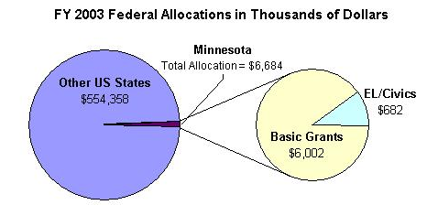
Enrollment by Race/Ethnicity and by Gender
 | 2003–04 |  |  |  | % Change from 2002–03
 | ABE | ASE | EL | Total | % Change from 2002–03
Race/Ethnicity
American Indian/Alaskan Native | 902 | 501 | 16 | 1,419 | -11%
Asian | 629 | 287 | 5,506 | 6,422 | 3%
Black/African American | 4,452 | 1,609 | 7,438 | 13,499 | 0%
Hispanic/Latino | 1,163 | 419 | 10,220 | 11,802 | 2%
Native Hawaiian/Pacific Islander | 37 | 24 | 45 | 106 | -60%
White | 5,013 | 3,455 | 2,504 | 10,972 | -7%
TOTAL | 12,196 | 6,295 | 25,729 | 44,220 | -1%
Gender
Male | 7,171 | 3,647 | 10,363 | 21,181 | -1%
Female | 5,025 | 2,648 | 15,366 | 23,039 | 2%

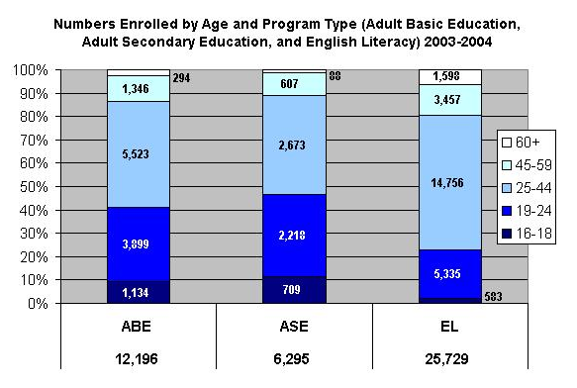

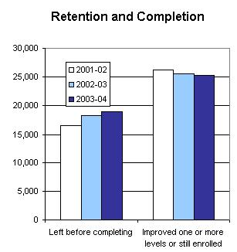

PROGRAM FACTS 2003–2004

Minnesota | Actual Performance
Minnesota | 2001–02 | 2002–03 | 2003–04 |  | TOTAL
Minnesota | Percent | Percent | Percent | # Adults completing at least one level or one outcome | 3-Year Total #
Performance Measure I: Demonstrated Improvement in Literacy Skills
Sub Measures:  - Adult Basic and Secondary Education  The percentage of adults enrolled in basic literacy programs who acquired the basic skills needed to complete one or more levels of instruction in which they were initially enrolled. | 22 | 25 | 28 | 4,394 | 11,689
- English Literacy  The percentage of adults enrolled in English literacy programs who acquired the level of English language skills needed to complete one or more levels of instruction in which they were initially enrolled. | 20 | 25 | 26 | 6,746 | 17,816
Performance Measure II: High School Completion
The percentage of adult learners with a high school completion goal who earned a high school diploma or GED after exiting the program. | 29 | 32 | 35 | 1,872 | 6,183
Performance Measure III: Entered Postsecondary Education or Training
The percentage of adult learners with a goal to continue their education who enter postsecondary education or training after exiting the program. | 28 | 25 | 26 | 813 | 2,312
Performance Measure IV: Entered Employment
The percentage of unemployed adult learners (in the workforce) with an employment goal who were employed at the end of the first quarter after exiting the program. | 32 | 28 | 41 | 1,823 | 3,867
Performance Measure V: Retained Employment
The percentage of adult learners with (a) a job retention goal at the time of enrollment and (b) those adults with an employment goal who obtained work by the end of the first quarter after leaving the program who were employed at the end of the third quarter after exiting the program. | 56 | 54 | 62 | 1,403 | 3,713

PROGRAM FACTS 2003–2004
mississippi
Participant Status
 | 2002–03 | 2003–04
Employed | 12,911 | 8,030
Unemployed | 16,765 | 13,582
Correctional Setting | 7,268 | 3,625
On Public Assistance | 3,732 | 2,826
Other Institutionalized | 4,824 | 536
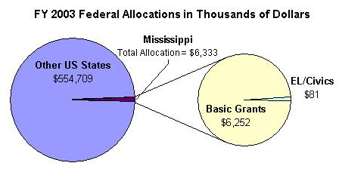
Enrollment by Race/Ethnicity and by Gender
 | 2003–04 |  |  |  | % Change from 2002–03
 | ABE | ASE | EL | Total | % Change from 2002–03
Race/Ethnicity
American Indian/Alaskan Native | 138 | 31 | 6 | 175 | 70%
Asian | 88 | 22 | 169 | 279 | -52%
Black/African American | 13,797 | 1,329 | 45 | 15,171 | -32%
Hispanic/Latino | 173 | 45 | 545 | 763 | -58%
Native Hawaiian/Pacific Islander | 20 | 3 | 3 | 26 | 8%
White | 7,088 | 2,899 | 66 | 10,053 | -28%
TOTAL | 21,304 | 4,329 | 834 | 26,467 | -32%
Gender
Male | 9,677 | 1,896 | 409 | 11,982 | -25%
Female | 11,627 | 2,433 | 425 | 14,485 | -30%

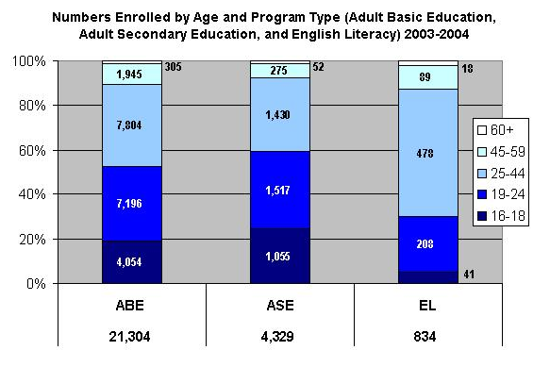

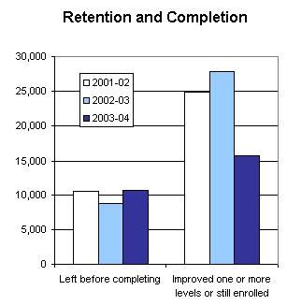

PROGRAM FACTS 2003–2004

Mississippi | Actual Performance
Mississippi | 2001–02 | 2002–03 | 2003–04 |  | TOTAL
Mississippi | Percent | Percent | Percent | # Adults completing at least one level or one outcome | 3-Year Total #
Performance Measure I: Demonstrated Improvement in Literacy Skills
Sub Measures:  - Adult Basic and Secondary Education  The percentage of adults enrolled in basic literacy programs who acquired the basic skills needed to complete one or more levels of instruction in which they were initially enrolled. | 43 | 43 | 20 | 4,737 | 31,093
- English Literacy  The percentage of adults enrolled in English literacy programs who acquired the level of English language skills needed to complete one or more levels of instruction in which they were initially enrolled. | 37 | 36 | 15 | 126 | 1,358
Performance Measure II: High School Completion
The percentage of adult learners with a high school completion goal who earned a high school diploma or GED after exiting the program. | 50 | 41 | 25 | 1,362 | 6,096
Performance Measure III: Entered Postsecondary Education or Training
The percentage of adult learners with a goal to continue their education who enter postsecondary education or training after exiting the program. | 56 | 55 | 35 | 260 | 3,493
Performance Measure IV: Entered Employment
The percentage of unemployed adult learners (in the workforce) with an employment goal who were employed at the end of the first quarter after exiting the program. | 72 | 49 | 29 | 267 | 2,805
Performance Measure V: Retained Employment
The percentage of adult learners with (a) a job retention goal at the time of enrollment and (b) those adults with an employment goal who obtained work by the end of the first quarter after leaving the program who were employed at the end of the third quarter after exiting the program. | 84 | 76 | 37 | 64 | 3,799

PROGRAM FACTS 2003–2004
missouri
Participant Status
 | 2002–03 | 2003–04
Employed | 11,051 | 9,680
Unemployed | 16,359 | 14,861
Correctional Setting | 9,210 | 9,011
On Public Assistance | 2,657 | 2,579
Other Institutionalized | 484 | 0
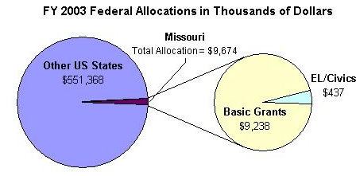
Enrollment by Race/Ethnicity and by Gender
 | 2003–04 |  |  |  | % Change from 2002–03
 | ABE | ASE | EL | Total | % Change from 2002–03
Race/Ethnicity
American Indian/Alaskan Native | 235 | 65 | 3 | 303 | -26%
Asian | 165 | 39 | 2,052 | 2,256 | -10%
Black/African American | 9,127 | 879 | 740 | 10,746 | -8%
Hispanic/Latino | 864 | 145 | 3,894 | 7,903 | -7%
Native Hawaiian/Pacific Islander | 29 | 10 | 6 | 45 | -48%
White | 13,766 | 4,369 | 1,341 | 19,476 | -9%
TOTAL | 24,186 | 5,507 | 8,036 | 37,729 | -9%
Gender
Male | 13,966 | 2,970 | 3,648 | 20,584 | -8%
Female | 10,220 | 2,537 | 4,388 | 17,145 | -13%

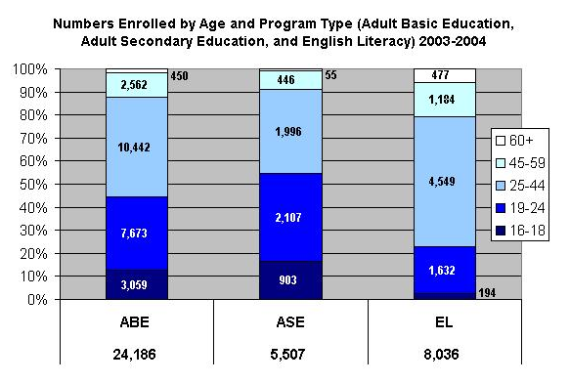

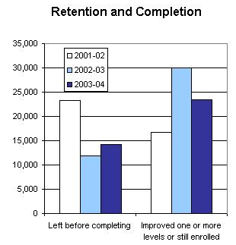

PROGRAM FACTS 2003–2004

Missouri | Actual Performance
Missouri | 2001–02 | 2002–03 | 2003–04 |  | TOTAL
Missouri | Percent | Percent | Percent | # Adults completing at least one level or one outcome | 3-Year Total #
Performance Measure I: Demonstrated Improvement in Literacy Skills
Sub Measures:  - Adult Basic and Secondary Education  The percentage of adults enrolled in basic literacy programs who acquired the basic skills needed to complete one or more levels of instruction in which they were initially enrolled. | 31 | 48 | 35 | 9,639 | 32,619
- English Literacy  The percentage of adults enrolled in English literacy programs who acquired the level of English language skills needed to complete one or more levels of instruction in which they were initially enrolled. | 29 | 31 | 31 | 2,487 | 7,846
Performance Measure II: High School Completion
The percentage of adult learners with a high school completion goal who earned a high school diploma or GED after exiting the program. | 33 | 37 | 54 | 1,510 | 4,677
Performance Measure III: Entered Postsecondary Education or Training
The percentage of adult learners with a goal to continue their education who enter postsecondary education or training after exiting the program. | 19 | 19 | 22 | 1,627 | 4,009
Performance Measure IV: Entered Employment
The percentage of unemployed adult learners (in the workforce) with an employment goal who were employed at the end of the first quarter after exiting the program. | 51 | 54 | 55 | 1,967 | 24,406
Performance Measure V: Retained Employment
The percentage of adult learners with (a) a job retention goal at the time of enrollment and (b) those adults with an employment goal who obtained work by the end of the first quarter after leaving the program who were employed at the end of the third quarter after exiting the program. | 70 | 67 | 68 | 189 | 2,231

PROGRAM FACTS 2003–2004
montana
Participant Status
 | 2002–03 | 2003–04
Employed | 1,173 | 1,066
Unemployed | 1,952 | 1,673
Correctional Setting | 981 | 807
On Public Assistance | 1,304 | 1,151
Other Institutionalized | 49 | 28
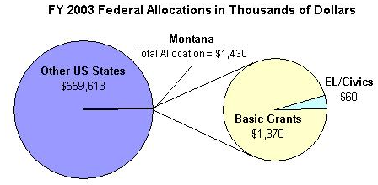
Enrollment by Race/Ethnicity and by Gender
 | 2003–04 |  |  |  | % Change from 2002–03
 | ABE | ASE | EL | Total | % Change from 2002–03
Race/Ethnicity
American Indian/Alaskan Native | 626 | 93 | 1 | 720 | -28%
Asian | 53 | 8 | 89 | 150 | 18%
Black/African American | 31 | 11 | 1 | 43 | -22%
Hispanic/Latino | 164 | 30 | 66 | 260 | -24%
Native Hawaiian/Pacific Islander | 11 | 6 | 1 | 18 | -10%
White | 1,756 | 877 | 40 | 2,673 | -19%
TOTAL | 2,641 | 1,025 | 198 | 3,864 | -20%
Gender
Male | 1,250 | 513 | 65 | 1,828 | -16%
Female | 1,391 | 512 | 133 | 2,036 | -10%

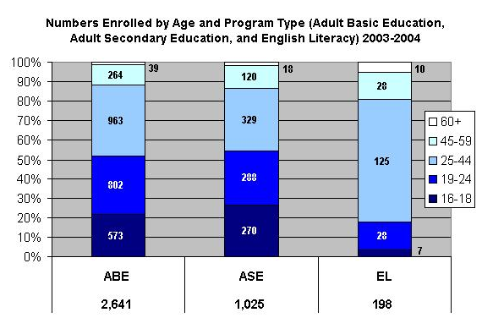

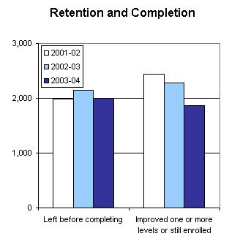

PROGRAM FACTS 2003–2004

Montana | Actual Performance
Montana | 2001–02 | 2002–03 | 2003–04 |  | TOTAL
Montana | Percent | Percent | Percent | # Adults completing at least one level or one outcome | 3-Year Total #
Performance Measure I: Demonstrated Improvement in Literacy Skills
Sub Measures:  - Adult Basic and Secondary Education  The percentage of adults enrolled in basic literacy programs who acquired the basic skills needed to complete one or more levels of instruction in which they were initially enrolled. | 35 | 30 | 29 | 933 | 3,358
- English Literacy  The percentage of adults enrolled in English literacy programs who acquired the level of English language skills needed to complete one or more levels of instruction in which they were initially enrolled. | 48 | 49 | 35 | 69 | 263
Performance Measure II: High School Completion
The percentage of adult learners with a high school completion goal who earned a high school diploma or GED after exiting the program. | 48 | 73 | 51 | 729 | 2,574
Performance Measure III: Entered Postsecondary Education or Training
The percentage of adult learners with a goal to continue their education who enter postsecondary education or training after exiting the program. | 44 | 82 | 48 | 230 | 811
Performance Measure IV: Entered Employment
The percentage of unemployed adult learners (in the workforce) with an employment goal who were employed at the end of the first quarter after exiting the program. | 63 | 77 | 45 | 170 | 759
Performance Measure V: Retained Employment
The percentage of adult learners with (a) a job retention goal at the time of enrollment and (b) those adults with an employment goal who obtained work by the end of the first quarter after leaving the program who were employed at the end of the third quarter after exiting the program. | 58 | 59 | 35 | 33 | 319

PROGRAM FACTS 2003–2004
Nebraska
Participant Status
 | 2002–03 | 2003–04
Employed | 4,085 | 4,011
Unemployed | 4,457 | 4,469
Correctional Setting | 1,306 | 1,445
On Public Assistance | 894 | 915
Other Institutionalized | 50 | 35
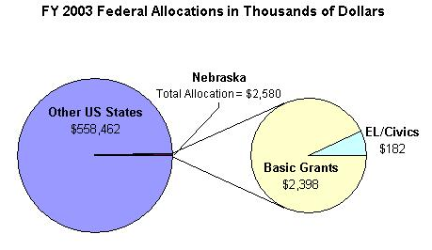
Enrollment by Race/Ethnicity and by Gender
 | 2003–04 |  |  |  | % Change from 2002–03
 | ABE | ASE | EL | Total | % Change from 2002–03
Race/Ethnicity
American Indian/Alaskan Native | 375 | 55 | 4 | 434 | 8%
Asian | 79 | 7 | 309 | 395 | -9%
Black/African American | 1,162 | 101 | 271 | 1,534 | -9%
Hispanic/Latino | 882 | 120 | 3,486 | 4,488 | -3%
Native Hawaiian/Pacific Islander | 18 | 6 | 4 | 28 | -15%
White | 2,326 | 899 | 163 | 3,388 | -8%
TOTAL | 4,842 | 1,188 | 4,237 | 10,267 | -6%
Gender
Male | 2,407 | 690 | 2,089 | 5,186 | 0%
Female | 2,435 | 498 | 2,148 | 5,081 | 1%

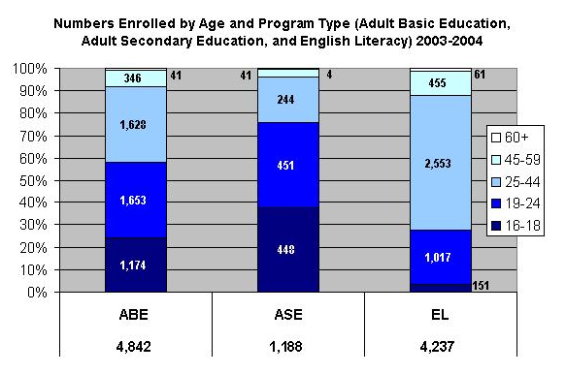

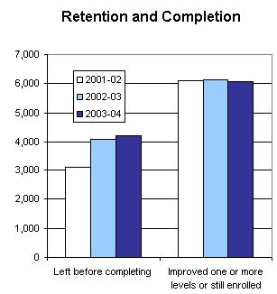

PROGRAM FACTS 2003–2004

Nebraska | Actual Performance
Nebraska | 2001–02 | 2002–03 | 2003–04 |  | TOTAL
Nebraska | Percent | Percent | Percent | # Adults completing at least one level or one outcome | 3-Year Total #
Performance Measure I: Demonstrated Improvement in Literacy Skills
Sub Measures:  - Adult Basic and Secondary Education  The percentage of adults enrolled in basic literacy programs who acquired the basic skills needed to complete one or more levels of instruction in which they were initially enrolled. | 36 | 35 | 34 | 1,879 | 5,633
- English Literacy  The percentage of adults enrolled in English literacy programs who acquired the level of English language skills needed to complete one or more levels of instruction in which they were initially enrolled. | 34 | 34 | 38 | 1,612 | 4,356
Performance Measure II: High School Completion
The percentage of adult learners with a high school completion goal who earned a high school diploma or GED after exiting the program. | 63 | 44 | 46 | 1,090 | 3,287
Performance Measure III: Entered Postsecondary Education or Training
The percentage of adult learners with a goal to continue their education who enter postsecondary education or training after exiting the program. | 61 | 25 | 25 | 109 | 298
Performance Measure IV: Entered Employment
The percentage of unemployed adult learners (in the workforce) with an employment goal who were employed at the end of the first quarter after exiting the program. | 41 | 32 | 39 | 117 | 258
Performance Measure V: Retained Employment
The percentage of adult learners with (a) a job retention goal at the time of enrollment and (b) those adults with an employment goal who obtained work by the end of the first quarter after leaving the program who were employed at the end of the third quarter after exiting the program. | 70 | 49 | 31 | 42 | 143

PROGRAM FACTS 2003–2004
Nevada
Participant Status
 | 2002–03 | 2003–04
Employed | 3,615 | 3,908
Unemployed | 3,174 | 3,577
Correctional Setting | 220 | 222
On Public Assistance | 589 | 540
Other Institutionalized | 0 | 0
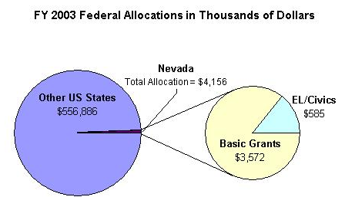
Enrollment by Race/Ethnicity and by Gender
 | 2003–04 |  |  |  | % Change from 2002–03
 | ABE | ASE | EL | Total | % Change from 2002–03
Race/Ethnicity
American Indian/Alaskan Native | 45 | 36 | 12 | 93 | 12%
Asian | 36 | 20 | 534 | 590 | -2%
Black/African American | 187 | 56 | 183 | 426 | 21%
Hispanic/Latino | 393 | 145 | 6,010 | 6,548 | 23%
Native Hawaiian/Pacific Islander | 23 | 12 | 27 | 62 | 22%
White | 464 | 300 | 249 | 1,013 | -19%
TOTAL | 1,148 | 569 | 7,015 | 8,732 | 14%
Gender
Male | 536 | 298 | 2,997 | 3,831 | 15%
Female | 612 | 271 | 4,018 | 4,901 | 15%

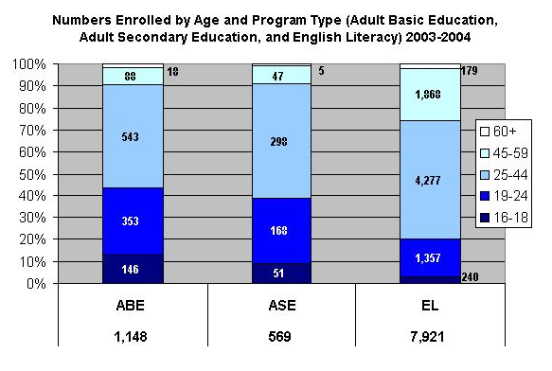

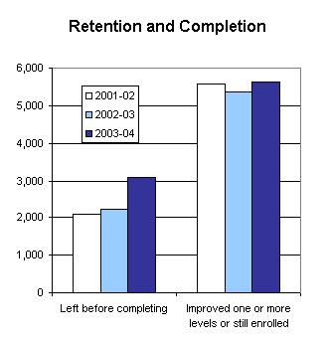

PROGRAM FACTS 2003–2004

Nevada | Actual Performance
Nevada | 2001–02 | 2002–03 | 2003–04 |  | TOTAL
Nevada | Percent | Percent | Percent | # Adults completing at least one level or one outcome | 3-Year Total #
Performance Measure I: Demonstrated Improvement in Literacy Skills
Sub Measures:  - Adult Basic and Secondary Education  The percentage of adults enrolled in basic literacy programs who acquired the basic skills needed to complete one or more levels of instruction in which they were initially enrolled. | 46 | 46 | 40 | 592 | 2,062
- English Literacy  The percentage of adults enrolled in English literacy programs who acquired the level of English language skills needed to complete one or more levels of instruction in which they were initially enrolled. | 52 | 50 | 47 | 3,315 | 9,235
Performance Measure II: High School Completion
The percentage of adult learners with a high school completion goal who earned a high school diploma or GED after exiting the program. | 32 | 24 | 50 | 296 | 881
Performance Measure III: Entered Postsecondary Education or Training
The percentage of adult learners with a goal to continue their education who enter postsecondary education or training after exiting the program. | 22 | 5 | 68 | 58 | 252
Performance Measure IV: Entered Employment
The percentage of unemployed adult learners (in the workforce) with an employment goal who were employed at the end of the first quarter after exiting the program. | 62 | 45 | 49 | 422 | 1,391
Performance Measure V: Retained Employment
The percentage of adult learners with (a) a job retention goal at the time of enrollment and (b) those adults with an employment goal who obtained work by the end of the first quarter after leaving the program who were employed at the end of the third quarter after exiting the program. | 74 | 35 | 78 | 188 | 826

PROGRAM FACTS 2003–2004
New Hampshire
Participant Status
 | 2002–03 | 2003–04
Employed | 3,244 | 2,820
Unemployed | 2,195 | 1,926
Correctional Setting | 156 | 109
On Public Assistance | 252 | 172,28
Other Institutionalized | 87
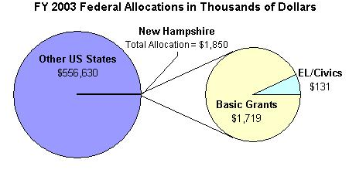
Enrollment by Race/Ethnicity and by Gender
 | 2003–04 |  |  |  | % Change from 2002–03
 | ABE | ASE | EL | Total | % Change from 2002–03
Race/Ethnicity
American Indian/Alaskan Native | 25 | 9 | 2 | 36 | 6%
Asian | 55 | 24 | 475 | 554 | -6%
Black/African American | 68 | 18 | 135 | 221 | 4%
Hispanic/Latino | 171 | 58 | 820 | 1,049 | -8%
Native Hawaiian/Pacific Islander | 6 | 2 | 26 | 34 | -36%
White | 1,508 | 2,056 | 408 | 3,972 | -12%
TOTAL | 1,833 | 2,167 | 1,866 | 5,866 | -11%
Gender
Male | 696 | 1,007 | 613 | 2,316 | -8%
Female | 1,137 | 1,160 | 1,253 | 3,550 | -10%

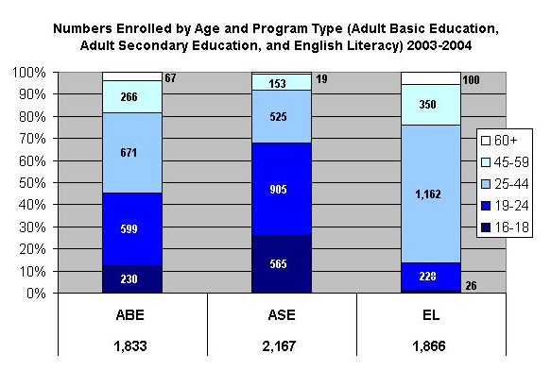

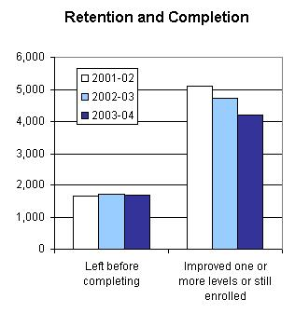

PROGRAM FACTS 2003–2004

New Hampshire | Actual Performance
New Hampshire | 2001–02 | 2002–03 | 2003–04 |  | TOTAL
New Hampshire | Percent | Percent | Percent | # Adults completing at least one level or one outcome | 3-Year Total #
Performance Measure I: Demonstrated Improvement in Literacy Skills
Sub Measures:  - Adult Basic and Secondary Education  The percentage of adults enrolled in basic literacy programs who acquired the basic skills needed to complete one or more levels of instruction in which they were initially enrolled. | 40 | 36 | 43 | 1,303 | 3,718
- English Literacy  The percentage of adults enrolled in English literacy programs who acquired the level of English language skills needed to complete one or more levels of instruction in which they were initially enrolled. | 35 | 33 | 30 | 566 | 1,998
Performance Measure II: High School Completion
The percentage of adult learners with a high school completion goal who earned a high school diploma or GED after exiting the program. | 76 | 70 | 74 | 926 | 2,886
Performance Measure III: Entered Postsecondary Education or Training
The percentage of adult learners with a goal to continue their education who enter postsecondary education or training after exiting the program. | 76 | 68 | 70 | 119 | 290
Performance Measure IV: Entered Employment
The percentage of unemployed adult learners (in the workforce) with an employment goal who were employed at the end of the first quarter after exiting the program. | 95 | 91 | 90 | 199 | 551
Performance Measure V: Retained Employment
The percentage of adult learners with (a) a job retention goal at the time of enrollment and (b) those adults with an employment goal who obtained work by the end of the first quarter after leaving the program who were employed at the end of the third quarter after exiting the program. | 97 | 95 | 91 | 158 | 382

PROGRAM FACTS 2003–2004
New Jersey
Participant Status
 | 2002–03 | 2003–04
Employed | 22,069 | 20,677
Unemployed | 12,518 | 12,710
Correctional Setting | 4,039 | 4,501
On Public Assistance | 2,493 | 2,295
Other Institutionalized | 78 | 76
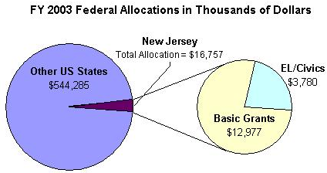
Enrollment by Race/Ethnicity and by Gender
 | 2003–04 |  |  |  | % Change from 2002–03
 | ABE | ASE | EL | Total | % Change from 2002–03
Race/Ethnicity
American Indian/Alaskan Native | 44 | 9 | 14 | 67 | -3%
Asian | 231 | 62 | 2,254 | 2,547 | -8%
Black/African American | 6,500 | 1,935 | 1,512 | 9,947 | -4%
Hispanic/Latino | 4,059 | 1,387 | 17,819 | 23,265 | -2%
Native Hawaiian/Pacific Islander | 18 | 10 | 32 | 60 | 11%
White | 2,066 | 985 | 2,866 | 5,917 | -12%
TOTAL | 12,918 | 4,388 | 24,497 | 41,803 | -4%
Gender
Male | 6,734 | 2,298 | 8,817 | 17,849 | -3%
Female | 6,184 | 2,090 | 15,680 | 23,954 | -1%

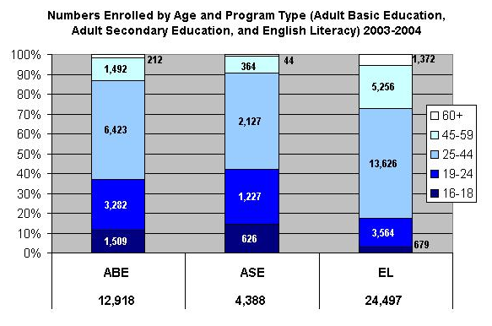

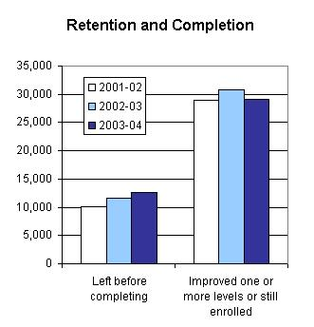

PROGRAM FACTS 2003–2004

New Jersey | Actual Performance
New Jersey | 2001–02 | 2002–03 | 2003–04 |  | TOTAL
New Jersey | Percent | Percent | Percent | # Adults completing at least one level or one outcome | 3-Year Total #
Performance Measure I: Demonstrated Improvement in Literacy Skills
Sub Measures:  - Adult Basic and Secondary Education  The percentage of adults enrolled in basic literacy programs who acquired the basic skills needed to complete one or more levels of instruction in which they were initially enrolled. | 32 | 29 | 30 | 4,621 | 13,757
- English Literacy  The percentage of adults enrolled in English literacy programs who acquired the level of English language skills needed to complete one or more levels of instruction in which they were initially enrolled. | 36 | 37 | 37 | 9,125 | 26,410
Performance Measure II: High School Completion
The percentage of adult learners with a high school completion goal who earned a high school diploma or GED after exiting the program. | 39 | 54 | 24 | 1,156 | 5,739
Performance Measure III: Entered Postsecondary Education or Training
The percentage of adult learners with a goal to continue their education who enter postsecondary education or training after exiting the program. | 39 | 94 | 30 | 643 | 2,637
Performance Measure IV: Entered Employment
The percentage of unemployed adult learners (in the workforce) with an employment goal who were employed at the end of the first quarter after exiting the program. | 54 | 85 | 38 | 1,174 | 4,278
Performance Measure V: Retained Employment
The percentage of adult learners with (a) a job retention goal at the time of enrollment and (b) those adults with an employment goal who obtained work by the end of the first quarter after leaving the program who were employed at the end of the third quarter after exiting the program. | 71 | 65 | 57 | 2,870 | 8,584

PROGRAM FACTS 2003–2004
New Mexico
Participant Status
 | 2002–03 | 2003–04
Employed | 8,319 | 8,290
Unemployed | 8,573 | 8,402
Correctional Setting | 1,773 | 2,524
On Public Assistance | 3,546 | 3,730
Other Institutionalized | 167 | 67
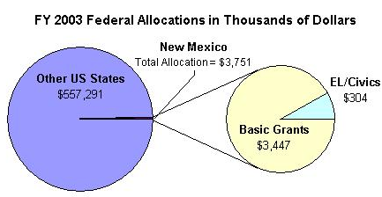
Enrollment by Race/Ethnicity and by Gender
 | 2003–04 |  |  |  | % Change from 2002–03
 | ABE | ASE | EL | Total | % Change from 2002–03
Race/Ethnicity
American Indian/Alaskan Native | 2,288 | 190 | 181 | 2,659 | -5%
Asian | 106 | 11 | 578 | 695 | 2%
Black/African American | 375 | 48 | 51 | 474 | 3%
Hispanic/Latino | 7,479 | 1,081 | 7,266 | 15,826 | 2%
Native Hawaiian/Pacific Islander | 36 | 5 | 4 | 45 | 61%
White | 2,099 | 658 | 386 | 3,143 | -5%
TOTAL | 12,383 | 1,993 | 8,466 | 22,842 | 0%
Gender
Male | 6,258 | 1,051 | 3,275 | 10,584 | 10%
Female | 6,125 | 942 | 5,191 | 12,258 | 2%

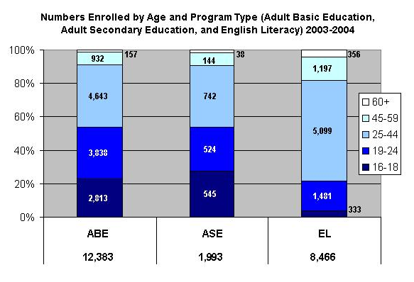

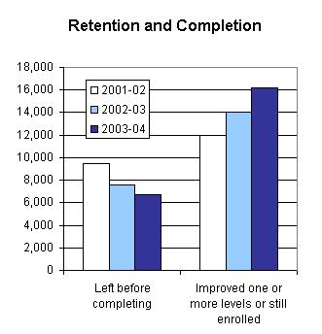

PROGRAM FACTS 2003–2004

New Mexico | Actual Performance
New Mexico | 2001–02 | 2002–03 | 2003–04 |  | TOTAL
New Mexico | Percent | Percent | Percent | # Adults completing at least one level or one outcome | 3-Year Total #
Performance Measure I: Demonstrated Improvement in Literacy Skills
Sub Measures:  - Adult Basic and Secondary Education  The percentage of adults enrolled in basic literacy programs who acquired the basic skills needed to complete one or more levels of instruction in which they were initially enrolled. | 29 | 31 | 33 | 4,514 | 12,343
- English Literacy  The percentage of adults enrolled in English literacy programs who acquired the level of English language skills needed to complete one or more levels of instruction in which they were initially enrolled. | 29 | 30 | 30 | 2,580 | 7,031
Performance Measure II: High School Completion
The percentage of adult learners with a high school completion goal who earned a high school diploma or GED after exiting the program. | 30 | 56 | 44 | 1,190 | 3,642
Performance Measure III: Entered Postsecondary Education or Training
The percentage of adult learners with a goal to continue their education who enter postsecondary education or training after exiting the program. | 64 | 48 | 51 | 624 | 2,232
Performance Measure IV: Entered Employment
The percentage of unemployed adult learners (in the workforce) with an employment goal who were employed at the end of the first quarter after exiting the program. | 38 | 52 | 48 | 283 | 911
Performance Measure V: Retained Employment
The percentage of adult learners with (a) a job retention goal at the time of enrollment and (b) those adults with an employment goal who obtained work by the end of the first quarter after leaving the program who were employed at the end of the third quarter after exiting the program. | 79 | 79 | 70 | 469 | 1,287

PROGRAM FACTS 2003–2004
New York
Participant Status
 | 2002–03 | 2003–04
Employed | 65,443 | 78,662
Unemployed | 47,709 | 59,881
Correctional Setting | 8,659 | 12,954
On Public Assistance | 15,915 | 22,792
Other Institutionalized | 3,042 | 3,141
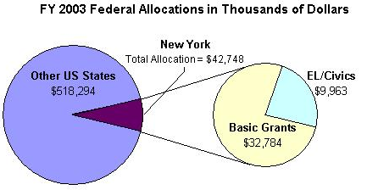
Enrollment by Race/Ethnicity and by Gender
 | 2003–04 |  |  |  | % Change from 2002–03
 | ABE | ASE | EL | Total | % Change from 2002–03
Race/Ethnicity
American Indian/Alaskan Native | 935 | 181 | 105 | 1,221 | 37%
Asian | 1,722 | 244 | 11,724 | 13,690 | 15%
Black/African American | 28,167 | 3,678 | 7,102 | 38,947 | 16%
Hispanic/Latino | 10,849 | 2,128 | 59,631 | 72,608 | 17%
Native Hawaiian/Pacific Islander | 613 | 66 | 150 | 829 | 241%
White | 21,469 | 5,261 | 11,593 | 38,323 | 15%
TOTAL | 63,755 | 11,558 | 90,305 | 165,618 | 17%
Gender
Male | 26,882 | 5,350 | 36,019 | 68,251 | 20%
Female | 36,873 | 6,208 | 54,286 | 97,367 | 20%

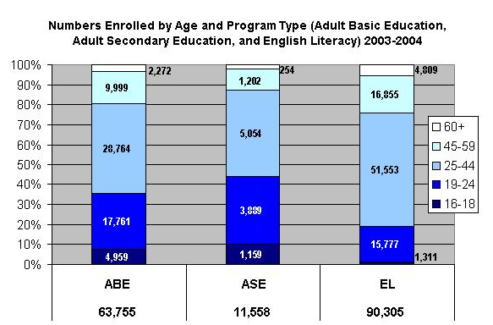

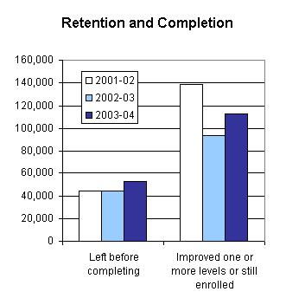

PROGRAM FACTS 2003–2004

New York | Actual Performance
New York | 2001–02 | 2002–03 | 2003–04 |  | TOTAL
New York | Percent | Percent | Percent | # Adults completing at least one level or one outcome | 3-Year Total #
Performance Measure I: Demonstrated Improvement in Literacy Skills
Sub Measures:  - Adult Basic and Secondary Education  The percentage of adults enrolled in basic literacy programs who acquired the basic skills needed to complete one or more levels of instruction in which they were initially enrolled. | 31 | 24 | 29 | 20,381 | 56,720
- English Literacy  The percentage of adults enrolled in English literacy programs who acquired the level of English language skills needed to complete one or more levels of instruction in which they were initially enrolled. | 43 | 37 | 37 | 33,846 | 102,847
Performance Measure II: High School Completion*
The percentage of adult learners with a high school completion goal who earned a high school diploma or GED after exiting the program. | 48 | 76 | 90 | 5,414 | 14,553
Performance Measure III: Entered Postsecondary Education or Training*
The percentage of adult learners with a goal to continue their education who enter postsecondary education or training after exiting the program. | 58 | 79 | 63 | 1,978 | 5,337
Performance Measure IV: Entered Employment*
The percentage of unemployed adult learners (in the workforce) with an employment goal who were employed at the end of the first quarter after exiting the program. | 63 | 85 | 43 | 3,587 | 10,081
Performance Measure V: Retained Employment
The percentage of adult learners with (a) a job retention goal at the time of enrollment and (b) those adults with an employment goal who obtained work by the end of the first quarter after leaving the program who were employed at the end of the third quarter after exiting the program. | 81 | 44 | 33 | 399 | 6,429
* Response rate was too low on follow-up survey to validate outcomes.

PROGRAM FACTS 2003–2004
North Carolina
Participant Status
 | 2002–03 | 2003–04
Employed | 41,511 | 40,985
Unemployed | 36,658 | 45,299
Correctional Setting | 12,854 | 14,810
On Public Assistance | 7,626 | 7,803
Other Institutionalized | 313 | 6
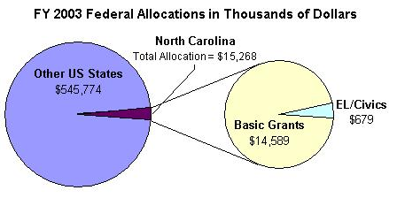
Enrollment by Race/Ethnicity and by Gender
 | 2003–04 |  |  |  | % Change from 2002–03
 | ABE | ASE | EL | Total | % Change from 2002–03
Race/Ethnicity
American Indian/Alaskan Native | 1,750 | 418 | 62 | 2,230 | -4%
Asian | 768 | 250 | 3,471 | 4,489 | -1%
Black/African American | 29,555 | 6,267 | 782 | 36,604 | -5%
Hispanic/Latino | 2,953 | 957 | 23,233 | 27,143 | 2%
Native Hawaiian/Pacific Islander | 734 | 217 | 475 | 1,426 | 9%
White | 24,935 | 11,735 | 1,623 | 38,293 | 4%
TOTAL | 60,695 | 19,844 | 29,646 | 110,185 | 0%
Gender
Male | 30,835 | 9,902 | 14,858 | 55,595 | -1%
Female | 29,860 | 9,942 | 14,788 | 54,590 | 4%

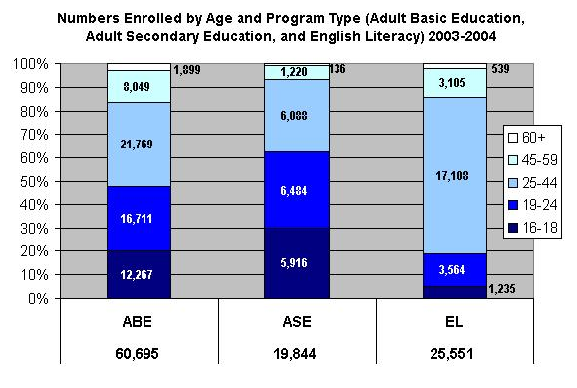

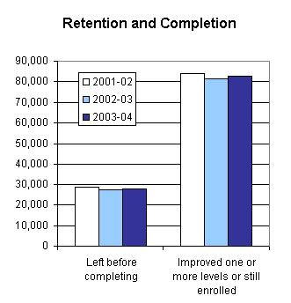

PROGRAM FACTS 2003–2004

North Carolina | Actual Performance
North Carolina | 2001–02 | 2002–03 | 2003–04 |  | TOTAL
North Carolina | Percent | Percent | Percent | # Adults completing at least one level or one outcome | 3-Year Total #
Performance Measure I: Demonstrated Improvement in Literacy Skills
Sub Measures:  - Adult Basic and Secondary Education  The percentage of adults enrolled in basic literacy programs who acquired the basic skills needed to complete one or more levels of instruction in which they were initially enrolled. | 36 | 34 | 36 | 26,046 | 74,986
- English Literacy  The percentage of adults enrolled in English literacy programs who acquired the level of English language skills needed to complete one or more levels of instruction in which they were initially enrolled. | 28 | 31 | 31 | 9,243 | 26,593
Performance Measure II: High School Completion
The percentage of adult learners with a high school completion goal who earned a high school diploma or GED after exiting the program. | 52 | 41 | 42 | 10,306 | 27,142
Performance Measure III: Entered Postsecondary Education or Training
The percentage of adult learners with a goal to continue their education who enter postsecondary education or training after exiting the program. | 19 | 14 | 25 | 2,920 | 4,933
Performance Measure IV: Entered Employment
The percentage of unemployed adult learners (in the workforce) with an employment goal who were employed at the end of the first quarter after exiting the program. | 35 | 23 | 17 | 3,587 | 3,044
Performance Measure V: Retained Employment
The percentage of adult learners with (a) a job retention goal at the time of enrollment and (b) those adults with an employment goal who obtained work by the end of the first quarter after leaving the program who were employed at the end of the third quarter after exiting the program. | 37 | 29 | 20 | 1,804 | 7,488

PROGRAM FACTS 2003–2004
North Dakota
Participant Status
 | 2002–03 | 2003–04
Employed | 665 | 681
Unemployed | 1,069 | 1,014
Correctional Setting | 316 | 299
On Public Assistance | 915 | 656
Other Institutionalized | 11 | 0
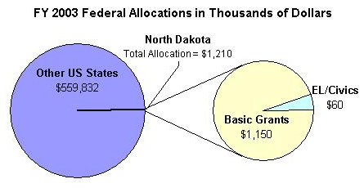
Enrollment by Race/Ethnicity and by Gender
 | 2003–04 |  |  |  | % Change from 2002–03
 | ABE | ASE | EL | Total | % Change from 2002–03
Race/Ethnicity
American Indian/Alaskan Native | 410 | 67 | 0 | 477 | -21%
Asian | 23 | 1 | 63 | 87 | 24%
Black/African American | 53 | 11 | 114 | 178 | 37%
Hispanic/Latino | 72 | 10 | 25 | 107 | -10%
Native Hawaiian/Pacific Islander | 4 | 2 | 1 | 7 | -42%
White | 759 | 479 | 60 | 1,298 | -5%
TOTAL | 1,321 | 570 | 263 | 2,154 | -6%
Gender
Male | 640 | 263 | 91 | 994 | -2%
Female | 681 | 307 | 172 | 1,160 | 3%

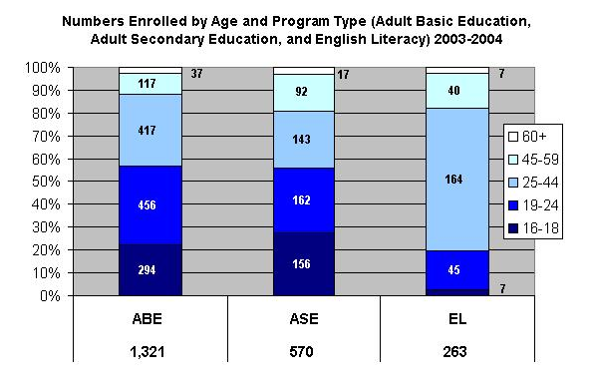

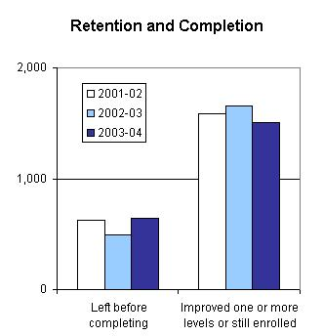

PROGRAM FACTS 2003–2004

North Dakota | Actual Performance
North Dakota | 2001–02 | 2002–03 | 2003–04 |  | TOTAL
North Dakota | Percent | Percent | Percent | # Adults completing at least one level or one outcome | 3-Year Total #
Performance Measure I: Demonstrated Improvement in Literacy Skills
Sub Measures:  - Adult Basic and Secondary Education  The percentage of adults enrolled in basic literacy programs who acquired the basic skills needed to complete one or more levels of instruction in which they were initially enrolled. | 69 | 74 | 66 | 1,053 | 3,324
- English Literacy  The percentage of adults enrolled in English literacy programs who acquired the level of English language skills needed to complete one or more levels of instruction in which they were initially enrolled. | 67 | 80 | 62 | 164 | 611
Performance Measure II: High School Completion
The percentage of adult learners with a high school completion goal who earned a high school diploma or GED after exiting the program. | 76 | 73 | 73 | 619 | 2,061
Performance Measure III: Entered Postsecondary Education or Training
The percentage of adult learners with a goal to continue their education who enter postsecondary education or training after exiting the program. | 100 | 100 | 78 | 73 | 252
Performance Measure IV: Entered Employment
The percentage of unemployed adult learners (in the workforce) with an employment goal who were employed at the end of the first quarter after exiting the program. | 82 | 86 | 72 | 63 | 634
Performance Measure V: Retained Employment
The percentage of adult learners with (a) a job retention goal at the time of enrollment and (b) those adults with an employment goal who obtained work by the end of the first quarter after leaving the program who were employed at the end of the third quarter after exiting the program. | 81 | 80 | 90 | 112 | 740

PROGRAM FACTS 2003–2004
Ohio
Participant Status
 | 2002–03 | 2003–04
Employed | 24,389 | 22,685
Unemployed | 24,513 | 24,115
Correctional Setting | 4,034 | 5,546
On Public Assistance | 12,054 | 12,461
Other Institutionalized | 514 | 365
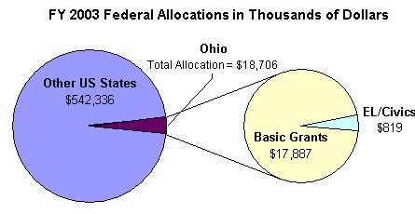
Enrollment by Race/Ethnicity and by Gender
 | 2003–04 |  |  |  | % Change from 2002–03
 | ABE | ASE | EL | Total | % Change from 2002–03
Race/Ethnicity
American Indian/Alaskan Native | 368 | 86 | 5 | 459 | -28%
Asian | 285 | 80 | 2,277 | 2,642 | -6%
Black/African American | 12,741 | 1,904 | 1,265 | 15,910 | -15%
Hispanic/Latino | 1,398 | 289 | 3,042 | 4,729 | -11%
Native Hawaiian/Pacific Islander | 43 | 22 | 16 | 81 | -39%
White | 22,500 | 7,851 | 2,435 | 32,786 | -13%
TOTAL | 37,335 | 10,232 | 9,040 | 56,607 | -13%
Gender
Male | 15,515 | 4,855 | 3,314 | 23,684 | -8%
Female | 21,820 | 5,377 | 5,726 | 32,923 | -3%

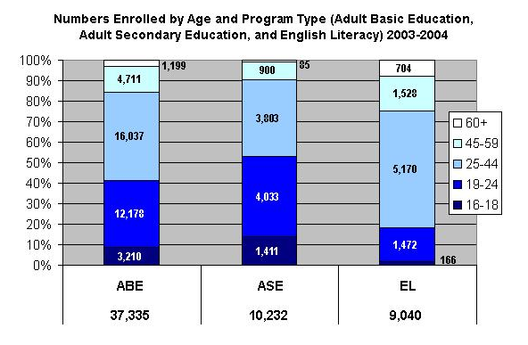

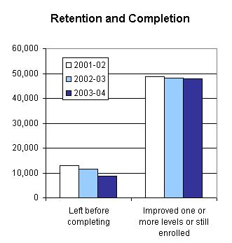

PROGRAM FACTS 2003–2004

Ohio | Actual Performance
Ohio | 2001–02 | 2002–03 | 2003–04 |  | TOTAL
Ohio | Percent | Percent | Percent | # Adults completing at least one level or one outcome | 3-Year Total #
Performance Measure I: Demonstrated Improvement in Literacy Skills
Sub Measures:  - Adult Basic and Secondary Education  The percentage of adults enrolled in basic literacy programs who acquired the basic skills needed to complete one or more levels of instruction in which they were initially enrolled. | 55 | 54 | 56 | 24,202 | 75,064
- English Literacy  The percentage of adults enrolled in English literacy programs who acquired the level of English language skills needed to complete one or more levels of instruction in which they were initially enrolled. | 44 | 48 | 55 | 5,010 | 26,593
Performance Measure II: High School Completion
The percentage of adult learners with a high school completion goal who earned a high school diploma or GED after exiting the program. | 50 | 60 | 63 | 7,177 | 20,600
Performance Measure III: Entered Postsecondary Education or Training
The percentage of adult learners with a goal to continue their education who enter postsecondary education or training after exiting the program. | 54 | 100 | 76 | 2,441 | 6,325
Performance Measure IV: Entered Employment
The percentage of unemployed adult learners (in the workforce) with an employment goal who were employed at the end of the first quarter after exiting the program. | 62 | 66 | 69 | 3,323 | 7,568
Performance Measure V: Retained Employment
The percentage of adult learners with (a) a job retention goal at the time of enrollment and (b) those adults with an employment goal who obtained work by the end of the first quarter after leaving the program who were employed at the end of the third quarter after exiting the program. | 50 | 69 | 70 | 1,357 | 2,779

PROGRAM FACTS 2003–2004
Oklahoma
Participant Status
 | 2002–03 | 2003–04
Employed | 7,215 | 6,617
Unemployed | 7,698 | 7,767
Correctional Setting | 5,901 | 5,873
On Public Assistance | 2,075 | 2,725
Other Institutionalized | 1,111 | 1,597
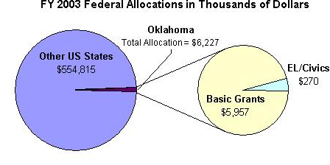
Enrollment by Race/Ethnicity and by Gender
 | 2003–04 |  |  |  | % Change from 2002–03
 | ABE | ASE | EL | Total | % Change from 2002–03
Race/Ethnicity
American Indian/Alaskan Native | 1,926 | 378 | 14 | 2,318 | -3%
Asian | 140 | 26 | 655 | 821 | -11%
Black/African American | 2,765 | 283 | 58 | 3,106 | -4%
Hispanic/Latino | 1,266 | 147 | 3,569 | 4,982 | -10%
Native Hawaiian/Pacific Islander | 22 | 5 | 7 | 34 | -17%
White | 7,580 | 2,046 | 277 | 9,903 | -13%
TOTAL | 13,699 | 2,885 | 4,580 | 21,164 | -10%
Gender
Male | 6,843 | 1,397 | 1,647 | 9,887 | -8%
Female | 6,856 | 1,488 | 2,933 | 11,277 | 4%

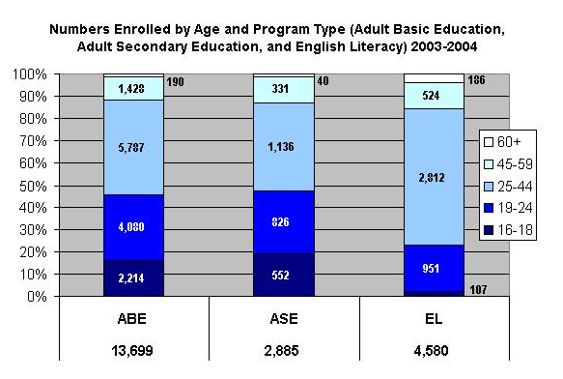

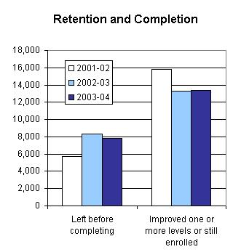

PROGRAM FACTS 2003–2004

Oklahoma | Actual Performance
Oklahoma | 2001–02 | 2002–03 | 2003–04 |  | TOTAL
Oklahoma | Percent | Percent | Percent | # Adults completing at least one level or one outcome | 3-Year Total #
Performance Measure I: Demonstrated Improvement in Literacy Skills
Sub Measures:  - Adult Basic and Secondary Education  The percentage of adults enrolled in basic literacy programs who acquired the basic skills needed to complete one or more levels of instruction in which they were initially enrolled. | 42 | 40 | 42 | 6,384 | 19,078
- English Literacy  The percentage of adults enrolled in English literacy programs who acquired the level of English language skills needed to complete one or more levels of instruction in which they were initially enrolled. | 24 | 33 | 39 | 1,784 | 4,606
Performance Measure II: High School Completion
The percentage of adult learners with a high school completion goal who earned a high school diploma or GED after exiting the program. | 36 | 43 | 61 | 2,663 | 6,270
Performance Measure III: Entered Postsecondary Education or Training
The percentage of adult learners with a goal to continue their education who enter postsecondary education or training after exiting the program. | 23 | 11 | 14 | 198 | 604
Performance Measure IV: Entered Employment
The percentage of unemployed adult learners (in the workforce) with an employment goal who were employed at the end of the first quarter after exiting the program. | 64 | 76 | 74 | 2,667 | 6,093
Performance Measure V: Retained Employment
The percentage of adult learners with (a) a job retention goal at the time of enrollment and (b) those adults with an employment goal who obtained work by the end of the first quarter after leaving the program who were employed at the end of the third quarter after exiting the program. | 85 | 65 | 80 | 2,857 | 5,080

PROGRAM FACTS 2003–2004
Oregon
Participant Status
 | 2002–03 | 2003–04
Employed | 9,453 | 8,272
Unemployed | 10,487 | 8,911
Correctional Setting | 3,660 | 3,311
On Public Assistance | 1,737 | 1,189
Other Institutionalized | Not Collected | 0
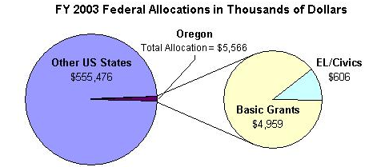
Enrollment by Race/Ethnicity and by Gender
 | 2003–04 |  |  |  | % Change from 2002–03
 | ABE | ASE | EL | Total | % Change from 2002–03
Race/Ethnicity
American Indian/Alaskan Native | 536 | 59 | 32 | 627 | -24%
Asian | 266 | 29 | 1,366 | 1,661 | -20%
Black/African American | 635 | 67 | 252 | 954 | -17%
Hispanic/Latino | 1,410 | 133 | 8,038 | 9,581 | -17%
Native Hawaiian/Pacific Islander | 133 | 12 | 64 | 209 | -24%
White | 6,424 | 974 | 1,271 | 8,669 | -17%
TOTAL | 9,404 | 1,274 | 11,023 | 21,701 | -17%
Gender
Male | 5,267 | 808 | 4,881 | 10,956 | -14%
Female | 4,137 | 466 | 6,142 | 22,993 | -11%

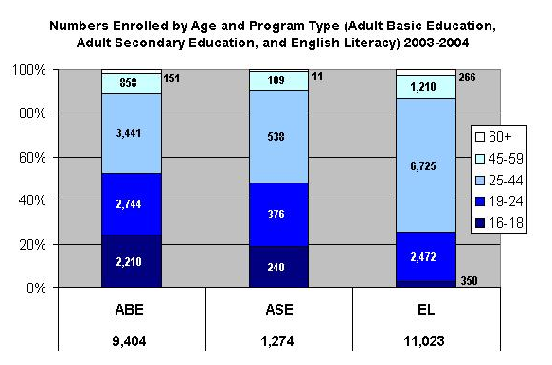

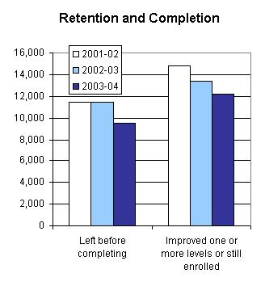

PROGRAM FACTS 2003–2004

Oregon | Actual Performance
Oregon | 2001–02 | 2002–03 | 2003–04 |  | TOTAL
Oregon | Percent | Percent | Percent | # Adults completing at least one level or one outcome | 3-Year Total #
Performance Measure I: Demonstrated Improvement in Literacy Skills
Sub Measures:  - Adult Basic and Secondary Education  The percentage of adults enrolled in basic literacy programs who acquired the basic skills needed to complete one or more levels of instruction in which they were initially enrolled. | 47 | 46 | 43 | 4,485 | 16,478
- English Literacy  The percentage of adults enrolled in English literacy programs who acquired the level of English language skills needed to complete one or more levels of instruction in which they were initially enrolled. | 26 | 31 | 30 | 3,256 | 10,261
Performance Measure II: High School Completion
The percentage of adult learners with a high school completion goal who earned a high school diploma or GED after exiting the program. | 46 | 46 | 37 | 1,446 | 6,452
Performance Measure III: Entered Postsecondary Education or Training
The percentage of adult learners with a goal to continue their education who enter postsecondary education or training after exiting the program. | 32 | 41 | 50 | 600 | 1,587
Performance Measure IV: Entered Employment
The percentage of unemployed adult learners (in the workforce) with an employment goal who were employed at the end of the first quarter after exiting the program. | 51 | 51 | 54 | 843 | 2,550
Performance Measure V: Retained Employment
The percentage of adult learners with (a) a job retention goal at the time of enrollment and (b) those adults with an employment goal who obtained work by the end of the first quarter after leaving the program who were employed at the end of the third quarter after exiting the program. | 58 | 28 | 36 | 168 | 655

PROGRAM FACTS 2003–2004
Pennsylvania
Participant Status
 | 2002–03 | 2003–04
Employed | 18,233 | 17,332
Unemployed | 24,132 | 26,086
Correctional Setting | 5,870 | 6,513
On Public Assistance | 11,092 | 13,325
Other Institutionalized | 881 | 1,375
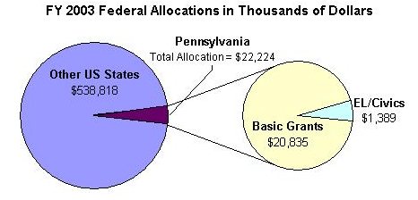
Enrollment by Race/Ethnicity and by Gender
 | 2003–04 |  |  |  | % Change from 2002–03
 | ABE | ASE | EL | Total | % Change from 2002–03
Race/Ethnicity
American Indian/Alaskan Native | 94 | 47 | 7 | 148 | 2%
Asian | 471 | 134 | 4,177 | 4,782 | -1%
Black/African American | 10,203 | 2,605 | 970 | 13,778 | -1%
Hispanic/Latino | 2,985 | 773 | 6,931 | 10,689 | 1%
Native Hawaiian/Pacific Islander | 23 | 11 | 12 | 46 | -4%
White | 12,446 | 8,002 | 3,815 | 24,263 | -4%
TOTAL | 26,222 | 11,572 | 15,912 | 53,706 | -2%
Gender
Male | 11,485 | 5,495 | 6,013 | 22,993 | 0%
Female | 14,737 | 6,077 | 9,899 | 30,713 | 3%

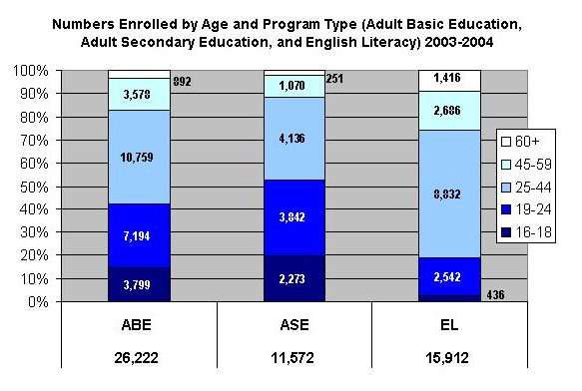

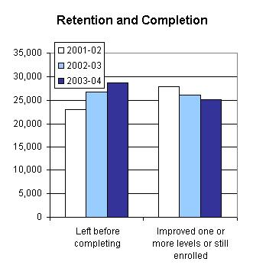

PROGRAM FACTS 2003–2004

Pennsylvania | Actual Performance
Pennsylvania | 2001–02 | 2002–03 | 2003–04 |  | TOTAL
Pennsylvania | Percent | Percent | Percent | # Adults completing at least one level or one outcome | 3-Year Total #
Performance Measure I: Demonstrated Improvement in Literacy Skills
Sub Measures:  - Adult Basic and Secondary Education  The percentage of adults enrolled in basic literacy programs who acquired the basic skills needed to complete one or more levels of instruction in which they were initially enrolled. | 33 | 33 | 33 | 10,591 | 29,847
- English Literacy  The percentage of adults enrolled in English literacy programs who acquired the level of English language skills needed to complete one or more levels of instruction in which they were initially enrolled. | 29 | 32 | 29 | 4,605 | 14,510
Performance Measure II: High School Completion
The percentage of adult learners with a high school completion goal who earned a high school diploma or GED after exiting the program. | 50 | 45 | 46 | 3,352 | 10,857
Performance Measure III: Entered Postsecondary Education or Training*
The percentage of adult learners with a goal to continue their education who enter postsecondary education or training after exiting the program. | 38 | 46 | 33 | 188 | 1,446
Performance Measure IV: Entered Employment
The percentage of unemployed adult learners (in the workforce) with an employment goal who were employed at the end of the first quarter after exiting the program. | 43 | 37 | 44 | 1,295 | 3,557
Performance Measure V: Retained Employment
The percentage of adult learners with (a) a job retention goal at the time of enrollment and (b) those adults with an employment goal who obtained work by the end of the first quarter after leaving the program who were employed at the end of the third quarter after exiting the program. | 43 | 45 | 56 | 796 | 1,665
* Response rate was too low on follow-up survey to validate outcomes.

PROGRAM FACTS 2003–2004
Puerto Rico
Participant Status
 | 2002–03 | 2003–04
Employed | 6,386 | 5,365
Unemployed | 14,210 | 11,600
Correctional Setting | 3,120 | 3,018
On Public Assistance | 9,337 | 9,353
Other Institutionalized | 100 | 1,457
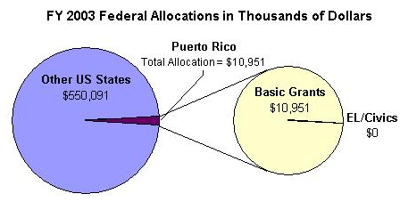
Enrollment by Race/Ethnicity and by Gender
 | 2003–04 |  |  |  | % Change from 2002–03
 | ABE | ASE | EL | Total | % Change from 2002–03
Race/Ethnicity
American Indian/Alaskan Native | 0 | 0 | 0 | 0 | *
Asian | 5 | 1 | 0 | 6 | 100%
Black/African American | 0 | 0 | 0 | 0 | *
Hispanic/Latino | 16,070 | 27,013 | 2,673 | 45,756 | 14%
Native Hawaiian/Pacific Islander | 1 | 1 | 0 | 2 | *
White | 3 | 28 | 1 | 32 | -32%
TOTAL | 16,079 | 27,043 | 2,674 | 45,796 | 14%
Gender
Male | 7,830 | 15,640 | 976 | 24,446 | -1%
Female | 8,249 | 11,403 | 1,698 | 21,350 | -16%
*There were no students in this demographic category in 2002-03

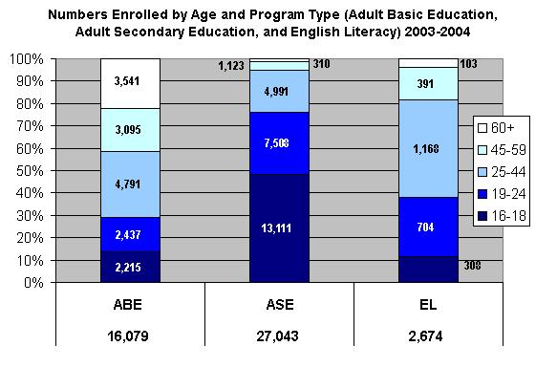

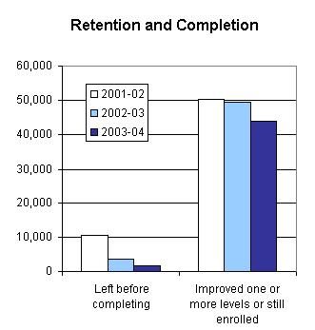

PROGRAM FACTS 2003–2004
Puerto Rico | Actual Performance
Puerto Rico | 2001–02 | 2002–03 | 2003–04 |  | TOTAL
Puerto Rico | Percent | Percent | Percent | # Adults completing at least one level or one outcome | 3-Year Total #
Performance Measure I: Demonstrated Improvement in Literacy Skills
Sub Measures:  - Adult Basic and Secondary Education  The percentage of adults enrolled in basic literacy programs who acquired the basic skills needed to complete one or more levels of instruction in which they were initially enrolled. | 53 | 74 | 60 | 15,927 | 55,782
- English Literacy  The percentage of adults enrolled in English literacy programs who acquired the level of English language skills needed to complete one or more levels of instruction in which they were initially enrolled. | 77 | 57 | 71 | 1,908 | 3,931
Performance Measure II: High School Completion
The percentage of adult learners with a high school completion goal who earned a high school diploma or GED after exiting the program. | 56 | 51 | 42 | 267 | 5,942
Performance Measure III: Entered Postsecondary Education or Training
The percentage of adult learners with a goal to continue their education who enter postsecondary education or training after exiting the program. | 37 | 32 | 23 | 59 | 334
Performance Measure IV: Entered Employment
The percentage of unemployed adult learners (in the workforce) with an employment goal who were employed at the end of the first quarter after exiting the program. | 49 | 58 | 43 | 309 | 1,076
Performance Measure V: Retained Employment
The percentage of adult learners with (a) a job retention goal at the time of enrollment and (b) those adults with an employment goal who obtained work by the end of the first quarter after leaving the program who were employed at the end of the third quarter after exiting the program. | 59 | 53 | 73 | 254 | 855

PROGRAM FACTS 2003–2004
Rhode Island
Participant Status
 | 2002–03 | 2003–04
Employed | 1,778 | 1,775
Unemployed | 1,575 | 1,953
Correctional Setting | 470 | 298
On Public Assistance | 488 | 808
Other Institutionalized | 5 | 25
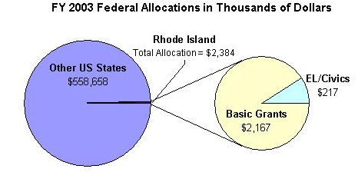
Enrollment by Race/Ethnicity and by Gender
 | 2003–04 |  |  |  | % Change from 2002–03
 | ABE | ASE | EL | Total | % Change from 2002–03
Race/Ethnicity
American Indian/Alaskan Native | 45 | 19 | 0 | 64 | -29%
Asian | 77 | 43 | 242 | 362 | 47%
Black/African American | 362 | 117 | 136 | 615 | -20%
Hispanic/Latino | 476 | 149 | 1,277 | 1,902 | 25%
Native Hawaiian/Pacific Islander | 17 | 10 | 10 | 37 | -21%
White | 1,018 | 883 | 285 | 2,186 | 11%
TOTAL | 1,995 | 1,221 | 1,950 | 5,166 | 11%
Gender
Male | 845 | 563 | 614 | 2,022 | 6%
Female | 1,150 | 658 | 1,336 | 3,144 | 18%

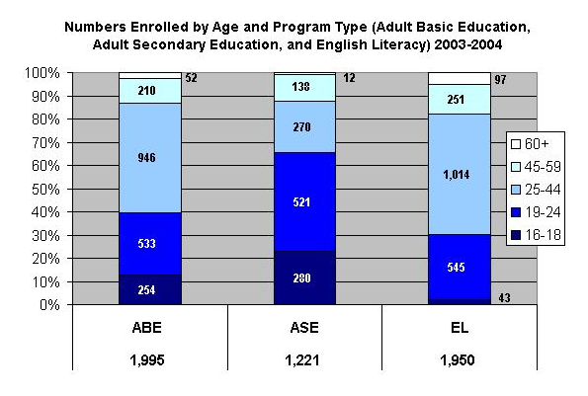

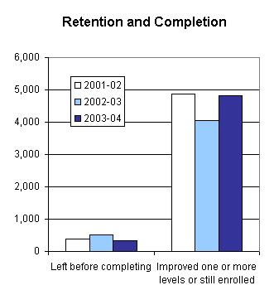

PROGRAM FACTS 2003–2004

Rhode Island | Actual Performance
Rhode Island | 2001–02 | 2002–03 | 2003–04 |  | TOTAL
Rhode Island | Percent | Percent | Percent | # Adults completing at least one level or one outcome | 3-Year Total #
Performance Measure I: Demonstrated Improvement in Literacy Skills
Sub Measures:  - Adult Basic and Secondary Education  The percentage of adults enrolled in basic literacy programs who acquired the basic skills needed to complete one or more levels of instruction in which they were initially enrolled. | 82 | 68 | 72 | 1,914 | 5,409
- English Literacy  The percentage of adults enrolled in English literacy programs who acquired the level of English language skills needed to complete one or more levels of instruction in which they were initially enrolled. | 67 | 52 | 58 | 1,139 | 6,421
Performance Measure II: High School Completion
The percentage of adult learners with a high school completion goal who earned a high school diploma or GED after exiting the program. | 52 | 82 | 86 | 770 | 2,786
Performance Measure III: Entered Postsecondary Education or Training
The percentage of adult learners with a goal to continue their education who enter postsecondary education or training after exiting the program. | 43 | 69 | 73 | 173 | 534
Performance Measure IV: Entered Employment
The percentage of unemployed adult learners (in the workforce) with an employment goal who were employed at the end of the first quarter after exiting the program. | 83 | 95 | 81 | 137 | 709
Performance Measure V: Retained Employment
The percentage of adult learners with (a) a job retention goal at the time of enrollment and (b) those adults with an employment goal who obtained work by the end of the first quarter after leaving the program who were employed at the end of the third quarter after exiting the program. | 28 | 63 | 100 | 168 | 655

PROGRAM FACTS 2003–2004
South Carolina
Participant Status
 | 2002–03 | 2003–04
Employed | 30,287 | 25,989
Unemployed | 13,504 | 12,915
Correctional Setting | 10,595 | 9,408
On Public Assistance | 2,481 | 2,038
Other Institutionalized | 810 | 779
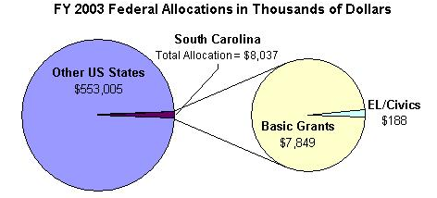
Enrollment by Race/Ethnicity and by Gender
 | 2003–04 |  |  |  | % Change from 2002–03
 | ABE | ASE | EL | Total | % Change from 2002–03
Race/Ethnicity
American Indian/Alaskan Native | 155 | 84 | 5 | 244 | 2%
Asian | 241 | 92 | 967 | 1,300 | 1%
Black/African American | 26,103 | 6,423 | 72 | 32,598 | -7%
Hispanic/Latino | 902 | 305 | 5,863 | 7,070 | -11%
Native Hawaiian/Pacific Islander | 43 | 15 | 7 | 65 | 7%
White | 17,269 | 8,252 | 610 | 26,131 | -10%
TOTAL | 44,713 | 15,171 | 8,524 | 67,408 | -8%
Gender
Male | 19,645 | 6,199 | 3,679 | 29,523 | -4%
Female | 25,068 | 8,972 | 3,845 | 37,885 | -1%

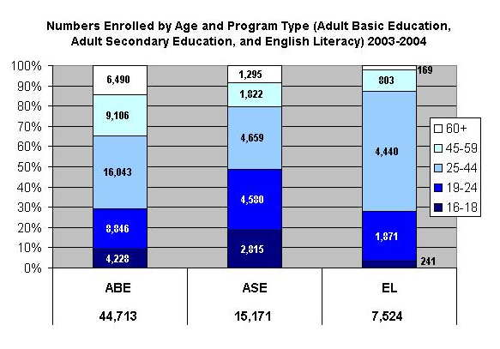

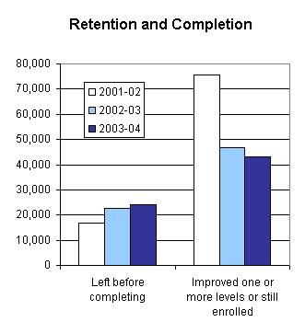

PROGRAM FACTS 2003–2004

South Carolina | Actual Performance
South Carolina | 2001–02 | 2002–03 | 2003–04 |  | TOTAL
South Carolina | Percent | Percent | Percent | # Adults completing at least one level or one outcome | 3-Year Total #
Performance Measure I: Demonstrated Improvement in Literacy Skills
Sub Measures:  - Adult Basic and Secondary Education  The percentage of adults enrolled in basic literacy programs who acquired the basic skills needed to complete one or more levels of instruction in which they were initially enrolled. | 36 | 41 | 41 | 21,596 | 63,421
- English Literacy  The percentage of adults enrolled in English literacy programs who acquired the level of English language skills needed to complete one or more levels of instruction in which they were initially enrolled. | 28 | 37 | 33 | 2,485 | 2,953
Performance Measure II: High School Completion
The percentage of adult learners with a high school completion goal who earned a high school diploma or GED after exiting the program. | 89 | 99 | 55 | 3,673 | 9,853
Performance Measure III: Entered Postsecondary Education or Training
The percentage of adult learners with a goal to continue their education who enter postsecondary education or training after exiting the program. | 74 | 99 | 78 | 263 | 6,077
Performance Measure IV: Entered Employment
The percentage of unemployed adult learners (in the workforce) with an employment goal who were employed at the end of the first quarter after exiting the program. | 47 | 97 | 67 | 197 | 724
Performance Measure V: Retained Employment
The percentage of adult learners with (a) a job retention goal at the time of enrollment and (b) those adults with an employment goal who obtained work by the end of the first quarter after leaving the program who were employed at the end of the third quarter after exiting the program. | 12 | 100 | 94 | 130 | 331

PROGRAM FACTS 2003–2004
South Dakota
Participant Status
 | 2002–03 | 2003–04
Employed | 1,308 | 1,326
Unemployed | 1,325 | 1,346
Correctional Setting | 621 | 652
On Public Assistance | 590 | 664
Other Institutionalized | 20 | 11
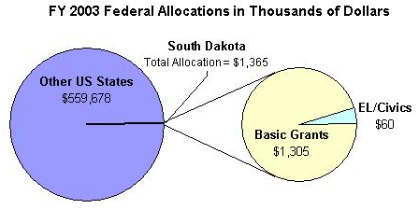
Enrollment by Race/Ethnicity and by Gender
 | 2003–04 |  |  |  | % Change from 2002–03
 | ABE | ASE | EL | Total | % Change from 2002–03
Race/Ethnicity
American Indian/Alaskan Native | 784 | 173 | 3 | 960 | -4%
Asian | 31 | 10 | 89 | 130 | 19%
Black/African American | 129 | 10 | 169 | 308 | -6%
Hispanic/Latino | 103 | 17 | 250 | 370 | 5%
Native Hawaiian/Pacific Islander | 8 | 4 | 2 | 14 | 40%
White | 1,301 | 439 | 85 | 1,825 | 0%
TOTAL | 2,356 | 653 | 598 | 3,607 | -1%
Gender
Male | 1,188 | 372 | 264 | 1,824 | 5%
Female | 1,168 | 281 | 334 | 1,783 | 4%

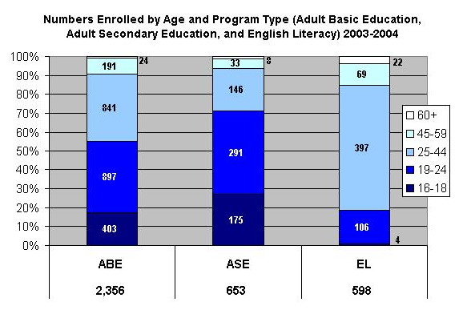

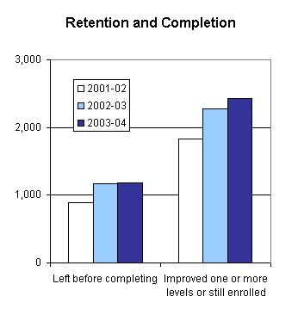

PROGRAM FACTS 2003–2004

South Dakota | Actual Performance
South Dakota | 2001–02 | 2002–03 | 2003–04 |  | TOTAL
South Dakota | Percent | Percent | Percent | # Adults completing at least one level or one outcome | 3-Year Total #
Performance Measure I: Demonstrated Improvement in Literacy Skills
Sub Measures:  - Adult Basic and Secondary Education  The percentage of adults enrolled in basic literacy programs who acquired the basic skills needed to complete one or more levels of instruction in which they were initially enrolled. | 42 | 46 | 53 | 1,456 | 3,471
- English Literacy  The percentage of adults enrolled in English literacy programs who acquired the level of English language skills needed to complete one or more levels of instruction in which they were initially enrolled. | 40 | 51 | 48 | 287 | 4,500
Performance Measure II: High School Completion
The percentage of adult learners with a high school completion goal who earned a high school diploma or GED after exiting the program. | 77 | 81 | 88 | 917 | 2,258
Performance Measure III: Entered Postsecondary Education or Training
The percentage of adult learners with a goal to continue their education who enter postsecondary education or training after exiting the program. | 76 | 63 | 63 | 107 | 232
Performance Measure IV: Entered Employment
The percentage of unemployed adult learners (in the workforce) with an employment goal who were employed at the end of the first quarter after exiting the program. | 73 | 41 | 33 | 232 | 589
Performance Measure V: Retained Employment
The percentage of adult learners with (a) a job retention goal at the time of enrollment and (b) those adults with an employment goal who obtained work by the end of the first quarter after leaving the program who were employed at the end of the third quarter after exiting the program. | 95 | 80 | 42 | 53 | 183

PROGRAM FACTS 2003–2004
Tennessee
Participant Status
 | 2002–03 | 2003–04
Employed | 16,630 | 16,310
Unemployed | 21,166 | 25,518
Correctional Setting | 3,247 | 2,892
On Public Assistance | 11,117 | 18,719
Other Institutionalized | 230 | 423
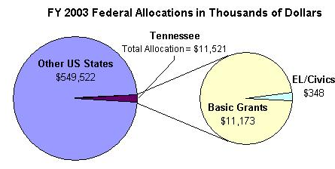
Enrollment by Race/Ethnicity and by Gender
 | 2003–04 |  |  |  | % Change from 2002–03
 | ABE | ASE | EL | Total | % Change from 2002–03
Race/Ethnicity
American Indian/Alaskan Native | 215 | 46 | 2 | 263 | -10%
Asian | 286 | 47 | 1,122 | 1,455 | -4%
Black/African American | 12,068 | 747 | 609 | 13,424 | -2%
Hispanic/Latino | 855 | 147 | 4,098 | 5,100 | -2%
Native Hawaiian/Pacific Islander | 42 | 6 | 4 | 52 | 8%
White | 21,098 | 5,598 | 765 | 27,461 | -3%
TOTAL | 34,564 | 6,591 | 6,600 | 47,755 | -3%
Gender
Male | 13,400 | 2,946 | 3,092 | 19,438 | 0%
Female | 21,164 | 3,645 | 3,508 | 28,317 | 6%

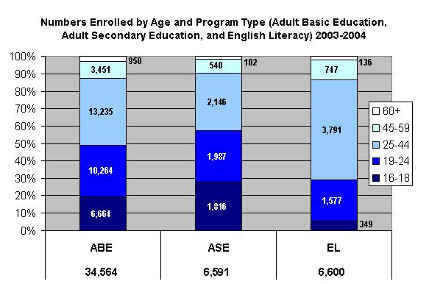

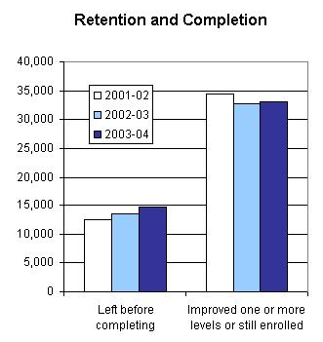

PROGRAM FACTS 2003–2004

Tennessee | Actual Performance
Tennessee | 2001–02 | 2002–03 | 2003–04 |  | TOTAL
Tennessee | Percent | Percent | Percent | # Adults completing at least one level or one outcome | 3-Year Total #
Performance Measure I: Demonstrated Improvement in Literacy Skills
Sub Measures:  - Adult Basic and Secondary Education  The percentage of adults enrolled in basic literacy programs who acquired the basic skills needed to complete one or more levels of instruction in which they were initially enrolled. | 40 | 44 | 35 | 13,456 | 43,870
- English Literacy  The percentage of adults enrolled in English literacy programs who acquired the level of English language skills needed to complete one or more levels of instruction in which they were initially enrolled. | 30 | 32 | 25 | 1,675 | 51,003
Performance Measure II: High School Completion
The percentage of adult learners with a high school completion goal who earned a high school diploma or GED after exiting the program. | 35 | 46 | 58 | 4,987 | 18,067
Performance Measure III: Entered Postsecondary Education or Training
The percentage of adult learners with a goal to continue their education who enter postsecondary education or training after exiting the program. | 51 | 78 | 49 | 646 | 4,038
Performance Measure IV: Entered Employment
The percentage of unemployed adult learners (in the workforce) with an employment goal who were employed at the end of the first quarter after exiting the program. | 47 | 51 | 59 | 831 | 8,456
Performance Measure V: Retained Employment
The percentage of adult learners with (a) a job retention goal at the time of enrollment and (b) those adults with an employment goal who obtained work by the end of the first quarter after leaving the program who were employed at the end of the third quarter after exiting the program. | 82 | 88 | 64 | 584 | 13,420

PROGRAM FACTS 2003–2004
Texas
Participant Status
 | 2002–03 | 2003–04
Employed | 56,168 | 53,201
Unemployed | 30,569 | 25,875
Correctional Setting | 9,179 | 7,635
On Public Assistance | 9,191 | 10,255
Other Institutionalized | 1,347 | 1,091
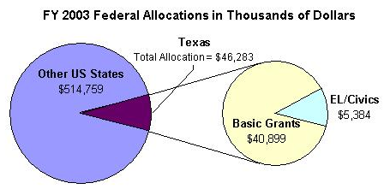
Enrollment by Race/Ethnicity and by Gender
 | 2003–04 |  |  |  | % Change from 2002–03
 | ABE | ASE | EL | Total | % Change from 2002–03
Race/Ethnicity
American Indian/Alaskan Native | 288 | 33 | 23 | 344 | -33%
Asian | 789 | 64 | 3,471 | 4,324 | -7%
Black/African American | 9,650 | 809 | 376 | 10,835 | -14%
Hispanic/Latino | 27,477 | 3,167 | 62,108 | 92,752 | -9%
Native Hawaiian/Pacific Islander | 77 | 9 | 450 | 136 | -12%
White | 11,002 | 2,741 | 639 | 14,382 | -13%
TOTAL | 49,283 | 6,823 | 66,667 | 122,773 | -10%
Gender
Male | 21,315 | 3,155 | 23,610 | 48,080 | -7%
Female | 27,968 | 3,668 | 43,057 | 74,693 | -2%

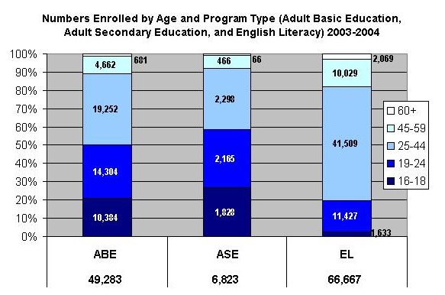

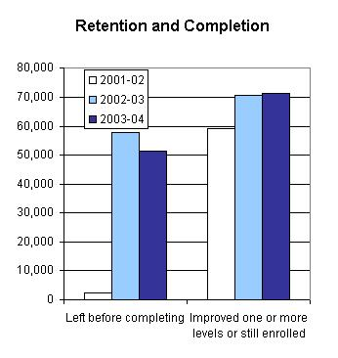

PROGRAM FACTS 2003–2004

Texas | Actual Performance
Texas | 2001–02 | 2002–03 | 2003–04 |  | TOTAL
Texas | Percent | Percent | Percent | # Adults completing at least one level or one outcome | 3-Year Total #
Performance Measure I: Demonstrated Improvement in Literacy Skills
Sub Measures:  - Adult Basic and Secondary Education  The percentage of adults enrolled in basic literacy programs who acquired the basic skills needed to complete one or more levels of instruction in which they were initially enrolled. | 29 | 34 | 38 | 19,984 | 54,404
- English Literacy  The percentage of adults enrolled in English literacy programs who acquired the level of English language skills needed to complete one or more levels of instruction in which they were initially enrolled. | 35 | 39 | 42 | 28,086 | 36,891
Performance Measure II: High School Completion
The percentage of adult learners with a high school completion goal who earned a high school diploma or GED after exiting the program. | 38 | 64 | 50 | 5,584 | 22,911
Performance Measure III: Entered Postsecondary Education or Training
The percentage of adult learners with a goal to continue their education who enter postsecondary education or training after exiting the program. | 14 | 24 | 8 | 183 | 3,104
Performance Measure IV: Entered Employment
The percentage of unemployed adult learners (in the workforce) with an employment goal who were employed at the end of the first quarter after exiting the program. | 69 | 17 | 21 | 801 | 28,428
Performance Measure V: Retained Employment
The percentage of adult learners with (a) a job retention goal at the time of enrollment and (b) those adults with an employment goal who obtained work by the end of the first quarter after leaving the program who were employed at the end of the third quarter after exiting the program. | 20 | 59 | 38 | 4,188 | 19,654

PROGRAM FACTS 2003–2004
Utah
Participant Status
 | 2002–03 | 2003–04
Employed | 10,816 | 11,875
Unemployed | 8,762 | 9,960
Correctional Setting | 9,239 | 7,400
On Public Assistance | 6,611 | 6,136
Other Institutionalized | 233 | 122
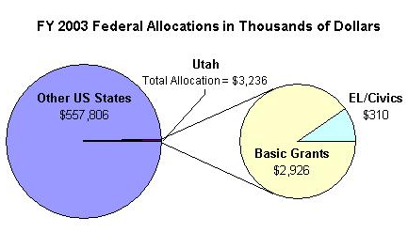
Enrollment by Race/Ethnicity and by Gender
 | 2003–04 |  |  |  | % Change from 2002–03
 | ABE | ASE | EL | Total | % Change from 2002–03
Race/Ethnicity
American Indian/Alaskan Native | 485 | 227 | 22 | 734 | -38%
Asian | 241 | 219 | 974 | 1,434 | 16%
Black/African American | 536 | 301 | 506 | 1,343 | 9%
Hispanic/Latino | 3,668 | 1,214 | 8,395 | 13,277 | 3%
Native Hawaiian/Pacific Islander | 143 | 118 | 84 | 345 | -8%
White | 8,140 | 4,447 | 1,709 | 14,296 | -14%
TOTAL | 13,213 | 6,526 | 11,690 | 31,429 | -6%
Gender
Male | 7,986 | 4,164 | 5,035 | 17,185 | -9%
Female | 5,227 | 2,362 | 6,655 | 14,244 | 2%

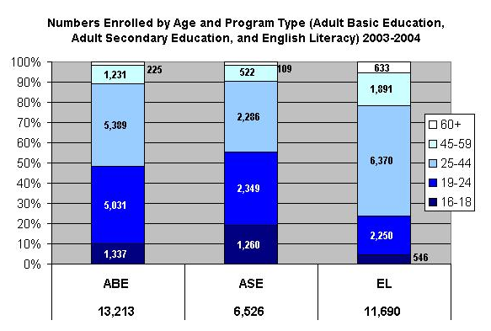

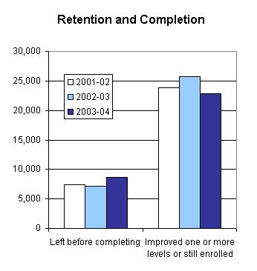

PROGRAM FACTS 2003–2004

Utah | Actual Performance
Utah | 2001–02 | 2002–03 | 2003–04 |  | TOTAL
Utah | Percent | Percent | Percent | # Adults completing at least one level or one outcome | 3-Year Total #
Performance Measure I: Demonstrated Improvement in Literacy Skills
Sub Measures:  - Adult Basic and Secondary Education  The percentage of adults enrolled in basic literacy programs who acquired the basic skills needed to complete one or more levels of instruction in which they were initially enrolled. | 42 | 33 | 29 | 5,024 | 16,799
- English Literacy  The percentage of adults enrolled in English literacy programs who acquired the level of English language skills needed to complete one or more levels of instruction in which they were initially enrolled. | 42 | 39 | 33 | 3,881 | 3,949
Performance Measure II: High School Completion
The percentage of adult learners with a high school completion goal who earned a high school diploma or GED after exiting the program. | 13 | 80 | 24 | 5,076 | 16,512
Performance Measure III: Entered Postsecondary Education or Training
The percentage of adult learners with a goal to continue their education who enter postsecondary education or training after exiting the program. | 12 | 90 | 41 | 2,548 | 5,384
Performance Measure IV: Entered Employment
The percentage of unemployed adult learners (in the workforce) with an employment goal who were employed at the end of the first quarter after exiting the program. | 13 | 53 | 32 | 2,788 | 8,305
Performance Measure V: Retained Employment
The percentage of adult learners with (a) a job retention goal at the time of enrollment and (b) those adults with an employment goal who obtained work by the end of the first quarter after leaving the program who were employed at the end of the third quarter after exiting the program. | 16 | 88 | 54 | 2,754 | 6,819

PROGRAM FACTS 2003–2004
Vermont
Participant Status
 | 2002–03 | 2003–04
Employed | 733 | 762
Unemployed | 704 | 712
Correctional Setting | 83 | 86
On Public Assistance | 527 | 507
Other Institutionalized | 6 | 12
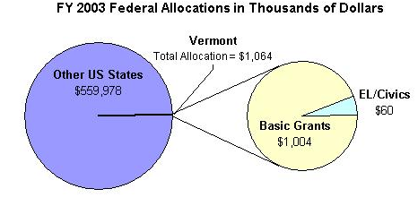
Enrollment by Race/Ethnicity and by Gender
 | 2003–04 |  |  |  | % Change from 2002–03
 | ABE | ASE | EL | Total | % Change from 2002–03
Race/Ethnicity
American Indian/Alaskan Native | 13 | 12 | 4 | 29 | -24%
Asian | 5 | 11 | 84 | 100 | -22%
Black/African American | 55 | 23 | 28 | 106 | 100%
Hispanic/Latino | 50 | 18 | 50 | 118 | 46%
Native Hawaiian/Pacific Islander | 5 | 9 | 0 | 14 | -74%
White | 1,161 | 667 | 88 | 1,916 | 21%
TOTAL | 1,289 | 740 | 254 | 2,283 | 18%
Gender
Male | 543 | 330 | 82 | 955 | 28%
Female | 746 | 410 | 172 | 1,328 | 12%

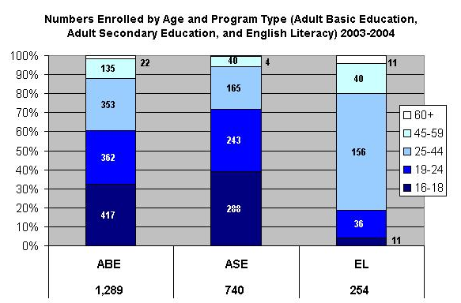

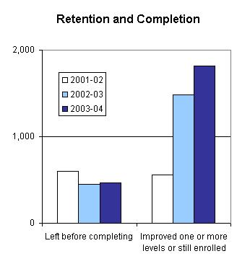

PROGRAM FACTS 2003–2004

Vermont | Actual Performance
Vermont | 2001–02 | 2002–03 | 2003–04 |  | TOTAL
Vermont | Percent | Percent | Percent | # Adults completing at least one level or one outcome | 3-Year Total #
Performance Measure I: Demonstrated Improvement in Literacy Skills
Sub Measures:  - Adult Basic and Secondary Education  The percentage of adults enrolled in basic literacy programs who acquired the basic skills needed to complete one or more levels of instruction in which they were initially enrolled. | 11 | 35 | 43 | 724 | 1,315
- English Literacy  The percentage of adults enrolled in English literacy programs who acquired the level of English language skills needed to complete one or more levels of instruction in which they were initially enrolled. | 14 | 16 | 17 | 43 | 9,973
Performance Measure II: High School Completion
The percentage of adult learners with a high school completion goal who earned a high school diploma or GED after exiting the program. | 47 | 84 | 90 | 663 | 1,223
Performance Measure III: Entered Postsecondary Education or Training*
The percentage of adult learners with a goal to continue their education who enter postsecondary education or training after exiting the program. | 61 | 61 | 82 | 46 | 96
Performance Measure IV: Entered Employment
The percentage of unemployed adult learners (in the workforce) with an employment goal who were employed at the end of the first quarter after exiting the program. | 70 | 73 | 60 | 45 | 106
Performance Measure V: Retained Employment
The percentage of adult learners with (a) a job retention goal at the time of enrollment and (b) those adults with an employment goal who obtained work by the end of the first quarter after leaving the program who were employed at the end of the third quarter after exiting the program. | 74 | 50 | 0 | 0 | 30
* Response rate was too low on follow-up survey to validate outcomes.

PROGRAM FACTS 2003–2004
Virginia
Participant Status
 | 2002–03 | 2003–04
Employed | 1,051 | 13,780
Unemployed | 10,001 | 7,028
Correctional Setting | 3,037 | 2,865
On Public Assistance | 2,277 | 1,504
Other Institutionalized | 85 | 94
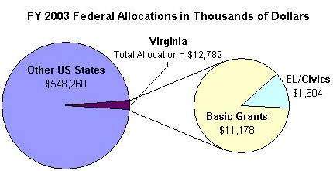
Enrollment by Race/Ethnicity and by Gender
 | 2003–04 |  |  |  | % Change from 2002–03
 | ABE | ASE | EL | Total | % Change from 2002–03
Race/Ethnicity
American Indian/Alaskan Native | 50 | 17 | 9 | 76 | 33%
Asian | 327 | 62 | 2,649 | 3,038 | -21%
Black/African American | 6,063 | 964 | 693 | 7,720 | -11%
Hispanic/Latino | 816 | 213 | 7,206 | 8,235 | -7%
Native Hawaiian/Pacific Islander | 35 | 4 | 26 | 65 | -24%
White | 5,171 | 2,247 | 1,485 | 8,903 | -15%
TOTAL | 12,462 | 3,507 | 12,068 | 28,037 | -12%
Gender
Male | 5,559 | 1,676 | 4,535 | 11,770 | -13%
Female | 6,903 | 1,831 | 7,533 | 16,267 | -10%

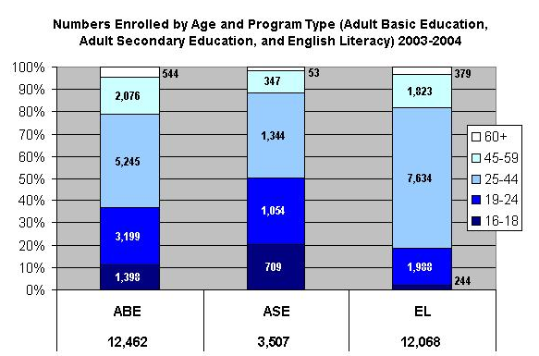

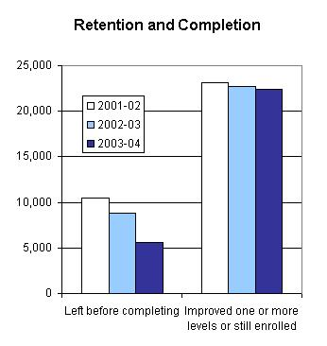

PROGRAM FACTS 2003–2004

Virginia | Actual Performance
Virginia | 2001–02 | 2002–03 | 2003–04 |  | TOTAL
Virginia | Percent | Percent | Percent | # Adults completing at least one level or one outcome | 3-Year Total #
Performance Measure I: Demonstrated Improvement in Literacy Skills
Sub Measures:  - Adult Basic and Secondary Education  The percentage of adults enrolled in basic literacy programs who acquired the basic skills needed to complete one or more levels of instruction in which they were initially enrolled. | 40 | 41 | 45 | 6,568 | 19,328
- English Literacy  The percentage of adults enrolled in English literacy programs who acquired the level of English language skills needed to complete one or more levels of instruction in which they were initially enrolled. | 36 | 34 | 35 | 4,258 | 31,979
Performance Measure II: High School Completion
The percentage of adult learners with a high school completion goal who earned a high school diploma or GED after exiting the program. | 95 | 66 | 78 | 1,858 | 5,659
Performance Measure III: Entered Postsecondary Education or Training
The percentage of adult learners with a goal to continue their education who enter postsecondary education or training after exiting the program. | 78 | 48 | 22 | 50 | 500
Performance Measure IV: Entered Employment
The percentage of unemployed adult learners (in the workforce) with an employment goal who were employed at the end of the first quarter after exiting the program. | 33 | 57 | 32 | 312 | 1,447
Performance Measure V: Retained Employment
The percentage of adult learners with (a) a job retention goal at the time of enrollment and (b) those adults with an employment goal who obtained work by the end of the first quarter after leaving the program who were employed at the end of the third quarter after exiting the program. | 57 | 28 | 54 | 772 | 1,717

PROGRAM FACTS 2003–2004
Washington
Participant Status
 | 2002–03 | 2003–04
Employed | 15,331 | 10,549
Unemployed | 17,442 | 13,014
Correctional Setting | 8,626 | 4,158
On Public Assistance | 7,292 | 4,894
Other Institutionalized | 45 | 18
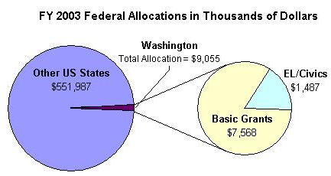
Enrollment by Race/Ethnicity and by Gender
 | 2003–04 |  |  |  | % Change from 2002–03
 | ABE | ASE | EL | Total | % Change from 2002–03
Race/Ethnicity
American Indian/Alaskan Native | 887 | 136 | 26 | 1,049 | -29%
Asian | 756 | 137 | 5,570 | 6,463 | -18%
Black/African American | 2,138 | 171 | 1,506 | 3,815 | -18%
Hispanic/Latino | 2,160 | 252 | 10,984 | 13,396 | -24%
Native Hawaiian/Pacific Islander | 339 | 43 | 274 | 656 | 8%
White | 7,877 | 1,802 | 5,135 | 14,814 | -22%
TOTAL | 14,157 | 2,541 | 23,495 | 40,193 | -26%
Gender
Male | 7,032 | 1,394 | 9,339 | 17,765 | -32%
Female | 7,125 | 1,147 | 14,156 | 22,428 | -23%

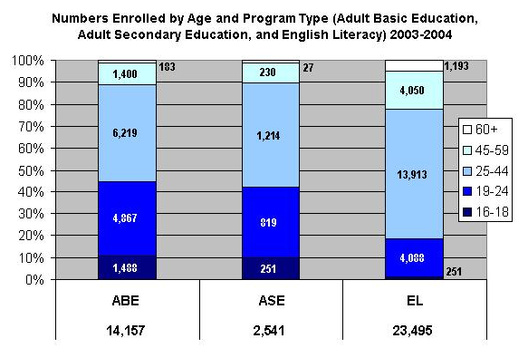

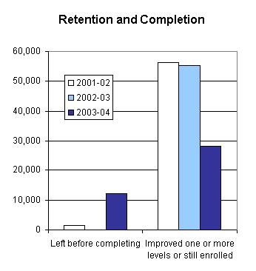

PROGRAM FACTS 2003–2004

Washington | Actual Performance
Washington | 2001–02 | 2002–03 | 2003–04 |  | TOTAL
Washington | Percent | Percent | Percent | # Adults completing at least one level or one outcome | 3-Year Total #
Performance Measure I: Demonstrated Improvement in Literacy Skills
Sub Measures:  - Adult Basic and Secondary Education  The percentage of adults enrolled in basic literacy programs who acquired the basic skills needed to complete one or more levels of instruction in which they were initially enrolled. | 41 | 48 | 18 | 2,902 | 25,409
- English Literacy  The percentage of adults enrolled in English literacy programs who acquired the level of English language skills needed to complete one or more levels of instruction in which they were initially enrolled. | 42 | 49 | 36 | 8,546 | 8,826
Performance Measure II: High School Completion
The percentage of adult learners with a high school completion goal who earned a high school diploma or GED after exiting the program. | 25 | 22 | 27 | 2,003 | 6,075
Performance Measure III: Entered Postsecondary Education or Training
The percentage of adult learners with a goal to continue their education who enter postsecondary education or training after exiting the program. | 31 | 93 | 63 | 2,819 | 6,417
Performance Measure IV: Entered Employment
The percentage of unemployed adult learners (in the workforce) with an employment goal who were employed at the end of the first quarter after exiting the program. | 44 | 19 | 44 | 5,716 | 9,571
Performance Measure V: Retained Employment
The percentage of adult learners with (a) a job retention goal at the time of enrollment and (b) those adults with an employment goal who obtained work by the end of the first quarter after leaving the program who were employed at the end of the third quarter after exiting the program. | 77 | 42 | 64 | 2,923 | 3,808

PROGRAM FACTS 2003–2004
West Virginia
Participant Status
 | 2002–03 | 2003–04
Employed | 3,001 | 2,705
Unemployed | 3,531 | 3,094
Correctional Setting | 2,146 | 2,297
On Public Assistance | 6,918 | 3,253
Other Institutionalized | 21 | 17
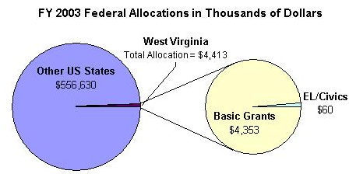
Enrollment by Race/Ethnicity and by Gender
 | 2003–04 |  |  |  | % Change from 2002–03
 | ABE | ASE | EL | Total | % Change from 2002–03
Race/Ethnicity
American Indian/Alaskan Native | 47 | 10 | 2 | 59 | -18%
Asian | 13 | 9 | 94 | 116 | -26%
Black/African American | 764 | 98 | 12 | 874 | -14%
Hispanic/Latino | 56 | 7 | 103 | 166 | -2%
Native Hawaiian/Pacific Islander | 5 | 3 | 1 | 9 | -18%
White | 7,163 | 1,763 | 63 | 8,989 | -14%
TOTAL | 8,048 | 1,890 | 275 | 10,213 | -14%
Gender
Male | 3,783 | 838 | 77 | 4,698 | -5%
Female | 4,265 | 1,052 | 198 | 5,515 | -5%

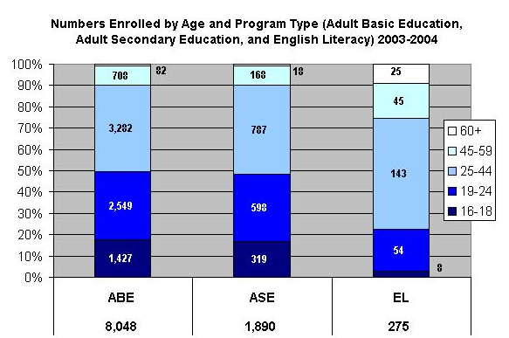

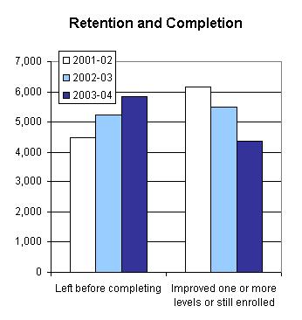

PROGRAM FACTS 2003–2004

West Virginia | Actual Performance
West Virginia | 2001–02 | 2002–03 | 2003–04 |  | TOTAL
West Virginia | Percent | Percent | Percent | # Adults completing at least one level or one outcome | 3-Year Total #
Performance Measure I: Demonstrated Improvement in Literacy Skills
Sub Measures:  - Adult Basic and Secondary Education  The percentage of adults enrolled in basic literacy programs who acquired the basic skills needed to complete one or more levels of instruction in which they were initially enrolled. | 54 | 50 | 46 | 4,226 | 14,156
- English Literacy  The percentage of adults enrolled in English literacy programs who acquired the level of English language skills needed to complete one or more levels of instruction in which they were initially enrolled. | 46 | 57 | 46 | 126 | 8,161
Performance Measure II: High School Completion
The percentage of adult learners with a high school completion goal who earned a high school diploma or GED after exiting the program. | 56 | 54 | 72 | 1,270 | 2,885
Performance Measure III: Entered Postsecondary Education or Training
The percentage of adult learners with a goal to continue their education who enter postsecondary education or training after exiting the program. | 47 | 40 | 54 | 382 | 1,900
Performance Measure IV: Entered Employment
The percentage of unemployed adult learners (in the workforce) with an employment goal who were employed at the end of the first quarter after exiting the program. | 47 | 33 | 49 | 289 | 688
Performance Measure V: Retained Employment
The percentage of adult learners with (a) a job retention goal at the time of enrollment and (b) those adults with an employment goal who obtained work by the end of the first quarter after leaving the program who were employed at the end of the third quarter after exiting the program. | 66 | 62 | 64 | 66 | 495

PROGRAM FACTS 2003–2004
Wisconsin
Participant Status
 | 2002–03 | 2003–04
Employed | 14,624 | 14,054
Unemployed | 9,705 | 9,729
Correctional Setting | 2,976 | 2,104
On Public Assistance | 2,256 | 2,192
Other Institutionalized | 15 | 16
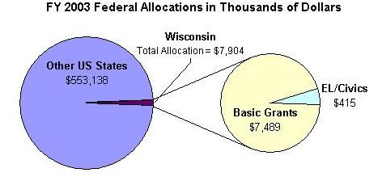
Enrollment by Race/Ethnicity and by Gender
 | 2003–04 |  |  |  | % Change from 2002–03
 | ABE | ASE | EL | Total | % Change from 2002–03
Race/Ethnicity
American Indian/Alaskan Native | 364 | 206 | 76 | 646 | -5%
Asian | 668 | 190 | 1,163 | 2,021 | -10%
Black/African American | 3,764 | 731 | 272 | 4,767 | -22%
Hispanic/Latino | 1,531 | 585 | 5,533 | 7,649 | -1%
Native Hawaiian/Pacific Islander | 21 | 7 | 8 | 36 | 44%
White | 7,638 | 5,809 | 566 | 14,013 | -9%
TOTAL | 13,986 | 7,528 | 7,618 | 29,132 | -10%
Gender
Male | 6,276 | 3,531 | 3,532 | 13,339 | -6%
Female | 7,710 | 3,997 | 4,086 | 15,793 | -2%

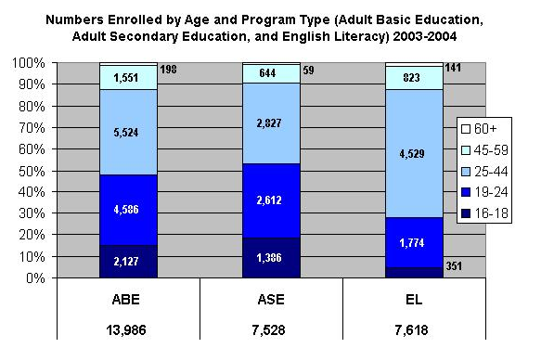

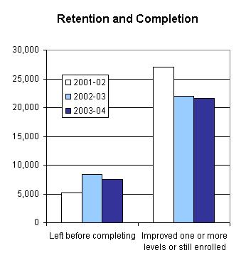

PROGRAM FACTS 2003–2004

Wisconsin | Actual Performance
Wisconsin | 2001–02 | 2002–03 | 2003–04 |  | TOTAL
Wisconsin | Percent | Percent | Percent | # Adults completing at least one level or one outcome | 3-Year Total #
Performance Measure I: Demonstrated Improvement in Literacy Skills
Sub Measures:  - Adult Basic and Secondary Education  The percentage of adults enrolled in basic literacy programs who acquired the basic skills needed to complete one or more levels of instruction in which they were initially enrolled. | 80 | 58 | 60 | 10,359 | 38,792
- English Literacy  The percentage of adults enrolled in English literacy programs who acquired the level of English language skills needed to complete one or more levels of instruction in which they were initially enrolled. | 50 | 54 | 52 | 3,980 | 4,231
Performance Measure II: High School Completion
The percentage of adult learners with a high school completion goal who earned a high school diploma or GED after exiting the program. | 36 | 47 | 58 | 1,652 | 6,300
Performance Measure III: Entered Postsecondary Education or Training
The percentage of adult learners with a goal to continue their education who enter postsecondary education or training after exiting the program. | 42 | 54 | 72 | 1,587 | 5,215
Performance Measure IV: Entered Employment
The percentage of unemployed adult learners (in the workforce) with an employment goal who were employed at the end of the first quarter after exiting the program. | 44 | 48 | 42 | 574 | 3,741
Performance Measure V: Retained Employment
The percentage of adult learners with (a) a job retention goal at the time of enrollment and (b) those adults with an employment goal who obtained work by the end of the first quarter after leaving the program who were employed at the end of the third quarter after exiting the program. | 56 | 46 | 63 | 341 | 2,770

PROGRAM FACTS 2003–2004
Wyoming
Participant Status
 | 2002–03 | 2003–04
Employed | 1,010 | 809
Unemployed | 1,099 | 1,108
Correctional Setting | 425 | 382
On Public Assistance | 467 | 403
Other Institutionalized | 36 | 14
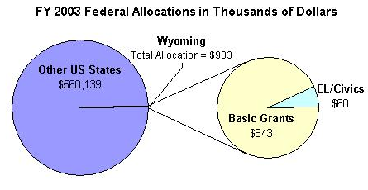
Enrollment by Race/Ethnicity and by Gender
 | 2003–04 |  |  |  | % Change from 2002–03
 | ABE | ASE | EL | Total | % Change from 2002–03
Race/Ethnicity
American Indian/Alaskan Native | 189 | 39 | 0 | 228 | -22%
Asian | 15 | 1 | 64 | 80 | -21%
Black/African American | 33 | 10 | 1 | 44 | 7%
Hispanic/Latino | 221 | 55 | 298 | 574 | -8%
Native Hawaiian/Pacific Islander | 1 | 3 | 0 | 4 | -50%
White | 997 | 457 | 40 | 1,494 | -16%
TOTAL | 1,456 | 565 | 403 | 2,424 | -15%
Gender
Male | 717 | 286 | 136 | 1,139 | -10%
Female | 739 | 279 | 267 | 1,285 | -8%

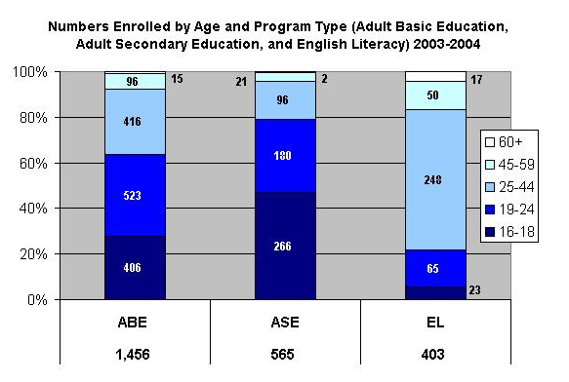

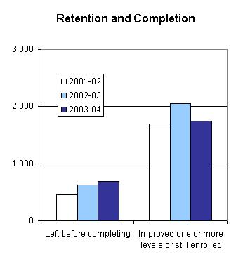

PROGRAM FACTS 2003–2004

Wyoming | Actual Performance
Wyoming | 2001–02 | 2002–03 | 2003–04 |  | TOTAL
Wyoming | Percent | Percent | Percent | # Adults completing at least one level or one outcome | 3-Year Total #
Performance Measure I: Demonstrated Improvement in Literacy Skills
Sub Measures:  - Adult Basic and Secondary Education  The percentage of adults enrolled in basic literacy programs who acquired the basic skills needed to complete one or more levels of instruction in which they were initially enrolled. | 53 | 52 | 54 | 942 | 2,838
- English Literacy  The percentage of adults enrolled in English literacy programs who acquired the level of English language skills needed to complete one or more levels of instruction in which they were initially enrolled. | 35 | 34 | 43 | 175 | 3,764
Performance Measure II: High School Completion
The percentage of adult learners with a high school completion goal who earned a high school diploma or GED after exiting the program. | 76 | 76 | 74 | 776 | 2,187
Performance Measure III: Entered Postsecondary Education or Training
The percentage of adult learners with a goal to continue their education who enter postsecondary education or training after exiting the program. | 52 | 66 | 50 | 175 | 622
Performance Measure IV: Entered Employment
The percentage of unemployed adult learners (in the workforce) with an employment goal who were employed at the end of the first quarter after exiting the program. | 59 | 47 | 59 | 67 | 185
Performance Measure V: Retained Employment
The percentage of adult learners with (a) a job retention goal at the time of enrollment and (b) those adults with an employment goal who obtained work by the end of the first quarter after leaving the program who were employed at the end of the third quarter after exiting the program. | 70 | 76 | 57 | 8 | 70

Adult Basic and Secondary Education programs consist of five instructional levels representing a hierarchy of basic skills ranging from beginning literacy to high school completion.
English Literacy education programs consist of six instructional levels representing a hierarchy of English language skills ranging from beginning English and literacy to advanced language proficiency.
Adult Basic and Secondary Education programs consist of five instructional levels representing a hierarchy of basic skills ranging from beginning literacy to high school completion.
English Literacy education programs consist of six instructional levels representing a hierarchy of English language skills ranging from beginning English and literacy to advanced language proficiency.
Adult Basic and Secondary Education programs consist of five instructional levels representing a hierarchy of basic skills ranging from beginning literacy to high school completion.
English Literacy education programs consist of six instructional levels representing a hierarchy of English language skills ranging from beginning English and literacy to advanced language proficiency.
Adult Basic and Secondary Education programs consist of five instructional levels representing a hierarchy of basic skills ranging from beginning literacy to high school completion.
English Literacy education programs consist of six instructional levels representing a hierarchy of English language skills ranging from beginning English and literacy to advanced language proficiency.
Adult Basic and Secondary Education programs consist of five instructional levels representing a hierarchy of basic skills ranging from beginning literacy to high school completion.
English Literacy education programs consist of six instructional levels representing a hierarchy of English language skills ranging from beginning English and literacy to advanced language proficiency.
Adult Basic and Secondary Education programs consist of five instructional levels representing a hierarchy of basic skills ranging from beginning literacy to high school completion.
English Literacy education programs consist of six instructional levels representing a hierarchy of English language skills ranging from beginning English and literacy to advanced language proficiency.
Adult Basic and Secondary Education programs consist of five instructional levels representing a hierarchy of basic skills ranging from beginning literacy to high school completion.
English Literacy education programs consist of six instructional levels representing a hierarchy of English language skills ranging from beginning English and literacy to advanced language proficiency.
Adult Basic and Secondary Education programs consist of five instructional levels representing a hierarchy of basic skills ranging from beginning literacy to high school completion.
English Literacy education programs consist of six instructional levels representing a hierarchy of English language skills ranging from beginning English and literacy to advanced language proficiency.
Adult Basic and Secondary Education programs consist of five instructional levels representing a hierarchy of basic skills ranging from beginning literacy to high school completion.
English Literacy education programs consist of six instructional levels representing a hierarchy of English language skills ranging from beginning English and literacy to advanced language proficiency.
Adult Basic and Secondary Education programs consist of five instructional levels representing a hierarchy of basic skills ranging from beginning literacy to high school completion.
English Literacy education programs consist of six instructional levels representing a hierarchy of English language skills ranging from beginning English and literacy to advanced language proficiency.
Adult Basic and Secondary Education programs consist of five instructional levels representing a hierarchy of basic skills ranging from beginning literacy to high school completion.
English Literacy education programs consist of six instructional levels representing a hierarchy of English language skills ranging from beginning English and literacy to advanced language proficiency.
Adult Basic and Secondary Education programs consist of five instructional levels representing a hierarchy of basic skills ranging from beginning literacy to high school completion.
English Literacy education programs consist of six instructional levels representing a hierarchy of English language skills ranging from beginning English and literacy to advanced language proficiency.
Adult Basic and Secondary Education programs consist of five instructional levels representing a hierarchy of basic skills ranging from beginning literacy to high school completion.
English Literacy education programs consist of six instructional levels representing a hierarchy of English language skills ranging from beginning English and literacy to advanced language proficiency.
Adult Basic and Secondary Education programs consist of five instructional levels representing a hierarchy of basic skills ranging from beginning literacy to high school completion.
English Literacy education programs consist of six instructional levels representing a hierarchy of English language skills ranging from beginning English and literacy to advanced language proficiency.
Adult Basic and Secondary Education programs consist of five instructional levels representing a hierarchy of basic skills ranging from beginning literacy to high school completion.
English Literacy education programs consist of six instructional levels representing a hierarchy of English language skills ranging from beginning English and literacy to advanced language proficiency.
Adult Basic and Secondary Education programs consist of five instructional levels representing a hierarchy of basic skills ranging from beginning literacy to high school completion.
English Literacy education programs consist of six instructional levels representing a hierarchy of English language skills ranging from beginning English and literacy to advanced language proficiency.
Adult Basic and Secondary Education programs consist of five instructional levels representing a hierarchy of basic skills ranging from beginning literacy to high school completion.
English Literacy education programs consist of six instructional levels representing a hierarchy of English language skills ranging from beginning English and literacy to advanced language proficiency.
Adult Basic and Secondary Education programs consist of five instructional levels representing a hierarchy of basic skills ranging from beginning literacy to high school completion.
English Literacy education programs consist of six instructional levels representing a hierarchy of English language skills ranging from beginning English and literacy to advanced language proficiency.
Adult Basic and Secondary Education programs consist of five instructional levels representing a hierarchy of basic skills ranging from beginning literacy to high school completion.
English Literacy education programs consist of six instructional levels representing a hierarchy of English language skills ranging from beginning English and literacy to advanced language proficiency.
Adult Basic and Secondary Education programs consist of five instructional levels representing a hierarchy of basic skills ranging from beginning literacy to high school completion.
English Literacy education programs consist of six instructional levels representing a hierarchy of English language skills ranging from beginning English and literacy to advanced language proficiency.
Adult Basic and Secondary Education programs consist of five instructional levels representing a hierarchy of basic skills ranging from beginning literacy to high school completion.
English Literacy education programs consist of six instructional levels representing a hierarchy of English language skills ranging from beginning English and literacy to advanced language proficiency.
Adult Basic and Secondary Education programs consist of five instructional levels representing a hierarchy of basic skills ranging from beginning literacy to high school completion.
English Literacy education programs consist of six instructional levels representing a hierarchy of English language skills ranging from beginning English and literacy to advanced language proficiency.
Adult Basic and Secondary Education programs consist of five instructional levels representing a hierarchy of basic skills ranging from beginning literacy to high school completion.
English Literacy education programs consist of six instructional levels representing a hierarchy of English language skills ranging from beginning English and literacy to advanced language proficiency.
Adult Basic and Secondary Education programs consist of five instructional levels representing a hierarchy of basic skills ranging from beginning literacy to high school completion.
English Literacy education programs consist of six instructional levels representing a hierarchy of English language skills ranging from beginning English and literacy to advanced language proficiency.
Adult Basic and Secondary Education programs consist of five instructional levels representing a hierarchy of basic skills ranging from beginning literacy to high school completion.
English Literacy education programs consist of six instructional levels representing a hierarchy of English language skills ranging from beginning English and literacy to advanced language proficiency.
Adult Basic and Secondary Education programs consist of five instructional levels representing a hierarchy of basic skills ranging from beginning literacy to high school completion.
English Literacy education programs consist of six instructional levels representing a hierarchy of English language skills ranging from beginning English and literacy to advanced language proficiency.
Adult Basic and Secondary Education programs consist of five instructional levels representing a hierarchy of basic skills ranging from beginning literacy to high school completion.
English Literacy education programs consist of six instructional levels representing a hierarchy of English language skills ranging from beginning English and literacy to advanced language proficiency.
Adult Basic and Secondary Education programs consist of five instructional levels representing a hierarchy of basic skills ranging from beginning literacy to high school completion.
English Literacy education programs consist of six instructional levels representing a hierarchy of English language skills ranging from beginning English and literacy to advanced language proficiency.
Adult Basic and Secondary Education programs consist of five instructional levels representing a hierarchy of basic skills ranging from beginning literacy to high school completion.
English Literacy education programs consist of six instructional levels representing a hierarchy of English language skills ranging from beginning English and literacy to advanced language proficiency.
Adult Basic and Secondary Education programs consist of five instructional levels representing a hierarchy of basic skills ranging from beginning literacy to high school completion.
English Literacy education programs consist of six instructional levels representing a hierarchy of English language skills ranging from beginning English and literacy to advanced language proficiency.
Adult Basic and Secondary Education programs consist of five instructional levels representing a hierarchy of basic skills ranging from beginning literacy to high school completion.
English Literacy education programs consist of six instructional levels representing a hierarchy of English language skills ranging from beginning English and literacy to advanced language proficiency.
Adult Basic and Secondary Education programs consist of five instructional levels representing a hierarchy of basic skills ranging from beginning literacy to high school completion.
English Literacy education programs consist of six instructional levels representing a hierarchy of English language skills ranging from beginning English and literacy to advanced language proficiency.
Adult Basic and Secondary Education programs consist of five instructional levels representing a hierarchy of basic skills ranging from beginning literacy to high school completion.
English Literacy education programs consist of six instructional levels representing a hierarchy of English language skills ranging from beginning English and literacy to advanced language proficiency.
Adult Basic and Secondary Education programs consist of five instructional levels representing a hierarchy of basic skills ranging from beginning literacy to high school completion.
English Literacy education programs consist of six instructional levels representing a hierarchy of English language skills ranging from beginning English and literacy to advanced language proficiency.
Adult Basic and Secondary Education programs consist of five instructional levels representing a hierarchy of basic skills ranging from beginning literacy to high school completion.
English Literacy education programs consist of six instructional levels representing a hierarchy of English language skills ranging from beginning English and literacy to advanced language proficiency.
Adult Basic and Secondary Education programs consist of five instructional levels representing a hierarchy of basic skills ranging from beginning literacy to high school completion.
English Literacy education programs consist of six instructional levels representing a hierarchy of English language skills ranging from beginning English and literacy to advanced language proficiency.
Adult Basic and Secondary Education programs consist of five instructional levels representing a hierarchy of basic skills ranging from beginning literacy to high school completion.
English Literacy education programs consist of six instructional levels representing a hierarchy of English language skills ranging from beginning English and literacy to advanced language proficiency.
Adult Basic and Secondary Education programs consist of five instructional levels representing a hierarchy of basic skills ranging from beginning literacy to high school completion.
English Literacy education programs consist of six instructional levels representing a hierarchy of English language skills ranging from beginning English and literacy to advanced language proficiency.
Adult Basic and Secondary Education programs consist of five instructional levels representing a hierarchy of basic skills ranging from beginning literacy to high school completion.
English Literacy education programs consist of six instructional levels representing a hierarchy of English language skills ranging from beginning English and literacy to advanced language proficiency.
Adult Basic and Secondary Education programs consist of five instructional levels representing a hierarchy of basic skills ranging from beginning literacy to high school completion.
English Literacy education programs consist of six instructional levels representing a hierarchy of English language skills ranging from beginning English and literacy to advanced language proficiency.
Adult Basic and Secondary Education programs consist of five instructional levels representing a hierarchy of basic skills ranging from beginning literacy to high school completion.
English Literacy education programs consist of six instructional levels representing a hierarchy of English language skills ranging from beginning English and literacy to advanced language proficiency.
Adult Basic and Secondary Education programs consist of five instructional levels representing a hierarchy of basic skills ranging from beginning literacy to high school completion.
English Literacy education programs consist of six instructional levels representing a hierarchy of English language skills ranging from beginning English and literacy to advanced language proficiency.
Adult Basic and Secondary Education programs consist of five instructional levels representing a hierarchy of basic skills ranging from beginning literacy to high school completion.
English Literacy education programs consist of six instructional levels representing a hierarchy of English language skills ranging from beginning English and literacy to advanced language proficiency.
Adult Basic and Secondary Education programs consist of five instructional levels representing a hierarchy of basic skills ranging from beginning literacy to high school completion.
English Literacy education programs consist of six instructional levels representing a hierarchy of English language skills ranging from beginning English and literacy to advanced language proficiency.
Adult Basic and Secondary Education programs consist of five instructional levels representing a hierarchy of basic skills ranging from beginning literacy to high school completion.
English Literacy education programs consist of six instructional levels representing a hierarchy of English language skills ranging from beginning English and literacy to advanced language proficiency.
Adult Basic and Secondary Education programs consist of five instructional levels representing a hierarchy of basic skills ranging from beginning literacy to high school completion.
English Literacy education programs consist of six instructional levels representing a hierarchy of English language skills ranging from beginning English and literacy to advanced language proficiency.
Adult Basic and Secondary Education programs consist of five instructional levels representing a hierarchy of basic skills ranging from beginning literacy to high school completion.
English Literacy education programs consist of six instructional levels representing a hierarchy of English language skills ranging from beginning English and literacy to advanced language proficiency.
Adult Basic and Secondary Education programs consist of five instructional levels representing a hierarchy of basic skills ranging from beginning literacy to high school completion.
English Literacy education programs consist of six instructional levels representing a hierarchy of English language skills ranging from beginning English and literacy to advanced language proficiency.
Adult Basic and Secondary Education programs consist of five instructional levels representing a hierarchy of basic skills ranging from beginning literacy to high school completion.
English Literacy education programs consist of six instructional levels representing a hierarchy of English language skills ranging from beginning English and literacy to advanced language proficiency.
Adult Basic and Secondary Education programs consist of five instructional levels representing a hierarchy of basic skills ranging from beginning literacy to high school completion.
English Literacy education programs consist of six instructional levels representing a hierarchy of English language skills ranging from beginning English and literacy to advanced language proficiency.
Adult Basic and Secondary Education programs consist of five instructional levels representing a hierarchy of basic skills ranging from beginning literacy to high school completion.
English Literacy education programs consist of six instructional levels representing a hierarchy of English language skills ranging from beginning English and literacy to advanced language proficiency.
Adult Basic and Secondary Education programs consist of five instructional levels representing a hierarchy of basic skills ranging from beginning literacy to high school completion.
English Literacy education programs consist of six instructional levels representing a hierarchy of English language skills ranging from beginning English and literacy to advanced language proficiency.
Adult Basic and Secondary Education programs consist of five instructional levels representing a hierarchy of basic skills ranging from beginning literacy to high school completion.
English Literacy education programs consist of six instructional levels representing a hierarchy of English language skills ranging from beginning English and literacy to advanced language proficiency.

