North Dakota

http://www.dpi.state.nd.us

Districts and schools

Number of districts (CCD) | 1993-94 | 2002-03
 | 251 | 222

Number of public schools (CCD) | 1993-94 | 2002-03
Elementary | 352 | 306
Middle | 34 | 38
High | 204 | 181
Combined | 9 | 1
Other | 2 | 2
Total | 601 | 528

Number of charter schools (CCD) | 2002-03
 | n/a

Finances

Total current expenditures  (CCD, in thousands of dollars, adjusted for inflation to 2001-02) | 1993-94 | 2001-02
Instructional | $410,032 | $436,583
Noninstructional | 57,624 | 54,996
Support | 201,080 | 219,585
Total | 668,736 | 711,164

Per-pupil expenditures  (CCD, adjusted for inflation to 2001-02) | 1993-94 | 2001-02
 | $5,614 | $6,709

Sources of funding
(CCD, 2001-02)

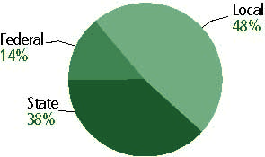

Title I allocation 2001-02 (ED; Includes Title I, Part A) | $26,529,973

Students

Public school enrollment (CCD) | 1993-94 | 2002-03
Pre-K | 615 | 773
K-8 | 83,512 | 68,316
9-12 | 35,000 | 35,136
Total (K-12) | 118,512 | 103,452

Race/ethnicity (CCD) | 1993-94 | 2002-03
American Indian/Alaskan Native | 6% | 8%
Asian/Pacific Islander | 1 | 1
Black, non-Hispanic | 1 | 1
Hispanic | 1 | 1
White, non-Hispanic | 91 | 89

Students with disabilities (OSEP) | 1993-94 | 2002-03
 | 9% | 12%

Students with limited  English proficiency (NCELA) | 1993-94 | 2002-03
 | 7% | 6%

Migrant students (OME) | 1993-94 | 2002-03
 | 1% | 1%

Eighth-grade students enrolled in Algebra I for high school credit (NAEP) | 1996 | 2003
 | 20% | 18%

Students eligible to participate in the Free or Reduced-Price Lunch Program, 2002-03 (CCD) | 29,270

All schools by percent of students eligible to participate in the Free or Reduced-Price Lunch Program, 2002-03 (CCD)

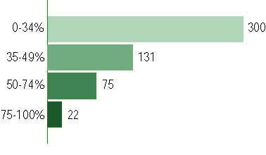

Staff

Number of FTE teachers (CCD) | 1993-94 | 2002-03
Elementary | 3,974 | 3,880
Middle | 848 | 1,031
High | 2,716 | 2,799
Combined | 94 | 19
Other | 123 | 349
Total | 7,755 | 8,078

Number of FTE non-teacher staff (CCD) | 1993-94 | 2002-03
Instructional aides | 1,290 | 1,798
Instructional coordinators | 58 | 126
Administrators | 654 | 829
Other | 4,023 | 4,259
Total | 6,025 | 7,012

Percentage of teachers with a major in the main subject taught, grades 7-12 (SASS) | 1994 | 2000
English | 80% | 66%
Mathematics | 87 | 83
Science | 85 | 85
Social Studies | 77 | 74

Percentage of core courses taught by highly qualified teachers, 2002-03
(As defined and reported by states, collected by ED)

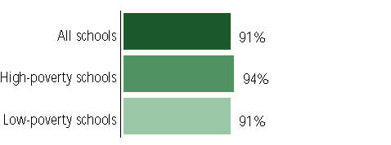

Outcomes

 | 1993-94 | 2000-01
High school dropout rate (NCES) | 3% | 2%
Avg. freshman graduation rate (NCES) | 88 | 85
College-going rate (IPEDS/NCES) | 68 | 69

NAEP state results
Reading, Grade 4 | 1994 | 2003
Proficient level or above | 38% | 32%
Basic level or above | 73 | 69
Math, Grade 8 | 1996 | 2003
Proficient level or above | 33% | 36%
Basic level or above | 77 | 81

Statewide Accountability Information:

State Accountability Website:
http://www.dpi.state.nd.us/dpi/reports/profile/0304/ProfileDistrict/99999.pdf

State assessment for NCLB accountability: North Dakota State Assessment

State student achievement levels: Novice, Partially Proficient, Proficient, Advanced

 |  | 2001-02  Annual measurable  objective starting point | Target  2002-03
Grade 4 | Reading | 65.1% | 68%
 | Mathematics | 45.7 | 50.2
Grade 8 | Reading | 64.1 | 64.6
 | Mathematics | 33.3 | 38.9
High School | Reading | 42.9 | 47.7
 | Mathematics | 24.1 | 30.4

AYP outcomes and consequences * | Title I schools |  | All schools |  | All districts
Made AYP | n/a | n/a | 451 | 91% | 178 | 89%
Identified for improvement:
Year 1 | 23 | 5% | 23 | 5% | 0 | 0
Year 2 | 1 | * | 1 | * | 0 | 0
Corrective action | 22 | 4% | 22 | 4% | 0 | 0
Restructuring | 0 | 0 | 0 | 0 | 0 | 0
Exited improvement status (made AYP twice after missing twice or more, includes total “made” above) | 6 | 1% | 6 | 1% | 0 | 0
*AYP outcomes for this state are not available due to issues with data collection, measurement, or other reasons. For more information, please visit the state’s Web site, above.

Other indicator, 2002-03 | State target | State outcome
Elementary indicator: Attendance | 93% | Met
Middle indicator: Attendance | 93% | Met
High school indicator: Graduation rate | 89.90% | Met

NCLB choice participation | Number of Title I students | Percent of Eligible Students
Title I school choice: | 0 | *
Supplemental educational services: | 118 | 1%

Student Achievement 2002-03

North Dakota State Assessment, used for NCLB accountability
Grade 3

Reading
Proficient Level or above for:
All students | n/a
Economically disadvantaged students | n/a
Migrant students | n/a
Students with disabilities | n/a
Students with limited English proficiency | n/a
Black, non-Hispanic students | n/a
Hispanic students | n/a
White, non-Hispanic students | n/a

Trend Data Not Available

North Dakota State Assessment, used for NCLB accountability
Grade 3

Mathematics
Proficient Level or above for:
All students | n/a
Economically disadvantaged students | n/a
Migrant students | n/a
Students with disabilities | n/a
Students with limited English proficiency | n/a
Black, non-Hispanic students | n/a
Hispanic students | n/a
White, non-Hispanic students | n/a

Trend Data Not Available

North Dakota State Assessment, used for NCLB accountability
Grade 4

Reading
Proficient Level or above for:
All students | 74%
Economically disadvantaged students | 64
Migrant students | n/a
Students with disabilities | 38
Students with limited English proficiency | 39
Black, non-Hispanic students | 67
Hispanic students | 56
White, non-Hispanic students | 77

Student achievement trend: Reading percent proficient level or above

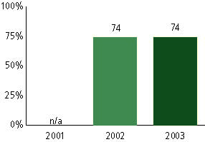

North Dakota State Assessment, used for NCLB accountability
Grade 4

Mathematics
Proficient Level or above for:
All students | 58%
Economically disadvantaged students | 45
Migrant students | n/a
Students with disabilities | 24
Students with limited English proficiency | 22
Black, non-Hispanic students | 40
Hispanic students | 42
White, non-Hispanic students | 61

Student achievement trend: Mathematics percent proficient level or above

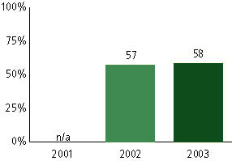

North Dakota State Assessment, used for NCLB accountability
Grade 5

Reading
Proficient Level or above for:
All students | n/a
Economically disadvantaged students | n/a
Migrant students | n/a
Students with disabilities | n/a
Students with limited English proficiency | n/a
Black, non-Hispanic students | n/a
Hispanic students | n/a
White, non-Hispanic students | n/a

Trend Data Not Available

North Dakota State Assessment, used for NCLB accountability
Grade 5

Mathematics
Proficient Level or above for:
All students | n/a
Economically disadvantaged students | n/a
Migrant students | n/a
Students with disabilities | n/a
Students with limited English proficiency | n/a
Black, non-Hispanic students | n/a
Hispanic students | n/a
White, non-Hispanic students | n/a

Trend Data Not Available

North Dakota State Assessment, used for NCLB accountability
Grade 6

Reading
Proficient Level or above for:
All students | n/a
Economically disadvantaged students | n/a
Migrant students | n/a
Students with disabilities | n/a
Students with limited English proficiency | n/a
Black, non-Hispanic students | n/a
Hispanic students | n/a
White, non-Hispanic students | n/a

Trend Data Not Available

North Dakota State Assessment, used for NCLB accountability
Grade 6

Mathematics
Proficient Level or above for:
All students | n/a
Economically disadvantaged students | n/a
Migrant students | n/a
Students with disabilities | n/a
Students with limited English proficiency | n/a
Black, non-Hispanic students | n/a
Hispanic students | n/a
White, non-Hispanic students | n/a

Trend Data Not Available

North Dakota State Assessment, used for NCLB accountability
Grade 7

Reading
Proficient Level or above for:
All students | n/a
Economically disadvantaged students | n/a
Migrant students | n/a
Students with disabilities | n/a
Students with limited English proficiency | n/a
Black, non-Hispanic students | n/a
Hispanic students | n/a
White, non-Hispanic students | n/a

Trend Data Not Available

North Dakota State Assessment, used for NCLB accountability
Grade 7

Mathematics
Proficient Level or above for:
All students | n/a
Economically disadvantaged students | n/a
Migrant students | n/a
Students with disabilities | n/a
Students with limited English proficiency | n/a
Black, non-Hispanic students | n/a
Hispanic students | n/a
White, non-Hispanic students | n/a

Trend Data Not Available

North Dakota State Assessment, used for NCLB accountability
Grade 8

Reading
Proficient Level or above for:
All students | 69%
Economically disadvantaged students | 55
Migrant students | 42
Students with disabilities | 22
Students with limited English proficiency | 22
Black, non-Hispanic students | 58
Hispanic students | 58
White, non-Hispanic students | 72

Student achievement trend: Reading percent proficient level or above

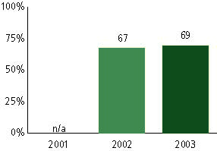

North Dakota State Assessment, used for NCLB accountability
Grade 8

Mathematics
Proficient Level or above for:
All students | 44%
Economically disadvantaged students | 29
Migrant students | 8
Students with disabilities | 7
Students with limited English proficiency | 9
Black, non-Hispanic students | 23
Hispanic students | 26
White, non-Hispanic students | 47

Student achievement trend: Mathematics percent proficient level or above

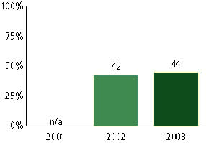

North Dakota State Assessment, used for NCLB accountability
High School

Reading
Proficient Level or above for:
All students | 52%
Economically disadvantaged students | 36
Migrant students | n/a
Students with disabilities | 9
Students with limited English proficiency | 7
Black, non-Hispanic students | 24
Hispanic students | 36
White, non-Hispanic students | 54

Student achievement trend: Reading percent proficient level or above

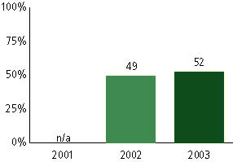

North Dakota State Assessment, used for NCLB accountability
High School

Mathematics
Proficient Level or above for:
All students | 33%
Economically disadvantaged students | 18
Migrant students | n/a
Students with disabilities | <5
Students with limited English proficiency | 8
Black, non-Hispanic students | 10
Hispanic students | 17
White, non-Hispanic students | 34

Student achievement trend: Mathematics percent proficient level or above

