New Jersey

http://www.state.nj.us/education

Districts and schools

Number of districts (CCD) | 1993-94 | 2002-03
 | 583 | 598

Number of public schools (CCD) | 1993-94 | 2002-03
Elementary | 1,457 | 1,520
Middle | 393 | 431
High | 310 | 363
Combined | 3 | 12
Other | 124 | 88
Total | 2,287 | 2,414

Number of charter schools (CCD) | 2002-03
 | 50

Finances

Total current expenditures  (CCD, in thousands of dollars, adjusted for inflation to 2001-02) | 1993-94 | 2001-02
Instructional | $8,015,197 | $9,358,608
Noninstructional | 428,378 | 488,508
Support | 4,931,955 | 5,975,494
Total | 13,375,530 | 15,822,610

Per-pupil expenditures  (CCD, adjusted for inflation to 2001-02) | 1993-94 | 2001-02
 | $11,618 | $11,793

Sources of funding
(CCD, 2001-02)

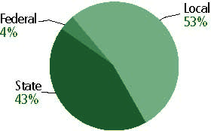

Title I allocation 2001-02 (ED; Includes Title I, Part A) | $257,022,021

Students

Public school enrollment (CCD) | 1993-94 | 2002-03
Pre-K | 9,225 | 21,590
K-8 | 775,959 | 903,367
9-12 | 288,263 | 369,115
Total (K-12) | 1,064,222 | 1,272,482

Race/ethnicity (CCD) | 1993-94 | 2002-03
American Indian/Alaskan Native | * | *
Asian/Pacific Islander | 5% | 7%
Black, non-Hispanic | 19 | 18
Hispanic | 13 | 17
White, non-Hispanic | 63 | 59

Students with disabilities (OSEP) | 1993-94 | 2002-03
 | 14% | 14%

Students with limited  English proficiency (NCELA) | 1993-94 | 2002-03
 | 4% | 4%

Migrant students (OME) | 1993-94 | 2002-03
 | * | *

Eighth-grade students enrolled in Algebra I for high school credit (NAEP) | 1996 | 2003
 | n/a | 26%

Students eligible to participate in the Free or Reduced-Price Lunch Program, 2002-03 (CCD) | 371,392

All schools by percent of students eligible to participate in the Free or Reduced-Price Lunch Program, 2002-03† (CCD)

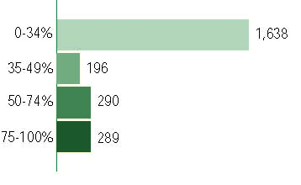
† 1 school did not report
Staff

Number of FTE teachers (CCD) | 1993-94 | 2002-03
Elementary | 37,425 | 49,547
Middle | 15,473 | 21,307
High | 23,432 | 29,877
Combined | 141 | 392
Other | 8,094 | 5,881
Total | 84,564 | 107,004

Number of FTE non-teacher staff (CCD) | 1993-94 | 2002-03
Instructional aides | 12,806 | 22,671
Instructional coordinators | 1,378 | 1,464
Administrators | 6,236 | 6,774
Other | 55,218 | 61,468
Total | 75,638 | 92,377

Percentage of teachers with a major in the main subject taught, grades 7-12 (SASS) | 1994 | 2000
English | 87% | 74%
Mathematics | 69 | 90
Science | 82 | 93
Social Studies | 93 | 93

Percentage of core courses taught by highly qualified teachers, 2002-03
(As defined and reported by states, collected by ED)

Not Available

Outcomes

 | 1993-94 | 2000-01
High school dropout rate (NCES) | 4% | 3%
Avg. freshman graduation rate (NCES) | 83 | 85
College-going rate (IPEDS/NCES) | 64 | 64

NAEP state results
Reading, Grade 4 | 1994 | 2003
Proficient level or above | 33% | 39%
Basic level or above | 65 | 70
Math, Grade 8 | 1996 | 2003
Proficient level or above | n/a | 33%
Basic level or above | n/a | 71

Statewide Accountability Information:

State Accountability Website:
http://education.state.nj.us/rc/

State assessment for NCLB accountability: New Jersey Skills & Knowledge Assessment

State student achievement levels: Partially Proficient, Proficient, Advanced Proficient

 |  | 2001-02  Annual measurable  objective starting point | Target  2002-03
Grade 4 | Language arts literacy | 68% | 68%
 | Mathematics | 53 | 53
Grade 8 | Language arts literacy | 58 | 58
 | Mathematics | 39 | 39
High School | Language arts literacy | 73 | 73
 | Mathematics | 55 | 55

AYP outcomes and consequences | Title I schools |  | All schools |  | All districts
Made AYP | 1,115 | 81% | 1,443 | 59% | n/a | n/a
Identified for improvement:
Year 1 | 14 | 1% | 14 | 1% | 0 | 0
Year 2 | 250 | 18% | 50 | 2% | 0 | 0
Corrective action | 0 | 0 | 0 | 0 | 0 | 0
Restructuring | 0 | 0 | 0 | 0 | 0 | 0
Exited improvement status (made AYP twice after missing twice or more, includes total “made” above) | 0 | 0 | 0 | 0 | 0 | 0

Other indicator, 2002-03 | State target | State outcome
Elementary indicator: Attendance | Meet or progress toward 90% | Met
Middle indicator: Attendance | Meet or progress toward 90% | Met
High school indicator: Dropout rate | Reduce rate by .5% per year until prior year's dropout percentage is reached | Met

NCLB choice participation | Number of Title I students | Percent of Eligible Students
Title I school choice: | 0 | 0
Supplemental educational services: | 11,097 | 4%

Student Achievement 2002-03

New Jersey Skills and Knowledge Assessment, Grade Eight Proficiency Assessment, and High School Proficiency Assessment used for NCLB accountability
Grade 3

Language arts literacy
Proficient Level or above for:
All students | n/a
Economically disadvantaged students | n/a
Migrant students | n/a
Students with disabilities | n/a
Students with limited English proficiency | n/a
Black, non-Hispanic students | n/a
Hispanic students | n/a
White, non-Hispanic students | n/a

Trend Data Not Available

New Jersey Skills and Knowledge Assessment, Grade Eight Proficiency Assessment, and High School Proficiency Assessment used for NCLB accountability
Grade 3

Mathematics
Proficient Level or above for:
All students | n/a
Economically disadvantaged students | n/a
Migrant students | n/a
Students with disabilities | n/a
Students with limited English proficiency | n/a
Black, non-Hispanic students | n/a
Hispanic students | n/a
White, non-Hispanic students | n/a

Trend Data Not Available

New Jersey Skills and Knowledge Assessment, Grade Eight Proficiency Assessment, and High School Proficiency Assessment used for NCLB accountability
Grade 4

Language arts literacy
Proficient Level or above for:
All students | 78%
Economically disadvantaged students | 58
Migrant students | 37
Students with disabilities | 42
Students with limited English proficiency | 31
Black, non-Hispanic students | 58
Hispanic students | 63
White, non-Hispanic students | 87

Student achievement trend: Language arts literacy percent proficient level or above

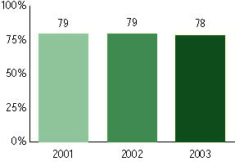

New Jersey Skills and Knowledge Assessment, Grade Eight Proficiency Assessment, and High School Proficiency Assessment used for NCLB accountability
Grade 4

Mathematics
Proficient Level or above for:
All students | 68%
Economically disadvantaged students | 47
Migrant students | 39
Students with disabilities | 40
Students with limited English proficiency | 34
Black, non-Hispanic students | 42
Hispanic students | 53
White, non-Hispanic students | 79

Student achievement trend: Mathematics percent proficient level or above

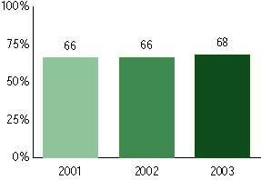

New Jersey Skills and Knowledge Assessment, Grade Eight Proficiency Assessment, and High School Proficiency Assessment used for NCLB accountability
Grade 5

Language arts literacy
Proficient Level or above for:
All students | n/a
Economically disadvantaged students | n/a
Migrant students | n/a
Students with disabilities | n/a
Students with limited English proficiency | n/a
Black, non-Hispanic students | n/a
Hispanic students | n/a
White, non-Hispanic students | n/a

Trend Data Not Available

New Jersey Skills and Knowledge Assessment, Grade Eight Proficiency Assessment, and High School Proficiency Assessment used for NCLB accountability
Grade 5

Mathematics
Proficient Level or above for:
All students | n/a
Economically disadvantaged students | n/a
Migrant students | n/a
Students with disabilities | n/a
Students with limited English proficiency | n/a
Black, non-Hispanic students | n/a
Hispanic students | n/a
White, non-Hispanic students | n/a

Trend Data Not Available

New Jersey Skills and Knowledge Assessment, Grade Eight Proficiency Assessment, and High School Proficiency Assessment used for NCLB accountability
Grade 6

Language arts literacy
Proficient Level or above for:
All students | n/a
Economically disadvantaged students | n/a
Migrant students | n/a
Students with disabilities | n/a
Students with limited English proficiency | n/a
Black, non-Hispanic students | n/a
Hispanic students | n/a
White, non-Hispanic students | n/a

Trend Data Not Available

New Jersey Skills and Knowledge Assessment, Grade Eight Proficiency Assessment, and High School Proficiency Assessment used for NCLB accountability
Grade 6

Mathematics
Proficient Level or above for:
All students | n/a
Economically disadvantaged students | n/a
Migrant students | n/a
Students with disabilities | n/a
Students with limited English proficiency | n/a
Black, non-Hispanic students | n/a
Hispanic students | n/a
White, non-Hispanic students | n/a

Trend Data Not Available

New Jersey Skills and Knowledge Assessment, Grade Eight Proficiency Assessment, and High School Proficiency Assessment used for NCLB accountability
Grade 7

Language arts literacy
Proficient Level or above for:
All students | n/a
Economically disadvantaged students | n/a
Migrant students | n/a
Students with disabilities | n/a
Students with limited English proficiency | n/a
Black, non-Hispanic students | n/a
Hispanic students | n/a
White, non-Hispanic students | n/a

Trend Data Not Available

New Jersey Skills and Knowledge Assessment, Grade Eight Proficiency Assessment, and High School Proficiency Assessment used for NCLB accountability
Grade 7

Mathematics
Proficient Level or above for:
All students | n/a
Economically disadvantaged students | n/a
Migrant students | n/a
Students with disabilities | n/a
Students with limited English proficiency | n/a
Black, non-Hispanic students | n/a
Hispanic students | n/a
White, non-Hispanic students | n/a

Trend Data Not Available

New Jersey Skills and Knowledge Assessment, Grade Eight Proficiency Assessment, and High School Proficiency Assessment used for NCLB accountability
Grade 8

Language arts literacy
Proficient Level or above for:
All students | 74%
Economically disadvantaged students | 48
Migrant students | 17
Students with disabilities | 28
Students with limited English proficiency | 14
Black, non-Hispanic students | 48
Hispanic students | 55
White, non-Hispanic students | 85

Student achievement trend: Language arts literacy percent proficient level or above

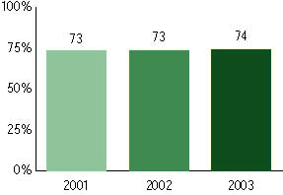

New Jersey Skills and Knowledge Assessment, Grade Eight Proficiency Assessment, and High School Proficiency Assessment used for NCLB accountability
Grade 8

Mathematics
Proficient Level or above for:
All students | 57%
Economically disadvantaged students | 30
Migrant students | 13
Students with disabilities | 16
Students with limited English proficiency | 19
Black, non-Hispanic students | 25
Hispanic students | 36
White, non-Hispanic students | 69

Student achievement trend: Mathematics percent proficient level or above

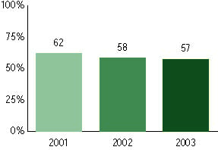

New Jersey Skills and Knowledge Assessment, Grade Eight Proficiency Assessment, and High School Proficiency Assessment used for NCLB accountability
High School

Language arts literacy
Proficient Level or above for:
All students | 80%
Economically disadvantaged students | 57
Migrant students | 61
Students with disabilities | 35
Students with limited English proficiency | 18
Black, non-Hispanic students | 61
Hispanic students | 63
White, non-Hispanic students | 88

Student achievement trend: Language arts literacy percent proficient level or above

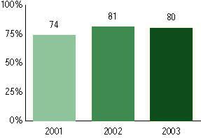

New Jersey Skills and Knowledge Assessment, Grade Eight Proficiency Assessment, and High School Proficiency Assessment used for NCLB accountability
High school

Mathematics
Proficient Level or above for:
All students | 66%
Economically disadvantaged students | 36
Migrant students | 37
Students with disabilities | 23
Students with limited English proficiency | 22
Black, non-Hispanic students | 33
Hispanic students | 42
White, non-Hispanic students | 77

Student achievement trend: Mathematics percent proficient level or above

