New Hampshire

http://www.ed.state.nh.us

Districts and schools

Number of districts (CCD) | 1993-94 | 2002-03
 | 178 | 178

Number of public schools (CCD) | 1993-94 | 2002-03
Elementary | 293 | 298
Middle | 91 | 96
High | 77 | 78
Combined | n/a | n/a
Other | n/a | 1
Total | 461 | 473

Number of charter schools (CCD) | 2002-03
 | 0

Finances

Total current expenditures  (CCD, in thousands of dollars, adjusted for inflation to 2001-02) | 1993-94 | 2001-02
Instructional | $827,873 | $1,064,917
Noninstructional | 45,576 | 52,283
Support | 415,900 | 524,179
Total | 1,289,349 | 1,641,379

Per-pupil expenditures  (CCD, adjusted for inflation to 2001-02) | 1993-94 | 2001-02
 | $6,955 | $7,935

Sources of funding
(CCD, 2001-02)

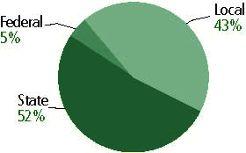

Title I allocation 2001-02 (ED; Includes Title I, Part A) | $29,733,465

Students

Public school enrollment (CCD) | 1993-94 | 2002-03
Pre-K | 1,292 | 1,923
K-8 | 134,367 | 141,139
9-12 | 49,098 | 63,988
Total (K-12) | 183,465 | 205,127

Race/ethnicity (CCD) | 1993-94 | 2002-03
American Indian/Alaskan Native | * | *
Asian/Pacific Islander | 1% | 2%
Black, non-Hispanic | 1 | 1
Hispanic | 1 | 2
White, non-Hispanic | 97 | 94

Students with disabilities (OSEP) | 1993-94 | 2002-03
 | 11% | 12%

Students with limited  English proficiency (NCELA) | 1993-94 | 2002-03
 | 1% | 2%

Migrant students (OME) | 1993-94 | 2002-03
 | * | *

Eighth-grade students enrolled in Algebra I for high school credit (NAEP) | 1996 | 2003
 | n/a | 27%

Students eligible to participate in the Free or Reduced-Price Lunch Program, 2002-03 (CCD) | 32,132

All schools by percent of students eligible to participate in the Free or Reduced-Price Lunch Program, 2002-03† (CCD)

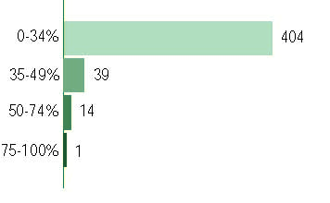
† 15 schools did not report
Staff

Number of FTE teachers (CCD) | 1993-94 | 2002-03
Elementary | 5,767 | 6,845
Middle | 2,711 | 3,619
High | 3,493 | 4,465
Combined | n/a | n/a
Other | n/a | n/a
Total | 11,971 | 14,929

Number of FTE non-teacher staff (CCD) | 1993-94 | 2002-03
Instructional aides | 2,902 | 6,050
Instructional coordinators | 128 | 196
Administrators | 807 | 1,028
Other | 6,093 | 7,836
Total | 9,930 | 15,110

Percentage of teachers with a major in the main subject taught, grades 7-12 (SASS) | 1994 | 2000
English | 90% | 73%
Mathematics | 76 | 69
Science | 91 | 90
Social Studies | 90 | 88

Percentage of core courses taught by highly qualified teachers, 2002-03
(As defined and reported by states, collected by ED)

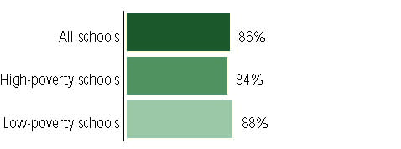

Outcomes

 | 1993-94 | 2000-01
High school dropout rate (NCES) | n/a | 5%
Avg. freshman graduation rate (NCES) | 81% | 78
College-going rate (IPEDS/NCES) | 56 | 59

NAEP state results
Reading, Grade 4 | 1994 | 2003
Proficient level or above | 36% | 40%
Basic level or above | 70 | 75
Math, Grade 8 | 1996 | 2003
Proficient level or above | n/a | 35%
Basic level or above | n/a | 79

Statewide Accountability Information:

State Accountability Website:
http://www.ed.state.nh.us/education/doe/organization/curriculum/Assessment/materials04.htm

State assessment for NCLB accountability: New Hampshire Educational Improvement Assessment Program (NHEIAP)

State student achievement levels: Novice, Basic, Proficient, Advanced

 |  | 2001-02  Annual measurable  objective starting point | Target  2002-03
Grade 3 | Reading | 60% | 60%
 | Mathematics | 64 | 64
Grade 6 | Reading | 60 | 60
 | Mathematics | 64 | 64
High School | Reading | 70 | 70
 | Mathematics | 52 | 52

AYP outcomes and consequences | Title I schools |  | All schools |  | All districts
Made AYP | 201 | 75% | 321 | 69% | 118 | 73%
Identified for improvement:
Year 1 | 4 | * | 4 | * | 0 | 0
Year 2 | 2 | * | 2 | * | 0 | 0
Corrective action | 0 | 0 | 0 | 0 | 0 | 0
Restructuring | 0 | 0 | 0 | 0 | 0 | 0
Exited improvement status (made AYP twice after missing twice or more, includes total “made” above) | 3 | * | 3 | * | 0 | 0

Other indicator, 2002-03 | State target | State outcome
Elementary indicator: Attendance | Meet or progress toward 90% | Met
Middle indicator: Attendance | Meet or progress toward 90% | Met
High school indicator: Graduation | Meet or progress toward 75% | Met

NCLB choice participation | Number of Title I students | Percent of Eligible Students
Title I school choice: | 1 | *
Supplemental educational services: | 15 | *

Student Achievement 2002-03

New Hampshire Educational Improvement Assessment Program, used for NCLB accountability
Grade 3

Reading
Proficient Level or above for:
All students | 77%
Economically disadvantaged students | 58
Migrant students | #
Students with disabilities | 31
Students with limited English proficiency | 43
Black, non-Hispanic students | 62
Hispanic students | 57
White, non-Hispanic students | 77

Student achievement trend: Reading percent proficient level or above

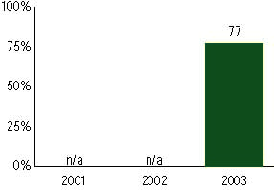

New Hampshire Educational Improvement Assessment Program, used for NCLB accountability
Grade 3

Mathematics
Proficient Level or above for:
All students | 80%
Economically disadvantaged students | 67
Migrant students | #
Students with disabilities | 52
Students with limited English proficiency | 58
Black, non-Hispanic students | 64
Hispanic students | 64
White, non-Hispanic students | 80

Student achievement trend: Mathematics percent proficient level or above

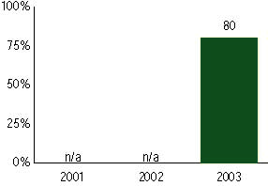

New Hampshire Educational Improvement Assessment Program, used for NCLB accountability
Grade 4

Reading
Proficient Level or above for:
All students | n/a
Economically disadvantaged students | n/a
Migrant students | n/a
Students with disabilities | n/a
Students with limited English proficiency | n/a
Black, non-Hispanic students | n/a
Hispanic students | n/a
White, non-Hispanic students | n/a

Trend Data Not Available

New Hampshire Educational Improvement Assessment Program, used for NCLB accountability
Grade 4

Mathematics
Proficient Level or above for:
All students | n/a
Economically disadvantaged students | n/a
Migrant students | n/a
Students with disabilities | n/a
Students with limited English proficiency | n/a
Black, non-Hispanic students | n/a
Hispanic students | n/a
White, non-Hispanic students | n/a

Trend Data Not Available

New Hampshire Educational Improvement Assessment Program, used for NCLB accountability
Grade 5

Reading
Proficient Level or above for:
All students | n/a
Economically disadvantaged students | n/a
Migrant students | n/a
Students with disabilities | n/a
Students with limited English proficiency | n/a
Black, non-Hispanic students | n/a
Hispanic students | n/a
White, non-Hispanic students | n/a

Trend Data Not Available

New Hampshire Educational Improvement Assessment Program, used for NCLB accountability
Grade 5

Mathematics
Proficient Level or above for:
All students | n/a
Economically disadvantaged students | n/a
Migrant students | n/a
Students with disabilities | n/a
Students with limited English proficiency | n/a
Black, non-Hispanic students | n/a
Hispanic students | n/a
White, non-Hispanic students | n/a

Trend Data Not Available

New Hampshire Educational Improvement Assessment Program, used for NCLB accountability
Grade 6

Reading
Proficient Level or above for:
All students | 72%
Economically disadvantaged students | 53
Migrant students | #
Students with disabilities | 26
Students with limited English proficiency | 26
Black, non-Hispanic students | 60
Hispanic students | 54
White, non-Hispanic students | 72

Student achievement trend: Reading percent proficient level or above

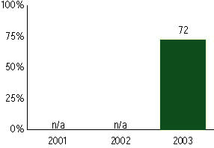

New Hampshire Educational Improvement Assessment Program, used for NCLB accountability
Grade 6

Mathematics
Proficient Level or above for:
All students | 74%
Economically disadvantaged students | 57
Migrant students | #
Students with disabilities | 35
Students with limited English proficiency | 36
Black, non-Hispanic students | 51
Hispanic students | 56
White, non-Hispanic students | 74

Student achievement trend: Mathematics percent proficient level or above

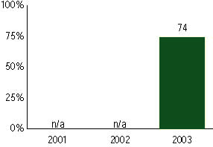

New Hampshire Educational Improvement Assessment Program, used for NCLB accountability
Grade 7

Reading
Proficient Level or above for:
All students | n/a
Economically disadvantaged students | n/a
Migrant students | n/a
Students with disabilities | n/a
Students with limited English proficiency | n/a
Black, non-Hispanic students | n/a
Hispanic students | n/a
White, non-Hispanic students | n/a

Trend Data Not Available

New Hampshire Educational Improvement Assessment Program, used for NCLB accountability
Grade 7

Mathematics
Proficient Level or above for:
All students | n/a
Economically disadvantaged students | n/a
Migrant students | n/a
Students with disabilities | n/a
Students with limited English proficiency | n/a
Black, non-Hispanic students | n/a
Hispanic students | n/a
White, non-Hispanic students | n/a

Trend Data Not Available

New Hampshire Educational Improvement Assessment Program, used for NCLB accountability
Grade 8

Reading
Proficient Level or above for:
All students | n/a
Economically disadvantaged students | n/a
Migrant students | n/a
Students with disabilities | n/a
Students with limited English proficiency | n/a
Black, non-Hispanic students | n/a
Hispanic students | n/a
White, non-Hispanic students | n/a

Trend Data Not Available

New Hampshire Educational Improvement Assessment Program, used for NCLB accountability
Grade 8

Mathematics
Proficient Level or above for:
All students | n/a
Economically disadvantaged students | n/a
Migrant students | n/a
Students with disabilities | n/a
Students with limited English proficiency | n/a
Black, non-Hispanic students | n/a
Hispanic students | n/a
White, non-Hispanic students | n/a

Trend Data Not Available

New Hampshire Educational Improvement Assessment Program, used for NCLB accountability
High school

Reading
Proficient Level or above for:
All students | 70%
Economically disadvantaged students | 51
Migrant students | #
Students with disabilities | 25
Students with limited English proficiency | 16
Black, non-Hispanic students | 47
Hispanic students | 47
White, non-Hispanic students | 71

Student achievement trend: Reading percent proficient level or above

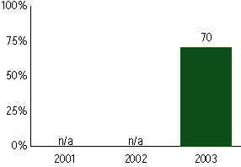

New Hampshire Educational Improvement Assessment Program, used for NCLB accountability
High School

Mathematics
Proficient Level or above for:
All students | 63%
Economically disadvantaged students | 44
Migrant students | #
Students with disabilities | 20
Students with limited English proficiency | 29
Black, non-Hispanic students | 41
Hispanic students | 41
White, non-Hispanic students | 64

Student achievement trend: Mathematics percent proficient level or above

