Illinois

http://www.isbe.state.il.us

Districts and schools

Number of districts (CCD) | 1993-94 | 2002-03
 | 922 | 893

Number of public schools (CCD) | 1993-94 | 2002-03
Elementary | 2,618 | 2,619
Middle | 707 | 740
High | 645 | 753
Combined | 27 | 123
Other | 181 | 36
Total | 4,178 | 4,271

Number of charter schools (CCD) | 2002-03
 | 22

Finances

Total current expenditures  (CCD, in thousands of dollars, adjusted for inflation to 2001-02) | 1993-94 | 2001-02
Instructional | $7,763,834 | $9,804,430
Noninstructional | 437,918 | 536,275
Support | 4,698,564 | 6,140,082
Total | 12,900,315 | 16,480,787

Per-pupil expenditures  (CCD, adjusted for inflation to 2001-02) | 1993-94 | 2001-02
 | $6,814 | $7,956

Sources of funding
(CCD, 2001-02)

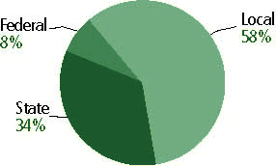

Title I allocation 2001-02 (ED; Includes Title I, Part A) | $430,679,234

Students

Public school enrollment (CCD) | 1993-94 | 2002-03
Pre-K | 42,359 | 60,524
K-8 | 1,259,394 | 1,425,283
9-12 | 503,024 | 595,349
Total (K-12) | 1,762,418 | 2,020,632

Race/ethnicity (CCD) | 1993-94 | 2002-03
American Indian/Alaskan Native | * | *
Asian/Pacific Islander | 3% | 4%
Black, non-Hispanic | 21 | 21
Hispanic | 11 | 17
White, non-Hispanic | 65 | 58

Students with disabilities (OSEP) | 1993-94 | 2002-03
 | 11% | 12%

Students with limited  English proficiency (NCELA) | 1993-94 | 2002-03
 | 5% | 8%

Migrant Students (OME) | 1993-94 | 2002-03
 | * | *

Eighth-grade students enrolled in Algebra I for high school credit (NAEP) | 1996 | 2003
 | n/a | 23%

Students eligible to participate in the Free or Reduced-Price Lunch Program, 2002-03 (CCD) | 741,954

All schools by percent of students eligible to participate in the Free or Reduced-Price Lunch Program, 2002-03† (CCD)

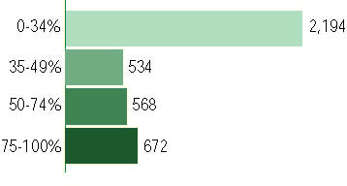
† 303 schools did not report
Staff

Number of FTE teachers (CCD) | 1993-94 | 2002-03
Elementary | 55,317 | 65,432
Middle | 17,322 | 22,421
High | 29,174 | 36,121
Combined | 872 | 1,959
Other | 8,190 | 5,112
Total | 110,874 | 131,045

Number of FTE non-teacher staff (CCD) | 1993-94 | 2002-03
Instructional aides | 17,609 | 32,902
Instructional coordinators | 1,507 | 1,298
Administrators | 6,031 | 10,333
Other | 63,201 | 82,656
Total | 88,348 | 127,189

Percentage of teachers with a major in the main subject taught, grades 7-12 (SASS) | 1994 | 2000
English | 89% | 70%
Mathematics | 82 | 65
Science | 77 | 93
Social Studies | 80 | 90

Percentage of core courses taught by highly qualified teachers, 2002-03 (As defined and reported by states, collected by ED)

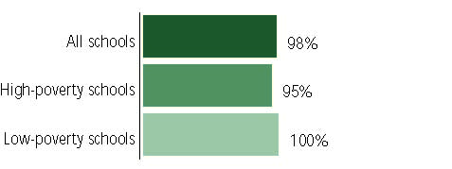

Outcomes

 | 1993-94 | 2000-01
High school dropout rate (NCES) | 7% | 6%
Averaged freshman graduation rate (NCES) | 76 | 76
College-going rate (IPEDS/NCES) | 64 | 60

NAEP state results
Reading, Grade 4 | 1994 | 2003
Proficient level or above | n/a | 31%
Basic level or above | n/a | 61
Math, 2003, Grade 8 | 1996 | 2003
Proficient level or above | n/a | 29%
Basic level or above | n/a | 66

Statewide Accountability Information:

State Accountability Website:
http://webprod.isbe.net/ereportcard/publicsite/default.htm

State assessment for NCLB accountability: Illinois Standards Achievement Test (ISAT)

State student achievement levels: Academic Warning, Below Standards, Meets Standards, Exceeds Standards

 |  | 2001-02  Annual measurable  objective starting point | Target  2002-03
Grade 3 | Reading | 40% | 40%
 | Mathematics | 40 | 40
Grade 8 | Reading | 40 | 40
 | Mathematics | 40 | 40
Grade 11 | Reading | 40 | 40
 | Mathematics | 40 | 40

AYP outcomes and consequences | Title I schools |  | All schools |  | All districts
Made AYP | 1,441 | 62% | 2,582 | 68% | 455 | 51%
Identified for improvement:
Year 1 | 252 | 10% | 244 | 6% | 0 | 0
Year 2 | 287 | 11% | 279 | 7% | 0 | 0
Corrective action | 23 | 1% | 240 | 1% | 0 | 0
Restructuring | 221 | 1% | 22 | * | 0 | 0
Exited improvement status (made AYP twice after missing twice or more, includes total “made” above) | 0 | 0 | 0 | 0 | 0 | 0

Other indicator, 2002-03 | State target | State outcome
Elementary indicator: Attendance | Meet or progress toward 88% | Met
Middle indicator: Attendance | Meet or progress toward 88% | Met
High school indicator: Graduation rate | Meet or progress toward 65%. | Met

NCLB choice participation | Number of Title I students | Percent of Eligible Students
Title I school choice | 1,313 | *
Supplemental educational services | 18,000 | 3%

Student Achievement 2002-03

Illinois Standards Achievement Test, used for NCLB accountability
Grade 3

Reading
Proficient Level or above for:
All students | 62%
Economically disadvantaged students | 42
Migrant students | 26
Students with disabilities | 32
Students with limited English proficiency | 38
Black, non-Hispanic students | 35
Hispanic students | 49
White, non-Hispanic students | 76

Student achievement trend: Reading percent proficient level or above

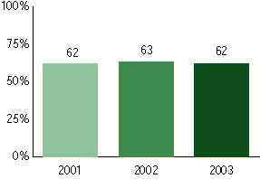

Illinois Standards Achievement Test, used for NCLB accountability
Grade 3

Mathematics
Proficient Level or above for:
All students | 76%
Economically disadvantaged students | 58
Migrant students | 48
Students with disabilities | 55
Students with limited English proficiency | 57
Black, non-Hispanic students | 49
Hispanic students | 69
White, non-Hispanic students | 89

Student achievement trend: Mathematics percent proficient level or above

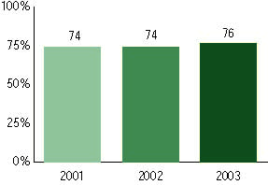

Illinois Standards Achievement Test, used for NCLB accountability
Grade 4

Reading
Proficient Level or above for:
All students | n/a
Economically disadvantaged students | n/a
Migrant students | n/a
Students with disabilities | n/a
Students with limited English proficiency | n/a
Black, non-Hispanic students | n/a
Hispanic students | n/a
White, non-Hispanic students | n/a

Trend Data Not Available

Illinois Standards Achievement Test, used for NCLB accountability
Grade 4

Mathematics
Proficient Level or above for:
All students | n/a
Economically disadvantaged students | n/a
Migrant students | n/a
Students with disabilities | n/a
Students with limited English proficiency | n/a
Black, non-Hispanic students | n/a
Hispanic students | n/a
White, non-Hispanic students | n/a

Trend Data Not Available

Illinois Standards Achievement Test, used for NCLB accountability
Grade 5

Reading
Proficient Level or above for:
All students | 60%
Economically disadvantaged students | 40
Migrant students | 35
Students with disabilities | 27
Students with limited English proficiency | 20
Black, non-Hispanic students | 36
Hispanic students | 41
White, non-Hispanic students | 73

Student achievement trend: Reading percent proficient level or above

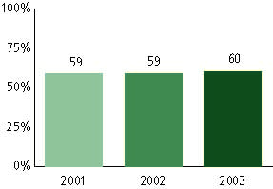

Illinois Standards Achievement Test, used for NCLB accountability
Grade 5

Mathematics
Proficient Level or above for:
All students | 67%
Economically disadvantaged students | 48
Migrant students | 41
Students with disabilities | 36
Students with limited English proficiency | 30
Black, non-Hispanic students | 40
Hispanic students | 52
White, non-Hispanic students | 81

Student achievement trend: Mathematics percent proficient level or above

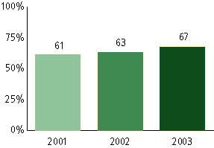

Illinois Standards Achievement Test, used for NCLB accountability
Grade 6

Reading
Proficient Level or above for:
All students | n/a
Economically disadvantaged students | n/a
Migrant students | n/a
Students with disabilities | n/a
Students with limited English proficiency | n/a
Black, non-Hispanic students | n/a
Hispanic students | n/a
White, non-Hispanic students | n/a

Trend Data Not Available

Illinois Standards Achievement Test, used for NCLB accountability
Grade 6

Mathematics
Proficient Level or above for:
All students | n/a
Economically disadvantaged students | n/a
Migrant students | n/a
Students with disabilities | n/a
Students with limited English proficiency | n/a
Black, non-Hispanic students | n/a
Hispanic students | n/a
White, non-Hispanic students | n/a

Trend Data Not Available

Illinois Standards Achievement Test, used for NCLB accountability
Grade 7

Reading
Proficient Level or above for:
All students | n/a
Economically disadvantaged students | n/a
Migrant students | n/a
Students with disabilities | n/a
Students with limited English proficiency | n/a
Black, non-Hispanic students | n/a
Hispanic students | n/a
White, non-Hispanic students | n/a

Trend Data Not Available

Illinois Standards Achievement Test, used for NCLB accountability
Grade 7

Mathematics
Proficient Level or above for:
All students | n/a
Economically disadvantaged students | n/a
Migrant students | n/a
Students with disabilities | n/a
Students with limited English proficiency | n/a
Black, non-Hispanic students | n/a
Hispanic students | n/a
White, non-Hispanic students | n/a

Trend Data Not Available

Illinois Standards Achievement Test, used for NCLB accountability
Grade 8

Reading
Proficient Level or above for:
All students | 64%
Economically disadvantaged students | 46
Migrant students | 20
Students with disabilities | 20
Students with limited English proficiency | 15
Black, non-Hispanic students | 45
Hispanic students | 47
White, non-Hispanic students | 73

Student achievement trend: Reading percent proficient level or above

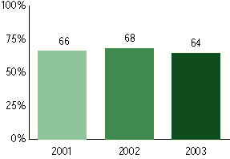

Illinois Standards Achievement Test, used for NCLB accountability
Grade 8

Mathematics
Proficient Level or above for:
All students | 53%
Economically disadvantaged students | 30
Migrant students | 22
Students with disabilities | 13
Students with limited English proficiency | 18
Black, non-Hispanic students | 23
Hispanic students | 36
White, non-Hispanic students | 66

Student achievement trend: Mathematics percent proficient level or above

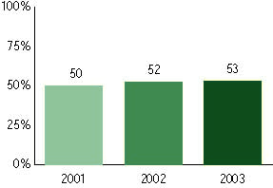

Illinois Standards Achievement Test, used for NCLB accountability
Grade 11

Reading
Proficient Level or above for:
All students | 56%
Economically disadvantaged students | 32
Migrant students | 18
Students with disabilities | 15
Students with limited English proficiency | 16
Black, non-Hispanic students | 31
Hispanic students | 35
White, non-Hispanic students | 65

Student achievement trend: Reading percent proficient level or above

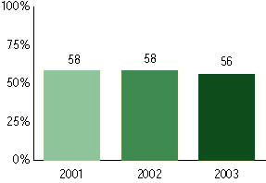

Illinois Standards Achievement Test, used for NCLB accountability
Grade 11

Mathematics
Proficient Level or above for:
All students | 53%
Economically disadvantaged students | 25
Migrant students | 10
Students with disabilities | 13
Students with limited English proficiency | 24
Black, non-Hispanic students | 21
Hispanic students | 29
White, non-Hispanic students | 63

Student achievement trend: Mathematics percent proficient level or above

