New Mexico

http://sde.state.nm.us

Districts and schools

Number of districts (CCD) | 1993-94 | 2002-03
 | 88 | 89

Number of public schools (CCD) | 1993-94 | 2002-03
Elementary | 420 | 444
Middle | 139 | 163
High | 125 | 161
Combined | 9 | 24
Other | 15 | 9
Total | 708 | 801

Number of charter schools (CCD) | 2002-03
 | 27

Finances

Total current expenditures  (CCD, in thousands of dollars, adjusted for inflation to 2001-02) | 1993-94 | 2001-02
Instructional | $992,210 | $1,232,319
Noninstructional | 97,902 | 101,976
Support | 604,163 | 869,870
Total | 1,694,275 | 2,204,165

Per-pupil expenditures  (CCD, adjusted for inflation to 2001-02) | 1993-94 | 2001-02
 | $5,256 | $6,882

Sources of funding
(CCD, 2001-02)

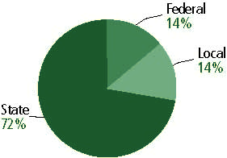

Title I allocation 2001-02 (ED; Includes Title I, Part A) | $82,193,013

Students

Public school enrollment (CCD) | 1993-94 | 2002-03
Pre-K | 1,933 | 3,529
K-8 | 224,354 | 220,967
9-12 | 87,768 | 95,767
Total (K-12) | 312,122 | 316,734

Race/ethnicity (CCD) | 1993-94 | 2002-03
American Indian/Alaskan Native | 10% | 11%
Asian/Pacific Islander | 1 | 1
Black, non-Hispanic | 2 | 2
Hispanic | 46 | 52
White, non-Hispanic | 40 | 34

Students with disabilities (OSEP) | 1993-94 | 2002-03
 | 12% | 13%

Students with limited  English proficiency (NCELA) | 1993-94 | 2002-03
 | 25% | 20%

Migrant students (OME) | 1993-94 | 2002-03
 | 1% | 1%

Eighth-grade students enrolled in Algebra I for high school credit (NAEP) | 1996 | 2003
 | 22% | 20%

Students eligible to participate in the Free or Reduced-Price Lunch Program, 2002-03 (CCD) | 182,469

All schools by percent of students eligible to participate in the Free or Reduced-Price Lunch Program, 2002-03† (CCD)

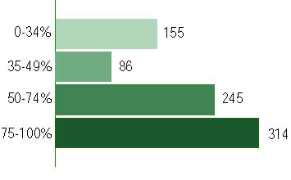
† 1 school did not report
Staff

Number of FTE teachers (CCD) | 1993-94 | 2002-03
Elementary | 9,029 | 10,279
Middle | 4,020 | 4,685
High | 4,338 | 5,657
Combined | 54 | 218
Other | 964 | 334
Total | 18,404 | 21,172

Number of FTE non-teacher staff (CCD) | 1993-94 | 2002-03
Instructional aides | 4,066 | 5,158
Instructional coordinators | 468 | 660
Administrators | 1,278 | 1,849
Other | 12,478 | 14,987
Total | 18,290 | 22,654

Percentage of teachers with a major in the main subject taught, grades 7-12 (SASS) | 1994 | 2000
English | 76% | 65%
Mathematics | 69 | 52
Science | 71 | 55
Social Studies | 60 | 39

Percentage of core courses taught by highly qualified teachers, 2002-03
(As defined and reported by states, collected by ED)

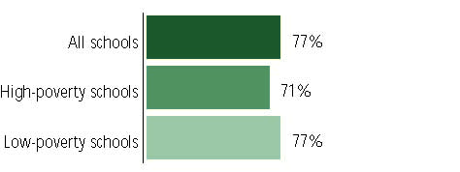

Outcomes

 | 1993-94 | 2000-01
High school dropout rate (NCES) | 8% | 5%
Avg. freshman graduation rate (NCES) | 67 | 66
College-going rate (IPEDS/NCES) | 54 | 59

NAEP state results
Reading, Grade 4 | 1994 | 2003
Proficient level or above | 21% | 19%
Basic level or above | 49 | 48
Math, Grade 8 | 1996 | 2003
Proficient level or above | 14% | 15%
Basic level or above | 51 | 52

Statewide Accountability Information:

State Accountability Website:
http://sde.state.nm.us/div/acc.assess/accountability/ayp.html#reportcard

State assessment for NCLB accountability: -

State student achievement levels: Beginning Proficiency, Nearing Proficient, Proficient, Advanced

 |  | 2001-02  Annual measurable  objective starting point | Target  2002-03
Grade 4 | Reading | n/a | n/a
 | Mathematics | n/a | n/a
Grade 8 | Reading | n/a | n/a
 | Mathematics | n/a | n/a
Grade 10 | Reading | n/a | n/a
 | Mathematics | n/a | n/a

AYP outcomes and consequences* | Title I schools |  | All schools |  | All districts
Made AYP | n/a | n/a | n/a | n/a | n/a | n/a
Identified for improvement:
Year 1 | n/a | n/a | n/a | n/a | n/a | n/a
Year 2 | n/a | n/a | n/a | n/a | n/a | n/a
Corrective action | n/a | n/a | n/a | n/a | n/a | n/a
Restructuring | n/a | n/a | n/a | n/a | n/a | n/a
Exited improvement status (made AYP twice after missing twice or more, includes total “made” above) | n/a | n/a | n/a | n/a | n/a | n/a
*AYP outcomes for this state are not available due to issues with data collection, measurement, or other reasons. For more information, please visit the state’s Web site, above.

Other indicator, 2002-03 | State target | State outcome
Elementary indicator: n/a | n/a | n/a
Middle indicator: n/a | n/a | n/a
High school indicator: n/a | n/a | n/a

NCLB choice participation | Number of Title I students | Percent of Eligible Students
Title I school choice: | n/a | n/a
Supplemental educational services: | n/a | n/a

Student Achievement 2002-03

New Mexico Standards Based Assessment, not used for NCLB accountability
Grade 3

Reading
Proficient Level or above for:
All students | 65%
Economically disadvantaged students | 48
Migrant students | 31
Students with disabilities | 41
Students with limited English proficiency | 31
Black, non-Hispanic students | 65
Hispanic students | 58
White, non-Hispanic students | 78

Student achievement trend: Reading percent proficient level or above

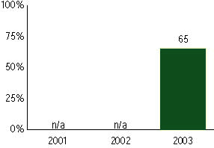

New Mexico Standards Based Assessment, not used for NCLB accountability
Grade 3

Mathematics
Proficient Level or above for:
All students | 67%
Economically disadvantaged students | 53
Migrant students | 46
Students with disabilities | 46
Students with limited English proficiency | 42
Black, non-Hispanic students | 62
Hispanic students | 61
White, non-Hispanic students | 79

Student achievement trend: Mathematics percent proficient level or above

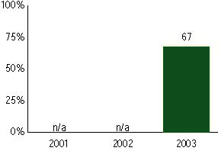

New Mexico Standards Based Assessment, not used for NCLB accountability
Grade 4

Reading
Proficient Level or above for:
All students | 70%
Economically disadvantaged students | 53
Migrant students | 35
Students with disabilities | 44
Students with limited English proficiency | 37
Black, non-Hispanic students | 63
Hispanic students | 64
White, non-Hispanic students | 83

Student achievement trend: Reading percent proficient level or above

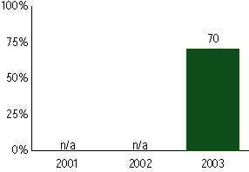

New Mexico Standards Based Assessment, not used for NCLB accountability
Grade 4

Mathematics
Proficient Level or above for:
All students | 65%
Economically disadvantaged students | 49
Migrant students | 32
Students with disabilities | 45
Students with limited English proficiency | 36
Black, non-Hispanic students | 57
Hispanic students | 58
White, non-Hispanic students | 79

Student achievement trend: Mathematics percent proficient level or above

New Mexico Standards Based Assessment, not used for NCLB accountability
Grade 5

Reading
Proficient Level or above for:
All students | 69%
Economically disadvantaged students | 51
Migrant students | 33
Students with disabilities | 46
Students with limited English proficiency | 32
Black, non-Hispanic students | 67
Hispanic students | 63
White, non-Hispanic students | 82

Student achievement trend: Reading percent proficient level or above

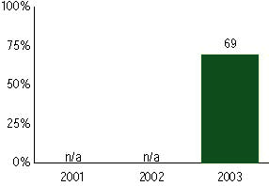

New Mexico Standards Based Assessment, not used for NCLB accountability
Grade 5

Mathematics
Proficient Level or above for:
All students | 62%
Economically disadvantaged students | 45
Migrant students | 33
Students with disabilities | 41
Students with limited English proficiency | 30
Black, non-Hispanic students | 52
Hispanic students | 55
White, non-Hispanic students | 76

Student achievement trend: Mathematics percent proficient level or above

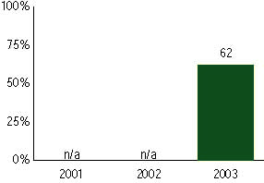

New Mexico Standards Based Assessment, not used for NCLB accountability
Grade 6

Reading
Proficient Level or above for:
All students | 67%
Economically disadvantaged students | 48
Migrant students | 33
Students with disabilities | 42
Students with limited English proficiency | 29
Black, non-Hispanic students | 61
Hispanic students | 60
White, non-Hispanic students | 82

Student achievement trend: Reading percent proficient level or above

New Mexico Standards Based Assessment, not used for NCLB accountability
Grade 6

Mathematics
Proficient Level or above for:
All students | 62%
Economically disadvantaged students | 43
Migrant students | 44
Students with disabilities | 36
Students with limited English proficiency | 28
Black, non-Hispanic students | 53
Hispanic students | 54
White, non-Hispanic students | 77

Student achievement trend: Mathematics percent proficient level or above

New Mexico Standards Based Assessment, not used for NCLB accountability
Grade 7

Reading
Proficient Level or above for:
All students | 64%
Economically disadvantaged students | 44
Migrant students | 33
Students with disabilities | 40
Students with limited English proficiency | 26
Black, non-Hispanic students | 59
Hispanic students | 55
White, non-Hispanic students | 80

Student achievement trend: Reading percent proficient level or above

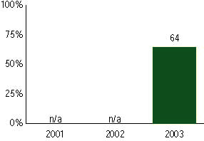

New Mexico Standards Based Assessment, not used for NCLB accountability
Grade 7

Mathematics
Proficient Level or above for:
All students | 62%
Economically disadvantaged students | 43
Migrant students | 40
Students with disabilities | 38
Students with limited English proficiency | 29
Black, non-Hispanic students | 51
Hispanic students | 53
White, non-Hispanic students | 77

Student achievement trend: Mathematics percent proficient level or above

New Mexico Standards Based Assessment, not used for NCLB accountability
Grade 8

Reading
Proficient Level or above for:
All students | 69%
Economically disadvantaged students | 50
Migrant students | 33
Students with disabilities | 41
Students with limited English proficiency | 30
Black, non-Hispanic students | 63
Hispanic students | 61
White, non-Hispanic students | 84

Student achievement trend: Reading percent proficient level or above

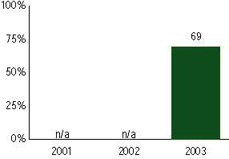

New Mexico Standards Based Assessment, not used for NCLB accountability
Grade 8

Mathematics
Proficient Level or above for:
All students | 64%
Economically disadvantaged students | 45
Migrant students | 34
Students with disabilities | 37
Students with limited English proficiency | 30
Black, non-Hispanic students | 54
Hispanic students | 55
White, non-Hispanic students | 80

Student achievement trend: Mathematics percent proficient level or above

New Mexico Standards Based Assessment, not used for NCLB accountability
Grade 10

Reading
Proficient Level or above for:
All students | 91%
Economically disadvantaged students | 81
Migrant students | 51
Students with disabilities | 70
Students with limited English proficiency | 68
Black, non-Hispanic students | 91
Hispanic students | 88
White, non-Hispanic students | 98

Student achievement trend: Reading percent proficient level or above

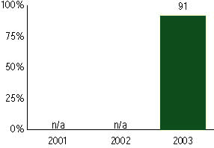

New Mexico Standards Based Assessment, not used for NCLB accountability
Grade 10

Mathematics
Proficient Level or above for:
All students | 84%
Economically disadvantaged students | 71
Migrant students | 56
Students with disabilities | 56
Students with limited English proficiency | 60
Black, non-Hispanic students | 78
Hispanic students | 79
White, non-Hispanic students | 93

Student achievement trend: Mathematics percent proficient level or above

