Minnesota

http://www.educ.state.mn.us

Districts and schools

Number of districts (CCD) | 1993-94 | 2002-03
 | 400 | 417

Number of public schools (CCD) | 1993-94 | 2002-03
Elementary | 888 | 1,024
Middle | 220 | 290
High | 371 | 646
Combined | 15 | 207
Other | 3 | 15
Total | 1,497 | 2,182

Number of charter schools (CCD) | 2002-03
 | 89

Finances

Total current expenditures  (CCD, in thousands of dollars, adjusted for inflation to 2001-02) | 1993-94 | 2001-02
Instructional | $3,530,240 | $4,192,253
Noninstructional | 224,024 | 281,475
Support | 1,786,512 | 2,112,832
Total | 5,540,775 | 6,586,560

Per-pupil expenditures  (CCD, adjusted for inflation to 2001-02) | 1993-94 | 2001-02
 | $6,839 | $7,736

Sources of funding
(CCD, 2001-02)

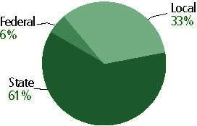

Title I allocation 2001-02 (ED; Includes Title I, Part A) | $112,964,619

Students

Public school enrollment (CCD) | 1993-94 | 2002-03
Pre-K | 6,656 | 10,037
K-8 | 570,324 | 557,664
9-12 | 233,253 | 279,190
Total (K-12) | 803,577 | 836,854

Race/ethnicity (CCD) | 1993-94 | 2002-03
American Indian/Alaskan Native | 2% | 2%
Asian/Pacific Islander | 4 | 5
Black, non-Hispanic | 4 | 7
Hispanic | 2 | 4
White, non-Hispanic | 89 | 81

Students with disabilities (OSEP) | 1993-94 | 2002-03
 | 9% | 11%

Students with limited  English proficiency (NCELA) | 1993-94 | 2002-03
 | 3% | 6%

Migrant students (OME) | 1993-94 | 2002-03
 | 1% | 1%

Eighth-grade students enrolled in Algebra I for high school credit (NAEP) | 1996 | 2003
 | 34% | 22%

Students eligible to participate in the Free or Reduced-Price Lunch Program, 2002-03 (CCD) | 231,450

All schools by percent of students eligible to participate in the Free or Reduced-Price Lunch Program, 2002-03† (CCD)
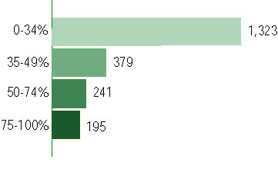
† 44 schools did not report
Staff

Number of FTE teachers (CCD) | 1993-94 | 2002-03
Elementary | 21,654 | 24,061
Middle | 7,969 | 9,584
High | 12,690 | 16,025
Combined | 355 | 1,501
Other | 4,288 | 1,636
Total | 46,956 | 52,808

Number of FTE non-teacher staff (CCD) | 1993-94 | 2002-03
Instructional aides | 6,089 | 14,758
Instructional coordinators | 487 | 439
Administrators | 2,872 | 3,220
Other | 18,445 | 34,086
Total | 27,903 | 52,503

Percentage of teachers with a major in the main subject taught, grades 7-12 (SASS) | 1994 | 2000
English | 84% | 92%
Mathematics | 94 | 90
Science | 97 | 93
Social Studies | 89 | 94

Percentage of core courses taught by highly qualified teachers, 2002-03
(As defined and reported by states, collected by ED)

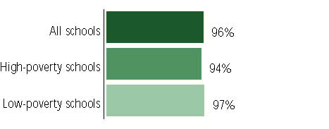

Outcomes

 | 1993-94 | 2000-01
High school dropout rate (NCES) | 5% | 4%
Avg. freshman graduation rate (NCES) | 89 | 84
College-going rate (IPEDS/NCES) | 53 | 64

NAEP state results
Reading, Grade 4 | 1994 | 2003
Proficient level or above | 33% | 37%
Basic level or above | 65 | 69
Math, Grade 8 | 1996 | 2003
Proficient level or above | 34% | 44%
Basic level or above | 75 | 82

Statewide Accountability Information:

State Accountability Website:
http://education.state.mn.us/html/intro_sch_dist_data.htm

State assessment for NCLB accountability: Minnesota Comprehensive Assessments (MCAs)

State student achievement levels: Level 1, Level 2, Level 3, Level 4, Level 5

 |  | 2001-02  Annual measurable  objective starting point | Target  2002-03
Grade 3 | Reading | 62.9% | 62.9%
 | Mathematics | 65.4 | 65.4
Grade - | n/a | - | -
 | n/a | - | -
Grade - | n/a | - | -
 | n/a | - | -

AYP outcomes and consequences | Title I schools |  | All schools |  | All districts
Made AYP | 824 | 90 | 1,692 | 92% | 361 | 89%
Identified for improvement:
Year 1 | 23 | 3% | 23 | 1% | 0 | 0
Year 2 | 15 | 2% | 15 | 1% | 0 | 0
Corrective action | 0 | 0 | 0 | 0 | 0 | 0
Restructuring | 0 | 0 | 0 | 0 | 0 | 0
Exited improvement status (made AYP twice after missing twice or more, includes total “made” above) | 30 | 3% | 30 | 2% | 0 | 0

Other indicator, 2002-03 | State target | State outcome
Elementary indicator: Attendance | Meet or progress toward 94.5% | Met
Middle indicator: Attendance | Meet or progress toward 94.5% | Met
High school indicator: Graduation rate | Meet or growth towards 87.4% | Met

NCLB choice participation | Number of Title I students | Percent of Eligible Students
Title I school choice: | 306 | *
Supplemental educational services: | 1,498 | 1%

Student Achievement 2002-03

Minnesota Comprehensive Assessments, used for NCLB accountability
Grade 3

Reading
Proficient Level or above for:
All students | 76%
Economically disadvantaged students | 57
Migrant students | 36
Students with disabilities | 44
Students with limited English proficiency | 38
Black, non-Hispanic students | 47
Hispanic students | 47
White, non-Hispanic students | 82

Student achievement trend: Reading percent proficient level or above

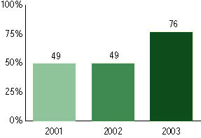

Minnesota Comprehensive Assessments, used for NCLB accountability
Grade 3

Mathematics
Proficient Level or above for:
All students | 74%
Economically disadvantaged students | 57
Migrant students | 38
Students with disabilities | 48
Students with limited English proficiency | 43
Black, non-Hispanic students | 44
Hispanic students | 47
White, non-Hispanic students | 81

Student achievement trend: Mathematics percent proficient level or above

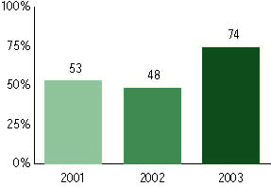

Minnesota Comprehensive Assessments, used for NCLB accountability
Grade 4

Reading
Proficient Level or above for:
All students | n/a
Economically disadvantaged students | n/a
Migrant students | n/a
Students with disabilities | n/a
Students with limited English proficiency | n/a
Black, non-Hispanic students | n/a
Hispanic students | n/a
White, non-Hispanic students | n/a

Trend Data Not Available

Minnesota Comprehensive Assessments, used for NCLB accountability
Grade 4

Mathematics
Proficient Level or above for:
All students | n/a
Economically disadvantaged students | n/a
Migrant students | n/a
Students with disabilities | n/a
Students with limited English proficiency | n/a
Black, non-Hispanic students | n/a
Hispanic students | n/a
White, non-Hispanic students | n/a

Trend Data Not Available

Minnesota Comprehensive Assessments, used for NCLB accountability
Grade 5

Reading
Proficient Level or above for:
All students | 81%
Economically disadvantaged students | 64
Migrant students | 38
Students with disabilities | 49
Students with limited English proficiency | 41
Black, non-Hispanic students | 54
Hispanic students | 54
White, non-Hispanic students | 86

Student achievement trend: Reading percent proficient level or above

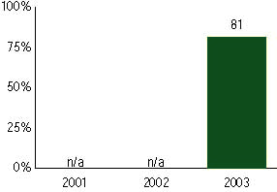

Minnesota Comprehensive Assessments, used for NCLB accountability
Grade 5

Mathematics
Proficient Level or above for:
All students | 77%
Economically disadvantaged students | 58
Migrant students | 36
Students with disabilities | 47
Students with limited English proficiency | 39
Black, non-Hispanic students | 41
Hispanic students | 49
White, non-Hispanic students | 82

Student achievement trend: Mathematics percent proficient level or above

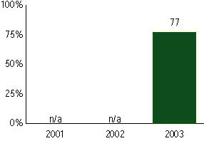

Minnesota Comprehensive Assessments, used for NCLB accountability
Grade 6

Reading
Proficient Level or above for:
All students | n/a
Economically disadvantaged students | n/a
Migrant students | n/a
Students with disabilities | n/a
Students with limited English proficiency | n/a
Black, non-Hispanic students | n/a
Hispanic students | n/a
White, non-Hispanic students | n/a

Trend Data Not Available

Minnesota Comprehensive Assessments, used for NCLB accountability
Grade 6

Mathematics
Proficient Level or above for:
All students | n/a
Economically disadvantaged students | n/a
Migrant students | n/a
Students with disabilities | n/a
Students with limited English proficiency | n/a
Black, non-Hispanic students | n/a
Hispanic students | n/a
White, non-Hispanic students | n/a

Trend Data Not Available

Minnesota Comprehensive Assessments, used for NCLB accountability
Grade 7

Reading
Proficient Level or above for:
All students | n/a
Economically disadvantaged students | n/a
Migrant students | n/a
Students with disabilities | n/a
Students with limited English proficiency | n/a
Black, non-Hispanic students | n/a
Hispanic students | n/a
White, non-Hispanic students | n/a

Trend Data Not Available

Minnesota Comprehensive Assessments, used for NCLB accountability
Grade 7

Mathematics
Proficient Level or above for:
All students | n/a
Economically disadvantaged students | n/a
Migrant students | n/a
Students with disabilities | n/a
Students with limited English proficiency | n/a
Black, non-Hispanic students | n/a
Hispanic students | n/a
White, non-Hispanic students | n/a

Trend Data Not Available

Minnesota Comprehensive Assessments, used for NCLB accountability
Grade 8

Reading
Proficient Level or above for:
All students | n/a
Economically disadvantaged students | n/a
Migrant students | n/a
Students with disabilities | n/a
Students with limited English proficiency | n/a
Black, non-Hispanic students | n/a
Hispanic students | n/a
White, non-Hispanic students | n/a

Trend Data Not Available

Minnesota Comprehensive Assessments, used for NCLB accountability
Grade 8

Mathematics
Proficient Level or above for:
All students | n/a
Economically disadvantaged students | n/a
Migrant students | n/a
Students with disabilities | n/a
Students with limited English proficiency | n/a
Black, non-Hispanic students | n/a
Hispanic students | n/a
White, non-Hispanic students | n/a

Trend Data Not Available

Minnesota Comprehensive Assessments, used for NCLB accountability
High School

Reading
Proficient Level or above for:
All students | n/a
Economically disadvantaged students | n/a
Migrant students | n/a
Students with disabilities | n/a
Students with limited English proficiency | n/a
Black, non-Hispanic students | n/a
Hispanic students | n/a
White, non-Hispanic students | n/a

Trend Data Not Available

Minnesota Comprehensive Assessments, used for NCLB accountability
High School

Mathematics
Proficient Level or above for:
All students | n/a
Economically disadvantaged students | n/a
Migrant students | n/a
Students with disabilities | n/a
Students with limited English proficiency | n/a
Black, non-Hispanic students | n/a
Hispanic students | n/a
White, non-Hispanic students | n/a

Trend Data Not Available

