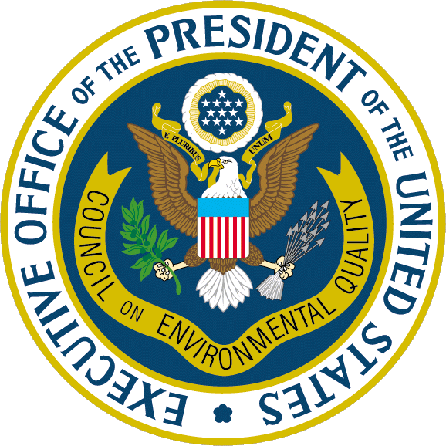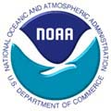

For Immediate Release May 1, 2003
Contact:

Federal Agencies Reach Consensus Ending Development of the Oregon Inlet Jetty Proposal

WASHINGTON - The White House Council on Environmental Quality, the U.S. Army Corps of Engineers, and the Interior and Commerce Departments today announced that they have reached mutual agreement not to proceed with a proposed navigation project at Oregon Inlet on North Carolina's Outer Banks. This agreement resolves a 30-year process seeking to reconcile complex economic and engineering issues with the goal of improving navigation safety and protecting the fishery, the Cape Hatteras National Seashore, and the Pea Island National Wildlife Refuge.

Instead of that project, the Corps will improve the current 14-foot navigation channel while working with the Department of Commerce's National Oceanic and Atmospheric Administration (NOAA) to enhance boating safety by providing the public with more accurate and up-to-date navigational data on changing sand conditions in the channel.

The decision to cease work on the Oregon Inlet jetty project included extensive inter-agency coordination and communications, including a public hearing in Manteo, N.C., at which local citizens expressed earnest and differing views on the project.

"This decision resolves a long-standing debate among federal agencies with different Congressional mandates. Working with the Army and the other agencies, we looked closely at the economic and environmental data and jointly determined that the uncertainties in projecting both the estimated economic and environmental effects, and the risk to important resources, weigh against proceeding with the project,” said CEQ Chairman James L. Connaughton. “Although we are not moving forward with this project, we are committed to working with the local community to improve navigation of the channel. We will continue to work with their elected leaders on other actions that can be taken toward those goals.”

"Today’s agreement demonstrates that the federal agencies must work together to resolve difficult issues in the public interest," said Army Under Secretary Les Brownlee.

In 1970, Congress authorized the project, in which the Corps was to dredge a 20-foot by 400-foot navigation channel to accommodate deep draft fishing vessels and construct two large jetties designed to divert sands from the channel.

Oregon Inlet is the only barrier island break in the northern part of the Outer Banks, providing access for boats between the Atlantic Ocean and the Albermarle-Pamlico Sound. The project was designed to ensure navigation for deep-draft fishing vessels as well as recreational boats. It would have had an initial cost of $108 million in addition to annual dredging costs of $6.1 million.

Over the past three decades, the Corps of Engineers has conducted numerous economic studies and substantial environmental analyses under the National Environmental Policy Act. A final decision was delayed repeatedly because of concerns expressed by other federal agencies. NOAA opposed the project during formal consultations with the Corps because of a potentially significant impact on the area's already diminished fisheries. Species that depend on the inlet for habitat include flounder, blue crab, white shrimp, bluefish, various sharks and at least 70 other species of fish and shellfish.

In addition, two Interior agencies -- the National Park Service and the U.S. Fish and Wildlife Service -- expressed concern over potential erosion of national park and national wildlife refuge lands. The Park Service manages Cape Hatteras National Seashore on the north side of the inlet while Fish and Wildlife manages Pea Island National Wildlife Refuge on the south side.

"This was a difficult decision to reach, but ultimately it was the right decision," said Interior Secretary Gale A. Norton. "From the Interior Department's perspective, we have a mandate to protect and conserve our nation's parks and refuges for the benefit of the American people."

In reaching the consensus agreement not to proceed with the project, the agencies found that the available economic data contained uncertainties that raised questions as to whether the project would generate even modest net benefits to the local economy. With local fish stocks in decline, NOAA and the Corps concluded that the project probably would not lead to additional fish landings. At the same time, tourism has become a mainstay of the local economy. While use of the inlet by commercial fishing has declined, the number of recreational boaters has climbed along with visitation to both the national seashore and the national wildlife refuge.

"The agreement between CEQ, the Army Corps of Engineers, and NOAA demonstrates that good environmental policy, good economics, and cooperative decision making can result in a workable solution," said the Under Secretary of Commerce for Oceans and Atmosphere and NOAA Administrator, retired Navy Vice Admiral Conrad C. Lautenbacher, Ph.D. "This joint decision helps larval fish, their habitat, and the barrier beaches of the Outer Banks, and improves navigation safety for the boating public. For our part, we will provide for state-of-the-art navigational aids to ensure that Oregon Inlet remains a safe passageway for commercial and recreational vessels.”

A further description of the aids to navigation follows this release.

###

