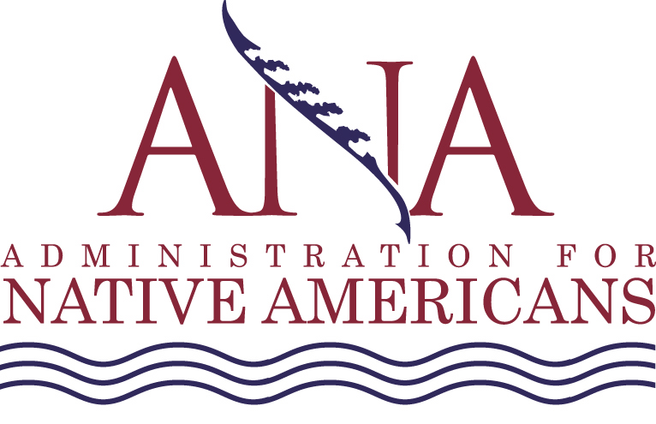
Grant Application Data Summary (GADS) Form

The Paperwork Reduction Act of 1995: Public reporting burden for this collection of information is estimated to average 1/2 hour per response, including the time for reviewing instructions, gathering and maintaining the data needed, and reviewing the collection of information. An agency may not conduct or sponsor, and a person is not required to respond to, a collection of information unless it displays a currently valid OMB number.

1. Applicant Name: |  |  | 2. State:
3. EIN (Employer Identification Number as assigned by the Internal Revenue Service): |  |  | 4. DUNS Number (Provide Data Universal Numbering System number received from Dun and Bradstreet):
5. Federal Amount Requested (Provide dollar amount requested for each one year budget period):
Year 1: |  | Year 2: |  |  | Year 3:
6. Choose the proposed project time frame:
12 Months | 24 Months |  |  | 36 Months
7. Applicant Type (Choose ONE that best describes your organization):
Federally Recognized Indian Tribe
Consortia of Indian Tribes
Incorporated Non-Federally Recognized Tribe
Incorporated Non-Federally Recognized Tribe and State Recognized Indian Tribes
Incorporated Non-Profit Multi-Purpose Community-Based Native American Organization
Urban Indian Center
National or Regional Incorporated Non-Profit Native American Organization
Alaska Native Village or Non-Profit Village Consortia
Incorporated Non-Profit Alaska Native Multi-purpose Community Based Organization
Non-Profit Alaska Native Regional Corporation/Association in Alaska
Non-Profit Native Organization in Alaska
Public or Non-Profit Private Agency Serving Native Hawaiians
Agency Serving Native Peoples from Guam, American Samoa, or Northern Mariana Islands
Tribally Controlled College or University, or Post-Secondary Vocational Institution
College or University Located in HI, GU, AS or MP Serving Native Pacific Islanders
Non-Profit Alaska Native Community Entity or Tribal Governing Body
Other Tribal or Village Organization
Tribal Governing Body
8. Partnerships (Collaborations) - Choose all that apply:
Other Federal Agencies
Community Organizations
National/Local Non-Profit Organizations
Tribes
State or Local Government
Private Business
Philanthropic Organizations
Faith-Based Organizations

9. Projected number of jobs created (Please provide ANA the number of jobs you anticipate creating if you are awarded an ANA grant):
10. Please choose the competitive area, for which you are applying for funding (SEDS, Environmental, Native Language). Under the competitive area you have chosen, please check only ONE ANA program area of interest that best describes the focus of your project i.e., only ONE check mark per applicant:
Social and Economic Development Strategies (SEDS)
- Economic Development
Business Development
Community Strategic Planning
Organizational Capacity Building
Subsistence Project
Emergency Response Activities
Transportation for Elders and Disabled
Transportation for Workforce Development
International Tourism and Trade
Job Training
- Social Development
Youth Development
Strengthening Family Relationship Skills
Cultural Preservation Activities
Family Violence Prevention
Education Development
Foster Parent Training
Supporting Elders
Supporting People with Disabilities
- Governance
Tribal Government Program Enhancement
Management and Leadership Development
Information Management Systems
Codes and Ordinances
Constitutional Reform
Operational Planning
Tribal Court Systems
- Special Initiative: Improving the Well-being of Children: Native American Healthy Marriage Initiative
Relationship and Marriage Education for Adults
Relationship and Marriage Education for Youth
Marriage Enrichment
Pre-marital education and marriage skills
Relationship Skills
Public Advertising Campaigns
Research
Environmental Regulatory Enhancement
Environmental Assessment
Infrastructure Improvement
Develop Regulations, Ordinances, or Laws
Develop a Technical Program
Training
Enforcement
Energy Assessment
Energy Projects for Export
Renewable Energy Resources
Native Language Preservation and Maintenance
- Category I - Assessment
Data Collection
Formal Language Assessment
Informal Language Assessment
- Category II - Planning
Develop Long Range Community Goals for Language
Develop a Language Strategic Plan
- Category III - Project Implementation
Establish Intergenerational Program
Train Language Teachers
Develop Printed Materials to Teach Language
Programs to Broadcast Native Language
Preservation of Oral Testimony
Digitize Materials

