1. Introduction

All individuals wishing to become an ANA Proposal Reviewer must complete the on-line application form. This includes those that have never been an ANA Proposal Reviewer as well as those individuals that have been an ANA Proposal Reviewer in the past. You will be creating your personal profile much like the information submitted in the paper form. The on-line application form will create an automated profile of your qualifications and interests and allow you, the applicant, to update your profile as necessary.

The on-line application contains nine categories. These categories are used to collect information on your personal and professional experience and to create your profile. The following categories will be covered:
- General Information -- this includes your social security number, address and telephone contact information.

- ANA Evaluator Experience – this includes any previous ANA Proposal Reviewer experience that you may have in ANA’s program fields.

- Other Evaluator Experience – this includes any previous Proposal Reviewer experience with other funding institutions.

- ANA Program Areas – this includes your expertise in social and economic development strategies, language, environment and governance.

- Demographic Information – this includes your ethnic heritage and tribal membership information.

- Experience in Providing Training and Technical Assistance (T/TA) – this includes your experience, if any, in the provision of T/TA to Native Communities and individuals.

- Resume – this includes the attachment of your updated resume.

- Review – this allows you to review all of the information that your have entered into your personal profile and submission to ANA.

After you log-on to the system, you will see on the left hand side of the screen the primary categories listed. By left clicking on any of the primary categories you can go directly to that subject to add information or to edit your profile information at any time.

The following instructions provides step-by-step guide on how to navigate through the ANA Proposal Reviewer Application Form process. The on-line application process will begin with how to log-on to the system. This will include instructions for previous ANA Proposal Reviewers as well as new ANA Proposal Reviewer applicants.

Please pay strict attention to the instructions. If you have any questions contact the ANA Help Desk at 877-922-9262.

Navigational Tools and Buttons

Throughout the on-line application, on the screens you will find buttons that allow you to edit, cancel, save and/or proceed to another screen. The following is a glossary of terms and explanation of their functions:

Cancel – removes the information without saving it to the database.

Edit – allows information edition that was permanently saved to the database.

Reset- clears the display fields and allows you to re-enter information.

Previous – takes you to the previous screen

Save – causes the information to be permanently added to your personal profile.

Next – takes you to the next screen

The first section of these instructions will begin with how to log-on to the system. There are separate instructions for previous Proposal Reviewers that have already been issued a password and user id, and for new evaluators that need to obtain a password and user id.

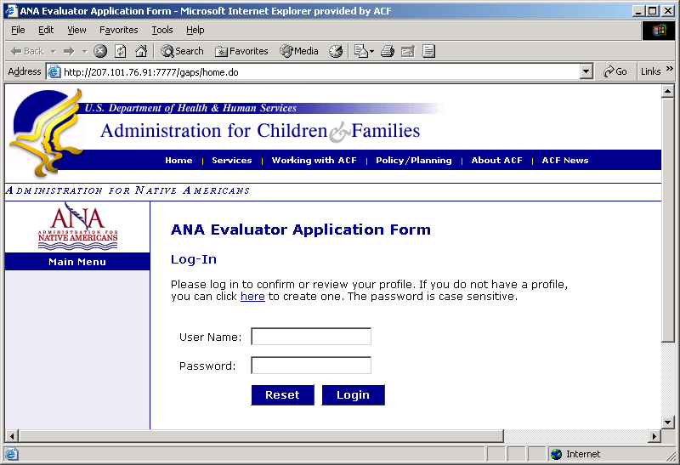

2. Log-In

Evaluators
Previous ANA Proposal Reviewers: If you have been an ANA Proposal Reviewer in the past and have already been issued a user name and password:
- Type in your user name and password in the appropriate field.
- Left click Log-in.
Remember that the password and user name are case sensitive.
Once you log-on, go to Proposal Reviewer Dashboard and click on “View/Update Profile.”
If you have forgotten your user name and password contact the ANA Help Desk.
New ANA Proposal Reviwers: If you are a new Proposal Reviewer or need a user name and password:
- Left click “Here” for log-in instructions.
- This will take you to General Information.
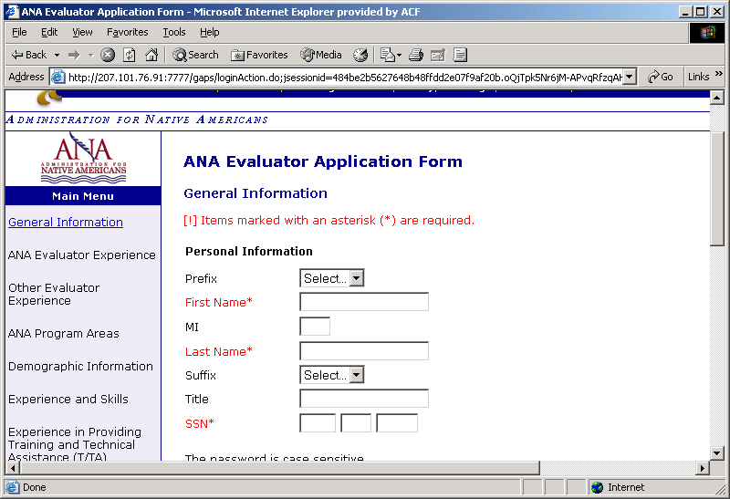

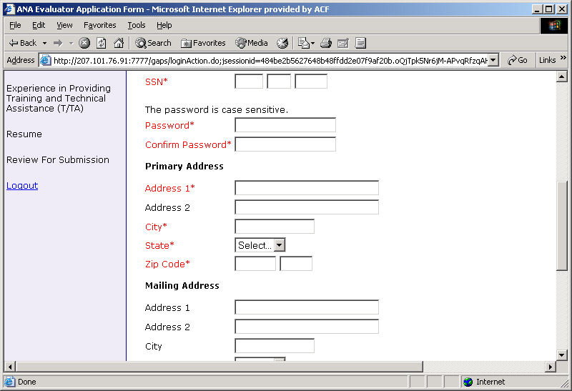
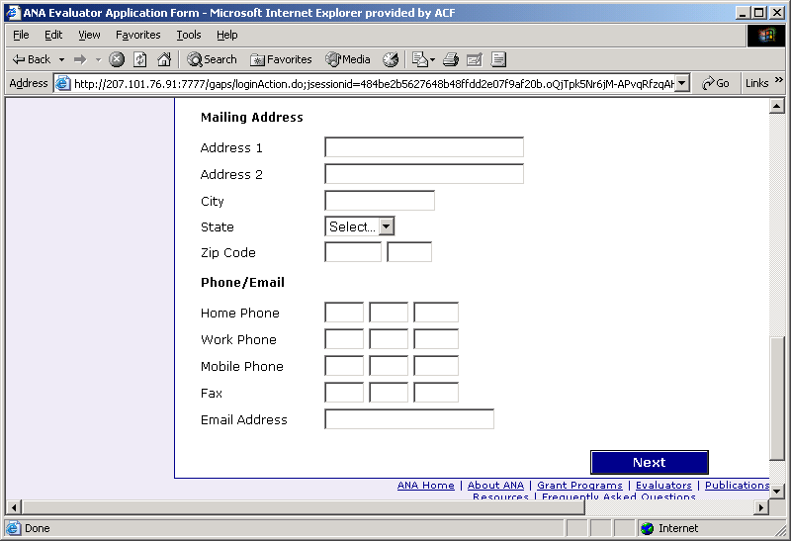

General Information

New ANA Proposal Reviewer will be required to provide your name, address, social security number, and telephone contact information. All fields with an asterisk (*) are mandatory. You can tab from one field to the next or use your mouse pointer and click in the appropriate field for information entry.

Type your name and social security number in the designated fields.

Please choose a password and type in the appropriate field. Then re-type the password for confirmation. Please make note of the password for future use for your profile update.

Type your primary address in the address fields. If you have a PO Box number address, please provide a mailing address to facilitate overnight deliveries, if required.

Type your telephone, fax and email contact information in the appropriate fields.

When finished left click “Next” to proceed to the Log-In Screen.

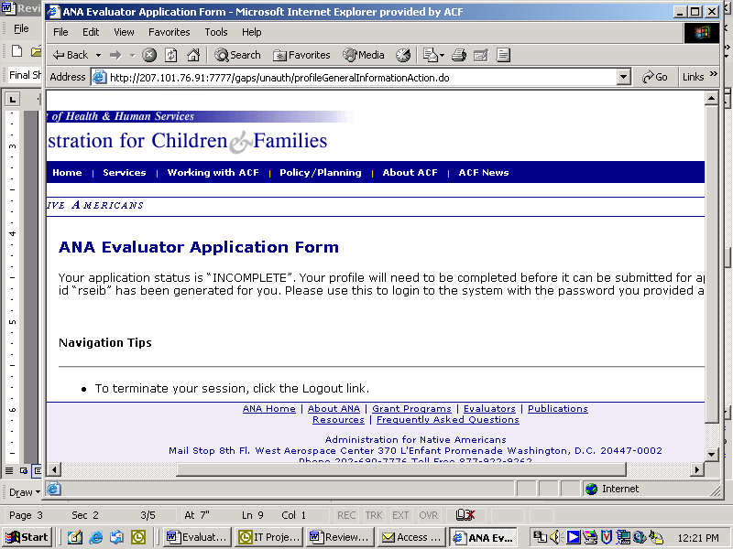

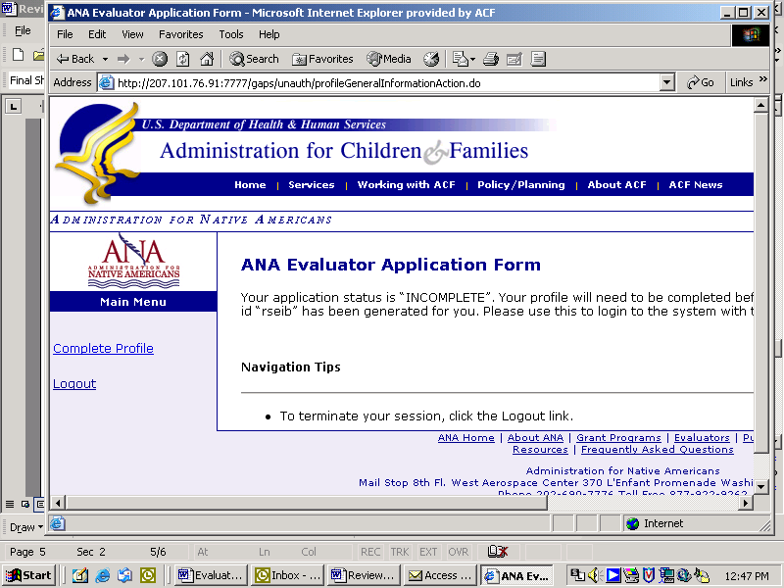

Next, a screen will appear stating:

Your application status is “incomplete.”

But don’t worry. This section automatically generates your user id/name. Within the body of the screen a user id/name is generated for you.

Please make note of the user id/name and keep it with your password. You will need both to log-on to the system.

Remember the user id and the user name are the same.

After writing down the user id/name:
- Left click “Complete Profile” on the left hand side of the screen.

- Proceed to the Log-in Screen

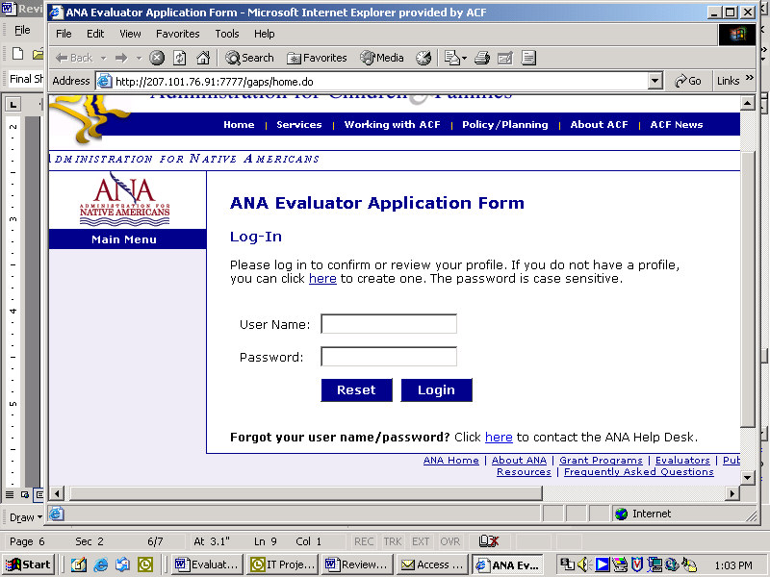

Log-in

The log-in screen will appear.

Type in your generated user id in the User Name field on the log-in screen.

Also type in your password in the Password Field.

If you do not enter your user id correctly, a message saying,

“The user name/password combination was not valid. Please check your user name and password and try again.”

If this occurs, you will need to check and make sure you entered the information correctly, or contact the ANA Help Desk with the link provided.

When finished:
- Left click “Log-In.”
- Proceed to the ANA Proposal Reviewer Profile Section

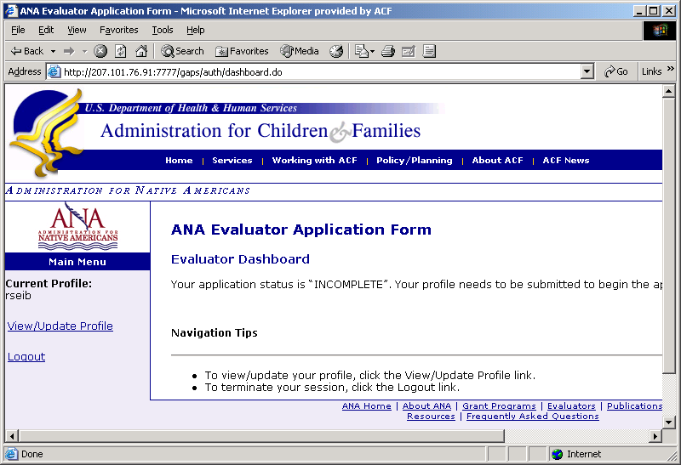

3. ANA Proposal Reviewer Profile

Completing the Profile

Once you successfully log-in the Proposal Reviewer Dashboard screen will appear. It will state:
“Your application status is “incomplete.” Your profile needs to be submitted to begin the approval process.”

Again, don’t worry about this message.

To complete your profile left click “View/Update Profile” on the left hand side of the screen to proceed to next screen.

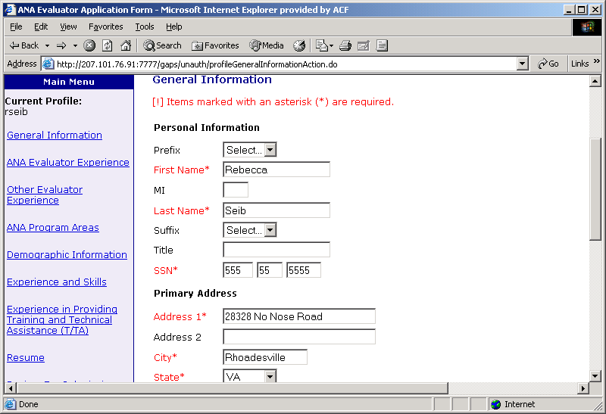

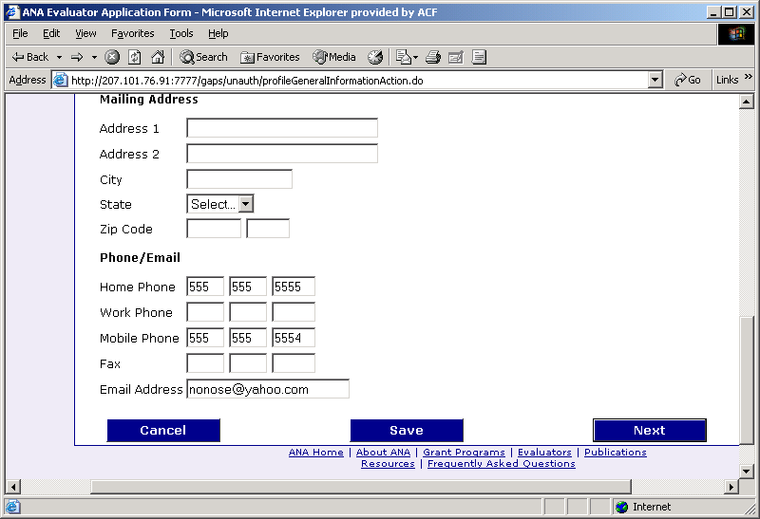

general Information
The General Information screen will appear and will contain your contact information that you previously entered. Check the information for correctness.

If the information is incorrect or incomplete, please correct or complete the information at this time.

To update or correct your contact information scroll down to the bottom of the screen and
- Left click “Edit.”
- Change or edit any information that may be necessary.

- Left click “Save”.
- Left click “Next”
- Proceed to the ANA Proposal Reviewer Experience Screen.

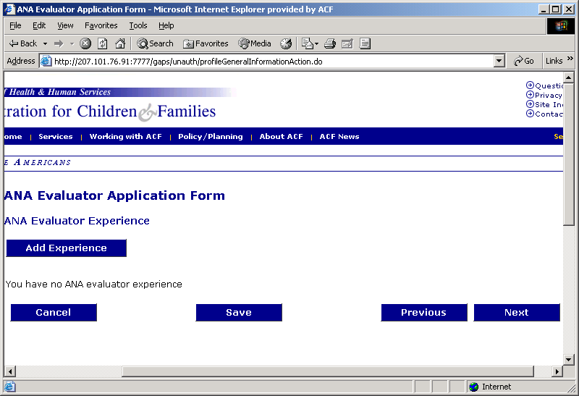

4. ANA Proposal Reviewer Experience

This section of the on-line application asks for any previous ANA Proposal Reviewer Experience. The first screen will state:

“You have no ANA Proposal Reviewer Experience.”

Don’t be confused by this message. This message will appear for all applicants logging-on for the first time. If you have no previous experience as a Proposal Reviewer for ANA, click “Next” and proceed to the next screen.

If you have previous experience as a ANA Proposal Reviewer or want to add additional experience to your profile, click “Add Experience.”
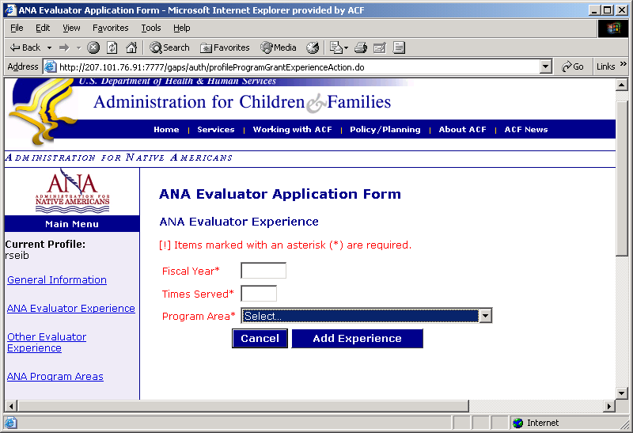

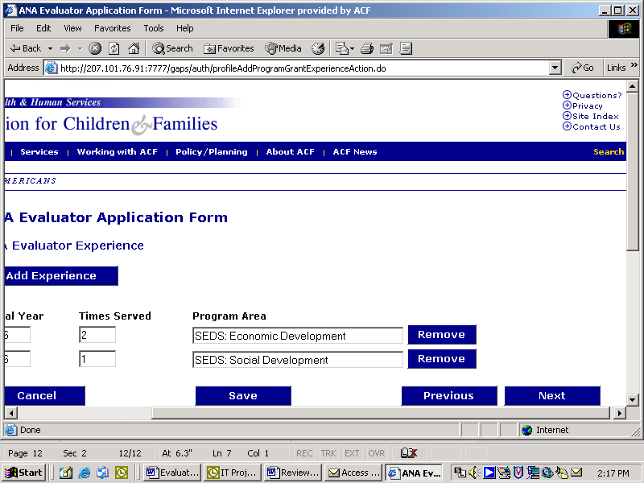

Previous ANA Proposal Reviewer Experience
A screen will appear requesting information on your previous ANA Proposal Reviewer experience. The information requested includes the fiscal year, times served during that fiscal year, and the program area.

If you were an ANA Proposal Reviewer for more than one program within the same fiscal year, you must record and save them separately. Therefore in recording your previous experience, choose one program at a time.

For Example:
You were an ANA Proposal Reviewer for SEDS two times in 1996, enter:
Fiscal Year* 1996 (Enter the four digit year)
Times Served* 2 (Use the numeric number)
Program Area* SEDS Economic Development

Left click “Add Experience.”

A review screen will appear. If the information is correct:
- Left click “Save.”
If you do not have additional ANA Proposal Reviewer Experience to add to your profile:
- Left click “Next” to proceed to the Other Proposal Reviewer Experience Screen.

If you have additional ANA Proposal Reviewer Experience
- Left Click “Add Experience”

Remember you must “Save” after each entry to include the information in your personal profile.
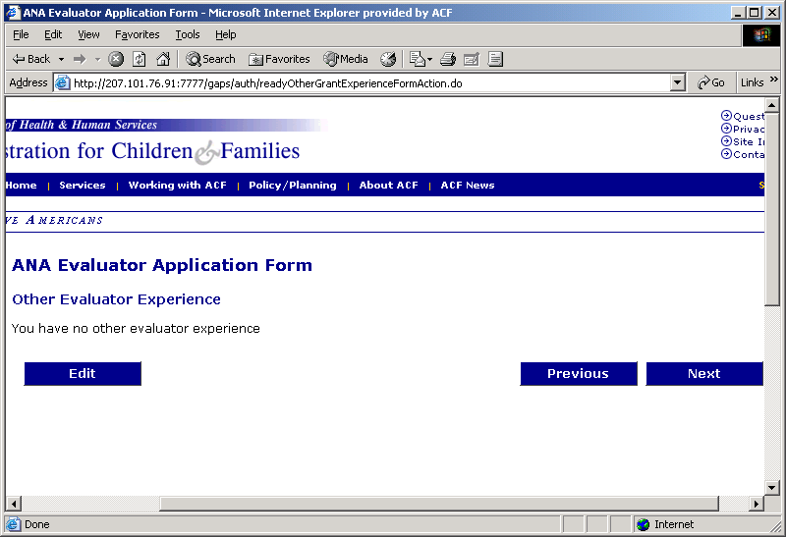

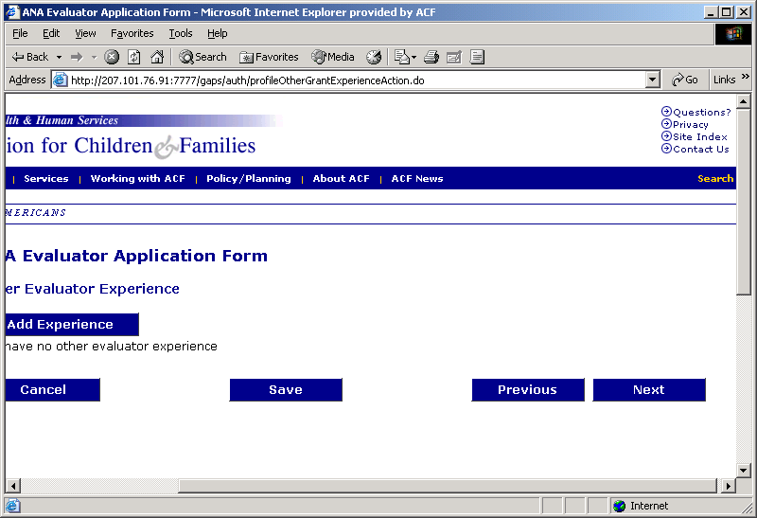

5. Other ANA Proposal Reviewer Experience

After clicking “Next” a screen titled “Other Proposal Reviewer Experience will appear. If you do not have additional Proposal Reviewer experience or grant review experience
- Left click “Next” to continue to the ANA Program Area section.

If you have additional Proposal Reviewer experience in reviewing grant requests from other funding institutions (i.e. Ford Foundation, USDA)
- Left click “Edit” to add the additional experience.

Once you click Edit, a screen will appear stating that

“You have no other evaluator experience.”

To add additional Proposal Reviewer experience
- Left click “Add Experience”

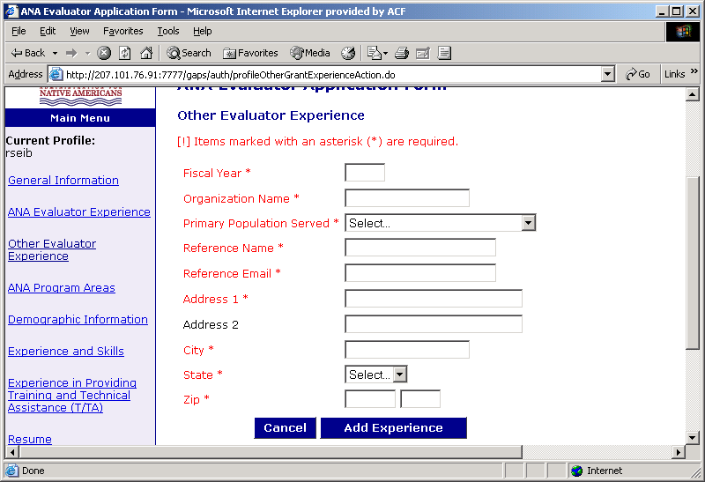

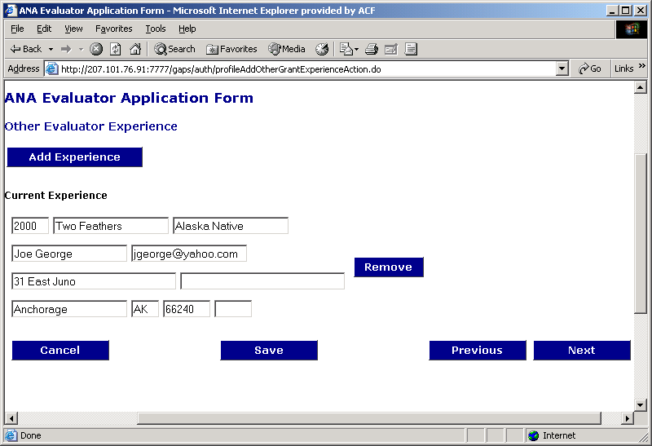

The next screen will ask for the specifics of your additional Proposal Reviewer experience.

All the fields with an asterisk (*) are required.

Once completed
- Left click “Add Experience”

The next screen that appears allows you to review the information. If complete and correct
- Left click “Save”
- Left click “Next” to proceed to ANA Program Areas.
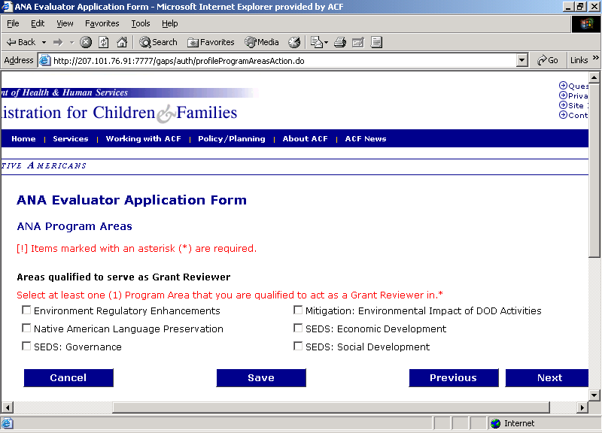

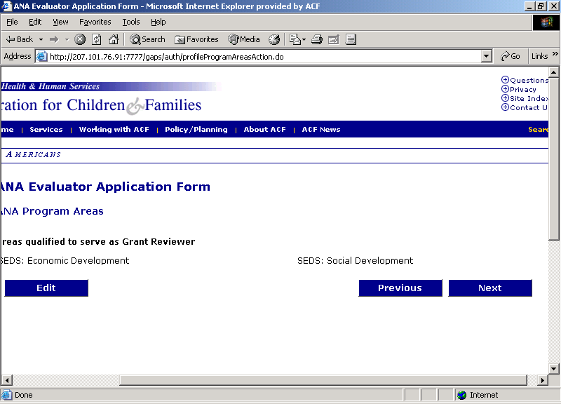

6. ANA Program Areas
The ANA Program Areas screen is requesting information on the ANA program areas for which you are qualified to serve as a Proposal Reviewer.

You must select at least one program area to be an eligible ANA Proposal Reviewer. If necessary you can select more than one ANA Program area.
- Left click on all appropriate program boxes that qualify you to act as an Proposal Reviewer.

- When finished left click “Save”
- Left click “Next”

A review screen will appear. If the information is correct
- Left click “Next” and proceed to the Demographic Information screen.

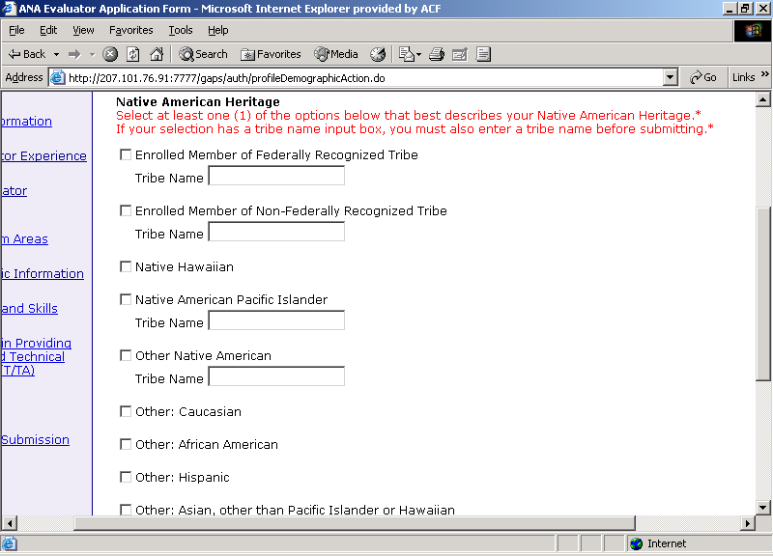

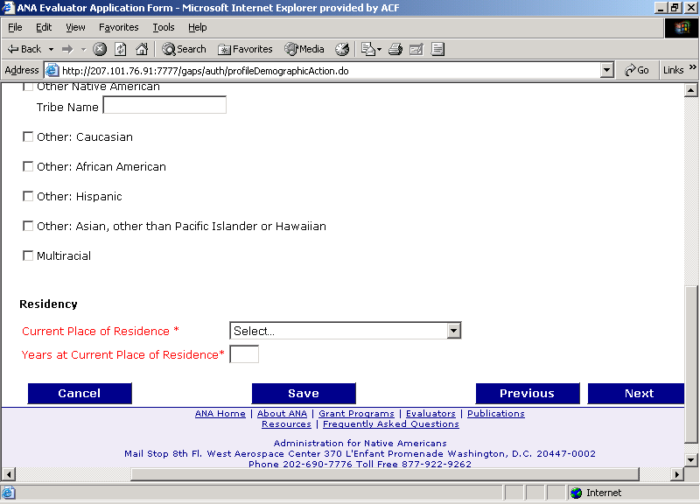

7. Demographic Information
The Demographic Information screen requests information on your Native heritage. Please review carefully and select the appropriate category that best describes your Native Heritage.

When appropriate, please type the name of your Tribe or Native community in the Tribe Name field.

In addition, please record your current place of residency and the number of years that you have been living at this location.
- Left click the drop down box to select the category that best describes your current place of residency.

- Left click “Save”

- Left click “Next” to proceed to the Experience and Skills section

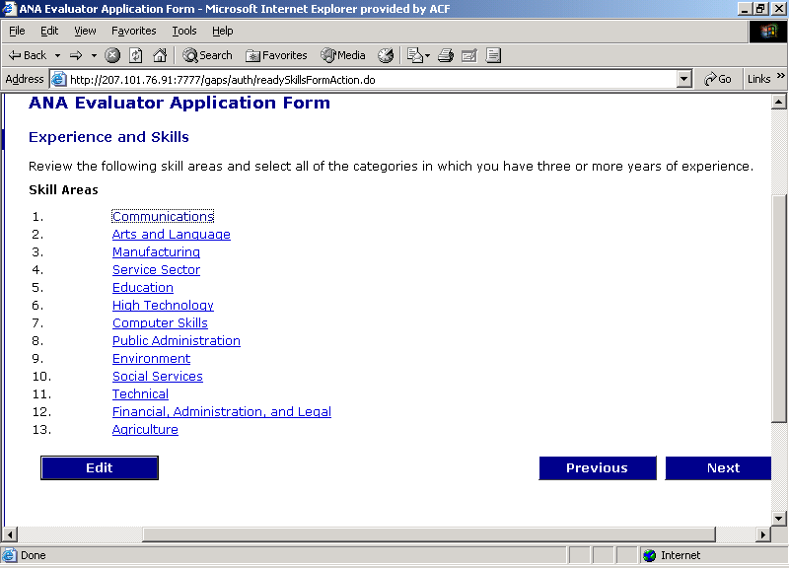

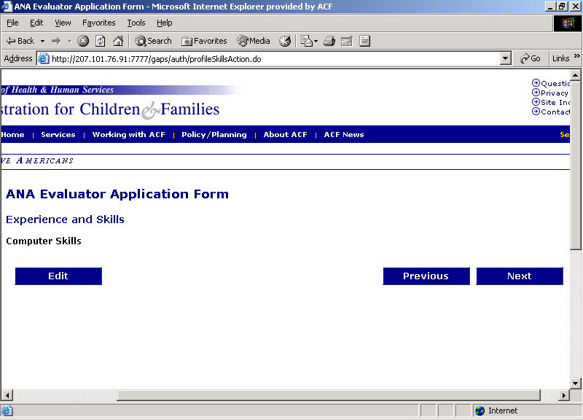

8. Experience and Skills
The Experience and Skills screen will request information on your experience and skills in thirteen different primary categories. Each primary category has sub-categories, which can be accessed by left clicking on each primary category. Left click a primary category to open the sub-category selections.

For demonstration, the Computer Skills primary category was opened. The Computer Skills screen appeared.
- Left click “Edit” to open the sub-category screen
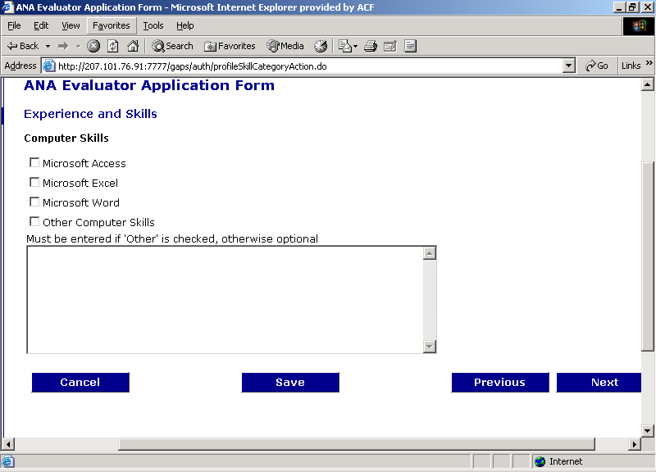

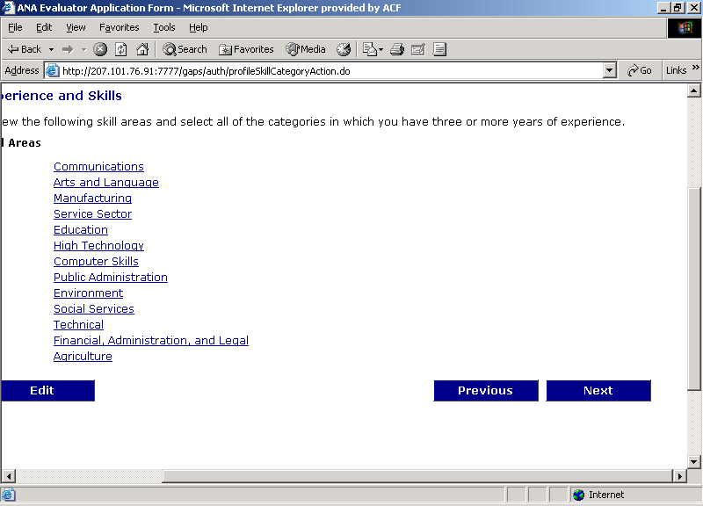

The sub-category screen will appear. Click on all the sub-categories that apply to your experience and skills. If a description of your skills and experience is not listed in the sub-categories, choose “Other” and briefly describe the experience or skill in the box provided.

When completed
- Left click “Save”
- Left click “Next” to return to the Experience and Skills screen.

Remember to “Save” after the sub-category selection. If you do not “Save” the selections will not be recorded in your personal profile.

Repeat the process for each primary category that is applicable to your experience and skills. If you have no experience or skills in a particular primary category, skip and proceed to the next primary category.

When you are finished with all the primary categories, left click “Next” and proceed to the Training and Technical Assistance (T/TA) section.

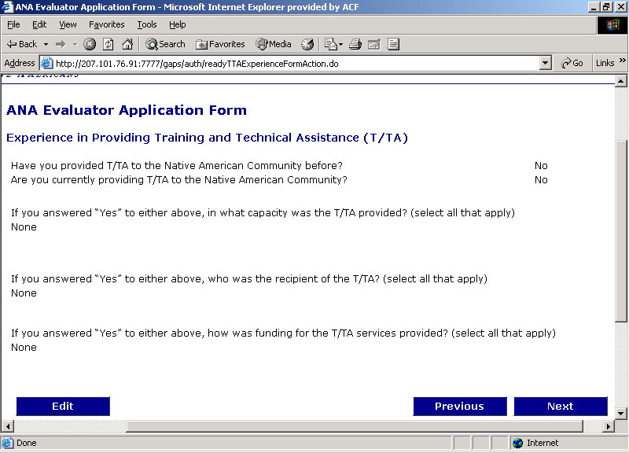

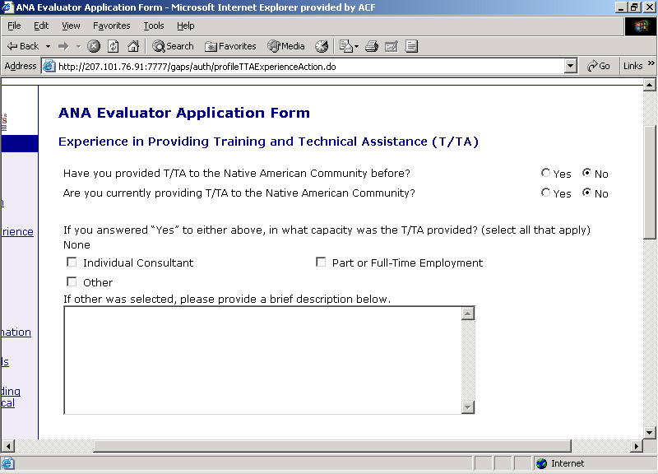

9. Training and Technical Assistance (T/Ta) Experience
This section is requesting information on your experience in providing training and technical assistance (T/TA) to native communities and individuals. Read the two questions at the top of the screen.
If you answered “no” to both of the two questions
- Left click “Next” and proceed to the Resume section.

If you answered, “yes” to either of the two questions
- Left click “Edit” to add T/Ta information to your profile.

After you click “Edit” a more detailed screen will appear requesting additional information. Now you can record your answers to the two questions. Left click “yes” or “no” to the two questions.

The first entry, requests information on your capacity in T/TA provision. You can select more than one category if applicable. If you provided T/TA in a mode not listed, click “Other” and provide a brief description in the box provided.

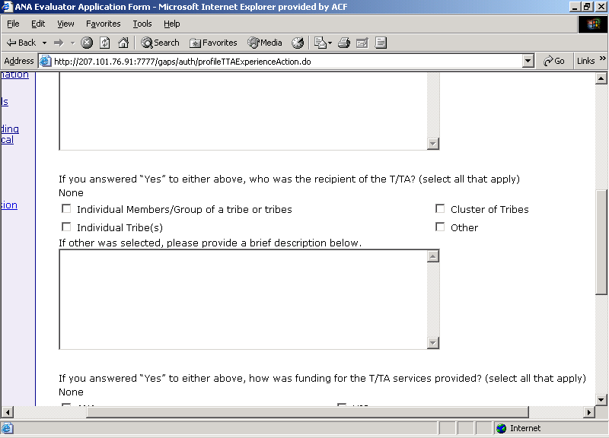

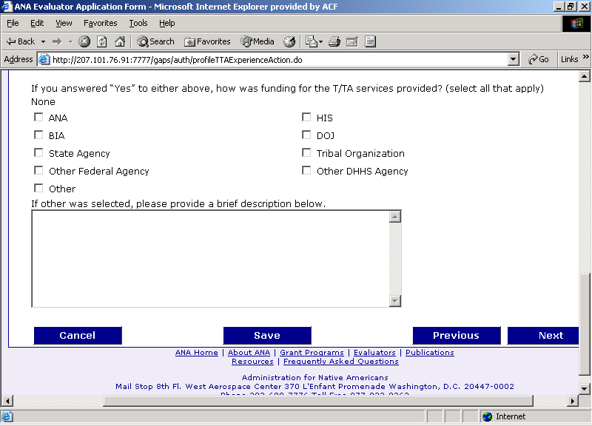

The second question is directed toward the types of recipients of the T/TA. Again you can select all that apply to your experience in providing T/TA.

The last question relates to the type of funding utilized to pay for the T/Ta that you provided. The provision of this information is not mandatory and can be skipped if the funding source is unknown.

When you are finished completing this portion of the application
- Left click “Save”
- Left click “Next”
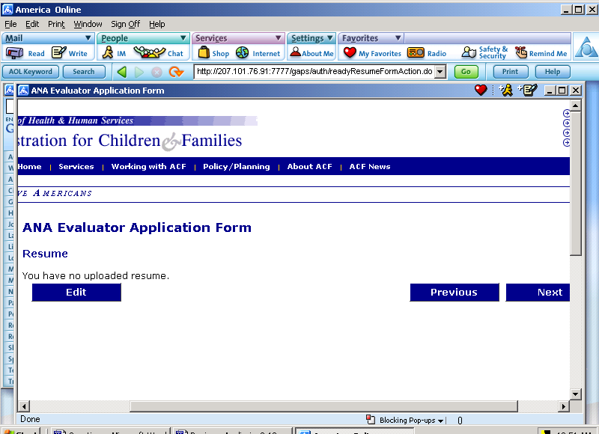

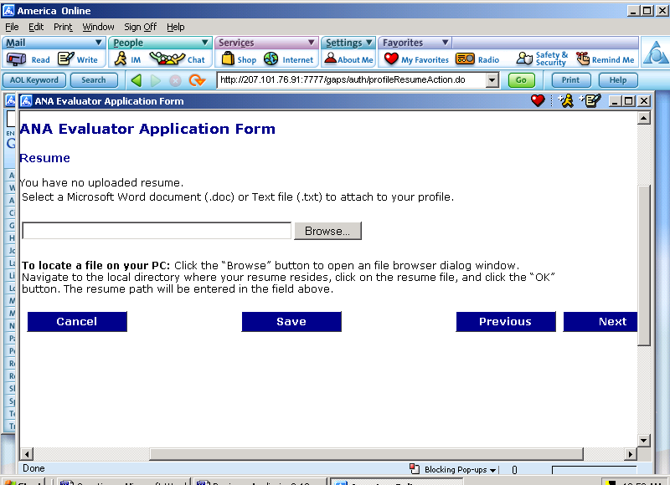

10. Resume
The Resume section of the on-line Proposal Reviewer Application Form requests that you attach your current resume. A screen will appear and state,
“You have no uploaded resume.”
Don’t panic. It you have a resume, it is suggested that you attach it to your profile. To attach your resume left click “Edit.”

If you do not want to attach your resume, left click “Next” and proceed to the Review section.

After selecting “Edit”, the next screen allows you to attach your resume from your personal computer files.
- Left click “Browse” to locate your resume on your computer system.

- Your resume should be in text, PDF or Microsoft Word format.

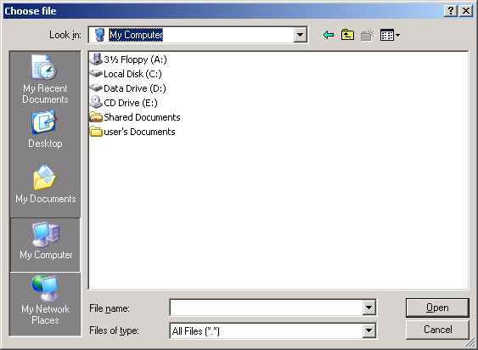

After clicking “Browse”, a windows screen will appear and you can locate your resume by navigating through the appropriate data drive.

Once you locate your resume, highlight it. To attach your resume to your Proposal Reviewer profile left click “Open” on your windows screen.

It will automatically place the resume address in the “Browse” field.
To save it to your personal profile:
- Left click “Save”
- Left click “Next”

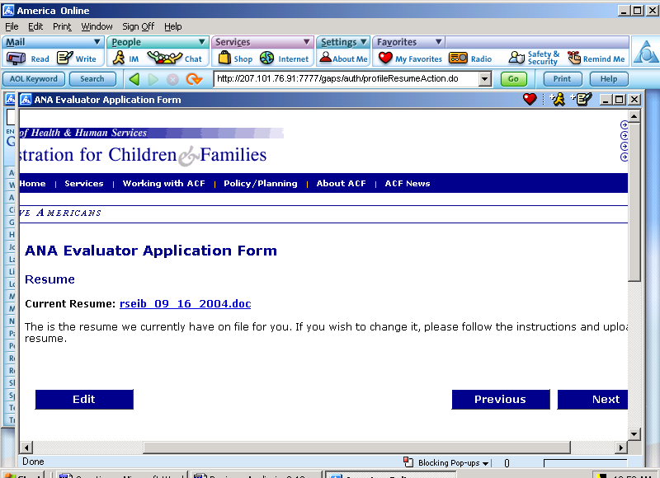

Another screen will appear that will indicate the date the resume document was attached to your personal profile.

If you want to attach an updated resume, left click “Edit” and follow the same procedure as before.

To proceed to the next screen, left click “Next.”

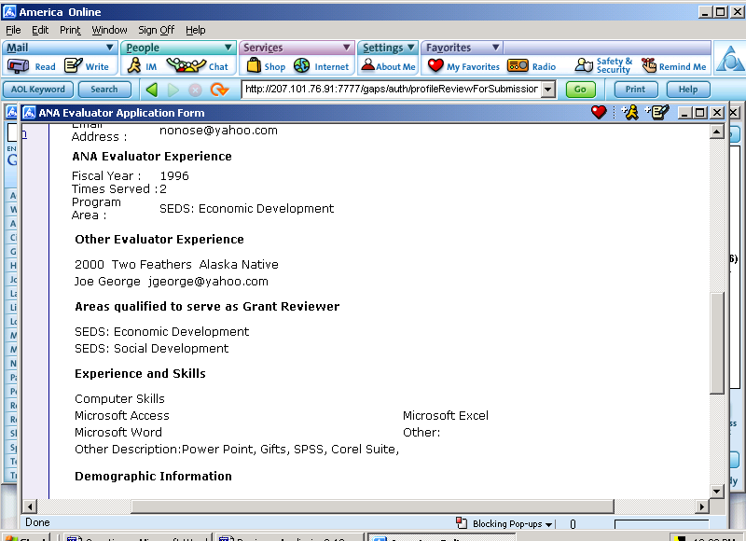

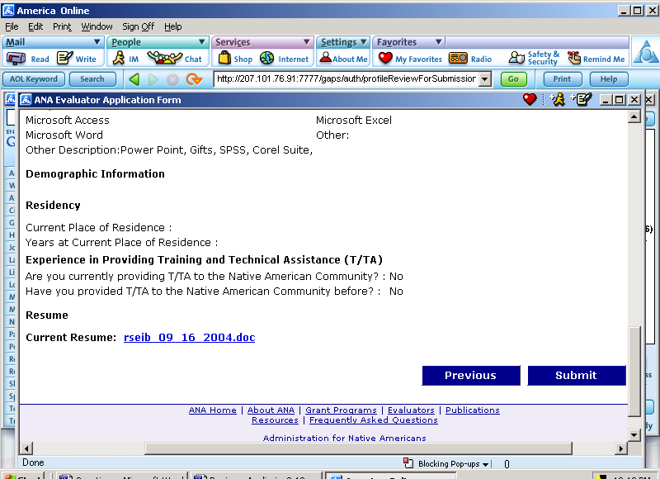

11. Review and Submit
The last screen, Review and Submit, allows you to review all your profile information that you have entered. This information should be reviewed for correctness and completeness prior to submitting to ANA.

Check all of your information and make sure everything is correct and complete.
If you need to make changes, left click on the appropriate primary category on the left hand-side of the screen. This will take you to the appropriate screen.
For example:
Your Demographic information was not attached to your personal profile.
- Left click “Demographic Information”
- Refer to 7. Demographic Information in these instructions and enter your information.

If you are satisfied with all the information, left click “Submit.” Your ANA Proposal Reviewer Profile has been submitted to ANA.

FINI

