News from the House Agriculture Committee
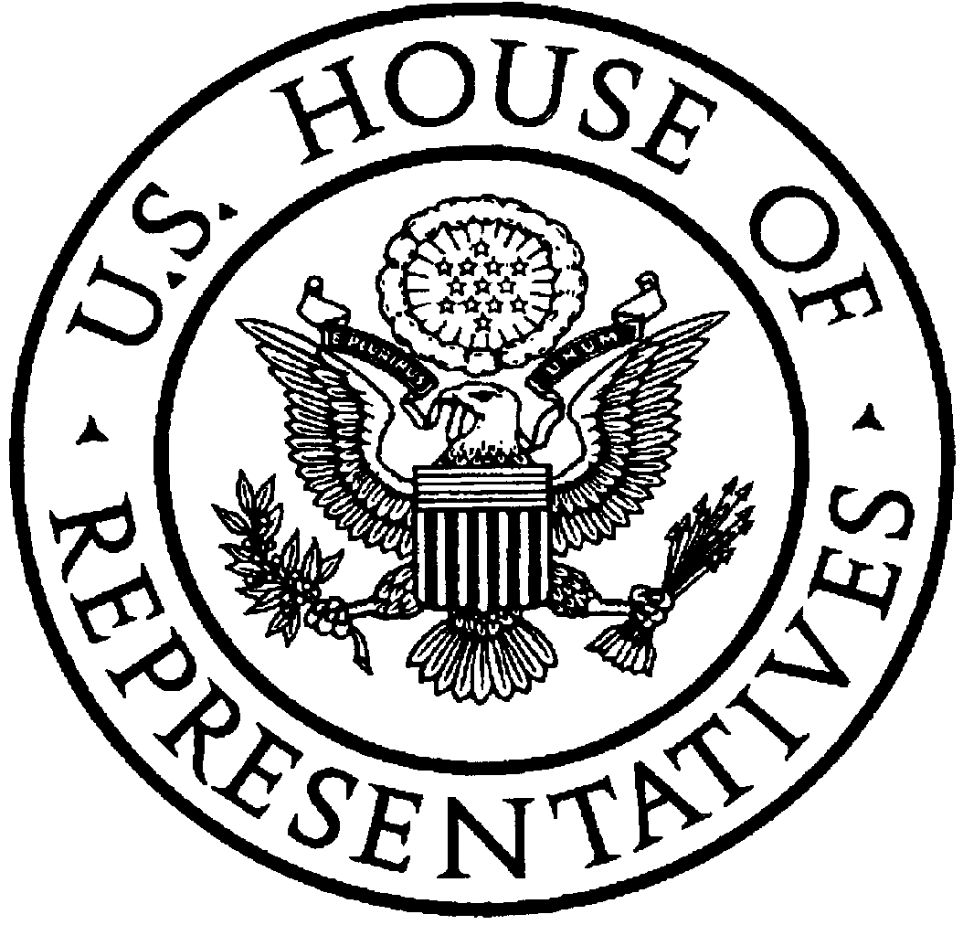
U.S. House of Representatives
Committee on Agriculture
Collin C. Peterson, Minnesota

Chairman

http://agriculture.house.gov

Opening Statement
Chairman Collin C. Peterson
House Agriculture Committee – Full Committee Business Meeting
To Consider Reauthorization of the Commodity Futures Trading Commission
December 12, 2007

Today, the House Agriculture Committee is considering the reauthorization of the Commodity Futures Trading Commission through fiscal year 2013.

I want to commend the Chairman of the General Farm Commodities and Risk Management Subcommittee, Bob Etheridge, and Ranking Member Jerry Moran, for their work on this bill and for staying on top of CFTC reauthorization at the same time we have been working on getting a Farm Bill done and signed by the President. I also want to thank the Ranking Member of the Full Committee, Mr. Goodlatte, for the work he did on reauthorization when he was Chairman along with Mr. Moran, the Subcommittee Chairman at that time. Title I of the bill before the Committee today is nearly identical to H.R. 4473 from the 109th Congress, a bipartisan bill that passed the House of Representatives by voice vote.

In addition, Mr. Barrow, Mr. Graves and Mr. Marshall on this committee have worked very hard on important issues in this bill related to energy markets and have been tireless advocates for their constituents. I think the bill before us today makes important progress thanks to their efforts.

I also want to thank Acting CFTC Chairman Walter Lukken, CFTC commissioners Michael Dunn, Jill Sommers, Bart Chilton, and their staffs for their input and recommendations in crafting this bill and for being available for questions today if members have questions or need clarification.

The bipartisan bill we are considering today reauthorizes the Commodity Futures Trading Commission, the regulator of futures markets. The CFTC was last reauthorized in 2000 with passage of the Commodity Futures Modernization Act, which brought legal certainty to the growing off-exchange derivatives industry and brought the exchange-traded regulatory program into a new era where electronic markets have largely replaced the open-outcry trading pits.

The CFMA acknowledged that adequate regulation and investor protection must be balanced with the need to allow emerging exchanges to thrive and promote responsible innovations. The principles-based regulatory structure of the CFTC has allowed the Commission flexibility in a variety of matters from approving new trading contracts to speeding up the registration of new exchanges and clearing houses. The bill the committee is considering today will continue to reach those goals while making improvements that will reduce fraud, strengthen price discovery and more effectively police the retail foreign exchange industry.
This bill will strengthen oversight over the retail foreign exchange trading industry and will stem the unintended consequences of the Zelener decision, which held that certain disguised retail foreign exchange contracts were not futures contracts and could be legally sold. That case involved a boiler room selling off-exchange forex contracts with the CFTC powerless to stop them because the contracts in question were not futures even though they appeared to be. This bill includes additional legal authority over retail foreign exchange agreements and contracts in foreign currency to stop unscrupulous persons who write and market contracts in foreign currencies that are nothing more than scams to defraud the public.

As was the case when we attempted reauthorization in 2005, I believe the remedy incorporated in this bill will restore the CFTC's ability to ensure that similar perpetrators of deceptive schemes involving foreign exchange trading can be policed effectively. However, because the scope of this fix is limited to foreign exchange contracts, we need to be prepared for the possibility that a similar problem will arise in other product areas like gasoline, heating oil, or any other commodity that can be sold to the public without effective regulation.

This bill also incorporates some of CFTC’s recommendations to increase the oversight of some trading activity on electronic trading facilities known as Exempt Commercial Markets (ECMs). It establishes large trader position reporting, position limits, self-regulatory oversight, and emergency anti-manipulation authority for certain ECM contracts that serve a significant price discovery function. Furthermore, the bill clarifies the Commission's anti-fraud authority to bring actions in off-exchange principal-to-principal transactions under section 4(b) of the Commodity Exchange Act. Such fraud authority will give the CFTC more effective oversight on the over-the-counter (OTC) market for energy derivatives.

The futures industry is an important segment of our economy. The principles-based regulation model created by the Commodity Futures Modernization Act has allowed the futures industry to grow and respond to ever-changing markets. Chairman Lukken himself said not long ago that “good regulators play where the markets are going, not where the markets have been.” I believe continuing the model of the 2000 law will allow CFTC to continue protecting America's investors without impeding market innovation.

With that, I urge the committee to approve the bill and I yield to Mr. Goodlatte for an opening statement.

###

