News from the House Agriculture Committee
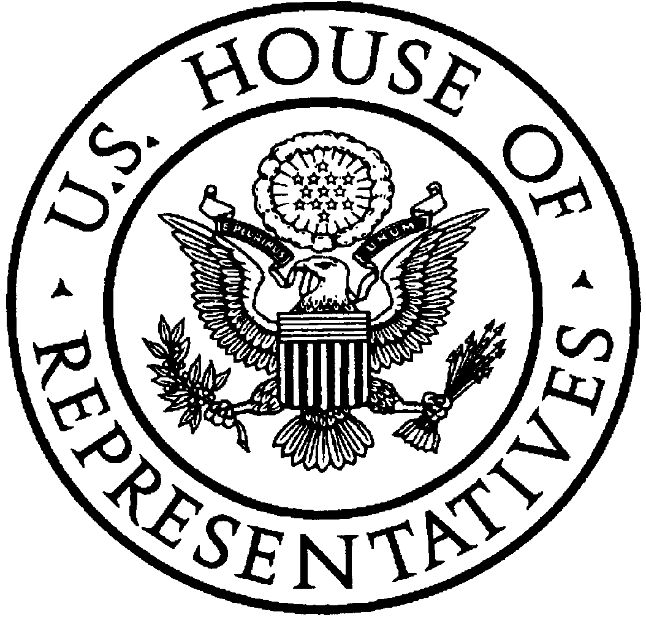
U.S. House of Representatives
Committee on Agriculture
Collin C. Peterson, Minnesota

Chairman

http://agriculture.house.gov

110th Congress Accomplishments of the
House Committee on Agriculture

An Ambitious Agenda for the House Agriculture Committee
- Agriculture Committee Chairman Collin Peterson brought an open, transparent approach to Committee business and maintained the strong bipartisan tradition of the Committee.

- The House Agriculture Committee successfully drafted and passed a bipartisan, forward- looking Farm Bill that makes historic new investments in food, farm and conservation programs.

- The process of writing the House version of the Farm Bill was done in public with input from all perspectives. Each of the Committee’s six subcommittees held open, public hearings in Washington, DC and around the country and held markups on every title of the Farm Bill before the full Committee approved it with strong bipartisan support.

- The Agriculture Committee held 14 full committee hearings and 11 business meetings during the 110th Congress. Various subcommittees held 37 hearings and 6 business meetings during the 110th Congress.

- The Committee heard testimony from Administration officials on 56 occasions, including 32 testimonies from U.S. Department of Agriculture representatives, 6 from the Commodities Futures Trading Commission, and 4 from the U.S. Food and Drug Administration. Additional testimony heard by the Committee was offered by university researchers, non-profit organizations, consumer groups, trade groups, and farmers and ranchers from across the United States.

The Food, Conservation and Energy Act of 2008
- The Food, Conservation and Energy Act, also known as the 2008 Farm Bill, extends and modernizes the basic farm program safety net that protects farmers when crop prices are low. This safety net provides the security our farmers need to stay on the land, producing the safest, most abundant food supply in the world.

- The Farm Bill invests more than $406 billion over ten years in nutrition programs to help more than 38 million Americans afford healthy meals and to update the Food Stamp Program to reflect the economic reality working families face.

- The Farm Bill provides more than $54 billion over 10 years in conservation program spending to protect and enhance water, air, and soil quality; to prevent erosion; and to conserve natural resources.

- The Farm Bill makes a substantial new investment of $1.3 billion over 10 years for programs to promote the production and consumption of fruits and vegetables. This is the first farm bill that directs substantial resources particularly to address the needs of fruit and vegetable producers.

- The Farm Bill provides $1.1 billion over 10 years for renewable energy programs, a historic investment in research, development and production of renewable energy, which will encourage the development of cellulosic biofuels and decrease our dependence on foreign oil.

- The Farm Bill includes significant reforms, reducing the existing payment limit for farm programs by 80%, closing business structure loopholes to prevent people from receiving multiple payments, and increasing transparency by requiring farm program payments to be linked directly to the person receiving them.

- The Farm Bill implements the long-delayed Country-of-Origin labeling program that provides consumers with important information about where the meat and produce they purchase was grown.

Nutrition Programs
- The Subcommittee on Department Operations, Oversight, Nutrition and Forestry held two hearings on the importance of federal nutrition program efforts during the 110th Congress; one hearing to review the impact of the federal Food Stamp Program on children’s health and one to explore the short and long-term costs of hunger in America.

- The Committee renamed the Food Stamp Program in the Farm Bill, changing the program’s name to the Supplemental Nutrition Assistance Program (SNAP). The new program name is more suitable since the program no longer uses food stamp coupons and has transitioned to using Electronic Benefit Transfer technology for benefit distribution.

- The Farm Bill improves benefit rules for the Supplemental Nutrition Assistance Program (formerly the Food Stamp Program) to more adequately cover food expenses better support families in need and to ensure that food stamp benefits will always keep up with inflation.

- The Farm Bill also significantly expands funding for The Emergency Food Assistance Program (TEFAP) from $140 million to $250 million per year. TEFAP is a critically important program that provides food and other resources to help stock food banks.

- The bill also included $5 million per year for Community Food Projects grants for innovative community projects, including the Healthy Urban Food Enterprise Development Center Program, which will provide grants to programs that improve access to fresh foods in isolated urban and rural food deserts.

- The bill also expands the USDA Snack Program nationwide, which helps schools provide healthy snacks and educate kids about the importance of healthy eating.

Oversight of the U.S. Department of Agriculture and the Commodities Futures Trading Commission
- During the 110th Congress, the Agriculture Committee held 5 oversight hearings to review concerns related to commodity and energy markets and credit derivative trading. These hearings were held both before and after the recent credit and financial crisis that highlighted the role of credit derivatives.

- The Committee reauthorized the Commodities Futures Trading Commission and gave the CFTC greater authority over previously unregulated energy markets in the Farm Bill.

- The Committee drafted and the House of Representatives passed H.R. 6604, the Commodity Markets Transparency and Accountability Act of 2008, which would increase transparency, oversight, and anti-manipulation authority over commodity futures and options markets.

- In June 2008, the House passed H.R. 6377, which would require the Commodity Futures Trading Commission (CFTC) to utilize all its authority, including emergency powers, to take steps to curb excessive speculation in the energy futures markets.

- In addition to oversight hearings on commodity and energy markets, the Committee held three hearings on reauthorization of the Commodities Futures Trading Commission and the Commodities Exchange Act.

- In May 2007, the Committee investigated the USDA’s use and release of Social Security numbers of more than 38,000 USDA farm program participants.

Renewable Energy
- The Committee has made the transition to the next generations of ethanol and biofuels a top priority, holding hearings on the renewable energy financing, the reliability of electricity in rural America, the transition to environmentally-beneficial cellulosic feedstocks, and ongoing research into the use of ethanol by-products in livestock feed.

- The Farm Bill provides $1.1 billion for renewable energy programs, particularly programs related to the development of cellulosic biofuels. It also reduces tax credit for corn-based ethanol and increases incentive for ethanol made from cellulosic sources.

- The Committee passed H. Con. Res. 25 - also known as 25x’25 - expressing the sense of Congress that by the year 2025, America’s agricultural and forest lands should provide at least 25 percent of the total energy consumed in the United States through renewable sources.

- In 2007 and 2008, the Subcommittee on Conservation, Credit, Energy and Research held hearings on the implementation and producer eligibility for the Renewable Fuels Standard, financing for renewable energy projects and companies, and the reliability of electricity in rural America.

Conserving our Natural Resources
- The Subcommittee on Conservation, Credit, Energy and Research held a hearing prior to drafting the conservation components of the Farm Bill to look at how USDA’s Farm Bill conservation programs were implemented and utilized and to discuss proposed improvements to those programs.

- The Farm Bill includes $54 billion over 10 years for conservation programs to protect and enhance water, air, and soil quality and to conserve natural resources.

- The bill also provides crucial funding to restore the Chesapeake Bay, preserve open space through the Farm and Ranchland Protection Program, and improve water quality and quantity in targeted regions through the Wetlands Reserve Program and other programs.

Preserving the Farm Safety net
- The Farm Bill extends and modernizes the basic farm program safety net that protects farmers when crop prices are very low.

- The Farm Bill sets the stage for future improvements to U.S. farm policy by establishing the Average Crop Revenue Election (ACRE) program. The 2008 law allows producers to choose a market-oriented safety net program that adjusts with market prices and pays farmers only when they need it – when they suffer a real loss in revenue.

- The Subcommittee on General Farm Commodities and Risk Management held three hearings in 2007 on the Federal Crop Insurance Program to look at concerns with industry, some of which were addressed in the Farm Bill.

Improving Disaster Response
- Despite opposition from President Bush, Congress provided disaster assistance needed by farmers and ranchers who experienced serious losses due to weather related disasters in 2005-2007.

- In October 2007, the Committee held a hearing to review agriculture disaster conditions, including droughts, floods, fires and other conditions across the country and the impact on agriculture communities facing these conditions.

- The Farm Bill includes permanent disaster assistance programs that farmers and ranchers can count on when weather-related disasters hurt their operations. The permanent programs ensure an immediate response and prevent the bureaucratic delay that has occurred in previous years.

Organic Agriculture and Fruit and Vegetable Production
- At the beginning of the 110th Congress, a new Subcommittee was created to specifically address the needs of fruit and vegetable growers and organic farmers. The Subcommittee on Horticulture and Organic Agriculture held hearings and included Farm Bill provisions on issues of importance to this vital segment of the agriculture industry.

- The Subcommittee on Horticulture and Organic Agriculture held the first Agriculture Committee hearing dedicated specifically to the needs, concerns and issues of importance to organic agriculture producers, processors and marketers. Organic agriculture is a $14 billion per year industry that is growing exponentially.

- The Subcommittee held the first Congressional hearings to focus exclusively on the honey bee industry and their vital role as pollinators of the nation’s food supply. The two hearings focused on Colony Collapse Disorder, an epidemic that is killing honey bees at a rapid rate nationwide and the U.S. Department of Agriculture’s efforts to address the situation.

- During two hearings in 2007 and 2008, the Subcommittee looked at food safety concerns and traceability in fresh produce. The Subcommittee also focused on the performance of the U.S. Department of Agriculture’s Animal and Plant Health Inspection Service and the U.S. Department of Homeland Security Customs and Border Protection to protect U.S. agriculture from foreign pests and diseases.

- The Farm Bill provides new annual funding to defray the costs that producers and handlers incur when seeking organic certification and new annual funding for organic marketing data collection and publication.

- The Farm Bill also includes new funding specifically targeting the needs of fruit, vegetable and organic farmers, including $78 million for organic research and $230 million for the Specialty Crop Research Initiative.

Meeting the Credit, Infrastructure and Resource Needs of Rural Communities
- The Committee focused on the economic needs of rural America by holding hearings on access to health care and credit in rural America, the effectiveness of USDA Rural Development programs, improving access to broadband telecommunications services in underserved rural areas.

- The Farm Bill includes programs and funding that make critical investments in the infrastructure, technology, water, emergency services, telecommunications and small business needs of rural communities nationwide. It provides $120 million for critical water and wastewater projects in rural areas.

- The Subcommittee on Conservation, Credit, Energy and Research held a hearing to review the availability of credit for farmers and ranchers in March 2007. The Farm Bill made several necessary improvements to credit programs to ensure that agriculture producers can obtain credit.

- The Farm Bill also created a new Rural Entrepreneur and Microenterprise Assistance Program that will provide technical and financial assistance to micro-enterprises and small businesses and provided $15 million to initiate the program.

Food Safety and Animal Health
- The Subcommittee on Horticulture and Organic Agriculture held a hearing to investigate the produce industry’s response to recent foodborne illness outbreaks associated with fresh and fresh-cut produce.

- In September 2008, the Subcommittee on Livestock, Dairy and Poultry held a hearing to review advances in animal health, particularly the use of antimicrobials in the livestock industry.

- In February 2008, the Subcommittee on Livestock, Dairy and Poultry held a hearing to examine the U.S. Department of Agriculture’s inaction on National Veterinary Medical Service Act – a law to increase the availability of veterinary care to areas with limited or no access.

- In May 2007, the Committee investigated the response of the Department of Agriculture and the U.S. Food and Drug Administration to melamine-tainted imports from China that were used in pet food and animal feed.

- In May 2007, the Subcommittee on Livestock, Dairy and Poultry held the Committee’s first hearing since 2000 that was dedicated to discussing various perspectives on animal welfare issues.

Livestock and Dairy Industries
- The Subcommittee on Livestock, Dairy and Poultry held a hearing on recent food safety recalls in the meat industry.

- In February 2008, the Subcommittee on Livestock, Dairy and Poultry held a hearing to review the Federal Milk Marketing Order rulemaking procedures in order to increase program efficiency and market responsiveness in the Farm Bill.

- The Farm Bill updates the dairy price support program to support the price of cheddar cheese, butter, and nonfat dry milk by government purchase of such products.

- The Farm Bill also reestablishes the Dairy Forward Pricing Program, which allows dairy farmers to voluntarily enter into forward contracts with milk handlers. Other commodity producers also use forward contracts to manage risk.

- In March and April 2007, the Subcommittee on Livestock, Dairy and Poultry held hearings on the market structure of the livestock industry and the impact of feed costs on the farmers and ranchers.

- The 2008 Farm Bill provides basic legal protections for producers in livestock and poultry markets, including protections for producers who enter into contracts with livestock and poultry companies.

- The Farm Bill streamlines meat and poultry inspection programs to allow state inspectors to clear products for interstate sale if they meet the meet Federal inspection requirements.

International Trade
- The Committee held hearings to examine the role of food aid in assisting the world's hungry and poor and to highlight the role of U.S.-funded international agricultural development efforts in helping nations meet their food needs.

- In the Farm Bill, the Committee authorized $60 million for a program to conduct local and regional purchase of food aid and included an organized effort to ensure that such purchases do not adversely affect local populations and markets. The Committee also modified the rules of the Bill Emerson Humanitarian Trust program to enhance its responsiveness to food crises and give it added flexibility.

- The Farm Bill also helps feed hungry children in needy areas of the world and encourages school attendance by funding the McGovern-Dole International Food for Education and Child Nutrition Program.

Forestry
- The Farm Bill sets new national private forest conservation priorities, directs states to conduct assessments of current forest resources, and requires states to develop a long-term strategy for forest resource management.

- The Committee held a hearing on H.R. 1011, the Virginia Ridge and Valley Act of 2007, which would require USDA to develop management plans and ecological restoration requirements for designated areas of the forests. The bill passed the House in October 2007.

Increasing Opportunity for Minorities, Women and Beginning Farmers
- The 2008 Farm Bill increases funding for training, education, outreach and technical assistance initiatives for beginning farmers and ranchers, and improves transparency and accountability through annual reports by the USDA.

- The Farm Bill provides $75 million to better meet the needs of socially disadvantaged farmers or ranchers by enhancing coordination between the outreach, technical assistance, and educational efforts under USDA and broadening participation in the farm and conservation programs.

- Through the Farm Bill, the Committee created an Office of Advocacy and Outreach in the Department of Agriculture, and established a Farmworker Coordinator to serve as a liaison to groups that represent low income migrant and seasonal farmworkers, ensure that farmworker needs are met during declared disasters and emergencies, and ensure that farmworkers have access to the services and support to become agricultural producers.

