U.S. DEPARTMENT OF ENERGY
DOE F 1332.3# MILESTONE SCHEDULE PLAN STATUS REPORT FORM APPROVED
(11-84) OMB NO. 1910-1400
- TITLE |  |  |  |  |  |  |  |  |  |  |  |  | - REPORTING PERIOD |  |  |  |  |  |  | - IDENTIFICATION NUMBER
- PARTICIPANT NAME AND ADDRESS |  |  |  |  |  |  |  |  |  |  |  |  |  |  |  |  |  |  |  | - START DATE
 |  |  |  |  |  |  |  |  |  |  |  |  |  |  |  |  |  |  |  | - COMPLETION DATE
7. ELEMENT  CODE | 8. REPORTING  ELEMENT | 9. DURATION |  |  |  |  |  |  |  |  |  |  |  |  |  |  |  |  |  |  |  |  |  | FY | FY | 10. PERCENT  COMPLETE
 |  |  |  |  |  |  |  |  |  |  |  |  |  |  |  |  |  |  |  |  |  |  |  |  |  | a.  Plan | b.  Actual
11. SIGNATURE OF PARTICIPANT’S PROJECT MANAGER AND DATE

MILESTONE SCHEDULE PLAN/STATUS REPORT

PURPOSE

A dual-purpose format to establish a baseline schedule and indicate performance status for each reporting element identified in the award instrument.

INSTRUCTIONS

Check the appropriate box to indicate whether the form is being submitted as a plan or a report.

Item 1. Enter the title as it appears in the official document establishing the contractual agreement.*

Item 2. Enter the inclusive start and completion dates for the reporting period when used as a report.*

Item 3. Enter the identification number as it appears in the official establishing document and append the latest modification number.

Item 4. Enter the name and address of the contractor, organization, or agency, as they appear in the contractual agreement.*

Item 5. Enter the official start date of the original contractual agreement.*

Item 6. Enter the official completion date, as of the latest official modification to the contractual agreement.*

Item 7. Enter the element codes relating to the line items, tasks, products, or work breakdown structure elements reported in Item 8.

Item 8. Enter the same contractually specified reporting elements that are on the associated "Cost Plan" and "Labor Plan."

Item 9. In the lower portion of the space for the item heading, enter the first letter of the month for the first report in the extreme left block.

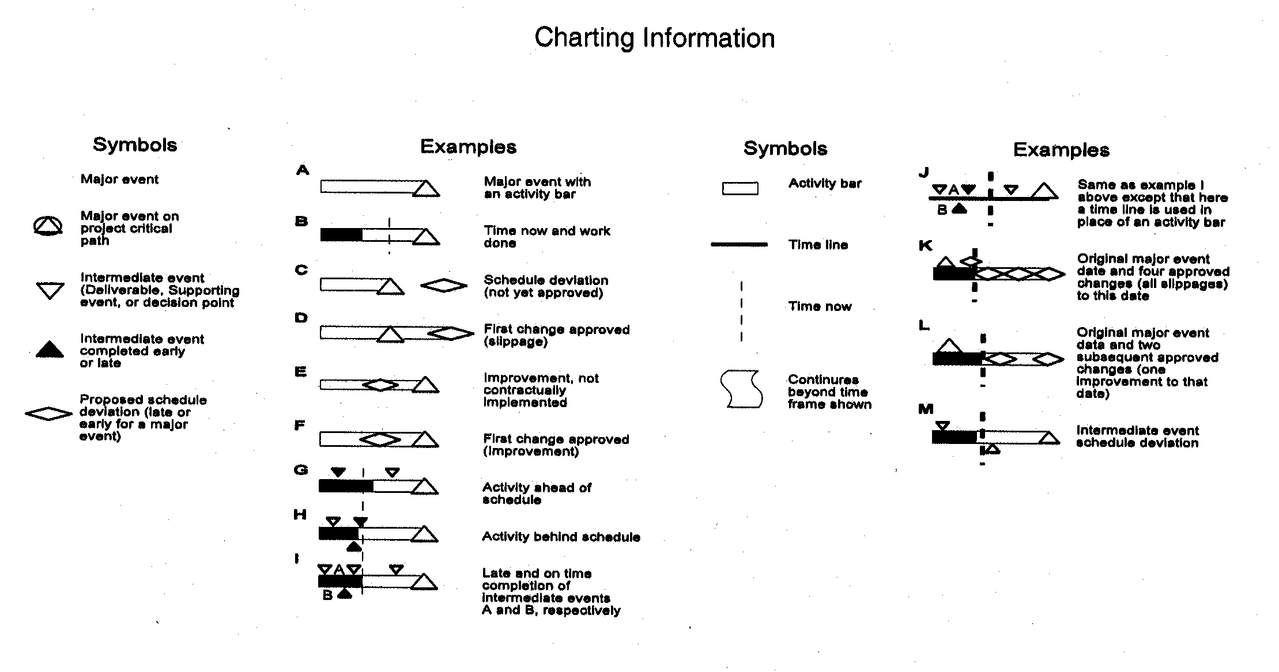* These items need only be entered on the first page of multipage reports.
Enter successive months as required. Enter fiscal years in the upper portion of the heading space as appropriate for months. Separate fiscal years by extending vertical line between the months of September and October. Enter schedule data below the fiscal year and month headings and to the right of each element listed in Item 8. Use charting information shown at the end of these instructions.

Note: a. Only one major event may be shown on a single horizontal line.

- Intermediate events may be shown only with an activity bar or time line. These event symbols are placed above the bar or line and coded. A description of each should be provided in an attachment.

Item 10. Based on the participant's best judgment, enter an assessment of actual percentage completed toward meeting the objective of each reporting element listed in Item 8. All schedule variances which exceed established contract thresholds must be explained in the "Status Report."

Item 11. Enter signature of responsible contractor, agency, or organization project manager and date signed verifying validity of the information furnished, based upon the participant's knowledge of the contract's progress and status.

