Earthquakes: A US Geological Survey earthquake hazard map shows that the earthquake hazard should be profiled for most of New Jersey. The map shows peak ground acceleration (pga) with a 10% chance of being exceeded over 50 years as highest in northeastern NJ (6%g) and decreasing to the south (2%g) http://earthquake.usgs.gov/research/hazmaps/products_data/2002/2002October/CEUS/CEUSpga500v3.pdf . According to FEMA How-To guidance, Understanding Your Risks, FEMA 386-2, p. 1-7, earthquakes should be profiled as a hazard if the pga is greater than 3%g.
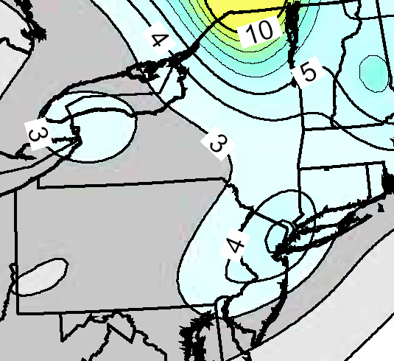
- In addition, HAZUS studies indicate a low frequency, but high potential dollar losses for earthquakes in northern NJ. (Note that a low frequency is equivalent to a low probability of future occurrence in any given year.)
-The New York Consortium for Earthquake Mitigation (NYCEM) HAZUS MH study of the greater NYC metro area (including parts of northern NJ) indicates a low hazard frequency, but high severity because of its dense population, vulnerable infrastructure and substantial economic value. For instance, in a 2,500-year event, Bergen County is estimated to have a $5.69 billion in building losses. A 50-page summary report for this study can be accessed through the Plan Development Toolkit or NYCEM’s website at http://nycem.org/default.asp.
- The NJ Geological Survey is conducting HAZUS earthquake loss estimation studies for northern NJ counties. Completed reports posted at its website include ones for Bergen and Passaic counties (www.state.nj.us/dep/njgs/enviroed/hazus.htm). The Bergen County report estimates $7.2 billion economic losses for a magnitude 6.0 earthquake, and the Passaic County one estimates a range of 2.00 to 8.10 billion dollar losses.

