GUIDE FOR CONDUCTING EXTERNAL PEER REVIEWS OF THE AUDIT OPERATIONS OF OFFICES OF INSPECTOR GENERAL

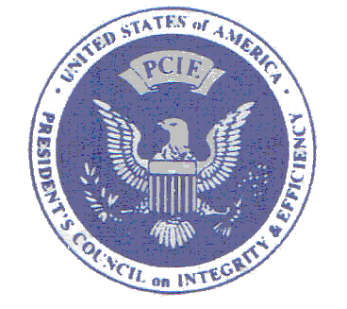

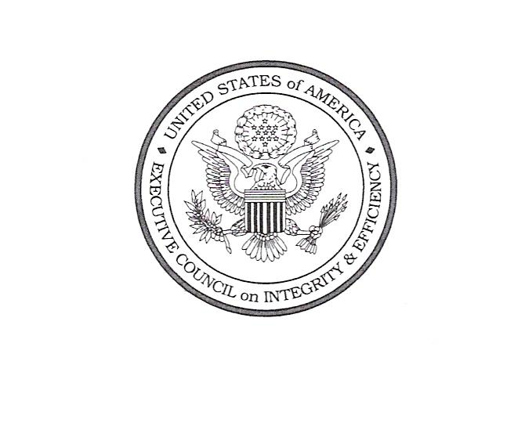
APRIL 2005

Table of Contents

PCIE AUDIT COMMITTEE iii

AUDIT COMMITTEE POLICY STATEMENT
ON INTERNAL QUALITY CONTROL
SYSTEMS AND EXTERNAL PEER REVIEWS 1

GUIDELINES FOR OIG QUALITY
ASSURANCE PROGRAMS ADDENDUM 1

EXTERNAL PEER
REVIEW GUIDE ADDENDUM 2

ILLUSTRATIVE REPORTS ADDENDUM 3

APPENDICES

A OIG’s Audit Quality Control Policies and Procedures
B Checklist for Review of Adherence to Selected General Standards

C Checklist for Assessment of the Internal Quality Assurance Program
D Checklist for Review of Individual Financial Statement Audits Performed by Inspectors General
E Checklist for Review of Individual Performance Audits
F Checklist for Review of OIG Monitoring of Audits Performed by Independent Public Accountants
G Checklist for Review of Attestation Engagements

Audit Committee

Chair: | John Higgins | IG, Department of Education
Members: | Gregory Friedman | IG, Department of Energy
 | Phyllis Fong | IG, Department of Agriculture
 | Gordon Heddell | IG, Department of Labor
 | Bruce Crandlemire | Acting IG, Agency for International Development
 | Patrick P. O'Carroll | IG, Social Security Administration
 | Dennis S. Schindel | Acting IG, Department of the Treasury
 | Ken Konz | IG, Corporation for Public Broadcasting
 | Jane Altenhofen | IG, National Labor Relations Board
 | Alexis Stefani | FAEC Liaison, Department of Commerce
 | Ken Donohue ad hoc | IG, Department of Housing and Urban Development

