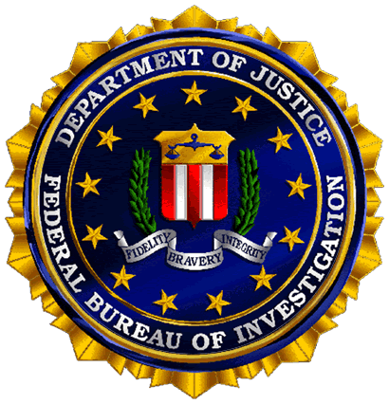

Managing Digital Evidence in the 21st Century:
What Every Peace Officer Must Know

According to the FBI, digital evidence is present in nearly every crime scene. That’s why front line investigators must know how to recognize, seize, transport, and store original digital evidence in order to preserve it for forensic examination.

A free Webinar, presented by the FBI’s Regional Computer Forensics Laboratory (RCFL) Program will teach first responders the important basics about managing and storing digital evidence during a criminal investigation. Different types of exotic media and legal issues will also be discussed.

Criminals and terrorists are increasingly tech-savvy. Are you? Register now at www.rcfl.gov for this free Webinar being offered twice on June 6, 2007, from 10:00am-12:00pm EST or 2:00pm-4:00pm EST. Registration takes just 60 seconds.

To learn more about this digital evidence Webinar and the more advanced training courses offered by the RCFL Program, visit www.rcfl.gov.

This Webinar is Sponsored by the FBI’s RCFL Program—America’s Premier Digital Forensics Laboratory Network.

