Federal Parent Locator Service
Federal Offset Program
Release 04-01 – Minor
August 20, 2004
Release Specifications
May 14, 2004
Administration for Children and Families
Office of Child Support Enforcement
370 L’Enfant Promenade S.W.
Washington, DC 20447
DCN: CI-02.03.04.02
This document was prepared for the United States Department of Health and Human Services, Office of Child Support Enforcement under Contract Number NIH CIOSP 263-01-D-0054 by Lockheed Martin, Information Technology, Incorporated. The work was authorized in compliance with the following specific prime task order:
Delivery Order Number: HHS-ACF-2003-C-2218M
Delivery Order Title: Federal Offset Program
Document Date: May 2004
Table of Contents
1.0 More Efficient Method for Submitting Case Updates (FOP 1723) 1-1
1.1 Summary of Changes 1-1
1.2 Background 1-1
1.3 Description of Changes 1-1
1.4 Impact on States 1-2
2.0 New Date Fields on the DoS Certification or Withdrawal Screen (FOP 1724) 2-1
2.1 Summary of Changes 2-1
2.2 Background 2-1
2.3 Description of Changes 2-1
2.4 Impact on States 2-1
2.5 Screen Layout 2-2
3.0 Enhance Current Year Query Screen (FOP 1725) 3-1
3.1 Summary of Changes 3-1
3.2 Background 3-1
3.3 Description of Changes 3-1
3.4 Impact on States 3-2
3.5 Screen Layout 3-2
4.0 OCSE-ISSUED Pre-Offset Notice Request (FOP 1822) 4-1
4.1 Summary of Changes 4-1
4.2 Background 4-1
4.3 Description of Changes 4-1
4.4 Impact on States 4-2
4.5 Screen Layout 4-2
4.6 Rejected Case Submission and Update Warning Codes 4-3
4.7 Input Record Specifications 4-3
4.8 Output Record Specifications 4-3
4.9 Weekly Update Report 4-3
5.0 Warning Code Counts Added to Reject Control Record and Weekly Update Report (FOP 1823) 5-1
5.1 Summary of Changes 5-1
5.2 Background 5-1
5.3 Description of Changes 5-1
5.4 Impact on States 5-1
5.5 Output Record Specifications 5-1
5.6 Weekly Update Report 5-1
6.0 Filing Status Indicator (Single or Joint) Associated with Collection Detail Record (FOP 1829) 6-1
6.1 Summary of Changes 6-1
6.2 Background 6-1
6.3 Description of Changes 6-1
6.4 Impact on States 6-1
6.5 Screen Layout 6-2
APPENDICES
A. Input Record Specifications A-1
B. Output Record Specifications B-1
C. Weekly Update Report C-1
D. New Query Case Master D-1
List of Figures and Charts
Figure 2-1: DoS Certification or Withdrawal Screen 2-2
Figure 3-1: Query Case Master Screen – Case Information 3-2
Figure 3-2: Query Case Master Screen – Case History Detail 3-3
Figure 4-1: Enter Weekly Update Screen 4-2
Figure 6-1: Filing Status Screen 6-2
Figure C-1: Weekly Update Report C-1
Chart 4-1: Rejected Case Submission and Update Warning Codes 4-3
Chart A-1: Case Submission And Update Record Layout A-2
Chart B-1: Rejected Case Submission And Update Record Layout B-2
Chart B-2: Rejected Case Submission And Update Control Record Layout B-4
Chart D-1: New Query Case Master Detail Records D-1

Part 1.0:
More Efficient Method for Submitting Case Updates (FOP 1723)

More Efficient Method for Submitting Case Updates (FOP 1723)

Summary of Changes
Federal Offset System processing is being modified to enable states to more efficiently submit case updates, whether using the batch process or the online data entry screen. The changes include elimination of the Reject Error ‘05’ for arrearage amounts that have not changed and, where possible, elimination of deferred processing, which caused undue error rejections and synchronization difficulties.

Background
The Federal Offset System rejects the Modify Transaction Type ‘M’ with an Error Code ‘05’ when the state submits an arrearage amount that is equal to the arrearage amount on the OCSE Case Master File.
The steps required to change a case from one case type to another, while ensuring suppression of OCSE-issued Pre-Offset Notices (PONs), and elimination of the hold period, takes a minimum of two processing cycles.
Analysis of transactions returned to the states has identified areas of concern to be corrected. These regard inaccurate error rejections due to deferred updating.

Description of Changes
States that submit their arrearage balances on a regular schedule with no actual change to the OCSE balance will no longer receive a Reject Error Code of ‘05’. These non-changing arrearage balance amounts will not create a detail record, but will update the Arrears Update Date (which can be viewed on the Query Case Master screen). This change will reduce the number of rejected records returned to the state.
The function of changing a case from one case type to the opposite case type will now be easily accomplished by submitting a Delete Transaction Type ‘D’ and an Add/Recertify Transaction Type ‘A’ in the same processing cycle. If desired, a case type change may still be performed over multiple processing cycles within the case type change period (40 days from the day of the original PON date). An OCSE-issued PON will not be automatically generated for a case type change that is completed within this 40-day period, whether it is accomplished in the same processing cycle or over multiple cycles. See Section 4.3 for the method of requesting a PON be issued when a case type is changed within this 40 day period.
Processing has been modified to ensure accurate matching of FMS rejections to the correct transaction. In the instance of state payments, all multi-year state payments will not be returned to the state as rejected if only one rejection actually occurred at FMS.
States will now be notified of the rejection of an ‘M’ transaction with Error Code ‘38’ when it is submitted in the same processing cycle as a ‘D’ transaction for the same case.
Elimination of unnecessary deferred processing will provide states with the ability to update a case in the same cycle in which the case is being added.
The implementation of these changes will improve synchronization of data between state and Federal files, enhance case tracking, and reduce the number of reject records returned to the states.

Impact on States
There is no impact on states. States can continue to submit transactions as they currently do, if they wish.

Part 2.0:
New Date Fields on the DoS Certification or Withdrawal Screen (FOP 1724)

New Date Fields on the DoS Certification or Withdrawal Screen (FOP 1724)

Summary of Changes
Federal Offset System processing is being modified to provide additional Passport Denial status dates on the DoS Certification or Withdrawal Screen.

Background
The Federal Offset System DoS Certification or Withdrawal screen does not have fields that display the dates when an obligor was certified and/or withdrawn from the Passport Denial Program.

Description of Changes
The screen will display the date a case was certified and/or withdrawn from the Passport Denial Program.
The implementation of this change will improve customer service by providing states with accurate information regarding an obligor’s status in the Passport Denial Program.

Impact on States
There is no impact on states.

Screen Layout
The following is the online screen that allows daily entry of changes for active cases.
Figure 2-1: DoS Certification or Withdrawal Screen

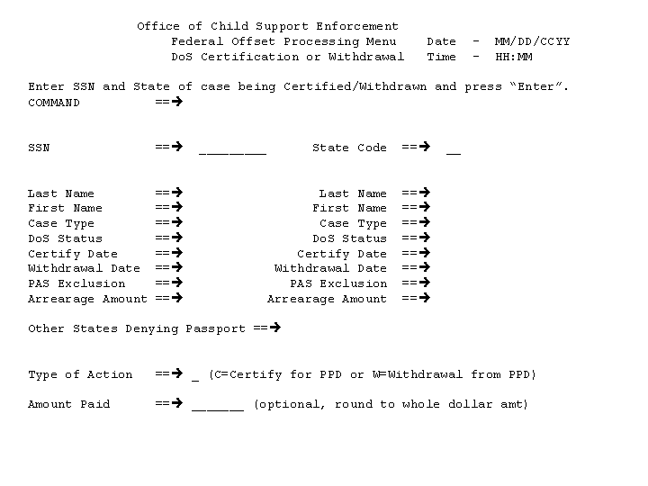
Part 3.0:
Enhance Current Year Query Screen (FOP 1725)

Enhance Current Year Query Screen (FOP 1725)

Summary of Changes
Federal Offset System processing is being modified to provide states with enhanced case information on the Query Case Master screen, Option 4 on the Federal Offset Processing Menu.

Background
The online Query Case Master screen displays case information that is held on the OCSE Case Master File. The screen displays specific information about a case with a detailed history of transactions that have modified the case.

Description of Changes
The screen will be modified to provide the states with an improved layout and new information that will be stored for a case. The new information includes:
- Date a case was opened and/or closed at FMS,
- Date a case was recertified at OCSE,
- Date a case was closed at OCSE,
- Date a case was certified and/or withdrawn from Passport Denial,
- Arrearage amount used to certify obligor for Passport Denial,
- Date of most recent arrearage amount modification,
- Obligor’s date and place of birth,
- Detail record created for a name change (See Chart D-1, “New Query Case Master Detail Records”, in Appendix D),
- Detail record created for a Case ID change (See Chart D-1 in Appendix D),
- Detail record for DoS Certification and/or Withdrawal from Passport Denial (See Chart D-1 in Appendix D),
- Detail record enhancements for Pre-Offset Notice Request (See Chart D-1 in Appendix D), and
- Detail records for case updates prior to FMS activation.
Due to the additional case level information, all detail history will begin on Page 2 of the Query Case Master screen.
The implementation of this change will improve access to case information that is held at the Federal level and will provide better case management and tracking due to the extended detail history that will be kept on each case.

Impact on States
There is no impact on states.

Screen Layout
The following are the online screens that display specific case information and the detail history of transactions that modified case data.
Figure 3-2: Query Case Master Screen – Case Information
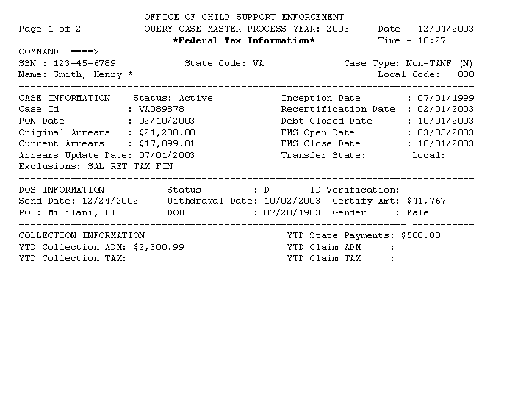
Figure 3-3: Query Case Master Screen – Case History Detail

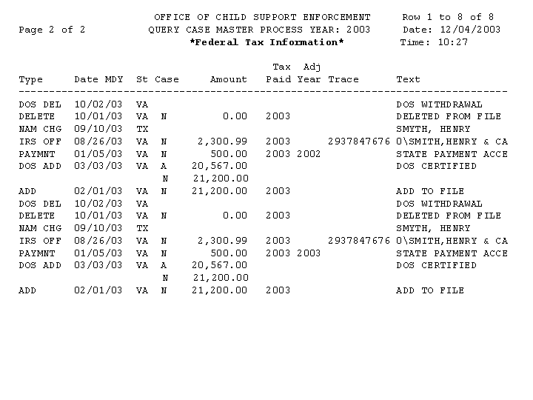
Part 4.0:
OCSE-ISSUED Pre-Offset notice Request (FOP 1822)

OCSE-ISSUED Pre-Offset Notice Request (FOP 1822)

Summary of Changes
Federal Offset System processing is being modified to provide states whose notices are generated by OCSE with a new option to request that a PON be generated on an active case.

Background
The Federal Offset System generates OCSE-issued PONs for new and recertified cases. Additionally, states may submit a request at anytime throughout the year to have PONs issued for all their cases simultaneously. There is no mechanism to accommodate requests for an additional PON to be issued for individual cases.

Description of Changes
The Federal Offset System will be modified to provide a method to request that a PON be generated for an individual case using the Case Submission and Update File or through the Enter Weekly Update Records screen (Option 1 on the Federal Offset Processing Menu).
States can submit a request only for an individual PON for cases that are active and have previously been issued a PON. A new field on the ‘M’ transaction will allow the state to make this request for the specified case. Position 245 on the Case Submission and Update Record will allow the entry of a ‘P’ in the Request Code field to signify an individual PON request. Online, this field can be updated via the ‘Print Pre-Offset Notice’ option on Part 2 of 2 on the Enter Weekly Update Records screen.
The edits must first pass the ‘M’ transaction before the Federal Offset System will evaluate the PON request. Edits not passed for the PON will be issued as warnings to the state. If an ‘M’ transaction passed its edits, but the PON fails its edits, a warning will be sent on the Rejected Case Submission and Update record for the PON request. The ‘M’ transaction arrearage amount update will still be applied. If the ‘M’ transaction does not pass its edits, an appropriate reject Error Code is created, and the ‘P’ is not considered. Refer to Section 4.6, Chart 4-1, “Rejected Case Submission and Update Warning Codes”, for the warning codes and related messages that apply to the new Request Code field.
States may submit an Address Change Transaction ‘Z’ in the same cycle as an ‘M’ transaction with a PON request. If accepted, the address change would be used on the requested PON.
The use of the ‘M’ Transaction with a PON request will provide states with the capability to override the automatic suppression of PONs that occurs when a case type is changed during the case type change period (40 days from the day of the original PON date).
The implementation of this change will enable states to easily request the issuance of a Pre-Offset Notice at any time on an existing case.

Impact on States
There is no impact on states. This is an optional field that states whose PONs are generated by OCSE can use to request a PON.

Screen Layout
The following is the change to Page 2 of the Enter Weekly Update Records screen, Option 1 of the Federal Offset Processing Menu. The entry of a ‘P’ in the Print Pre-Offset Notice field will be used for requesting a PON.
Figure 4-4: Enter Weekly Update Screen
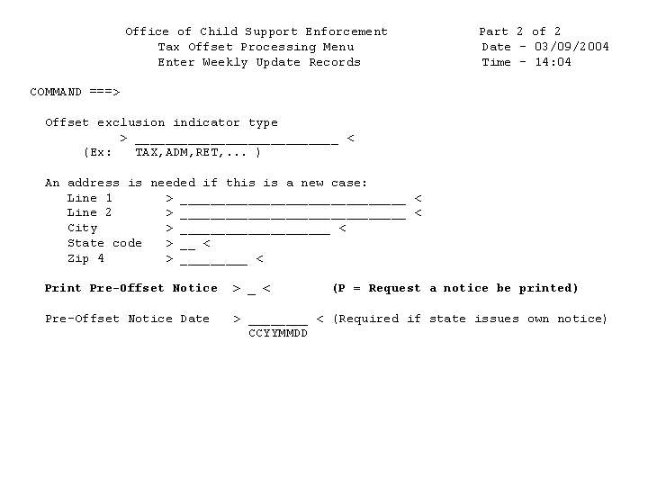

Rejected Case Submission and Update Warning Codes
Chart 4-1: Rejected Case Submission and Update Warning Codes
Warning Code | Warning Message | Transaction Type
55 | No PON Request for Mod to $0  Arrearage amount on the ‘M’ transaction was equal to zero (0). The zero (0) amount caused the case to be deleted. PON cannot be generated for a deleted case. | M
56 | PON Req Invalid for FIDM-Only case  A request cannot be made for a PON if the case is FIDM-only. | M
57 | No Prev PON Date for PON Req  A request for a PON cannot be made on a case that did not previously have a notice. | M
58 | PON Request Missing Address  An existing address must be present on the OCSE Address Master File to generate a PON. OCSE will not search for an address based on a PON request. | M
59 | PON Req not Avail for State Notice  A state that issues their own notices cannot request a notice from OCSE. | M

Input Record Specifications
Appendix A, “Input Record Specifications”, provides the state with the Case Submission and Update record and the field position in which the ‘P’, for the new field, Request Code, must be placed.

Output Record Specifications
Appendix B, “Output Record Specifications”, Chart B-1, “Rejected Case Submission and Update Record Layout”, provides the state with the Rejected Case Submission and Update record and the field position in which the new field, Request Code, will be returned if the transaction was rejected.

Weekly Update Report
Appendix C, “Weekly Update Report”, provides the state with accepted, rejected and warning totals for cases submitted to the Federal Offset System weekly update process. Warning totals are now displayed for PON warnings. The new totals appear in boldface type.
Part 5.0:
Warning Code Counts Added to Reject Control Record and Weekly Update Report (FOP 1823)

Warning Code Counts Added to Reject Control Record and Weekly Update Report (FOP 1823)

Summary of Changes
Federal Offset System processing is being modified to provide states with counts of warning codes in their Rejected Case Submission and Update Control Record.

Background
The Federal Offset System does not handle counts for warning codes in the control record returned to the states. The sum of all of the records may not always agree with the sum of the rejected counts.

Description of Changes
The Federal Offset System will be modified to accumulate records with a warning code in a new warning count field in the Rejected Case Submission and Update Control Record. The sum of all of the records that are returned to the state will equal the sum of the rejected and warning count fields. The total number of transactions submitted by a state will continue to equal the total accepted and rejected records.
The implementation of this change will improve reconciliation between the actual number of records in the Rejected Case Submission and Update File and the counts reported in the Rejected Case Submission and Update Control Record.

Impact on States
There is no impact on states. This change is for the output control record only. There are no changes to the state input control record.

Output Record Specifications
In Appendix B, “Output Record Specifications”, Chart B-2, “Rejected Case Submission and Update Control Record Layout”, provides the state with the Rejected Case Submission and Update Control Record and the field position in which the new warning code total fields, TANF Warning, and Non-TANF Warning, will be returned.

Weekly Update Report
Appendix C, “Weekly Update Report”, provides the state with accepted, rejected and warning totals for cases that were submitted to the Federal Offset System weekly update process.
Part 6.0:
Filing Status Indicator (Single or Joint) Associated with Collection Detail Record (FOP 1829)

Filing Status Indicator (Single or Joint) Associated with Collection Detail Record (FOP 1829)

Summary of Changes
Federal Offset System processing is being modified to provide an indicator on individual detail history records for offsets. This indicator will identify whether an offset was against a single or joint filing.

Background
The Federal Offset System does not identify the filing status on the detail history record. The Joint Return field displayed on the Query Case Master screen reflects only one offset for the case.

Description of Changes
The Federal Offset System will be modified to place the filing status that is associated with an offset in the first position of the taxpayer name in the Text column on the online screen. The indicator will be identified as a ‘0’ for a single filing and a ‘2’ for a joint filing.
The implementation of this change will improve the accuracy of offset information provided to states when querying case collection details.

Impact on States
There is no impact on states.

Screen Layout
The following is the online Query Case Master Detail History page that displays the filing status. The status will appear in the taxpayer name field in the Text column that is associated with an IRS Offset (IRS OFF).
Figure 6-5: Filing Status Screen
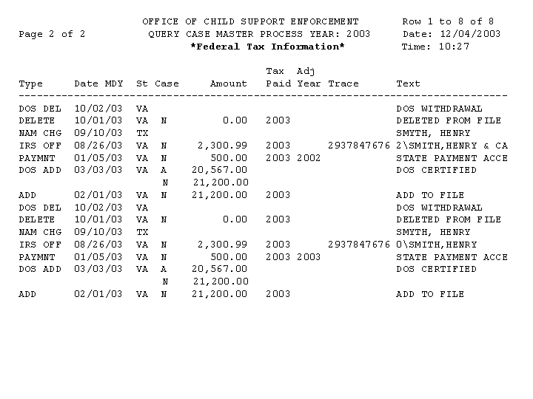
Appendices

A. Input Record Specifications
This appendix contains the record specifications for the FOP Case Submission and Update Record that is affected by the changes made for this release.
Chart A-2 presents the entire Case Submission and Update Record with changes highlighted in turquoise.

Chart A-1: Case Submission And Update Record Layout
Field Name | Location | Length | A/N | Comments
Submitting State Code | 1-2 | 2 | A | Required – Key Data  - This field is required for all Transaction Types. This field must contain a valid, two-character, alphabetic State abbreviation code for the submitting State. Refer to Appendix H, “State and Territory Abbreviations; Country Codes”, for a list of these codes.  - For Transaction Types ‘B’, ‘C’, ‘L’, ‘M’, ‘R’, ‘S’, ‘T’, ‘Z’ and ‘D’, all key fields (Submitting State Code, SSN, Case Type Indicator) must match key fields on the OCSE Case Master File in order for the transaction to be processed. If there is no match, the transaction will be rejected.
Local Code | 3-5 | 3 | A/N | Optional  This field is used with Transaction Types ‘A’ and ‘L’. This field contains the code that will be used to associate the obligor with a State or local contact address when the Pre-Offset Notice is produced by OCSE or an offset notice is produced by FMS.  - For Transaction Type ‘A’ (Add/Recertify Case), the local code submitted is compared against the State’s Local Code File. If the local code contains spaces or is not found, the local code for the case will be set to zeros on the OCSE Case Master File, and a local code of zeros will be submitted for the case to FMS.  - For Transaction Type ‘L’, if the local code submitted contains spaces, the local code for the case will be set to zeros on the OCSE Case Master File, and a local code of zeros will be submitted for the case to FMS. Otherwise, the local code submitted is compared against the State’s Local Code File. If the local code is not found, the transaction will be rejected.  - For all other Transaction Types (‘B’, ‘C’, ‘M’, ‘S’, ‘R’, ‘D’, ‘Z’ and ‘T’), the local code, if present, will not be updated at OCSE or FMS. Refer to Section 2.2.1.1, “State/Local Contact Phone and Address File”, for information on keeping local codes and addresses up to date at OCSE.
SSN | 6-14 | 9 | N | Required – Key Data  This field is required for all Transaction Types. This field must be numeric, must be greater than zero, and must contain a valid SSN.  - For Transaction Type ‘A’ (Add/Recertify Case) the SSN is verified using an SSA-defined range check that automatically validates the area portion of the SSN (the first three positions of the SSN) against the current high digit being used for area. In addition, the group portion of the SSN (the fourth and fifth positions of the SSN) is compared against the area to ensure that the group number was issued with the particular area number. To verify the current high digits for area and group issued by SSA, refer to Chart D-3, “Useful Web Sites”.  - For Transaction Types ‘B’, ‘C’, ‘L’, ‘M’, ‘R’, ‘S’, ‘T’, ‘Z’ and ‘D’, all key fields (Submitting State Code, SSN, and Case Type Indicator) must match key fields on the OCSE Case Master File in order for the transaction to be processed. If there is no match, the transaction will be rejected.
Case ID | 15-29 | 15 | A/N | Conditionally Required  This field is for State use only. This field is required for Transaction Type ‘C’ (Change Case ID). The new Case ID will overwrite the existing. This field should be filled with spaces if it is not used by the State.  - For Transaction Type ‘A’ (Add/Recertify Case), if present, OCSE will store the field on the Case Master File without performing any edits. This field is not sent to FMS or DoS.  - For all other Transaction Types (‘B’, ‘L’, ‘M’, ‘R’, ‘S’, ‘T’, ‘Z’ and ‘D’), the Case ID, if present, will not be updated at OCSE.
Obligor Last Name | 30-49 | 20 | A | Required  This field is required for all Transaction Types. The first four positions of this field must contain an alphabetic character. No imbedded spaces or special characters, except a hyphen, can be present within the first four positions.  - For Transaction Types ‘A’ (Add Case) and ‘B’ (Name Change), the entire last name is stored on the OCSE Case Master File after the last name passes the edit check above.  - For Transaction Types ‘C’, ‘L’, ‘M’, ‘R’, ‘S’, ‘T’, ‘Z’ and ‘D’, the first 4 characters submitted must match the first 4 characters stored on the OCSE Case Master File or the first 4 characters of a Transaction Type ‘B’ (Name Change) transaction for the same case in the same process. If there is no match, the transaction will be rejected.  - For Transaction Type ‘A’ (Recertify Case), if the last name does not match against the OCSE Case Master File, the name is processed as a name change.  If imbedded spaces or special characters exist after the first four characters, the case will be submitted to FMS for offset. However, DoS may reject the case for passport denial.
Obligor First Name | 50-64 | 15 | A | Conditionally Required  This field is required for Transaction Types ‘A’ and ‘B’. The first position of this field must contain an alphabetic character.  - For Transaction Types ‘A’ (Add Case) and ‘B’ (Name Change), the entire first name is stored on the OCSE Case Master File after the first character passes the edit check above.  - For Transaction Type ‘A’ (Recertify Case), the first character must pass the edit above. The obligor first name is not matched against the first name stored on the OCSE Case Master File; the entire first name is stored on the OCSE Case Master File.  For all other Transaction Types (‘C’, ‘L’, ‘M’, ‘R’, ‘S’, ‘T’, ‘Z’ and ‘D’), the obligor first name, if present, will not be updated at OCSE or FMS.
Arrearage Amount (Accumulated Payment Amount) | 65-72 | 8 | N | Conditionally Required  This field is required for Transaction Types ‘A’, ‘M’ and ‘S’. This field must contain a numeric amount in whole dollars only. Decimal points, dollar signs, commas, or plus/minus signs are not valid (e.g., $1,500.00 = 00001500).  - For Transaction Type ‘A’ (Add/Recertify Case), the arrearage amount is the current amount owed by the obligor. If the arrearage amount is less than $25, the Add Case transaction will be rejected.  - For Transaction Type ‘D’, this field is not required. However, the existing arrearage amount will be zeroed out.  - For Transaction Type ‘M’, the arrearage amount is the current amount owed by the obligor. If the arrearage amount is equal to zero, the case will be flagged as deleted.  - For Transaction Type ‘S’, this field functions as the Accumulated Payment Amount Field, and is referred to by that name. The accumulated payment amount is the accumulated State Payment Amount for the processing year.  - For all other Transaction Types (‘B’, ‘C’, ‘L’, ‘R’, ‘Z’ and ‘T’), the arrearage amount, if present, will not be updated at OCSE or FMS.
Transaction Type | 73 | 1 | A | Required  This field must contain a valid Transaction Type code. Valid codes for this field are:  A Add/Recertify Case  B Name Change  C Case ID Change  D Delete Case  L Local Code Change  M Modify Arrearage Amount  R Replace Exclusion Indicator(s)  S State Payment  T Transfer for Administrative Review  Z Obligor Address Change
Case Type Indicator | 74 | 1 | A | Required - Key Data  - This field is required for all Transaction Types. This field must contain one of the following valid case type codes:  A – TANF  N – Non-TANF  - For Transaction Types ‘B’, ‘C’, ‘L’, ‘M’, ‘R’, ‘S’, ‘T’, ‘Z’ and ‘D’, all key fields (Submitting State Code, SSN, and Case Type Indicator) must match key fields on the OCSE Case Master File in order for the transaction to be processed. If there is no match, the transaction will be rejected.
Transfer State Code | 75-76 | 2 | A | Conditionally Required  - For Transaction Type ‘T’, This field must contain a valid, two-character, alphabetic State abbreviation code for the transfer State. Refer to Appendix H, “State and Territory Abbreviations; Country Codes”, for a list of these codes.  - For all other Transaction Types (‘A’, ‘B’, ‘C’, ‘D’, ‘L’, ‘M’, ‘S’, ‘Z’ and ‘R’), this field, if present, will not be updated at OCSE.
Transfer Local Code | 77-79 | 3 | A/N | Optional  - For Transaction Type ‘T’, this field should contain a three-position, alpha-numeric local code for the transfer State. If present, this field is stored on the OCSE Case Master File.  - For all other Transaction Types (‘A’, ‘B’, ‘C’, ‘D’, ‘L’, ‘M’, ‘S’, ‘Z’ and ‘R’), this field, if present, will not be updated at OCSE.
Process Year | 80-83 | 4 | A/N | Conditionally Required  - For Transaction Type ‘S’, this field must be in the Year 2000-compliant format of CCYY, and must contain the year the tax refund or administrative payment was offset. The date must fall within the previous seven years of the current year.  - For all other Transaction Types (‘A’, ‘B’, ‘C’, ‘D’, ‘L’, ‘M’, ‘R’, ‘Z’ and ‘T’), this field, if present, will not be updated at OCSE.
Obligor Address Line1 | 84-113 | 30 | A/N | Conditionally Required  - For Transaction Types ‘A’ (Add Case) and ‘Z’ (Address Change), this field contains the first address line of the obligor’s mailing address. If this line is blank, the Obligor Address Line2 Field will be checked for an address (refer to Part 3, “Federal Offset Program Pre-Offset Notices”, for information regarding address processing).  - For Transaction Type ‘Z’ (Address Change), Obligor Address Line 1, Obligor Address Line 2, Obligor City, Obligor State, and Obligor Zip Code cannot all be spaces.  - For Transaction Type ‘A’ (Recertify Case), this field is not required. If present, the address currently stored at OCSE will be updated with the submitted address.  - For all other Transaction Types (‘B’, ‘C’, ‘D’, ‘L’, ‘M’, ‘S’, ‘R’ and ‘T’), the address, if present, will not be updated at OCSE or FMS.
Obligor Address Line2 | 114-143 | 30 | A/N | Optional  - For Transaction Types ‘A’ (Add Case) and ‘Z’ (Address Change), this field may contain the second address line for the obligor. On an Add Case, if OCSE sends the Pre-Offset Notices and no address information is submitted in either address line, OCSE will attempt to obtain an address (refer to Part 3, “Federal Offset Program Pre-Offset Notices”, for information regarding address processing).  - For Transaction Type ‘Z’ (Address Change), Obligor Address Line 1, Obligor Address Line 2, Obligor City, Obligor State, and Obligor Zip Code cannot all be spaces.  - For Transaction Type ‘A’ (Recertify Case), this field is not required. If an address is present, the address currently stored at OCSE will be updated with the submitted address.  - For all other Transaction Types (‘B’, ‘C’, ‘D’, ‘L’, ‘M’, ‘S’, ‘R’ and ‘T’), the address, if present, will not be updated at OCSE or FMS.
Obligor City | 144-168 | 25 | A | Conditionally Required  - For Transaction Types ‘A’ (Add Case) and ‘Z’ (Address Change), this field contains the city of the obligor’s mailing address (refer to Part 3, “Federal Offset Program Pre-Offset Notices”, for information regarding address processing).  - For Transaction Type ‘Z’ (Address Change), Obligor Address Line 1, Obligor Address Line 2, Obligor City, Obligor State, and Obligor Zip Code cannot all be spaces.  - For Transaction Type ‘A’ (Recertify Case), this field is not required. If an address is present, the address currently stored at OCSE will be updated with the submitted address.  - For all other Transaction Types (‘B’, ‘C’, ‘D’, ‘L’, ‘M’, ‘S’, ‘R’ and ‘T’), the address, if present, will not be updated at OCSE or FMS.
Obligor State | 169-170 | 2 | A | Conditionally Required  - For Transaction Types ‘A’ (Add Case) and ‘Z’ (Address Change), this field contains a two-character, alphabetic State abbreviation code for the State of the obligor’s mailing address (refer to Part 3, “Federal Offset Program Pre-Offset Notices”, for information regarding address processing).  - For Transaction Type ‘Z’ (Address Change), Obligor Address Line 1, Obligor Address Line 2, Obligor City, Obligor State, and Obligor Zip Code cannot all be spaces.  - For Transaction Type ‘A’ (Recertify Case), this field is not required. If an address is present, the address currently stored at OCSE will be updated with the submitted address.  - For all other Transaction Types (‘B’, ‘C’, ‘D’, ‘L’, ‘M’, ‘S’, ‘R’ and ‘T’), the address, if present, will not be updated at OCSE or FMS.
Obligor Zip Code | 171-179 | 9 | N | Conditionally Required  - For Transaction Types ‘A’ (Add Case) and ‘Z’ (Address Change), this field contains a 5 or 9 digit zip code (refer to Part 3, “Federal Offset Program Pre-Offset Notices”, for information regarding address processing).  - For Transaction Type ‘Z’ (Address Change), Obligor Address Line 1, Obligor Address Line 2, Obligor City, Obligor State, and Obligor Zip Code cannot all be spaces.  - For Transaction Type ‘A’ (Recertify Case), this field is not required. If an address is present, the address currently stored at OCSE will be updated with the submitted address.  - For all other Transaction Types (‘B’, ‘C’, ‘D’, ‘L’, ‘M’, ‘S’, ‘R’ and ‘T’), the address, if present, will not be updated at OCSE or FMS.
Date Issued | 180-187 | 8 | A/N | Conditionally Required  For Transaction Type ‘A’ (Add/Recertify Case), if the State issues their own Pre-Offset Notices, this field is required. The date must be in the Year 2000-compliant format of CCYYMMDD. This field indicates the date the Pre-Offset Notice was mailed. If OCSE issues the Pre-Offset Notices, OCSE will fill in the date.  - For all other Transaction Types (‘B’, ‘C’, ‘D’, ‘L’, ‘M’, ‘S’, ‘R’, ‘T’ and ‘Z’), the date issued, if present, will not be updated at OCSE or FMS.
Exclusion Indicator(s) | 188-227 | 40 | A | Optional  - For Transaction Types ‘A’ (Add/Recertify Case) and ‘R’, this field is optional. If setting more than one exclusion indicator, the indicators must be separated with a comma or space (e.g., RET,PAS,FIN, or RET PAS FIN).  - Valid exclusion indicators are:  - ADM – Exclude all Administrative Offsets (RET, SAL,VEN)  - RET – Exclude Federal Retirement Offset  - VEN – Exclude Vendor Payment/Miscellaneous Offset  - SAL – Exclude Federal Salary Offset (not yet activated)  - TAX – Exclude Tax Refund Offset  - PAS – Exclude Passport Denial  - FIN – Exclude Multistate Financial Institution Data Match  - Space Remove all existing exclusion indicators  - For all other Transaction Types (‘B’, ‘C’, ‘D’, ‘L’, ‘M’, ‘S’, ‘Z’ and ‘T’), this field, if present, will not be updated at OCSE or FMS.
Filler | 228-244 | 18 | A/N | Space filled
Request Code | 245 | 1 | A | Optional  - For Transaction Type ‘M’, this field should contain a ‘P’, to request a Pre-Offset Notice be generated by OCSE. If present, this field will generate a PON if all edits are passed for updating an arrearage amount and processing a notice.  - For all other Transaction Types (‘A’, ‘B’, ‘C’, ‘D’, ‘L’, ‘R’, ‘S’, and ‘Z’), no action will be taken at OCSE or FMS if this field contains a value.

B. OutpuT Record Specifications
This appendix contains the record specifications for the FOP output records that are affected by the changes made for this release.
Chart B-3 presents the entire Rejected Case Submission and Update Record layout with changes highlighted in turquoise.
Chart B-4 presents the entire Rejected Case Submission and Update Control Record layout with changes highlighted in turquoise.

Chart B-1: Rejected Case Submission And Update Record Layout
Field Name | Location | Length | A/N | Comments
Submitting State Code | 1-2 | 2 | A | This field contains the state abbreviation that was sent to OCSE on the Case Submission and Update Record.
Local Code | 3-5 | 3 | A/N | This field contains the local code sent to OCSE by the state on the Case Submission and Update Record.
SSN | 6-14 | 9 | N | This field contains the Social Security Number sent to OCSE by the state on the Case Submission and Update Record.
Case ID | 15-29 | 15 | A/N | This field contains the case ID that was submitted to OCSE on the Case Submission and Update Record.
Obligor Last Name | 30-49 | 20 | A | This field contains the obligor last name sent to OCSE by the state on the Case Submission and Update Record.
Obligor First Name | 50-64 | 15 | A | This field contains the obligor first name sent to OCSE by the state on the Case Submission and Update Record.
Arrearage Amount | 65-72 | 8 | N | This field contains the arrearage amount sent to OCSE by the state on the Case Submission and Update Record.
Transaction Type | 73 | 1 | A | This field contains the transaction type sent to OCSE by the state on the Case Submission and Update Record.
Case Type Indicator | 74 | 1 | A | This field contains the case type indicator sent to OCSE by the state on the Case Submission and Update Record.
Transfer State Code | 75-76 | 2 | A | This field contains the transfer state code sent to OCSE by the state on the Case Submission and Update Record.
Transfer Local Code | 77-79 | 3 | A/N | This field contains the transfer local code sent to OCSE by the state on the Case Submission and Update Record.
Process Year | 80-83 | 4 | A/N | This field contains the process year sent to OCSE by the state on the Case Submission and Update Record.
Obligor Address Line1 | 84-113 | 30 | A/N | This field contains the obligor address line 1 sent to OCSE by the state on the Case Submission and Update Record.
Obligor Address Line2 | 114-143 | 30 | A/N | This field contains the obligor address line 2 sent to OCSE by the state on the Case Submission and Update Record.
Obligor City | 144-168 | 25 | A | This field contains the obligor city sent to OCSE by the state on the Case Submission and Update Record.
Obligor State | 169-170 | 2 | A | This field contains the obligor state sent to OCSE by the state on the Case Submission and Update Record.
Obligor Zip Code | 171-179 | 9 | N | This field contains the obligor zip code sent to OCSE by the state on the Case Submission and Update Record.
Date Issued | 180-187 | 8 | A/N | This field contains the date issued sent to OCSE by the state on the Case Submission and Update Record.
Exclusion Indicator(s) | 188-227 | 40 | A | This field contains the exclusion indicator(s) sent to OCSE by the state on the Case Submission and Update Record.
Rejected Error Codes | 228-239 | 12 | A/N | This field contains up to six two-digit error codes. These codes are reported consecutively with no commas or spaces. Refer to Chart G-1, “Rejected Case Submission and Update Error Codes”, for a complete list of possible rejected error codes.
OCSE Last Name | 240-243 | 4 | A/N | When a case is rejected with error code 17, this field contains the first four characters of the Obligor Last Name as stored on the OCSE Case Master file for this case. The OCSE Last Name can be used to correct the Obligor Last Name at the state when a case is rejected with an Error Code of 17, “Last Name Does Not Match OCSE Last Name”. Refer to Chart G-1, “Rejected Case Submission and Update Error Codes”, for a complete description of Error Code 17.
Filler | 244 | 1 | A/N | Space filled.
Request Code | 245 | 1 | A | This field contains the request code sent to OCSE by the state on the Case Submission and Update Record.

Chart B-2: Rejected Case Submission And Update Control Record Layout
Field Name | Location | Length | A/N | Comments
Submitting State Code | 1-2 | 2 | A | This field contains the state abbreviation that was sent to OCSE by the state on the Case Submission and Update Record.
Reject Control | 3-5 | 3 | A | This is a constant field and contains ‘CTL’ to identify this record as the Reject Control Record.
TANF Accepted | 6-14 | 9 | N | This field contains the total number of TANF records accepted by OCSE that were on the Case Submission and Update Record.
TANF Rejected | 15-23 | 9 | N | This field contains the total number of TANF records rejected by OCSE that were on the Case Submission and Update Record.
Non-TANF Accepted | 24-32 | 9 | N | This field contains the total number of Non-TANF records accepted by OCSE that were on the Case Submission and Update Record.
Non-TANF Rejected | 33-41 | 9 | N | This field contains the total number of Non-TANF records rejected by OCSE that were on the Case Submission and Update Record.
TANF Warning | 42-50 | 9 | N | This field contains the total number of TANF records that received a warning from OCSE that were on the Case Submission and Update Record.
Non-TANF Warning | 51-59 | 9 | N | This field contains the total number of Non-TANF records that received a warning from OCSE that were on the Case Submission and Update Record.
Filler | 60-245 | 204 | A | Space filled.

C. Weekly Update Report
This appendix contains Figure C-6, which shows the changes to the Weekly Update Report for this release. The sample report below has changes noted in boldface type.
Figure C-1: Weekly Update Report
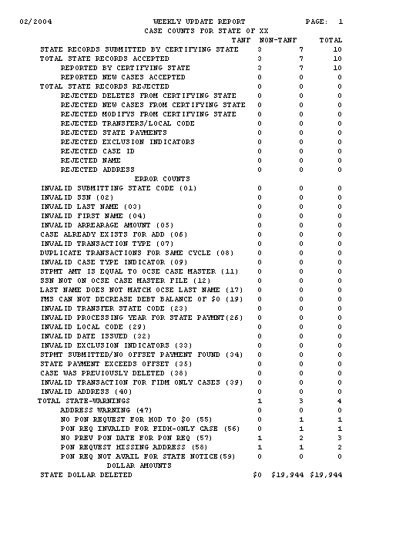

D. New Query Case Master
This appendix contains Chart D-1, which describes the new detail types, and their associated text and descriptions from the Query Case Master panel.
Chart D-5: New Query Case Master Detail Records
Type | Text | Description
CASE ID | CASE ID CHANGED | State submitted Case ID change for a case.
DOS ADD | DOS CERTIFY/ADD | Obligor accepted at DoS for Passport Denial.
DOS DEL | DOS WITHDRAWAL/DEL | Obligor withdrawn from DoS Passport Denial.
DOS REJ | DOS REJECT | Passport Denial request was rejected at DoS.
NAM CHG | NAME CHANGED | State submitted name change for an obligor.
MODIFY | AMT CHGD PON PRTD | The arrearage amount change was accepted. The request for Pre-Offset Notice was printed.
MODIFY | AMT CHGD PON RJCT | The arrearage amount change was accepted. The request for Pre-Offset Notice was rejected with a warning.

