Illustrative Examples from the NIGMS Single Molecule Detection and Manipulation Workshop
The topics of the talks at the meeting covered a range of single molecule methods and applications. Illustrative examples from some of the talks are presented below.

Single Molecule Fluorescence of Biomolecules and Complexes

Protein Folding

Fluorescence resonance energy transfer (FRET) has been used for many years to make spectroscopic distance measurements on ensembles of molecules. Recent advances in new fluorescent dyes and optical methods have increased the spatial resolution, distance range, and sensitivity of this method so that it continues to be one of the few tools available for measuring nanometer-scale distances in biological molecules. In FRET, energy is transferred from a donor fluorophore to an acceptor fluorophore over a range of 20-100 Å. The efficiency (E) of the transfer depends on the distance between donor and acceptor such that E = 1/ {1 + (R/R_{o})⁶ }, where R_{o} is the distance at which half the energy is transferred. The spectral characteristics of the dyes and their relative orientation affect the efficiency of the process, but by measuring E and knowing R_{o}, distance information can be obtained with reliability. Dynamic events, such as the relative motion between donor and acceptor molecules, however, cannot be detected by conventional FRET methods due to the lack of synchronized events in a population of molecules. Single-pair FRET (spFRET) is designed to overcome the averaging effects of ensemble studies because measurements are made on single molecules freely diffusing in solution. This method limits the observation period to the diffusion time of each molecule through the focal spot of a laser on the order of a few hundred milliseconds, but it permits the rapid gathering of data at single-molecule resolution on a large number of molecules in a short time period.

SpFRET can be used to study intramolecular conformational changes by placing the donor and acceptor fluorescent tags on two different sites of the same macromolecule, or alternatively, intermolecular interactions can be studied by attaching the donor and acceptor tags to two different macromolecules. The intramolecular labeling format can be applied, for example, to the study of fluctuations and stability within a single macromolecule, the dynamics of folding and unfolding, or enzyme structural changes during catalysis. Studies appropriate for intermolecular labeling might be receptor-ligand binding, enzyme-substrate association/dissociation, or protein-nucleic acid interactions that change over time.

Protein folding is a particularly good target for the application of single-molecule methods because its complexity and stochastic nature make it difficult to study using ensemble methods. A population of unfolded protein molecules consists of a large number of nearly degenerate and rapidly interconverting protein conformations. Different folding pathways and transition states for the folding reaction cannot be singled out in a heterogeneous ensemble of molecules.
An excellent model system for studying single-molecule folding is chymotrypsin 2 inhibitor (C12), which has been analyzed by Shimon Weiss and Peter Schultz using spFRET methods (1). In these experiments, C12 is specifically labeled with donor and acceptor tags at different sites and examined by spFRET for the extent of folding as a function of guanidinium chloride (GCl) concentration. Changes in the distance between the two tags can be measured as FRET efficiency, with the signal more efficient (more intense) in a folded, compact state when the two tags are closer together. At 3M GCl, most CI2 molecules are folded; at 4M, an equal number are folded and unfolded; and at 6M, most molecules are unfolded (Figure 1). CI2 exhibits a two-state folding mechanism with a denaturing transition at 4 M GCl, confirming earlier results from ensemble fluorescence measurements (Figure 2). Based on the measurements of fluorescence efficiency, the inter-dye distances are calculated to be 31 Å and 45 Å for the folded and denatured states, respectively. Additional experiments on mutants of CI2 demonstrate that changes in protein stability caused by a mutation result in a denaturation transition at 2.5 M GCl, instead of the 4 M transition for the wild-type protein.

C12 - Folded and Denatured Subpopulations
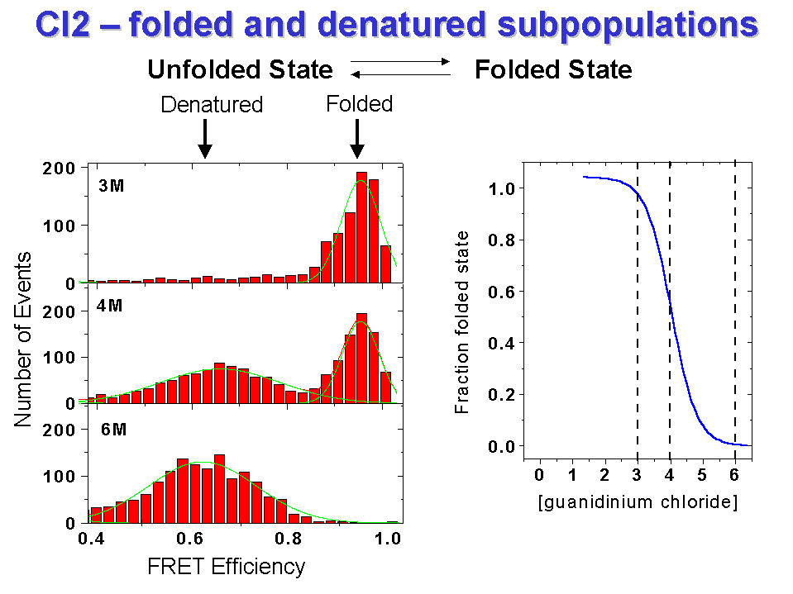
Figure 1: spFRET histograms of CI2 at 3, 4, and 6 M guanidinium chloride, with the midpoint of the transition between the folded and denatured state at 4 M.
(Permission of S. Weiss)

Ensemble vs. Single Molecule
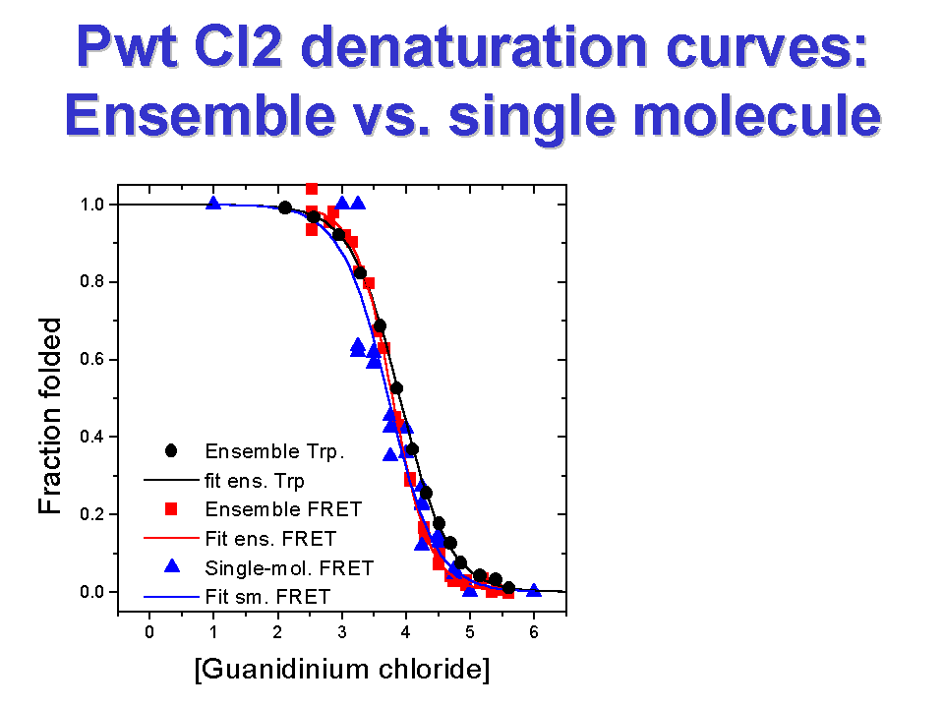
Figure 2: Denaturation curves of CI2 measured by ensemble intrinsic tryptophan fluorescence, ensemble FRET, and spFRET.
(Permission of S. Weiss)

SpFRET experiments can provide information on the energy landscape of the folding reaction (Figure 3) where changes in the position and number of minima are calculated at different concentrations of GCl. For example, the appearance of the double well at 4M GCl reflects the two-state folding of the protein, while the high energy barrier for the 6M plot at shorter inter-dye distances reflects the inability of the denatured protein to fold into a more compact state at higher concentrations of denaturant.

Distributions - Potential Energy Plots
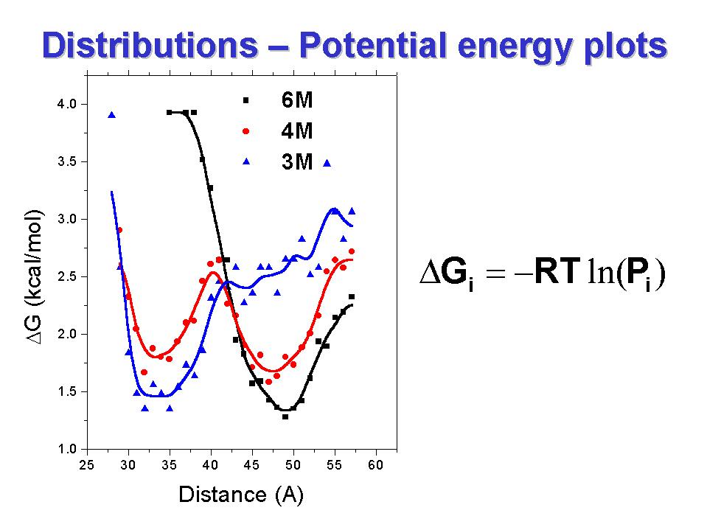

Figure 3: Free energy functions for CI2 at 3, 4, and 6 M guanidinium chloride, where P_{i} is the probability of populating bin i at distance R_{i.}
(Permission of S. Weiss)

The spFRET measurements carried out on CI2 provide a validation of the single-molecule methodology. This validation is important in order to verify that the sum of the independent single molecule observations "add up" to give the ensemble result. The power of the single molecule method, however, is that the contribution of each molecule can be seen, as well as the range of individual differences, so that the physical basis for the averaged behavior of the ensamble is more clearly understood.

RNA Folding and Catalysis

Surface immobilization facilitates measurements of the temporal behavior of single molecules using spFRET, provided the immobilization process does not cause distortions in the molecule under study. In a successful set of experiments carried out by Steve Chu and Dan Herschlag (2), the folding and catalysis of individual Tetrahymena thermophila ribozyme molecules were studied. They monitored, in real time, the reversible docking formed by base pairing between the 3' end of the ribozyme and its substrate. In this experiment, the fluorescence donor and acceptor are placed on two different sites of the ribozyme so that docking and undocking between the ribozyme and its substrate change the distance between the pair of dyes from 7 nm for the undocked state to 1-2 nm for the docked state. The FRET time trace for a single molecule shows that the FRET value fluctuates between two values reflecting these two states. The distribution of dwell times in the two states give the rate constants for docking and undocking, which are 1.25 s-¹ for k_{dock} and 11.5 s-¹ for k_{undock}. The equilibrium constant, K_{dock} = 0.109, is consistent with previous ensemble experiments. The small value of K_{dock} means that the docked state is rarely populated, because k_{dock} and k_{undock} cannot typically be measured by ensemble measurements.

Time-resolved spFRET measurements on the folding of the ribozyme shows that the ribozyme folds with two distinct rate constants, 1.0 s-¹ and 0.016 s-^{1 .} The slow rate constant of 0.016 s-¹ is the same as the previously established ensemble folding rate, confirming that the folding dynamics are not perturbed by the surface immobilization or dye-labeling used in the spFRET. The fast rate constant of 1.0 s-¹ had not been observed before and demonstrates the presence of a new folding pathway. Although not measured in the spFRET experiments, a third rate constant of 10⁻⁵ s⁻¹ is known to exist for this ribozyme, representing the very slow folding of the ribozyme from a completely misfolded state.

The existence of the two folding pathways in the spFRET experiments is observed directly as a difference in the dwell times at an intermediate FRET value representing a partially folded state. The average dwell times at this FRET level are 1 second and 60 seconds for the fast- and slow-folding molecules, respectively. The short-lived intermediate, representing about 35 percent of the molecules, occurs only in the presence of bound substrate. The longer-lived intermediate is believed to be a trapped state that does not fold readily. Although the molecular differences between these two states is not yet understood, the finding that there is a new fast-folding pathway for this ribozyme changes our view of what the mechanism of folding and catalysis might be for this ribozyme.

Single Molecule Enzymology

Single molecule measurements can provide a means to directly observe properties of individual steps or intermediates along a reaction pathway. A good example of a system where single molecule measurements have given new insight into the properties of a biochemical reaction comes from examining the enzymatic turnovers of single molecules of cholesterol oxidase. By monitoring the emission from the enzyme's fluorescent active site, flavin adenine dinucleotide (FAD), Sunney Xie and his colleagues have described characteristics of this enzyme that were previously unknown (3).

Cholesterol oxidase is a 53 kDa protein that catalyzes the oxidation of cholesterol by oxygen (Figure 4). The active site of the enzyme involves an FAD, which is naturally fluorescent in its oxidized form but not in its reduced form. FAD is reduced by a cholesterol molecule to FADH, which is then oxidized by molecular oxygen. The fluorescence turns on and off as the redox state of the FAD moves back and forth between the oxidized and reduced states; each on-off cycle corresponds to an enzymatic turnover.

Figure 4: Enzymatic cycle of cholesterol oxidase and real-time observations of enzymatic turnovers of a single cholesterol oxidase molecule. Each on-off cycle in the emission intensity trajectory corresponds to an enzymatic turnover.
(Permission of S. Xie)

Single molecules of cholesterol oxidase can be confined in an agarose gel of 99 percent water where they are able to rotate freely (Figure 5). The FAD chromophore is relatively photostable and resistant to photobleaching so that more than 500 turnovers can be recorded for each molecule. These experiments show that there is heterogeneity among individual molecules for different catalytic steps. For example, this heterogeneity is seen directly as a longer time spent in the fluorescent state (E-FAD/E-FADS) for some molecules under conditions where the substrate is slowly reacting, that is, where k₂ is rate limiting (Figure 6). The range and heterogeneity of on-times for individual molecules is masked in ensemble measurements. Nonetheless, the average distribution of on-times validates Michaelis-Menten kinetics describing the ensemble behavior of cholesterol oxidase, confirming the idea that single molecule measurements "add up" to give the ensemble result.

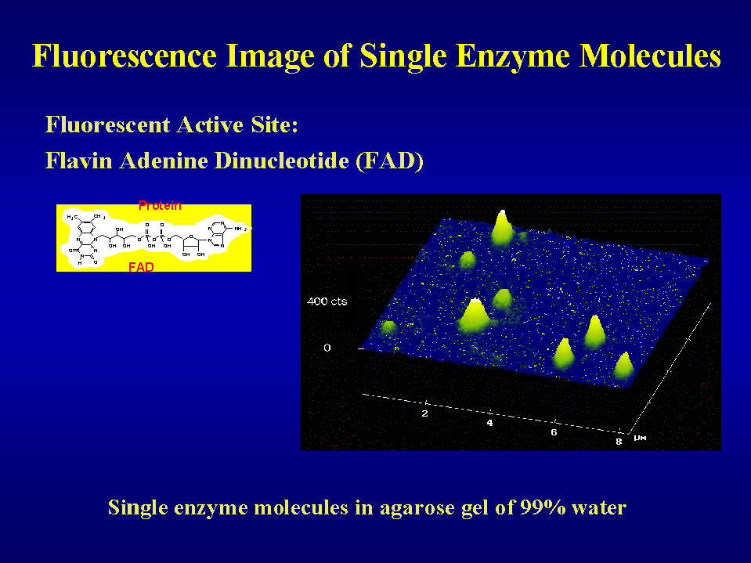
Figure 5: Fluorescent image of single cholesterol oxidase molecules immobilized in a 10-μM thick film of agarose gel. The emission is from the fluorescent active site, FAD, which is tightly bound to cholesterol oxidase. Each individual peak is attributed to a single cholesterol oxidase molecule. (Permission of S. Xie).

A second interesting observation made on single molecule studies with cholesterol oxidase is that the probability that a given turnover is affected by its previous turnovers. By following the time spent (on-time) in the fluorescent state (on-time or E-FADS) as a function of adjacent on-times, it was found that a short on-time is usually followed by another short on-time, and that a long on-time is likely to be followed by another long on-time. After many turnovers, however, this relationship evolves from slow to fast, and vice versa. There appears to be a memory effect that arises from a slowly varying rate constant (k₂) that is related in some way to a constantly evolving but poorly understood fluctuation in the protein.

Thus, although Michaelis-Menten kinetics provides a good description for the averaged behaviors of many molecules, it does not provide an accurate picture of the real-time behavior of a single molecule. For single molecules, the rate for the activation step is fluctuating over time, and varies from molecule to molecule.

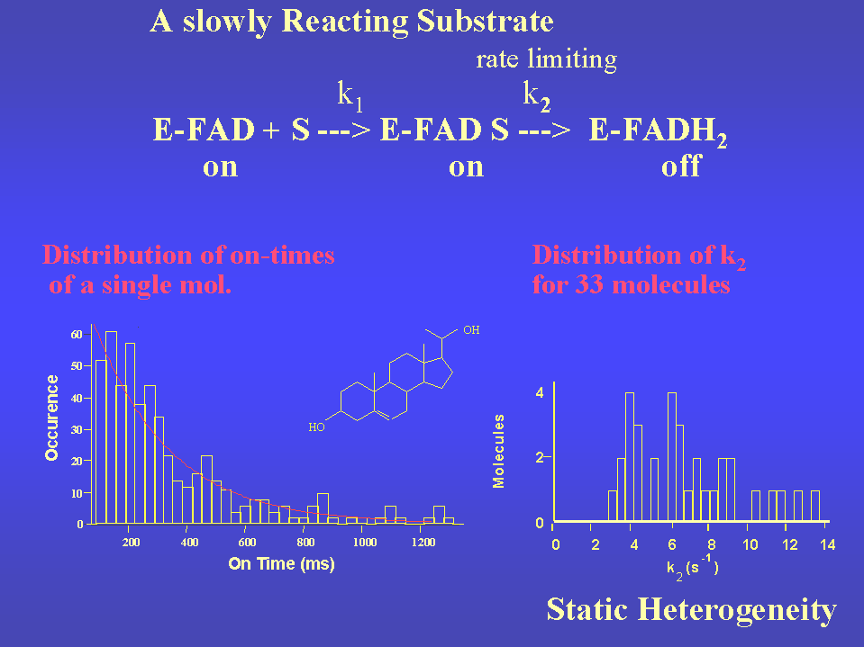

Figure 6: Distribution of times spent in the fluorescent state from single cholesterol oxidase molecules with a cholesterol derivative as substrate, where k₂ is the rate-limiting step. Left: the distribution of 'on-times' for a single molecule. Right: distribution of k₂ derived from 33 different molecules in the same sample. (Permission of S. Xie)

Development of New Fluorescent Probes

An important strategy for nonisotopic labeling of single molecules is the use of highly luminescent semiconductor nanocrystals, or 'quantum dots,' that can be covalently linked to biological molecules. This class of detectors, which range in size from 1- 5 nm, have been exploited for biological labeling by a number of laboratories, particularly those of Shimon Weiss, Paul Alivisatos and Shimung Nie (4, 5). Quantum dots offer several advantages over organic dyes, including increased brightness, stability against photobleaching, a broad continuous excitation spectrum, and a narrow, tunable, symmetric emission spectrum. Because quantum dots are nontoxic and can be made to dissolve in water, efforts are underway to explore their use in labeling single molecules in living cells. Similarly, green fluorescent protein (GFP) as a label for reporting cellular events in situ has been explored by a large number of laboratories. GFP and its mutants offer a powerful advantage as clonable markers for use in living tissue. However, photoisomerization and flickering of the emission signal ('blinking') create a challenge in single molecule experiments for both types of probe. Studies are in progress by W.E. Moerner and others (for example, see 6, 7) to understand the basis for the long-lived dark states that lead to fluctuations in the emission spectra from these molecules, and to develop improved probes with reduced photoisomerization and blinking.

Single Molecule Imaging and Manipulation with Atomic Force Microscopy

Atomic force microscopy (AFM) is a powerful tool for studying the size and range of small forces with high spatial resolution. Traditionally, AFM has been used to record the surface topography of a sample by recording the vertical motion of the probe tip as it is scanned over a sample. With a customized probe tip, however, specific interactions between the tip and the sample surface can be measured. In this type of experiment, molecular groups that interact with the sample are added to the tip so that separating the tip from the sample deflects the cantilever-tip assembly. The magnitude of the cantilever deflection can be used to calculate the binding interaction: F_{bind}= k_{cant} Δx, where F_{bind} is the binding force, kcant is the spring constant of the cantilever-tip assembly, and Δx is the displacement.

Measurements of force against separation have been used successfully in a number of different single molecule experiments. By absorbing larger molecules onto AFM probes, this approach has been used by Julio Fernandez and others to measure the unfolding and elasticity of multidomain proteins such as immunoglobulin, titin, or fibronectin (for example, see reference 8). Using forces in the range of 100-200 pNewtons, these experiments have measured the elongation 'steps', in nanometers, required to mechanically unfold individual domains of single proteins. Manipulations with AFM in these studies have provided information about the structural basis for flexibility in proteins that have unusual elastic properties.

In addition to making mechanical measurements, AFM has been used to observe the activity of individual proteins by measuring changes in protein positions over time. Recent advances in the ability to produce smaller cantilever AFMs have allowed faster and quieter measurements with higher resolution. For example, Paul Hansma and colleagues have been successful in using a silicon nitride cantilever, typically about 10 um long, 5 um wide, 75 nm thick, with an electron-deposited tip 1-2 um long. Using AFM in the tapping mode (frequency of 130kHz and oscillation amplitude at 10-20 nm) to minimize damage to the proteins, individual E. coli GroEL proteins with average diameters of 14 nm can be seen (Figure 7). By repeatedly scanning the same region, it is possible to see individual GroES molecules binding to and then dissociating from GroEL proteins, with an increase of 3.6 nm upon association of each GroES molecule, and an average lifetime of about 7 seconds for each complex (9).

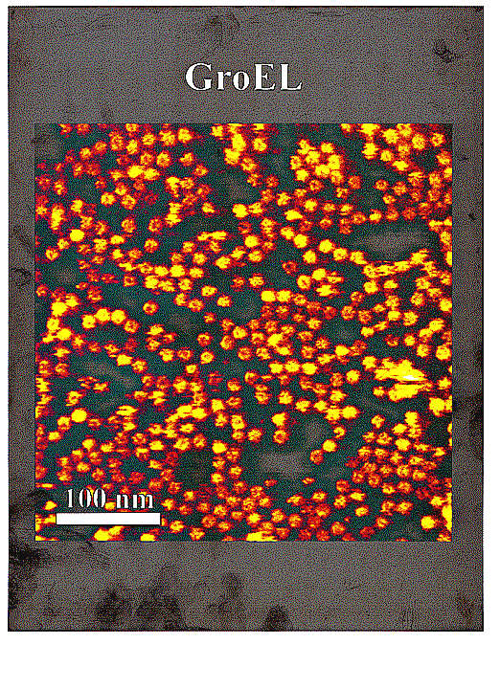

Figure 7: GroEL adsorbed on mica, in buffer solution. Image was taken by using a small cantilever AFM in the tapping mode. The height scale, from black to yellow, is 15 nm. The center channel of the GroEL molecules is visible as a dark region at center of a bright ring.
(Permission of P. Hansma)

The development of carbon nanotubes for use as AFM tips is another promising approach to increasing the resolution of the method. Carbon nanotube tips have several advantages, including high aspect ratio for imaging deep and narrow crevices, low tip-sample adhesion for gentle imaging, the ability to elastically buckle rather than break when large forces are applied, and the potential to achieve resolutions in the range of 1.0 nm or less. In addition, carbon nanotubes have well defined molecular structures so that it is possible to control their synthesis to make every tip with an identical structure and resolution. Carbon nanotubes can be selectively modified at their ends with organic or biological molecules to allow functional sensitive imaging.

As described and developed by Charles Lieber and colleagues, carbon nanotube tips can be 'grown' directly by a process called chemical vapor deposition (CVD), using a reaction of ethylene with an electrodeposited iron catalyst in etched pores on commercial silicon-cantilever-tip assemblies (10). The resulting nanotubes have radii of 3-8 nm if multiwalled; single-walled tubes have smaller radii, on the order of 1-2 nm or less, and potentially less than 0.5 nm if certain conditions are met (Figure 8).

Carbon Nanotubes & Probe Tips

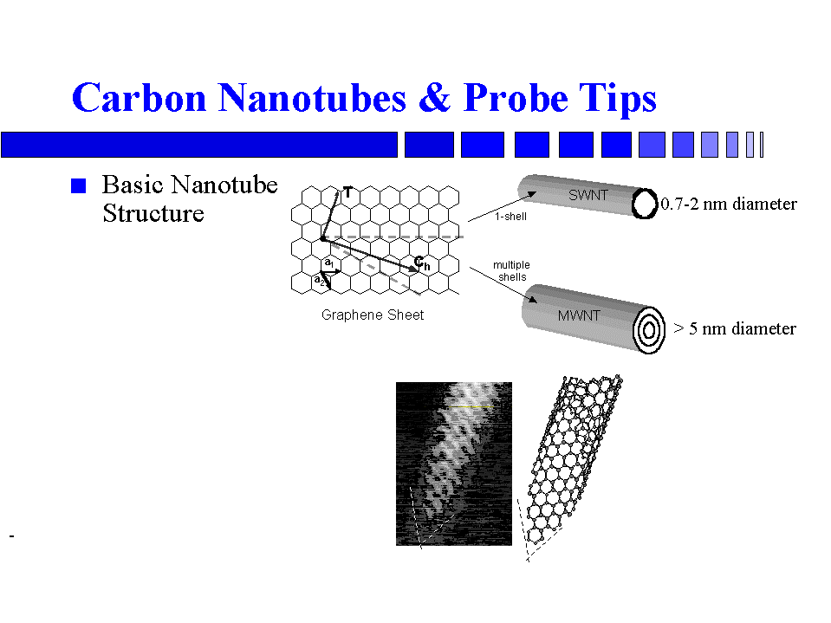

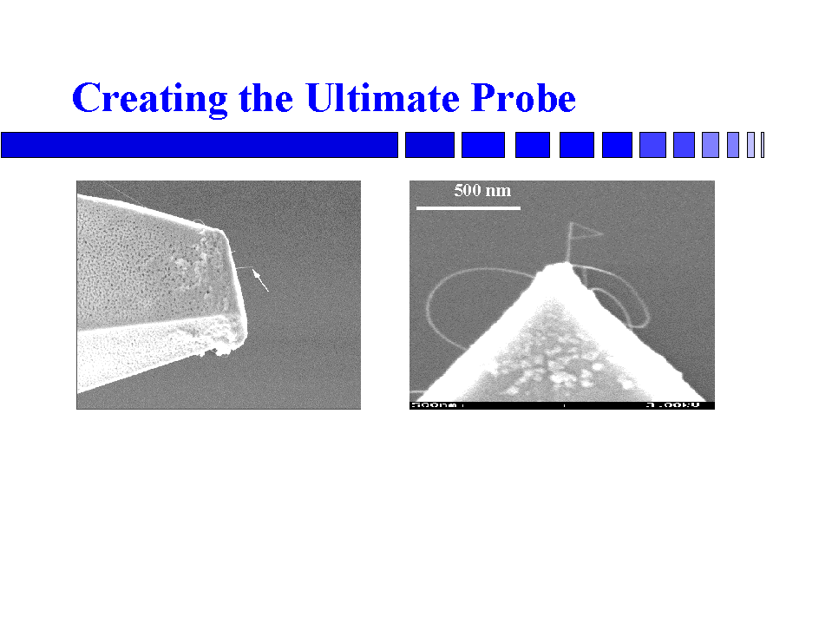

Figure 8: Fabrication of carbon nanotubes and probe tips. Metal-catalyzed CVD can be used to produce multi-walled nanotubes (MWNT), or individual single-walled nanotubes (SWNT). The ends of the nanotubes can be further tailored to produce molecularly defined structures. (Permission of C. Lieber)

CVD nanotubes have been used by Lieber to image a variety of biological structures with AFM, including individual molecules of IgG and GroES. IgG, a 150 kDa molecule that consists of four polypeptide chains arranged in a Y shape, can be imaged at room temperature as an individual protein molecule, with very little tip-induced broadening. Similarly, the resolution of AFM using the carbon nanotubes is high enough to see the seven-fold symmetry around the central pore of GroES, a 70 kDa heptameric protein measuring 8 nm in outer diameter.

Studies on Biomechanics Using Optical Tweezers

RNA Polymerase Pausing and Termination

The movement of RNA polymerase (RNAP) along DNA during transcription is a complex set of different activities, including initiation, elongation, pausing, backtracking, and arrest. A complete understanding of how this molecular machinery works requires characterization of the individual activities, when and why they occur, what structural components are required in each case, and what the biochemical parameters are. Since ensemble measurements will give only averages across a mixture of molecules engaged in a variety of these different behaviors, single molecule measurements may be the only way to examine the characteristics of each type of behavior independently.

Different aspects of RNAP as a molecular motor have been carried out by several laboratories, including those of Carlos Bustamante, Steve Block, Michelle Wang, and Jeff Gelles. In studies on E. coli RNAP pausing, Bustamante and his colleagues have used an optical trap/flow-control video microscopy technique to look at the behavior of single molecules (11). In this method, a transcription complex is tethered between two beads via a streptavidin-biotin linkage (Figure 9). At one end, the DNA template is attached directly to a bead, while at the other end, an RNAP molecule, to which the DNA is bound, is attached to a second bead. As the transcribing polymerase moves along the DNA, it pulls the two beads closer together. The separation of the beads is recorded by video microscopy and used to measure the distance that the RNAP moves along the DNA.

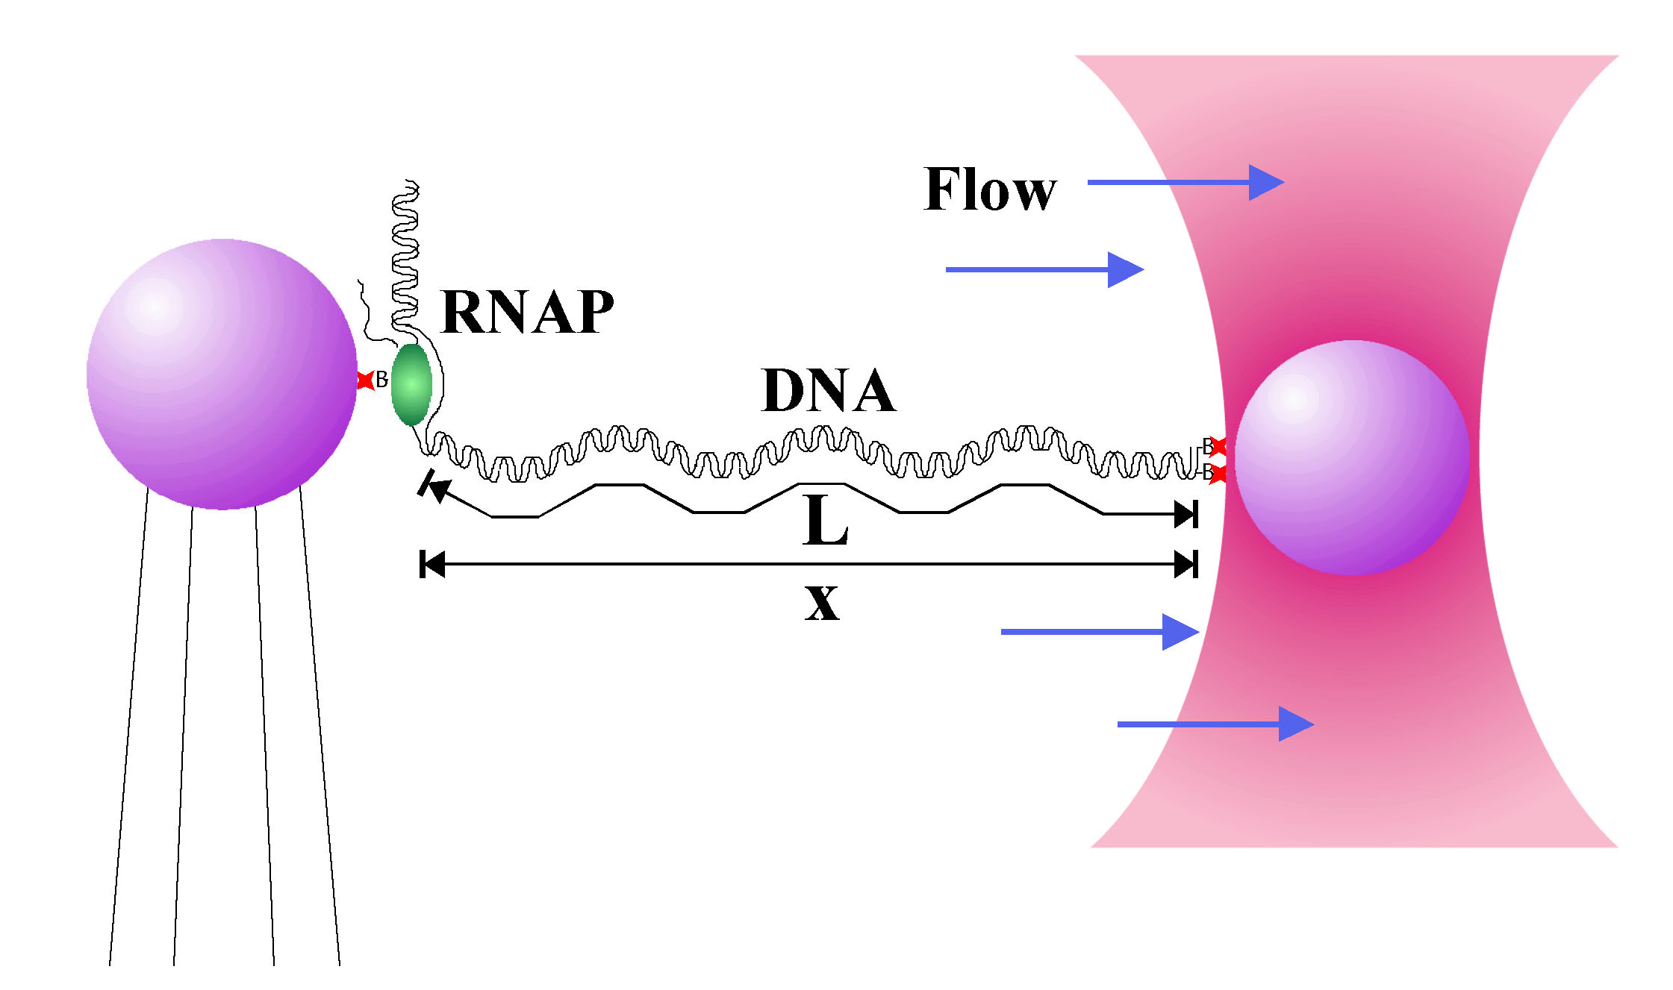
Figure 9: Laser Tweezers and Transcription. A transcription complex is tethered between two streptavidin-coated beads and kept in a continuous buffer flow. As a transcribing polymerase moves along the DNA, it physically pulls the two beads closer together. One bead is held in place with laser tweezers (red funnel) and the other by a pipette. The separation of the beads is measured by video microscopy and used to determine the end-to-end distance of the DNA. (Permission of C. Bustamante)

An example of the data obtained using this method is shown in Figure 10. RNAP moves discontinuously along the DNA template, pauses temporarily (arrows), and then eventually stops (asterisk). The average peak transcription rate of each RNAP molecule between pauses varies from molecule to molecule, from 2 to 11 base pairs/second. Pause sites are not random, but occur at certain discrete positions along the DNA. Arrest sites are also not random, and occur at previously identified pause sites. An analysis of the relationship between the rate at which a polymerase moves along the template, the likelihood of pausing, and the probability of arrest shows that RNAP molecules are more likely to arrest if they have first paused. The pause state appears to be a kinetic intermediate from which the polymerase can move towards arrest or towards further elongation. Switching between these two alternative states may be a mechanism for transcriptional control that was previously unrecognized.

RNA Polymerase Moves Discontinuously
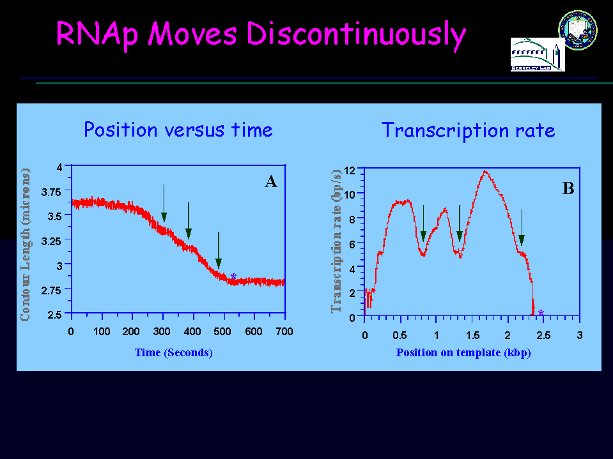

Figure 10: Transcription by a single molecule of RNAP. Pauses are indicated by arrows; permanent stops by (*). In A, the distance between the beads as a function of time shows the progress of the RNAP moving along the template. In B is the rate of RNAP, determined from the slopes of the plots and the position of the molecules on the template. The peak transcription rates appear in this graph as local maxima, and the temporary pauses as local minima. (Permission of C. Bustamante).

Related studies on transcription termination carried out by Jeff Gelles and colleagues have shed further light on the physical relationship between pausing and arrest. Using a single molecule light microscopy technique called TPM (tethered particle motion), Gelles has made observations on nanometer-scale movements of a single RNAP molecule as it transcribes a linear DNA fragment containing a terminator sequence (12).

In this experiment, a transcribing complex is adsorbed to a glass slide through a single molecule of RNAP. Transcription is observed by changes in the range of Brownian motion of a visible, submicrometer particle attached to the end of the DNA (Figure 11). The range of Brownian motion of the bead increases as transcription elongation takes place and as the DNA is translocated through the surface-immobilized RNAP; the rate of elongation can be calculated from these measurements. Similarly, pausing of elongation, or the release of the tethered bead from the complex indicating termination of transcription, can be directly visualized with this method.

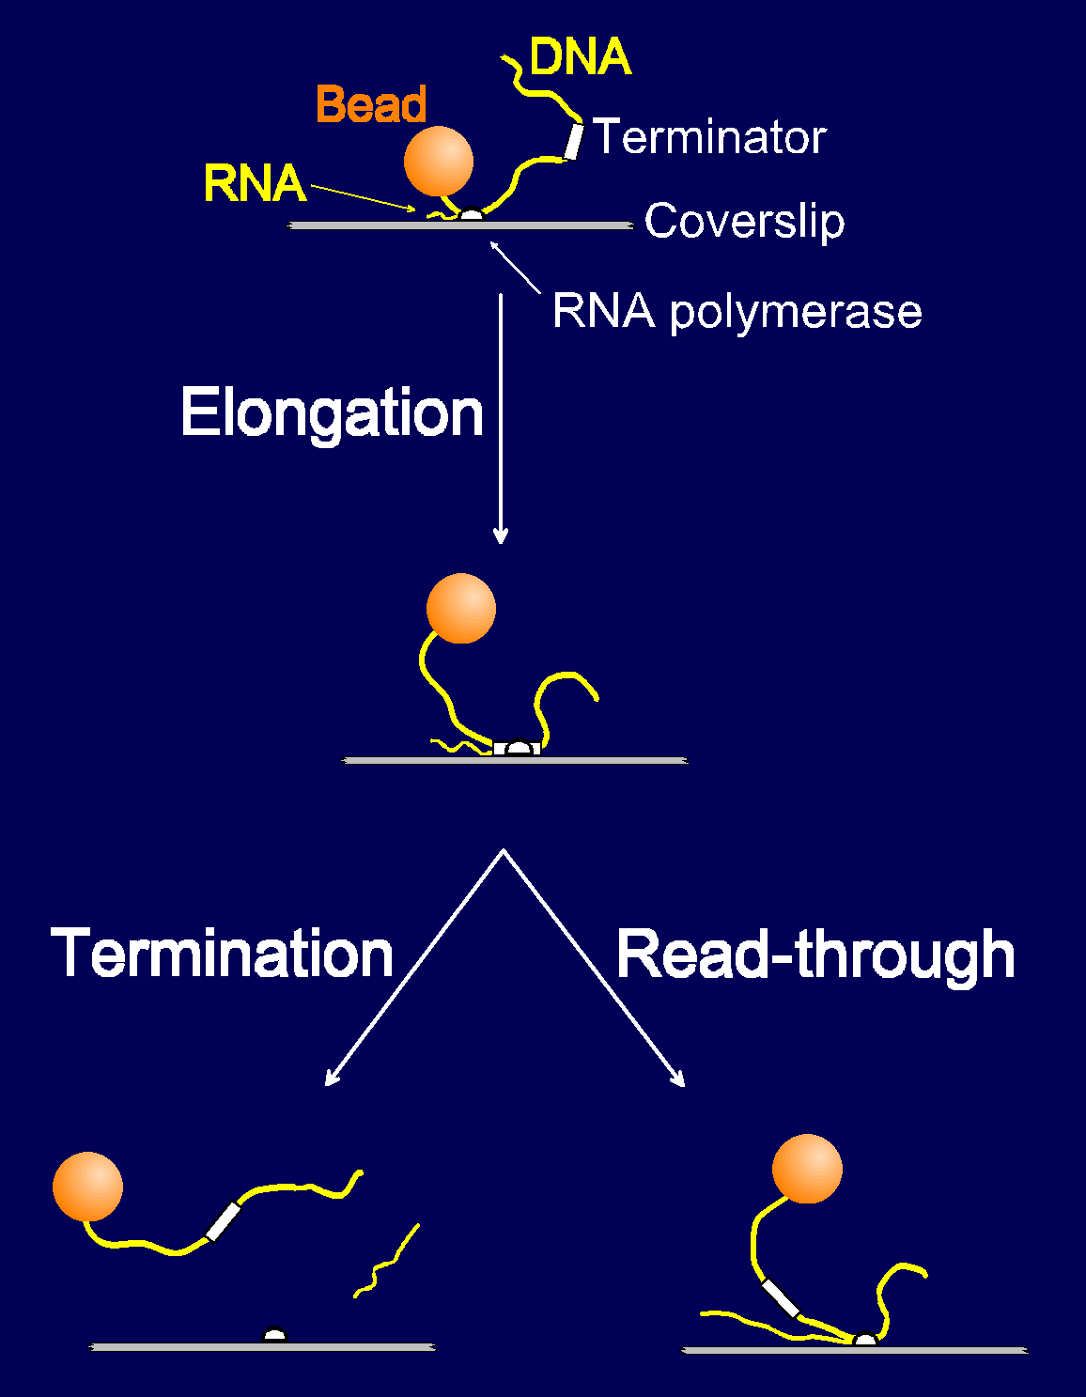
Figure 11: Single molecule termination experiment. Surface immobilized transcription complexes are labeled with a bead at one end of the template. RNAP moves along the template during elongation, changing the length of the DNA segment between the polymerase and the bead. On reaching the terminator, the enzyme either releases the DNA template and the RNA transcript (termination), or continues elongation through the terminator. (Permission of Jeff Gelles).

The results of these experiments show that an RNAP molecule can remain at a termination site for over 60 seconds before releasing DNA. If this occurs, the transcription complex is classified as an elongation-incompetent intermediate. Alternatively, RNAP may read through the terminator sequence, without significant pausing, and go on to elongate the RNA. The difference between these two paths is believed to be the consequence of pause lifetimes, where longer times spent at the terminator induce the release of RNAP. Thus, terminator effectiveness is determined by the relative rates of nucleotide addition for elongation versus entry into the paused state. The ability to analyze pause lifetimes at the single molecule level has established that termination is a nonequilibrium process in which the formation of the paused intermediate is a required step before the release of RNAP at the terminator. Prior to the single molecule analysis, the requirement for this intermediate was not known.

Papers Cited

1.) Deniz, A., Laurence, T., Beligere, G., Dahan, M., Martin, A., Chemla, D., Dawson, P.,
Schultz, P., and S. Weiss (2000). Single-molecule protein folding: Diffusion fluorescence
resonance energy transfer studies of the denaturation of chymotrypsin inhibitor. Proc. Natl.
Acad. Sci. 97: 5179-5184.

2.) Zhuang, Z., Bartley, L., Babcock, H., Russell, R., Ha, T., Herschlag, D., and S. Chu (2000).
A single-molecule study of RNA catalysis and folding. Science 288: 2049-2051.

3.) Lu, H., Xun, L., and S. Xie (1998). Single-molecule enzymatic dynamics. Science 282: 1877-1882.

4.) Chan, W., and S. Nie (1998). Quantum dot bioconjugates for ultrasensitive nonisotopic detection. Science 281: 2016-2018.

5.) Bruchez, M., Moronne, M., Gin, P., Weiss, S., and P. Alivisatos (1998). Semiconductor nanocrystals as fluorescent biological labels. Science 281: 2013-2016.

6.) Moerner, W.E. and M. Orrit (1999). Illuminating single molecules in condensed matter. Science 283:1670-1676.

7.) Schwille, P. Kummer, S., Heikal, A., Moerner, W. and W. Webb (2000). Fluorescence correlation spectroscopy reveals fast optical excitation-driven intramolecular dynamics of yellow fluorescent proteins. Proc. Natl. Acad. Sci. 97:151-156.

8.) Fisher, T., Marszalek, P., and J. Fernandez (2000). Stretching single molecules into novel conformations using the atomic force microscope. Nature Struct. Biol. 7: 719-724.

9.) Viani, M., Pietrasanta, L., Thompson, J., Chand, A., Gebeshuber, I., Kindt, J., Richter, M., Hansma, H., and P. Hansma (2000). Probing protein-protein interactions in real time. Nature Struct. Biol. 7: 644-647.

10.) Cheung, C., Hafner, J., and C. Lieber (2000). Carbon nanotube force microscopy tips: Direct growth by chemical vapor deposition and application to high resolution imaging. Proc. Natl. Acad. Sci. 97: 3809-38.

11.) Davenport, J., Wuite, G., Landick, R. and C. Bustamante (2000). Single -molecule study of transcriptional pausing and arrest by E. coli RNA polymerase. Science 287: 2497-2500.

12.) Yin, H., Artsimovitch, I., Landick, R. and J. Gelles (1999). Nonequilibrium mechanism of transcription termination from observations of single RNA polymerase molecules. Proc. Natl. Acad. Sci. 96: 13124-12129.

