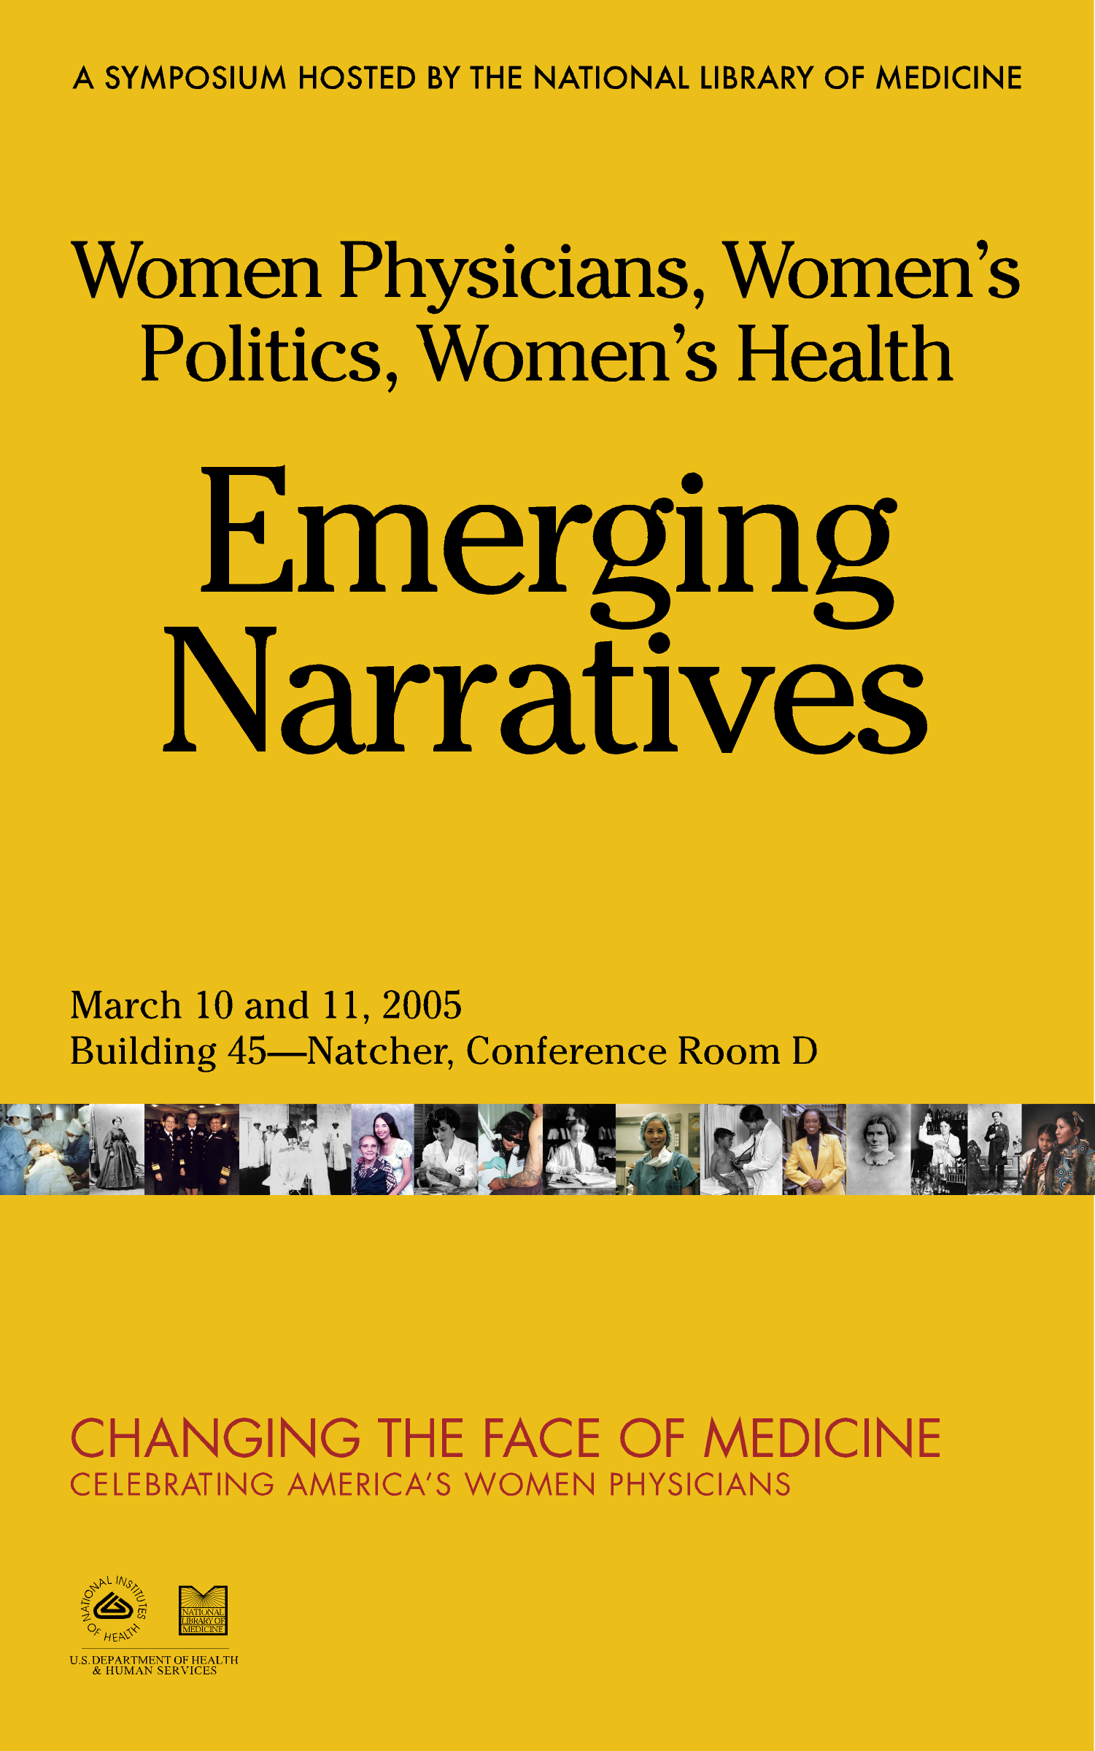
Welcome

Welcome to Women Physicians, Women’s Politics, and Women’s Health: Emerging Narratives. This event forms part of the History of Medicine Division’s recognition of Women’s History Month, and is being held in conjunction with the exhibition, Changing the Face of Medicine: Celebrating America’s Women Physicians. The symposium brings together distinguished scholars in the history of women and medicine, to present their latest research and to consider new directions for the field. The papers delivered here are works-in-progress, and we hope that this gathering will give participants an opportunity to further develop their work and share ideas with one another. Selected papers from this event will also be included in an edited collection, planned for publication in 2006–2007. We thank our panelists and session chairs for making this exciting event possible and invite all of our attendees to join us for a reception in the Rotunda of the National Library of Medicine from 5:30 pm–7:30 pm on Thursday, March 10, where visitors can view the exhibition.

We are grateful to the Elizabeth and Chauncey Leake Memorial Fund, Institute for the Medical Humanities, University of Texas Medical Branch, for co-sponsoring this event.

Elizabeth Fee
on behalf of the organizers and the History of Medicine Division

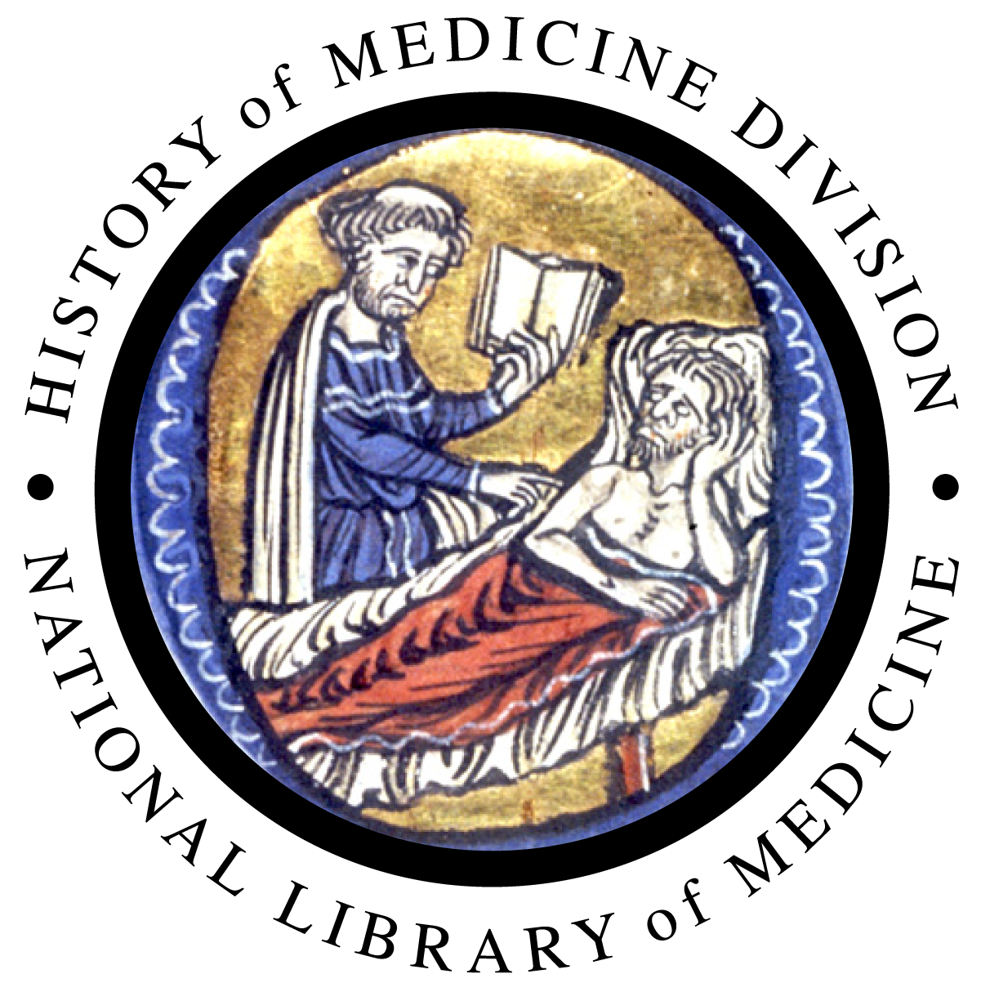
Other events

Traveling Exhibition
A traveling version of Changing the Face of Medicine: Celebrating America’s Women Physicians, developed in collaboration with the American Library Association, will begin a tour of 60 public and medical center libraries in August, 2005.

Women’s History Month Lecture
On March 28, 2005, Dr. Bernadine Healy will give a lecture at the National Library of Medicine, on the campus of the National Institutes of Health. The lecture will be held in the Lister Hill Auditorium, Building 38A, from 2:00 pm–3:15 pm. In 1991, Dr. Healy became the first woman to be appointed director of the National Institutes of Health. She is a former President and CEO of the American Red Cross, and currently serves on the President’s Council of Advisors on Science and Technology Policy. She also writes a column for U.S. News & World Report. Dr. Healy is featured in Changing the Face of Medicine: Celebrating America’s Women Physicians, located in the Rotunda of the NLM and online at: www.nlm.nih.gov/changingthefaceofmedicine

Day 1
March 10

8:30–9:00 Registration, Coffee and Breakfast

9:00–9:30 Introduction and Welcome

Betsy Humphreys, Deputy Director
National Library of Medicine

Elizabeth Fee, Chief, History of Medicine Division
National Library of Medicine

Ellen More, Visiting Professor of Psychiatry, University of Massachusetts Medical School, Worcester, and Professor of History of Medicine and Medical Humanities at the Institute for the Medical Humanities, University of Texas Medical Branch, Galveston

9:30–11:00 Session 1
Ancient Narratives: Male Professionalism and Female Professionals
Session Chair: Elizabeth Fee

- Rebecca Flemming, “New Perspectives on Ancient Physicians.”
- Monica Green, “Rethinking the Mistress Narrative: Riding the Third Wave to a New History of Women in Medicine.”
- Robert Nye, “Medicine as a Masculine Culture.”

11:00–11:15 Break

11:15–12:45 Session 2
Neither Separate nor Equal:
Early Women Medical Graduates Revisited
Session Chair: Steve Peitzman

- Ann Taylor Kirschmann, “An Uncommon Practice: Julia Minerva Green, M.D. (1871–1963).”
- Eve Fine, “Separatism in Medicine Reconsidered: Women Physicians in Nineteenth-Century Chicago.”
- Martha Gardner, “A ‘Coveted Diploma’: The Professional Identity of the New England Female Medical Graduates, 1854–1873.”
12:45–2:45 Lunch
Natcher Building Cafeteria or off-campus

2:45–3:45 Session 3
Women Doctors and Their Patients
Session Chair: Nancy Theriot

- Regina Morantz-Sanchez, “From Bodies to Persons: Female Patient Agency and the History of Women Physicians.”
- Judith Houck, “‘Hold Oneself Well in Hand’: Women Physicians Confront Menopause, 1897–1936.”

3:45–4:00 Break

4:00–5:30 Session 4
Mythologizing the Woman Physician:
Mothers, Wives, and Daughters
Session Chair: Susan Smith

- Virginia Metaxas, “American Women Physicians Overseas: Esther Pohl Lovejoy, Ruth A. Parmelee and the Narrative of Motherhood in Asia Minor and Greece in the Early Twentieth Century.”
- Georgina Feldberg, “Doctors as Debutants, Images of Canadian Medical Women.”
- Frederick Wegener, “‘Imaging’ Women Doctors in the United States, 1860–1920.”

5:30–7:30 Reception and Exhibition Visit
Rotunda, National Library of Medicine Building 38

Welcoming Remarks
Dr. Donald A.B. Lindberg
Director, National Library of Medicine
Day 2
March 11

9:00–9:30 Coffee and Breakfast

9:30–11:00 Session 1
Bodies of Knowledge: Women Physicians and the Feminine Body
Session Chair: Judith Leavitt

- Carla Bittel, “Gender, Politics, and Female Physiology: Mary Putnam Jacobi and the Science of Women's Rights Activism.”
- Arleen Tuchman, “Sexuality and the Female Body: The Case of Marie Zakrzewska (1829–1902).”
- Ellen More, “Dr. Mary Steichen Calderone: Professionalism, Sexuality, and the Politics of Shame.”

11:00–11:30 Break

11:30–1:00 Session 2
Women's Health and the Women’s Movement
Session Chair: Manon Parry

- Leslie Reagan, “Birth Defects and Reproductive Rights in the 1960s.”
- Susan Wells, “Chiasmus and Narrative Competence: Our Bodies, Ourselves and the Narrative Medicine Movement.”
- Sandra Morgen, “The Changer and the Changed: Women Physicians and the Women's Health Movement in the U.S., 1969–1990.”

1:00–2:00 Lunch
Natcher Building Cafeteria or off-campus

2:00–3:30 Session 3
Race, Gender, and Women in Medicine
Session Chair: Judy Wu

- Charlotte Borst, “Women Physicians and the AAMC Longitudinal Study of Medical School Graduates of 1960.”
- Vanessa Northington Gamble, "When Racism Trumps Sisterhood: A History of Racial Discrimination and White Women Physicians."
- Naomi Rogers, “‘Save Her For the Dean’: Medical Schools, Women Doctors and the Feminist Health Movement of the 1970s.”

3:30–4:00 Break

4:00–5:30 Session 4
Women Physicians and Health
Session Chair: Susan Rishworth

- Heather Prescott, “‘Coming of Age’: Gender and the Professionalization of College Health, 1920–1961.”
- Erica Frank, “What Do We Know About U.S. Women Physicians? Information Gathered from the Women Physicians' Health Study.”
- Diane K. Shrier and Lydia Shrier, “Mother-Daughter Physicians: An Intergenerational Comparison of the Professional and Personal Experiences of Women Physicians.”

5:30–6:00 Concluding Remarks
Wrap-Up and Future Plans
Ellen More, Elizabeth Fee, Manon Parry

Panelists

Carla Bittel is Assistant Professor of History at Loyola Marymount University in Los Angeles. Her research focuses on the history of women in medicine in nineteenth-century America, specifically the science and politics of Mary Putnam Jacobi.

Charlotte Borst is Dean of Arts and Sciences and Professor of History at Union College, where she has oversight responsibility for curriculum offerings in Arts and Sciences, faculty matters including faculty recruitment, development and evaluation, academic staffing, and faculty research for all faculty in the three Arts and Sciences Divisions (~170 FTE). She oversees chair relations and departmental issues for 17 departments and seven interdisciplinary programs, as well as student issues relating to two formal programs related to premedical studies (admissions, program requirements, and relations with Albany Med). Dean Borst’s current research investigates the history of medical education in twentieth-century America, specifically analyzing the role that race and gender played in medical school admissions.

Georgina Feldberg is Associate Professor of Social Science at York University (Canada). As Director of the York University Centre for Health Studies, she developed academic-community research partnerships in women’s health through its federally funded Centre of Excellence for Women’s Health. She is the co-editor of Women, Health and Nation: Canada and the U.S. since 1945 (McGill-Queen's 2003) and of several articles in the area of “defining women's health: community and elite initiatives in Canada.”

Eve Fine is a Ph.D. candidate in History of Science and Medicine at the University of Wisconsin-Madison and a Researcher for The Women in Science and Engineering Leadership Institute (WISELI), part of the NSF ADVANCE Institutional Transformation Grant Program. Her dissertation examines the history of women physicians in nineteenth-century Chicago and her broader research interests center around the history of women in science and medicine; in women as practitioners of science and medicine, as subjects of scientific research and/or theories, and as consumers and producers of medical advice.

Rebecca Flemming is Lecturer in Ancient History in the Department of Classics at King's College, London. She works on women, gender, and medicine in the ancient world, both together and separately.

Erica Frank is Vice Chair, Division Chief, and Associate Professor and Director of the Preventive Medicine Residency Program, in the Department of Family and Preventive Medicine at Emory University School of Medicine. She is also Principal Investigator, Women Physician's Health Study, Principal Investigator, Healthy Doc = Healthy Patient Study, and Education Coordinator, WHO Health InterNetwork.
Vanessa Northington Gamble is Director of the Tuskegee University National Center for Bioethics in Research and Health Care. In 1996, she founded and directed the Center for the Study of Race and Ethnicity in Medicine at the University of Wisconsin. She has served on the faculties of Harvard University, University of Massachusetts-Amherst, and The Johns Hopkins University Bloomberg School of Public Health. Dr. Gamble also chaired the Presidential Committee on the legacy of the Tuskegee Syphilis Study.
Martha Gardner will be Assistant Professor of History, Massachusetts College of Pharmacy and Health Sciences as of Fall of 2005. She is currently a Research Associate in the Department of Social Medicine, at Harvard Medical School. Her dissertation (in U.S. history from Brandeis University, finished in 2002) was entitled: “Midwife, Doctor or Doctress? The New England Female Medical College and Women's Place in Nineteenth-Century Medicine and Society.” Her research interests include the cultural history of the cigarette in the U.S. as well as the social and cultural position of U.S. women in medicine and the allied health professions in the nineteenth and twentieth centuries.

Monica Green is Professor of History at Arizona State University, with adjunct appointments in Women’s Studies, the Center for Biology and Society, and the Bioethics Program. She has published widely on medieval women’s medicine and has just completed a monograph, The Masculine Birth of Gynecology. Together with Heather Prescott, she is preparing a general survey of the impact of feminist scholarship of the History of Medicine.

Judy Houck is Assistant Professor of Medical History, History of Science, and Women’s Studies at the University of Wisconsin-Madison. Her research interests center on the history of women's health in the United States.

Anne Taylor Kirschmann is a full-time lecturer in American History at the University of Massachusetts, Dartmouth Campus. Her work focuses on alternative medicine in the nineteenth and twentieth century. She is currently researching women homeopathic physicians in the twentieth century.

Virginia Metaxas is Professor of History and Women’s Studies at Southern Connecticut State University. Her research interests include childbirth and childcare institutions in America, the history of occupational therapy in America, women physicians in Asia Minor and Greece, and the colonization of Hawaiian medicine.

Regina Morantz-Sanchez is Professor of History at the University of Michigan. She has published three books and many articles on the history of women physicians and gender and medicine.

Ellen S. More is Visiting Professor of Psychiatry at University of Massachusetts Medical School, Worcester, and Professor of History of Medicine and Medical Humanities at the Institute for the Medical Humanities, University of Texas Medical Branch, Galveston. She is the author of Restoring the Balance: Women Physicians and the Profession of Medicine, 1850–1995 (Harvard), which won the 2003 History of Science Society’s prize for the best book on women and science, now renamed the Margaret Rossiter Prize. With Manon Parry, she was co-curator of Changing the Face of Medicine: Celebrating America’s Women Physicians.

Sandra Morgen is Director of the Center for the Study of Women in Society and Professor of Anthropology at the University of Oregon. Her book, Into Our Own Hands: The Women’s Health Movement in the U.S., 1969–1990 won the Eileen Basker prize awarded by the Society for Medical Anthropology in 2004. Her current research focuses on how
low income families, welfare workers and welfare administrators experienced, enacted and contested welfare restructuring in Oregon.

Robert A. Nye is Thomas Hart and Mary Jones Horning Professor of the Humanities and Professor of History at Oregon State University. He works on modern European history, particularly gender history and the history of sexuality. His most recent book is an Oxford Reader, Sexuality (Oxford, 1999).
Heather Munro Prescott is Professor of History at Central Connecticut State University in New Britain. She is the author of “A Doctor of Their Own”: The History of Adolescent Medicine, as well as numerous other publications on the history child and adolescent health. She is currently working on a book entitled Student Bodies: The History of College and University Health, which is under contract with University of Michigan Press.

Leslie Reagan is Associate Professor at the University of Illinois, Urbana-Champaign with a joint appointment in the department of History and in Medicine; and an affiliation with Women's and Gender Studies. She received her Ph.D. from the University of Wisconsin, Madison. Dr. Reagan’s research interests are varied: sexuality, reproductive rights, movies, crime, and medicine. The talk for the conference is part of a forthcoming book on the history of miscarriage and birth defects in the twentieth-century United States, for which she currently enjoys a NIH-NLM grant. A related article, “From Hazard to Blessing to Tragedy: Representations of Miscarriage in Twentieth-Century America,” appeared in Feminist Studies, Summer 2003. That article is about miscarriages, emotions, and the practice of doing history. Her first book is When Abortion Was A Crime: Women, Medicine, and Law, 1867–1973 (University of California Press, 1997).

Naomi Rogers has written on disease and public health, the history of medical education, women and medicine, homeopathy, Sister Elizabeth Kenny (a nurse who challenged the American Medical Association), and radical medical students of the 1960s. This paper is part of her growing interest in the culture and politics of American medicine in the 1960s and 1970s, especially the dynamics between health radicalism and the medical establishment. She is currently Associate Professor in the Section of the History of Medicine and in the Women's, Gender and Sexuality Studies Program of Yale University.

Diane K. Shrier is Clinical Professor of Psychiatry and Behavioral Sciences and of Pediatrics, George Washington University Medical Center, Washington DC.

Lydia A. Shrier is Assistant Professor of Pediatrics, Harvard Medical School and Attending in Adolescent/Young Adult Medicine, Boston Children’s Hospital.

Arleen Tuchman is Associate Professor of History at Vanderbilt University. She is the author of Medicine, Science and the State in Germany and is just completing her biography of Marie Zakrzewska, entitled “Science Has No Sex.” Her next project will be a cultural history of diabetes.

Frederick Wegener is Associate Professor of English, and formerly the Director of the Program in American Studies, at California State University, Long Beach. His publications include Edith Wharton: The Uncollected Critical Writings and the forthcoming Penguin Classics edition of Sarah Orne Jewett's novel A Country Doctor. He is currently working on a study of representations of women doctors in the United States from 1860 to 1920.

Susan Wells is the author of Out of the Dead House: Nineteenth-Century Women Physicians and the Writing of Medicine (Wisconsin, 2001). She is Chair of the English Department at Temple University and slowly working on a book about the writing of Our Bodies, Ourselves.

Session Chairs

Elizabeth Fee is Chief of the History of Medicine Division of the National Library of Medicine, and Adjunct Professor of History and Health Policy, and the History of Medicine, at the Johns Hopkins University. She is the author of Disease and Discovery and co-editor of Making Medical History, among other works, and is contributing editor for history of the American Journal of Public Health. She has recently established a collaborative project with the World Health Organization on “Global Health Histories” and is working on a history of WHO as part of her study of global health. She is a coauthor of the Joint Learning Initiative’s report, Human Resources for Heath: Overcoming the Crisis (Harvard University Press, 2004).

Judith Leavitt is the Rupple Bascom and Ruth Bleier WARF Professor of the Medical History Department at the University of Wisconsin-Madison. She was also a member of the Ad Hoc Advisory Group for Changing the Face of Medicine: Celebrating America’s Women Physicians. Her current research is on the history of childbirth in the twentieth century, concentrating on fathers.

Manon Parry is Associate Curator in the History of Medicine Division at the National Library of Medicine, and, with Ellen S. More, co-curator of the exhibition, Changing the Face of Medicine: Celebrating America’s Women Physicians. She is currently working on the history of disability as a Ph.D. student in American Studies at the University of Maryland.

Steve Peitzman is Professor of Medicine at Drexel University College of Medicine, and a senior medical advisor in assessment services at the Educational Commission for Foreign Medical Graduates. His historical work and interests have centered on kidney disease and nephrology (his clinical field); women in American medicine; medical education in the United States; and medicine in Philadelphia. He was also a member of the Ad Hoc Advisory Group for Changing the Face of Medicine: Celebrating America’s Women Physicians.

Susan Rishworth is Archivist at the American College of Surgeons, Chicago. She is currently researching the life of Verina Morton Jones, MD, a 1888 graduate of the Woman’s Medical College of Pennsylvania and the first woman physician to practice in the state of Mississippi.

Susan L. Smith is Associate Professor of History at the University of Alberta in Canada. She is the author of Sick and Tired of Being Sick and Tired: Black Women's Health Activism in America, 1890–1950 (University of Pennsylvania Press, 1995), and Japanese American Midwives: Culture, Community, and Health Politics, 1880–1950 (University of Illinois Press, 2005). She is also co-editor, with Nancy Tomes, of the “Women, Gender, and Health” series at Ohio State University Press.

Nancy M. Theriot is Professor and Chairperson in the Department of Women’s and Gender Studies at the University of Louisville. Her most recent work focuses on physicians, patients, and illness narratives in the nineteenth century.

Judy Tzu-Chun Wu is an Associate Professor of History and the Coordinator for Asian American Studies at Ohio State University. She recently published Doctor Mom Chung of the Fair-Haired Bastards: The Life of a Wartime Celebrity (University of California Press, 2005), a biography of Dr. Margaret Chung (1889–1959), the first known American-born Chinese woman physician.
NOTES
NOTES

